Supplementary Data
Supplementary methods
- DNA extraction of fecal bacteria and abundance analysis by RT-qPCR.
Supplementary figures
Fig. 1 Effect of antibiotics treatment on gut microbiota in mice.
Supplementary Tables
Table 1 Primer sequence list for RT-qPCR.
Table 2 Bacterial primer sequences for RT-qPCR analysis.

Supplementary methods

1. DNA extraction of fecal bacteria and abundance analysis by RT-qPCR
Mouse feces were suspended in PBS buffer, and the fecal bacteria DNA was extracted using a Bacterial Genome DNA Extraction kit (Solarbio, Beijing, China). The abundances of all bacteria, Enterococcus, Bifidobacterium, Bacteroides, Akkermansia, and Bacillus, were quantified by RT-qPCR. Bacterial concentrations were determined by gene copy number. Primer sequences for the target genes are shown in Supplementary Table 2.

Supplementary figures
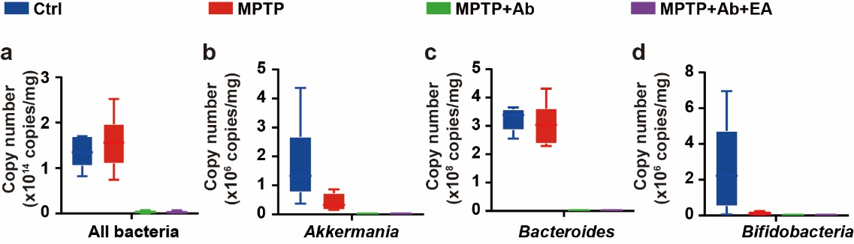
Fig. 1 Effect of antibiotics on gut microbiota in mice. The abundance of all bacteria (a), Akkermansia (b), Bacteroides (c), and Bifidobacterium (d) in mouse feces were identified by RT-qPCR. Data were presented as mean ± SEM.

Supplementary tables
Table 1 Primer sequence list for RT-qPCR
Gene | Forward primer (5ʹ-3 ʹ) | Reverse primer (5ʹ -3ʹ)
Caspase-1 | CCCCAGGCAAGCCAAATC | TGAGGGTCCCAGTCAGTCC
Caspase-3 | TGGTGATGAAGGGGTCATTTATG | TTCGGCTTTCCAGTCAGACTC
IL-6 | GAAACCGCTATGAAGTTCCTCTCTG | TGTTGGGAGTGGTATCCTCTGTGA
IL-10 | GCTCTTACTGACTGGCATGAG | CGCAGCTCTAGGAGCATGTG
IL-18 | ACACGCTTTACTTTATACCT | GTCACAGCCAGTCCTCT
TGF-β | ACCGCAACAACGCCATCTA | GCCCTGTATTCCGTCTCCTT
TNF-α | GGGTGTTCATCCATTCTC | GGAAAGCCCATTTGAGT
Bax | TGAAGACAGGGGCCTTTTTG | AATTCGCCGGAGACACTCG
TH | GTCTCAGAGCAGGATACCAAGC | CTCTCCTCGAATACCACAGCC
α-syn | GCAAGGGTGAGGAGGGGTA | CCTCTGAAGGCATTTCATAAGCC
BDNF | TCATACTTCGGTTGCATGAAGG | AGACCTCTCGAACCTGCCC
GDNF | TCCAACTGGGGGTCTACGG | GCCACGACATCCCATAACTTCAT
DAT | AAATGCTCCGTGGGACCAATG | GTCTCCCGCTCTTGAACCTC
Bcl-2 | GCTACCGTCGTGACTTCGC | TCCCAGCCTCCGTTATCC
Claudin-1 | GGGGACAACATCGTGACCG | AGGAGTCGAAGACTTTGCACT
β-actin | GGCTGTATTCCCCTCCATCG | CCAGTTGGTAACAATGCCATGT

Table 2 Bacterial primer sequences for RT-PCR analysis
Bacterium | Forward primer (5ʹ -3ʹ) | Reverse primer (5ʹ -3ʹ)
All bacterium | ACTCCTACGGGAGGCAGCAGT | ATTACCGCGGCTGCTGGC
Bacteroides | GGTTCTGAGAGGAGGTCCC | GCTGCCTCCCGTAGGAGT
Akkermansia | CAGCACGTGAAGGTGGGGAC | CCTTGCGGTTGGCTTCAGAT
Bifidobacterium | TCGCGTCCGGTGTGAAAG | CCACATCCAGCGTCCAC

