Figure S1. Taxonomic composition of the URT of beef calves. (A) Microbial community composition at domain level (B) Bacterial community composition at phylum level (C) Bacterial genera identified from calves at all time points (67 genera) (D) Viruses classified at genus level. Stack bars represents mean relative abundance of each bacterial group at each time point

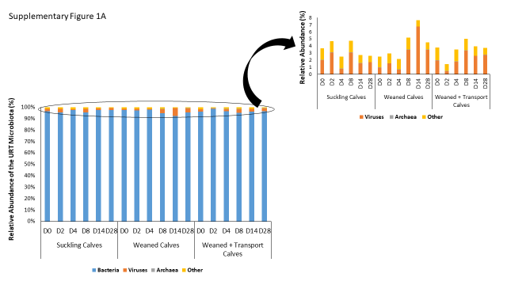
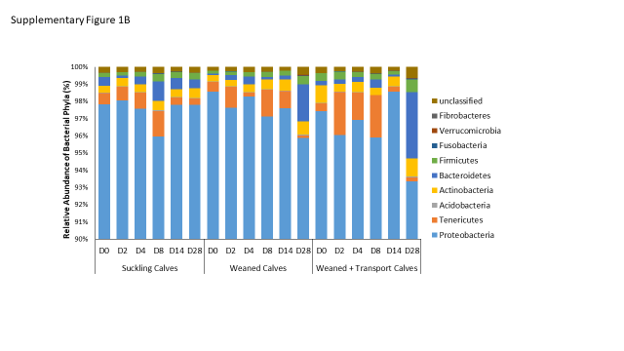

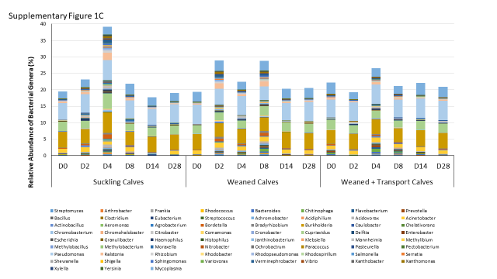

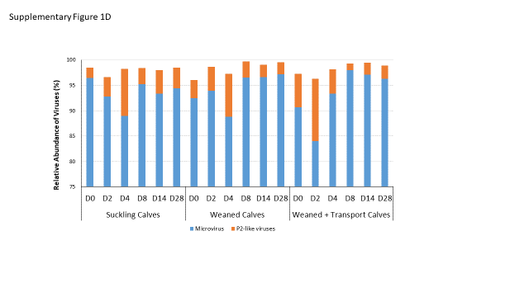
Figure S2. Comparison of the microbial profiles generated from the three groups of the calves at each sampling time point. Group A: Suckling calves; Group B: Weaned calves; Group C: Weaned + Transport Calves. There are 10 calves/group and analysis performed on Day 0, Day 2, Day 4, Day 8, Day 14, and Day 28 after weaning.
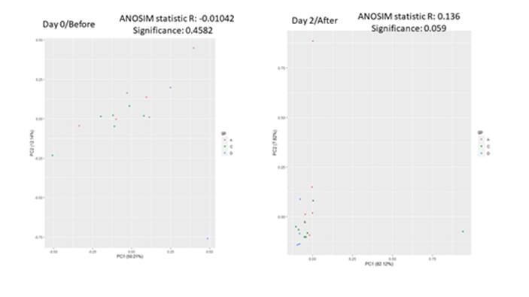

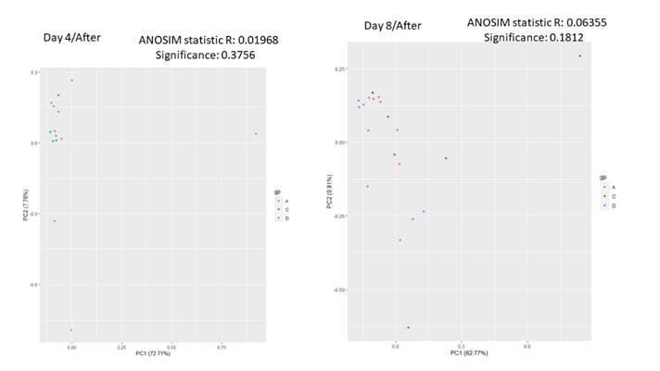
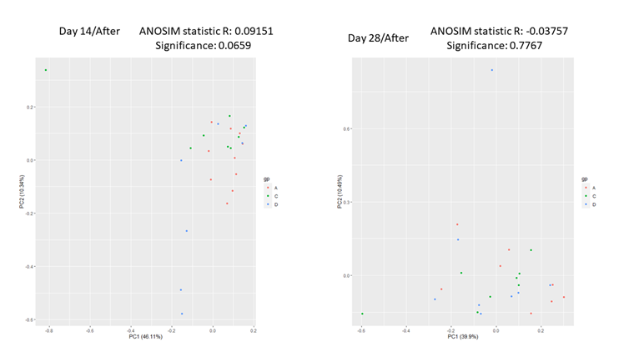
Figure S3. Comparison of the functional profiles of the URT of beef calves. Group A: Suckling calves; Group B: Weaned calves; Group C: Weaned + Transport Calves. There are 10 calves/group and analysis was performed on Day 0 (T1), Day 2 (T2), Day 4 (T3), Day 8 (T4), Day 14 (T5), and Day 28 (T6) after weaning.
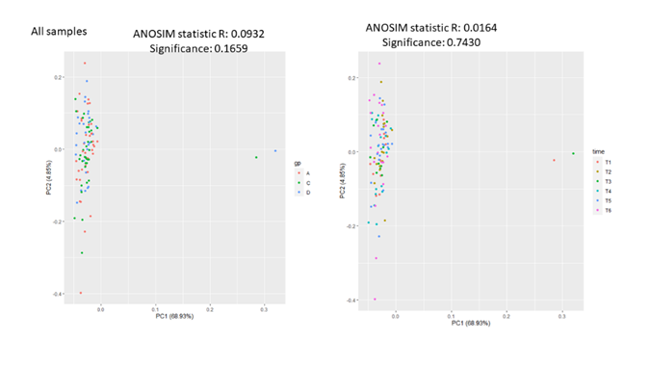
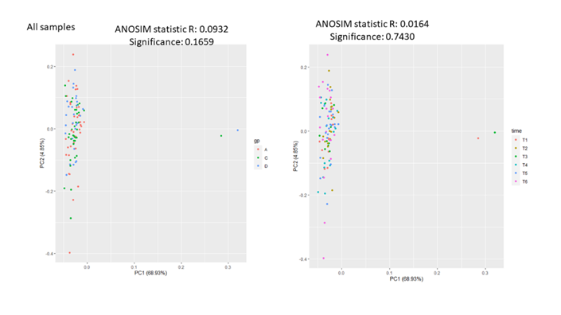
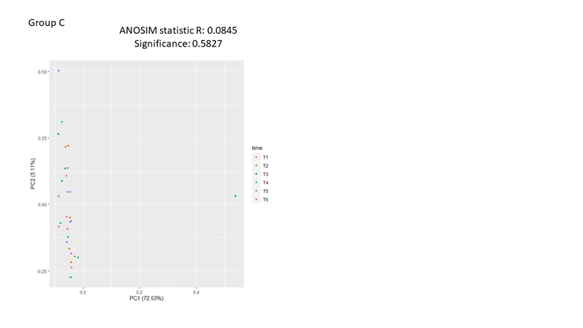

Figure S4. Microbial functional composition in the URT of beef calves

Supplementary Table 1. Relationship between the presence of a microbial function (KEGG Orthology at level 2) in the URT of beef calves with weaning and transportation stressors and sampling time points.
Microbial function | All samples |  |  |  |  | After Weaning
Microbial function | Factorª | OR | 25% | 97.5% | P-value | Factor^{b} | OR | 25% | 97.5% | P-value
Cell communication |  |  |  |  |  | D4 | 4.29 | 0.84 | 26.72 | 0.09
Cell communication |  |  |  |  |  | D8 | 4.09 | 1.00 | 18.94 | 0.06
Cell growth and death |  |  |  |  |  | D4 | 12.68 | 2.16 | 112.38 | 0.01
Cell growth and death |  |  |  |  |  | D8 | 3.60 | 0.86 | 17.38 | 0.09
Cell growth and death |  |  |  |  |  | D28 | 5.29 | 1.35 | 24.50 | 0.02
Cell motility | D28 | 0.22 | 0.04 | 0.91 | 0.04 | D28 | 0.27 | 0.07 | 1.01 | 0.06
Transport and catabolism | D4 | 5.15 | 0.91 | 36.4 | 0.08
Transport and catabolism | D28 | 3.71 | 0.88 | 18.0 | 0.08
Membrane Transport | W | 0.38 | 0.14 | 1.00 | 0.05 | W | 0.27 | 0.09 | 0.79 | 0.02
Membrane Transport | W+T | 0.40 | 0.14 | 1.10 | 0.08 | W+T | 0.27 | 0.08 | 0.83 | 0.03
Signal Transduction | D2 | 0.23 | 0.04 | 1.04 | 0.07
Signal Transduction | D28 | 0.26 | 0.05 | 1.11 | 0.08
Folding, sorting and degradation | D2 | 22.3 | 3.21 | 460 | 0.01
Folding, sorting and degradation | D4 | 28.8 | 3.38 | 670 | 0.01
Folding, sorting and degradation | D8 | 10.7 | 1.55 | 219 | 0.04
Folding, sorting and degradation | D14 | 8.38 | 1.28 | 167 | 0.06
Folding, sorting and degradation | D28 | 24.3 | 3.67 | 491 | 0.01
Replication and repair | W | 3.70 | 1.35 | 10.8 | 0.01 | W | 3.35 | 1.14 | 10.55 | 0.03
Replication and repair |  |  |  |  |  | D14 | 3.24 | 0.85 | 13.50 | 0.09
Replication and repair |  |  |  |  |  | D28 | 5.30 | 1.33 | 23.87 | 0.02
Transcription | D8 | 6.33 | 1.32 | 38.4 | 0.03
Transcription | D14 | 4.01 | 0.91 | 22.1 | 0.08
Transcription | D28 | 5.40 | 1.21 | 30.5 | 0.04
Carbohydrate metabolism |  |  |  |  |  | D8 | 0.23 | 0.05 | 0.92 | 0.04
Metabolism of cofactors and vitamins | W | 0.23 | 0.08 | 0.63 | 0.01 | W | 0.12 | 0.03 | 0.37 | <0.01
Metabolism of cofactors and vitamins | D14 | 10.6 | 1.98 | 74.4 | 0.01 | D8 | 4.85 | 0.99 | 27.74 | 0.06
Metabolism of cofactors and vitamins | D28 | 4.58 | 0.99 | 26.5 | 0.06
Metabolism of other amino acids |  |  |  |  |  | W+T | 2.74 | 0.90 | 9.08 | 0.08
Xenobiotics biodegradation and metabolism |  |  |  |  |  | D8 | 3.54 | 0.88 | 15.75 | 0.08
Xenobiotics biodegradation and metabolism |  |  |  |  |  | D14 | 4.06 | 1.09 | 16.75 | 0.04
ª Treatment effect is calculated with reference to Suckling calves including all sampling time points (D0-D28) and Time effect is calculated with reference to D0 sampling including all 3 treatment groups
^{b} Treatment effect is calculated with reference to Suckling calves including all sampling time points after weaning (D2-D28) and Time effect is calculated with reference to D2 sampling including all 3 treatment groups
OR < 1 indicates a negative relationship (colonization of microbial group decreased); OR > 1 indicates a positive relationship (colonization of microbial group increased)
W –Weaned calves; W+T – Weaned+Transport calves
Supplementary Table 2. Relationship between antibody responses and bacterial colonization
Comparison | Antibodies | Variable | Estimate | Std. Error | P - value
All | MH_OMP | Mannheimia | 0.19 | 0.15 | 0.20
All | MH_OMP | W | -0.20 | 0.20 | 0.33
All | MH_OMP | W+T | -0.07 | 0.21 | 0.75
All | MH_OMP | D2 | -0.08 | 0.32 | 0.80
All | MH_OMP | D4 | 0.33 | 0.35 | 0.34
All | MH_OMP | D8 | 0.24 | 0.31 | 0.45
All | MH_OMP | D14 | 0.66 | 0.30 | 0.03
All | MH_OMP | D28 | 2.13 | 0.31 | < 0.01
All | MH_LKT | Mannheimia | 0.16 | 0.15 | 0.27
All | MH_LKT | W | 0.21 | 0.20 | 0.29
All | MH_LKT | W+T | -0.03 | 0.20 | 0.90
All | MH_LKT | D2 | 0.41 | 0.31 | 0.19
All | MH_LKT | D4 | 0.40 | 0.34 | 0.24
All | MH_LKT | D8 | 0.37 | 0.31 | 0.23
All | MH_LKT | D14 | 0.96 | 0.30 | < 0.01
All | MH_LKT | D28 | 2.26 | 0.30 | < 0.01
All | MH_LKT | Pasteurella | 0.60 | 0.47 | 0.20
All | PM_OMP | W | 0.09 | 0.15 | 0.54
All | PM_OMP | W+T | -0.28 | 0.16 | 0.07
All | PM_OMP | D2 | -0.10 | 0.24 | 0.69
All | PM_OMP | D4 | 0.11 | 0.26 | 0.68
All | PM_OMP | D8 | 0.15 | 0.24 | 0.52
All | PM_OMP | D14 | 0.31 | 0.23 | 0.17
All | PM_OMP | D28 | 0.89 | 0.23 | < 0.01
Suckling Calves | MH_OMP | Mannheimia | 0.28 | 0.18 | 0.12
Suckling Calves | MH_OMP | D2 | -0.49 | 0.49 | 0.33
Suckling Calves | MH_OMP | D4 | -0.08 | 0.55 | 0.89
Suckling Calves | MH_OMP | D8 | -0.20 | 0.46 | 0.66
Suckling Calves | MH_OMP | D14 | -0.14 | 0.46 | 0.77
Suckling Calves | MH_OMP | D28 | 0.22 | 0.47 | 0.64
Suckling Calves | MH_LKT | Mannheimia | 0.23 | 0.16 | 0.15
Suckling Calves | MH_LKT | D2 | -0.12 | 0.44 | 0.79
Suckling Calves | MH_LKT | D4 | 0.04 | 0.49 | 0.93
Suckling Calves | MH_LKT | D8 | -0.12 | 0.41 | 0.77
Suckling Calves | MH_LKT | D14 | 0.10 | 0.41 | 0.81
Suckling Calves | MH_LKT | D28 | 0.20 | 0.42 | 0.64
Suckling Calves | PM_OMP | Pasteurella | 0.63 | 0.57 | 0.27
Suckling Calves | PM_OMP | D2 | 0.04 | 0.44 | 0.93
Suckling Calves | PM_OMP | D4 | 0.34 | 0.50 | 0.50
Suckling Calves | PM_OMP | D8 | 0.40 | 0.42 | 0.34
Suckling Calves | PM_OMP | D14 | 0.59 | 0.41 | 0.15
Suckling Calves | PM_OMP | D28 | 0.57 | 0.43 | 0.19
Weaned Calves | MH_OMP | Mannheimia | -0.04 | 0.46 | 0.92
Weaned Calves | MH_OMP | D2 | 0.22 | 0.37 | 0.56
Weaned Calves | MH_OMP | D4 | -0.13 | 0.51 | 0.79
Weaned Calves | MH_OMP | D8 | 0.26 | 0.39 | 0.51
Weaned Calves | MH_OMP | D14 | 0.47 | 0.36 | 0.20
Weaned Calves | MH_OMP | D28 | 2.75 | 0.37 | < 0.01
Weaned Calves | MH_LKT | Mannheimia | -0.63 | 0.51 | 0.21
Weaned Calves | MH_LKT | D2 | 0.91 | 0.40 | 0.02
Weaned Calves | MH_LKT | D4 | 0.72 | 0.56 | 0.20
Weaned Calves | MH_LKT | D8 | 0.59 | 0.43 | 0.17
Weaned Calves | MH_LKT | D14 | 1.28 | 0.40 | < 0.01
Weaned Calves | MH_LKT | D28 | 2.76 | 0.40 | < 0.01
Weaned Calves | PM_OMP | Pasteurella | 0.73 | 0.85 | 0.39
Weaned Calves | PM_OMP | D2 | -0.03 | 0.30 | 0.93
Weaned Calves | PM_OMP | D4 | 0.25 | 0.34 | 0.46
Weaned Calves | PM_OMP | D8 | 0.04 | 0.30 | 0.90
Weaned Calves | PM_OMP | D14 | 0.22 | 0.28 | 0.43
Weaned Calves | PM_OMP | D28 | 0.98 | 0.28 | < 0.01
Weaned + Transport Calves | MH_OMP | Mannheimia | 0.09 | 0.26 | 0.74
Weaned + Transport Calves | MH_OMP | D2 | -0.15 | 0.64 | 0.81
Weaned + Transport Calves | MH_OMP | D4 | 1.42 | 0.61 | 0.02
Weaned + Transport Calves | MH_OMP | D8 | 1.00 | 0.61 | 0.10
Weaned + Transport Calves | MH_OMP | D14 | 2.01 | 0.59 | < 0.01
Weaned + Transport Calves | MH_OMP | D28 | 3.21 | 0.58 | < 0.01
Weaned + Transport Calves | MH_LKT | Mannheimia | 0.37 | 0.25 | 0.14
Weaned + Transport Calves | MH_LKT | D2 | 0.06 | 0.64 | 0.92
Weaned + Transport Calves | MH_LKT | D4 | 1.08 | 0.61 | 0.07
Weaned + Transport Calves | MH_LKT | D8 | 0.97 | 0.60 | 0.11
Weaned + Transport Calves | MH_LKT | D14 | 1.92 | 0.59 | < 0.01
Weaned + Transport Calves | MH_LKT | D28 | 3.45 | 0.58 | < 0.01
Weaned + Transport Calves | PM_OMP | Pasteurella | 0.01 | 1.68 | 1.00
Weaned + Transport Calves | PM_OMP | D2 | -0.34 | 0.51 | 0.51
Weaned + Transport Calves | PM_OMP | D4 | -0.18 | 0.51 | 0.72
Weaned + Transport Calves | PM_OMP | D8 | -0.05 | 0.49 | 0.92
Weaned + Transport Calves | PM_OMP | D14 | 0.09 | 0.49 | 0.86
Weaned + Transport Calves | PM_OMP | D28 | 1.00 | 0.47 | 0.03
ª With reference to Suckling calves
^{b} With reference to D0 sampling
^{c} A negative estimate represents one unit increase in bacterial relative abundance decreased log count of antibody responses or stressors/postweaning time point has lower antibody responses than reference. A positive represents one unit increase in bacterial relative abundance increased log count of antibody responses or stressors/postweaning time point has higher antibody responses than reference.

Supplementary Table 3. Validated Primers for Bovine ADR Genes
Gene  (Accession number) | Primer Sequence | Product Size  (bp) |  | Primer Efficiency (%)
ADRB1  (NM_194266) | F 5’ – CCTAGCCAACGTGGTGAAGG - 3’  R 5’ – CTGCGGCAGTAGATGATGGG -3’ |  | 117 | 90.8
ADRB2  (NM_174231) | F 5’ – TAGCCATCACGTCACCCTTC - 3’  R 5’ – AAGGAGGTAAGGCCAGACAC -3’ |  | 100 | 93.6
ADRB3  (NM_174232) | F 5’ – TTCTGCCTCTGCGGGAACAC - 3’  R 5’ – GCACCACGTTGACCACAAAG -3’ |  | 99 | 91.3
ADRA1A  (NM_174498) | F 5’ – GATTTCAGGCCCTCAGAAAC – 3’  R 5’ – GCAGACACTGGATTCTCAAG – 3’ |  | 142 | 88.5
ADRA1B  (NM_001191139) | F 5’ – CCCTTCTATGCCCTCTTCTC – 3’  R 5’ – GGTTCTTGGTGGTCCTCTTG – 3’ |  | 109 | 91.7
ADRA1D  (NM_001205684) | F 5’ – CTTCCTGGCAGCCTTCATCC – 3’  R 5’ – GGAGCACTGTGGCACTTAGC – 3’ |  | 144 | 89.6
ADRA2A  (NM_174499) | F 5’ – CATCGGAGTGTTCGTGGTGT – 3’  R 5’ – AGCTGTTGCAGTAGCCGAAC – 3’ |  | 122 | 90.9
ADRA2B  (NM_001206628) | F 5’ – GGTCTACCTGCGCATCTACC – 3’  R 5’ – GGTGTGGCTGCTTAGACTCC – 3’ |  | 98 | 89.8
ADRA2C  (XM_024993712.1) | F 5’ – TACTGCAACAGCTCGCTCAAC – 3’  R 5’ – CTCCGTCGGAAGAGGATGTG – 3’ |  | 89 | 89.9

Supplementary Table 5. Primers used for the estimation of bacterial densities

Primer | Sequence (5’-3’) | Target gene | T_{a} | Reference
U2 | Froward: ACTCCTACGGGAGGCAG  Reverse: GACTACCAGGGTATCTAATCC | 16S rRNA | 62°C | Stevenson and Weimer, 2007
MH | Forward:AGCAGAATATCAGCGGGGAA  Reverse:ACCAGCAATAGCGGCCAAT | leukotoxin | 60°C | This study
PM | Forward:TTCGGTCGGGAACTCAAAGG  Reverse:CTCTCGCTGCCCTCTGTATG | 16S rRNA | 60°C | This study

U2 – Universal bacterial primers
MH – M. heamolytica primers
PM – P. multocida primers
T_{a} – Annealing temperature

