Chart 1. Selected cybermedia belonging to 27 EU countries 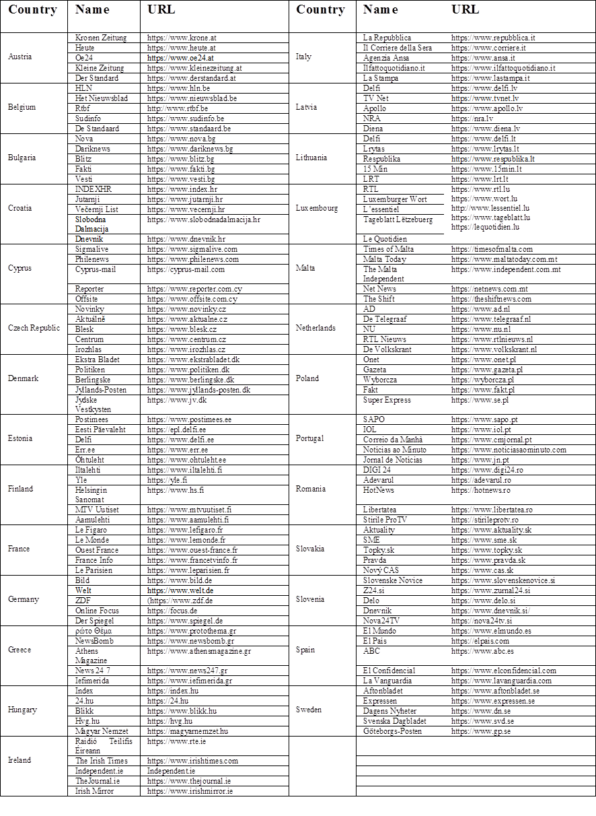

Chart 2. Percentage of traffic generated from social networks over total web traffic in each EU country
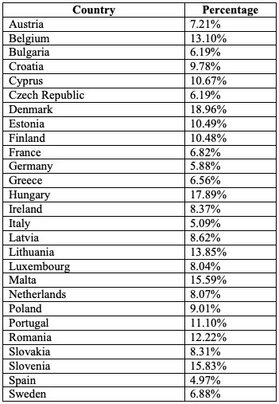

Chart 3. Comparison of web traffic generated from social networks with direct and search procedures in each EU country

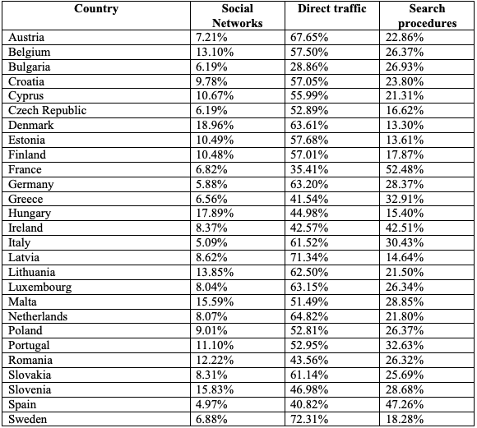

Chart 4. Main social networks by web traffic generated in each EU country
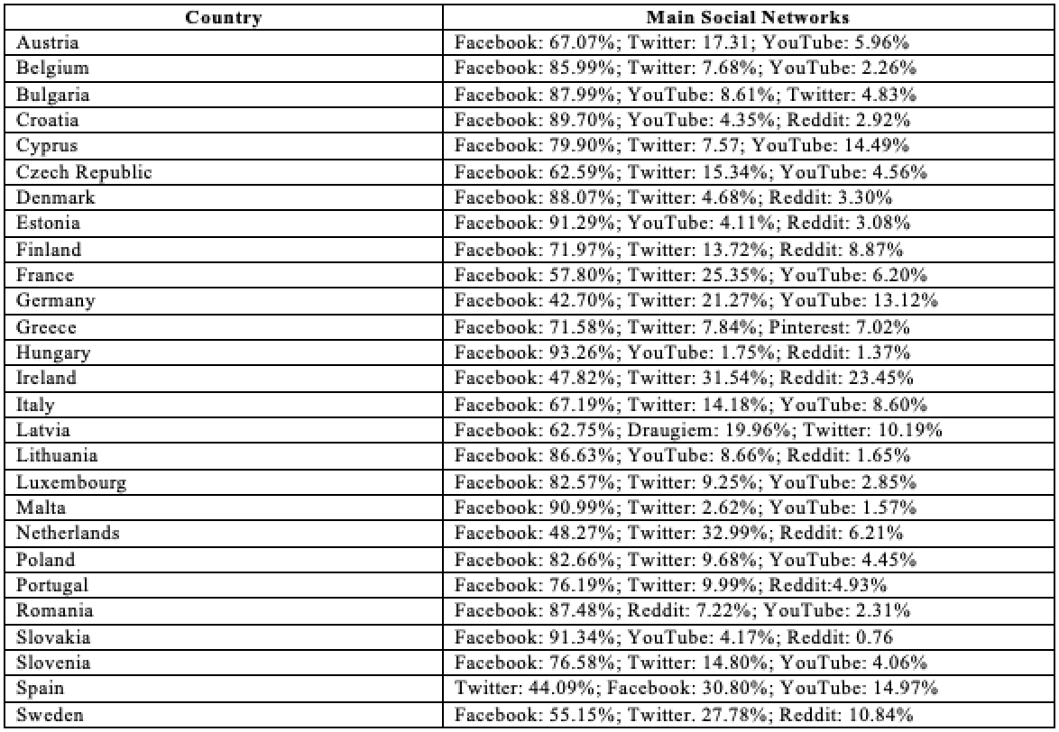

Chart 5. General data referring to the average duration of the user's visit (expressed in minutes and seconds), number of page views and bounce rate

