Supplementary Information
Supplementary figures
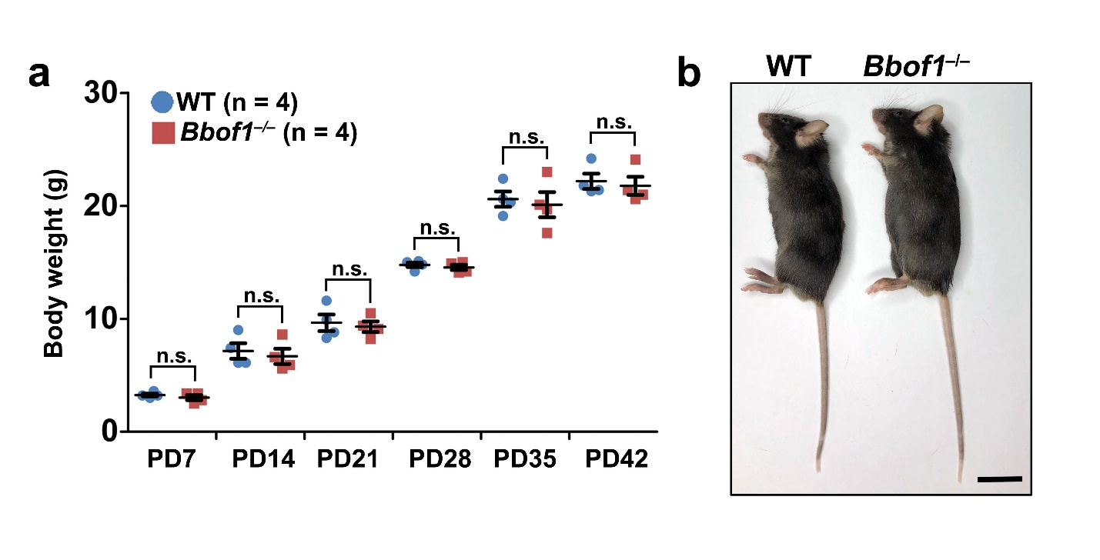
Supplementary Fig. 1. BBOF1-deletion does not affect mouse growth. a, Body weights of WT and Bbof1–/– males at the indicated ages. Numbers of mice analyzed (n) are indicated. Error bars indicate S.E.M. n.s., not significant by two-tailed Student’s t test. b, Representative images of WT and Bbof1–/– males at PD90. Scale bars, 2 cm.

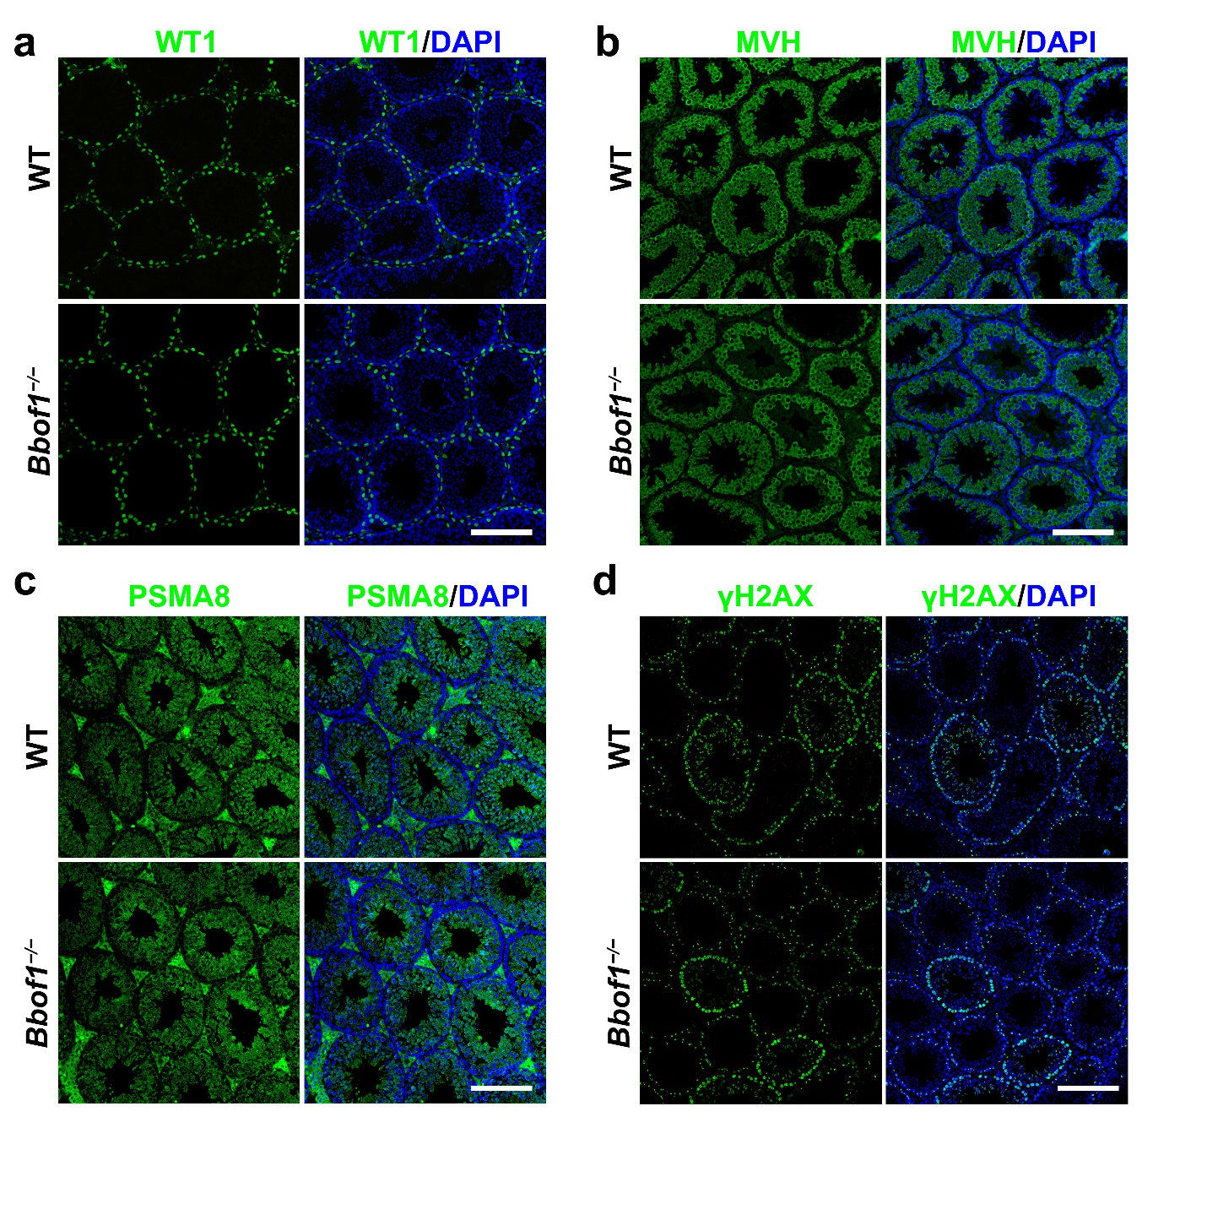
Supplementary Fig. 2. Immunofluorescent staining of WT1 (a), MVH (b), PSMA8 (c) and γH2AX (d) in WT and Bbof1–/– testes. Scale bars, 10 μm.
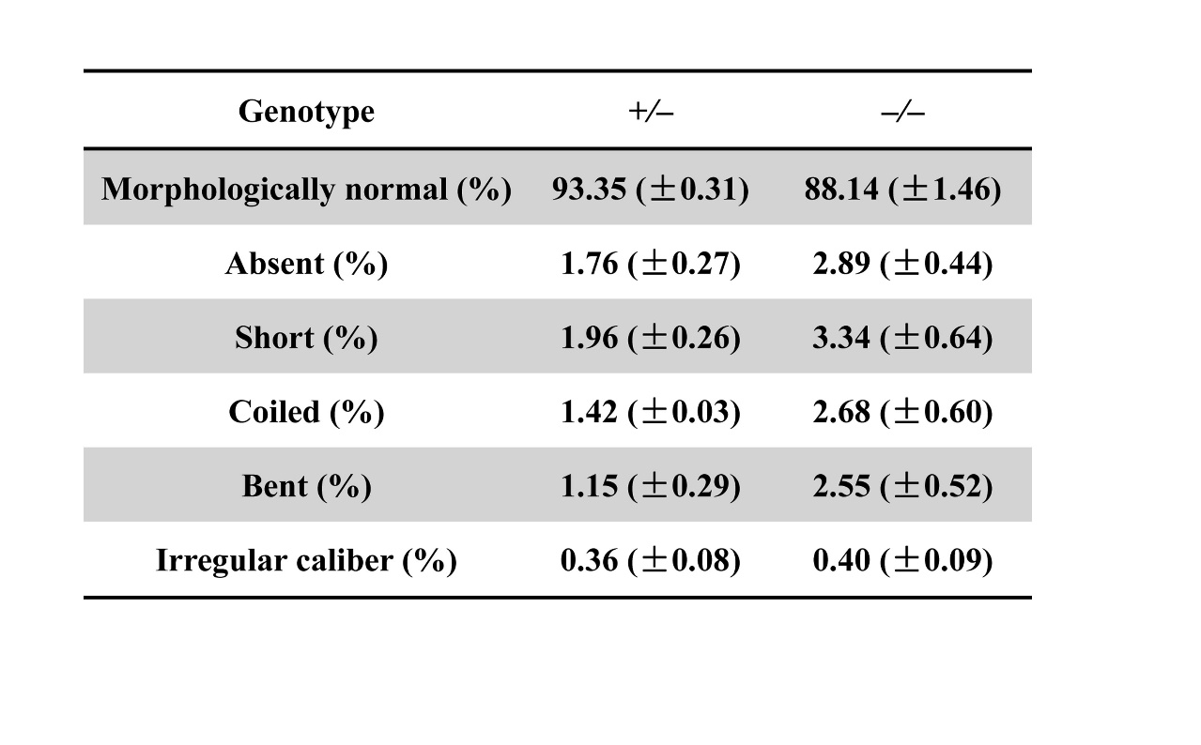Supplementary Fig. 3. Statistical analyses of sperm flagellar morphology. Percentages of sperm flagella with indicated morphology are presented as the mean (± S.E.M.).

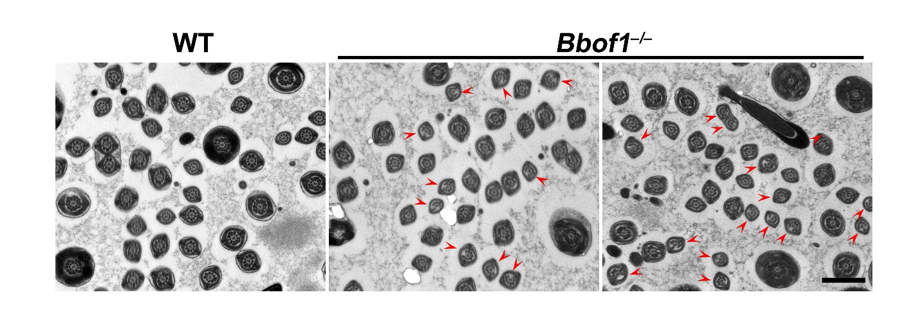Supplementary Fig. 4. TEM results showing the ultrastructure of WT and Bbof1–/– sperm flagella. Cross sections with certain MTDs missing are indicated by red arrow heads. Scale bar, 1 μm.

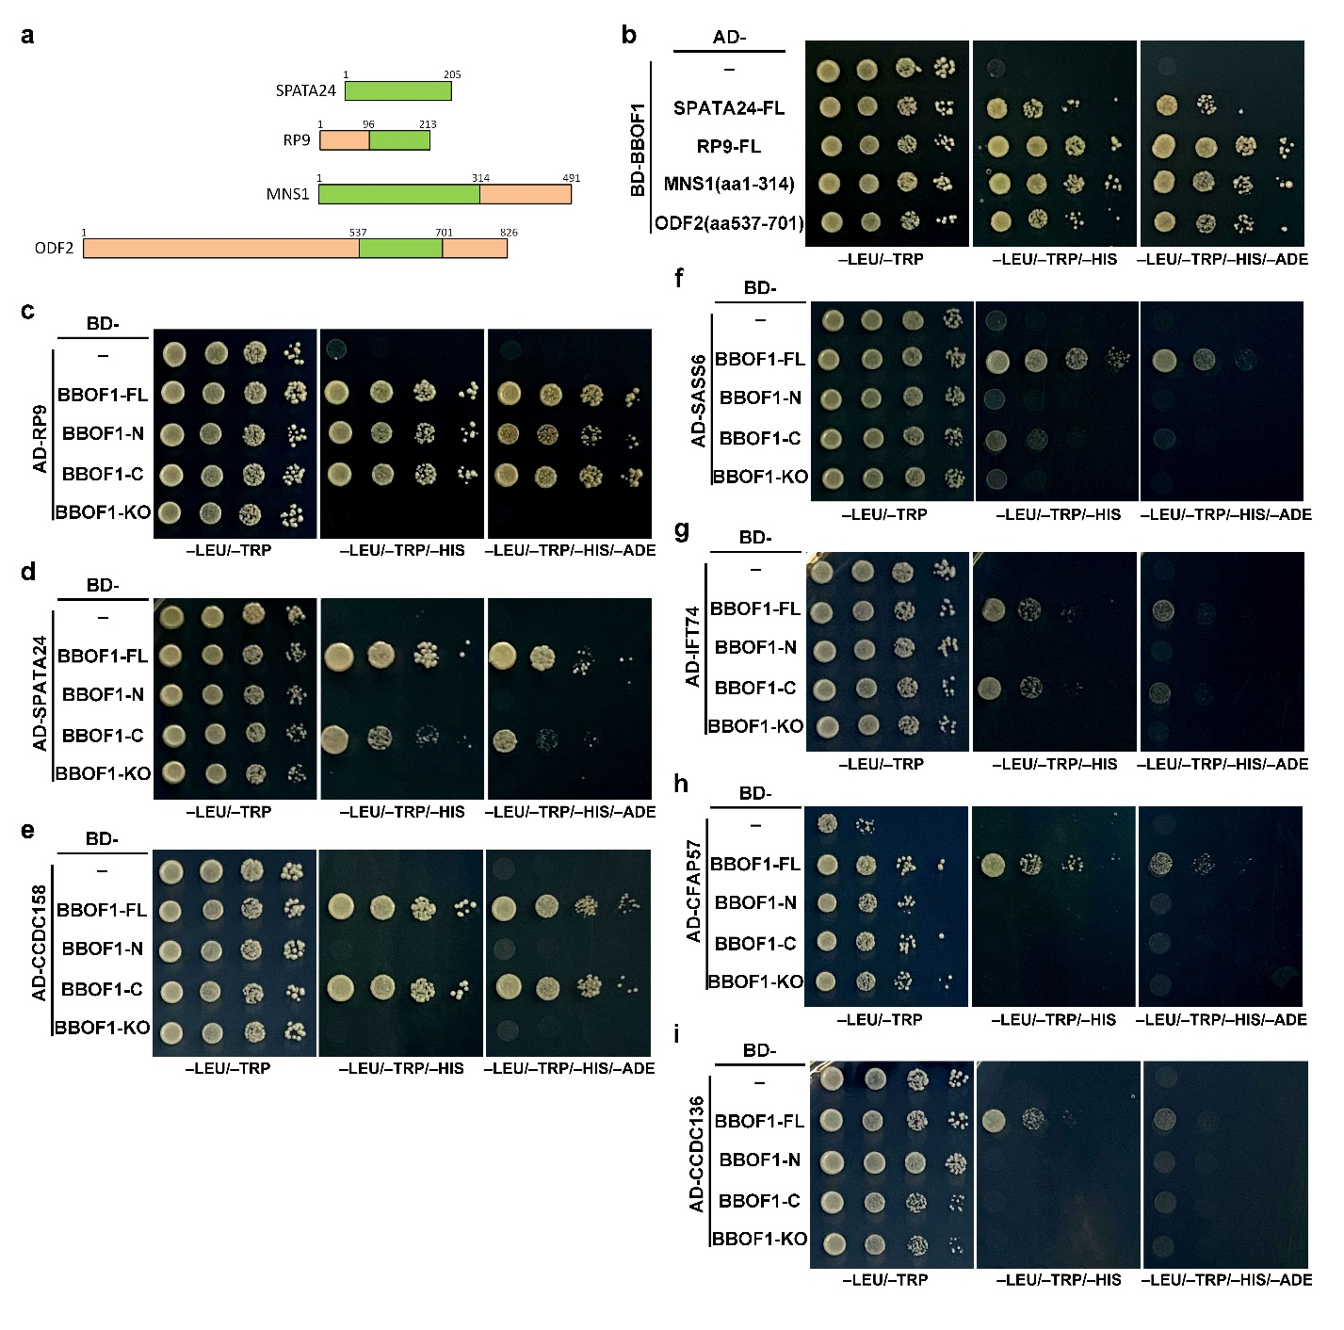
Supplementary Fig. 5. Y2H results of BBOF1 and its interacting proteins. a, Schematic diagram depicting the interacting domains of several BBOF1 interactors (SPATA24, RP9, MNS1 and ODF2). The minimal interacting regions are marked in green. b, Y2H analyses confirming the interaction between BBOF1 and the four top candidates (SPATA24, RP9, MNS1 and ODF2). Interactions were confirmed by the activation of reporter genes (HIS3 and ADE2) via the growth of colonies on selection plates (SD-LEU/TRP/HIS or SD-LEU/TRP/HIS/ADE). The domains used are indicated by amino acid (aa) sequences. c-i, Y2H experiments revealing the domaining mapping results of BBOF1 and its interactors.
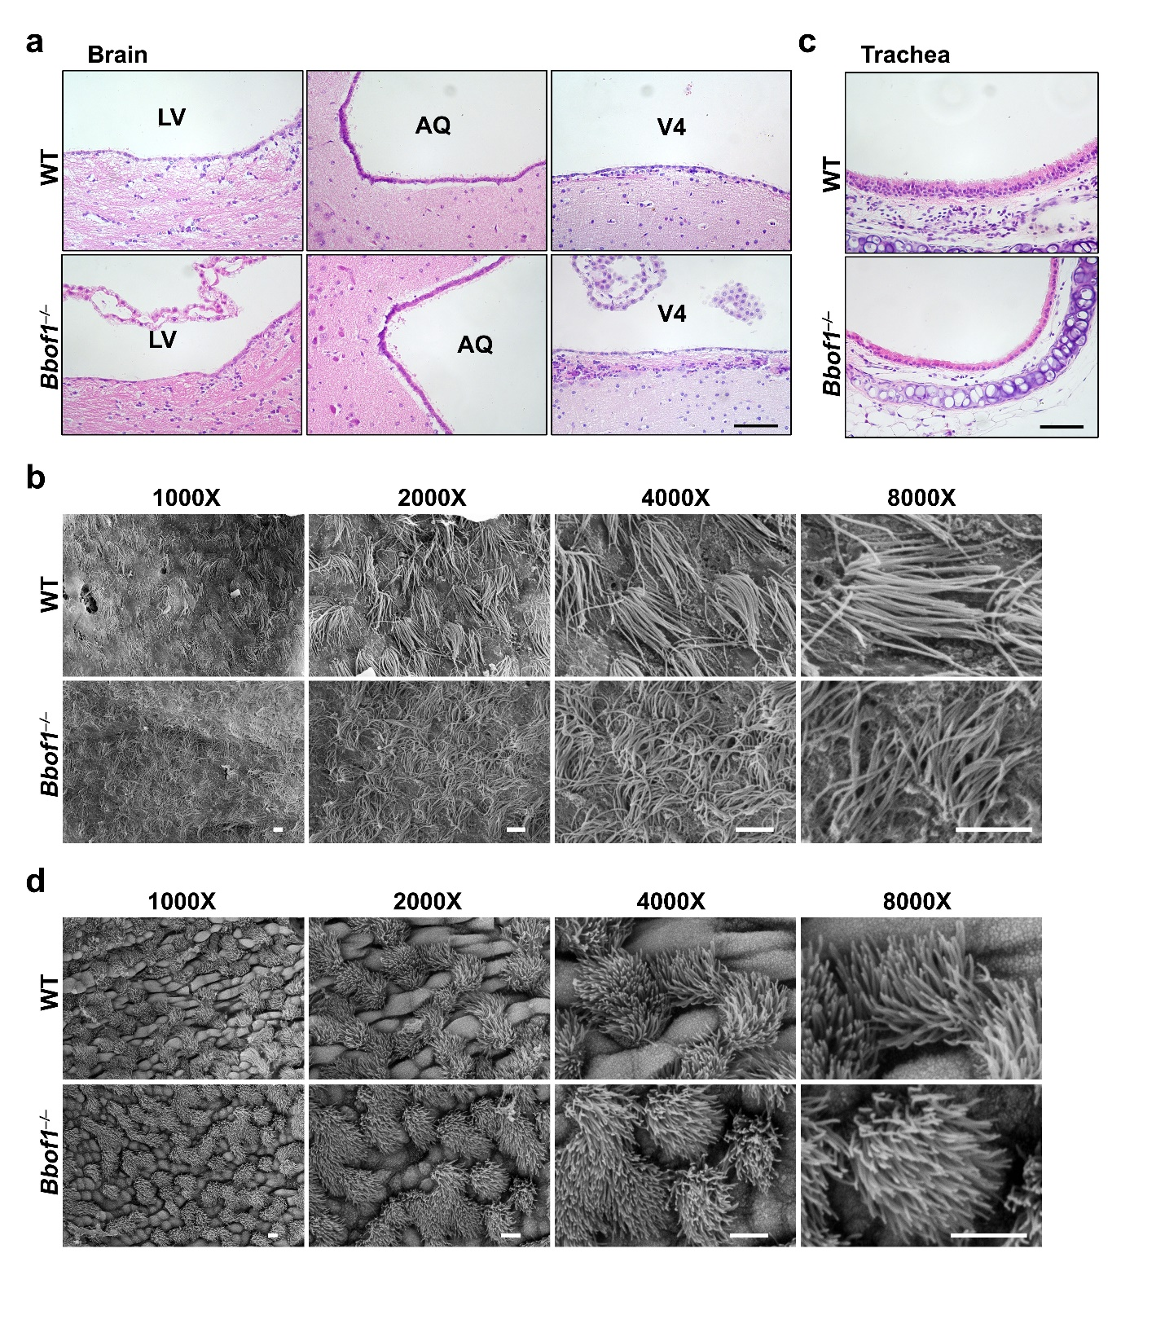
Supplementary Fig. 6. Histological analyses of brain ventricles and trachea epithelia in BBOF1-deleted mice. a, H&E staining of brain sections derived from WT and Bbof1–/– males at PD60. LV, lateral ventricle; AQ, aqueduct; 4V, fourth ventricle. Scale bar, 50 μm. b, Scanning electron microscopy (SEM) images of WT and Bbof1–/– brain lateral ventricles. Scale bars, 50 μm. c, H&E staining of trachea sections derived from WT and Bbof1–/– males at PD60. Scale bar, 50 μm. d, SEM images of WT and Bbof1–/– tracheal epithelia. Scale bar, 50 μm.
Supplementary Movie 1. Movement of spermatozoa derived from adult WT males.

Supplementary Movie 2. Movement of spermatozoa derived from adult Bbof1–/– males.

Supplementary Table 1. Primer sequences.
Primer name | Genes targeted | Application | Sequences (5’-3’)
Z023 | Bbof1 | RT-PCR (227 bp) | 5’-GGATATTAGAGATTTGACCTGGGA-3’
Z024 | Bbof1 | RT-PCR (227 bp) | 5’-CCATTCTATTGGAGTCTGATACTGG-3’
Z531 | Gapdh | RT-PCR (181 bp) | 5’-ACACTGAGGACCAGGTTGTCTC-3’
Z532 | Gapdh | RT-PCR (181 bp) | 5’-TACTCCTTGGAGGCCATGTAG-3’
P1 | Bbof1 | Genotyping (WT, 194 bp; KO, 169 bp) | 5’-ACCAAGTATCCTGTTTGATG-3’
P2 | Bbof1 | Genotyping (WT, 194 bp; KO, 169 bp) | 5’-CTGTCTGACTGAGGCCACAG-3’

Supplementary Table 2. Antibody information.
Protein name | Manufacture (catalogue number) | Origin | Applications  (working dilution) | Website Link*
α-tubulin | Merck (F2168) | Mouse | IF (1: 200) | https://www.sigmaaldrich.cn/CN/zh/product/sigma/f2168?context=product
Acetylated-α-tubulin | Merck (T7451) | Mouse | IF (1: 500) | https://www.sigmaaldrich.cn/CN/zh/product/sigma/t7451?context=product
Phalloidin | Merck (P1951) | Mouse | IF (1: 200) | https://www.sigmaaldrich.cn/CN/zh/product/sigma/p1951?context=product
S100β | Proteintech (15146-1-AP) | Rabbit | IF (1: 200) | https://www.ptglab.com/products/S100B-Antibody-15146-1-AP.htm
SLC2A3 （GLUT3） | Proteintech (20403-1-AP) | Rabbit | WB (1:1000) | http://www.ptgcn.com/products/SLC2A3-Antibody-20403-1-AP.htm
BBOF1 | Thermofisher (PA5-51833) | Rabbit | WB (1:1000) | https://www.thermofisher.cn/cn/zh/antibody/product/CCDC176-Antibody-Polyclonal/PA5-51833
ODF2 | Santa Cruz (sc-365874) | Mouse | IF (1: 200);  WB (1: 1000) | https://www.scbt.com/zh/p/odf2-antibody-g-8;jsessionid=636VBC7-0wUW1e6vm79IttqYa-V5oeHrRB0tk5FgG2ONXJley9UA!1122603258
ODF2 | Merck (HPA001874) | Rabbit | IF (1: 200);  WB (1: 1000) | https://www.sigmaaldrich.cn/CN/zh/product/sigma/hpa001874?context=product
ODF2 | Abcam (ab186412) | Rabbit | WB (1:1000) | https://www.abcam.com/cenexin1odf2-antibody-epr13561-ab186412.html
MNS1 | Merck (HPA039975) | Rabbit | WB (1:1000) | https://www.sigmaaldrich.cn/CN/zh/product/sigma/hpa039975?context=product
GAPDH | GNI (GNI4110-GH) | Mouse | WB (1:10000) | http://www.gnimission.com/resource/article/76
MVH | Abcam (ab13840) | Rabbit | IF (1: 200);  WB (1: 1000) | http://www.abcam.com/ddx4--mvh-antibody-ab13840.html
WT1 | Abcam (ab89901) | Rabbit | IF (1: 200) | https://www.abcam.com/wilms-tumor-protein-antibody-can-r9ihc-56-2-ab89901.html
PSMA8 | Proteintech (14022-1-AP) | Rabbit | IF (1: 200) | https://www.ptglab.com/Products/PSMA8-Antibody-14022-1-AP.htm

