Supporting Data
Design and synthesis of Diphenyl-1H-imidazole analogs as lead towards SARS CoV-2 3CLpro inhibition for the treatment of COVID-19
Authors: Ashish M. Kanhed*¹, Amisha Vora*¹, Ami Thakkar¹, Gudepalya Renukaiah Rudramurthy², Shridhar Narayanan², Radha Krishan Shandil², Maddipatla Yogi², Rajappa Harisha² and Mayas Singh²
¹Shobhaben Pratapbhai Patel - School of Pharmacy & Technology Management, SVKM’s NMIMS University, Vile Parle, Mumbai-400056, India
²Foundation for Neglected Disease Research, Bangalore-561203, Karnataka, India
* Corresponding Author(s):
Dr. Ashish M. Kanhed ashishvmk@gmail.com
Dr. Amisha Vora amisha.vora@nmims.edu

IR data
2-bromo-1-phenylethan-1-one (2a):
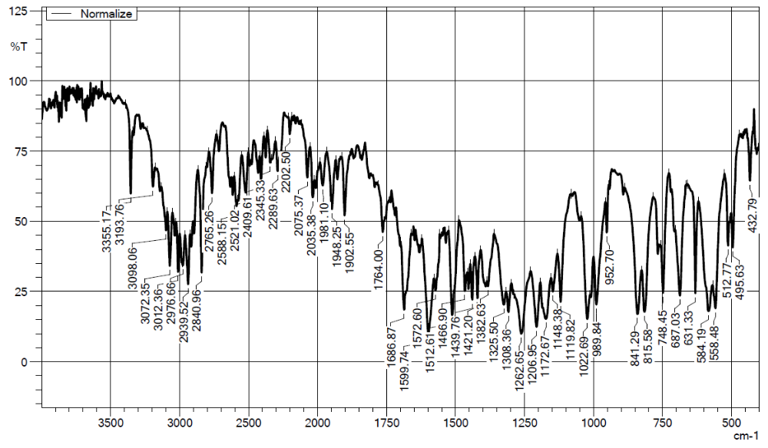
2-bromo-1-(p-tolyl)ethan-1-one (2b):
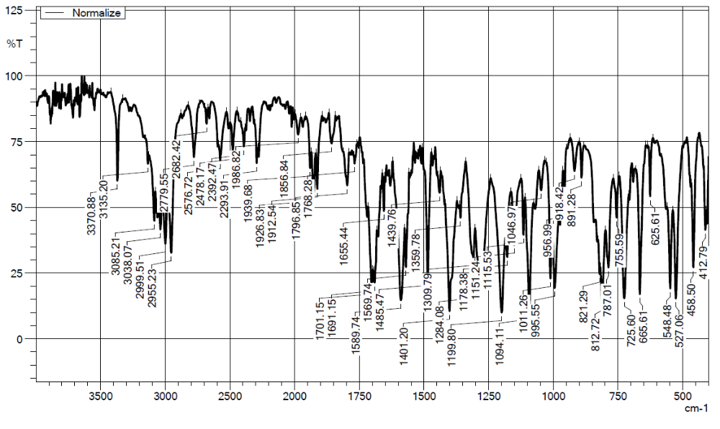

2-bromo-1-(4-chlorophenyl)ethan-1-one (2c):
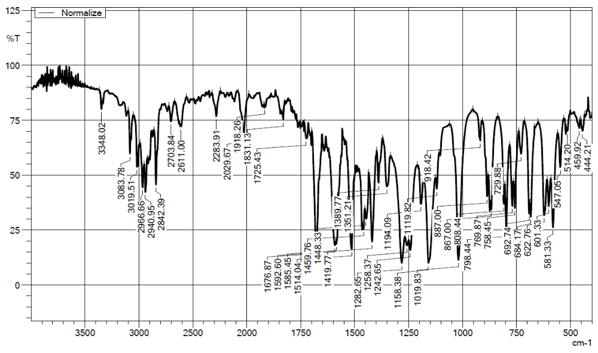
2-bromo-1-(2,4-dichlorophenyl)ethan-1-one (2d):
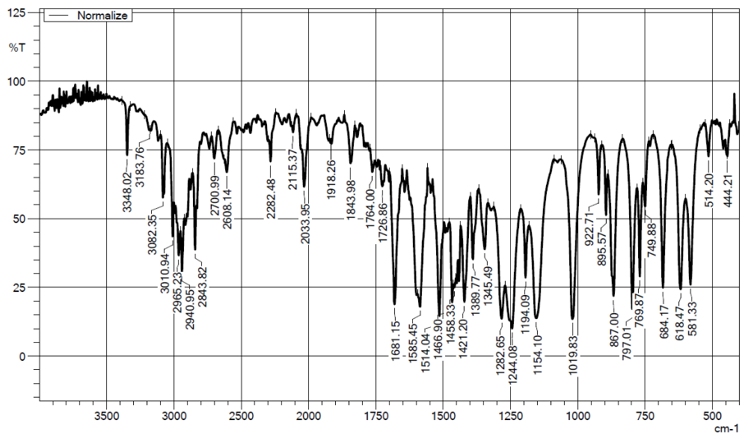

Benzonitrile (4a):
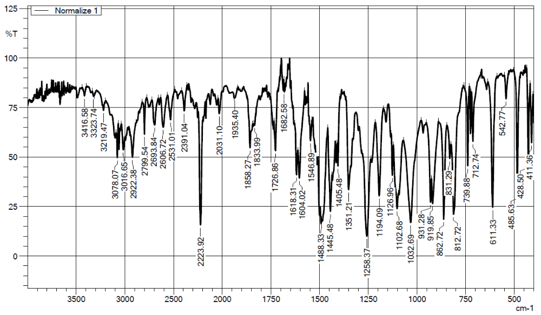
3,4-Dimethoxybenzonitrile (4b):
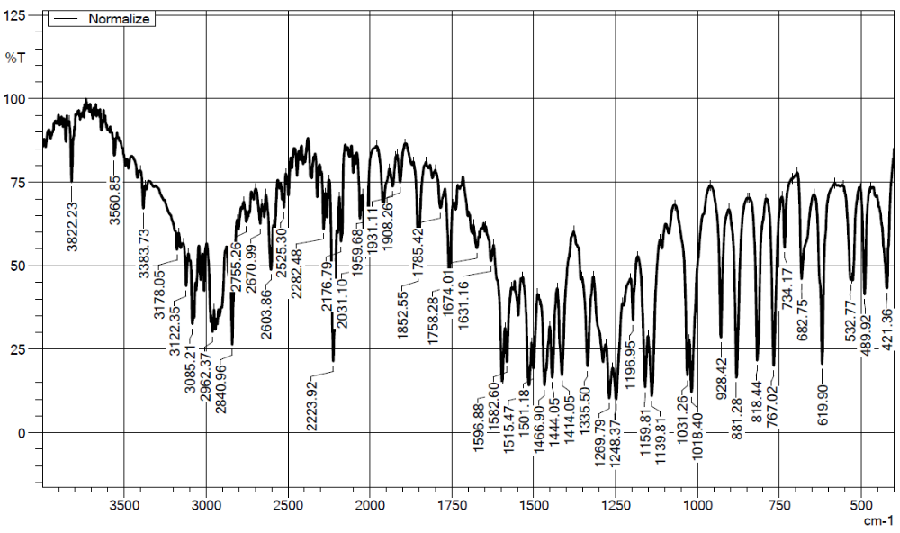

Benzimidamide (5a):
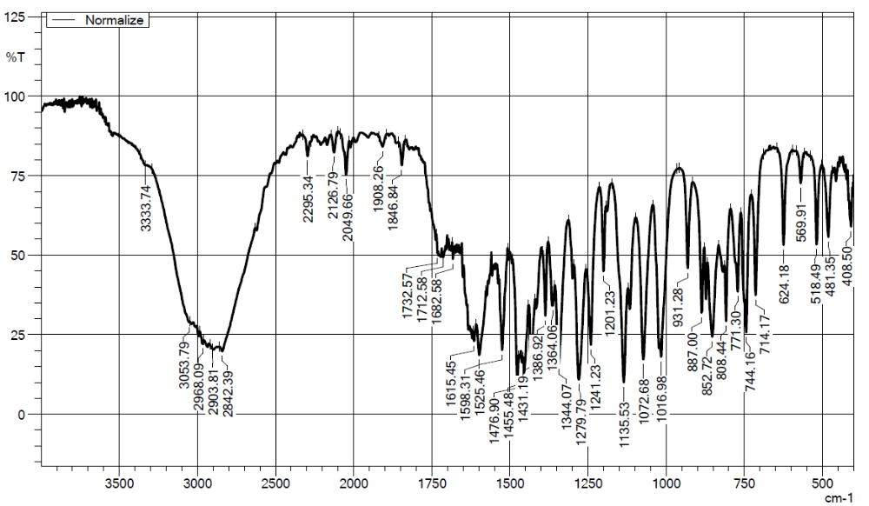
3,4-Dimethoxybenzimidamide (5b):
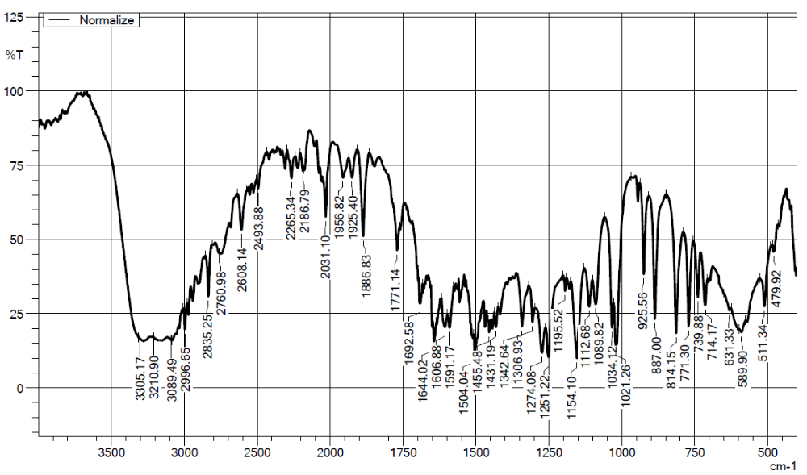

2,4-diphenyl-1H-imidazole (6):
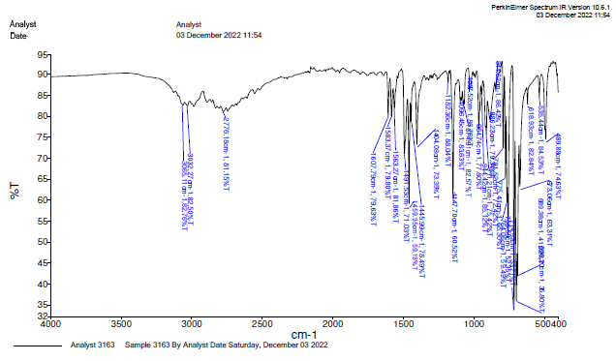
2-(3,4-dimethoxyphenyl)-4-phenyl-1H-imidazole (7):
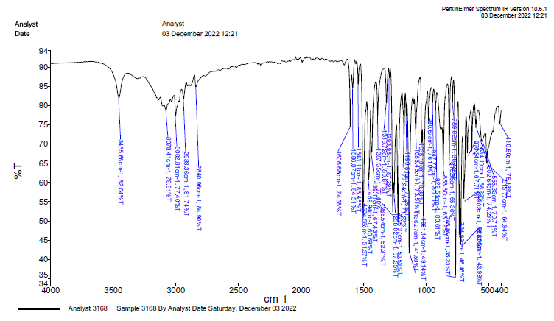

2-(3,4-dimethoxyphenyl)-4-(p-tolyl)-1H-imidazole (8):
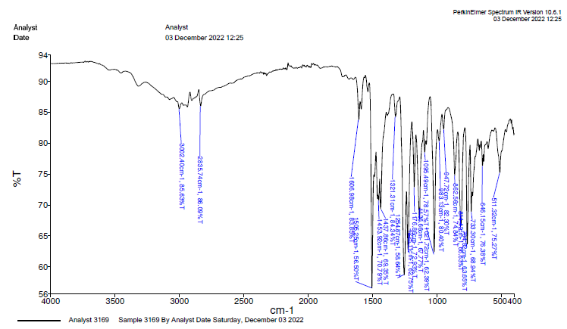
4-(4-chlorophenyl)-2-(3,4-dimethoxyphenyl)-1H-imidazole (9):
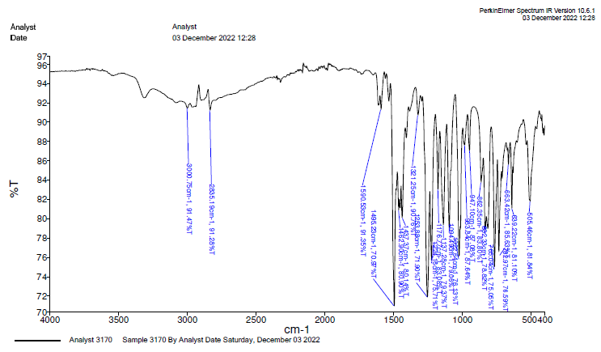

4-(2,4-dichlorophenyl)-2-(3,4-dimethoxyphenyl)-1H-imidazole (10):
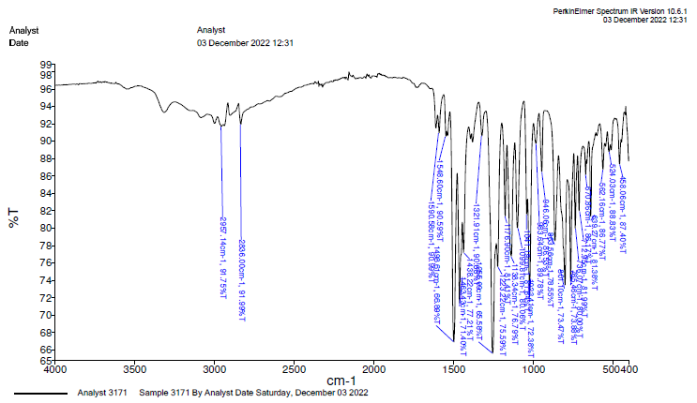
4-(4-phenyl-1H-imidazol-2-yl)benzene-1,2-diol (11):
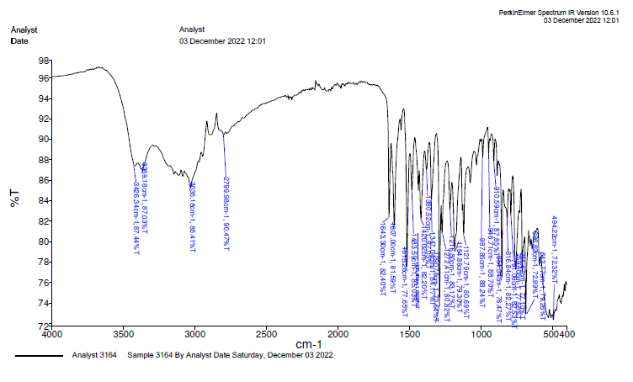
4-(4-(p-tolyl)-1H-imidazol-2-yl)benzene-1,2-diol (12):
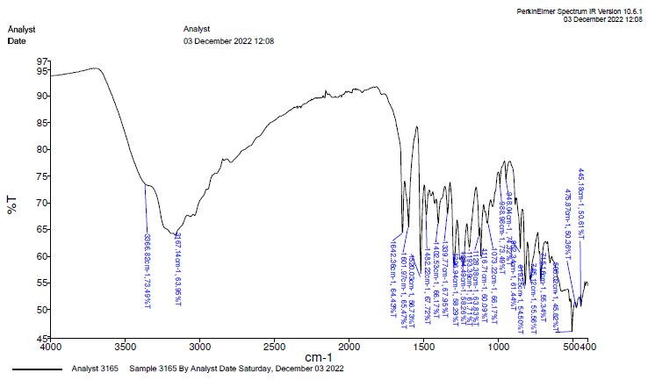
4-(4-(4-chlorophenyl)-1H-imidazol-2-yl)benzene-1,2-diol (13):
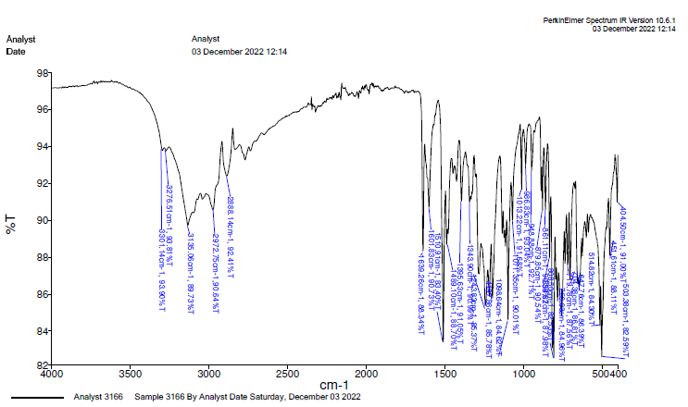
4-(4-(2,4-dichlorophenyl)-1H-imidazol-2-yl)benzene-1,2-diol (14):
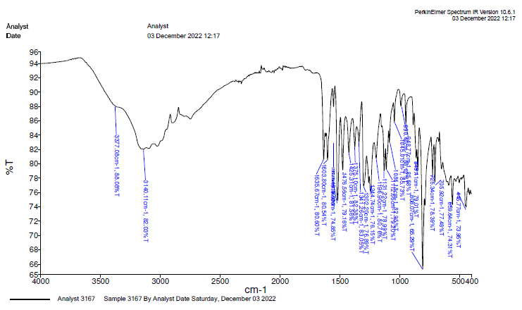

¹H-NMR
2,4-diphenyl-1H-imidazole (6):
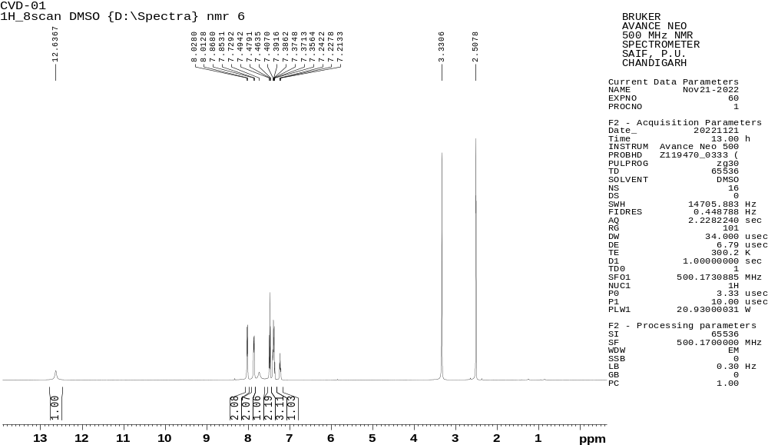
2-(3,4-dimethoxyphenyl)-4-phenyl-1H-imidazole (7):
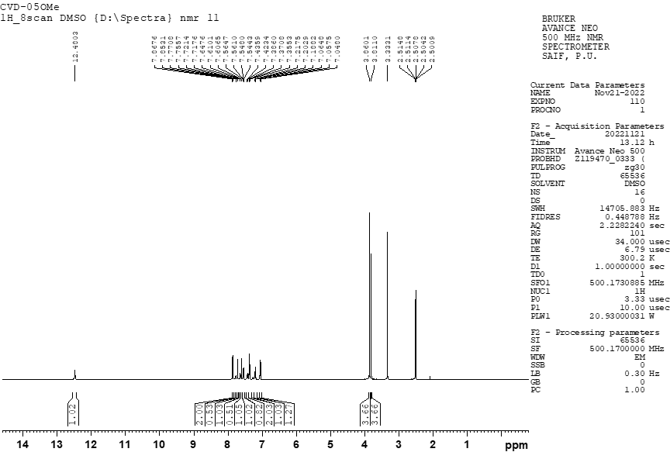
2-(3,4-dimethoxyphenyl)-4-(p-tolyl)-1H-imidazole (8):
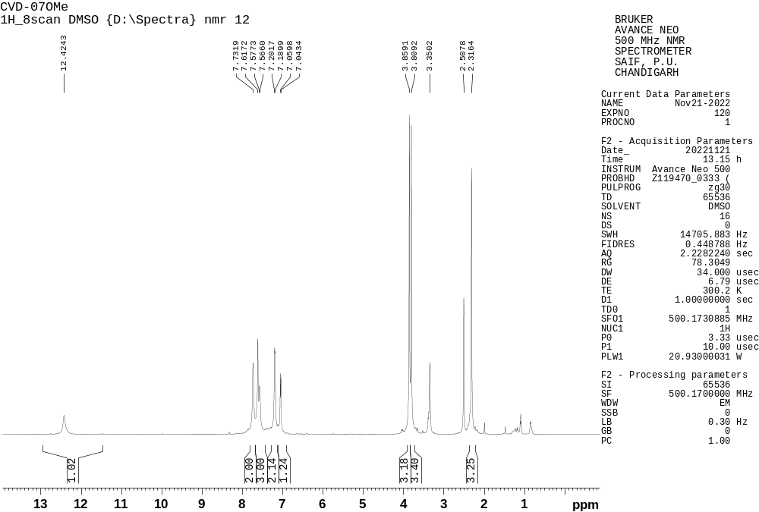
4-(4-chlorophenyl)-2-(3,4-dimethoxyphenyl)-1H-imidazole (9):
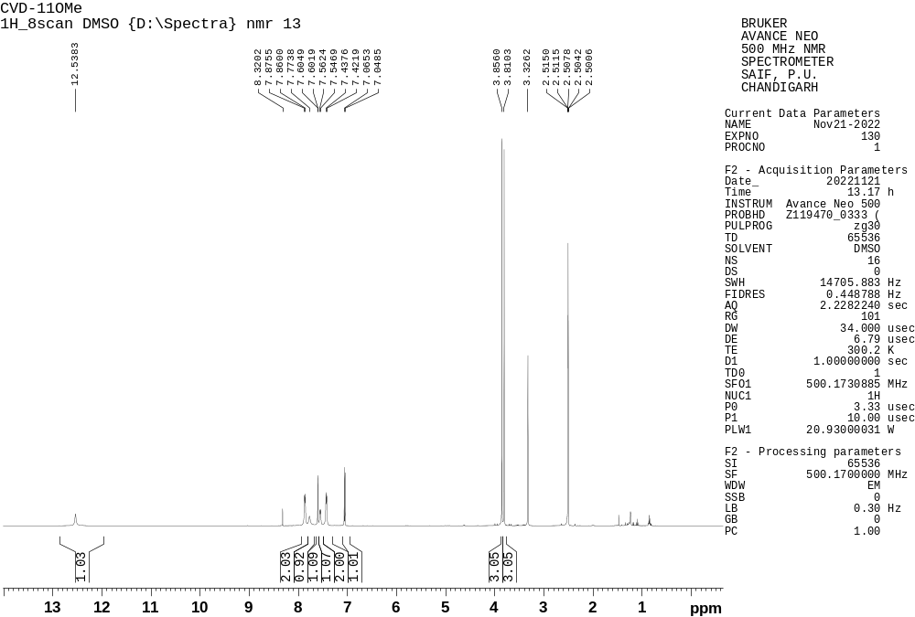
4-(2,4-dichlorophenyl)-2-(3,4-dimethoxyphenyl)-1H-imidazole (10):
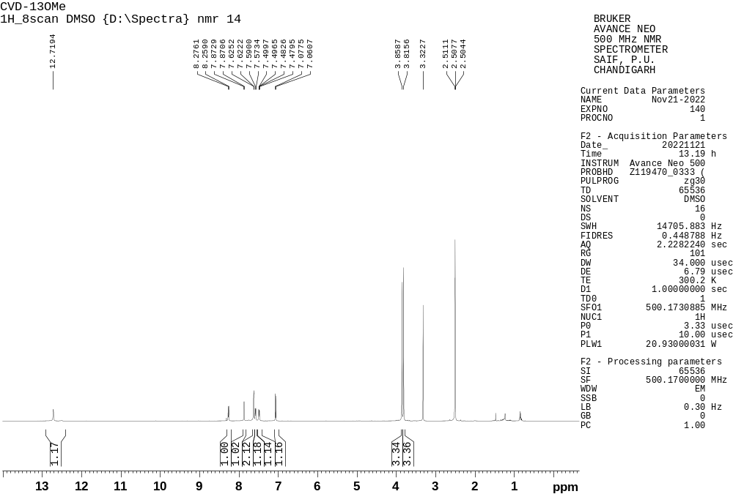
4-(4-phenyl-1H-imidazol-2-yl)benzene-1,2-diol (11):
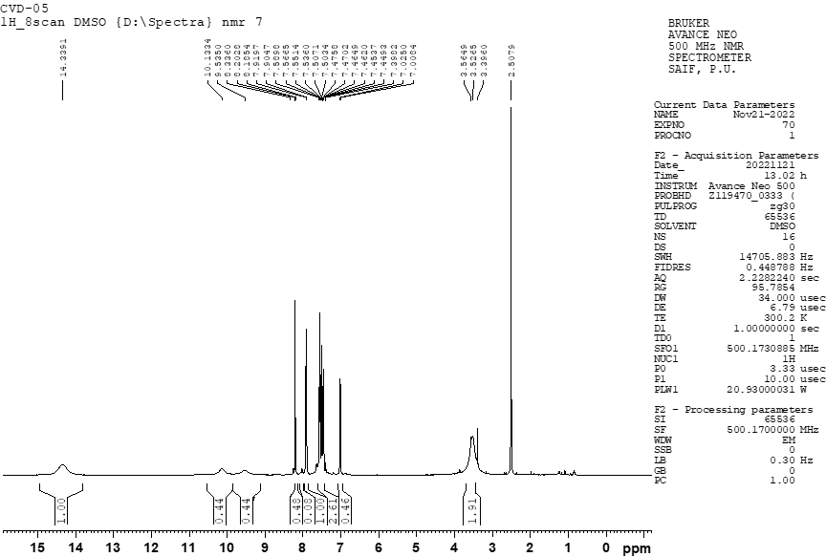
4-(4-(p-tolyl)-1H-imidazol-2-yl)benzene-1,2-diol (12):
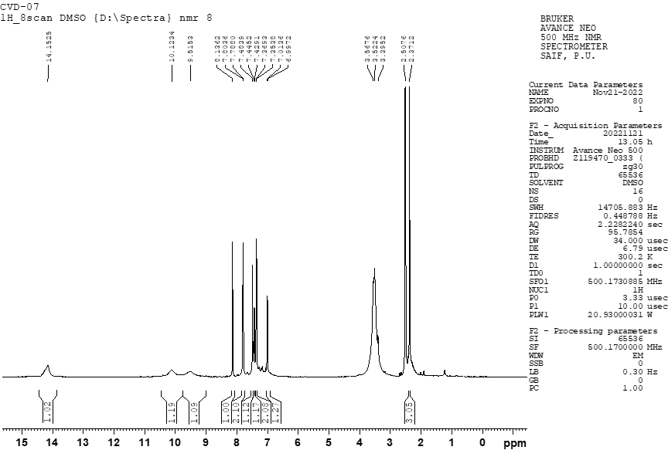
4-(4-(4-chlorophenyl)-1H-imidazol-2-yl)benzene-1,2-diol (13):
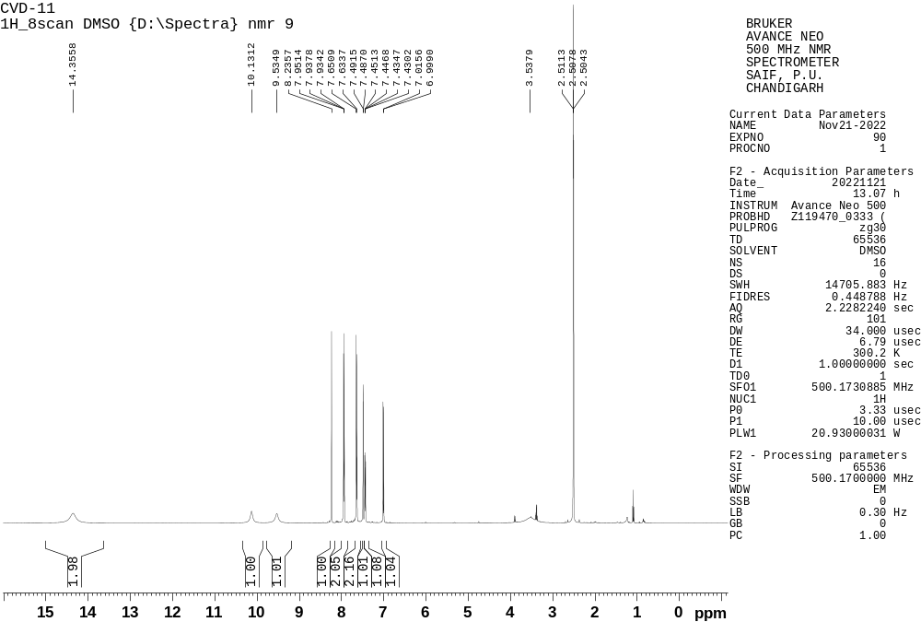
4-(4-(2,4-dichlorophenyl)-1H-imidazol-2-yl)benzene-1,2-diol (14):
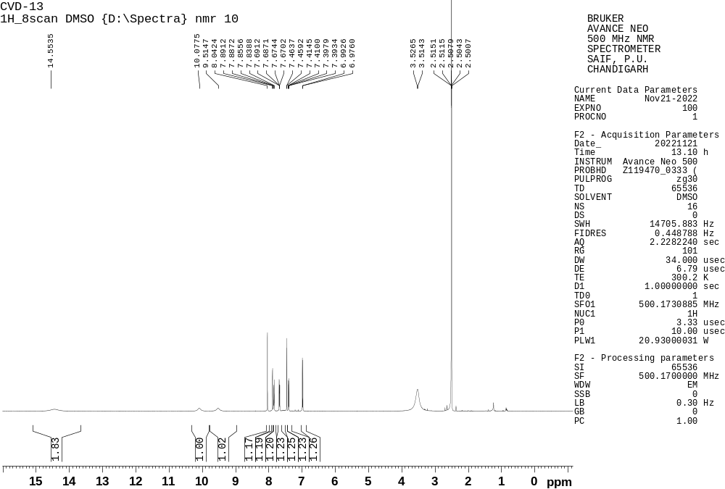
MASS Spectra
2,4-diphenyl-1H-imidazole (6):
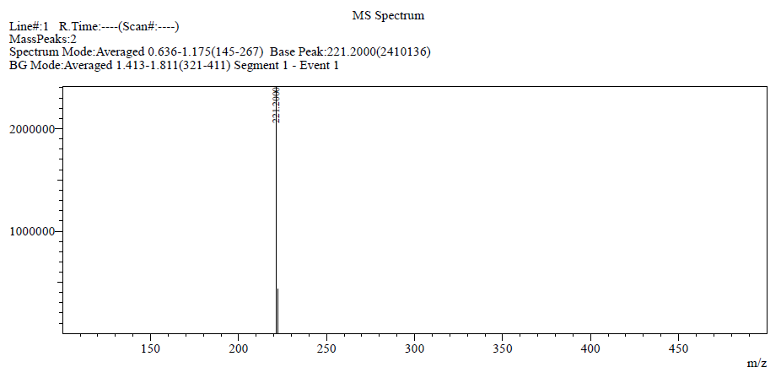
2-(3,4-dimethoxyphenyl)-4-phenyl-1H-imidazole (7):
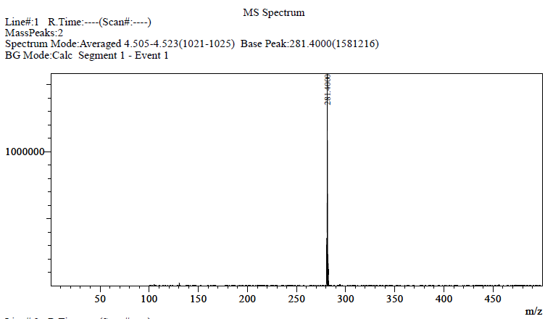

2-(3,4-dimethoxyphenyl)-4-(p-tolyl)-1H-imidazole (8):
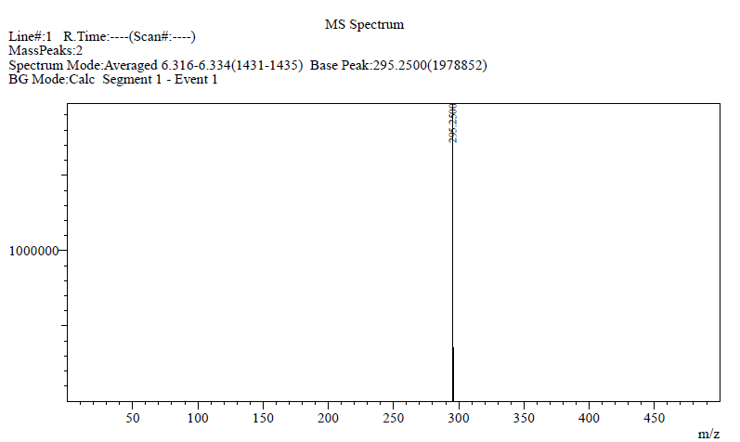
4-(4-chlorophenyl)-2-(3,4-dimethoxyphenyl)-1H-imidazole (9):
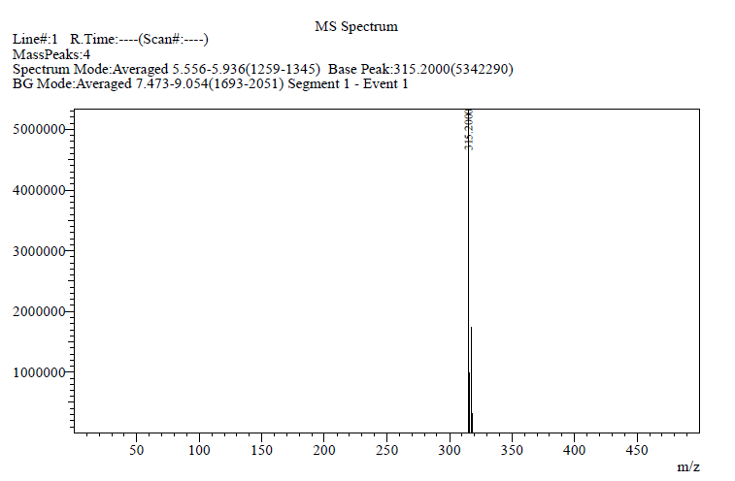
4-(2,4-dichlorophenyl)-2-(3,4-dimethoxyphenyl)-1H-imidazole (10):
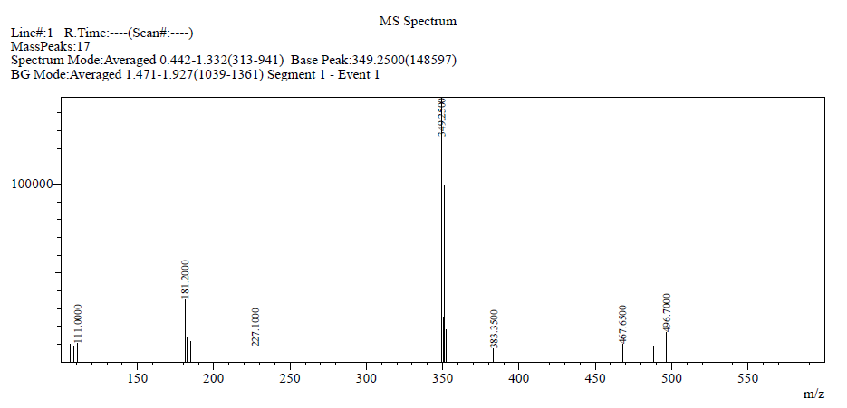
4-(4-phenyl-1H-imidazol-2-yl)benzene-1,2-diol (11):
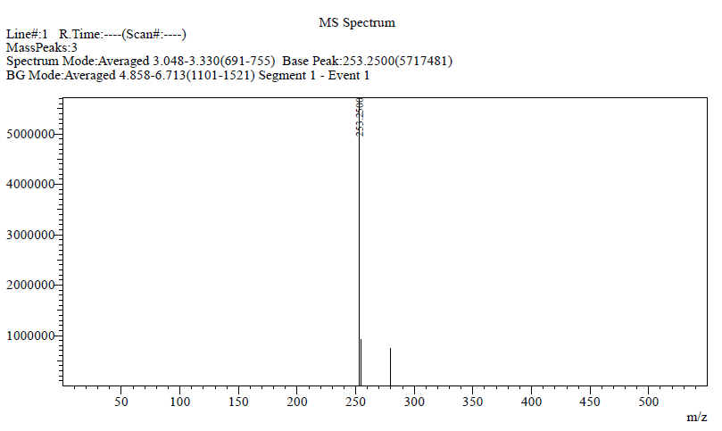

4-(4-(p-tolyl)-1H-imidazol-2-yl)benzene-1,2-diol (12):
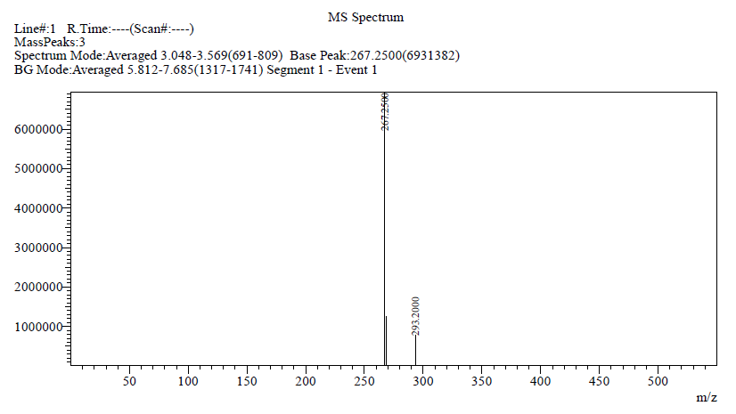
4-(4-(4-chlorophenyl)-1H-imidazol-2-yl)benzene-1,2-diol (13):
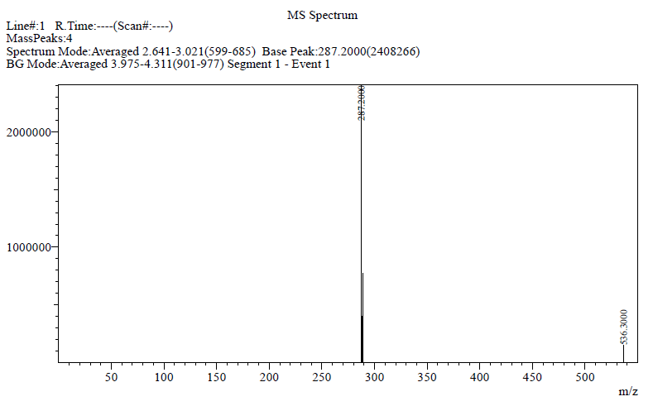

4-(4-(2,4-dichlorophenyl)-1H-imidazol-2-yl)benzene-1,2-diol (14):
