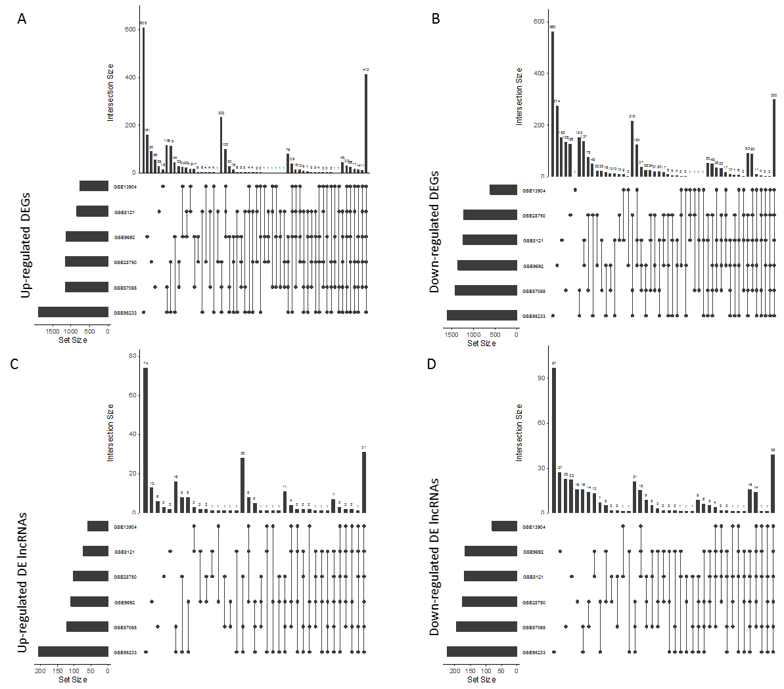
Figure S1. Overview of DEGs screened from different cohorts. The upset plots for the up-regulated DEGs (A), down-regulated DEGs (B), up-regulated DE lncRNAs (C), and down-regulated DE lncRNAs (D).

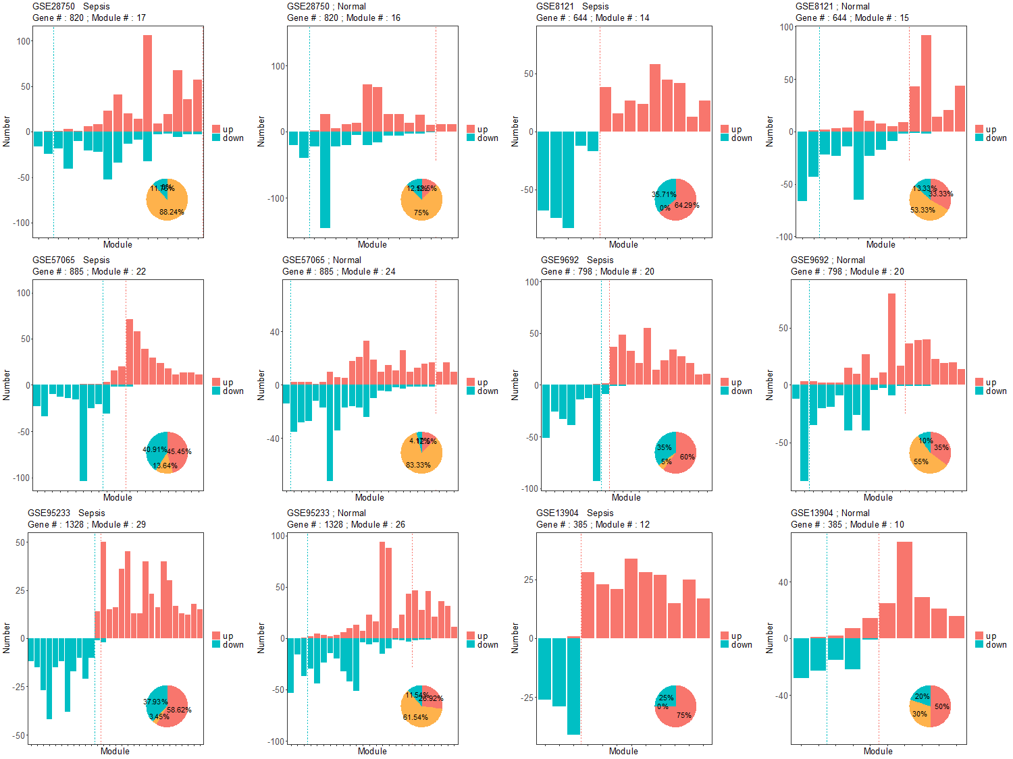Figure S2. The DEGs were screened by the criteria of p value < 0.01 and absolute fold change > 2. The minimum module size is 10.

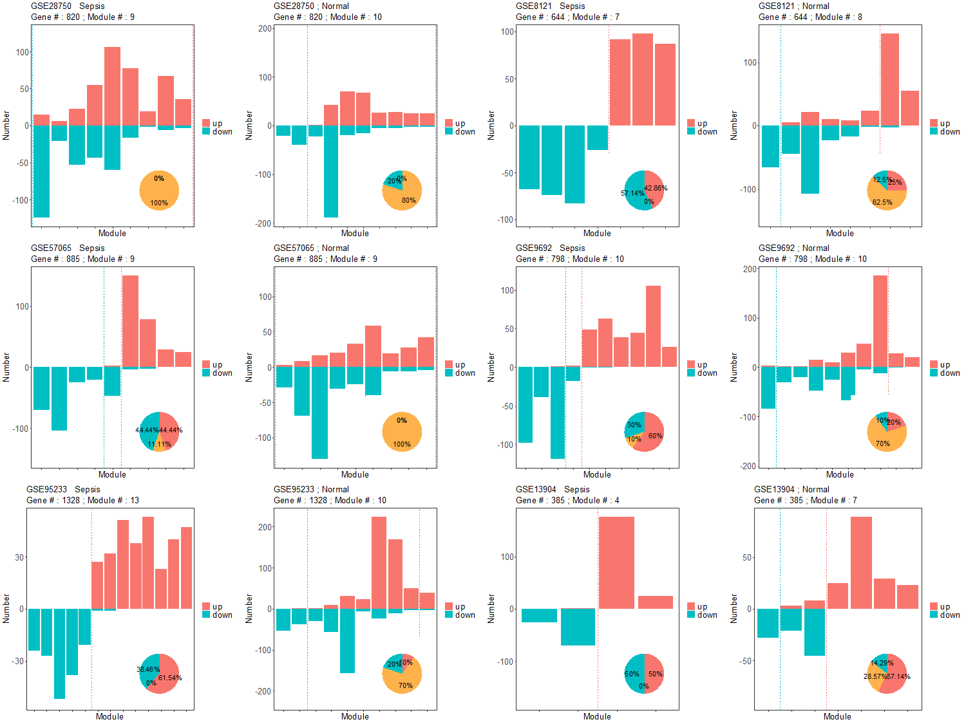
Figure S3. The DEGs were screened by the criteria of p value < 0.01 and absolute fold change > 2. The minimum module size is 20.

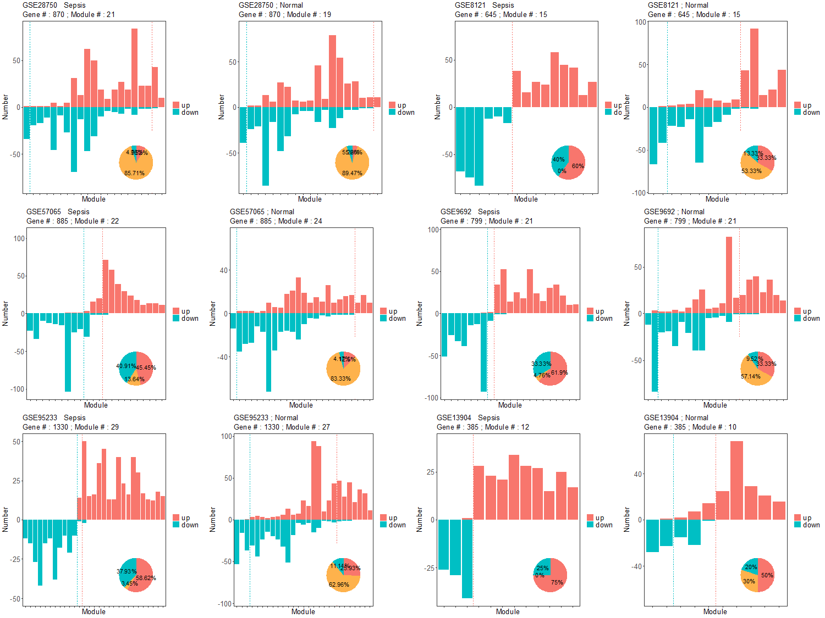
Figure S4. The DEGs were screened by the criteria of p value < 0.05 and absolute fold change > 2. The minimum module size is 10.

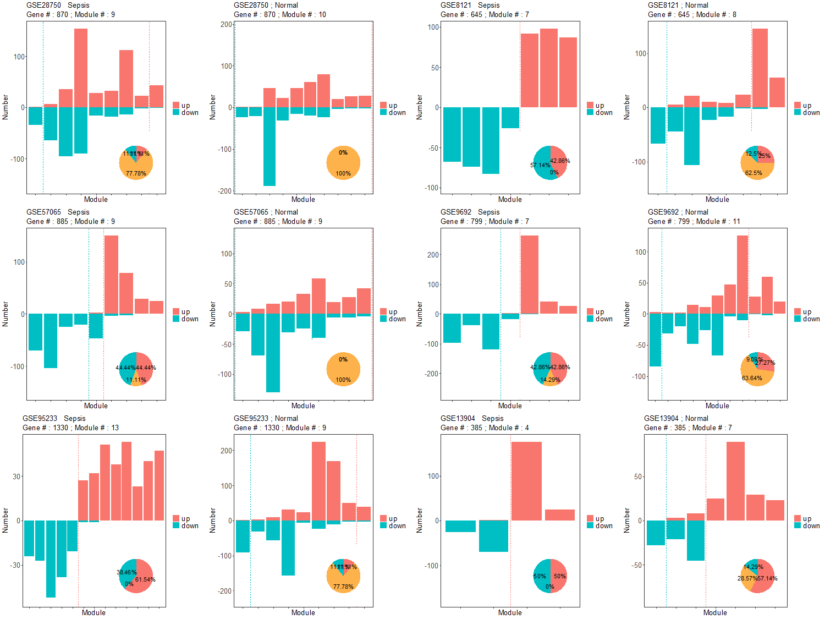
Figure S5. The DEGs were screened by the criteria of p value < 0.05 and absolute fold change > 2. The minimum module size is 20.

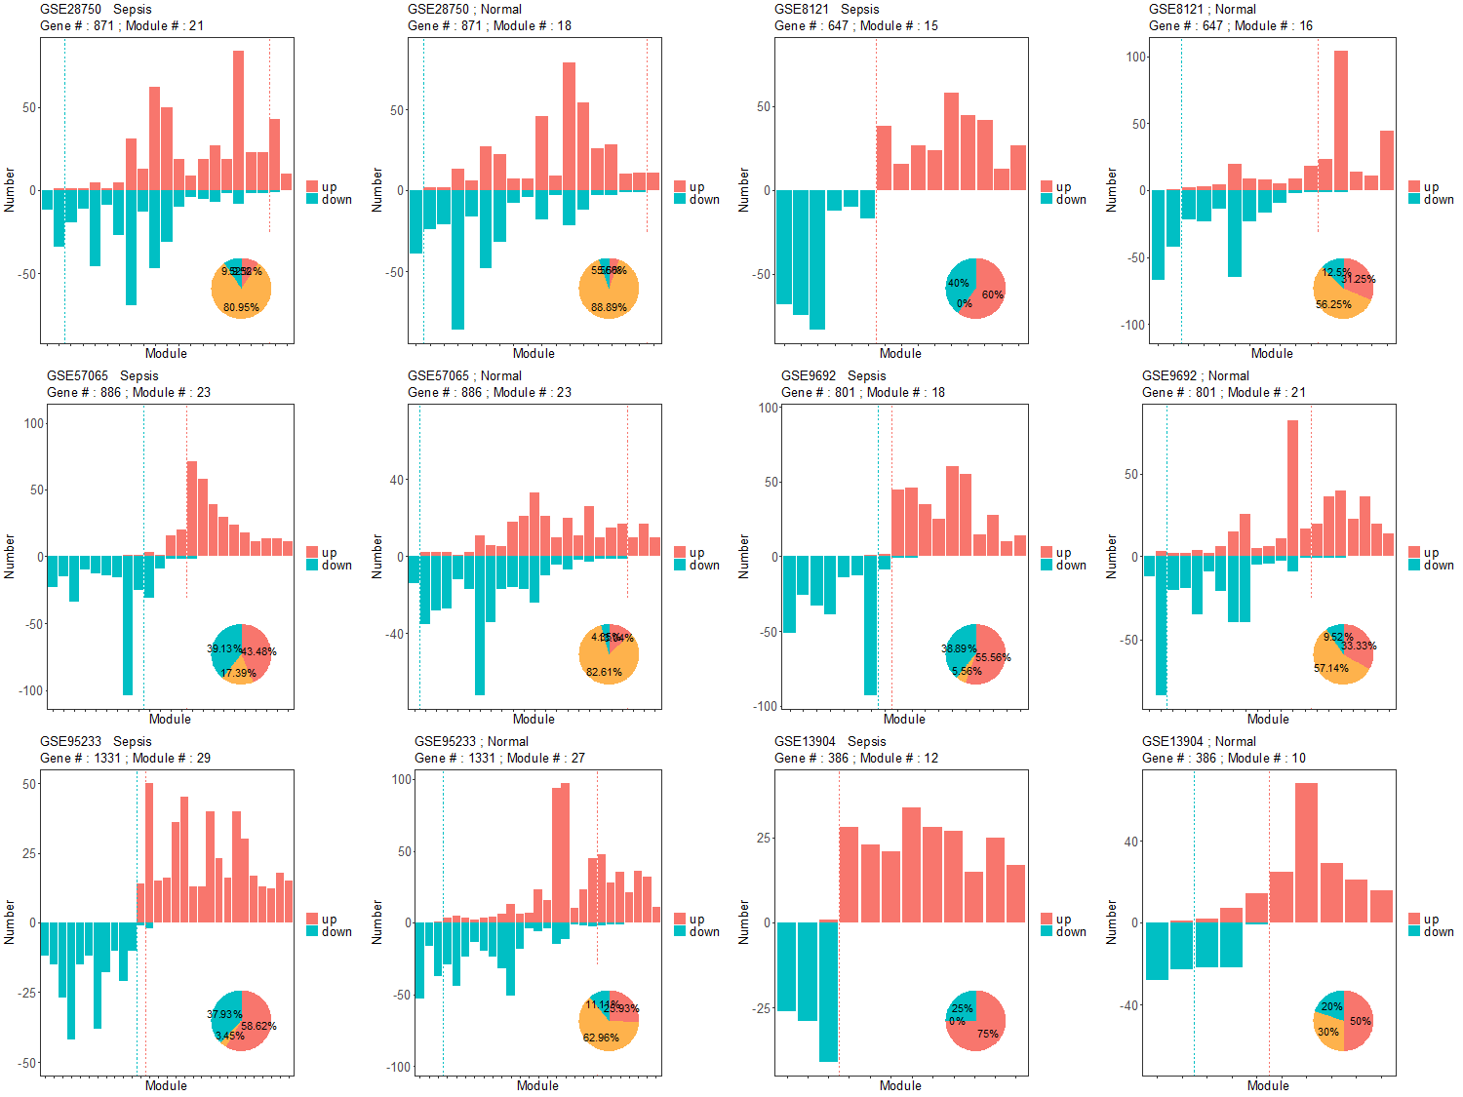
Figure S6. The DEGs were screened by the criteria of p value < 1 and absolute fold change > 2. The minimum module size is 10.

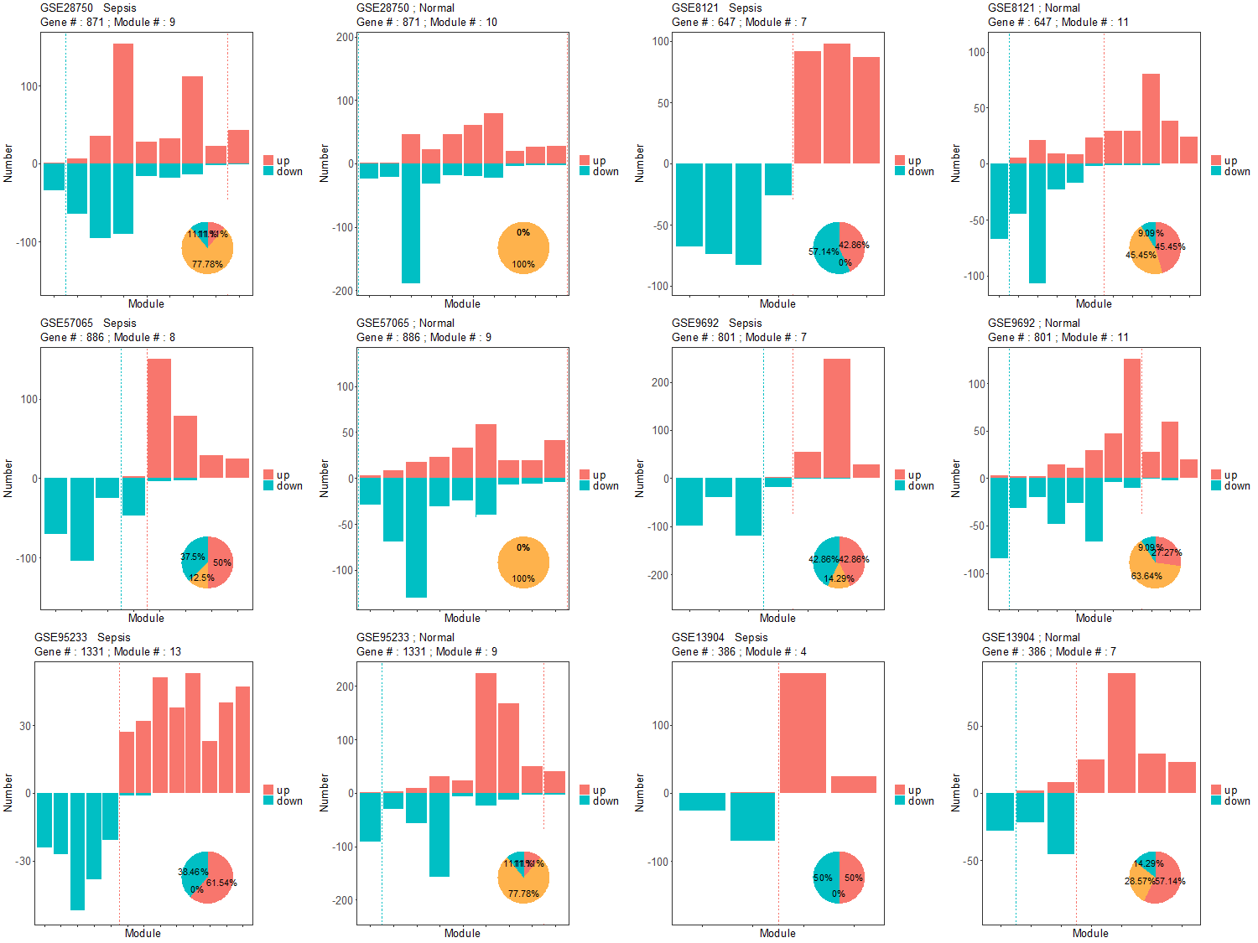
Figure S7. The DEGs were screened by the criteria of p value < 1 and absolute fold change > 2. The minimum module size is 20.

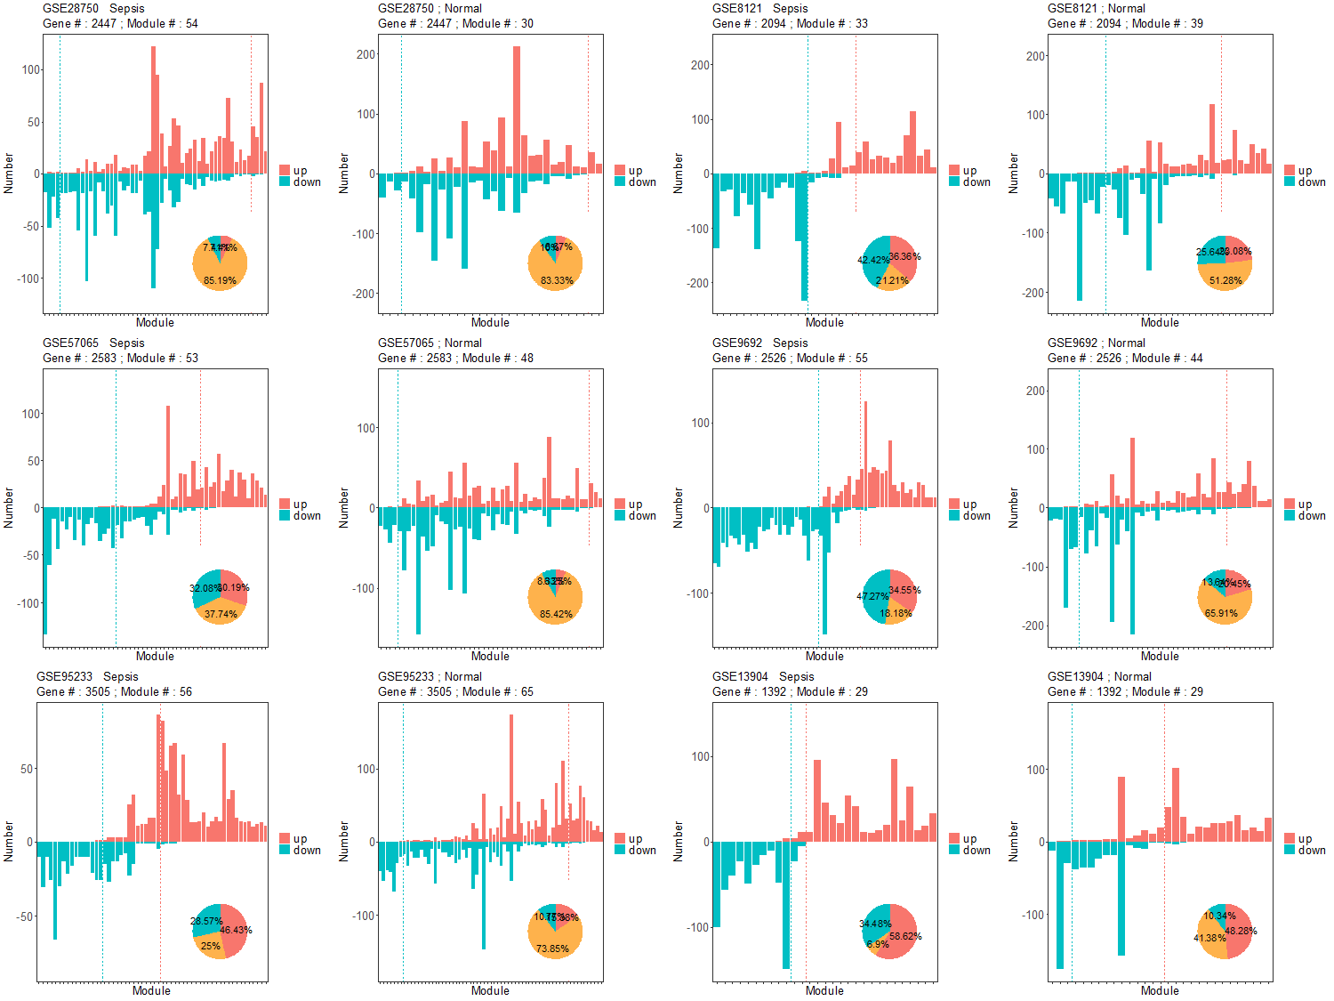
Figure S8. The DEGs were screened by the criteria of p value < 1 and absolute fold change > 1.5. The minimum module size is 10.

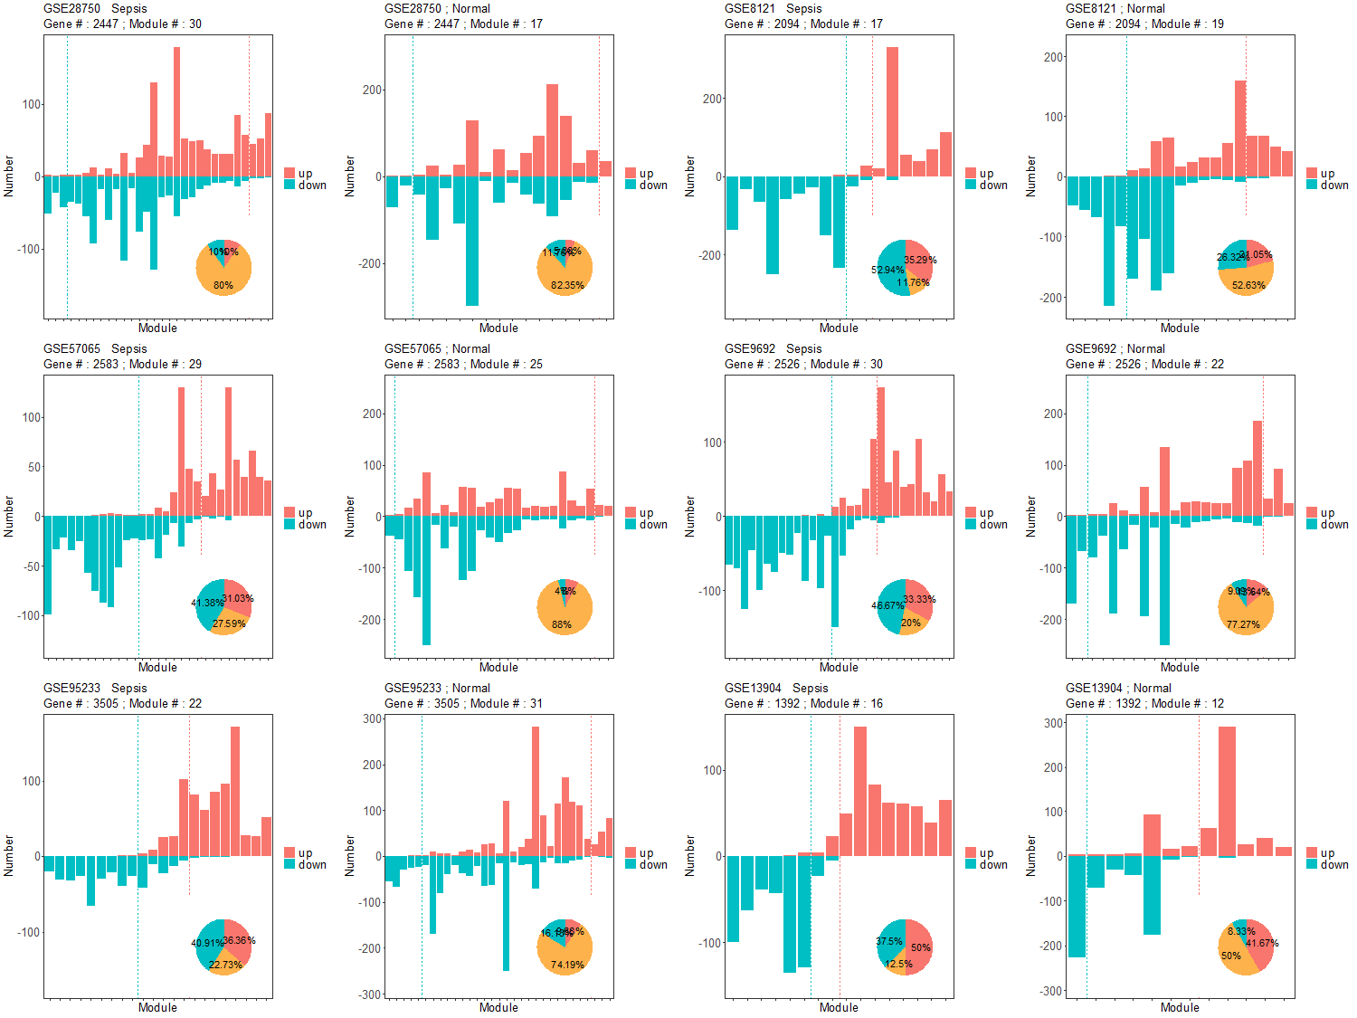
Figure S9. The DEGs were screened by the criteria of p value < 1 and absolute fold change > 1.5. The minimum module size is 20.

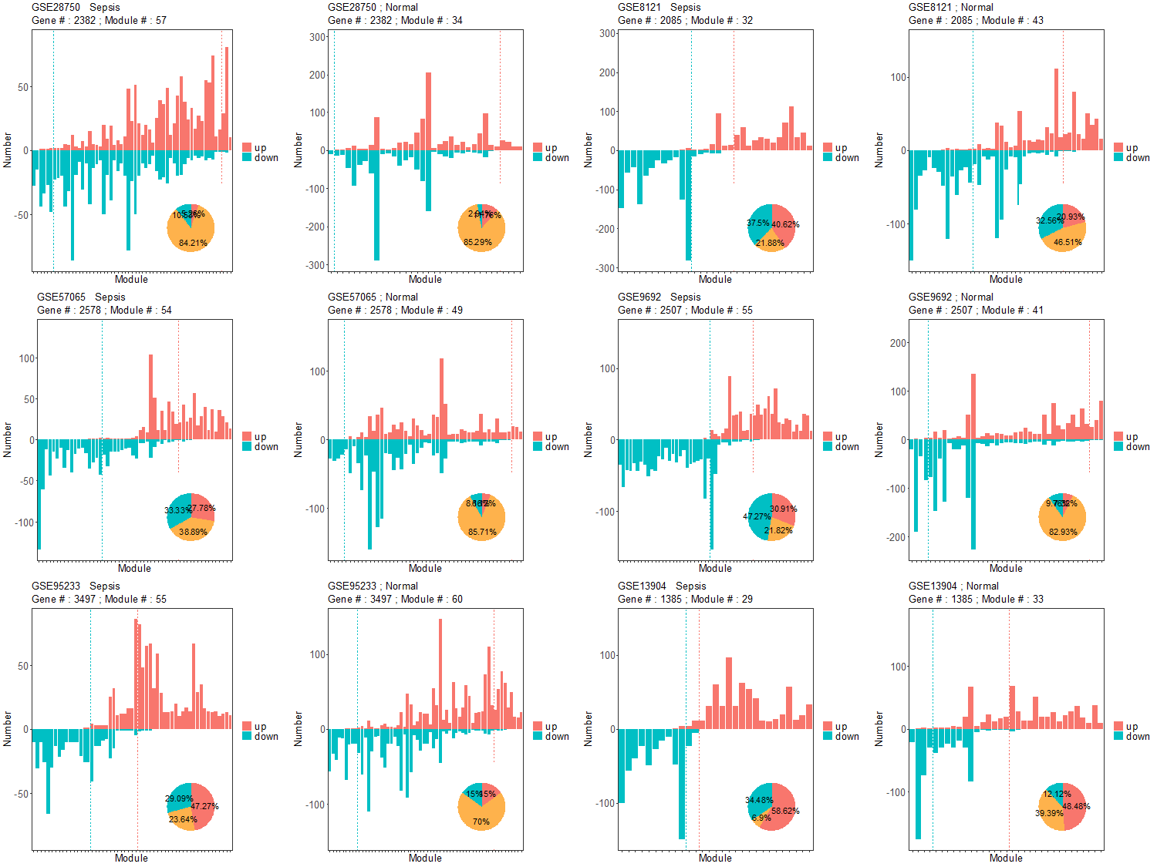
Figure S10. The DEGs were screened by the criteria of p value < 0.05 and absolute fold change > 1.5. The minimum module size is 10.

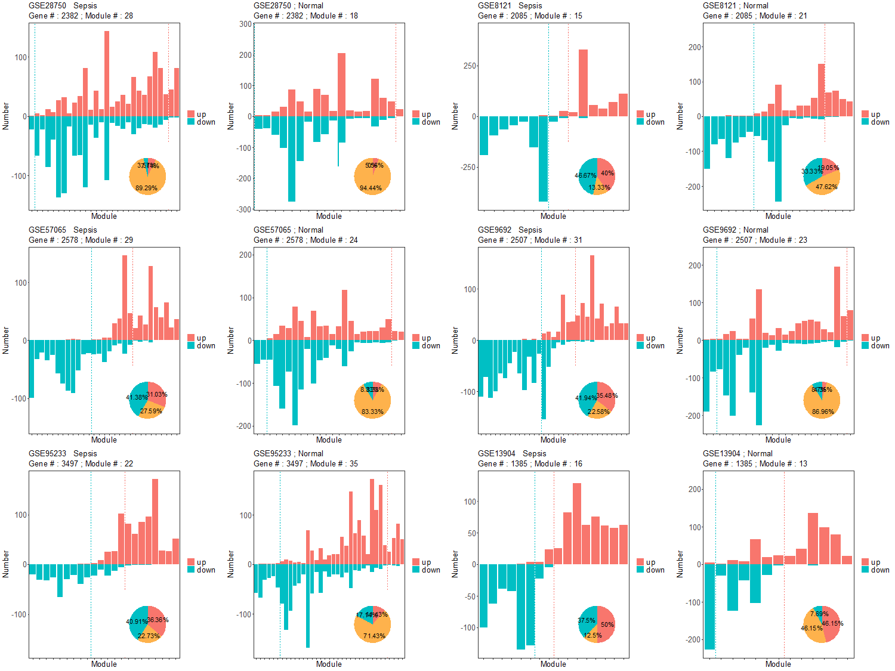
Figure S11. The DEGs were screened by the criteria of p value < 0.05 and absolute fold change > 1.5. The minimum module size is 20.

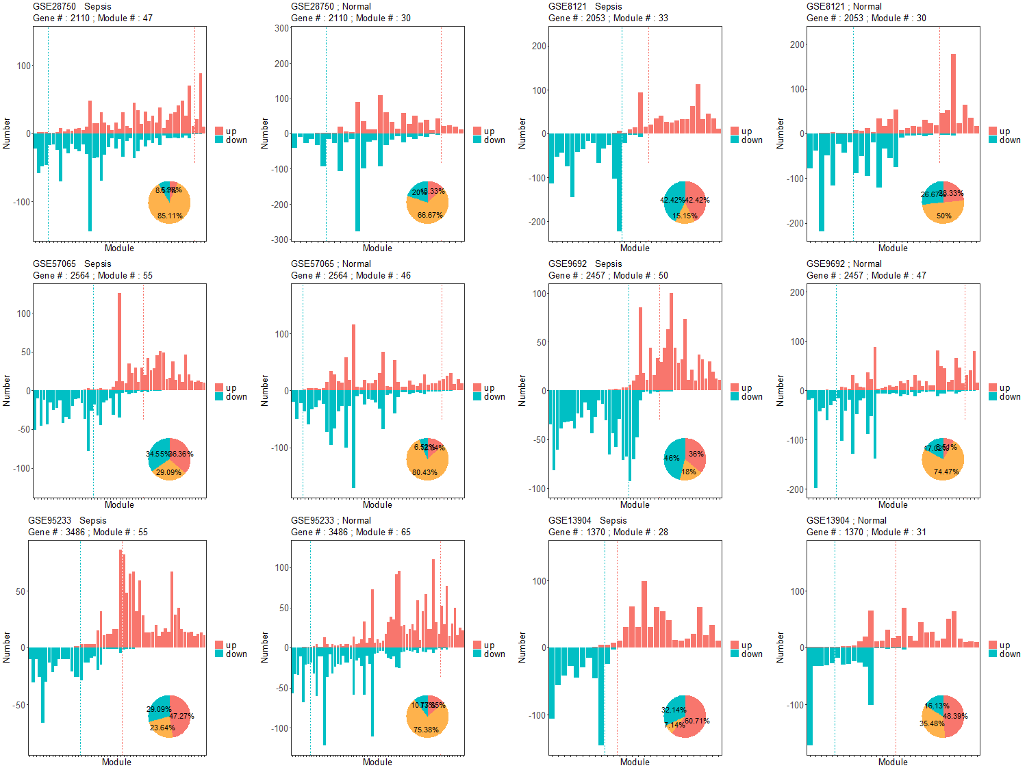
Figure S12. The DEGs were screened by the criteria of p value < 0.01 and absolute fold change > 1.5. The minimum module size is 10.

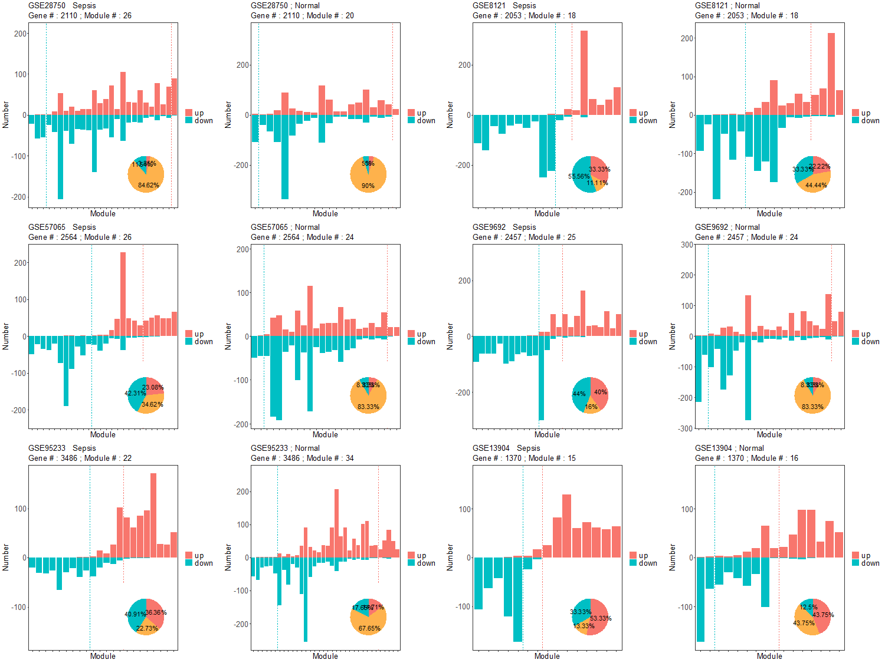
Figure S13. The DEGs were screened by the criteria of p value < 0.01 and absolute fold change > 1.5. The minimum module size is 20.

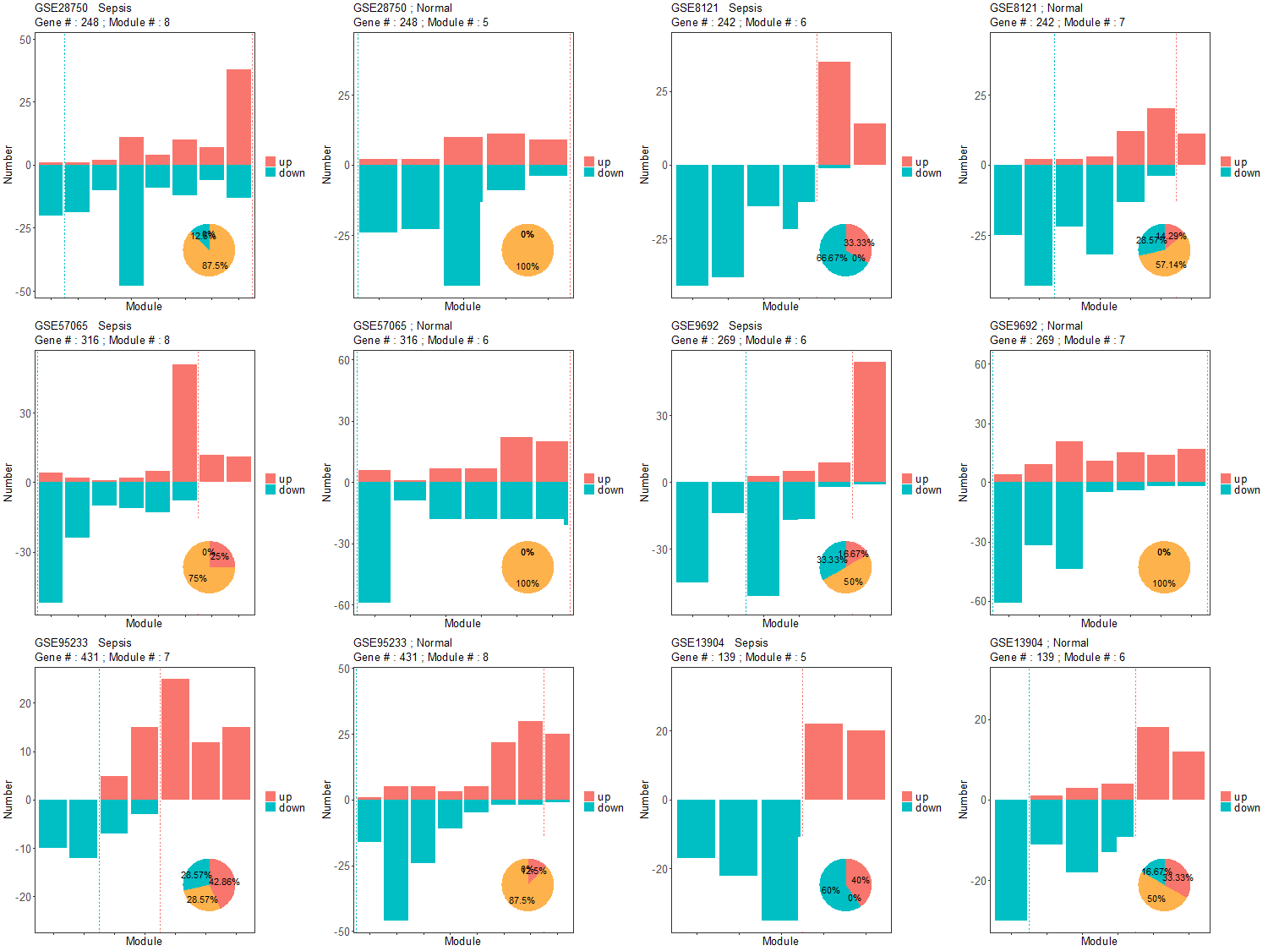
Figure S14. The DELs were screened by the criteria of p value < 0.01 and absolute fold change > 1.5. The minimum module size is 10.

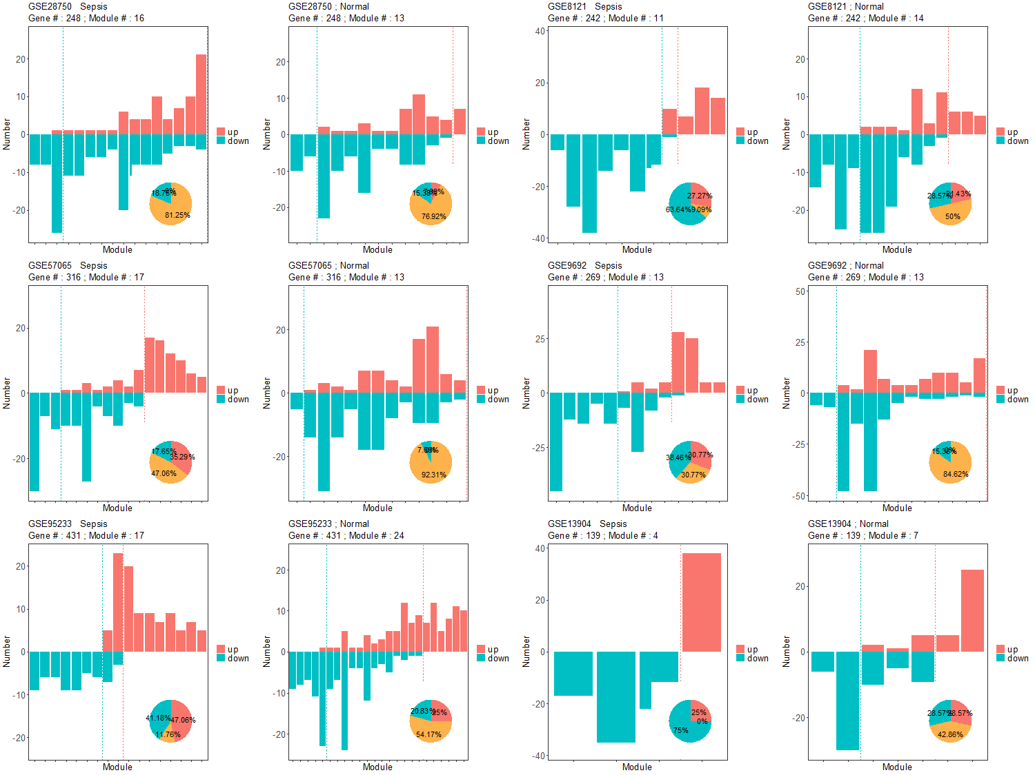
Figure S15. The DELs were screened by the criteria of p value < 0.01 and absolute fold change > 1.5. The minimum module size is 5.

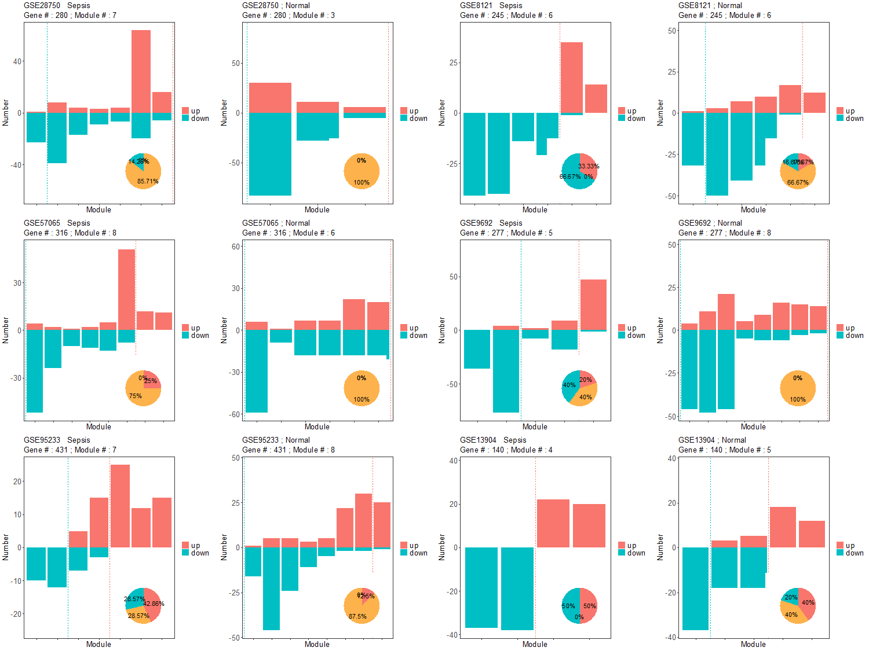
Figure S16. The DELs were screened by the criteria of p value < 0.05 and absolute fold change > 1.5. The minimum module size is 10.

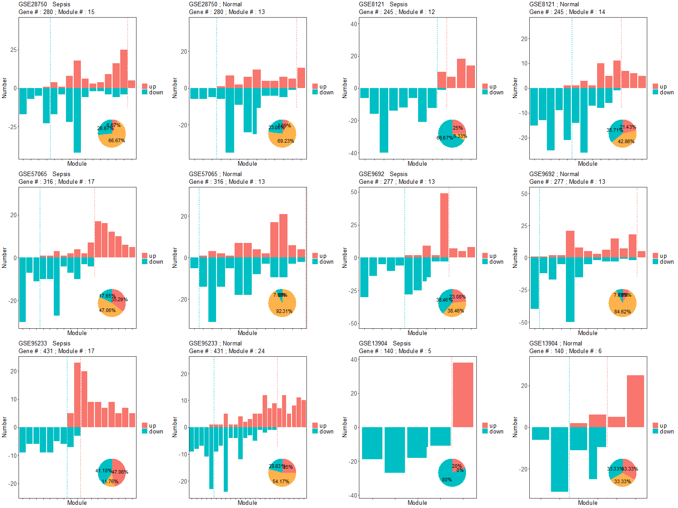
Figure S17. The DELs were screened by the criteria of p value < 0.05 and absolute fold change > 1.5. The minimum module size is 5.

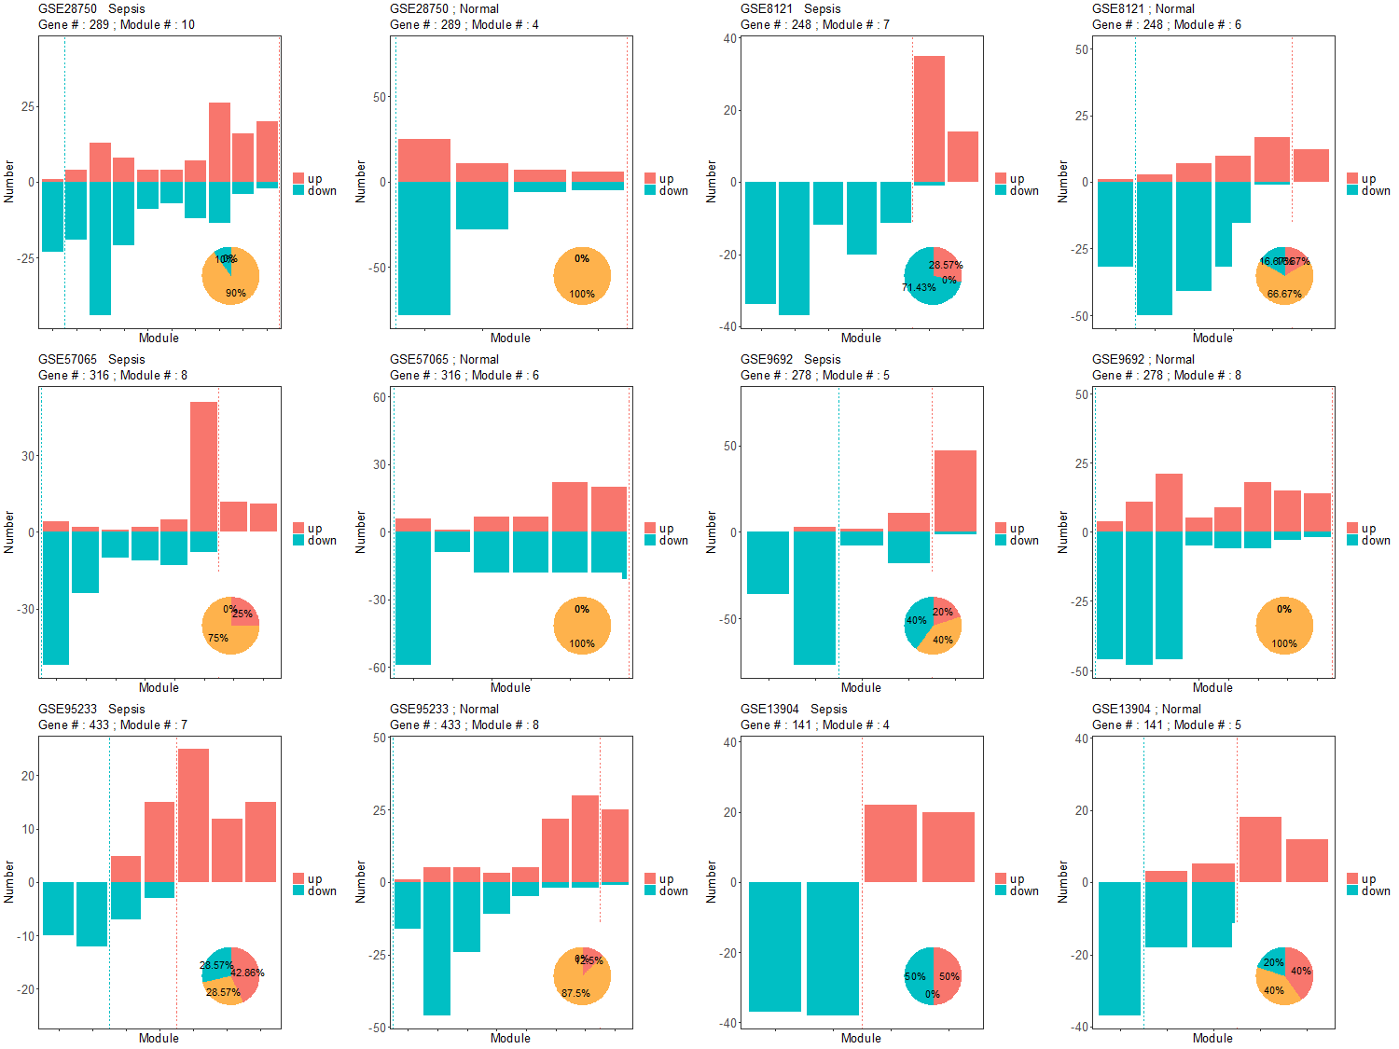
Figure S18. The DELs were screened by the criteria of p value < 1 and absolute fold change > 1.5. The minimum module size is 10.

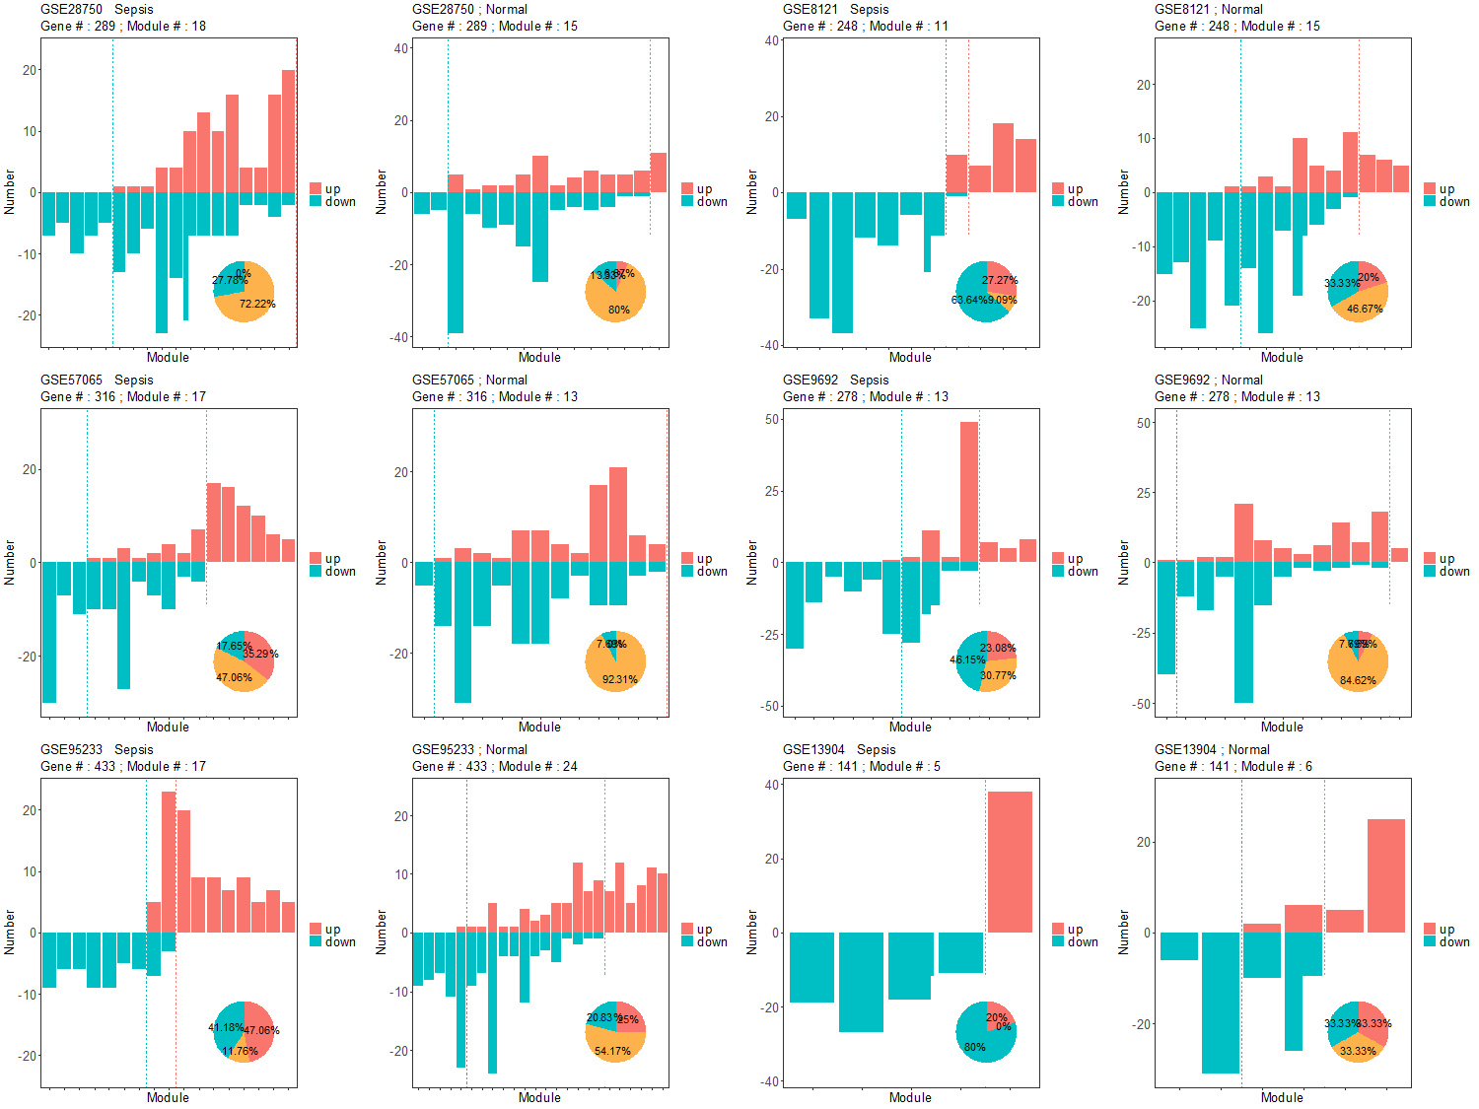
Figure S19. The DELs were screened by the criteria of p value < 1 and absolute fold change > 1.5. The minimum module size is 5.

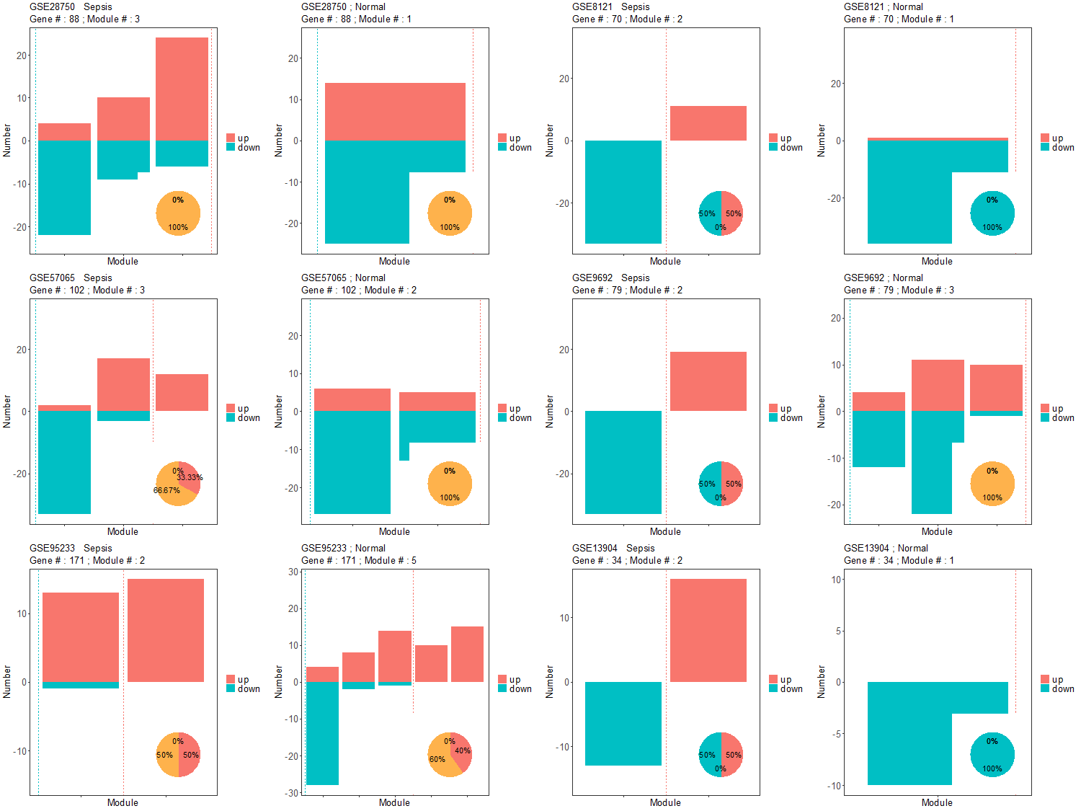
Figure S20.. The DELs were screened by the criteria of p value < 0.01 and absolute fold change > 2. The minimum module size is 10.

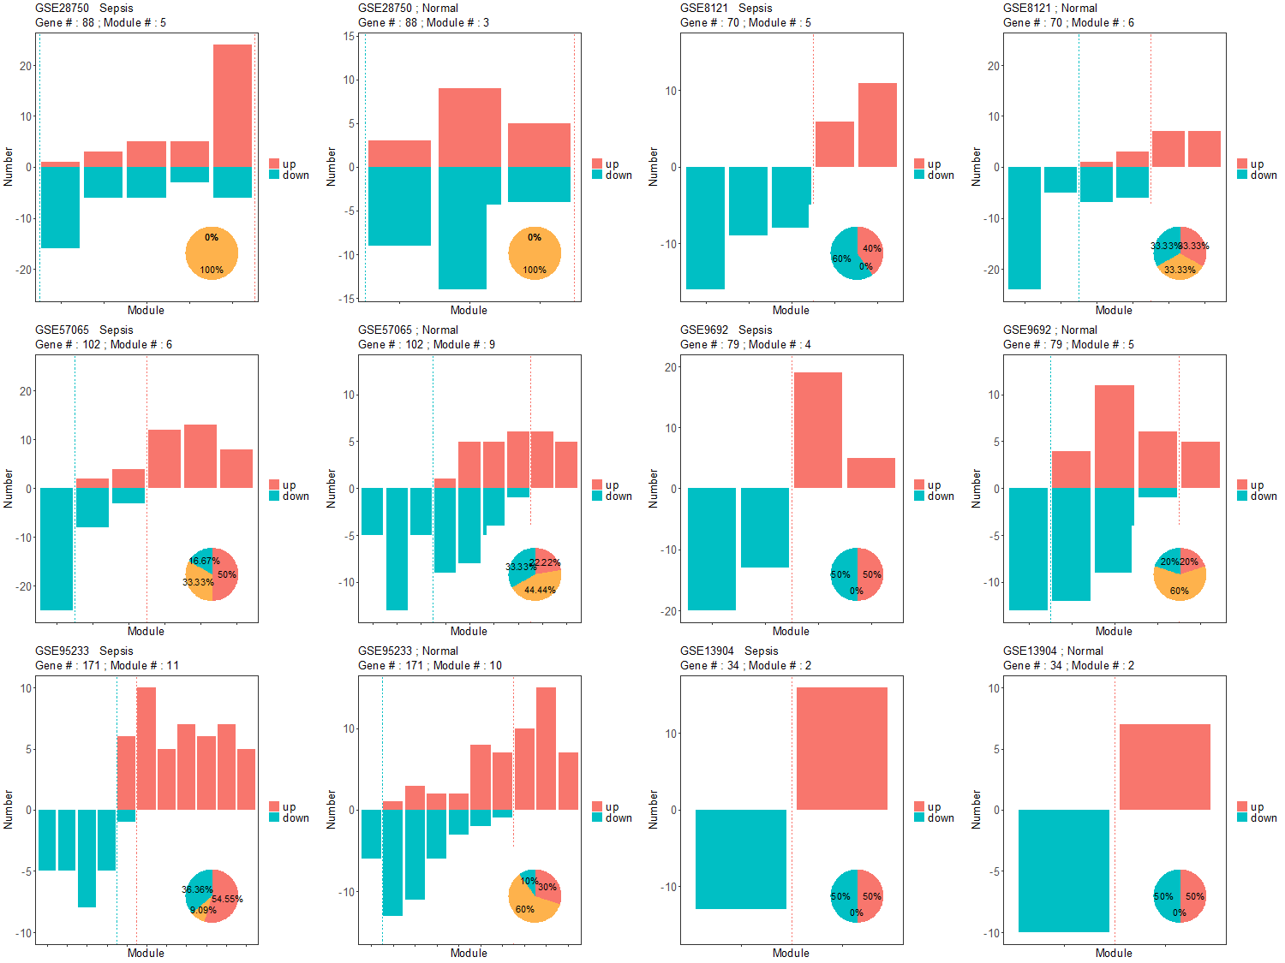
Figure S21. The DELs were screened by the criteria of p value < 0.01 and absolute fold change > 2. The minimum module size is 5.

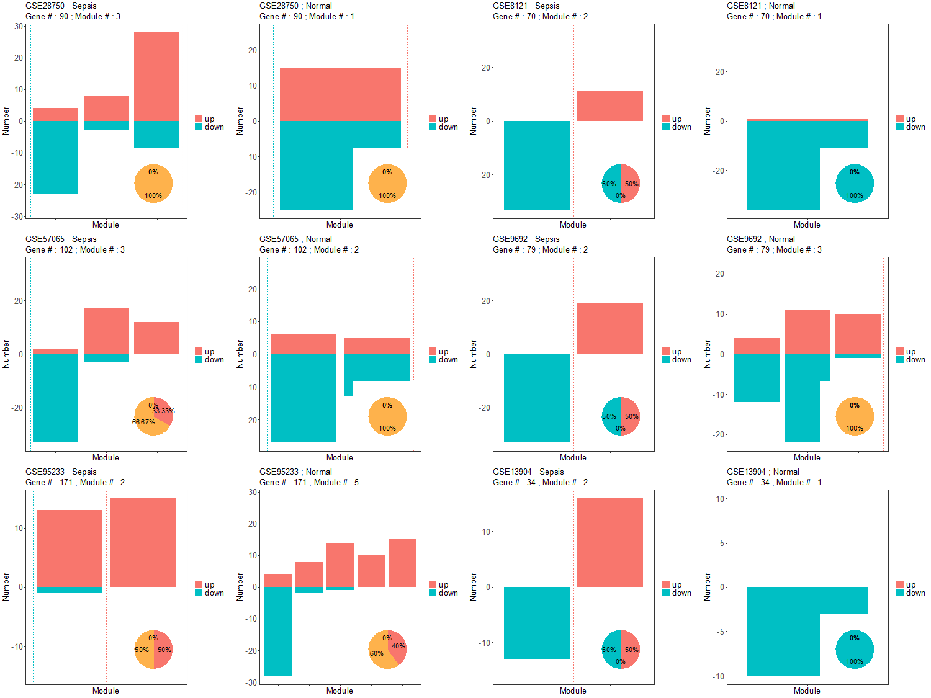
Figure S22. The DELs were screened by the criteria of p value < 0.05 and absolute fold change > 2. The minimum module size is 10.

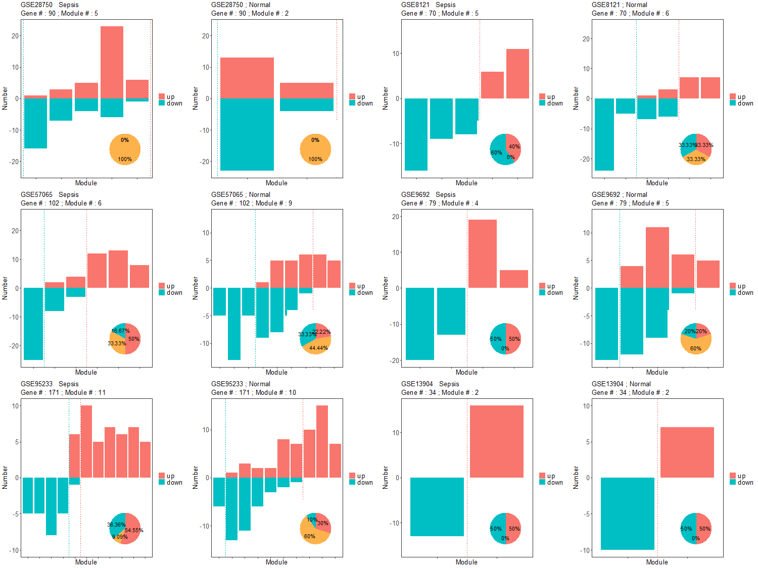
Figure S23. The DELs were screened by the criteria of p value < 0.05 and absolute fold change > 2. The minimum module size is 5.

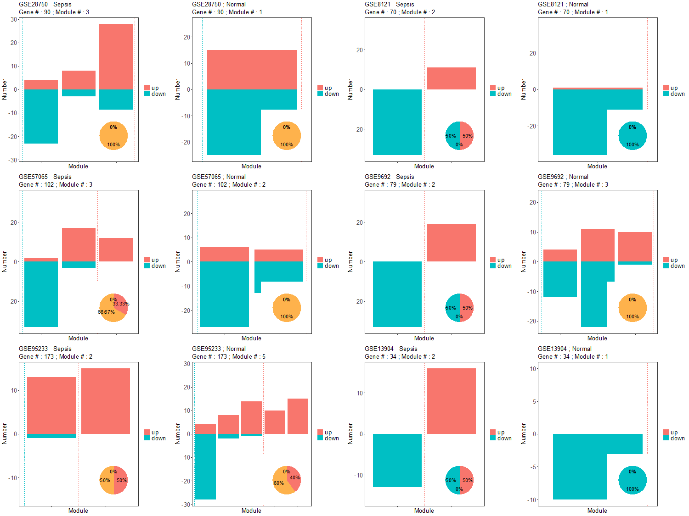
Figure S24. The DELs were screened by the criteria of p value < 1 and absolute fold change > 2. The minimum module size is 10.

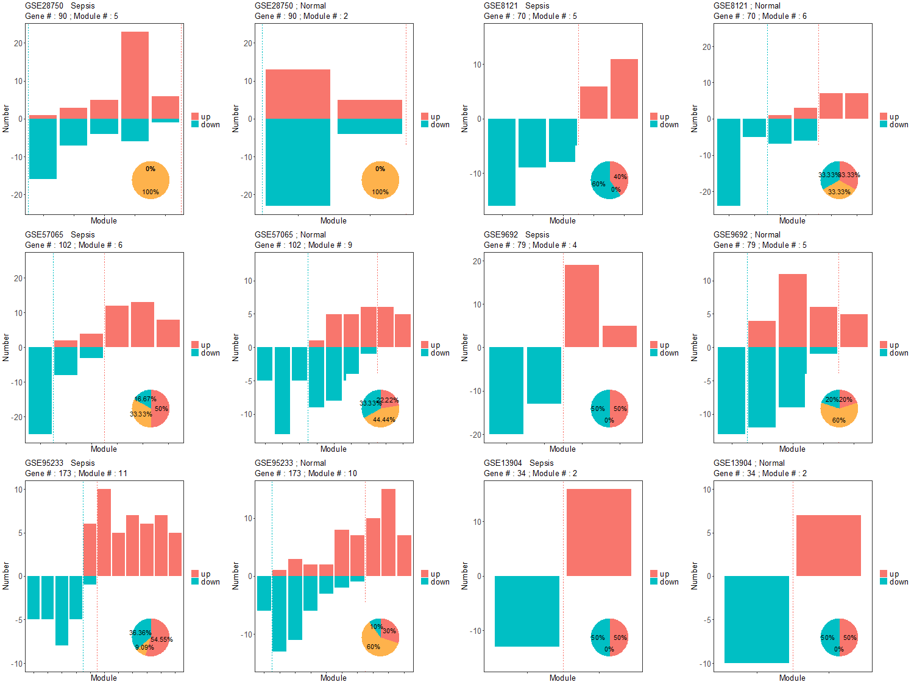
Figure S25. The DELs were screened by the criteria of p value < 1 and absolute fold change > 2. The minimum module size is 5.

