TD-DFT, DFT and concentration dependent SERS investigations of a bioactive trifluoromethyl derivative in silver colloids

Jamelah S.Al-Otaibi^{a*}, Y.Sheena Mary^{b}, Y.Shyma Mary^{b}, Martin Krátký^{c}, Jarmila Vinsova^{c}, Maria Cristina Gamberini^{d}

ª Department of Chemistry, College of Science, Princess Nourah Bint Abdulrahman University, P.O. Box 84428, Riyadh 11671, Saudi Arabia
^{b}Thushara, Neethinagar, Kollam, Kerala, India
^{c} Department of Organic and Bioorganic Chemistry, Faculty of Pharmacy in Hradec Králové, Charles University, Akademika Heyrovského 1203, 500 05 Hradec Králové, Czech Republic
^{d}Department of Life Sciences, University of Modena and Reggio Emilia, via G. Campi 103
41125 Modena, Italy
*author for correspondence: marysheena2018@rediffmail.com

Figure S1 IR spectrum of EMT
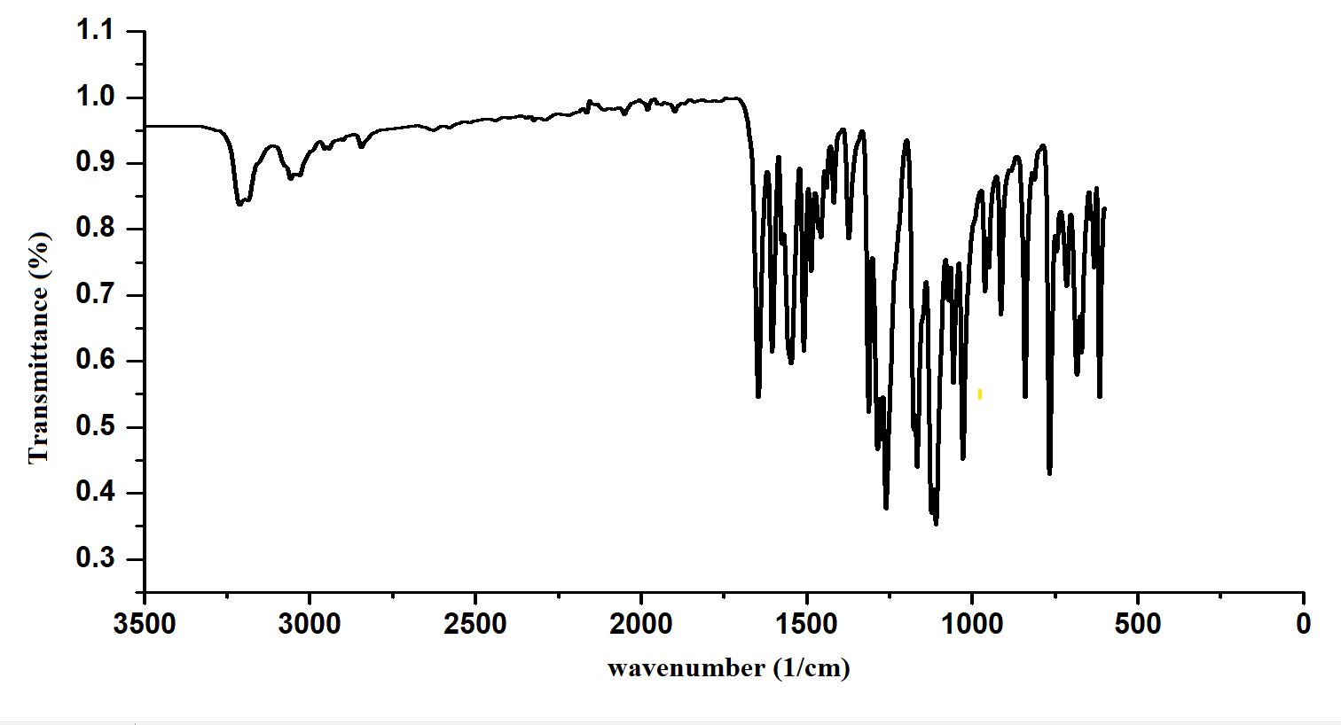
Figure S2 Raman spectrum of EMT
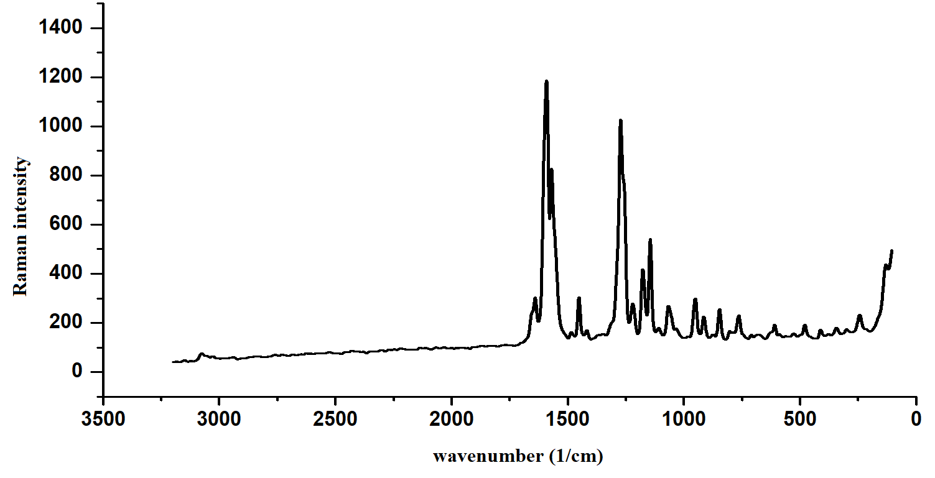
Figure S3 Scheme: Synthesis of EMT

Figure S4 UV-visible spectra of EMT and EMT-Ag₆
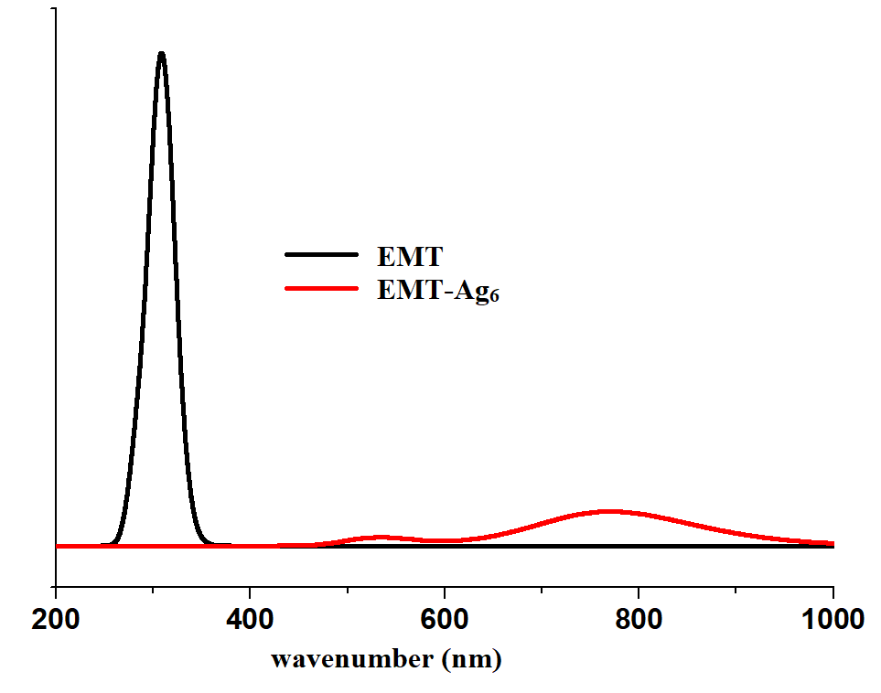
Figure S5 DOS spectra of (a) EMT (b) EMT-Ag₆
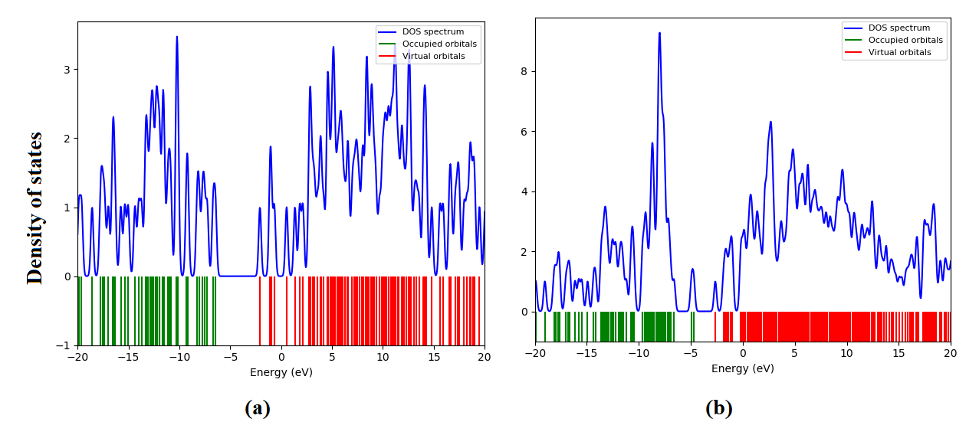

Table S1 Vibrational assignments of EMT

B3LYP/6-311++G* |  |  | IR  υ(cm⁻¹) | Raman  υ(cm⁻¹) | Assignmentsª
υ(cm⁻¹) | IR intensity | Raman activity | IR  υ(cm⁻¹) | Raman  υ(cm⁻¹) | Assignmentsª
3361 | 3.79 | 376.82 | 3220 |  | υNH(100)
3111 | 8.60 | 220.84 | 3120 | 3115 | υCHRA(96)
3106 | 1.77 | 28.97 |  |  | υCHRA(90)
3105 | 6.78 | 189.33 |  |  | υCHRB(97)
3104 | 8.24 | 18.94 |  |  | υCHRB(98)
3089 | 3.52 | 109.21 |  |  | υCHRB(99)
3086 | 18.07 | 201.86 | 3085 | 3085 | υCHRA(96)
3071 | 3.38 | 68.08 |  |  | υCHRA(95)
3063 | 18.53 | 49.67 | 3060 | 3060 | υCHRB(96)
3041 | 26.95 | 170.63 | 3038 | 3039 | υCH3(91)
2998 | 36.50 | 36.96 | 2995 | 3000 | υCH(99)
2973 | 39.28 | 53.55 | 2965 | 2965 | υCH3(99)
2913 | 56.59 | 125.95 | 2915 | 2912 | υCH3(99)
1721 | 231.10 | 387.77 |  |  | υC=O(77)
1623 | 13.14 | 1312.91 | 1639 | 1635 | υC=N(50), υRA(18)
1604 | 189.45 | 447.44 | 1604 |  | υRB(56), δCHRB(21)
1591 | 17.88 | 2430.23 |  | 1590 | υRA(58), δCHRA(13)
1564 | 10.07 | 139.56 | 1570 | 1568 | υRA(67), δCHRA(17)
1561 | 33.33 | 67.05 | 1555 |  | υRB(67), δCHRB(10)
1513 | 193.44 | 369.09 | 1511 |  | δNH(58)
1499 | 216.04 | 1.87 | 1494 | 1495 | δNH(14), δCHRB(11), υRB(53)
1474 | 24.80 | 13.09 |  |  | δCH3(90)
1469 | 191.28 | 190.45 | 1469 |  | δCHRA(14), υRA(59)
1463 | 6.19 | 31.11 | 1460 |  | δCH3(100)
1442 | 17.92 | 243.84 |  | 1445 | δCHRA(15), υRA(54)
1441 | 28.87 | 11.23 | 1441 |  | δCH3(86)
1409 | 5.56 | 19.51 | 1412 | 1415 | υRB(58), δCHRB(22)
1374 | 30.47 | 40.75 | 1373 | 1385 | δNH(40), δCH(47)
1316 | 42.74 | 5.08 | 1315 | 1315 | υRB(75)
1306 | 9.41 | 16.67 |  |  | υRA(79)
1292 | 0.32 | 1.29 | 1290 |  | δCHRB(83)
1284 | 158.97 | 20.07 | 1280 |  | υCC(19), δCHRA(53)
1264 | 134.65 | 477.88 | 1264 | 1267 | υCF(43), δCHRA(25)
1256 | 221.71 | 4.80 |  | 1258 | υCO(46), υRB(19), δCHRB(18)
1220 | 698.81 | 797.52 | 1219 | 1222 | υCC(13), υCN(44), δNH(11)
1211 | 16.71 | 163.14 |  |  | υCC(12), δCHRA(55), υRA(13)
1171 | 23.91 | 19.56 | 1174 | 1175 | δCH3(78)
1165 | 196.51 | 32.29 | 1166 |  | υCF(49), δCHRA(10), υRA(10)
1164 | 318.44 | 154.74 |  |  | δCHRB(67), υRB(10)
1153 | 47.61 | 22.34 | 1151 |  | δCHRA(64), υRA(10)
1141 | 103.32 | 536.52 |  | 1142 | υNN(40), υCF(15)
1138 | 0.74 | 5.23 |  |  | δCH3(95)
1121 | 252.62 | 1.48 | 1124 |  | υCF(89)
1103 | 36.26 | 12.89 | 1108 | 1103 | δCHRB(56), υRB(22)
1093 | 94.98 | 66.55 |  | 1075 | δCHRA(55), υRA(10)
1049 | 7.47 | 4.96 | 1052 | 1050 | υCC(38), υNN(18), υCO(10)
1042 | 49.95 | 37.32 |  |  | υRA(56), δCHRA(15)
1030 | 68.97 | 2.42 | 1032 | 1032 | υCO(62), υCC(12)
1015 | 62.36 | 24.00 |  |  | δCHRB(56), δRA(15), υCF(13)
990 | 2.42 | 0.64 | 992 | 988 | δRB(19), υRB(48)
969 | 0.39 | 1.64 | 966 |  | γCHRA(73), τRA(11)
950 | 2.80 | 2.85 | 951 | 951 | γCHRB(94)
937 | 4.74 | 0.41 |  |  | γCHRA(89)
908 | 11.43 | 10.70 | 912 | 910 | γCH(70)
906 | 0.05 | 0.92 |  |  | γCHRB(90)
902 | 39.21 | 16.68 |  |  | δC=O(34), γCH(26)
871 | 0.55 | 3.18 | 875 | 873 | γCHRA(84)
832 | 22.68 | 24.11 | 835 | 835 | γCHRB(76)
825 | 10.51 | 34.61 | 820 |  | δRA(25), γCHRB(17), υRA(18)
793 | 8.10 | 4.09 |  | 799 | γCHRB(83)
780 | 1.19 | 15.50 | 778 | 785 | δRB(41), υRB(35)
755 | 47.97 | 2.80 |  | 757 | γCHRA(89)
748 | 2.55 | 13.27 | 746 |  | δRA(44), υCC(13)
736 | 15.91 | 14.67 |  | 738 | τRB(41), γC=O(24), γCO(11)
732 | 3.87 | 1.38 | 725 |  | τRA(59), γCN(16), γCC(11)
674 | 9.18 | 0.73 | 672 | 675 | τRB(58), γC=O(25)
651 | 15.72 | 0.76 | 650 |  | δCF(38), δRA(27), δNH(12)
627 | 8.73 | 9.93 | 630 | 628 | δRA(44), δRB(19)
625 | 1.16 | 3.24 | 620 |  | δRB(46), δRA(16)
604 | 37.58 | 5.54 |  | 606 | δRB(49), δCO(22)
574 | 1.98 | 0.12 |  |  | τRA(62), δCF(18)
564 | 4.66 | 3.05 |  | 563 | δCF(41), δCC(10), δRA(13)
523 | 55.56 | 22.00 |  | 525 | γNH(16), τRB(15), γCO(15)
518 | 11.47 | 0.99 |  |  | τRA(56), γCN(24)
509 | 15.72 | 4.22 |  | 507 | γNH(44), γCO(11), τRB(18)
490 | 3.28 | 6.36 |  | 488 | γCO(28), τRB(22), δCO(10)
464 | 0.94 | 0.58 |  |  | δCO(46), δC=O(10)
460 | 3.18 | 5.54 |  |  | δCF(40), δCN(14), δC=O(10), δC=N(10)
459 | 1.00 | 1.87 |  |  | δCF(37), τRA(27), γCC(11)
410 | 0.51 | 1.66 |  | 412 | τRB(79)
384 | 2.06 | 0.82 |  | 382 | δCF(34), δC=N(11), δC=O(10), δCC(10)
360 | 5.42 | 1.42 |  |  | δRB(33), δCF(16)
344 | 0.22 | 2.88 |  | 343 | τRA(57), τC=N(13), δCF(11)
317 | 1.12 | 2.76 |  | 318 | τRA(17), γCC(16)
306 | 3.45 | 2.31 |  | 305 | γCC(21), τCH3(21)
281 | 4.09 | 0.84 |  |  | τRA(32), τCH3(27)
266 | 9.43 | 1.74 |  |  | δCO(15), δCC(19), δCF(16), τRA(24)
242 | 0.92 | 1.46 |  | 241 | δCC(12), δCF(38), δCN(19)
231 | 0.99 | 0.90 |  |  | τCH3(69)
215 | 5.46 | 2.37 |  |  | τC=O(27), δCO(24), τNH(16)
193 | 5.20 | 2.25 |  |  | δCC(11), τC=O(16), τRB(16)
142 | 1.78 | 1.26 |  |  | δCC(33), δNH(18)
136 | 6.97 | 1.58 |  | 135 | τCO(22), γNH(27), τRB(21)
127 | 2.93 | 3.02 |  |  | τCO(38), τCC(25)
111 | 4.50 | 4.58 |  |  | τCO(31), γCC(27), τRA(18)
99 | 2.05 | 3.48 |  |  | δCC(22), τRA(20), τCF(20)
71 | 1.05 | 3.87 |  |  | τCO(23), τRB(13), τCF(11), τCH3(11)
67 | 1.71 | 2.32 |  |  | τCC(33), τCF(28), τCO(16)
48 | 0.60 | 2.32 |  |  | τCF(46), τCC(33)
29 | 1.27 | 1.04 |  |  | τC=N(27), τNH(35), τC=O(15)
26 | 0.24 | 2.39 |  |  | τNH(28), τCC(20), τCN(17)
15 | 3.80 | 2.55 |  |  | τCN(43), τC=O(13), τC=N(10)
ª υ-stretching; δ-in-plane bending; γ-out-of-plane bending; τ-torsion

