Appendix
Table A1. Unadjusted means by label type, for single product label reactions
 | PME
 | Mean | SD
Overall
Nutriscore | 2.7 | 1.0
Nutrient warning | 3.9 | 0.9
GDA | 3.0 | 1.0
Cookies
Nutriscore | 2.8 | 1.0
Nutrient warning | 3.8 | 0.9
GDA | 3.3 | 1.0
Yogurt
Nutriscore | 2.6 | 0.9
Nutrient warning | 3.9 | 0.9
GDA | 3.0 | 1.0
Sliced bread
Nutriscore | 2.7 | 0.9
Nutrient warning | 3.9 | 0.9
GDA | 2.9 | 0.9
Cereal
Nutriscore | 2.8 | 1.0
Nutrient warning | 3.9 | 1.0
GDA | 2.7 | 1.0
Note. PME was not measured for the no-label condition, because PME measures reactions to labels

Table A2. Unadjusted proportions and means by label type, for single product assessment task

 | Correctly identified product as having excess of nutrient | Likelihood of purchasing the product in the next week if it were available
 | % |  | Mean | SD
Overall
Control | 23% |  | 3.5 | 0.9
Nutriscore | 26% |  | 3.5 | 0.9
Nutrient warning | 74% |  | 2.6 | 1.1
GDA | 43% |  | 3.2 | 1.0
Cookies
Control | 15% |  | 3.6 |  | 0.9
Nutriscore | 25% |  | 3.4 |  | 0.9
Nutrient warning | 70% |  | 2.6 |  | 1.1
GDA | 71% |  | 3.0 |  | 1.1
Yogurt
Control | 47% |  | 3.6 |  | 0.9
Nutriscore | 42% |  | 3.6 |  | 0.9
Nutrient warning | 85% |  | 2.6 |  | 1.1
GDA | 55% |  | 3.3 |  | 1.0
Sliced bread
Control | 24% |  | 3.4 |  | 0.9
Nutriscore | 22% |  | 3.4 |  | 0.9
Nutrient warning | 78% |  | 2.5 |  | 1.1
GDA | 38% |  | 3.4 |  | 0.9
Cereal
Control | 7%
Nutriscore | 16%
Nutrient warning | 64%
GDA | 7%

Table A3. CONSORT Checklist
Section/Topic | Item No | Checklist item | Reported on page No
Title and abstract
 | 1a | Identification as a randomised trial in the title | 1
 | 1b | Structured summary of trial design, methods, results, and conclusions (for specific guidance see CONSORT for abstracts) | 1-2
Introduction
Background and objectives | 2a | Scientific background and explanation of rationale | 2-3
Background and objectives | 2b | Specific objectives or hypotheses | 3
Methods
Trial design | 3a | Description of trial design (such as parallel, factorial) including allocation ratio | 6
Trial design | 3b | Important changes to methods after trial commencement (such as eligibility criteria), with reasons | N/A
Participants | 4a | Eligibility criteria for participants | 6
Participants | 4b | Settings and locations where the data were collected | 6
Interventions | 5 | The interventions for each group with sufficient details to allow replication, including how and when they were actually administered | 6
Outcomes | 6a | Completely defined pre-specified primary and secondary outcome measures, including how and when they were assessed | 8-9
Outcomes | 6b | Any changes to trial outcomes after the trial commenced, with reasons
Sample size | 7a | How sample size was determined | 7
Sample size | 7b | When applicable, explanation of any interim analyses and stopping guidelines
Randomisation:
Sequence generation | 8a | Method used to generate the random allocation sequence | 6
Sequence generation | 8b | Type of randomisation; details of any restriction (such as blocking and block size) | 6
Allocation concealment mechanism | 9 | Mechanism used to implement the random allocation sequence (such as sequentially numbered containers), describing any steps taken to conceal the sequence until interventions were assigned | 6
Implementation | 10 | Who generated the random allocation sequence, who enrolled participants, and who assigned participants to interventions | 6
Blinding | 11a | If done, who was blinded after assignment to interventions (for example, participants, care providers, those assessing outcomes) and how
Blinding | 11b | If relevant, description of the similarity of interventions
Statistical methods | 12a | Statistical methods used to compare groups for primary and secondary outcomes | 7-8
Statistical methods | 12b | Methods for additional analyses, such as subgroup analyses and adjusted analyses | 7-8
Results
Participant flow (a diagram is strongly recommended) | 13a | For each group, the numbers of participants who were randomly assigned, received intended treatment, and were analysed for the primary outcome | 8
Participant flow (a diagram is strongly recommended) | 13b | For each group, losses and exclusions after randomisation, together with reasons | 8
Recruitment | 14a | Dates defining the periods of recruitment and follow-up | 6
Recruitment | 14b | Why the trial ended or was stopped
Baseline data | 15 | A table showing baseline demographic and clinical characteristics for each group | 15-16
Numbers analysed | 16 | For each group, number of participants (denominator) included in each analysis and whether the analysis was by original assigned groups | 15
Outcomes and estimation | 17a | For each primary and secondary outcome, results for each group, and the estimated effect size and its precision (such as 95% confidence interval) | 9-12
Outcomes and estimation | 17b | For binary outcomes, presentation of both absolute and relative effect sizes is recommended
Ancillary analyses | 18 | Results of any other analyses performed, including subgroup analyses and adjusted analyses, distinguishing pre-specified from exploratory | 10-11
Harms | 19 | All important harms or unintended effects in each group (for specific guidance see CONSORT for harms)
Discussion
Limitations | 20 | Trial limitations, addressing sources of potential bias, imprecision, and, if relevant, multiplicity of analyses | 13-14
Generalisability | 21 | Generalisability (external validity, applicability) of the trial findings | 13-14
Interpretation | 22 | Interpretation consistent with results, balancing benefits and harms, and considering other relevant evidence | 12-13
Other information
Registration | 23 | Registration number and name of trial registry | 3
Protocol | 24 | Where the full trial protocol can be accessed, if available | 3
Funding | 25 | Sources of funding and other support (such as supply of drugs), role of funders | 15

Figure A1. Products used in the experiment

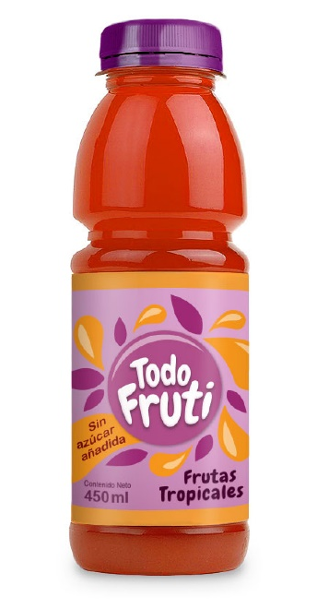 | 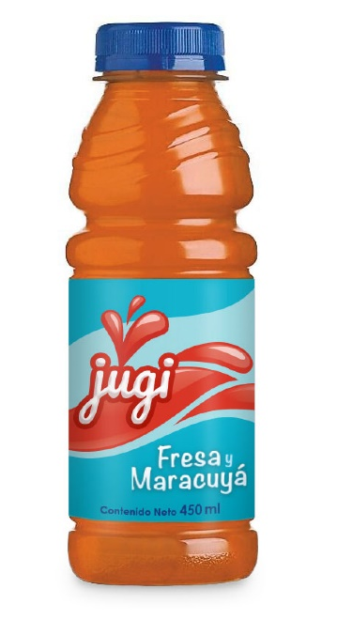
Healthier fruit drink  (no added sugar) | Less healthy fruit drink  (excess sugar)
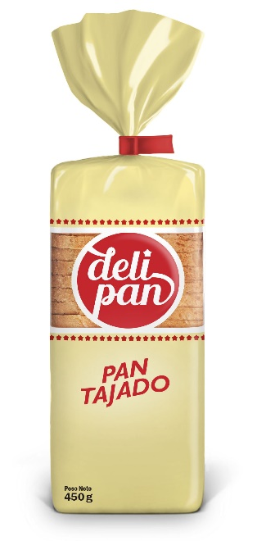 | 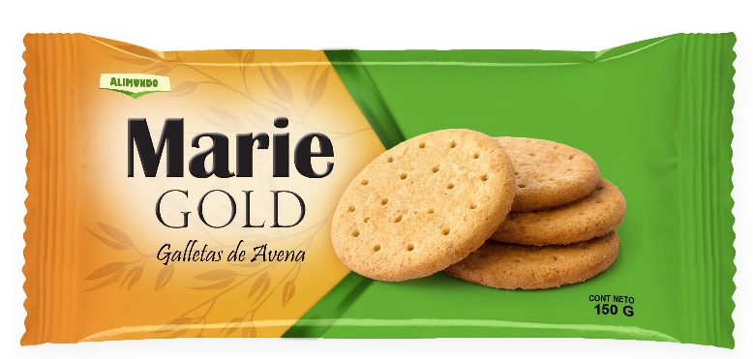
Sliced bread  (excess sodium) | Oatmeal cookies  (excess saturated fat)
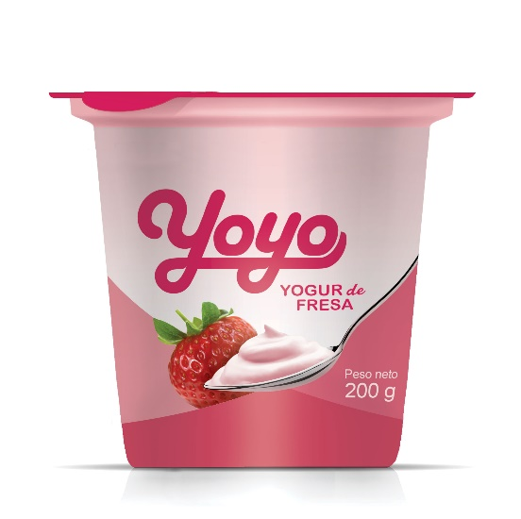 | 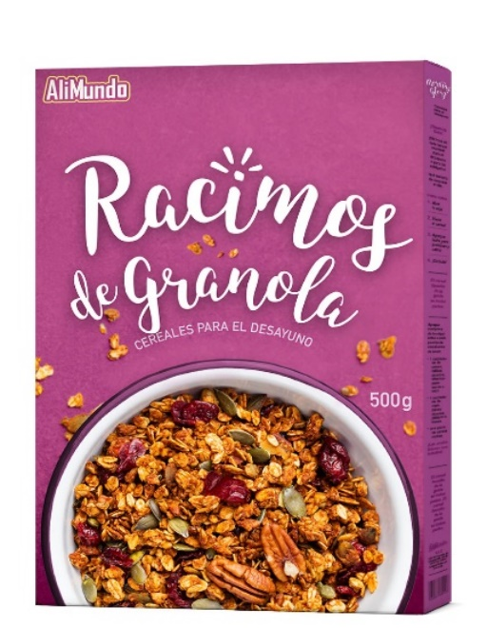
Strawberry yogurt  (excess sugar) | Breakfast cereal  (excess sugar and sodium)

