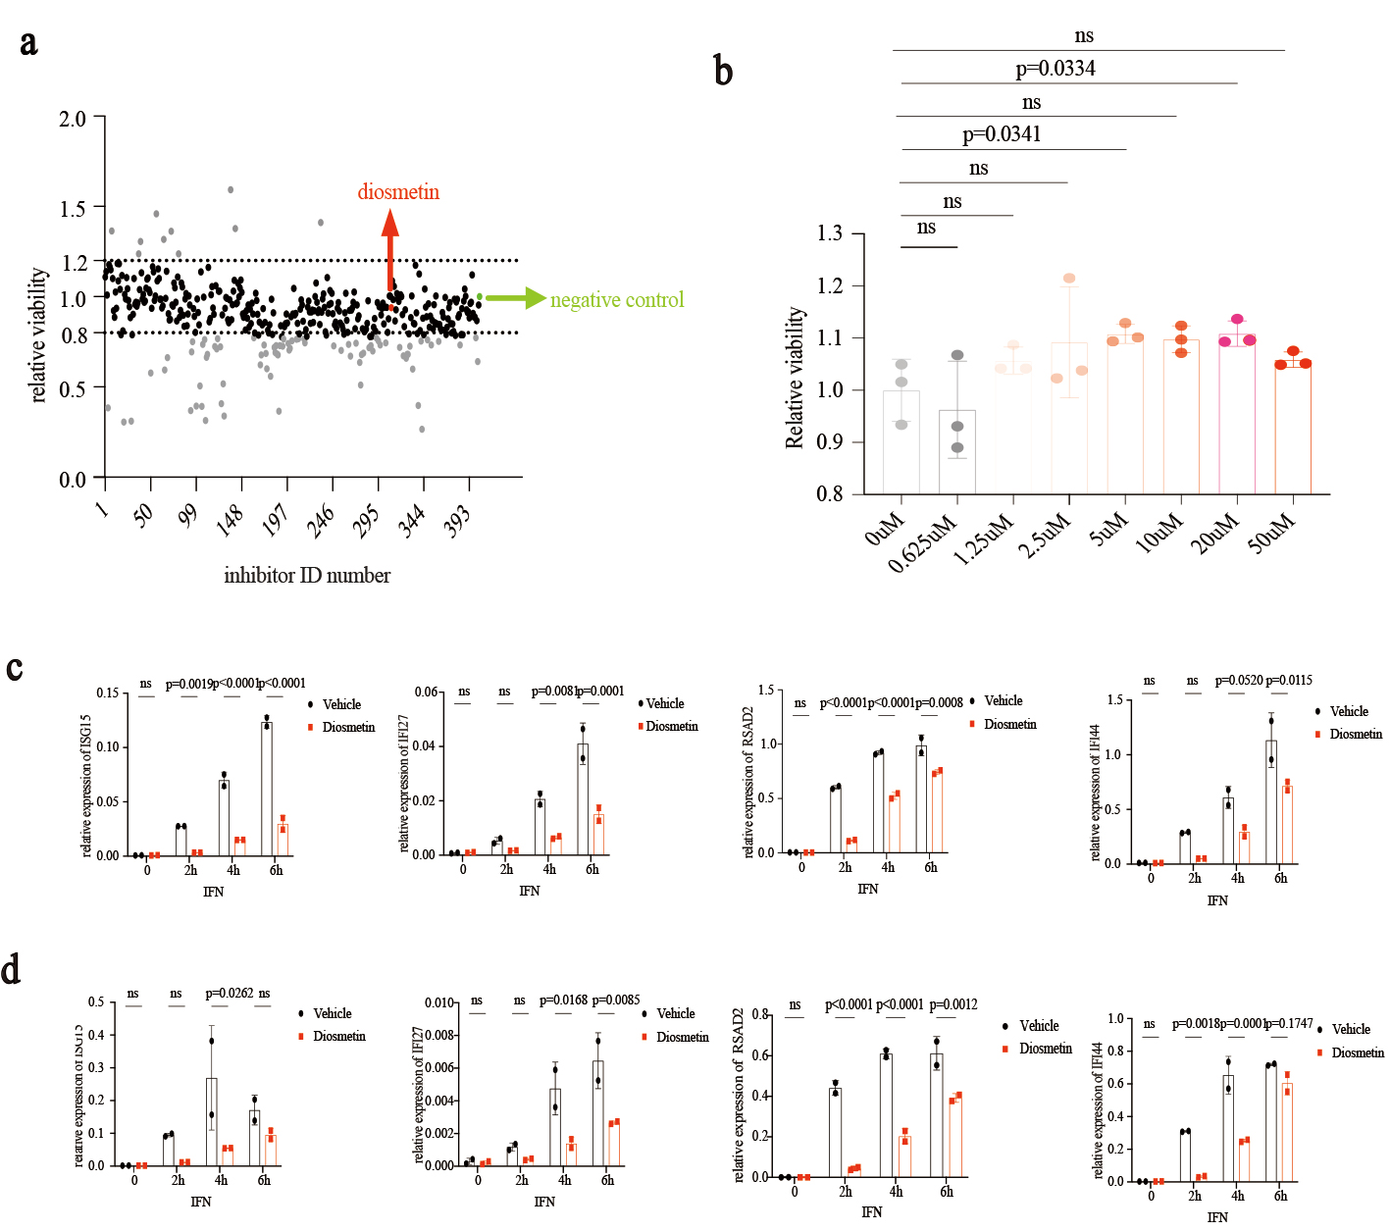
Supplementary Fig. 1 Diosmetin downregulates type Ⅰ interferon signaling in primary T cells and B cells. (a) A scatter plot of the effects of all compounds to cell relative viability. (b) The effects of diosmetin with different concentrations on cell relative viability. THP1-Dual cells were incubated with diosmetin (0.625uM, 1.25uM, 2.5uM, 5uM, 10uM, 20uM and 50uM) for 18h, then cell relative viability was detected by CCK8 assay. (c) CD3+ T cells were isolated from PBMC, incubated with diosmetin 50uM for 0.5 hours, then stimulated by type I IFN 1000U/ml for a time course. The expression of ISG15, IFI27, RSAD2, and IFI44 by RT-qPCR. (d) CD19+ B cells, the same experimental condition with CD3+ T cells. The expression of ISG15, IFI27, RSAD2, and IFI44 by RT-qPCR. b, c, d and E are shown as mean ± SD, Ordinary one-way ANOVA (b) and two-way ANOVA analysis (c, d) were used to determine statistical significance. ns, P>0.05; *, P < 0.05; **, P < 0.01; ***, P < 0.005; ****, P < 0.0001.

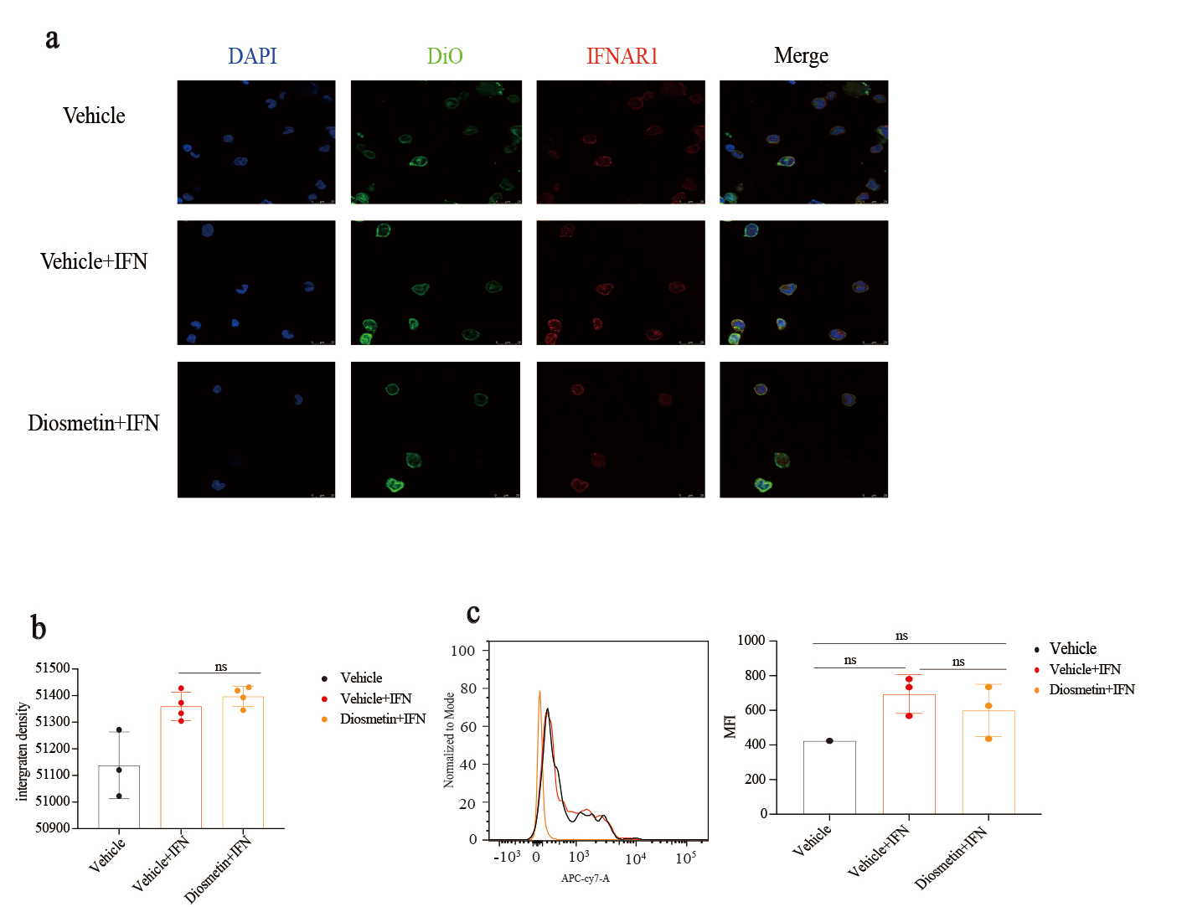
Supplementary Fig. 2 The location and expression of IFNAR1 in the stimulation with type I IFN. (a) Confocal images of DAPI, DIO, IFNAR1 of THP-1 cells in the activation of interferon and the effect of diosmetin. DIO was used to stain the plasma membrane. (b) The integrative intensity of IFNAR1 was quantified by Image J. (c) Flow cytometer analysis of IFNAR1.

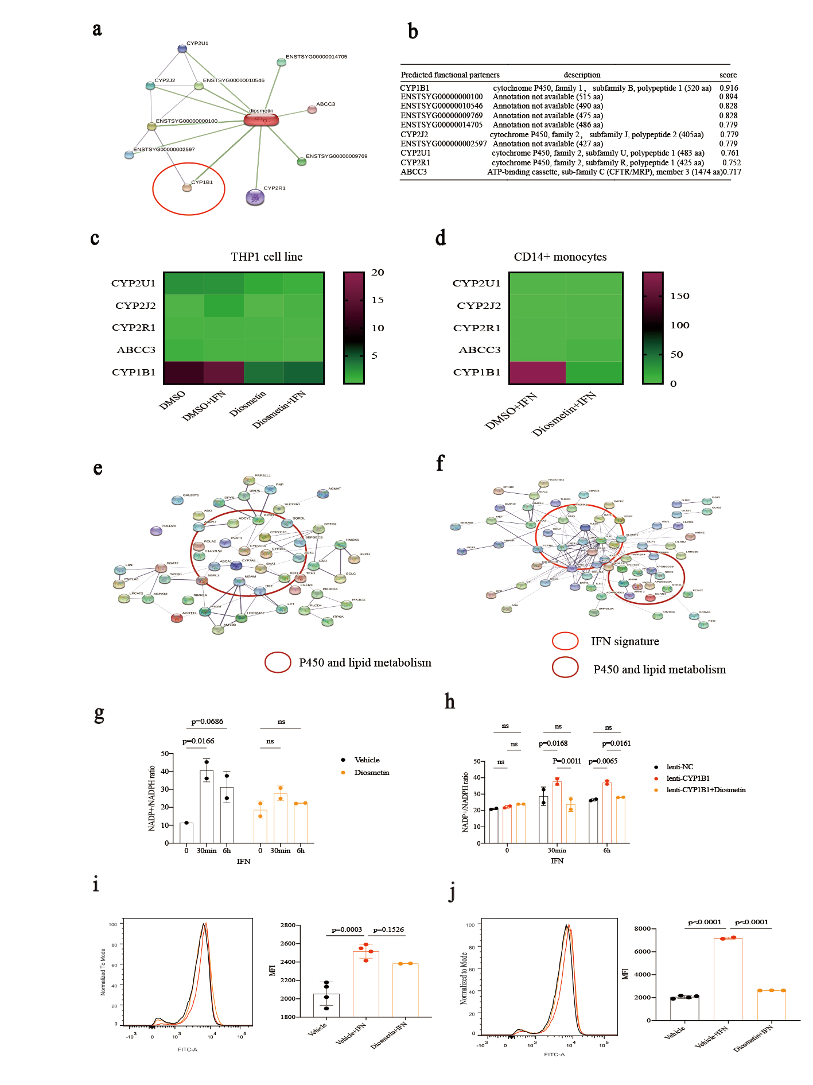
Supplementary Fig. 3 CYP1B1 is the real target of Diosmetin. (a) Network of interaction between diosmetin and predicted targets. According to the STITCH database, diosmetin was predicted to interact with 10 ligands. Edge confidence is revealed by the thickness of the connecting line. (b) Scores of predicted function partners. Among the ten predicted ligands, five are unannotated, the other five are CYP1B1, CYP2J2, CYP2U1, CYP2R1, and ABCC3. (c) The expression of five predicted ligands in THP-1 cell line with different treatments. (d) The expression of five predicted ligands in CD14+ monocytes with different treatments. (e) Protein interaction network display a significant P450 and lipid metabolism between diosmetin +IFN and DMSO+IFN in THP-1 cells. (f) Protein interaction network display a significant P450 and lipid metabolism between diosmetin +IFN and DMSO+IFN in CD14+ monocytes. (g) The NADP+/NADPH ratio in THP-1 cells. THP1 cells were treated with vehicle or diosmetin for 30 minutes, then stimulated by type I IFN for 30 minutes or 6 hours. Cell supernatant was collected for measuring and quantification of NADP+ and NADPH. (h) The NADP+/NADPH ratio in in THP-NC and THP1-CYP1B1 cells. THP-NC and THP1-CYP1B1 cells were treated with vehicle or diosmetin for 30 minutes, then stimulated by type I IFN for 30 minutes or 6 hours. Cell supernatant was collected for measuring and quantification of NADP+ and NADPH. (i) The measurement of intracellular pH (ipH). THP1 cells were treated with vehicle or diosmetin for 30 minutes, then stimulated by type I IFN for 30 minutes. Cells were collected and stained by BCECF-AM, then intracellular pH were evaluated by the mean fluorescence intensity. (j) The measurement of intracellular pH (ipH). THP1 cells were treated with vehicle or diosmetin for 30 minutes, then stimulated by type I IFN for 6 hours. Cells were collected and stained by BCECF-AM, then intracellular pH were evaluated by the mean fluorescence intensity. Data in g, h, i are shown as mean ± SD with P values calculated by a two-way ANOVA analysis. ns, P>0.05; *, P < 0.05; **, P < 0.01; ***, P < 0.005; ****, P < 0.0001.

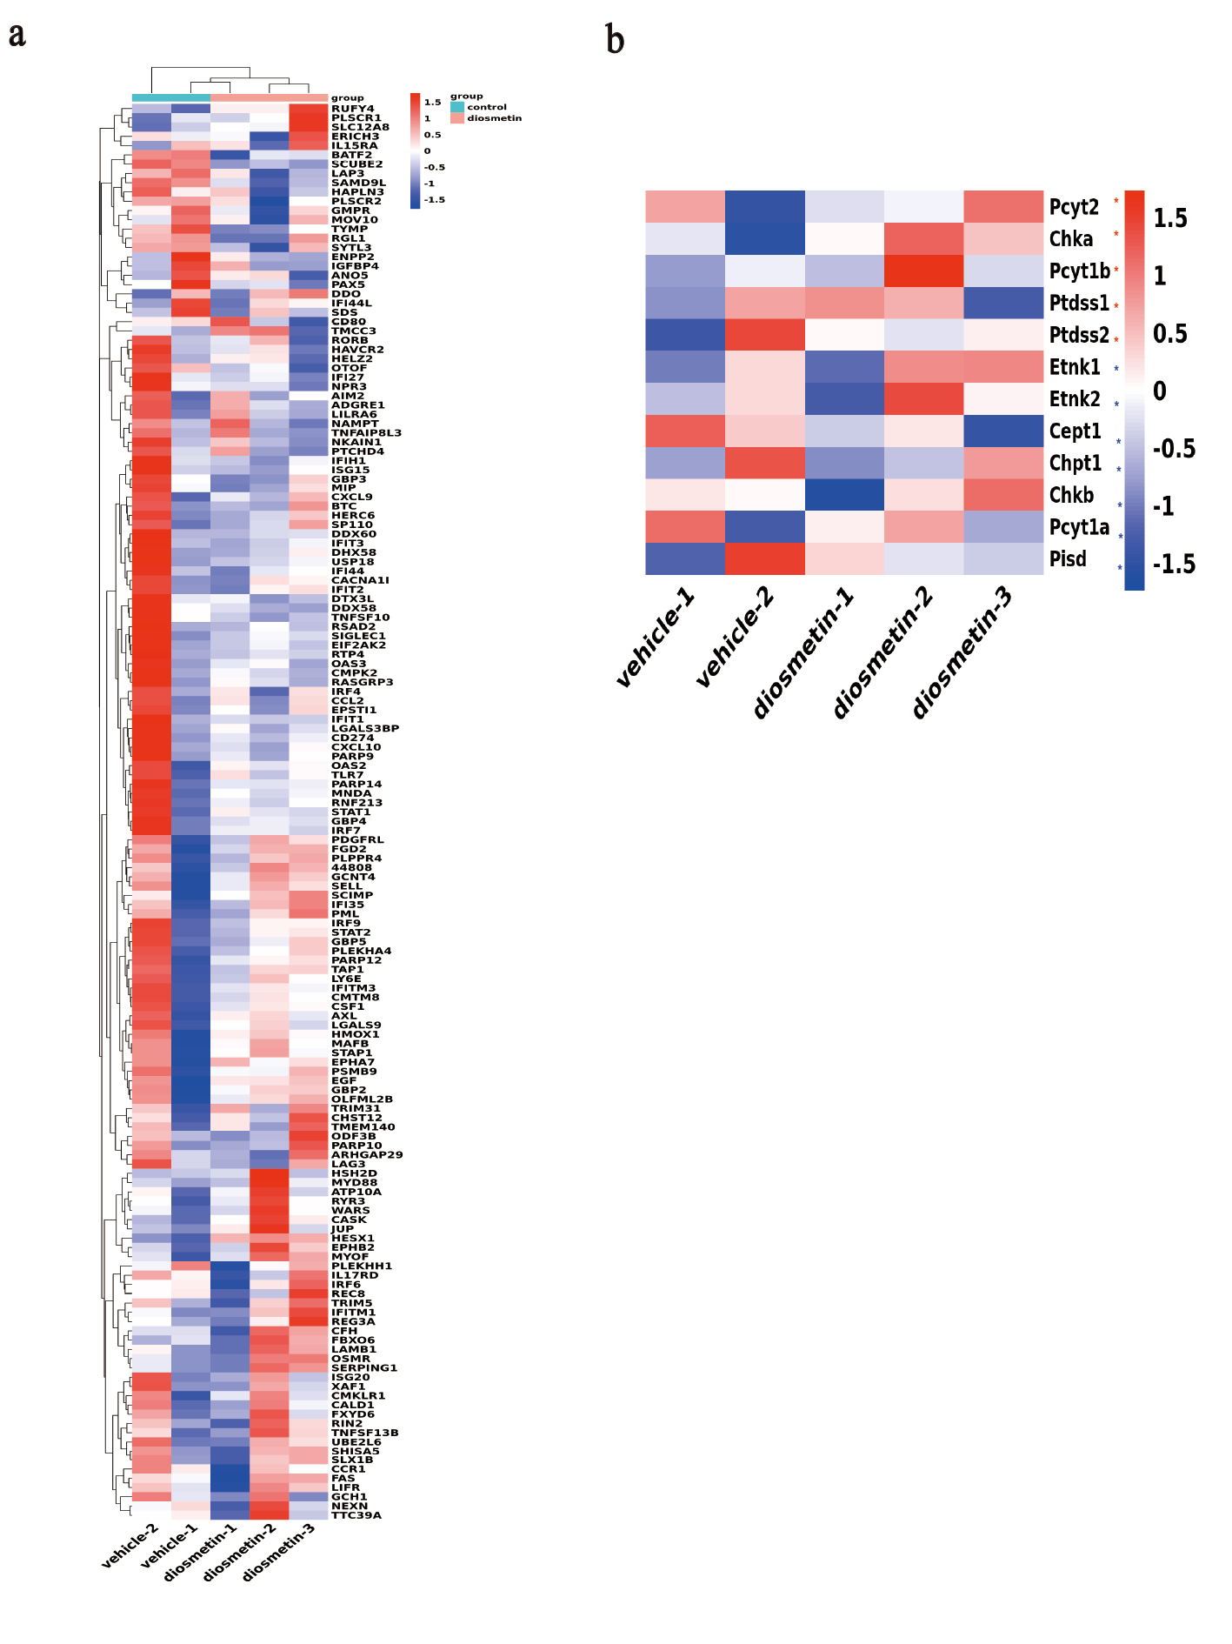
Supplementary Fig. 4 Diosmetin therapy affects in kidney tissue. (a) Heatmap demonstration of differentially expressed genes (DEGs) in kidney tissues with or without diosmetin treatment. Differential expression of 154 genes with a 4-fold increase and a p-value less than 0.01 as type I IFN stimulation were demonstrated in the heatmap. (b) Heatmap demonstration of enzymes involved the biosynthesis of phosphatidyl ethanolamine in kidney tissues with or without diosmetin treatment.
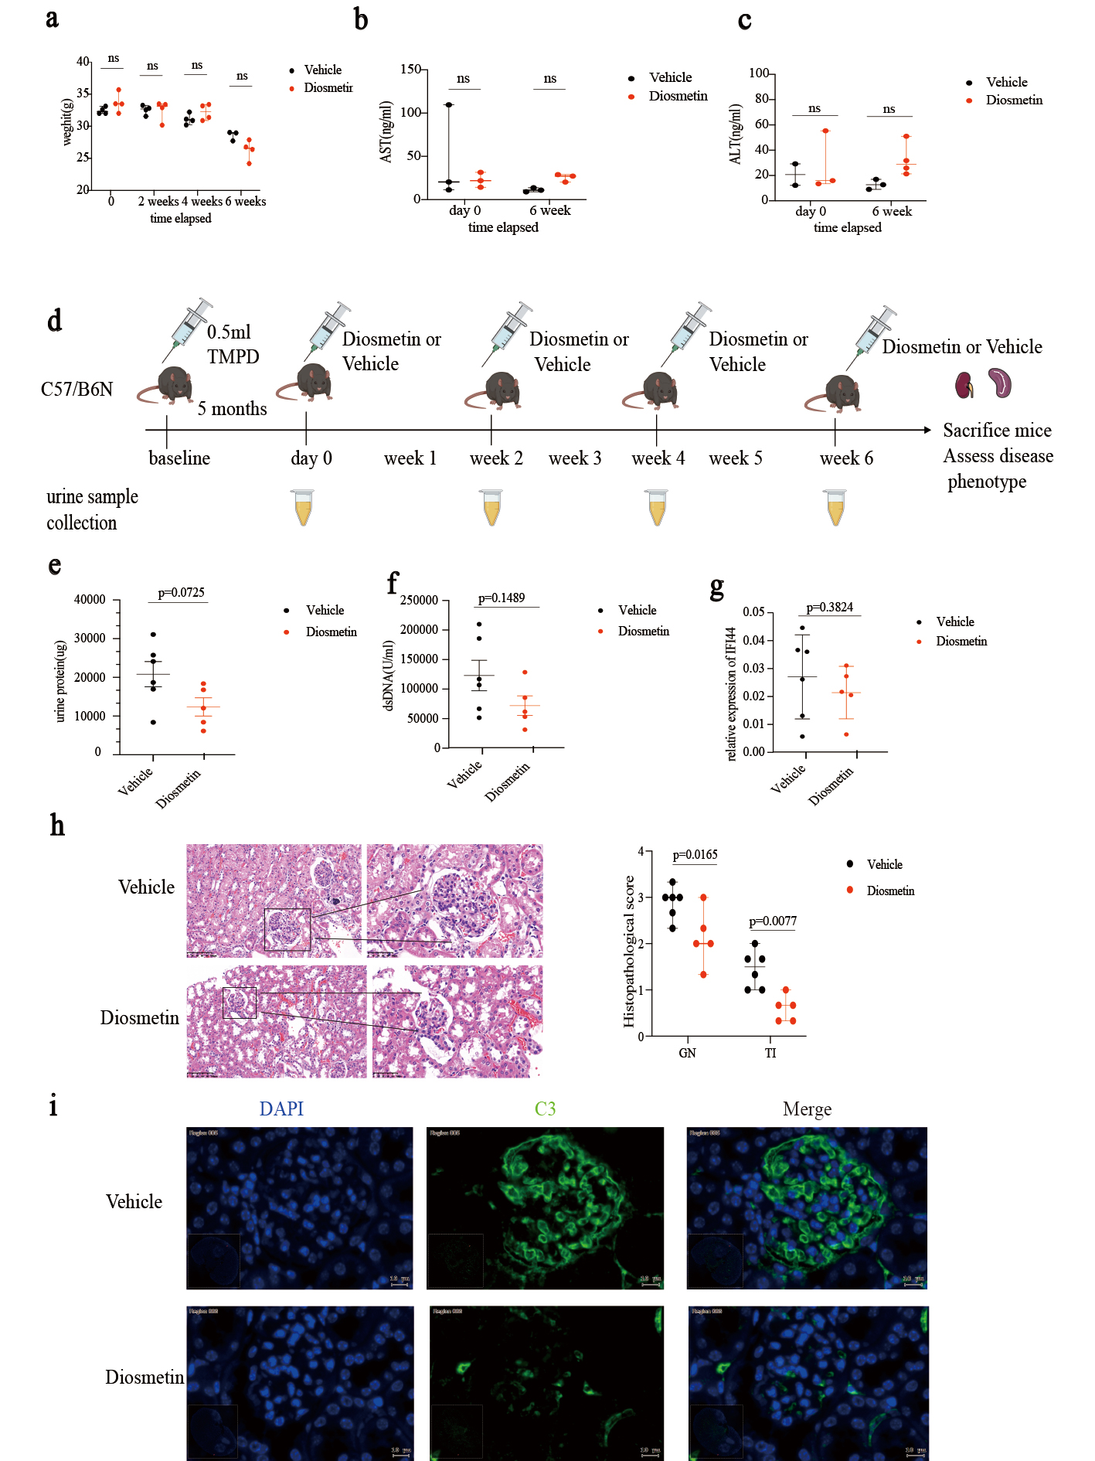
Supplementary Fig. 5 In vivo therapeutic effects of diosmetin. (a) Weight change in the diosmetin treatment of interferon-mediated lupus of NZB/NZW F1 mice. (vehicle: n=3, diosmetin: n=4). (b) and (c) Serum AST (vehicle: n=3, diosmetin: n=3) and ALT (vehicle: n=3, diosmetin: n=4) concentration in diosmetin treatment of interferon-mediated lupus of NZB/NZW F1 mice. (d) Treatment timeline of diosmetin in TMPD-induced lupus in C57/B6N mice. (e) Urine protein level. (f) Serum dsDNA levels. (g) The expression of IFI44 in the kidney. RT-qPCR was used to detect the expression of IFI44. (h) Hematoxylin and eosin (H&E) staining results and quantification. Scale bar, 50um. (i) Immunofluorescence of anti-mouse IgG2a and anti-mouse C3. Treatment of vehicle had a more deposition of immune complex in renal capsule and renal parenchyma compares to diosmetin treatment. d-i, n=6 in the vehicle group, n=5 in the diosmetin group. a, b, c, e, f, g and h are shown as mean ± SD, two-way ANOVA analysis (a, b, c, h) and unpaired two-tailed t test (e, f, g) were used to determine statistical significance. ns, P>0.05; *, P < 0.05; **, P < 0.01; ***, P < 0.005; ****, P < 0.0001.

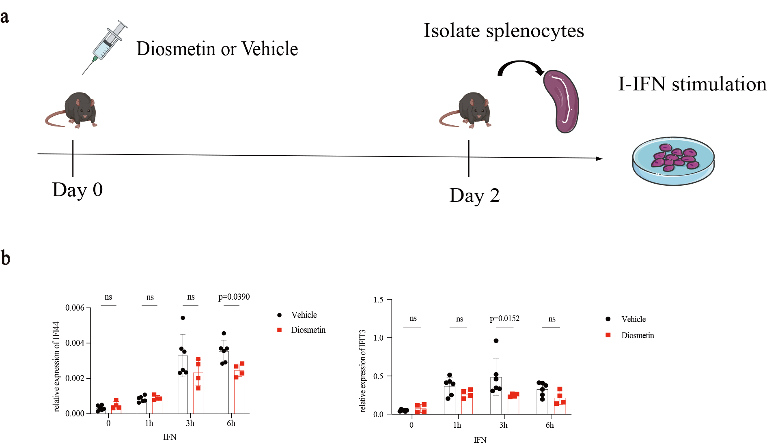
Supplementary Fig. 6 Diosmetin reduced splenocytes’ responsiveness to interferon stimulation. (a) Experimental procedure. C57/B6 mice were intraperitoneally administrated with diosmetin or vehicle, after 48 hours, splenocytes were isolated and seeded to plate, then splenocytes were stimulated by type I IFN 1000 U/ml. (b) Relative expression of IFI44 and IFIT3 in two groups. Data in b was shown as mean ± SD with P values calculated by a two-way ANOVA analysis. ns, P>0.05; *, P < 0.05; **, P < 0.01; ***, P < 0.005; ****, P < 0.0001.

Supplementary Tables
Supplementary Table 1. Baseline characteristics of patients with SLE (n=34)
Characteristic | Value
Age, year, median (range) | 45 (16-76)
Female/Male | 32/2
Duration of SLE, year, median (range) | 2.7 (0.08-22)
Prednisone dose, mg/day, median (range) | 5.5(5-50)
Use of concomitant agents (no. of patients) (n=27)
Hydroxychloroquine | 13
Cyclophosphamide | 2
Azathioprine | 0
Cyclosporine | 2
Methotrexate | 1
Mycophenolatemofetil | 5
Leflunomide | 2
Thalidomide | 0

Supplementary Table 2. Clinical characteristics of patients with SLE (n=34)
Characteristics | value
SELENA-SLEDAI, median (range) | 4 (0-16)
IgA, g/L, median (range) | 2.2 (1.4-7.8)
IgG, g/L, median (range) | 12.3 (4.0-32.0)
IgM, g/L, median (range) | 0.9 (0.2-2.2)
C3, g/L, median (range) | 0.8 (0.2-1.1)
C4, g/L, median (range) | 0.1 (0.017-0.307)
Anti-dsDNA, IU/mL, median (range) | 74.96 (22.65-645.3)
UrinePRO, mg/24h, median (range) | 1010 (82.7-9415)
Platelet, x10⁹/L, median (range) | 208 (95-433)
WBC, x10⁹/L, median (range) | 6.93 (3.20-19.65)
Lymphocyte, x10⁹/L, median (range) | 1.4 (0.37-4.74)
Monocyte, x10⁹/L, median (range) | 0.47 (0.05-1.08)
Neutrophil, x10⁹/L, median (range) | 4.68(1.93-13.77)
Eosinophil, x10⁹/L, median (range) | 0.0035 (0-0.31)
* Among the 34 patients, 7 patients’ treatment information was missing. The percentage calculation was based on 37 patients.
C3/4, complement component 3/4; dsDNA, anti-double stranded DNA; g/L, gram/liter; Ig, immunoglobulin; IU/mL, international units per milliliter; mg/24h: milligram/24 hours; SELENA, safety of estrogens in lupus national assessment; SLEDAI, systemic lupus erythematosus disease activity index; WBC, white blood count.

Supplementary Table 3. Baseline characteristics of healthy volunteers (n=16)
Characteristic | Value
Age, year, median (range) | 33 (24-51)
Female/Male | 16/0

Supplementary Table 4. Target sequence of si-CYP1B1
Name | Target sequence
genOFFTM st-h-CYP1B1_001 | GCACCGTTTTCCGCGAATT
genOFFTM st-h-CYP1B1_002 | AGAACGTACCGGCCACTAT
genOFFTM st-h-CYP1B1_003 | TGGCTCACCAGTGCGATTT

Supplementary Table 5. Primers used in this study.
Genes | Forward primer (5’-3’) | Reverse primer (5’-3’)
Human ISG15 | ACTCATCTTTGCCAGTACAGGAG | CAGCATCTTCACCGTCAGGTC
Human IFI27 | CTTGTGGCTACTCTGCAGT | GTAGAACCTCGCAATGACAG
Human RSAD2 | CAGCGTCAACTATCACTTCACT | AACTCTACTTTGCAGAACCTCAC
Human IFI44 | ACAATGGAAAATCTTGGACTTGCTC | TGGTTCATAAGTTCTCAAGGCAGAC
Human CYP1B1 | TACCGGCCACTATCACTGACA | TCCCCACGACCTGATCCAAT
Human IFNAR2 | TTGAACCACCAGAGTTTGAGATTGT | CCCTCTGACTGTTCTTCAATGACGA
Human GAPDH | CTCCTCCTGTTCGACAGTCA | CAATACGACCAAATCCGTTG
Mouse IFIT3 | TAAGGAAGTCAGAGCACAATG | TGTCTCACCTTGTCAACGTAA
Mouse IFI44 | GCTCGCAATAATGTCATACC | CCATAGGGCTTGTAGTCTCTC
Mouse RPL13A | GGGCAGGTTCTGGTATTGGAT | GGCTCGGAAGTGGTAGGGG

Supplementary Table 6. Antibodies used in western blot.
Antibody | Company | Cat.
HRP-conjugated GAPDH | Abclonal | AC035
Anti-STAT1 (phospho Y701) | Abcam | ab29045
STAT1 antibody | Cell Signaling Technology | 9172
Phospho-Jak1 (Tyr1034/1035) | Cell Signaling Technology | 3331
Jak1 (D1T6W) Mouse mAb | Cell Signaling Technology | 50996

