Supplement Material for Basin Dependence of the Tropical Cyclone Genesis Environmen and the Future Changes Revealed by Machine Learning Methods
QiFeng Qian^{1,2}, XiaoJing Jia^{*, 2}

¹ Zhejiang Institute of Meteorological Science (Chinese Academy of Meteorological Sciences, Zhejiang Branch), HangZhou, Zhejiang, China.
² Key Laboratory of Geoscience Big Data and Deep Resource of Zhejiang Province,
School of Earth Sciences, Zhejiang University, HangZhou, Zhejiang, China

Corresponding author address:
XiaoJing Jia
School of Earth Sciences, ZheJiang University, HangZhou, ZheJiang, China.
E-mail: jiaxiaojing@zju.edu.cn

Content
1 Principal Component Analysis (PCA) 3
2 Overview of PCA Workflow and Analysis 5
3 Data and Methods 6
3.1 Data 6
3.2 Methods 8
4 Selection of Remaining PCs 10
5 Confidence Ellipse and Correlation Circle 12
6 Maximum Entropy Model (MaxEnt) 14
7 Multivariate Environmental Similarity Surface (MESS) 15
Reference 16

1 Principal Component Analysis (PCA)
PCA is one of the most widely used multivariate statistical tools in climate research (e.g., Björnsson and Venegas, 1997; Storch and Zwiers, 2002; Wilks, 2011) and is also known as an unsupervised machine learning method in computer science (e.g., Hu et al., 2017). It is widely used to perform climate data analysis, per the methods of Lorenz (1956), and is called “empirical orthogonal function (EOF) analysis”. Typically, PCA can be applied to a single field or multiple fields in climate research (e.g., Storch and Zwiers, 2002; Wilks, 2011). Applying PCA to a single climate field is usually done to determine one or more uncorrelated modes of variability, while applying PCA to multiple fields is generally done to uncover meaningful joint relationships among these fields (Storch and Zwiers, 2002; Wilks, 2011). In other research areas, there are some different usages of PCA. For example, PCA can be used to identify the differences between samples in ecological and medical studies (e.g., Guisan et al., 2017). In these applications, the PCA calculation processes are the same, while their subsequent analysis processes are quite different from those of climate applications.
Following the methods of our previous work (Qian et al., 2022), we assume $n$ tropical cyclone (TC) genesis locations during a certain time period and that each TC genesis location has $p$ environmental variables. The goal of this study is to determine the resemblances/differences between the TC genesis environments of different basins by analyzing the $p$ environmental variables at the $n$ TC genesis locations. The aim of this study is quite similar to some ecological studies that use PCA to identify the resemblances/differences between specific living environments (which are called ecological niches in ecology) of some species by analyzing the corresponding environmental variables at locations where individuals of these species are observed. A conceptual diagram is shown in SFig. 1. In this study, we regard the TCs that are generated over a specific basin as a “species” and treat the TC genesis locations in a specific basin as “observed individuals” of this “species”. This treatment is reasonable because the variations in TC numbers in basins tend to be independent of each other (Sobel et al., 2021; Frank and Young, 2007). The specific environmental conditions of a certain basin, within which TCs can be generated over the basin, are treated as “ecological niches”. Therefore, using this treatment, we can use PCA to analyze the resemblances/differences in the TC genesis environment among different ocean basins following the processes shown in numerous ecological studies (e.g., Guisan et al., 2017). The mathematics of the PCA can be found in many textbooks (e.g., Storch and Zwiers, 2002; Wilks, 2011) and papers (e.g., Dray and Dufour, 2007), thus we do not elaborate on it in this supplemental material.
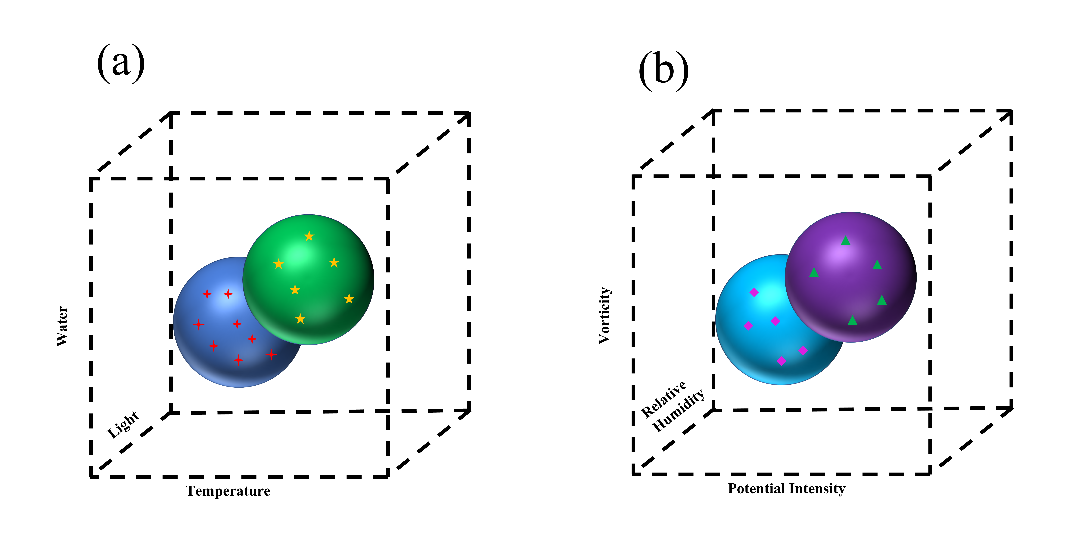
SFig. 1. (a) Blue and green balls represent the envelope of environmental conditions, within which a species can maintain a viable population. Red crosses and yellow stars denote individuals of a species. (b) Cyan and purple balls represent the envelope of environmental conditions of an ocean basin, within which TCs can be generated over this basin. The purple rhombus and green triangle represent the TCs that are generated in the basin.

2 Overview of PCA Workflow and Analysis
An overview of the PCA workflow is presented in SFig. 2. We first perform PCA on the observational environmental variable dataset. PCA will reduce the spatial dimensions of the data by selecting new dimensions (principal component; PC hereafter). By analyzing the explained variance of each PC and calculating the correlations between the PC and the environmental variables, we can select the essential PCs. We then use the selected PCs to form a new PC space and plot the TC genesis locations over different ocean basins in this space. The corresponding confidence ellipses of the TC genesis locations and the correlation circles of each basin can be calculated and plotted in the PC space. The confidence ellipses and correlation circles can tell us the resemblances/differences in the TC genesis environment of different ocean basins. Details on confidence ellipses and correlation circles can be found in many textbooks (e.g., Sanguansat, 2012; Guisan et al., 2017), thus they are only briefly introduced in the following sections.
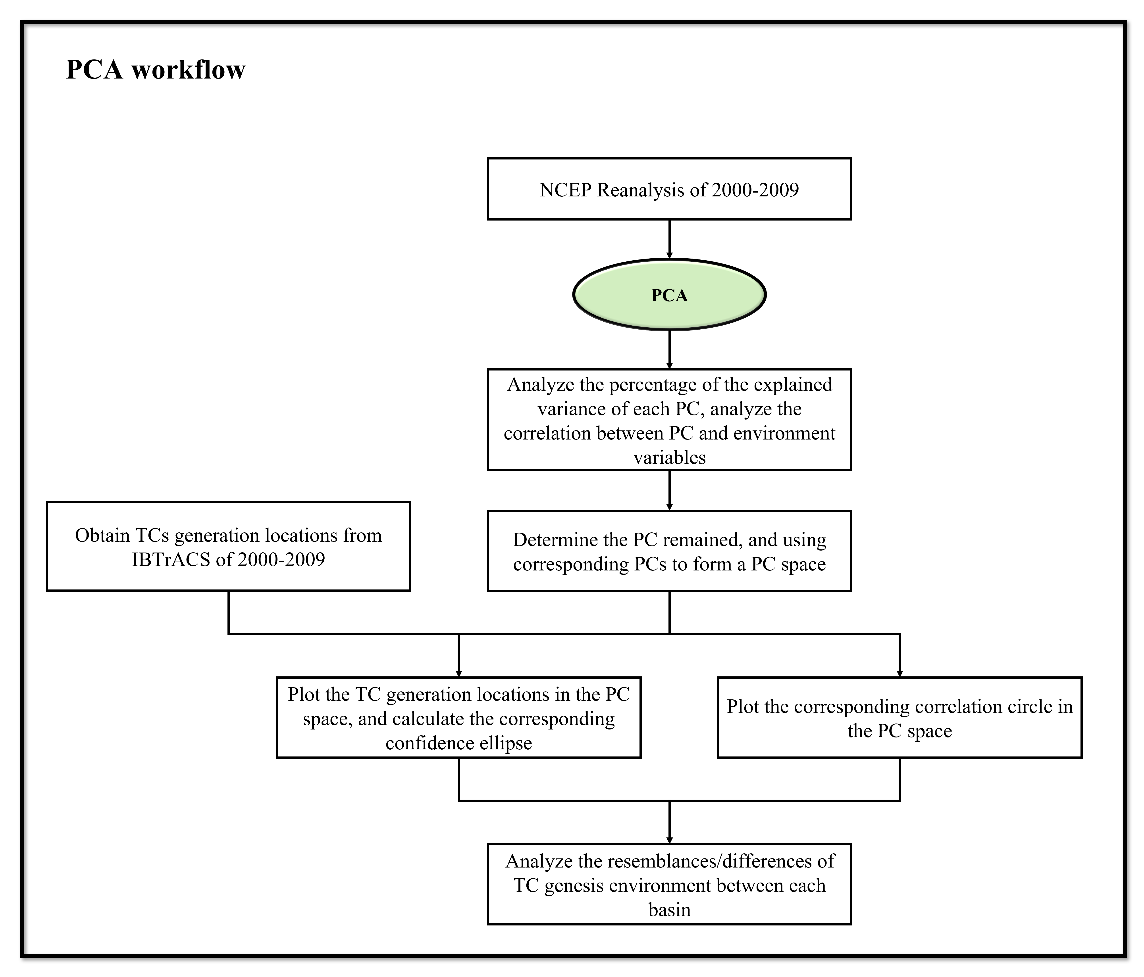
SFig. 2. Diagram of the analysis workflow.

3 Data and Methods

3.1 Data
The data used in this study are the same as those used by Qian et al. (2022). For convenience, we briefly describe them as follows:
- TC track data with a temporal resolution of six hours are obtained from the International Best track Archive for Climate Stewardship (IBTrACS; Knapp et al., 2010; https://www.ncdc.noaa.gov/ibtracs/);
- Monthly mean sea level pressure, air temperature, vertical velocity, relative humidity, and zonal and meridional wind speed data from 2000-2009 with a spatial resolution of 2.5°×2.5° are provided by the NCEP-NCAR Reanalysis I (Kalnay et al., 1996; https://www.esrl.noaa.gov/psd/data/gridded/);
- Monthly mean sea surface temperature (SST) data from 2000-2009 with a spatial resolution of 1°×1° are obtained from the Met Office Hadley Center (Rayner et al., 2003; https://www.metoffice.gov.uk/hadobs/index.html);
- The monthly mean historical runs (1850-2014) and the Shared Socioeconomic pathway (SSP) 119, SSP 126, SSP 245, SSP 370, SSP 434, SSP 460 and SSP 585 runs (2015-2100) by five Coupled Model Intercomparison Project Phase six (CMIP6) models (STable 1) are used in this study (https://esgf-node.llnl.gov/projects/esgf-llnl/). These models are selected because they provide all the abovementioned SSP scenarios, and using as many scenarios as possible can make the results more robust. Among these SSP scenarios, SSP 119 and SSP 126 will lead to ≤ 2°C temperature changes, SSP 245 and SSP 434 will lead to 2~3°C temperature changes, and SSP 460, SSP 370 and SSP 585 will lead to >3°C temperature changes (O’Neill et al., 2016).
All the data except the TC track data are interpolated onto the same 2.5°×2.5° longitudinal-latitudinal grids as the NCEP-NCAR Reanalysis I.
STable. 1. List of CMIP6 models used in this study.
Model | Institute | Nation | Atmospheric resolution | Reference
CanESM5 | Canadian Centre for Climate Modeling and Analysis | Canada | 2.8°×2.8° | Swart et al. (2019)
FGOALS-g3 | The Institute of Atmospheric Physics | China | 2°×2° | Li et al. (2020)
IPSL-CM6A-LR | Institut Pierre Simon Laplace | France | 1.25°×2.5° | Hourdin et al. (2020)
MIROC6 | Center for Climate System Research | Japan | 1.4°×1.4° | Tatebe et al. (2019)
 | University of Tokyo
 | Japan Agency for Marine-Earth Science and Technology
 | National Institute for Environmental Studies
MRI-ESM2-0 | The Meteorological Research Institute | Japan | T159 (~120km) | Yukimoto et al. (2019)

3.2 Methods
Similar to the data that are used, most of the methods used in this study follow those of Qian et al. (2022) and are briefly described as follows:
- The TC genesis locations are derived from the observational IBTrACS dataset for the period of 2000–2009. Following the methods of Li et al. (2019), only storms that reach a tropical storm intensity (with maximum sustained wind speeds >34 knots) are defined as TCs. Once a TC is selected, the first location of its track is defined as its genesis location. In the current work, a total of 828 TCs are defined from 2000–2009 and are used in the analysis;
- Per Qian et al. (2022), ten environmental variables during 2000-2009 are used to perform PCA. The ten variables are the potential intensity (PI); the vertical wind shear between 850 hPa and 200 hPa (vshear); the absolute vorticity at 150 hPa (eta-150), 200 hPa (eta-200), 850 hPa (eta-850) and 925 hPa (eta-925); the vertical velocity at 300 hPa (omega-300); and the relative humidity at 400 hPa (rh-400), 500 hPa (rh-500) and 700 hPa (rh-700). The vshear is defined as $\sqrt{{\left(u850-u200\right)}^{2}+{(v850-v200)}^{2}}$. These gridded environmental variables are used to perform PCA. The ten variables, overlaid with the TC genesis locations for the period of 2000–2009 are presented in SFig. 3;
- The ten environmental variables are derived from five CMIP6 models. The climatological average for each model run from 1860 to 2100 is calculated with a 10-year interval (e.g., 1850-1859, …, 2090-2099);
The definition of each basin (South Indian Ocean, SI; North Indian Ocean, NI; Northwest Pacific Ocean, WP; Northeast Pacific Ocean, EP; South Pacific Ocean, SP; North Atlantic Ocean, NA; South Atlantic Ocean, SA) matches the definitions provided by the IBTrACS dataset (Knapp et al., 2010), which can also be found in SFig. 3a. In this study, the area mean of TC genesis probability is calculated over each ocean basin, as shown in SFig. 3a.
In this study, we conduct PCA following the duality diagram (Dray and Dufour, 2007), which together with other plotting processes, is widely used in many previous studies and textbooks (e.g., Guisan et al., 2017). More details of the PCA calculation processes, figure plotting and technique details, i.e., variable centering method, plotting correlation circle and confidence ellipse, can be found in previous work (Thioulouse et al., 1997; Chessel et al., 2004; Dray and Dufour, 2007; Dray et al., 2007; Guisan et al., 2017; Thioulouse et al., 2018).

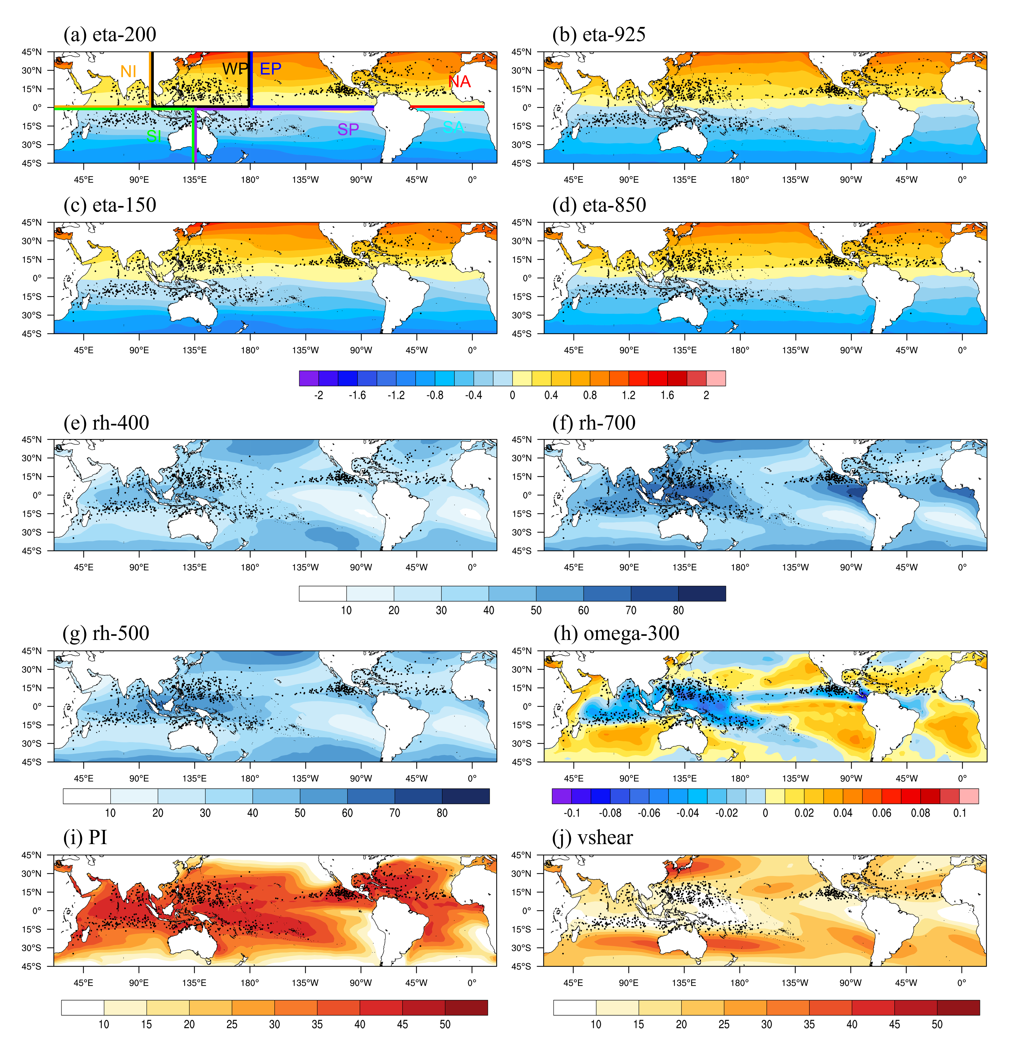
SFig. 3. Environmental variables (color shading) and TC genesis locations (black dots). The lines in (a) represent the definition of different ocean basins per Knapp et al. (2010).

4 Selection of Remaining PCs
PCA will reduce the variable space dimensions to several PCs. It is crucial to determine the remaining PCs, which represent the main features of the original variable space. The scree plot of each PC is shown in SFig. 4. The first two PCs explain most of the total variances, and the variance explained by the PCs decreases significantly after PC3. The first two PCs explain up to 75.54% of the total variance, and the remaining PCs explain 24.46% of the variance.
Typically, climate studies apply North et al.’s (1982) criteria to determine the remaining PCs (e.g., Storch and Zwiers, 2002; Wilks, 2011). PCs that meet these criteria are well separated from each other and can be considered independent. This is an effective tool for selecting PCs. However, it is unsuitable to use these criteria in this study because the aim of the PCA in this study is not to find independent modes of variability or joint relationships among environmental variables, thus applying those criteria may result in the selected PCs failing to contain sufficient information on the original environment variable space, which may bias the subsequent analysis. In addition, in the subsequent analysis, determining whether the PCs are independent of each other is not essential, as the PCA accepts correlations among PCs.
To clarify the relationship of these PCs and various environmental variables, their correlation coefficients are presented in SFig. 5. PC1 has large correlation coefficients with absolute vorticity at the upper and lower levels of the atmosphere (eta-150, eta-200, eta-850 and eta-925). This result indicates that PC1 mainly captures the features of the absolute vorticity at the upper and lower levels of the atmosphere. PC2 has a large correlation coefficient with low- and middle-level relative humidity (rh-500 and rh-700) and has a considerable correlation coefficient with the remaining variables. This result suggests that PC2 mainly depicts the features of low and mid-level relative humidity while also capturing part of the features of the other four environmental variables. In addition, this result also suggests that these six environmental variables may be correlated. PC3 has a large correlation coefficient with middle-level vertical velocity (omega-300) and PI, which is comparable to the correlation coefficients of PC2. This result implies that the features of middle-level vertical velocity (omega-300) and PI are captured by both PC2 and PC3. Similarly, PC4 has a large correlation coefficient with middle-level relative humidity (rh-400) and vertical wind shear (vshear), which is comparable to the correlation coefficients of PC2. This result suggests that the features of middle-level relative humidity (rh-400) and vshear are captured by both PC2 and PC4. The remaining PCs are barely correlated with the environmental variables and explain a very small amount of the variance, suggesting that they are redundant and contain little information about the environmental variables. In summary, in this study, PC1 and PC2 are selected and used in subsequent analysis because PC1 and PC2 account for most of the total variance and can capture the main features of all the environmental variables.
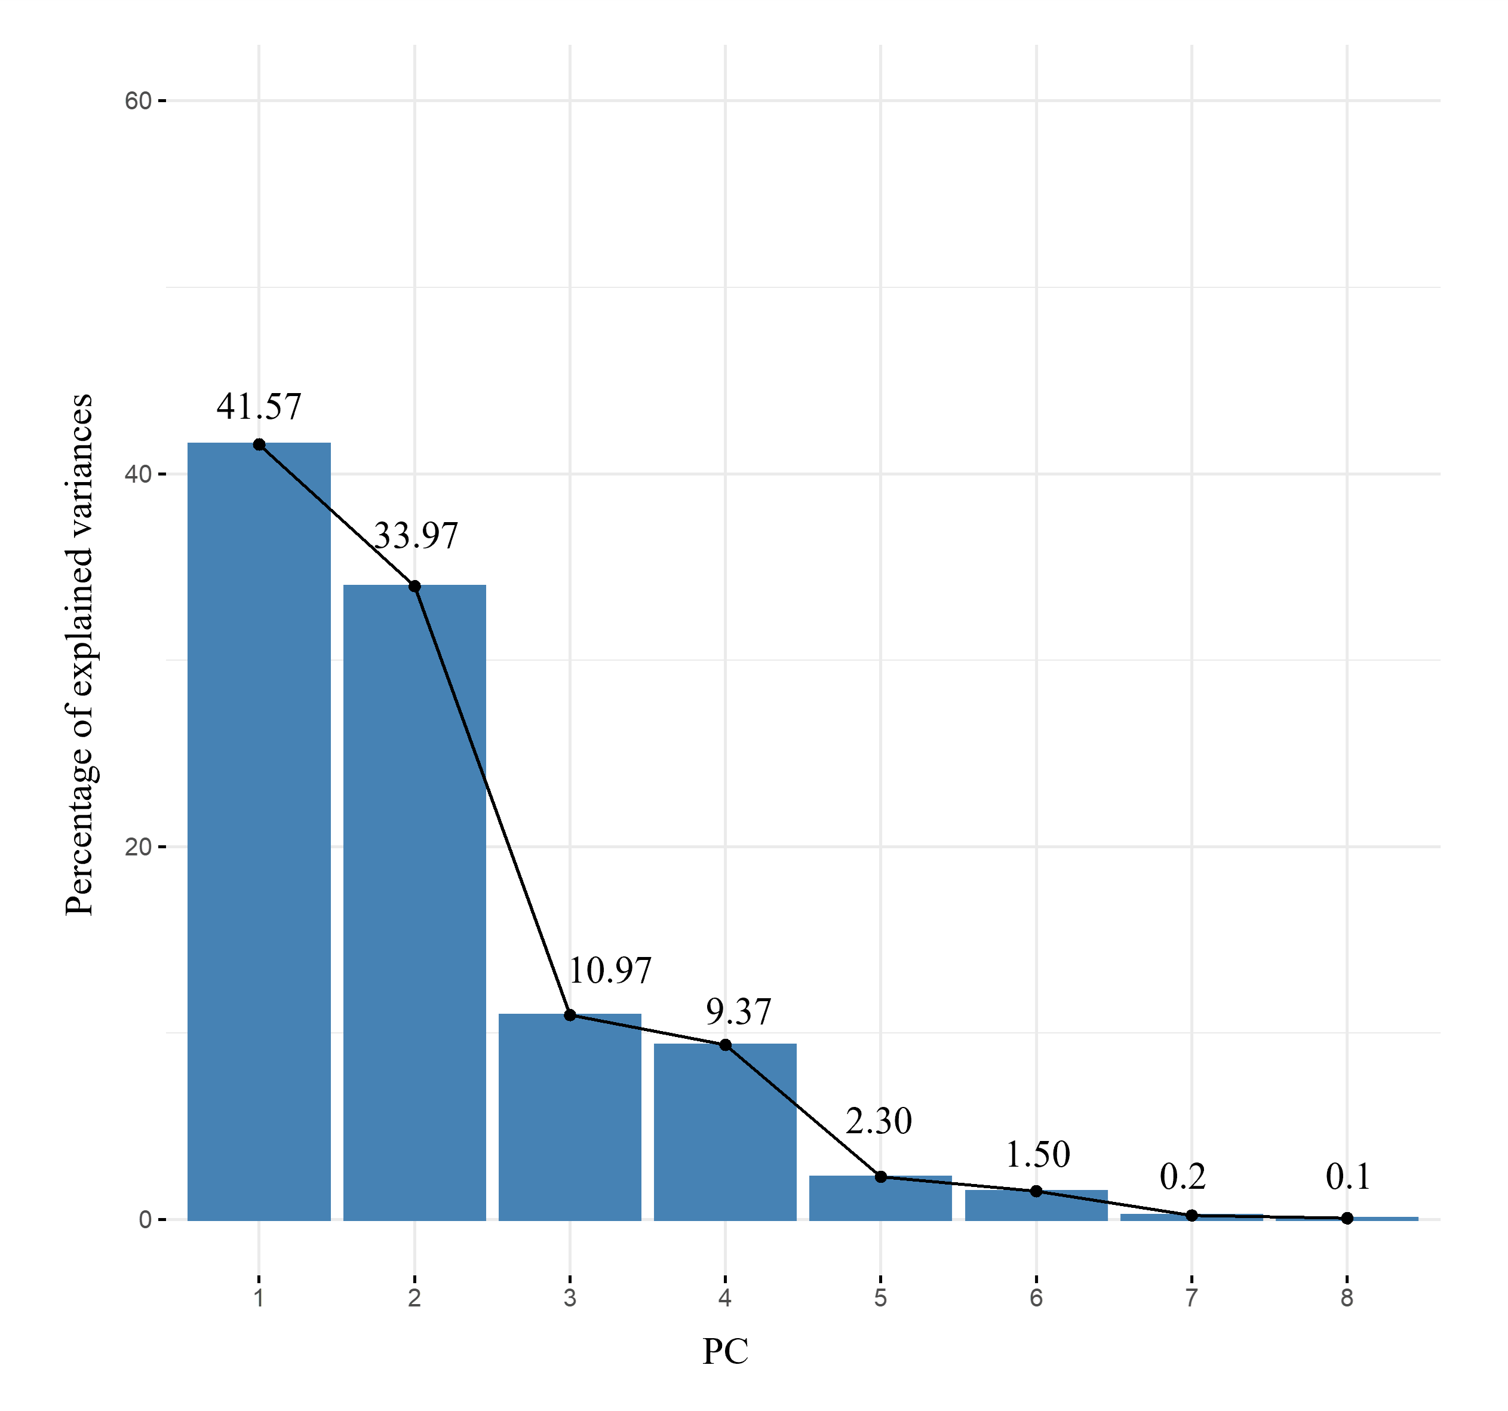
SFig. 4. The y-axis represents the percentage of the explained variance, and the x-axis represents the PCs. The numbers above each bar denote the explained variances of each PC.

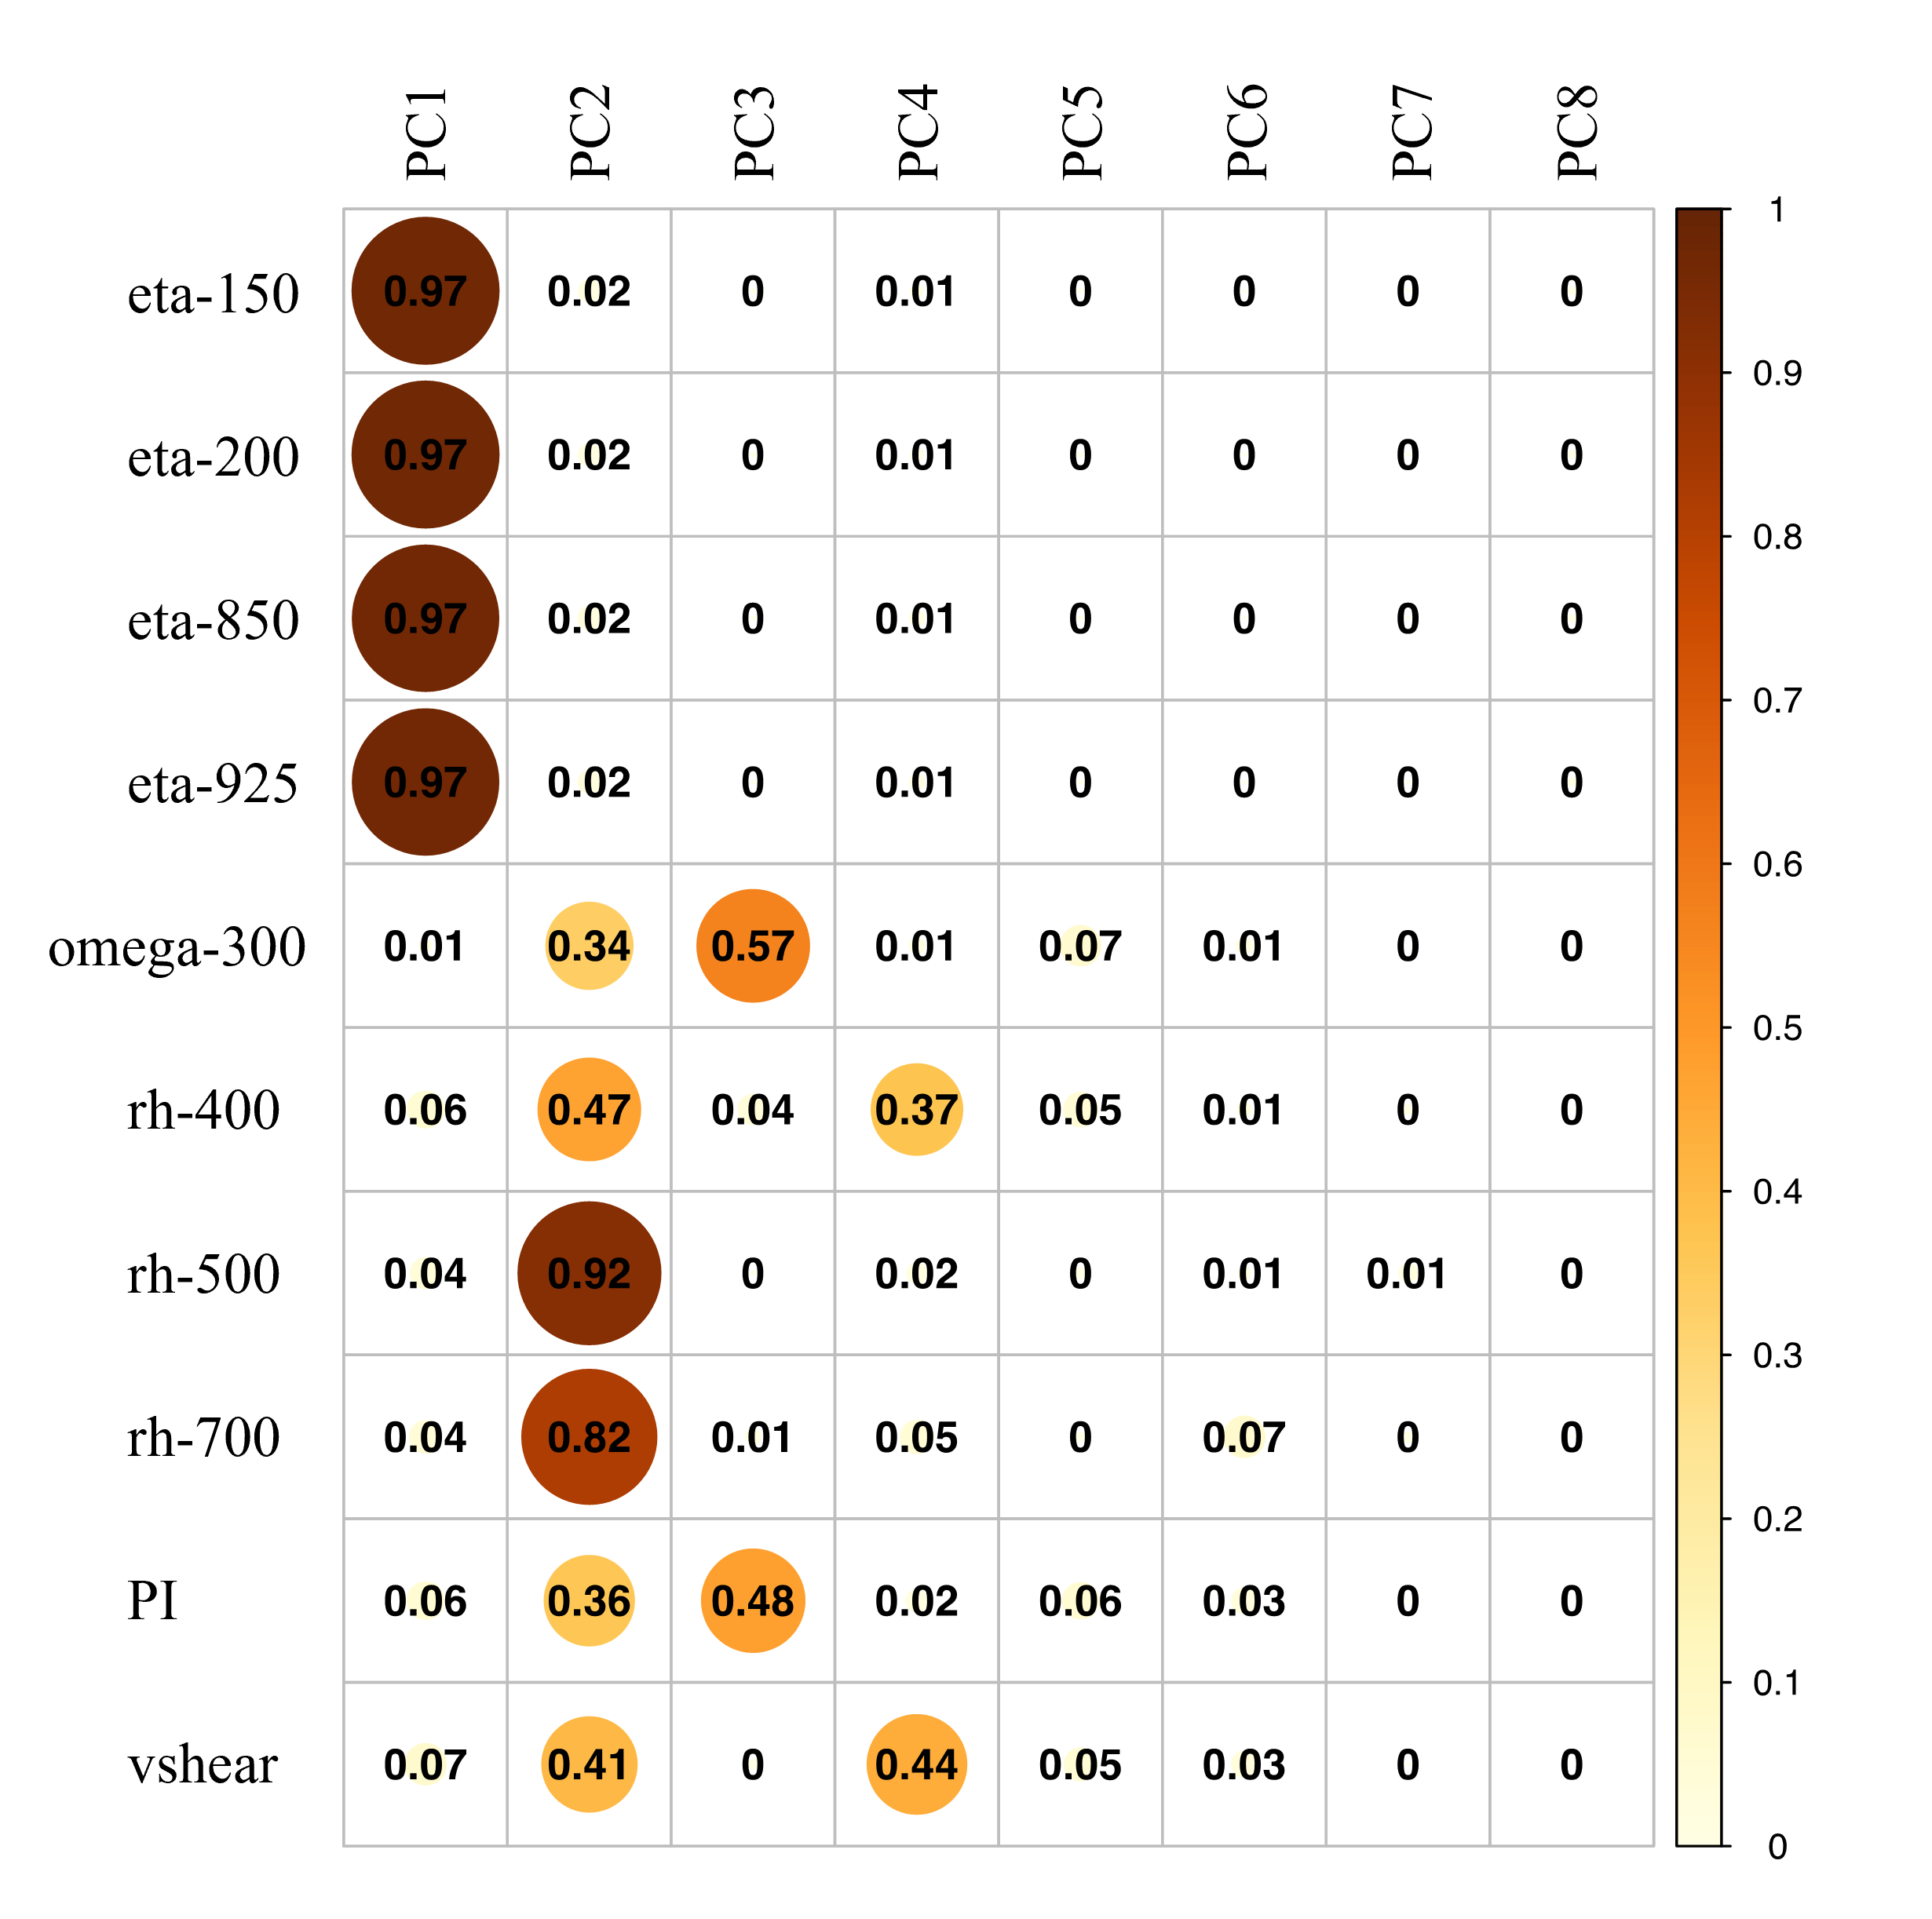
SFig. 5. The correlation coefficient heatmap of the PCs and the original environmental variables.

5 Confidence Ellipse and Correlation Circle
After determining the remaining PCs, we can use PC1 and PC2 to form a PC space. The TC genesis locations over each basin and the grid points of the reanalysis can be plotted in this PC space (Fig. 1 in the main text). The confidence ellipse can also be determined based on these locations or grid points. The basic mathematics of the confidence ellipse are briefly introduced as follows (Alexanderson, 2004):
Let $\overline{Z}$ and $S$ be the mean and the unbiased estimate of the covariance matrix, respectively, of a random sample of size $n$ from a bivariate normal distribution with mean $μ$ and covariance matrix $Σ$. The variable $\overline{Z}-μ$ is distributed as a bivariate normal variate with a mean of zero and a covariance of $n^{-1}Σ$, and it is independent of $S$. The confidence ellipse for $μ$ is based on Hotelling’s $T^{2}$ statistic:
$$T^{2}=n{\left(\overline{Z}-μ\right)}^{'S^{-1}}\left(\overline{Z}-μ\right) (1)$$
A $100\left(1-α\right)\%$ confidence ellipse for $μ$ is defined by the equation:
$${\left(\overline{Z}-μ\right)}^{'}S^{-1}\left(\overline{Z}-μ\right)=\frac{2\left(n-1\right)}{n\left(n-2\right)}F_{2,n-2}\left(1-α\right) (2)$$
where $F_{2,n-2}(1-α)$ is the $(1-α)$ critical value of an $F$ variate with 2 and $n-2$ degrees of freedom. When $μ$ is unknown, $Z$ is considered a bivariate random variable for an observation. The variable $Z-\overline{Z}$ is distributed as a bivariate normal variate with a mean of 0 and a covariance of $(1+n^{-1})Σ$, and it is independent of $S$. A $100\left(1-α\right)\%$ confidence ellipse is then given by the equation:
$${\left(Z-\overline{Z}\right)}^{'}S^{-1}\left(Z-\overline{Z}\right)=\frac{2(n+1)\left(n-1\right)}{n\left(n-2\right)}F_{2,n-2}\left(1-α\right) (3)$$
In this case, the confidence ellipse approximates a region containing a specified percentage of the population. The confidence ellipse is centered on the means, and the variance determines its width and height. The covariance sets the slope of the main axis of the ellipse.
In this study, since PCA is applied to the gridded reanalysis data, the confidence ellipse of the grided reanalysis data is centered at the original point, representing the environment of the global ocean that is defined by the two PCs. The confidence ellipse of the TC genesis locations of a certain ocean basin is smaller than that of the gridded reanalysis data, which denotes the specific TC genesis environment over the specific ocean basin. Note that there is only one TC generated over the South Atlantic Ocean; thus, it is meaningless to plot the corresponding confidence ellipse. Therefore, we depict the TC genesis environment of each basin in PC space; however, we still cannot analyze their resemblances/differences. To further investigate the TC genesis environment, we plot the correlation circles (Fig. 1 in the main text). The basics of correlation circles are introduced as follows (Abdi and Williams, 2010):
The correlation between a PC and an environmental variable can estimate the amount of similar information that they have. Such a correlation is called a loading in the framework of PCA. The environmental variables can be plotted as points in the PC space using their loadings as coordinates. In addition, the sum of the squared loadings between an environmental variable and all the PCs is equal to one. Therefore, the squared loadings are easier to interpret than the loadings because the squared loadings provide the proportion of the variance of the variables that are explained by the PCs. When all the environmental variable data are perfectly represented by the two PCs, the sum of the squared loadings is equal to 1, and thus, the loadings will be positioned on a circle, which is called a correlation circle. When more than two PCs are needed to represent the data perfectly, the environmental variables will be inside the correlation circle. In other words, the closer an environmental variable is to the circle, the better it can be reconstructed by the two PCs and the more important it is to interpret these PCs; when an environmental variable is closer to the center point of the circle, it means that it is less important for the two PCs. By plotting vectors away from the origin to environmental variable points in PC space, we are able to summarize the correlation relationship between environmental variables. Specifically, when the angle between two vectors is small, it means that the two environmental variables are positively correlated; an angle of 90° indicates that the environmental variables are not correlated, and an angle close to 180° indicates that the environmental variables are negatively correlated. Meanwhile, when a vector is close to the x or y axes, it means that this environmental variable is correlated with the corresponding PCs.
Using both the confidence ellipse and the correlation circle together, we are able to identify the resemblances/differences of the TC genesis environment. The results can be found in the main text.

6 Maximum Entropy Model (MaxEnt)
The MaxEnt model is a classic machine learning model proposed following the “maximum entropy principal” (Phillips et al., 2006; Phillips and Dudik, 2008; Phillips et al., 2017). This principal reveal that the best approximation of an unknown probability distribution should: 1. Satisfy all the known constraints on the unknown distribution; 2. Have maximum entropy (Jaynes, 1957). In our previous work (Qian et al., 2022), we applied a MaxEnt model to predict the changes of global TC genesis probability under different climate scenarios, which is used to investigate the variation of TC genesis probability in basins in this study. A simplified diagram of the MaxEnt workflow is presented in SFig. 6 (modified from SFig. 1 in the supplement information of Qian et al., 2022). The MaxEnt model is trained by climatological mean NCEP reanalysis data on TC genesis locations during 2000-2009, and then validated using several different methods on NCEP dataset at different time periods. After the MaxEnt model is validated on NCEP dataset, we deploy the environmental variables from CMIP6 model historical runs during 2000-2009 and make sure that the model output is reliable. Finally, the run outputs of the historical CMIP6 model (1850-2014), SSP 119, SSP 126, SSP 245, SSP 370, SSP 434, SSP 460 and SSP 585 (2015-2100) are supplied to the MaxEnt model to predict TC genesis in each basin in the future.
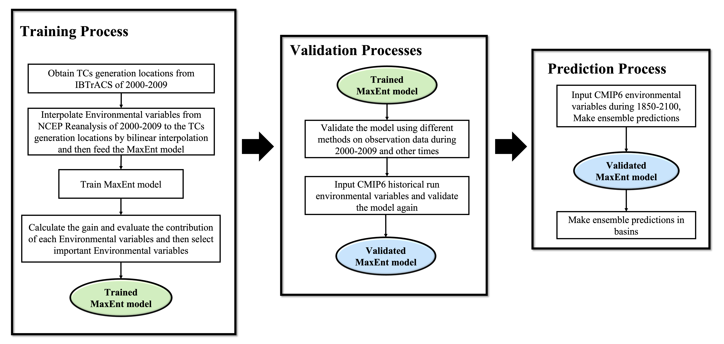
SFig. 6. Diagram of the MaxEnt model workflow. More details please refer to Qian et al., 2022.

7 Multivariate Environmental Similarity Surface (MESS)
MESS analysis is widely used in ecological studies to analyze the similarity between two environmental datasets (e.g., Elith et al., 2010). In the current work, we use it to investigate the similarity of the CMIP6 model-simulated TC genesis environment between two time periods.
We assume the environment variable dataset at a reference time period (in this study, this period is considered to be the historical runs of the CMIP6 models in the 1860s) is $R$, and $R_{i}$ is one environmental variable in $R$. The minimum value of $R_{i}$ is denoted as $\min_{R_{i}}$, and the maximum value of $R_{i}$ is denoted as $\max_{R_{i}}$. The model output at a target time period (in this study, this period is considered to be the SSP scenario runs of the CMIP6 models in the 2100s) of $R_{i}$ at a grid point $x$ is denoted as $T_{ix}$. Let $p_{i}$ be the percent of grid points at the reference time period whose value of $R_{i}$ is smaller than $T_{ix}$. For a grid point $x$, the similarity $S$ of $O_{i}$ between the reference and target time period is calculated using the following formulas:
$$S=\left\{\begin{matrix}\frac{T_{ix}-\min_{R_{i}}}{\max_{R_{i}}-\min_{R_{i}}}*100 & if p_{i}=0 \\ 2*p_{i} & if 0<p_{i}≤50 \\ 2*(100-p_{i}) & if 50<p_{i}<100 \\ \frac{\max_{R_{i}}-T_{ix}}{\max_{R_{i}}-\min_{R_{i}}}*100 & if p_{i}=100\end{matrix}\right. (4)$$
There is no difference between the two datasets if $S$ is 100; when $S$ is greater than zero, the larger the $S$ value is, the smaller the climate difference is between the future and the current scenarios. When $S$ is less than zero, it indicates that there is at least one environmental variable that is out of the range of the reference dataset. In other words, a grid cell with negative MESS values means that the simulated TC genesis environment significantly changes at the target time period compared with the reference time period under the influence of climate change. SFig. 6 shows the ensemble mean of the MESS values of the five CMIP6 models in the 2100s under the six SSP future scenarios. For example, there are negative MESS values near 180° and 30°S in SFig. 6f, which means that the simulated TC genesis environment apparently changes in the 2100s compared to the 1860s.
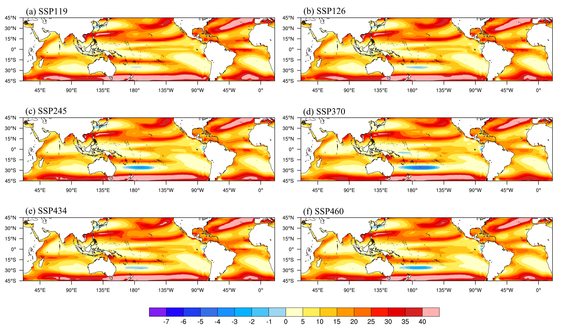
SFig. 6. The ensemble mean of the MESS values of the CMIP6 models in the 2100s under different SSP future scenarios. The SSP 585 scenario is provided in the main text.

Reference
Abdi, H., & Williams, L. J. (2010). Principal component analysis. Wiley interdisciplinary reviews: computational statistics, 2(4), 433-459.
Alexanderson, A. (2004). Graphing confidence ellipses: An update of ellip for Stata 8. The Stata Journal, 4(3), 242-256.
Björnsson, H., & Venegas, S. A. (1997). A manual for EOF and SVD analyses of climatic data. CCGCR Report, 97(1), 112-134.
Chessel, D., Dufour, A. B., & Thioulouse, J. (2004). The ade4 package-I-One-table methods. R news, 4(1), 5-10.
Dray, S., & Dufour, A. B. (2007). The ade4 package: implementing the duality diagram for ecologists. Journal of statistical software, 22, 1-20.
Dray, S., Dufour, A. B., & Chessel, D. (2007). The ade4 package-II: Two-table and K-table methods. R news, 7(2), 47-52.
Elith, J., Kearney, M., & Phillips, S. (2010). The art of modelling range‐shifting species. Methods in ecology and evolution, 1(4), 330-342.
Frank, W. M., & Young, G. S. (2007). The interannual variability of tropical cyclones. Monthly Weather Review, 135(10), 3587-3598.
Guisan, A., Thuiller, W., & Zimmermann, N. E. (2017). Habitat suitability and distribution models: with applications in R. Cambridge University Press.
Hourdin, F., Rio, C., Grandpeix, J. Y., Madeleine, J. B., Cheruy, F., Rochetin, N., ... & Ghattas, J. (2020). LMDZ6A: The atmospheric component of the IPSL climate model with improved and better tuned physics. Journal of Advances in Modeling Earth Systems, 12(7), e2019MS001892.
Hu, W., Singh, R. R., & Scalettar, R. T. (2017). Discovering phases, phase transitions, and crossovers through unsupervised machine learning: A critical examination. Physical Review E, 95(6), 062122.
Jaynes, E. T. (1957). Information theory and statistical mechanics. Physical Review, 106(4), 620.
Kalnay, E., Kanamitsu, M., Kistler, R., Collins, W., Deaven, D., Gandin, L., ... & Joseph, D. (1996). The NCEP/NCAR 40-year reanalysis project. Bulletin of the American meteorological Society, 77(3), 437-472.
Knapp, K. R., Kruk, M. C., Levinson, D. H., Diamond, H. J., & Neumann, C. J. (2010). The international best track archive for climate stewardship (IBTrACS) unifying tropical cyclone data. Bulletin of the American Meteorological Society, 91(3), 363-376.
Li, H., Xu, F., Sun, J., Lin, Y., & Wright, J. S. (2019). Subtropical high affects interdecadal variability of tropical cyclone genesis in the South China Sea. Journal of Geophysical Research: Atmospheres, 124(12), 6379-6392.
Li, L., Yu, Y., Tang, Y., Lin, P., Xie, J., Song, M., ... & Wei, J. (2020). The flexible global ocean‐atmosphere‐land system model grid‐point version 3 (FGOALS‐g3): description and evaluation. Journal of Advances in Modeling Earth Systems, 12(9), e2019MS002012.
Lorenz, E. N. (1956). Empirical orthogonal functions and statistical weather prediction (Vol. 1, p. 52). Cambridge: Massachusetts Institute of Technology, Department of Meteorology.
O'Neill, B. C., Tebaldi, C., Van Vuuren, D. P., Eyring, V., Friedlingstein, P., Hurtt, G., ... & Sanderson, B. M. (2016). The scenario model intercomparison project (ScenarioMIP) for CMIP6. Geoscientific Model Development, 9(9), 3461-3482.
Phillips, S. J., Anderson, R. P., & Schapire, R. E. (2006). Maximum entropy modeling of species geographic distributions. Ecological modelling, 190(3-4), 231-259.
Phillips, S. J., & Dudík, M. (2008). Modeling of species distributions with Maxent: new extensions and a comprehensive evaluation. Ecography, 31(2), 161-175.
Phillips, S. J., Anderson, R. P., Dudík, M., Schapire, R. E., & Blair, M. E. (2017). Opening the black box: An open‐source release of Maxent. Ecography, 40(7), 887-893.
Qian, Q., Jia, X., & Lin, Y. (2022). Reduced tropical cyclone genesis in the future as predicted by a machine learning model. Earth's Future, 10(2), e2021EF002455.
Rayner, N. A. A., Parker, D. E., Horton, E. B., Folland, C. K., Alexander, L. V., Rowell, D. P., ... & Kaplan, A. (2003). Global analyses of sea surface temperature, sea ice, and night marine air temperature since the late nineteenth century. Journal of Geophysical Research: Atmospheres, 108(D14).
Sanguansat, P. (Ed.). (2012). Principal Component Analysis: Multidisciplinary Applications. BoD–Books on Demand.
Sobel, A. H., Wing, A. A., Camargo, S. J., Patricola, C. M., Vecchi, G. A., Lee, C. Y., & Tippett, M. K. (2021). Tropical cyclone frequency. Earth's Future, 9(12), e2021EF002275.
Storch, H. V., & Zwiers, F. W. (2002). Statistical analysis in climate research. Cambridge university press.
Swart, N. C., Cole, J. N., Kharin, V. V., Lazare, M., Scinocca, J. F., Gillett, N. P., ... & Winter, B. (2019). The Canadian earth system model version 5 (CanESM5. 0.3). Geoscientific Model Development, 12(11), 4823-4873.
Tatebe, H., Ogura, T., Nitta, T., Komuro, Y., Ogochi, K., Takemura, T., ... & Kimoto, M. (2019). Description and basic evaluation of simulated mean state, internal variability, and climate sensitivity in MIROC6. Geoscientific Model Development, 12(7), 2727-2765.
Thioulouse, J., Chessel, D., & Olivier, J. M. (1997). ADE-4: a multivariate analysis and graphical display software. Statistics and computing, 7(1), 75-83.
Thioulouse, J., Dray, S., Dufour, A. B., Siberchicot, A., Jombart, T., & Pavoine, S. (2018). Multivariate analysis of ecological data with ade4.
Wilks, D. S. (2011). Statistical methods in the atmospheric sciences (Vol. 100). Academic press.
Yukimoto, S., Kawai, H., Koshiro, T., Oshima, N., Yoshida, K., Urakawa, S., ... & Ishii, M. (2019). The Meteorological Research Institute Earth System Model version 2.0, MRI-ESM2. 0: Description and basic evaluation of the physical component. Journal of the Meteorological Society of Japan. Ser. II.

