Table S1. Coordinates and elevation of fourteen 1.5 km transects located in northwestern Ecuador. Plants and hummingbirds richness, and interactions among them, were sampled at each transect between December 2017 to December 2019. Provided are also the number of plant and hummingbird species recorded at each transect.
Transect name | Latitude |  | Longitude | Mean elevation | Habitat | Block | Plant richness | Hummingbird richness
Verdecocha reserve |  | -0.11817 | -78.59747 | 3250 | forest | 1 | 43 | 9
Yanacocha farm |  | -0.10347 | -78.58790 | 3395 | deforested | 1 | 36 | 8
Alaspungo forest |  | -0.00151 | -78.62972 | 2850 | forest | 2 | 50 | 5
Alaspungo disturbed |  | -0.01508 | -78.60723 | 3021 | deforested | 2 | 55 | 6
Las Gralarias |  | -0.01071 | -78.73087 | 1972 | forest | 4 | 66 | 14
Puyucunapi |  | 0.02330 | -78.69577 | 1924 | deforested | 4 | 64 | 11
Sachatamia |  | -0.02538 | -78.76083 | 1723 | forest | 5 | 50 | 9
Sachatamia disturbed |  | -0.02788 | -78.76165 | 1701 | deforested | 5 | 47 | 14
Maquipucuna reserve |  | 0.12506 | -78.63149 | 1640 | forest | 3 | 41 | 12
Rumisitana farm |  | 0.06727 | -78.67378 | 1454 | deforested | 3 | 37 | 10
Mashpi Laguna |  | 0.16378 | -78.87350 | 1050 | forest | 6 | 61 | 13
Amagusa |  | 0.14385 | -78.80333 | 1100 | deforested | 6 | 77 | 13
Un Poco del Choco |  | 0.05233 | -78.84095 | 1050 | forest | 7 | 57 | 13
Un Poco del Choco disturbed |  | 0.05329 | -78.84171 | 1195 | deforested | 7 | 38 | 12
Mean richness |  |  |  |  |  |  | 51.57 | 10.64

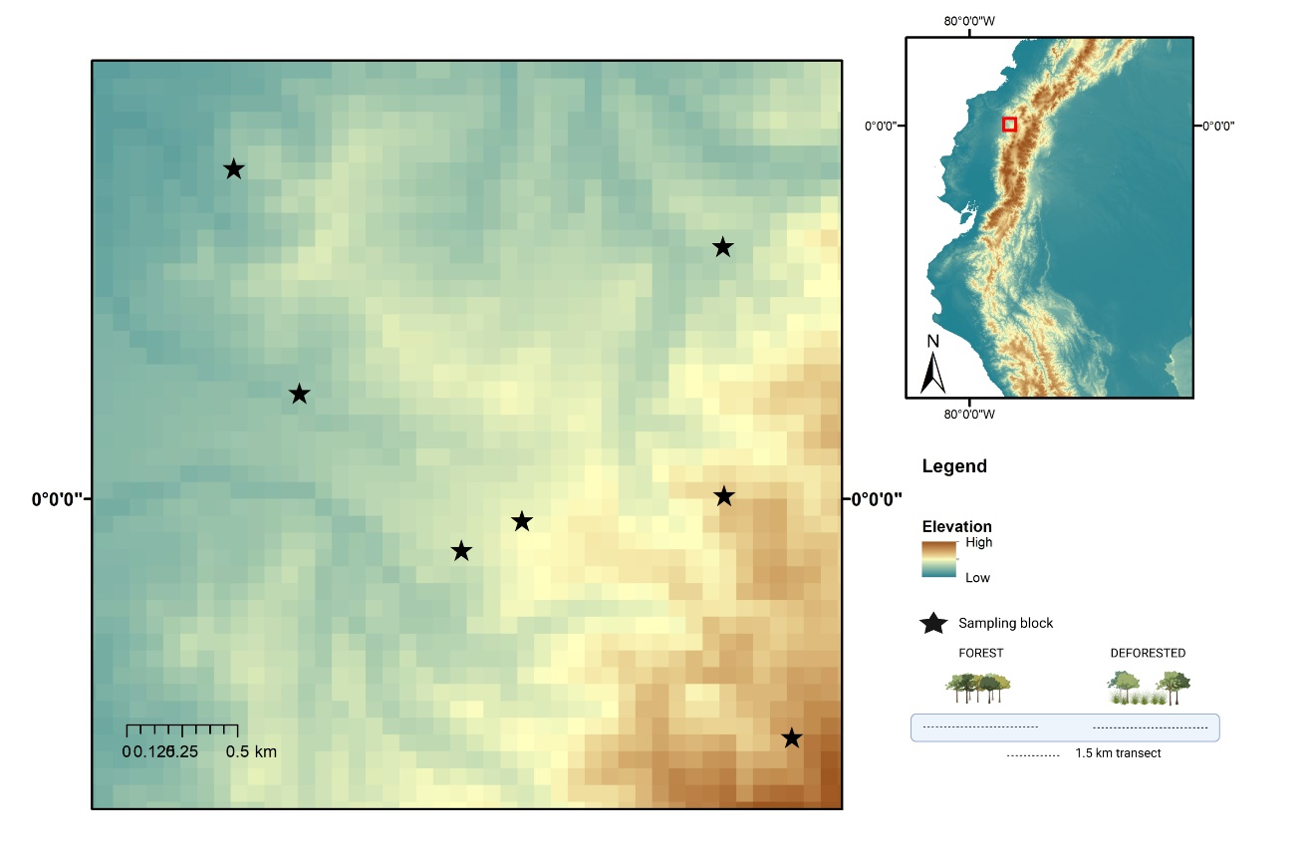
Figure S1. Map of the study area depicting the location of seven sampling blocks (black stars) along an elevation gradient (800-3500 m) in northwestern Andes of Ecuador (red square in right map). Each block consisted of two transects of length 1.5 km, one within forest and a second at a deforested site.

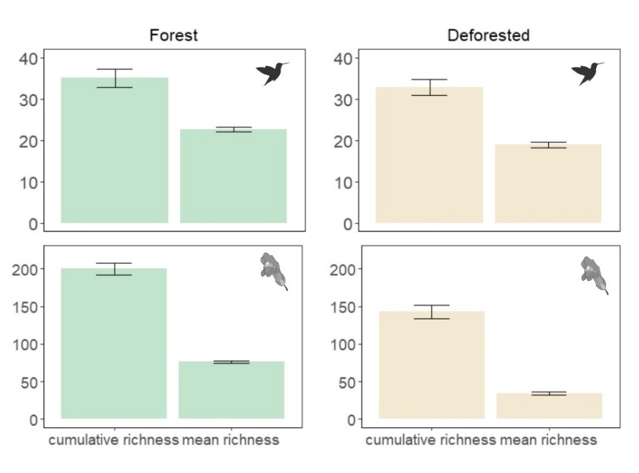
Fig S2. Observed (bars) and estimated (error bars, 999 bootstrap) hummingbird and plant
richness in forest and deforested transects. For plants and hummingbirds, cumulative richness
is the total number of hummingbirds and mean species richness is the average value over the sampling
units (i.e. monthly richness per site).

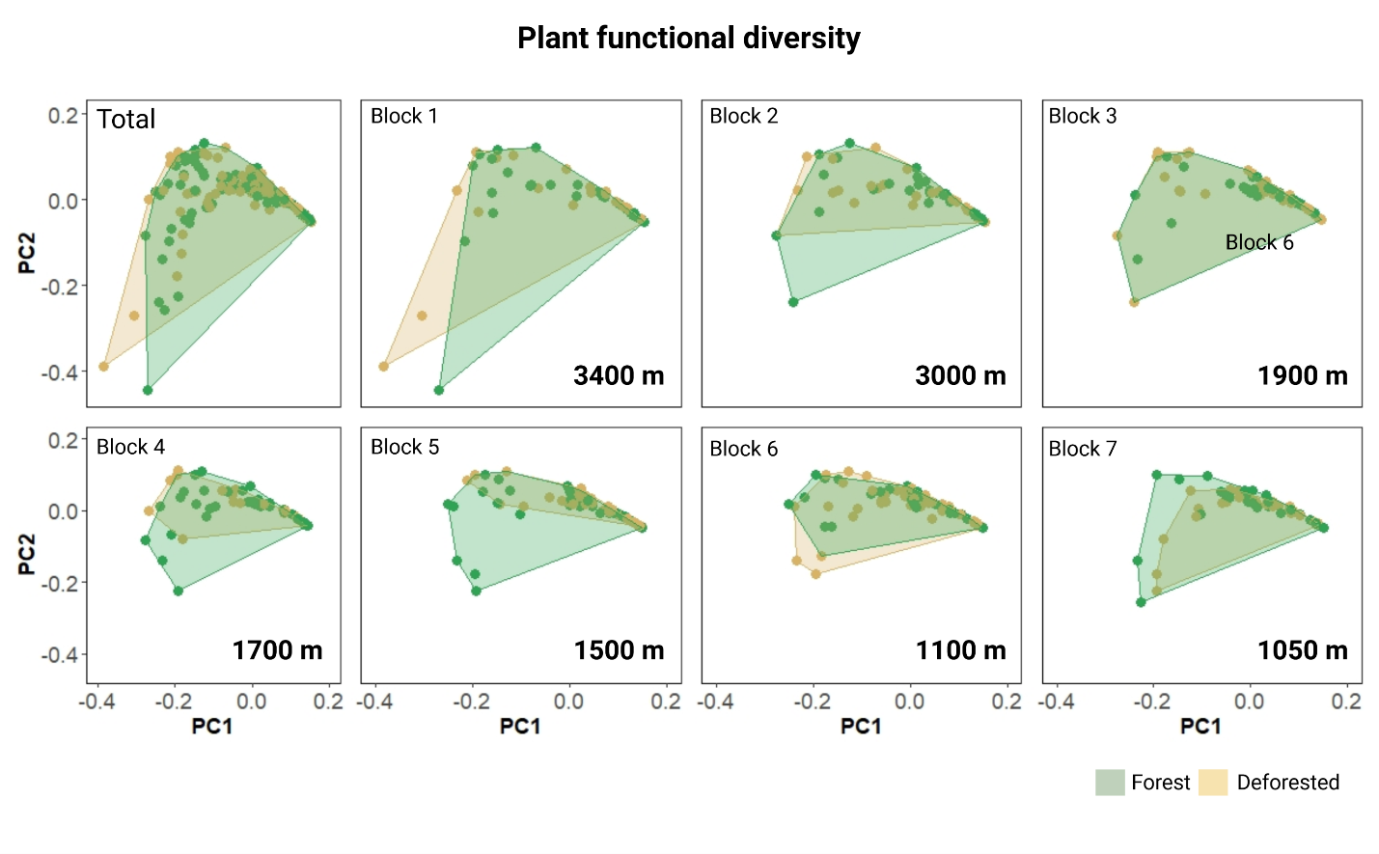

Figure S3. Functional space of plant communities calculated as convex hulls within the first two axis of Principal Coordinates Analyses (PCoA). The first two axis of the ordinations were calculated from three floral traits (corolla length, width, and anther length). Points represent species position within the functional space, and were used to estimate convex hulls for forest and deforested communities.

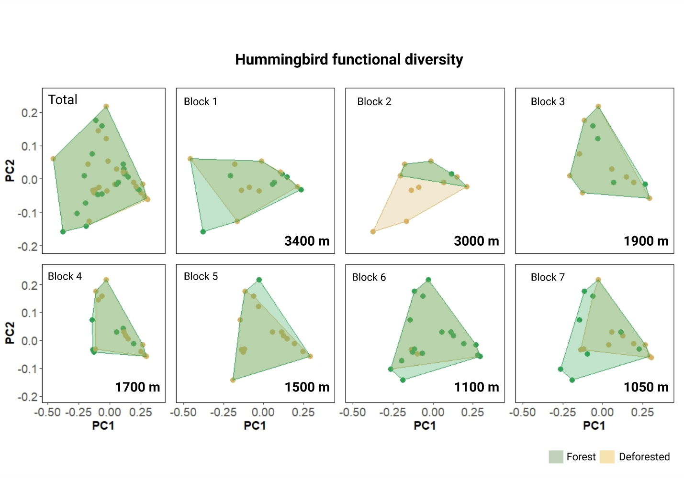

Figure S4. Functional space of hummingbirds assemblages calculated as convex hulls within the first two axis of Principal Coordinates Analyses (PCoA). The first two axis of the ordinations were calculated from four traits (bill length, body mass, wing length and tarsus length). Points represent species position within the functional space, and were used to estimate convex hulls for forest and deforested communities.
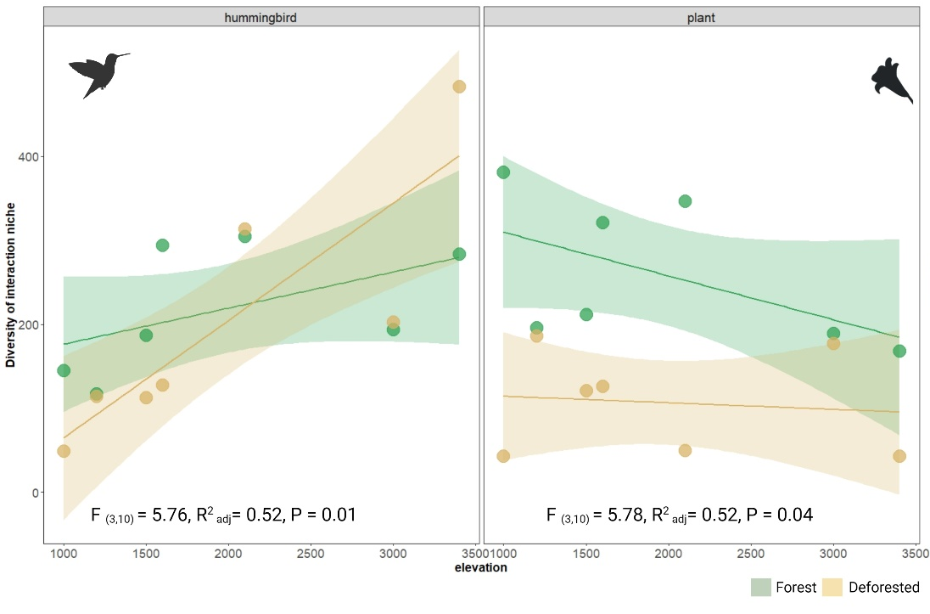
Fig S5. Diversity of interaction niches calculated with rare interactions (those occurring only once per day) excluded.

