Supplementary Materials for

Sirtuin 5‐mediated deacetylation of TAZ at K54 promotes melanoma development and lung metastasis

Garam Kim, Poshan Yugal Bhattarai, Sung-Chul Lim, Kwang Youl Lee, and Hong Seok Choi

Correspondence to: chs@chosun.ac.kr

This PDF file includes:

Figures S1 to S3

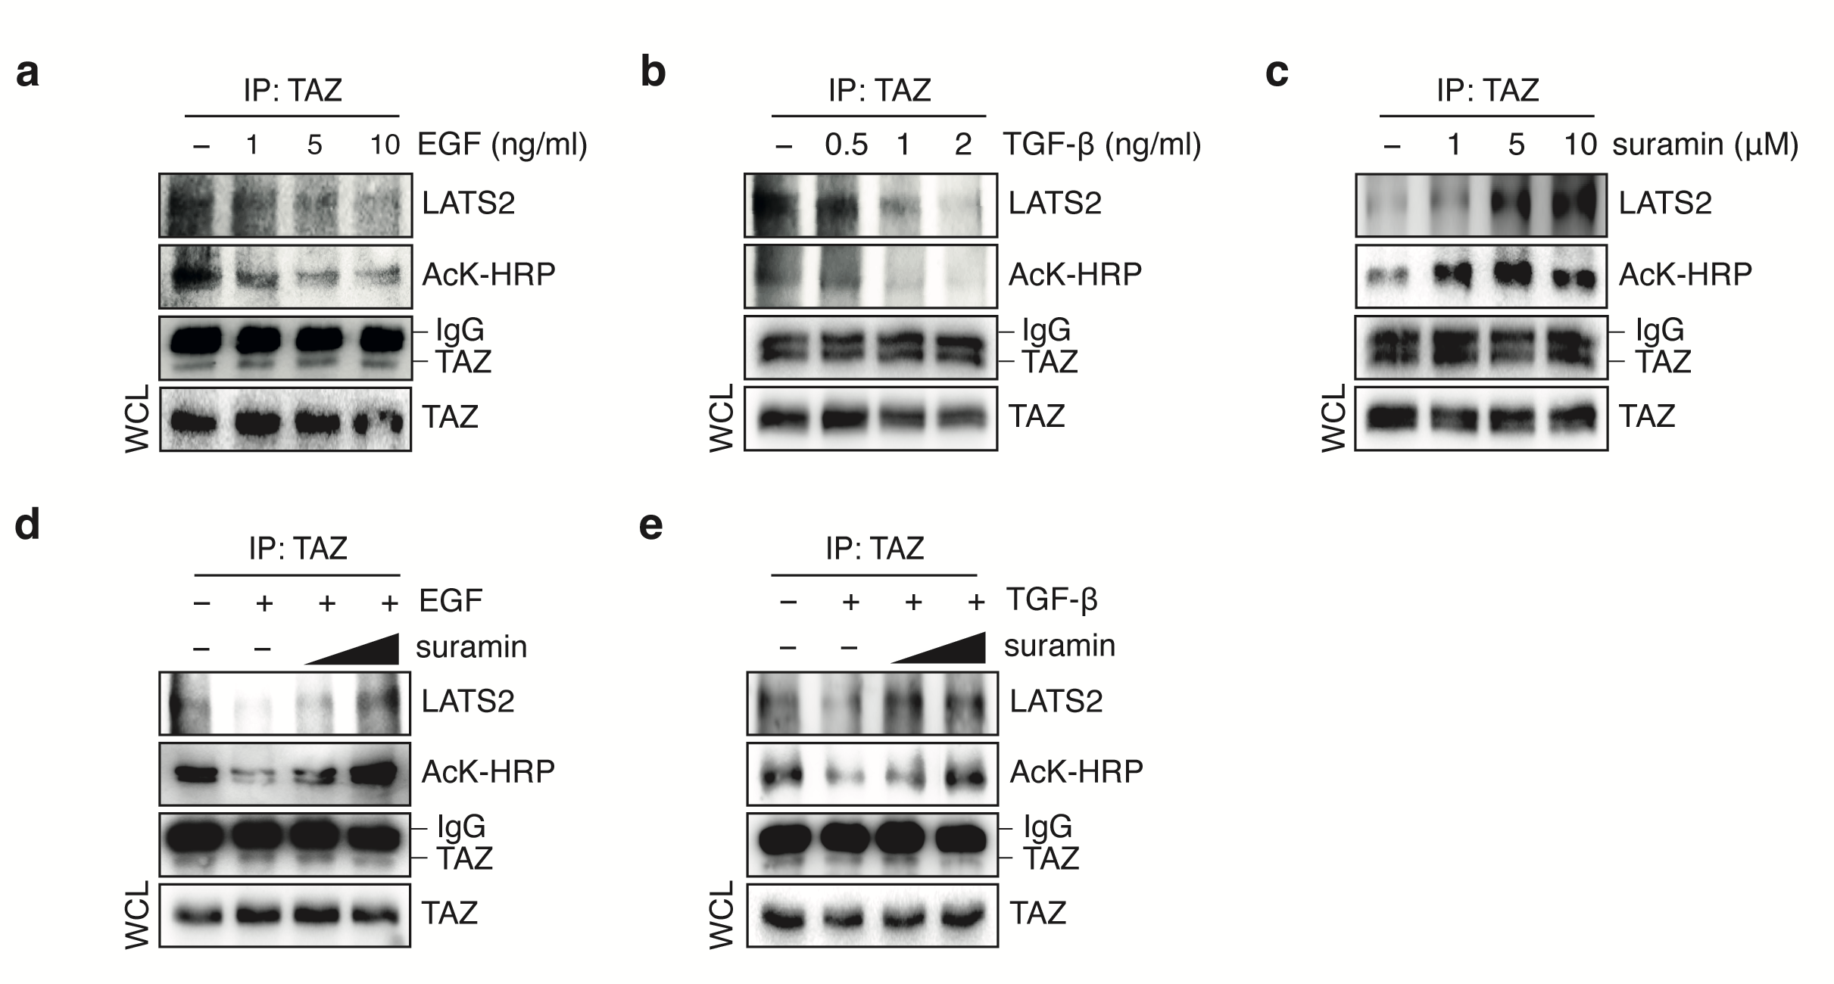
Fig. S1. TAZ K54 deacetylation by SIRT5 reduces its interactions with LATS2.

(a, b) EGF or TGF-β inhibits LATS2-TAZ interaction. A375 cells were serum-starved for 24 h and treated with EGF (a) or TGF-β (b) for 24 h in a dose-dependent manner. Cell lysates were subjected to immunoprecipitation with anti-TAZ antibody, followed by immunoblotting with anti-LATS2 or anti-AcK-HRP antibodies, respectively.

(c) Suramin increases LATS2-TAZ interaction. A375 cells were serum-starved for 24 h and treated with suramin for 24 h in a dose-dependent manner. Cell lysates were subjected to immunoprecipitation with anti-TAZ antibody, followed by immunoblotting with anti-LATS2 or anti-AcK-HRP antibodies, respectively.

(d, e) Suramin restores the inhibition of LATS2-TAZ interaction by EGF or TGF-β. A375 cells were serum-starved for 24 h, treated with 10 ng/ml EGF (d) or 2 ng/ml TGF-β (e) for 24 h, followed by treatment of suramin for 24 h in a dose-dependent manner. Cell lysates were subjected to immunoprecipitation with anti-TAZ antibody, followed by immunoblotting with anti-LATS2 or anti-AcK-HRP antibodies, respectively.
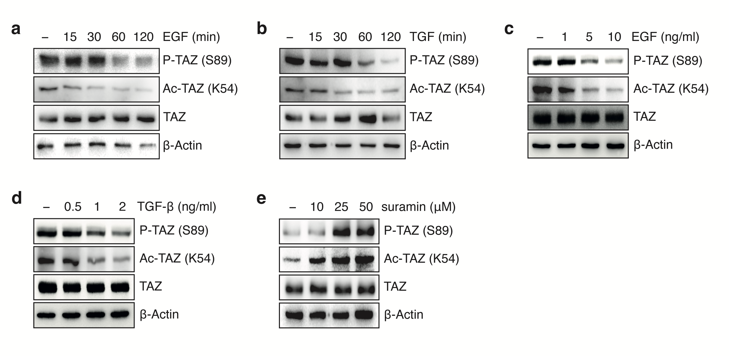

Fig. S2. Deacetylation of TAZ by SIRT5 inhibits TAZ phosphorylation

(a-d) EGF or TGF-β facilitates TAZ K54 deacetylation, followed by its reduced S89 phosphorylation. A375 cells were treated with 10 ng/ml EGF or 2 ng/ml TGF-β in a time-dependent manner (a, b), and indicated dose of EGF or TGF-β for 24 h in a dose-dependent manner (c, d), respectively. Cell lysates were subjected to immunoblotting analysis using the anti-Ac-TAZ (K54) and anti-P-TAZ (S89) antibodies.

(e) Suramin increases TAZ K54 acetylation and S89 phosphorylation. A375 cells were serum-starved for 24 h and treated with suramin for 24 h in a dose-dependent manner. Cell lysates were subjected to immunoblotting analysis using the anti-Ac-TAZ (K54) and anti-P-TAZ (S89) antibodies.

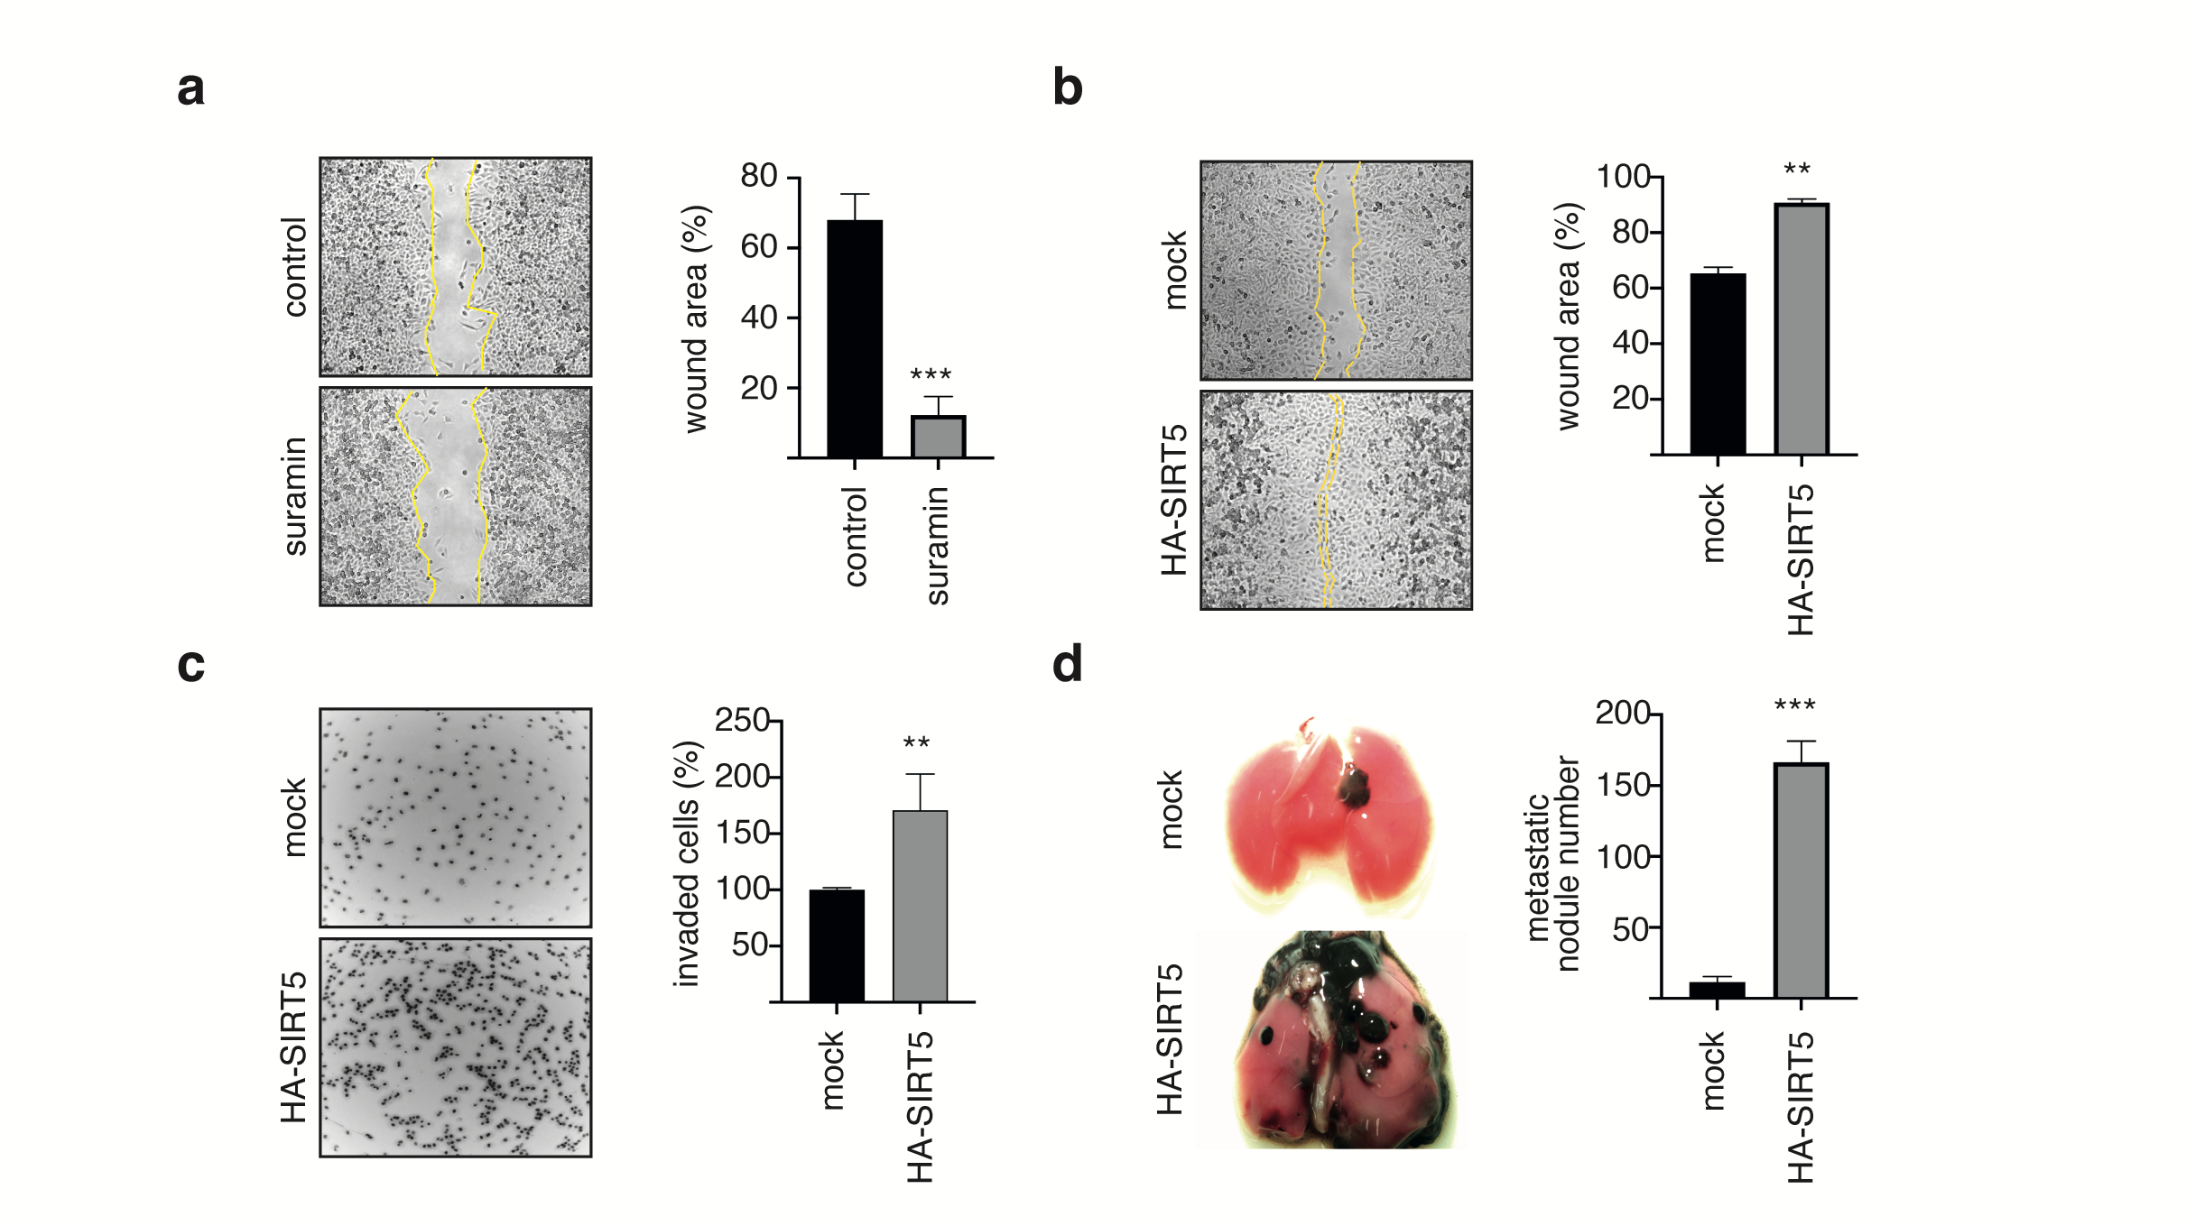

Fig. S3. SIRT5 overexpression induces melanoma development and metastatic potential in vivo.

(a, b) SIRT5 facilitates melanoma cell migration. A375 cells treated with 25 μM suramin for 24 h (a) or stably expressing mock or HA-SIRT5 (b) were subjected to wound healing assays and images were taken at 24 h (left), respectively. Semi-quantitative analysis of wound closure (right). Relative wound closure was determined by measuring the width of the wounds. Data are presented as means ± SDs, n = 3. **P < 0.01, ***P < 0.001 as compared with control or mock groups.

(c) SIRT5 facilitates melanoma cell invasion. Invasiveness of A375 cells stably expressing mock or HA-SIRT5 were determined using the Transwell assay, respectively. The number of cells that invaded through the Matrigel was counted in ten fields under the ×20 objective lens. Data are presented as means ± SDs, n = 3. **P < 0.01 as compared with mock groups.

(d) SIRT5 overexpression promotes lung metastasis of melanoma cells in mice. C57BL/6 mice were injected through the tail vein with 5 × 10⁵ B16-F10-mock or B16-F10-HA-SIRT5 cells. Lungs were removed from the mice at 3 weeks after inoculation. Representative images of lung tissues are shown (left). Number of metastatic lesions in the lung (n= 6). ***P < 0.001 as compared with mock group.

