Tables
parameter | Weight(kg) | Length(mm) | Width(mm) | maximum speed(km/h) | maximum acceleration
Average | 1044/55 | 4141/82 | 1656/85 | 164/53 | 1/927
Minimum | 134 | 3835 | 1605 | 1605 | 1/46
Maximum | 1264 | 4524 | 1755 | 200 | 2/72
Standard deviation | 104/122 | 280/65 | 47/01 | 21/5 | 0/41
Coefficient of variation | 29/3 | 14/76 | 35/2 | 7/65 | 4/7
Table 1 –specifications of equivalent unit passenger car

Cylinder volume (cc) | Weight(kg) | Length(mm) | Width(mm) | maximum speed(kh/h)
124 | 102 | 1900 | 745 | 120
table 2- Specifications of related to motorcycles

parameter | Length(mm) | Width(mm)
Average | 11745/3 | 2496/5
Minimum | 7950 | 1920
Maximum | 14550 | 2550
Standard deviation | 7967 | 67/9
Coefficient of variation | 14/74 | 36/7
Table3- Technical and physical specifications of the equivalent bus

maximum speed(kh/h) | Width(mm) | Length(mm) | Weight(kg) | Cylinder volume (cc) | Heavy vehicle
88 | 2995 | 7604 | 8920 | 11580 | Dump truck
110 | 2550 | 6844 | 10100 | 12880 | truck
Table 4 - specifications of heavy vehicles

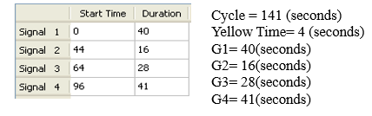
table5-timing of lights
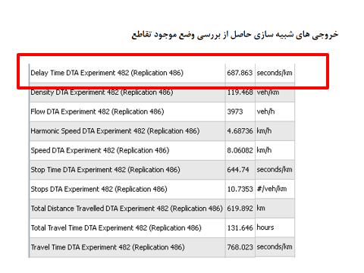
table 6-Simulation outputs result in checking the current status of the intersection

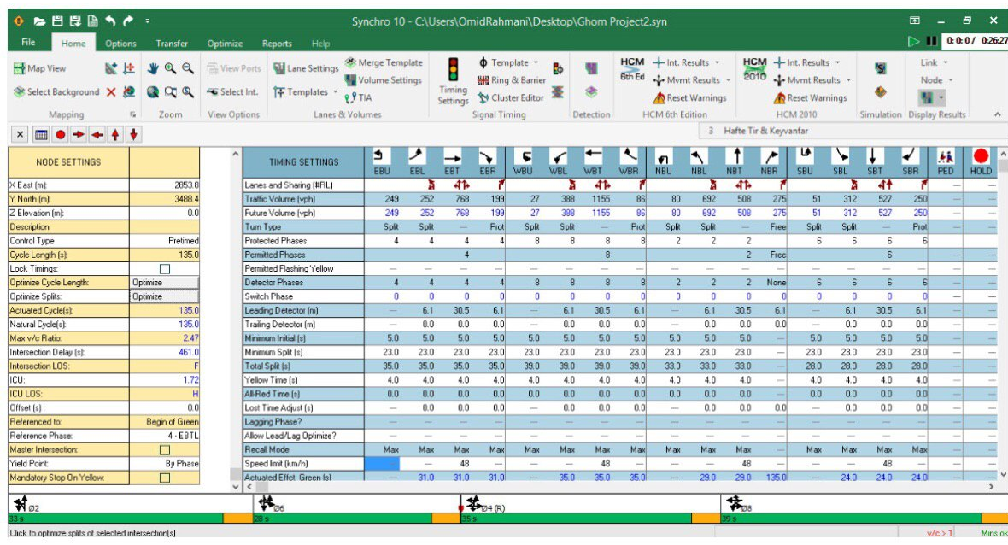
Table 7-the optimization of the current situation and the quality of traffic and the level crossing of the passages: second scenario in Synchro simulator

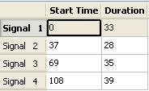
Table8-phasing based on second scenario

Traffic parameters | Scenario 1 (existing situation) 4 phases | Scenario 2- (Optimization of existing situation timing 4 phase)
Cycle(s) | 141 | 161
delay | 687.55 | 671.63
flow | 4018 | 3999
speed | 8.069 | 8.61

Table 9-traffic parameters

Traffic parameters | Scenario 1 (existing situation) 4 phases |  | Scenario 2- (Optimization of existing situation timing 4 phase)
Delay(efficiency) | 687.55 |  | 671.63
Safety (number of possible collisions) | **** |  | ****
Table10-traffic parameters

