Supplementary Methods

Acknowledgement
This work was funded in part by the German Federal Ministry of Education and Research (BMBF) under GenomeNet Grant No. 01IS18036A and 031L0199B. P.C.M. received funding from the German Research Foundation (Grant number 405892038). X.-Y. T. received funding from the German Center for Infection Research (DZIF) TI BBD.

Implementation and Data Handling in the deepG Library
In this section, we describe the implementation of the deepG library, which is a powerful tool for building and training deep learning models for sequence labeling tasks. The library is built on top of the Keras functional API, which provides a flexible framework for defining complex model architectures. One key feature of the deepG library is its support for data efficiency. During training, the network's parameters are stored in the binary HDF5 data format as checkpoints. Additionally, model predictions can be stored in HDF5 format. This binary format allows for efficient storage and retrieval of large amounts of data, which is essential for training deep learning models on large genomic datasets. Additionally, the deepG library includes functions for converting HDF5 data to human-readable formats, making it easy to explore and analyze the results of training. The deepG library supports two main training types: "language model" and "label classification". In language model training, the goal is to accurately predict the next character or set of characters in a sequence. This type of training is useful for tasks such as predicting the sequence of nucleotides in a DNA strand. In label classification training, the objective is to map one or more labels to a sequence. Overall, the deepG library provides a flexible and efficient tool for training deep learning models on sequence labeling tasks in genomics and other fields.

Efficient Training with the deepG Data Generator for FASTA and FASTQ Files
One main challenge is to use an efficient way to iterate over the training set provided by the user. To tackle this challenge, deepG uses a data generator that is specifically designed to efficiently extract training and validation samples from FASTA or FASTQ files. This generator uses a unique approach to ensure that the samples fed to the model are diverse and do not come from the same file too frequently. This approach allows deepG to maintain a high training speed, even when working with large FASTA or FASTQ files. The data generator also uses a random sampling algorithm to ensure that the samples extracted from the input files are diverse. This algorithm randomly selects samples from the input files, ensuring that the samples used for training and validation are representative of the entire dataset. This approach helps to prevent overfitting and ensures that the trained model is able to generalize well to new data. Overall, the data generator used by deepG is an essential component of the deep learning framework, allowing it to efficiently and effectively train models on large FASTA or FASTQ datasets.

Generating Data for Deep Learning in Genomics with the deepG Generator
The deepG generator is a tool that can be used to generate data for training deep learning models in genomics applications (Fig S1). It offers a range of options for controlling the data sampling strategy in order to balance the diversity of the data and the frequency with which new files are read. The available options for controlling the data sampling strategy are described in detail on the package website. Some of the key options include using random subsets of data from each file, sampling every n nucleotides, adding data augmentation via reverse complement, setting a maximum number of samples per file, and shuffling the order of the files. In addition to these options for controlling the data sampling strategy, the deepG generator also allows for storing the output in the rds format. This format is a binary file format for storing data in the R programming language. By storing the output in the rds format, it is possible to pre-process the data before feeding it to the model, which can lead to faster training times. Overall, the deepG generator provides a useful set of tools for generating data for training deep learning models in genomics applications. It offers a range of options for controlling the data sampling strategy and allows for storing the output in a format that can lead to faster training times.

Nucleotide Sequence Encoding Methods for Deep Learning Models
In this section, we will compare the different methods used to represent nucleotide sequences numerically before they are fed into deep learning models. One-hot encoding, quality encoding, and coverage encoding are all methods that involve dividing the nucleotide sequence into a vocabulary of valid characters, such as A, C, G, and T (Fig. S2). Any characters not in the vocabulary are treated as out-of-vocabulary and are typically denoted as "N". One-hot encoding involves creating a matrix where each character from the vocabulary corresponds to one column and each row corresponds to a nucleotide position in the sequence. In this representation, each row contains a single "1" in the column corresponding to the nucleotide at that position, and "0"s in all other columns. This method allows for the representation of the sequence in a simple and straightforward manner, but it does not take into account any additional information such as quality scores or coverage levels. Quality encoding is similar to one-hot encoding, but it incorporates information from the FASTQ file by replacing the "1" in each row with the corresponding quality score. The remaining probability is then distributed equally among the "0" entries. This method allows for the representation of additional information, but it may not be as effective as one-hot encoding for tasks that do not depend on quality scores. Coverage encoding is also similar to one-hot encoding, but it incorporates information about the coverage of the nucleotide sequence by replacing the "1" in each row with a score proportional to the coverage. This method allows for the representation of additional information, but it may not be as effective as one-hot encoding for tasks that do not depend on coverage levels. When it comes to handling out-of-vocabulary characters, there are four options: (1) discard all samples with characters not in the vocabulary; (2) encode as a zero vector; (3) encode as a probability vector according to the nucleotide distribution of the current file; (4) give every out-of-vocabulary character equal probability. Each of these options has its own advantages and disadvantages, and the appropriate method will depend on the specific task and the desired performance of the deep learning model. In conclusion, one-hot, quality, and coverage encodings are three different methods for representing nucleotide sequences numerically before they are fed into deep learning models. Each method has its own advantages and disadvantages, and the appropriate method should be chosen based on the specific task and the desired performance of the model.

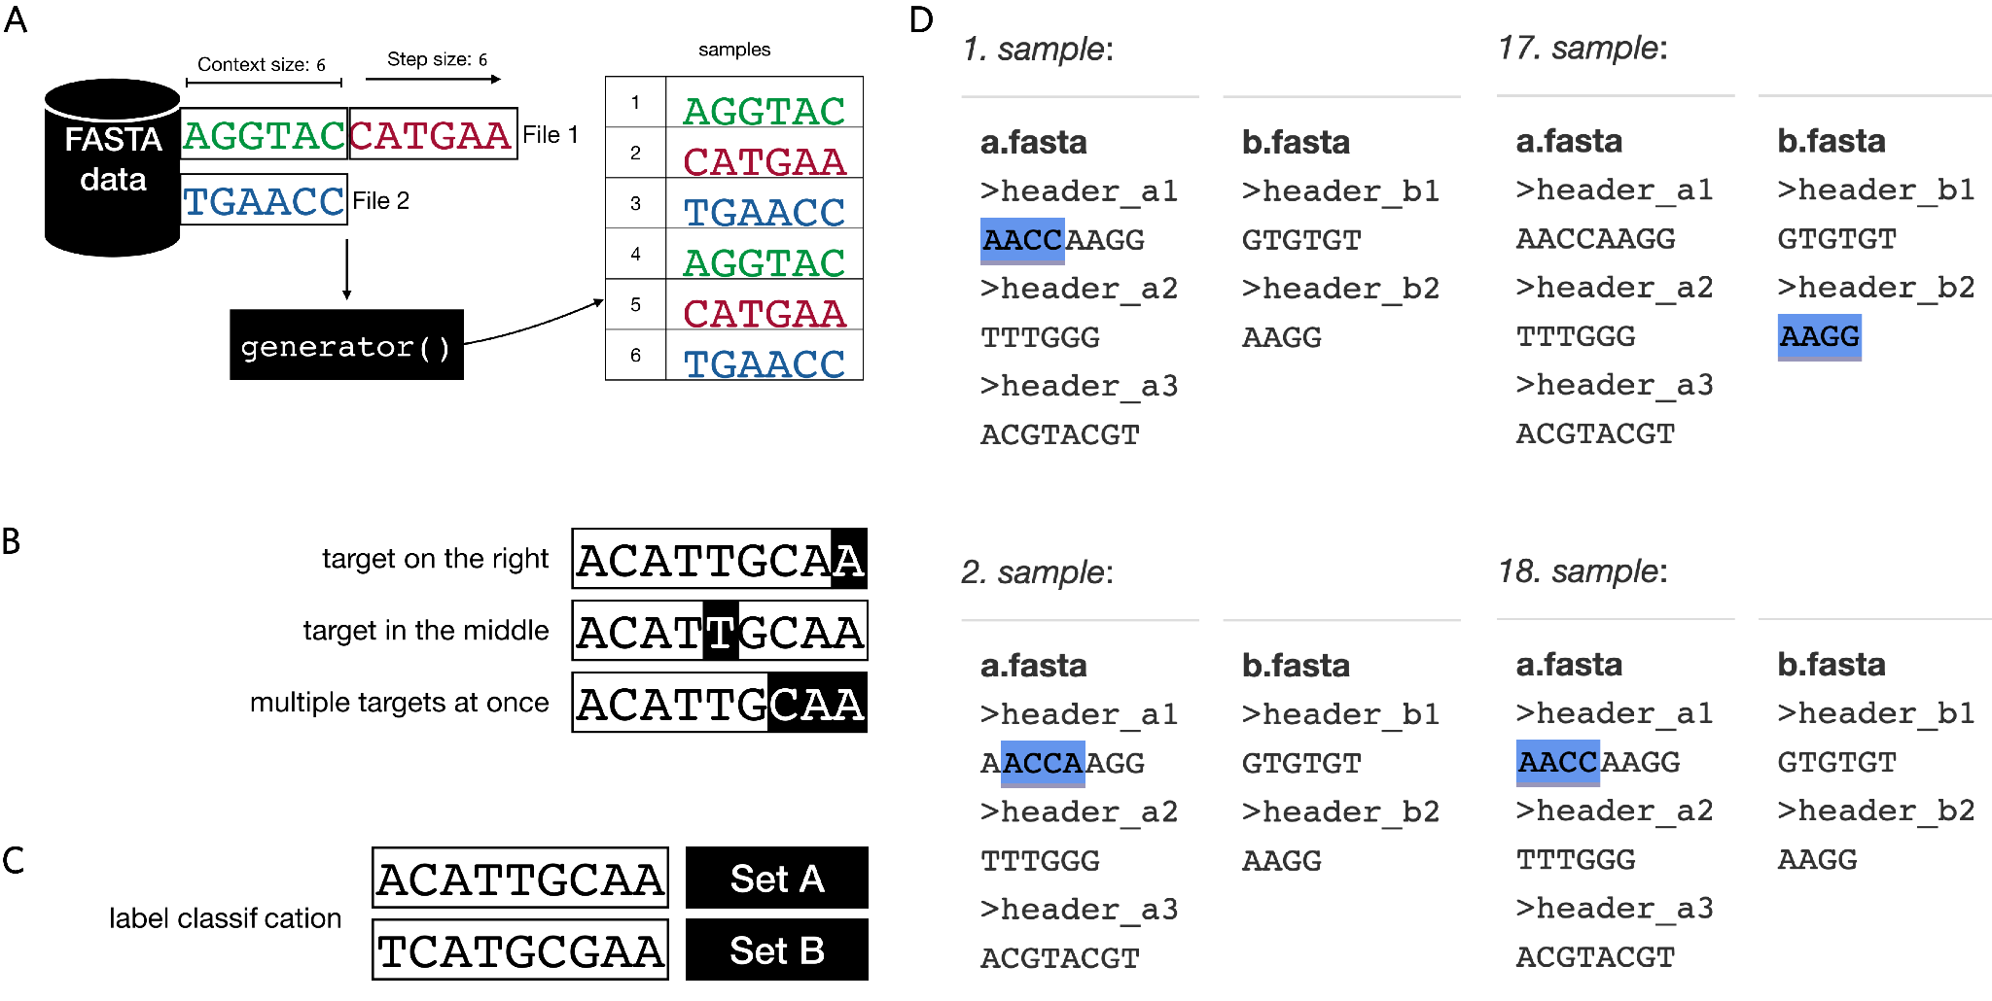
Supplementary Figure 1: Data Generator Types for Machine Learning Models. A) Example for sample extraction with data generator for 2 files with context size 6 and step size 6. B-C) Examples for language model (B) and label classification (C). Nucleotides with white background correspond to input and text with black background to target. Language models can be trained on sequences without external annotations, while label classification requires external annotations. D) Example for naive sampling approach for 2 FASTA files with input length 4. Samples are taken in chronological order and after each sample, the generator moves one nucleotide ahead. This approach is fast but data is very redundant (especially for larger files). Data generators offer several options to introduce more randomness for smoother training which can improve the performance of the trained model by reducing overfitting.
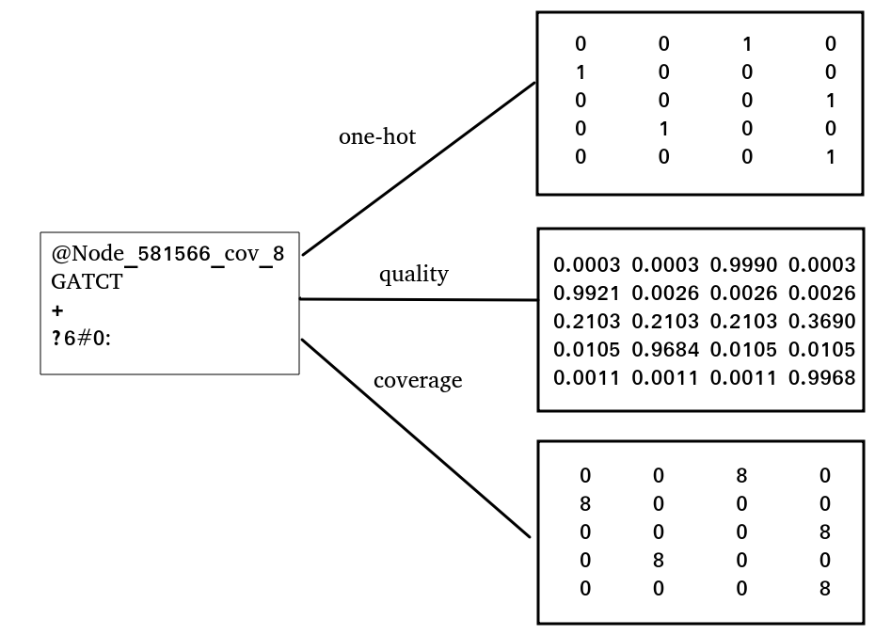
Supplementary Figure 2: Examples for different encoding strategies for FASTQ entry.

The output of a model can be extracted in various ways depending on the type of model being used. For instance, in the case of a language model, the output can be extracted and encoded from a FASTA/FASTQ file, which contains the sequence data that serves as input to the model. In addition, deepG offers the option to encode targets for a language model by combining multiple characters (known as n-grams) into a single target.

When it comes to extracting labels for a classification model, there are three main options:
- Get labels from data location: In this approach, data from each class is stored in a separate folder, and the labels are extracted from the folder names.
- Read labels from fasta header: The labels for a classification model can also be extracted from the fasta header, which contains metadata about the sequence data.
- Map FASTA/FASTQ file names to labels using a CSV file: In this approach, a CSV file is used to map each FASTA/FASTQ file to its corresponding label. The CSV file contains one row for each FASTA/FASTQ file, with the label(s) for that file listed in the corresponding column(s).
Overall, there are several ways to extract the output and labels for a machine learning model, depending on the specific type of model and the format of the input data.

Monitoring Training Progress with Tensorboard
The library provides a convenient way to monitor and compare the progress of training runs using tensorboard. This tool allows users to track a number of important metrics, including balanced accuracy, loss, learning rate, F1 score, AUC, and the percentage of processed training files. Additionally, tensorboard provides a visual representation of the confusion matrix and the hyperparameters used during training.
By monitoring these metrics, users can quickly identify any problems or issues with their training runs and take corrective action as needed. For example, if the validation loss is increasing rather than decreasing, this may indicate that the model is overfitting to the training data and may not generalize well to new data. In this case, users may need to adjust the hyperparameters or use regularization techniques to improve the model's performance.

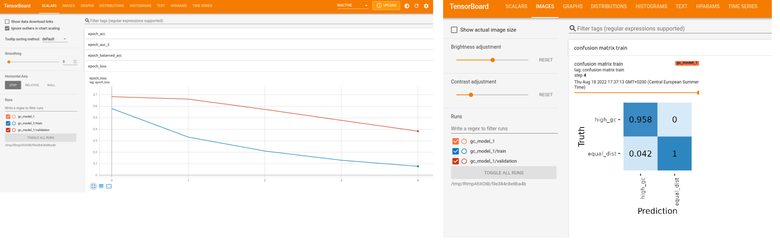
Supplementary Figure 3: Loss score and confusion matrix will be visualized in Tensorboard during and after training to monitor training progress.

Data Management and Model Training

Training a machine learning model involves adjusting the model's parameters to minimize the model's error on a dataset. This process is known as "fitting" the model to the data. One common method for training machine learning models is to use stochastic gradient descent (SGD), in which the model's parameters are updated based on the gradient of the loss function with respect to the model's parameters.

During training, it is often useful to save the model's state (i.e., its architecture and weights) to a file. This is useful for several reasons. For example, if the training process is interrupted, the training can be resumed from the saved state rather than starting over from scratch. Additionally, saved models can be shared with other researchers, allowing them to reproduce the results of the original training process or to use the trained model for their own purposes.
In practice, the model's state is typically saved to a file called a checkpoint. Checkpoints can be saved after every epoch or whenever the validation loss (i.e., the error of the model on a separate validation dataset) improves. This allows the model's performance to be monitored during training.

After training, the model can be loaded from the saved checkpoint and used for evaluation or prediction on new data. This allows the trained model to be applied to new, previously unseen data, allowing it to make predictions or inferences about that data.

Advanced Training Techniques in deepG
deepG is a machine learning framework that allows for a variety of advanced techniques to be used during training. One such technique is the use of class weights, which allows the model to assign different importance to different classes in the dataset. This can be useful if the dataset is imbalanced (i.e., some classes are overrepresented compared to others) and the model needs to be trained to pay more attention to the underrepresented classes.

Another useful feature of deepG is its ability to compute the integrated gradient for a given input. The integrated gradient is a method for attributing the prediction made by a model to each input feature. This can be useful for understanding which features the model is using to make its predictions and how much each feature contributes to the overall prediction.

deepG also allows for the integration of label noise, which can be helpful when there are mislabeled samples in the dataset. Label noise refers to incorrect labels in the training data, which can cause the model to learn incorrect patterns and ultimately perform poorly on unseen data. By integrating label noise, deepG can help to reduce the negative impact of mislabels on the model's performance. In addition, deepG allows for the use of set learning, which is a type of learning where the model is trained on sets of data rather than individual examples. This can be useful for tasks where we want to assign a label to a set of sequences rather than a single input. Finally, deepG allows for transfer learning, which is a technique where a pre-trained model is frozen and a new model is trained on top of it. This allows the pre-trained model to provide a useful starting point for the new model, allowing it to learn more quickly and with better performance than if it were trained from scratch.

Datasets

For all experiments, we randomly split the datasets into train, validation and test subsets, where the train set contains 70%, the validation set 20% and the test set 10% of the data. In machine learning experiments, it is common to split the dataset into different subsets for training, validation and testing. This allows the model to be trained and evaluated on different subsets of the data, which can help to prevent overfitting and to assess the generalization performance of the model. This allows for a large training set to be used for fitting the model, a validation set to be used for monitoring the model's performance during training, and a test set to be used for evaluating the final performance of the trained model.

Experiments
All models used in the experiments used a cross-entropy loss function and Adam optimizer. The cross-entropy loss function is a commonly used loss function for training machine learning models. It is often used in classification tasks, where the goal is to predict the class of a given input. In this context, the cross-entropy loss function is used to measure the difference between the model's predicted probabilities and the true label of the input belonging to each class. The Adam optimizer is a popular algorithm for training machine learning models based on gradient descent. It is an extension of the stochastic gradient descent (SGD) algorithm. The Adam optimizer has been shown to converge more quickly and to perform better on some tasks than the SGD algorithm.

Read-Level Classification of Human Contamination in Bacterial Samples
The use case described in this section involves training a machine learning model for classification at the read level. The model is designed to detect human contamination in bacterial samples. It uses a two-layer bidirectional LSTM architecture with 256 cells per layer. The input size of the model is 150 nucleotides (nt), which is the typical size of reads generated by next-generation sequencers. The training dataset for this model consists of the hg19 genome (i.e. the human genome) and a bacterial dataset. During training, the model is fed batches of 1024 samples, with each batch containing 512 human and 512 bacterial samples. The learning rate for the model is set to 10⁻⁴.

For the human genome data, we used the full GRCh38 reference genome splitted to subsequences of around length 2M nt, resulting in 2,136 files. We used 1,500 files for training, 423 for validation and 213 for the test set. The bacteria dataset consists of 10,881 high quality genomes downloaded from GenBank. We used 7,712 files for training, 2,112 for validation and 1,057 for the test set.

For evaluation we created 5 paired-end samples (10 samples in total) containing 100,000 reads each, where 25,000 reach are randomly sampled from low coverage WGS samples from the 1,000 genomes project (samples SRR19045, ERR020236, ERR013172, ERR022469, ERR050095). Sampling was done using the seqtk sample command. Remaining 750,000 reads are generated from the Escherichia coli str. K-12 substr. MG1655 downloaded from NCBI. Reads were generated using the art_illumina simulation tool with the parameters --paired -l 150 -ss HS25 -m 200 -s 10. On these samples we applied deepG to predict sequence origin (human or bacteria) and BMtagger and compared it with the ground truth. Paired end-samples were treated as individual samples. We evaluated the performance drop when the origin of contamination is different from the reference genome or the genomes that were used for model training. To test this generalization capability, we used instead of a human sample reads generated from the Mus musculus strain C57BL/6J while keeping all other processing steps equal. In this setting, BMtagger reaches only an accuracy of 75.25%, while the deepG model reaches a high accuracy of 98.13%.

Locus-Level Detection of CRISPR regions
We tested the deepG package also for the loci-classification use case, in which it is trained to predict CRISPR arrays within bacterial genomes. For this use case, the model uses a four-layer convolutional neural network (CNN) with 32, 64, 128, and 256 filters per layer, respectively; each with kernel size 12. Each CNN layer is followed by a max-pooling layer with pool size 2 and a batch normalization layer. After the final batch normalization layer, the model includes three fully connected layers with 256, 32, and 2 units, respectively. The input size for this model is 200 nt. During training, the model is fed batches of 520 samples, with each batch containing 500 non-CRISPR and 20 CRISPR samples. The learning rate for this model is set to 10⁻⁵, and to counteract class imbalance, class weights are used to give more importance to CRISPR samples in the ratio 1:26.
For the non-CRISPR dataset we used the bacteria data from the human contamination experiment. The CRISPR dataset consists of CRISPR regions with evidence level 4 found by CRISPRCasFinder collected in CRISPRCasDB¹. This resulted in 10,926 CRISPR cassettes, of which we used 7,619 for training, 2,227 for validation and 1,080 for testing. To evaluate predictions we applied CRT², CRISPRFinder³ and DeepCRISPR⁴ on 82 genomes. Code to reproduce this analysis is found on the website http://deepg.de.

Gene-Level Detection of 16S rRNA Genes with a CNN Model
For gene-level use case, we trained a model that detects 16S rRNA genes. The model architecture consists of 3 CNN layers with 32, 64 and 128 filters respectively, each with kernel size 12. Each CNN layer is followed by a max-pooling layer with pool size 3 and a batch normalization layer. After the last batch normalization layer, the model consists of one fully connected layer with 2 units. The input size is 500 nt. We used a batch size of 256 where every batch contains 128 16S rRNA and 128 bacteria samples and a learning rate of 10⁻³. With this approach, we were able to train a model that can effectively detect 16S rRNA genes, allowing for further analysis and understanding of bacterial communities. For the negative samples (non 16S rRNA) we used the bacteria data from the human contamination experiment. The 16S data set consists of 203,290 16S rRNA regions, of which we used 140,000 for training, 40,000 for validation and 23,290 for testing.

For evaluation we downloaded 1,059 bacterial genomes from Genbank and applied barrnap with the default settings and discarded predictions that are not related to 16S rRNA. We run the deepG model prediction on the same file collection and evaluated if predictions agree. For 1,050 of 1,057 genomes, both tools agree and detect the same regions. For 2 genomes, where Barrnap outputs warnings due to a low alignment fraction (“aligned only 33 percent of the 16S ribosomal RNA”), the deepG model reports no hits. The deepG model reports putative false positives (no hit to 16S rRNA genes using translated search to protein databases) on 5 genomes that could be filtered out using a reasonable length cutoff since these are on shorter sequences.

Genome-Level Prediction of Bacterial Sporulation

For genome-level use case, we trained a model for bacterial morphology (sporulation) prediction from the genomic sequence. The model architecture consists of 7 CNN layers with 32, 32, 64, 64, 128, 128 and 256 filters respectively, each with kernel size 24. Each CNN layer is followed by a max-pooling layer with pool size 4 and a batch normalization layer. After the last batch normalization layer, the model consists of two fully connected layers with 256 and 2 units. The input size is 1,000,000 nt. We used a batch size of 4 and started with learning rate of 5*10⁻⁵ with learning rate reduction of factor 0.9 after 5 epochs without validation accuracy improvement. To counteract class imbalance we used class weights set to a 1:2.7 ratio to give more importance to samples with a spore phenotype. For this experiment we downloaded 5,115 genomes with known sporulation labels from the BacDive database (1,327 with and 3,788 without sporulation ability). We used 3,581 files for training, 1,022 for validation and 512 for testing.

Training a CNN Model for Colorectal Cancer Prediction Using Full Metagenome Data
In this study, we trained a convolutional neural network (CNN) model to predict colorectal cancer (CRC) based on full metagenome data. The model architecture consisted of 9 CNN layers with a decreasing number of filters in each successive layer with 32, 32, 64, 64, 128, 128, 256, 256 and 512 filters respectively, each with kernel size 12. Each CNN layer is followed by a max-pooling layer with pool size 3 and a batch normalization layer. After the last batch normalization layer, the model consists of three fully-connected layers with 512, 64 and 2 units, respectively. The input to the model consisted of 595,000 nucleotide (nt) subsequences drawn from concatenated contigs of the full metagenome. We did not use an additional token to indicate the separation between contigs, as this did not improve performance. We used a batch size of 2 and a learning rate of 10⁻⁴.

For this experiment, we used fecal shotgun metagenomic studies from 128 individual patients located in China. For each patient, we have a fasta file containing the metagenome of that patient. Each file is either labeled with CRC (patient with colorectal cancer) or CTR (healthy control group). Overall there are 74 files labeled CRC and 54 labeled CTR. We used 88 files for training (51 CRC, 37 CTR), 26 for validation (15 CRC, 11 CTR) and 14 for testing (8 CRC, 6 CTR).

References
1. Pourcel, C. et al. CRISPRCasdb a successor of CRISPRdb containing CRISPR arrays and cas genes from complete genome sequences, and tools to download and query lists of repeats and spacers. Nucleic Acids Res. 48, D535–D544 (2020).
2. Bland, C. et al. CRISPR recognition tool (CRT): a tool for automatic detection of clustered regularly interspaced palindromic repeats. BMC Bioinformatics 8, 209 (2007).
3. Grissa, I., Vergnaud, G. & Pourcel, C. The CRISPRdb database and tools to display CRISPRs and to generate dictionaries of spacers and repeats. BMC Bioinformatics 8, 172 (2007).
4. Chuai, G. et al. DeepCRISPR: optimized CRISPR guide RNA design by deep learning. Genome Biol. 19, 80 (2018).

