Supplementary Material

Acknowledgement
We thank Curtis Huttenhower and Eric A. Franzosa for helpful discussions. This work was funded in part by the German Federal Ministry of Education and Research (BMBF) under Grant No. 01IS18036A and under GenomeNet Grant No. 031L0199A/031L0199B. P.C.M. received funding from the German Research Foundation (Grant number 405892038). X.-Y. T. received funding from the German Center for Infection Research (DZIF) TI BBD.

Supplementary Introduction

Related work and state-of-the art methods
We compared our proposed method, more specifically the selected models by hyperparameter optimization, with 6 different machine learning architectures in the literature, which are specifically developed for taxonomic classification tasks. These methods are, ViraMiner¹, DeepVirFinder², CHEER-One-Hot³, PPR-Meta⁴, Seeker⁵ and CNN model developed by Fiannaca et al⁶. We will abbreviate the last architecture as Fiannaca-CNN. We describe common methods for viral and taxonomic classification below.
One commonly observed architecture type for taxonomic classification tasks with one-hot encoded raw input consists of one convolutional layer, followed by one global pooling layer and a few fully connected layers. The convolutional layer can be understood as a pattern matching method that encodes the presence of motif in short subsequences. The global pooling layer then aggregates the information about specified patterns within the whole sequence, either by encoding their presence when global max-pooling (GMP) is used or their relative frequency in case of global average-pooling (GAP). Finally, the fully connected layers are used to learn complex relationships between detected patterns in early layers. The DeepVirFinder² model follows this architecture pattern, with one convolutional layer, followed by a global max-pooling layer and a fully connected layer. The ViraMiner¹ model builds on top of the DeepVirFinder model and proposes two branches named frequency and pattern branch, where, after separate convolutional layers, either GAP (frequency branch) and GMP (pattern branch) are used. In both branches, a fully connected layer follows, after which their output vectors are concatenated. Final another fully connected layer classifies whether a 300 bp nucleotide sequence is human or virus DNA. Tampuu et al.¹ show that the GAP alone achieves a higher performance than the GMP alone. Another similarly structured architecture for taxonomic classification is the CHEER model³. In this model, reads of 250 bp sequences are fed into four different convolutional layers with different kernel sizes: 3, 7, 11, and 15. Global max-pooling layers follow each convolutional layers after which the paths are concatenated. Similar to other architectures, several fully connected layers follow the concatenation. We will use CHEER-OneHot model as our baseline.
An alternative to convolutional or global pooling layers is recurrent (RNN) layers. Recurrent layers generate a hidden state for each sequence position, giving rise to a sequence-to-sequence layer similar to convolutional layers. However, because they propagate information along the sequence, recurrent layers can also be used to summarize information captured from that sequence, similar to pooling layers. Seeker⁵, is an RNN-based model where an LSTM layer is used for detection of bacteriophages. DeepMicrobes is another RNN-based DL model developed for taxonomic classification. The model consists of a 12-mer embedding layer, a bidirectional LSTM layer, a self-attention layer, and several fully connected layers.
It is possible to exploit both convolutional and recurrent layers, by stacking them on top of each other. The model developed by Wang et al. (2019)⁷ for missing next nucleotide prediction, which is another common machine learning task in genomics, has a convolutional layer and a recurrent layer on top of each other, followed by two fully connected layers. The convolutional layer in this model learns local representations, and the recurrent layer may learn long-term dependencies within these local representations in a sequential manner.

Although DL models based on raw nucleotide sequences are common, there are also alternatives. An example is Fiannaca-CNN⁶, which is a model for bacterial taxonomic classification. The model uses the counts of k-mer occurrences as input, which is fed into convolutional layers followed by max-pooling layers and fully connected layers. We used k=7 in our experiments, since they show the highest accuracy is achieved by this hyperparameter. Another example is PPR-Meta⁴, which is used to classify if the sequence is a plasmid, a chromosome or a phage. The input to the model is both one-hot encoded nucleotides as well as 3-mers, also known as codons. In addition, the reverse complements of the original input are concatenated to the original sequence for both inputs. The model consists of two different three convolutional layers, whose outputs are global average pooled, concatenated and fed into a fully connected layer. There are also max-pooling and batch-normalization layers after the first two convolutional layers.

Supplementary Results

GenomeNet-Architect detects successful architectures
We optimized and evaluated GenomeNet-Architect to the viral classification problem where the model decides if the DNA sequences belong either to bacteria, eukaryotic or prokaryotic viruses. We optimized the hyperparameters for the 2 and 6 hour runs for both CNN-GAP and CNN-RNN models. The best models in terms of class-balanced performance are GAP-6h and RNN-2h respectively for 150 and 10,000 sequence length sequences (see Supplementary Table 1).

We explored the results of the optimization for more general trends. Our hyperparameter optimization framework finds that more convolutional layers (CNN-GAP: 5 to 7 vs CNN-RNN: 1 to 4) and more fully connected layers (CNN-GAP: 1-2 vs CNN-RNN: 0-1) are utilized when GAP is used, compared to RNN, which could be because GAP layers do not learn features themselves, but simply aggregate what is learnt in convolutional layers by taking average over the sequence and fully connected layers are necessary to connect long distance information. One-layer bidirectional LSTM is consistently chosen over other alternatives like GRU, having more recurrent layers or not having bidirectionality. As of training parameters, typical optimized learning rate is between 10⁻³ and 10⁻⁴. Additionally, the Adam⁸ optimizer is chosen over Adagrad⁹, Rmsprop and SGD¹⁰ consistently.

Sequence Length |  | 150 |  |  |  |  | 10,000
Metric | CNN-GAP-2h | CNN-GAP-6h | CNN-RNN-2h | CNN-RNN-6h | CNN-GAP-2h | CNN-GAP-6h | CNN-RNN-2h | CNN-RNN-6h
Learning Rate | 0.0002295 | 0.0002138 | 0.0002630 | 0.0014382 | 0.0003255 | 0.00027436 | 0.0001168 | 0.0004349
RC as Additional Input | True | True | True | True | False | True | True | False
Optimizer | Adam | Adam | Adam | Adam | Adam | Adam | Adam | Adam
Model Type | GAP | GAP | RNN | RNN | GAP | GAP | RNN | RNN
Number of Conv. Layers (n_{c}) | 6 | 9 | 5 | 3 | 5 | 5 | 4 | 1
Number of Conv. Blocks (n_{cb}) | 7 | 7 | 3 | 4 | 5 | 7 | 9 | 10
First Kernel Size (k₀) | 3.7992 | 4.1379 | 2.6317 | 6.0517 | 7.8576 | 15.0923 | 2.8262 | 12.8539
Last Kernel Size (k_{end}) | 20.9910 | 44.4341 | 5.4452 | 53.4114 | 2.5291 | 2.6436 | 2.7787 | 58.9992
First Filter Size (f₀) | 777.8104 | 622.1899 | 262.3433 | 378.8905 | 146.1158 | 108.9821 | 60.1536 | 708.3316
Last Filter Size (f_{end}) | 22.3111 | 29.8014 | 901.9673 | 57.5173 | 370.7959 | 117.3769 | 401.0379 | 147.4949
Last Dilation Factor (d_{end}) | 2.1027 | 3.3495 | 1.9187 | 3.2531 | 11.1640 | 22.2875 | 6.0812 | 57.2750
Total Max-Pooling (p_{end}) | 15.4875 | 15.7883 | 14.7550 | 7.0775 | 69.7147 | 83.9126 | 115.4169 | 90.8419
Momentum of Batch-Norm | 0.6888 | 0.7605 | 0.4730 | 0.1840 | 0.7577 | 0.8495 | 0.1288 | 0.1993
Leaky-ReLU Alpha Value | 0.2630 | 0.0481 | 0.3142 | 0.0302 | 0.8579 | 0.8018 | 0.8324 | 0.2514
Residual Block | False | False | False | True | False | False | True | True
Number of Dense Layers | 1 | 2 | 0 | 0 | 2 | 2 | 1 | 0
Units of Dense Layers | 79 | 284 | 1474 | 32 | 365 | 470 | 152 | 73
Dropout | 0.1844 | 0.2257 | 0.3145 | 0.2108 | 0.1406 | 0.1424 | 0.3110 | 0.6830
Activation of Dense Layers | tanh | tanh | tanh | ReLU | ReLU | ReLU | tanh | tanh
Recurrent Type | - | - | LSTM | LSTM | - | - | LSTM | LSTM
Number of Rec.Layers | - | - | 3 | 1 | - | - | 1 | 1
Uni-/Bi- dir, Rec. Layers | - | - | True | True | - | - | True | True
Recurrent Units | - | - | 19 | 58 | - | - | 452 | 23
Skip Ratio for GAP | 0.6496 | 0.7169 | - | - | 0.6063 | 0.5176 | - | -
Class-Balanced Accuracy | 0.7609 | 0.7978 | 0.7788 | 0.7905 | 0.9870 | 0.9864 | 0.9879 | 0.9859
Number of Parameters | 2,675,616 | 3,471,893 | 8,050,761 | 1,606,250 | 1,367,073 | 714,802 | 3,704,628 | 175,426

Supplementary Table 1: We present the choices of our hyperparameter optimization framework along with the total number of parameters and evaluation results of the architectures. 2h and 6h represents the training time allocated for each run during the hyperparameter optimization. We wrote the best architectures in terms of class-balanced accuracy bold for sequence lengths of 150 and 10,000.

Supplementary Methods

Network hyperparameters
We design the template network layout used by GenomeNet-Architect to consist of three stages: (i) A stage of stacked convolutional layers that operate on the one-hot encoded input sequences, (ii) a stage for embedding the sequential output data of the convolutional layers into a vector representation, using either global average pooling (GAP) (in the CNN-GAP model) or a stack of recurrent layers (in the CNN-RNN model), and (iii) a fully connected neural network stage, operating on the embedded values (see Supplementary Fig. 1).
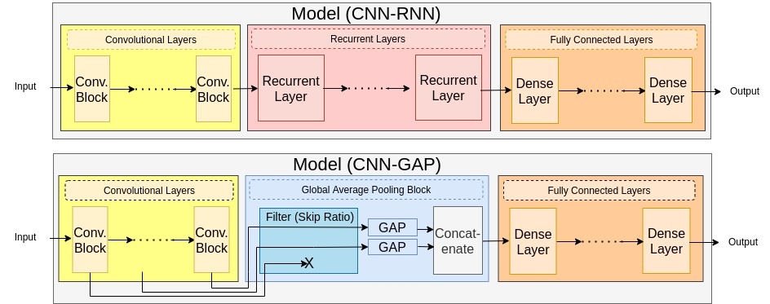
Supplementary Figure 1: The network layout optimized by GenomeNet-Architect consists of three stages: (i) A stage of stacked convolutional layers, (ii) global average pooling (GAP) (in the CNN-GAP model) or a stack of recurrent layers (in the CNN-RNN model), and (iii) a fully connected stage.

Exact number of model hyperparameters are not known before the hyperparameter optimization part. For example, if a fully connected layer is added to a model, the number of neurons in this layer is a new hyperparameter for the model. However, we need to define optimized hyperparameters before the hyperparameter optimization part so that these can be optimized at this stage. To that extent, we propose a set of hyperparameters that are not model hyperparameters themselves but still influence multiple hyperparameters of the model (see Supplementary Table 2). For example, f₀ and f_{end} influence the number of filters in any convolutional layers, although the number of convolutional layers can take a range of values. Additionally, optimizing less hyperparameters (compared to optimizing all hyperparameters) can also make the hyperparameter optimization faster.
Hyperparameter | Type | Range | Log-Search Space | Component
Learning Rate (l_{r}) | Float | [10⁻⁶,10⁻²] | ✅ | General
Reverse-Complement as Additional Input | Boolean | {True,False} |  | General
Optimizer | Categ | {Adam, Adagrad, Rmsprop, Sgd} |  | General
Model Type | Categ | {GAP, RNN} |  | General
Number of Convolutional Layers (n_{c}) | Integer | [1,20] |  | Convolutional
Number of Convolutional Blocks (n_{cb}) | Integer | [1,10] |  | Convolutional
First Kernel Size (k₀) | Float | [2⁴,2¹¹] | ✅ | Convolutional
Last Kernel Size (k_{end}) | Float | [2⁴,2¹¹] | ✅ | Convolutional
First Filter Size (f₀) | Float | [2¹,2⁶] | ✅ | Convolutional
Last Filter Size (f_{end}) | Float | [2¹,2⁶] | ✅ | Convolutional
Last Dilation Factor (d_{end}) | Float | [2⁰,2⁴] for L=150, [2⁰,2⁷] for L=10000 | ✅ | Convolutional
Total Max-Pooling (p_{end}) | Float | [2⁰,2⁴] for L=150, [2⁰,2⁷] for L=10000 | ✅ | Convolutional
Momentum of Batch-Normalization | Float | [0,0.99] |  | Convolutional
Leaky-ReLU Alpha Value | Float | [0,1] |  | Convolutional
Residual Block | Boolean | {True, False} |  | Convolutional
Number of Dense Layers | Integer | [0,5] |  | Dense
Units of Dense Layers | Float | [2⁴,2¹¹] | ✅ | Dense
Dropout | Float | [0,0.9] |  | Dense
Activation of Dense Layers | Categ | {ReLU / tanh / Sigmoid} |  | Dense
Recurrent Type | Categ | {LSTM, GRU} |  | Recurrent
Number of Recurrent Layers | Integer | [1,3] |  | Recurrent
Uni-/Bi- directional Recurrent Layers | Boolean | {True, False} |  | Recurrent
Recurrent Units | Float | [2⁴,2¹¹] |  | Recurrent
Skip Ratio for Global Average Pooling (r_{s}) | Float | [0,1] |  | GAP
Supplementary Table 2: Optimized hyperparameters, which influence the training and ultimate layout of the model, and their search space (hyperparameters are optimized between the indicated range) in the model-based optimization (MBO). Logarithmic search space indicates that the hyperparameters are originally optimized by sampling them between the log values of the indicated range and then transformed by the exponential transformation function. Boolean hyperparameter is optimized as integer value between 0 and 1. Yellow, orange, red, blue, and grey colors indicate convolution-, dense-, recurrent- (only CNN-RNN), and global average pooling- (only CNN-GAP) related hyperparameters and other hyperparameters respectively. Yellow, orange, red, blue, and grey colors indicate convolution-, dense-, recurrent- (only CNN-RNN), and global average pooling- (only CNN-GAP) related hyperparameters and other hyperparameters respectively.

We introduce how defined hyperparameters influence the model hyperparameters below with the equations and their explanations.
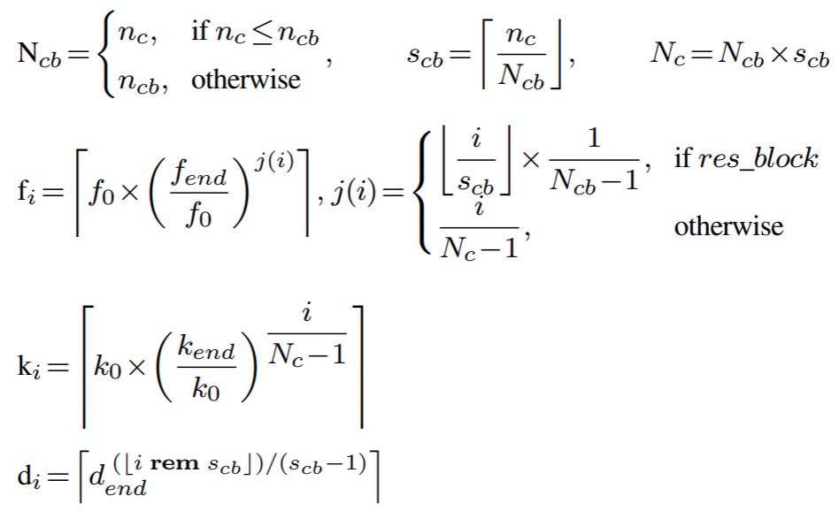
- The convolutional blocks consist of one or more convolutional layers. Since the number of convolutional blocks  should be less than the number of convolutional layers, is set to 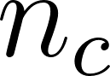 (hyperparamer related to the number of convolutional layers, which is optimized by the framework) if 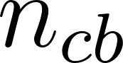 (hyperparamer related to the number of convolutional blocks, which is optimized by the framework) is bigger than or equal to . Otherwise, it is set to .
- The number of convolutional layers (size) in each convolutional block (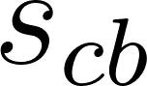) is determined by rounding the hyperparameter related to number of convolutional layers divided by the number of convolutional blocks . Rounding is necessary since the number of layers in a convolutional block must be an integer (and we also set the size of the blocks to be equal to the size of other blocks).
- The number of convolutional layers is set to the 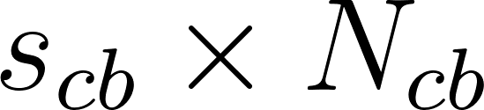.
- We set an exponential change (increase or decrease depending on 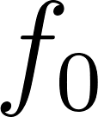 and 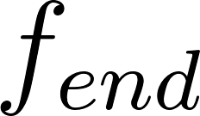) for the number of filters in the convolutional layers, with boundary conditions that the first convolutional layer has 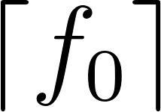 number of filters and the last convolutional layer has 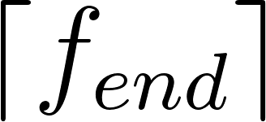 number of filters. If the model has only one convolutional layer, the number of filters are set to . If the model has residual blocks, then we keep the number of filters the same for each layer in the same block.
- We set an exponential change (increase or decrease depending on 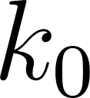 and 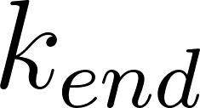) for the kernel sizes in the convolutional layers, with boundary conditions that the first convolutional layer has 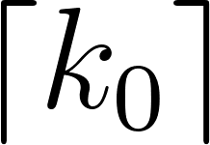 number of filters and the last convolutional layer has 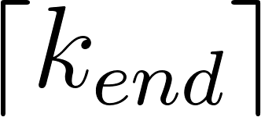 number of filters. If the model has only one convolutional layer, the kernel size is set to .
- We set an exponential increase in dilation factor so that the dilation factor of the last convolutional layer in each convolutional block has 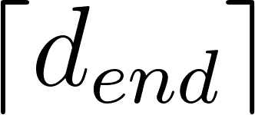 as the dilation factor, where the first convolutional layer in blocks have dilation factor of 1.
- We apply max-pooling after convolutional layers, depending on the total max-pooling factor p_{end}. The size and stride values are set to be equal to each other for any max-pooling layers. These values as well as if there will be any max-pooling layer after convolutional layers are chosen in a way that the sequence length of the output is reduced exponentially from the first layer to the last layer of the convolutional part of the model.
- For CNN-GAP, outputs from different convolutional blocks are used. Out of outputs, the last of them are fed into global average pooling layers and others are discarded.
The architecture of the model is thus designed by our defined hyperparameters.

Implementation of the optimization framework
Various challenges arise when optimizing DL architectures on complex data modalities such as genomics. First, on complex tasks, the time required for a single model to converge to a solution makes it impractically slow to optimize over a large search space like the one we have designed. A simple way to make model evaluations faster would be to limit the time for which each proposed model is trained even though models do not converge within a given timeframe, because models that perform well early during model fitting go on to perform well after more training epochs¹¹. While this reduces the time spent on individual evaluations, the resulting models can only provide an approximation of the true performance of a given hyperparameter configuration. Smaller models (that have fewer parameters therefore converge faster) might falsely appear to be superior to larger models that run for fewer epochs and can not converge in the given time limit. However, the models only trained for a short time are still informative about what parts of the search space are more likely to contain models that perform well. We can therefore use them in a “warm start” method, which accelerates the optimization process. This works by only partially evaluating initial configuration proposals at first and using the resulting data about what hyperparameters tend to perform well for short evaluation times to help determine which configurations are later evaluated for longer training times¹². We therefore run MBO first with a fixed, low setting for the model training time t=t₁ (we choose 2 hours). After a given amount of optimization iterations, we start a new MBO run with a higher setting of training time t=t₂ (we choose 6 hours), where the surrogate model contains the performance result data for t = t₁ as a “warm start”. The optimization procedure can then be restarted more times with higher values of t while including all previous points as warm start data. The models were trained for the given amount of time and afterward evaluated on the evaluation set. The resulting accuracy was used as the objective value to be optimized. For each architecture (CNN-GAP and CNN-RNN) and for each sequence length (150nt and 10,000nt), the best performing model configuration found within the optimization setting (2h, 6h) was saved and considered for further evaluation.
It is likely that optimal hyperparameters such as kernel sizes or a number of filters may vary for different sequence lengths. Similarly, optimal values might differ for CNN-GAP and CNN-RNN since and they might also change when residual blocks are used due to structural change. Therefore, we optimized models in 8 different settings, representing a fully crossed design of three binary dimensions: The lengths of the training mini-sequence (150 nt or 10,000 nt), the architecture (CNN-GAP or CNN-RNN), and whether residual connections are used (i.e., whether corresponding hyperparameter for using residual blocks is true or false). For each of the 8 settings, a model-based optimization run was started, parallelized on 3 NVidia T4 GPUs.
MBO was performed using the mlrMBO optimization software¹³ with a Gaussian process model from the DiceKriging R package¹⁴ using a Matérn-3/2 kernel¹⁵. The UCB¹⁶ infill criterion was used with sampled λ multi-point batch proposal method¹⁷.
The first t=t₁ (2 hour) optimization evaluated 1576 configurations in total, parallelized on 24 GPUs, running for 5.5 days (wall time). The warm-started t=t₂ (6 hour) optimization evaluated 816 further configurations, running for 14.0 days.

Longer Optimization Runs. As mentioned before, the optimization procedure can be restarted several times with increasing values of t (training time of each run in hyperparameter optimization) while including all previous points as warm start data. After setting the training time of the models to 2 hours and then to 6 hours in the hyperparameter optimization, we further increased the training time to 20 hours. This optimization evaluated 528 more configurations, increasing the training time by 33.1 days wall time, therefore increasing total optimization time by 170%. However, we did not observe any increase in the accuracy performance for the sequence length of 150. For sequence length of 10,000, the class-balanced misclassification error rate decreased from 1.21% to 1.11%, while the number of parameters also decreased from 3.7 million to 0.8 million (CNN-RNN-2h vs CNN-RNN-20h). However, we do not think this increase is compelling, since 0.1 percentage point change is rather small, considering the substantial increase in total optimization run-time.

Datasets
We download all complete bacterial and viral genomes from GeneBank and RefSeq using the genome updater script (https://github.com/pirovc/genome_updater) on 04-11-2020 with the arguments -d "genbank,refseq" -g "bacteria"/”viral” -c "all" and -l "Complete Genome". To filter out possible contamination consisting of plasmids and bacteriophages, we removed all genomes from the bacteria set that have more than one chromosome. We used the taxonomic metadata to split the viral set into eukaryotic or prokaryotic viruses. To assess the generalization performance of the model, we subset the genomes into training, validation and test subsets, where the training data was used for model fitting, the validation data was used to estimate generalization performance during hyperparameter optimization, and the test data was used to compare ultimate model performance and reach a conclusion. The approximate ratios of training, validation and test sets to the whole dataset are respectively 0.7, 0.2, and 0.1. Number of FASTA files in the sets and the number of non-overlapping samples are listed (see Supplementary Table 3). Listed are the number of different non-overlapping sequences that could be extracted within the datasets. However, whenever the training process reads a file again, for example in another epoch, the starting point of the sequence to sample is randomized, which results in a much larger number of possible distinct (although overlapping) samples. We used the “date of publishing” metadata to split the data by publication time, where the training data are mostly genomes published before 2020 and are validated and tested on genomes published recently. This estimates the classification performance of the models on yet unknown data when using them for newly sequenced DNA.

 | Number of FASTA Files |  |  | Number of Sequences (L = 150) |  |  | Number of Sequences (L = 10k)
Class | Training | Validation | Test | Training | Validation | Test | Training | Validation | Test
Bacteria | 15,826 | 4,523 | 2,263 | 373,404,076 | 118,398,785 | 59,111,408 | 5,579,451 | 1,772,121 | 881,031
Virus (non-Phage) | 18,093 | 5,171 | 2,588 | 2,262,526 | 568,717 | 458,526 | 20,075 | 5,552 | 5,350
Bacteriophage | 9,987 | 2,855 | 1,428 | 4,702,821 | 1,301,375 | 609,088 | 64,937 | 18,031 | 8,400
Supplementary Table 3: Number of FASTA files in the sets and the number of non-overlapping samples.

Architecture evaluation and benchmarks
Training, as well as validation, is performed by sampling random FASTA genome files and splitting them up into disjoint consecutive subsequences from a random starting point, to be used as training samples. A batch size that is a multiple of 3 (the number of target classes) is used, and the same number of samples from each class is contained in each batch. Validation set performance is evaluated in regular intervals after a predetermined number of seen samples (epochs). Number of seen samples in an epoch are set to 6,000,000 for L=150 and 600,000 for L=10,000. The trained model is evaluated on a random sample from the validation set, amounting to 50% the training epoch size. Validation set performance is used for hyperparameter optimization as well as model performance evaluation. During the model training, the typical number of batch size was 1200 for L=150 and either 120, 60 or 30 for L=10,000. We aimed to use a high batch size value, but we had to reduce the batch size when it does not fit to the GPU. The learning rate is automatically reduced by half during the model performance evaluation when the balanced accuracy on validation set does not increase by 3 epochs. We stop the training when the balanced accuracy does not increase for 10 consecutive epochs. This typically corresponds to 40/50 epochs of training for L=150 and 25/35 epochs of training for L=10,000.

References
1. Tampuu, A., Bzhalava, Z., Dillner, J. & Vicente, R. ViraMiner: Deep learning on raw DNA sequences for identifying viral genomes in human samples. PLoS One 14, e0222271 (2019).
2. Ren, J. et al. Identifying viruses from metagenomic data using deep learning. Quant Biol 8, 64–77 (2020).
3. Shang, J. & Sun, Y. CHEER: HierarCHical taxonomic classification for viral mEtagEnomic data via deep leaRning. Methods 189, 95–103 (2021).
4. Fang, Z. et al. PPR-Meta: a tool for identifying phages and plasmids from metagenomic fragments using deep learning. Gigascience 8, (2019).
5. Auslander, N., Gussow, A. B., Benler, S., Wolf, Y. I. & Koonin, E. V. Seeker: alignment-free identification of bacteriophage genomes by deep learning. Nucleic Acids Res. 48, e121 (2020).
6. Fiannaca, A. et al. Deep learning models for bacteria taxonomic classification of metagenomic data. BMC Bioinformatics 19, 198 (2018).
7. Wang, R., Zang, T. & Wang, Y. Human mitochondrial genome compression using machine learning techniques. Hum. Genomics 13, 49 (2019).
8. Kingma, D. P. & Ba, J. Adam: A Method for Stochastic Optimization. arXiv [cs.LG] (2014).
9. Stochastic Optimization. Adaptive Subgradient Methods for. https://www.jmlr.org/papers/volume12/duchi11a/duchi11a.pdf (2011).
10. Robbins, H. & Monro, S. A Stochastic Approximation Method. Ann. Math. Stat. 22, 400–407 (1951).
11. Li, L., Jamieson, K., DeSalvo, G., Rostamizadeh, A. & Talwalkar, A. Hyperband: A novel bandit-based approach to hyperparameter optimization. arXiv [cs.LG] (2016).
12. Booker, A. J. et al. A rigorous framework for optimization of expensive functions by surrogates. Structural optimization 17, 1–13 (1999).
13. Bischl, B. et al. mlrMBO: A Modular Framework for Model-Based Optimization of Expensive Black-Box Functions. arXiv [stat.ML] (2017).
14. Roustant, O., Ginsbourger, D. & Deville, Y. DiceKriging, DiceOptim: Two R Packages for the Analysis of Computer Experiments by Kriging-Based Metamodeling and Optimization. J. Stat. Softw. 51, 1–55 (2012).
15. Genton, M. G., Cristianini, N., Shawe-Taylor, J. & Williamson, R. Classes of kernels for machine learning: A statistics perspective. https://www.jmlr.org/papers/volume2/genton01a/genton01a.pdf?ref=https://githubhelp.com.
16. Srinivas, N., Krause, A., Kakade, S. M. & Seeger, M. Gaussian Process Optimization in the Bandit Setting: No Regret and Experimental Design. arXiv [cs.LG] (2009).
17. Hutter, F., Hoos, H. H. & Leyton-Brown, K. Parallel Algorithm Configuration. in Learning and Intelligent Optimization 55–70 (Springer Berlin Heidelberg, 2012).

