Supplementary Material

Acknowledgement
We thank Curtis Huttenhower and Eric A. Franzosa for helpful discussions. This work was funded in part by the German Federal Ministry of Education and Research (BMBF) under Grant No. 01IS18036A and under GenomeNet Grant No. 031L0199A/031L0199B. P.C.M. received funding from the German Research Foundation (Grant number 405892038). X.-Y. T. received funding from the German Center for Infection Research (DZIF) TI BBD.

Supplementary Results

Experiments with Scarce Labels
As shown in the main paper, we are quantifying how the model performance decreases when we successively withhold labeled samples to mimic scenarios where labels are scarce (from 100% of available labeled samples to 0.1%). For the viral dataset, our method is outperforming other four SSL methods adapted from NLP and CV, as well as the supervised baseline without any self-supervised training, at all evaluated fractions of removed labels, for the viral dataset in both cases of 150 nt and 1,000 nt (Fig. 1d and Supplementary Fig. 1a, respectively). This was also true for the DeepSEA dataset (Supplementary Fig. 1b),
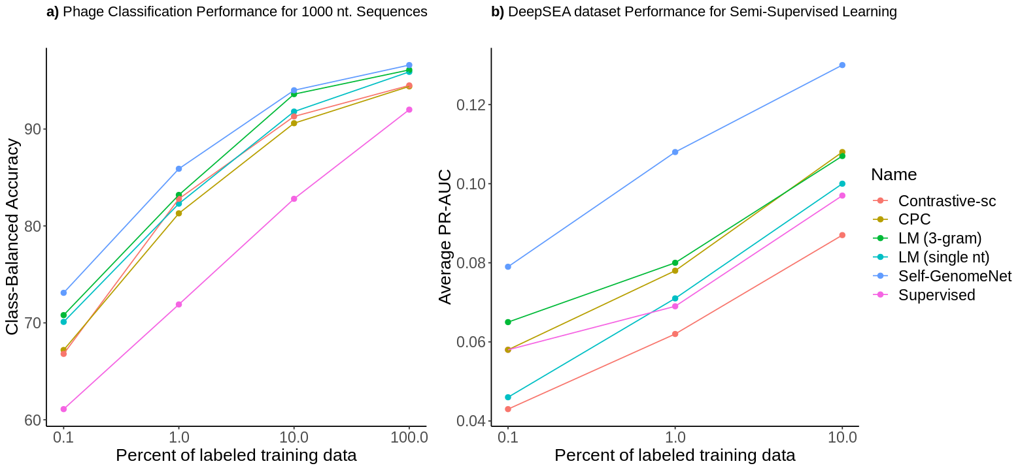
Supplementary Figure 1: Self-GenomeNet outperforms all baselines when we successively withhold labeled samples to mimic scenarios where labels are scarce (from 100% of available labeled samples to 0.1%) for a) viral dataset (1000 nt sequences) b) DeepSEA dataset.

Experiments: Freezing the Learned Weights in Self-Supervision for Downstream Tasks
One simple and efficient way to evaluate and compare the effectiveness of self-supervised methods is linear evaluation protocol. Here, the weights learned through self-supervision (without using any labels) are frozen (not updated in downstream task) and only a fully connected layer on top of frozen layers are trained on the same dataset (as downstream task). We have made this experiment and compared our method to the baselines on the Virus dataset (phage classification task) for both 150 nt. and 1,000 nt. Additionally, we similarly froze representations learned during the self-supervised pre-training on Bacteria dataset (for 1000 nt. sequences) and evaluated the performance of these representations on T6SS and Virus datasets. We show that Self-GenomeNet outperforms the baselines in all experiments and the relative increase of class-balanced accuracy against the second best-performing method is 9% on average (Supplementary Fig. 2).
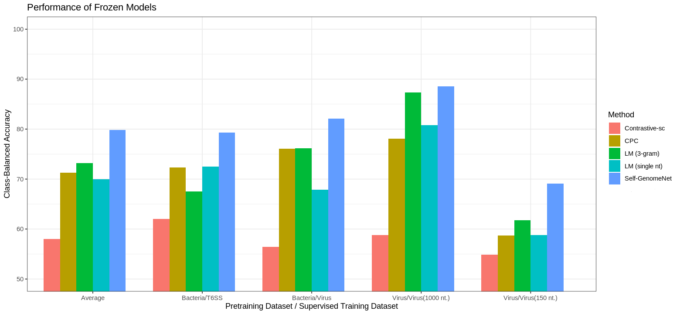Supplementary Figure 2: Self-GenomeNet outperforms the baselines in all linear evaluation protocol experiments with the frozen self-supervised weights and the relative increase of class-balanced accuracy against the second best-performing method is 9% on average.

Experiments: Fixed-Length Targets vs. Varying-Length Targets
Self-GenomeNet outperforms all other SSL methods, which predict fixed-length sequences, which may indicate the effectiveness of having targets of different length. However, we design additional experiments where we closely investigate the effect of having target sequences of different length, which is unique for our model compared to the baselines, and show that it helps the network to learn better representations. We train two self-supervised models to compare when the task is phage classification with pre-training made on the viral dataset with a sequence length is 1,000: (i) Self-GenomeNet where varying-length targets are defined as subsequences with length x ∈ {40, 60, 80, ...960} predict a subsequence with length 1,000 − x and (ii) Self-GenomeNet when only two fixed-length sequences (of 500 nt) predict each other and when other settings are equal to Self-GenomeNet. Our evaluations show that predicting varying-length subsequences (i) instead of fixed-length (ii) improves the model accuracy from 83.3% to 88.6%, when using the linear evaluation protocol, where the weights learned through self-supervision (without using any labels) are frozen (not updated in downstream task) and only a fully connected layer on top of frozen layers are trained on the same dataset (as downstream task).

Experiments: Using Reverse-Complement Neighbor Sequences as Targets to Predict
In Self-GenomeNet, the representations of reverse-complement of neighbor sequences are used as target representations to be predicted. We tested the effect of using reverse-complement neighbor sequences 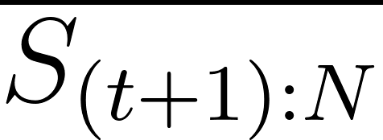 as targets (we will name this setting as “RC”) against other potential targets: neighbor sequences (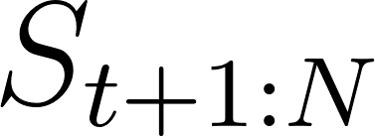) that we will name as “Forward” and reverse of neighbor sequences (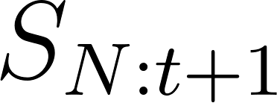) that we will name as “Reverse”. Besides Self-GenomeNet, we run both settings on the viral dataset (1,000 nt) under linear evaluation protocol (for definition, see Supplementary Material, Experiments: Freezing the Learned Weights in Self-Supervision for Downstream Tasks). On this dataset, having the reverse complements targets increased the relative class-balanced accuracy performance by 0.9% against having the reverse targets and by 3.3% against having forward targets. As the difference between reverse complement and reverse was small for this experiment, we further compared reverse complement and reverse by freezing self-supervised weights trained on Bacteria dataset and training a linear layer on top of the these weights for downstream tasks on the viral pre-training dataset (using the phage and non-phage classification task) and T6SS (effector gene prediction). We show that on these datasets, using reverse complements has a relative performance increase of 6.8% and 13.0% against reverse sequences, respectively. Therefore we show that the performance is further increased when reverse-complement targets are utilized, although the number of parameters do not increase.
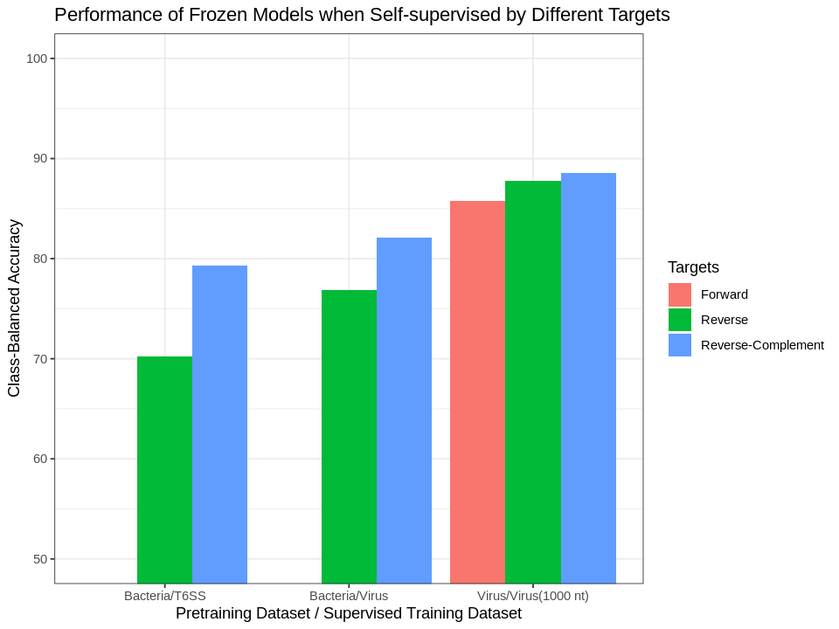
Supplementary Figure 3: Comparison of having reverse-complement targets against forward and reverse targets. Self-GenomeNet outperforms all other potential targets.

Supplementary Methods

Self-GenomeNet

The Self-GenomeNet architecture learns representations of genome sequences of varying length by encoding them in both convolutional and recurrent neural network layers, which are trained using a contrastive loss¹. The architecture enforces the symmetry using reverse-complement sequences and also makes computationally efficient use of intermediate results of the recurrent context network 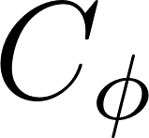. Conceptually our proposed method creates two subsequences from an input sequence by dividing it into two parts (see Supplementary Fig.4). Subsequences are encoded by a representation network composed of the convolutional encoder network 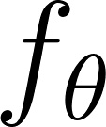, and the recurrent context network . Later, on top of the embedding representation, the linear prediction layer 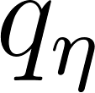 estimates the embedding of the other subsequence using a contrastive loss against random other subsequences. More specifically, given an unlabeled genome sequence of nucleotides 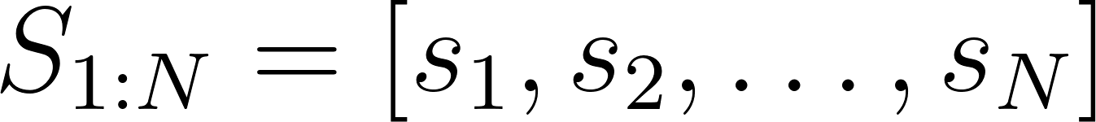 and its RC 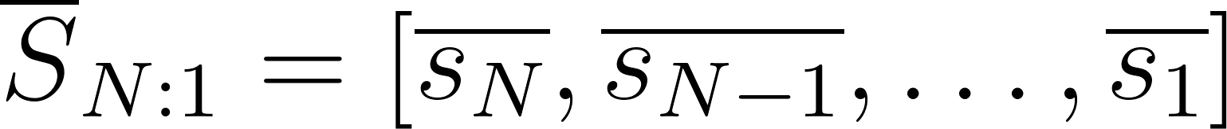, we aim to produce an embedding of a subsequence 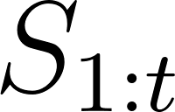 that contains the information needed to enable predicting the embedding of the RC of the remaining subsequence 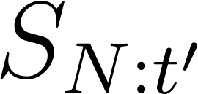, for some 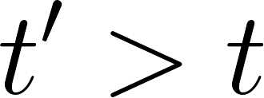. Additionally, using the same prediction layer , predicts in turn. The motivation behind such a weight-sharing strategy in the prediction layer will be justified in the next subsection. Note that 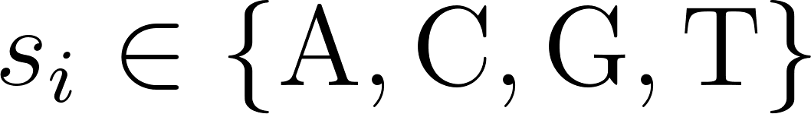 and 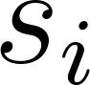 gives the complementary nucleotide, e.g. . In our experiments, we choose 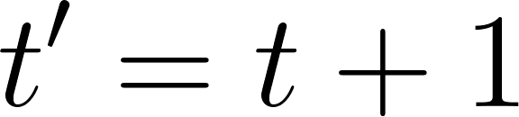.

To create the representation, the sequence is first divided into  overlapping patches 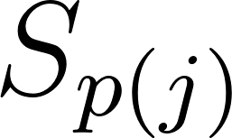 with the range indexing a subsequence, where 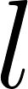 is the patch-length and  the patch stride length, and 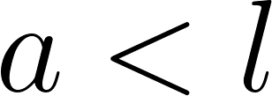 for overlapping patches. Patches are first encoded using a convolutional neural network 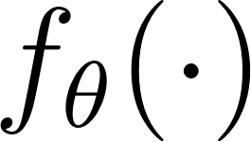. The resulting sequence of vectors is fed into a recurrent context network 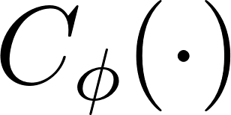, giving rise to embeddings 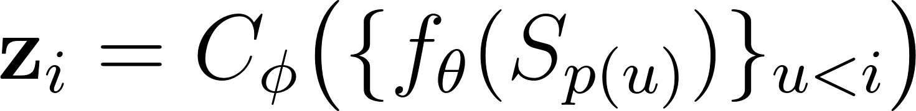 for 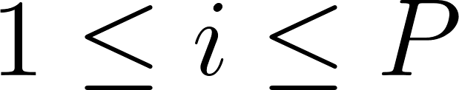. Patches of the RC, 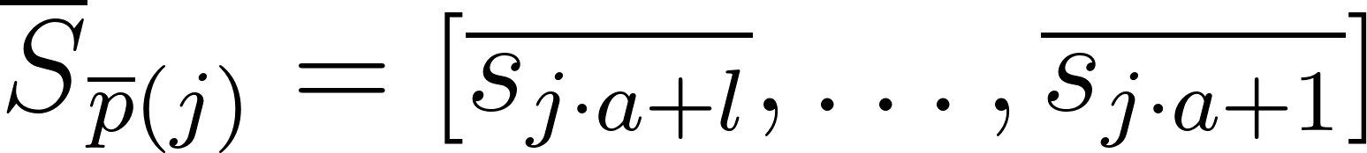 are equally fed into first then , giving rise to 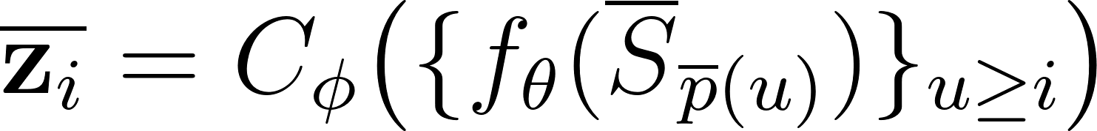. 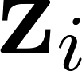 is then a representation of 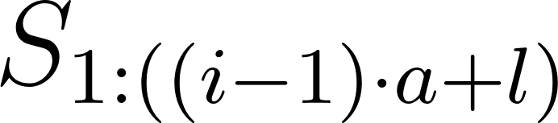; likewise, 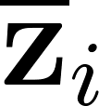 represents 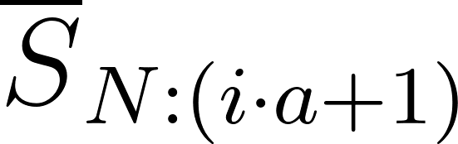.

Training the encoder and context networks consists of predicting from contrastively against corresponding embeddings from other, negative example sequences 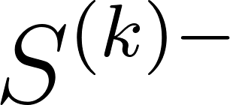, i.e. against 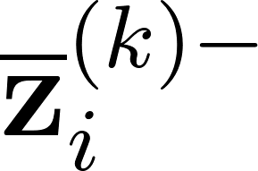. For this, a linear prediction layer and the Noise Contrastive Estimation or InfoNCE loss¹, which maximizes the mutual information shared between forward sequence and its matching reverse-complement sequence, is used:

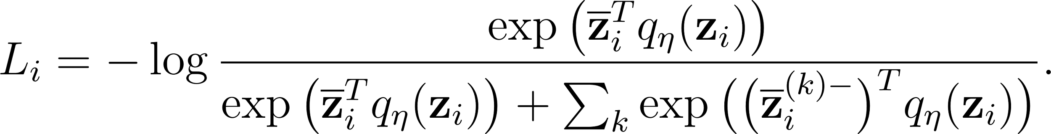

Negative samples are efficiently produced by comparing against representations of other sequences loaded in the same mini-batch. Every sequence in the minibatch produces two negative samples for other sequences, sequences themselves and their reverse-complement, giving 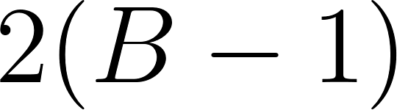 negative samples when using minibatch size .

Embeddings are always only contrasted with embeddings of sequences that have the same length as the positive sample. More precisely, 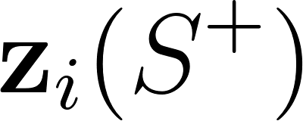 predicts 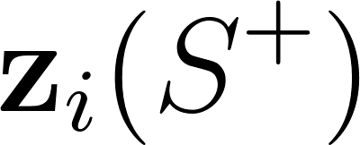 against 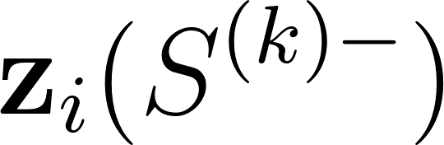 where contains negative samples (other samples in the batch and their reverse-complements) and not against 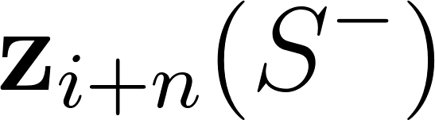 where 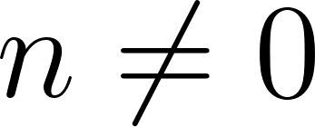. This is done in order to prevent the network from learning to encode the represented length directly to gain an advantage, which would not be an intrinsically interesting feature for downstream tasks.

One loss term is introduced for each index 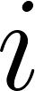, denoting the number of patches represented by . Because of the symmetry of the setup, the model is both predicting from as described above, as well as from . The corresponding loss 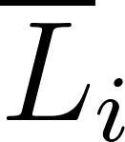, induced by prediction of from then uses negative examples with the same length as . The ultimate loss for each individual sequence 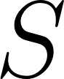 is therefore:

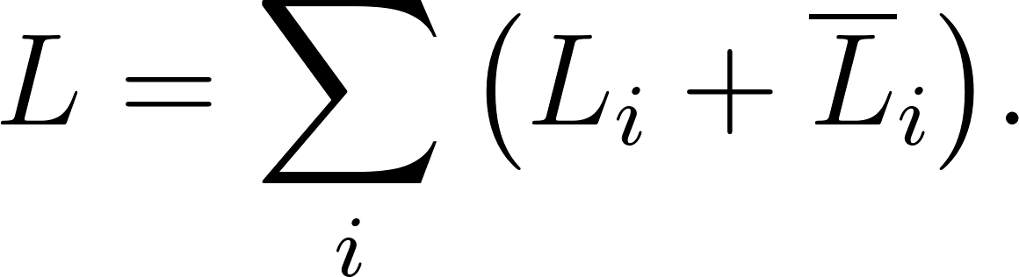

Motivation and Theory

Below, we will present our motivations to design the Self-GenomeNet as it is, whose contributions are also justified by additional experiments (see Supplementary Results).

(i) Our method learns both long- and short-range dependencies by maximizing the mutual information between varying-length subsequences and the learned representations. The self-supervision task of CPC² or generative language models³ are based on predicting representations of short, constant length target subsequences, or tokens such as one-hot encodings of N-gram or single nucleotides. Optimizing a contrastive loss by predicting future patches maximizes the lower bound of the mutual information between the patches and the embeddings². We hypothesize such target patches are often too short to contain long-range dependencies in DNA sequential data. Maximizing the mutual information between the learned representations and patches with missing long-range information may cause that the learned representations fail to contain long-range dependencies in the data. Our proposed self-supervision method maximizes the lower bound of mutual information between the embeddings 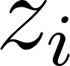 and varying-length reverse-complement targets for . The theoretical derivation of the lower bound maximization of the mutual information between targets of varying length and the learned representations can be shown by adopting the equations in CPC² as follows:

Given that is predicted from the representation , our loss is given as 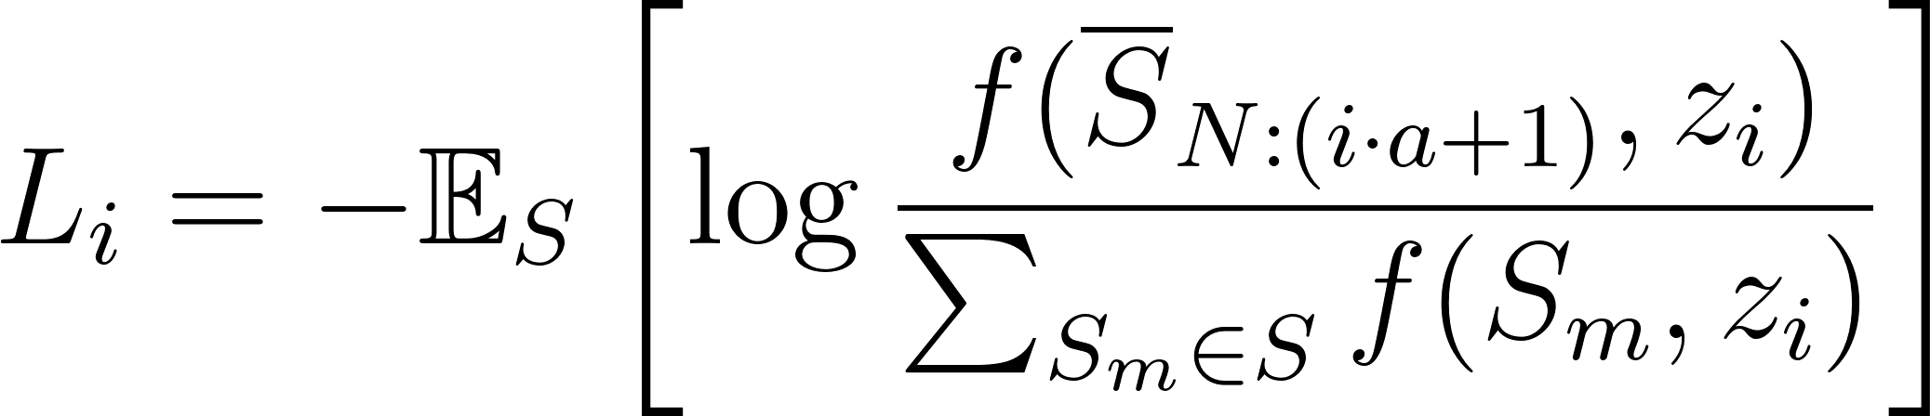

where includes (the set that contains all negative samples of the contrastive loss) and . 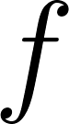 is the modeled density ratio and given as

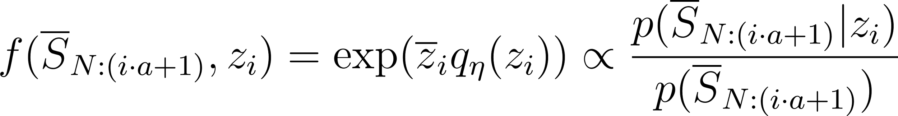.
The optimal loss is then:
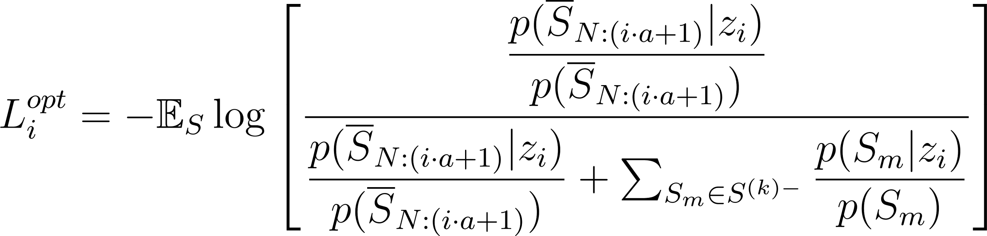
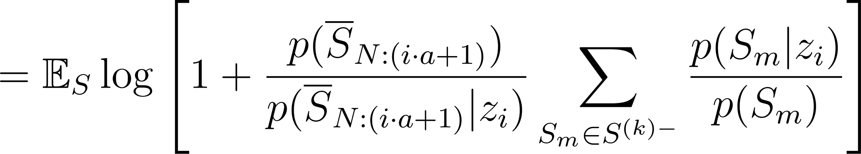
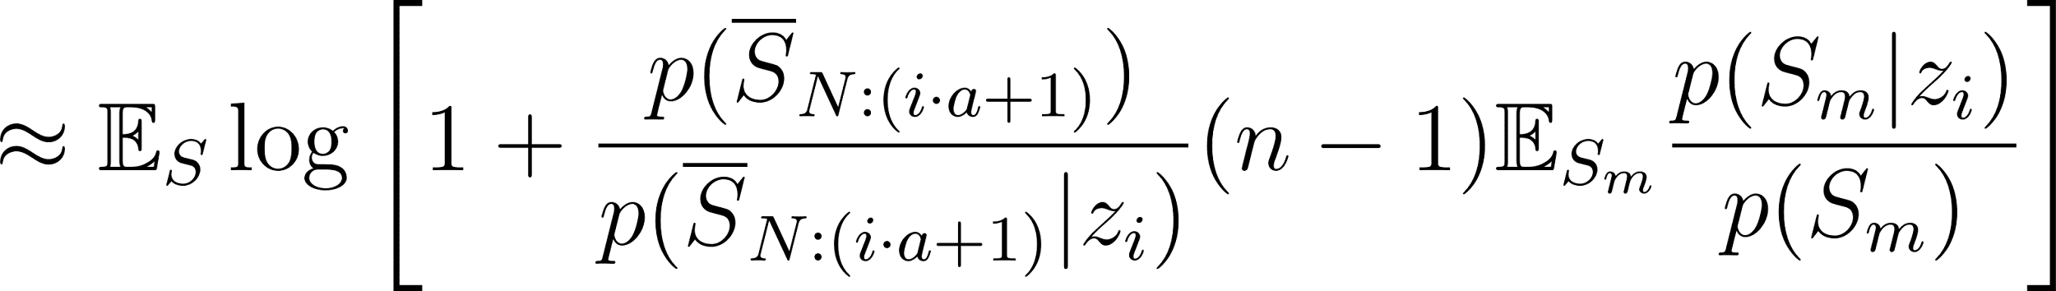
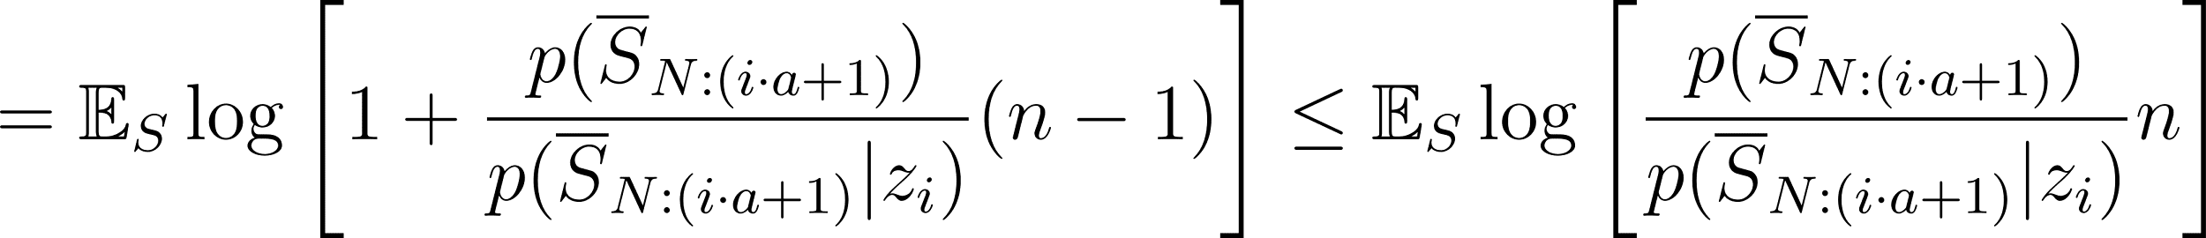.
This equals 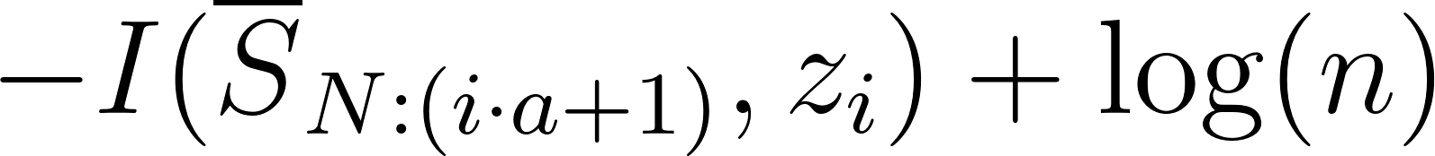. Thus, we finally show that, where 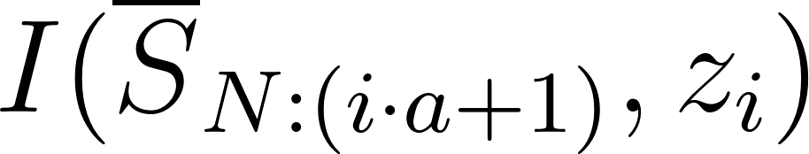 is the mutual information between the learned representation and the reverse-complement of the consecutive subsequence 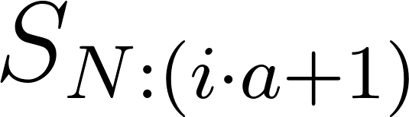. 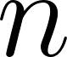 is the number of samples in the contrastive pretraining and is therefore 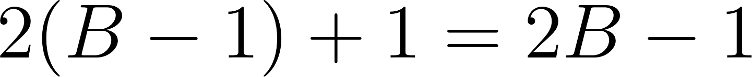. As the value of changes, the length of the predicted subsequence change. We therefore maximize the mutual information between varying-length targets and the learned representations by optimizing the loss 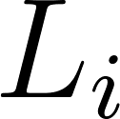 for different values of simultaneously. Thus representations learn both short and long-range semantics. Higher performance of Self-GenomeNet compared to the baselines indicates that our mutual information maximization strategy between varying-length subsequences and the learned representations is effective. However, more importantly, we also show that this strategy is beneficial in our ablation experiments, where we compare the performance of models when there are varying-length targets in the self-supervision task against having fixed-length targets, while all other parts of the self-supervision method are unchanged (see Supplementary Results).

(ii) We propose a weight-sharing strategy using the symmetry occurred by selecting the subsequences 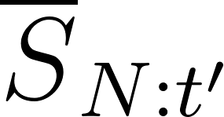 and to predict each other, which further increases the performance. The Self-GenomeNet learns to embed the meaningful information by predicting the context embedding of the reverse-complement of a neighbor subsequence from . In addition, predicts the first subsequence using the same prediction, context and encoder networks as the ones used by the network that predicts from .

As both a DNA sequence and its reverse-complement are co-existing valid genome sequences, feeding both sequences to the same machine learning model and evaluating the average of the model's decisions in order to predict regulatory and taxonomical characteristics is common for standard models in supervised training^{4,5}. Therefore feeding these two sequences to the same model such as a CNN+RNN model is a well-established practice for supervised learning tasks. Although the goal in these tasks is not to learn self-supervised representations by predicting another sequence, as our method does, these works justify the weight-sharing strategy in encoder and context networks of our architecture. We additionally propose to use the same prediction network on top in our self-supervision method since the spatial connection between to and to is identical. More precisely, while and are the reverse-complement of the future data for each other, our prediction network models the prediction of the reverse-complement of the future data in both predictions.

We would like to highlight that the subsequence pair we proposed, and , is the only subsequence pair, which can use the encoder network, context network and prediction network of shared weights when predicting each other, given that the same distribution is modeled by these networks while they are used. For example, using the same prediction network would be modelling different distributions with the same machine learning model when and 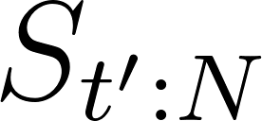 predict each other. Because while is the future data for , the vice versa does not hold. Therefore, the same prediction network should not be used to model both predictions. Similarly, the same context network should not be used if and 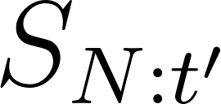 would predict each other. Because directions of and are opposite, namely while is a genome sequence, is a sequence that is read in opposite direction. Therefore, we would like to emphasize that the chosen subsequence pair, and , is carefully selected in order to follow a weight-sharing strategy. Our weight-sharing strategy is also shown to be more effective compared to other alternatives in our ablation analysis (see Supplementary Fig.3).

Comparison of Self-GenomeNet to baselines
The SSL baselines and our method are trained without using any labels. Then the models that are trained as described are further used for downstream tasks. The supervised baseline does not contain any self-supervised pre-training. Randomly initialized weights are trained for downstream tasks.
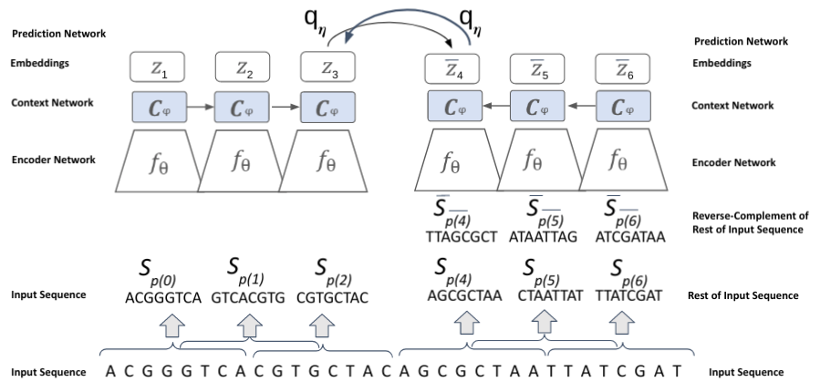
Supplementary Figure 4: Self-GenomeNet: The prediction network is used to predict representations of the RC of the neighbor sequence. The predicted sequences are of different lengths in Self-GenomeNet as the recurrent context network is able evaluate representations of such sequences efficiently. A contrastive loss is used, which means that the matching sequence is predicted among other non-matching sequences in the batch.
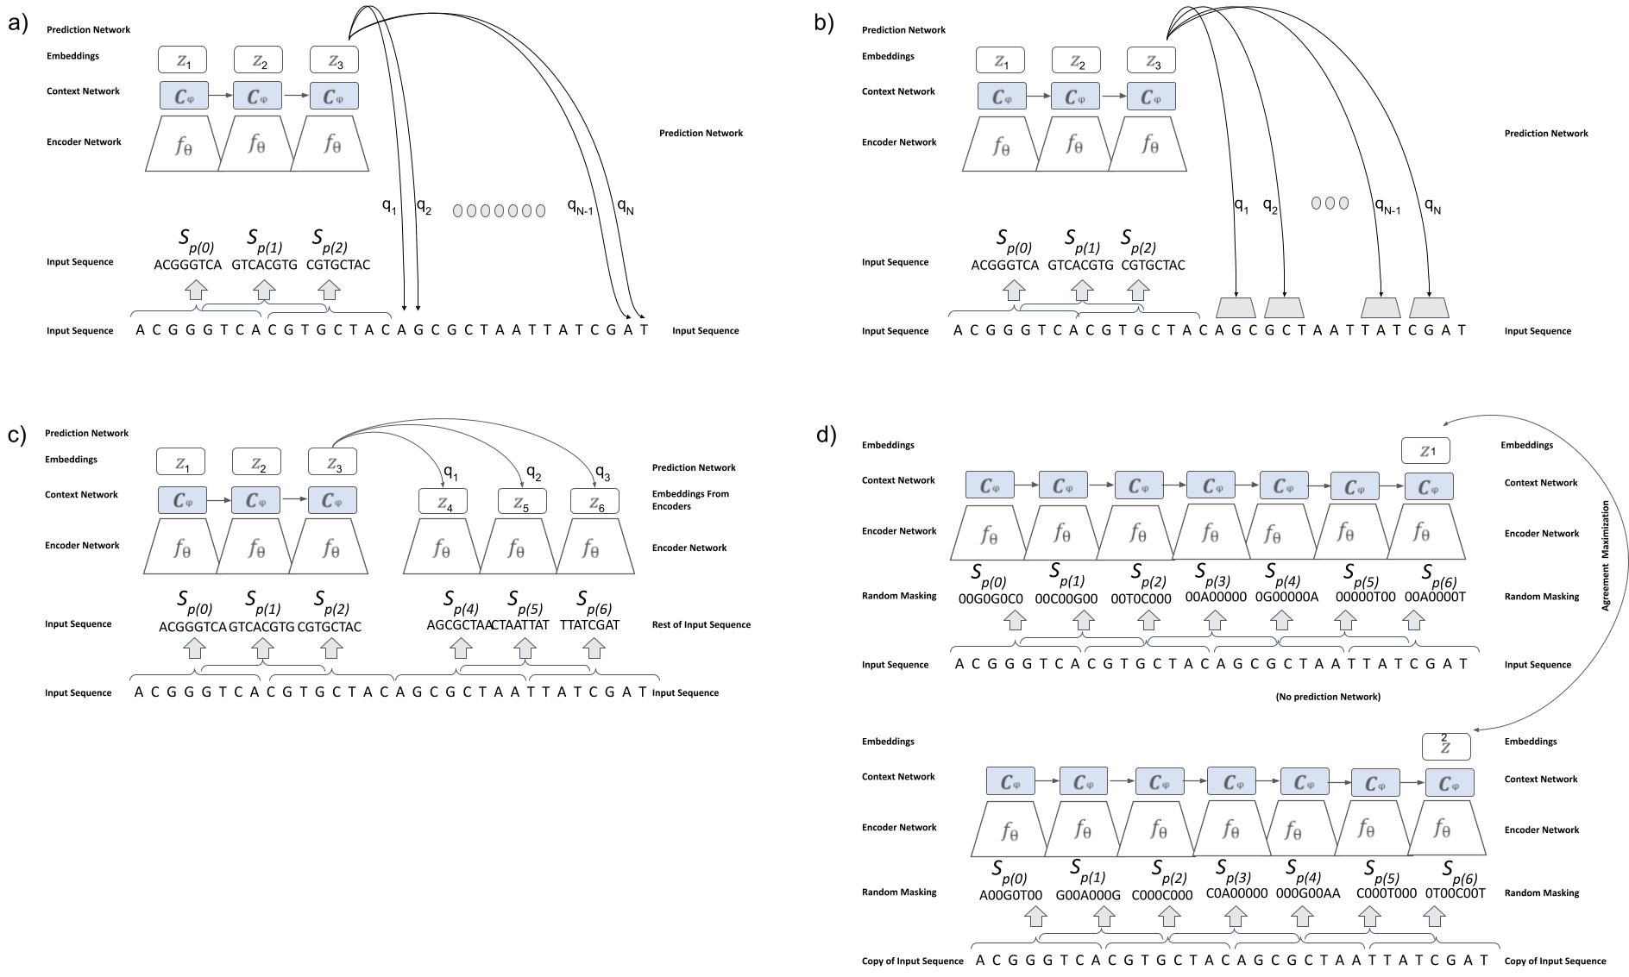
Supplementary Figure 5: a) Language Model - single nucleotide prediction (denoted as LM - single nt)³, where each nucleotide is one-hot encoded separately as a vector of 4 and predicted separately using cross-entropy loss. b) Language Model - 3-gram prediction (LM - 3-gram) : Each 3-gram (a group of 3 nucleotides) is one-hot encoded separately as a vector of 64 and predicted separately using cross-entropy loss. c) Contrastive Predictive Coding (CPC)^{2,6}: In CPC, the representations of the short and non-changing length neighbor sequences are predicted (in the figure below, these sequences contain 8 nucleotides) with a contrastive loss, which means that the matching sequence is predicted among other non-matching sequences in the batch. The representations of predicted sequences are obtained by feeding them into the encoder network. d) Contrastive-sc⁷ takes a sequence and a copy of the sequence and masks the input sequence randomly. Then, the agreement between embedding of two masked copies are maximized using the contrastive loss, which means that the copied sequences predict each other among other non-matching copied sequences in the batch.

Datasets
The DeepSEA dataset⁸ is an open benchmark dataset that many other deep learning models have evaluated before^{8–10}. It contains around 5 million subsequences of the human genome, each sample containing 1000 nucleotides as input and a label vector for 919 binary chromatin features such as transcription factor binding affinities, histone marks and DNase I sensitivity.

The Virus dataset is used as a representative of taxonomical classification tasks that often arise in metagenomics, where DNA found in environmental samples is analyzed by next generation sequencing¹¹. We downloaded all publicly available viral genomes from GenBank¹² and RefSeq¹³, divided the dataset into two taxonomic classes of bacteriophages vs. viruses that are not bacteriophages, based on provided annotations. In contrast to DeepSEA, which identifies properties of genomic regions, this task tries to differentiate an aspect of an entire given genome sequence. We allocated the downloaded FASTA files into training, validation, and test sets by approximate ratios of 70%, 20%, and 10% respectively. The bacteriophage class contained approximately 1.0 billion nucleotides, the non-phage virus dataset approximately 0.5 billion nucleotides. Samples were created from FASTA files by dividing them into same-length non-intersecting sequences.

The bacterial dataset contains bacterial genomes from GenBank¹² and RefSeq¹³, comprising approximately 83 billion nucleotides. It is only used for self-supervised pre-training. To create this dataset, we downloaded all publicly available bacteria genomes from GenBank, comprising approximately 83 billion nucleotides, and processed them similarly to how we processed the Virus dataset.

The T6SS effector protein dataset is present to demonstrate that our method works well for a real-world dataset with actual label scarcity, where the training set only contains 75 FASTA entries. It is based on publicly available bacteria data (SecReT6¹⁴) where we defined the task as the identification of effector proteins. T6SS effector proteins serve as the positive samples to identify, whereas T6SS immunity proteins, T6SS regulators, and T6SS accessory proteins are negative samples. We divided the training, validation, and test set by approximate ratios of 60%, 20%, and 20%.

Network Architecture
The particular architectures of the encoder network , as well as the context network , are hyperparameters of the method and can be chosen according to the task at hand. is a single fully connected layer with 1,024 hidden units, and for a simple LSTM layer with 512 units. For experiments trained on 150 nt sequences, the patch size, which is the number of nucleotides given to the encoder network was set to 24, and the stride (distance between the start points of patches) was set to 6, which resulted in 75% overlapping patches. For experiments trained on 1,000 nt sequences, the patch size was set to 40, and the stride to 20, resulting in 50% overlapping patches.

Model Training Process
We used the Adam optimizer¹⁵ with 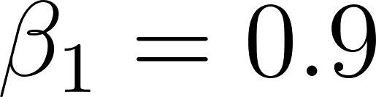, 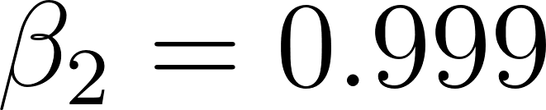 and a learning rate of 0.0001 for all experiments, except for the T6SS dataset fixed base network under transfer learning protocol in Subsection, where the learning rate was set to 0.001, as we observed 0.0001 was too low for this experiment. For weight initialization, Glorot uniform initialization¹⁶, which is the default Keras weight initialization, was chosen. The size of the minibatch was the largest possible given a GeForce RTX 2080 Ti, therefore it was set to 128 for the self-supervised pre-training and 2048 for the supervised downstream tasks. The hyperparameters, with regard to Adam or learning rate for instance, were set to the same values for all baseline experiments. When not applicable, we followed the suggested values for specific hyperparameters in the baseline papers.

References
1. Gutmann, M. U. & Hyvarinen, A. Noise-contrastive estimation of unnormalized statistical models, with applications to natural image statistics. https://www.jmlr.org/papers/volume13/gutmann12a/gutmann12a.pdf (2012).
2. van den Oord, A., Li, Y. & Vinyals, O. Representation Learning with Contrastive Predictive Coding. arXiv [cs.LG] (2018).
3. Dai, A. M. & Le, Q. V. Semi-supervised sequence learning. Adv. Neural Inf. Process. Syst. 28, (2015).
4. Quang, D. & Xie, X. FactorNet: A deep learning framework for predicting cell type specific transcription factor binding from nucleotide-resolution sequential data. Methods 166, 40–47 (2019).
5. Shrikumar, A., Greenside, P. & Kundaje, A. Reverse-complement parameter sharing improves deep learning models for genomics. bioRxiv 103663 (2017) doi:10.1101/103663.
6. Lu, A. X., Zhang, H., Ghassemi, M. & Moses, A. Self-Supervised Contrastive Learning of Protein Representations By Mutual Information Maximization. bioRxiv 2020.09.04.283929 (2020) doi:10.1101/2020.09.04.283929.
7. Ciortan, M. & Defrance, M. Contrastive self-supervised clustering of scRNA-seq data. BMC Bioinformatics 22, 280 (2021).
8. Zhou, J. & Troyanskaya, O. G. Predicting effects of noncoding variants with deep learning-based sequence model. Nat. Methods 12, 931–934 (2015).
9. Kelley, D. R. et al. Sequential regulatory activity prediction across chromosomes with convolutional neural networks. Genome Res. 28, 739–750 (2018).
10. Quang, D. & Xie, X. DanQ: a hybrid convolutional and recurrent deep neural network for quantifying the function of DNA sequences. Nucleic Acids Res. 44, e107 (2016).
11. Pust, M.-M. & Tümmler, B. Identification of core and rare species in metagenome samples based on shotgun metagenomic sequencing, Fourier transforms and spectral comparisons. ISME Communications 1, 1–4 (2021).
12. Clark, K., Karsch-Mizrachi, I., Lipman, D. J., Ostell, J. & Sayers, E. W. GenBank. Nucleic Acids Res. 44, D67–72 (2016).
13. O’Leary, N. A. et al. Reference sequence (RefSeq) database at NCBI: current status, taxonomic expansion, and functional annotation. Nucleic Acids Res. 44, D733–45 (2016).
14. Li, J. et al. SecReT6: a web-based resource for type VI secretion systems found in bacteria. Environ. Microbiol. 17, 2196–2202 (2015).
15. Kingma, D. P. & Ba, J. Adam: A Method for Stochastic Optimization. arXiv [cs.LG] (2014).
16. Glorot, X. & Bengio, Y. Understanding the difficulty of training deep feedforward neural networks. in Proceedings of the Thirteenth International Conference on Artificial Intelligence and Statistics (eds. Teh, Y. W. & Titterington, M.) vol. 9 249–256 (PMLR, 13--15 May 2010).

