Supplementary Materials
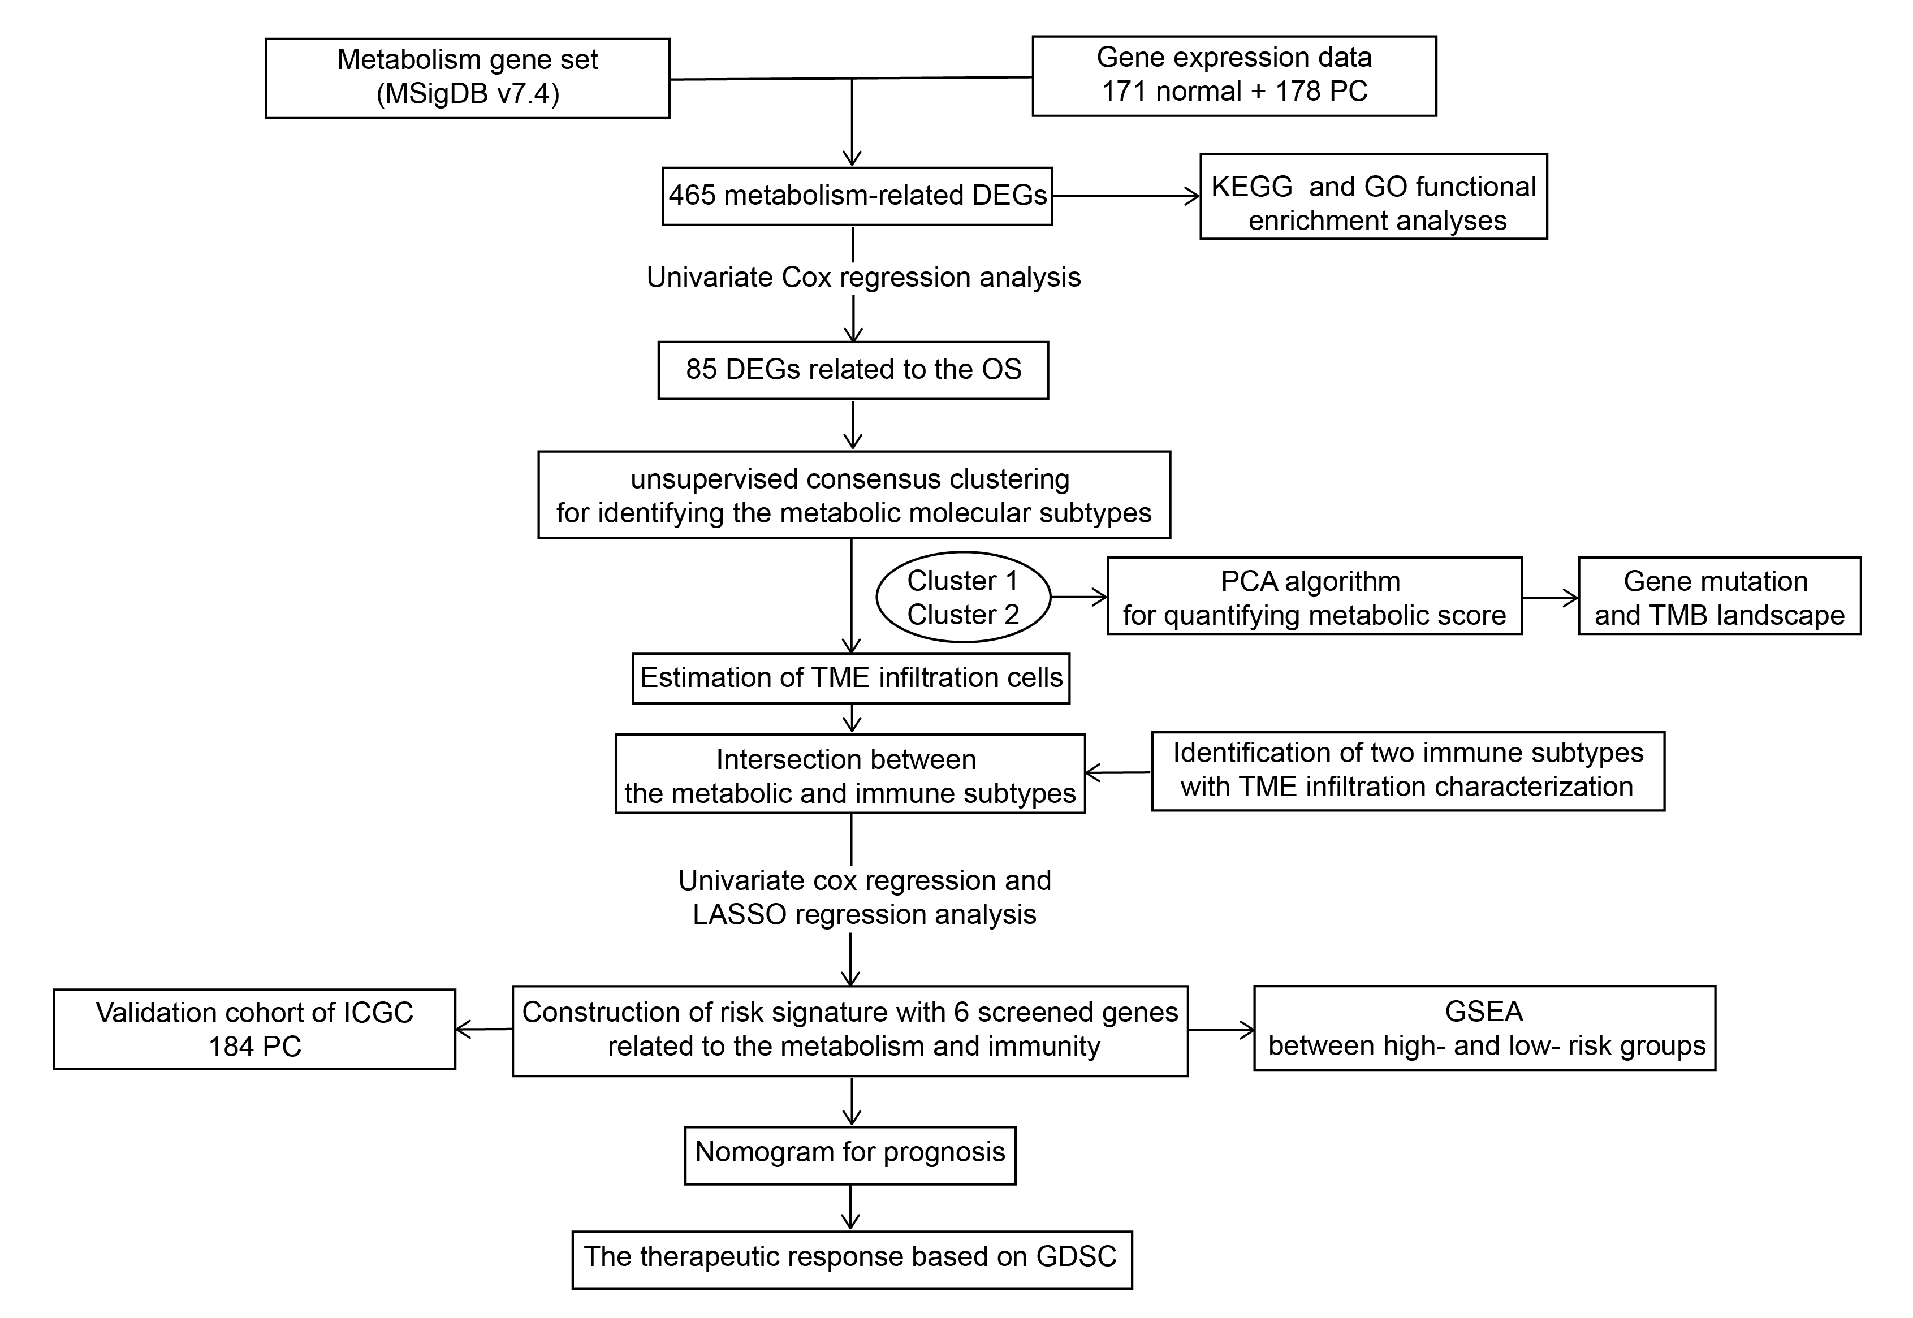
Supplementary Figure 1. Flowchart of this study.
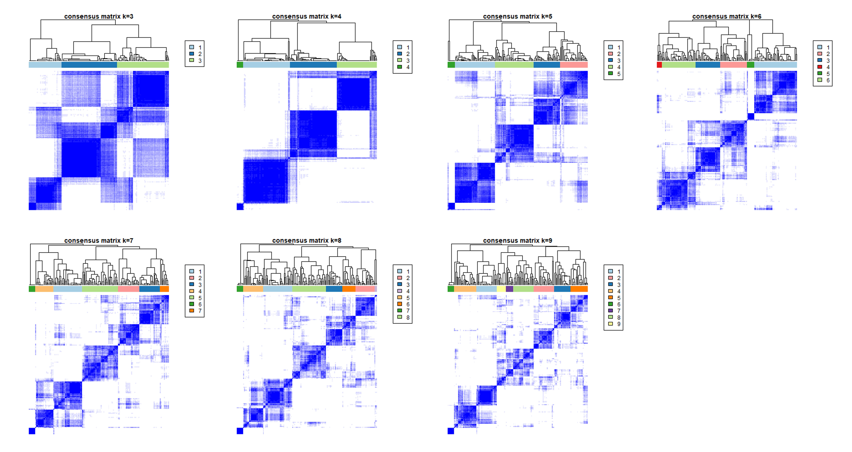
Supplementary Figure 2. Consensus heatmaps of the TCGA cohort for k = 3-9.
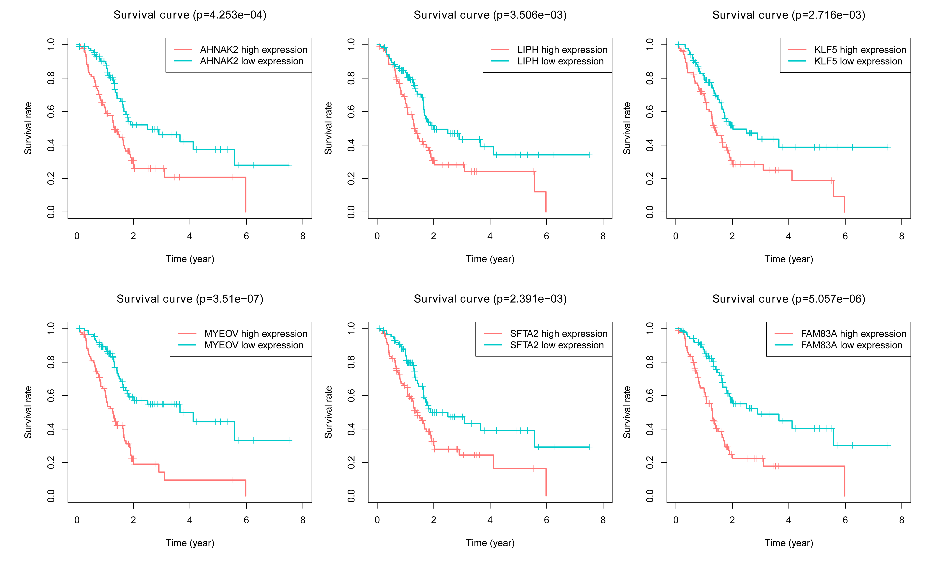
Supplementary Figure 3. Kaplan-Meier survival analyses of the PC patients with high/low expression of the 6 screened genes in the TCGA cohort.
Supplementary Figure 4. Kaplan-Meier survival analyses of the PC patients in the high- and low-risk groups with the different clinical factors including age (A), gender (B), N stage (C), and T stage (D).
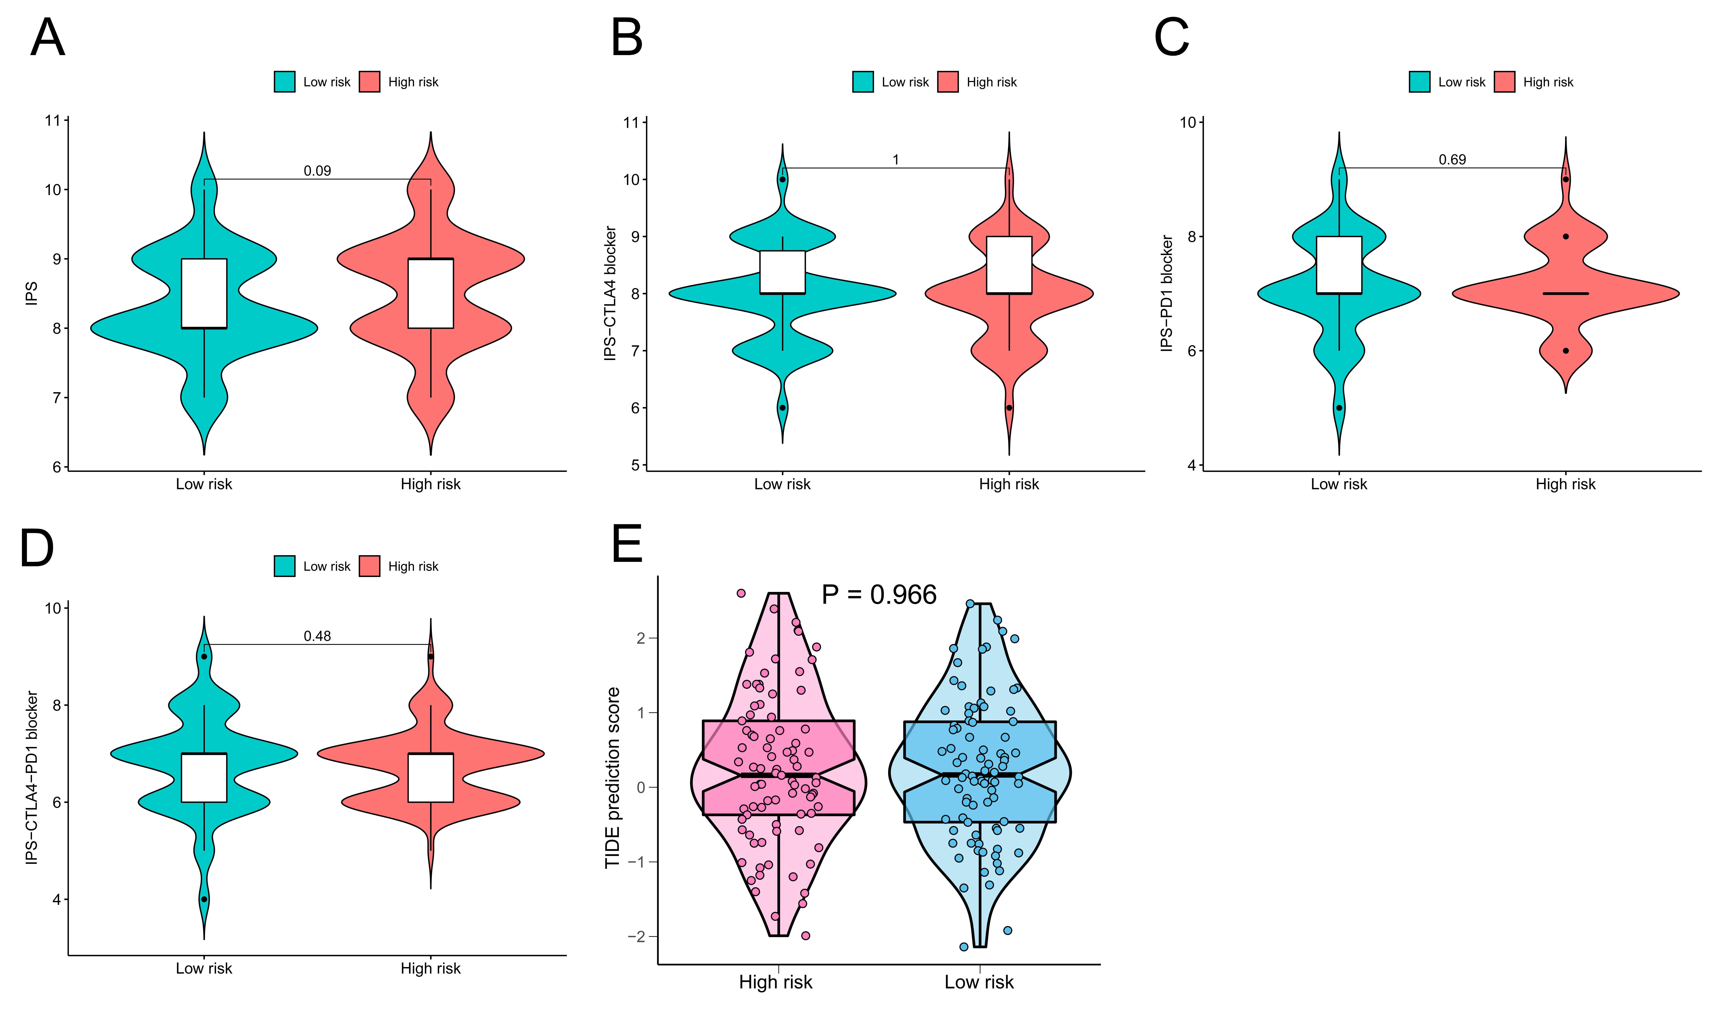
Supplementary Figure 5. Comparisons of the IPS (A), IPS-CTLA4 (B), IPS-PD1 (C), and IPS-PD1-CTLA4 (D) scores between the high-risk and low-risk groups. (E) Comparison of the TIDE prediction scores between the high-risk and low-risk groups.
Supplementary Table 1. Summary of the clinical characteristics in the TCGA cohort.
Supplementary Table 2. The list of primer sequences in the analysis
Supplementary Table 3. Univariate cox regression analysis of candidate prognostic genes.

