Clinical Features and Genomic Landscape of Myeloproliferative Neoplasm (MPN) Patients with Autoimmune and Inflammatory Diseases

Supplementary materials

Supplementary Figures:
Supplementary Figure 1: Impact of AID association on MPN patient's outcome according to MPN subtype.

Supplementary Tables:
Supplementary Table 1: List of 36 myeloid malignancies-related genes used for targeted next-generation sequencing.
Supplementary Table 2: Detailed AID response criteria.
Supplementary Table 3: Detailed MPN characteristics stratified by AID subgroups.
Supplementary Table 4: Detailed AID clinical and biological features stratified by AID subgroups.
Supplementary Table 5: Additional somatic mutations according to MPN subgroup and presence of associated AID.
Supplementary Table 6: Detailed somatic mutations according to MPN subgroup and presence of associated AID.

Supplementary Figure 1: Impact of AID association on MPN patient's outcome according to MPN subtype. (A) Overall survival (OS), (B) MDS/AML transformation-free survival (TFS), (C) Myelofibrosis-free survival (MFS). MPN patients with AID (red lines) are compared to control MPN patients without AID (blue lines).
Myelofibrosis-free survival analysis was performed excluding patients with primary myelofibrosis.
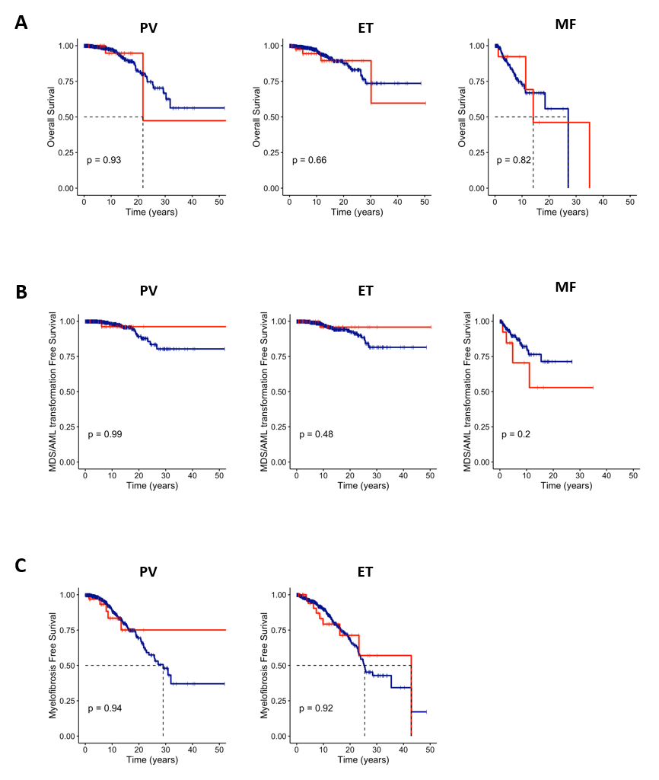

Supplementary Table 1: List of 36 myeloid malignancies-related genes used for targeted next-generation sequencing.

Gene | Reference
ABL1 | NM_005157
ASXL1 | NM_015338
BRAF | NM_004333
CALR | NM_004343
CBL | NM_005188
CCND2 | NM_001759
CEBPA | NM_004364
CSF3R | NM_156039
CUX1 | NM_001913
DNMT3A | NM_022552
ETNK1 | NM_018638
ETV6 | NM_001987
EZH2 | NM_004456
FLT3 | NM_004119
HRAS | NM_005343
IDH1 | NM_005896
IDH2 | NM_002168
IKZF1 | NM_006060
JAK2 | NM_004972
KIT | NM_000222
KRAS | NM_033360
MPL | NM_005373
NFE2 | NM_001261461
NPM1 | NM_002520
NRAS | NM_002524
PTPN11 | NM_002834
RUNX1 | NM_001754
SETBP1 | NM_015559
SF3B1 | NM_012433
SH2B3 | NM_005475
SRSF2 | NM_003016
TET2 | NM_001127208
TP53 | NM_001126112
U2AF1 | NM_006758
WT1 | NM_024426
ZRSR2 | NM_005089

Supplementary Table 2: Detailed AID response criteria.
AID: autoimmune and inflammatory disorder
AID response criteria
Clinical response:
— Complete: absence of new signs and complete disappearance of previous clinical signs
— Partial: >50% improvement of previous signs
— No response: appearance of new signs and/or clinical improvement less than 50%
Biological response:
— Complete: negativation of acute phase reactants (e.g., serum c-reactive protein)
— Partial: acute phase reactants decrease >50%
— No response: acute phase reactants increase and/or decrease <50%
Immunological response (if appropriate):
— Complete: normalization of the disease-specific immunological parameters (e.g., anti-dsDNA antibodies in systemic lupus erythematosus)
— Partial: decrease of >50%
— No response: increase and/or decrease <50%

Supplementary Table 3: Detailed MPN characteristics stratified by AID subgroups.
AID: autoimmune and inflammatory disease; ET: essential thrombocythemia; Hb: hemoglobin; Hte: hematocrit; PV: polycythemia vera; MDS: myelodysplastic neoplasm; MF: myelofibrosis; MPN: myeloproliferative neoplasm. The number of patients and proportion (within the total number of patients with AID, n=95) are described.

 | Organe specific diseases  (n=41, 43%) | Unclassified (n=18, 19%) | Inflammatory arthritis  (n=13, 14%) | Connective tissue disease (n=9, 9%) | Dermatosis (n=8, 8%) | Systemic vasculitis  (n=6, 6%)
Sex
Female | 29 (70.7%) | 13 (72.2%) | 8 (61.5%) | 5 (55.6%) | 4 (50.0%) | 3 (50.0%)
Male | 12 (29.3%) | 5 (27.8%) | 5 (38.5%) | 4 (44.4%) | 4 (50.0%) | 3 (50.0%)
Age at MPN diagnosis (median [IQR]) | 50.3 [41.3, 60.7] | 51.2 [46.6, 69.9] | 49.7 [38.9, 67.15] | 60.2 [48.8, 63.25] | 56.4 [51.8, 71] | 64.2 [61.9, 73.2]
MPN subtype, nb (%)
PV | 14 (34.1%) | 7 (38.9%) | 4 (30.8%) | 2 (22.2%) | 3 (37.5%) | 3 (50.0%)
ET | 20 (48.8%) | 9 (50.0%) | 6 (46.2%) | 4 (44.4%) | 4 (50.0%) | 2 (33.3%)
MF | 6 (14.6%) | 1 (5.6%) | 3 (23.1%) | 2 (22.2%) | 1 (12.5%) | 0 (0%)
MDS/MPN | 0 (0%) | 0 (0%) | 0 (0%) | 0 (0%) | 0 (0%) | 0 (0%)
MPN unclassified | 1 (2.4%) | 1 (5.6%) | 0 (0%) | 1 (11.1%) | 0 (0%) | 1 (16.7%)
MPN
JAK2 | 30 (73.2%) | 14 (77.8%) | 10 (76.9%) | 5 (55.6%) | 5 (62.5%) | 5 (83.3%)
CALR | 7 (17.1%) | 3 (16.7%) | 2 (15.4%) | 2 (22.2%) | 2 (25.0%) | 1 (16.7%)
MPL | 2 (4.9%) | 0 (0%) | 1 (7.7%) | 1 (11.1%) | 0 (0%) | 0 (0%)
Triple negative | 2 (4.9%) | 1 (5.6%) | 0 (0%) | 1 (11.1%) | 1 (12.5%) | 0 (0%)

Supplementary Table 4: Detailed AID clinical and biological features stratified by AID subgroups.
ACPA: anti-citrullinated protein antibodies, ANA: antinuclear antibodies, aPLs: antiphospholipid antibodies, ENA: extractable nuclear, ENT: ear, nose and throat; RF: rheumatoid factor.
 | Organ specific diseases | Unclassified | Inflammatory arthritis | Connective tissue disease | Dermatosis | Systemic vasculitis | Overall
CLINICAL AID MANIFESTATIONS | N=35 | N=13 | N=11 | N=8 | N=5 | N=5 | N=77/103
Cutaneous | 1 (3%) | 2 (15%) | 3 (27%) | 6 (75%) | 5 (100%) | 1 (20%) | 18 (23%)
Cardiovascular | 0 (0%) | 11 (85%) | 0 (0%) | 3 (38%) | 0 (0%) | 2 (40%) | 16 (21%)
Articular and muscular | 1 (3%) | 1 (8%) | 8 (73%) | 2 (25%) | 0 (0%) | 3 (60%) | 15 (19%)
Digestive | 6 (17%) | 0 (0%) | 0 (0%) | 0 (0%) | 0 (0%) | 2 (40%) | 8 (10%)
Eye and ENT | 1 (3%) | 1 (8%) | 0 (0%) | 0 (0%) | 0 (0%) | 3 (60%) | 5 (6%)
Constitutional symptoms | 1 (3%) | 0 (0%) | 0 (0%) | 0 (0%) | 0 (0%) | 3 (60%) | 4 (5%)
Periperal and central nervous system | 1 (3%) | 0 (0%) | 0 (0%) | 0 (0%) | 0 (0%) | 2 (40%) | 3 (4%)
Pulmonary | 0 (0%) | 0 (0%) | 0 (0%) | 1 (13%) | 0 (0%) | 1 (20%) | 2 (3%)
Kidney | 1 (3%) | 0 (0%) | 0 (0%) | 0 (0%) | 0 (0%) | 0 (0%) | 1 (1%)
BIOLOGICAL AID FEATURES | N=22 | N=9 | N=8 | N=8 | N=1 | N=2 | N=56/103
Anti-thyroid antibodies | 10 (45%) | 0 (0%) | 0 (0%) | 0 (0%) | 0 (0%) | 0 (0%) | 10 (18%)
ANA | 4 (18%) | 4 (44%) | 1 (13%) | 1 (13%) | 0 (0%) | 0 (0%) | 10 (18%)
RF | 0 (0%) | 1 (11%) | 4 (50%) | 1 (13%) | 0 (0%) | 0 (0%) | 6 (11%)
aPLs | 0 (0%) | 0 (0%) | 0 (0%) | 4 (50%) | 0 (0%) | 0 (0%) | 4 (7%)
ACPA | 0 (0%) | 0 (0%) | 3 (38%) | 0 (0%) | 0 (0%) | 0 (0%) | 3 (5%)
ENA antibodies | 0 (0%) | 2 (22%) | 0 (0%) | 1 (13%) | 0 (0%) | 0 (0%) | 3 (5%)
HLA B27 | 0 (0%) | 0 (0%) | 2 (25%) | 0 (0%) | 0 (0%) | 0 (0%) | 2 (4%)
Angiotensin converting enzyme | 0 (0%) | 0 (0%) | 0 (0%) | 1 (13%) | 0 (0%) | 0 (0%) | 1 (2%)

Supplementary Table 5: Additional somatic mutations according to MPN subgroup and presence of associated AID.
AID: autoimmune and inflammatory disease; HMR: high molecular risk

 | PV |  |  | ET |  |  | MF
 | Without AID (N=318) | With AID (N=26) | p value | Without AID (N=435) | With AID (N=28) | p value | Without AID (N=148) | With AID (N=7) | p value
Additional mutations | 199 (62.6%) | 15 (57.7%) | 0.78 | 231 (53.1%) | 17 (60.7%) | 0.56 | 123 (83.1%) | 6 (85.7%) | 1
HMR mutations (ASXL1, EZH2, SRSF2, IDH1/2) | 58 (18.2%) | 3 (11.5%) | 0.59 | 59 (13.5%) | 5 (17.9%) | 0.72 | 82 (55.4%) | 4 (57.1%) | 1
Epigenetic mutations (TET2, IDH1/2, DNMT3A, ASXL1) | 130 (40.9%) | 8 (30.8%) | 0.42 | 144 (33.1%) | 11 (39.3%) | 0.64 | 61 (41.2%) | 5 (71.4%) | 0.14
Transcription factors mutations (RUNX1, CUX1, TP53) | 21 (6.6%) | 3 (11.5%) | 0.58 | 29 (6.7%) | 2 (7.1%) | 1 | 14 (9.5%) | 2 (28.6%) | 0.32
Spliceosome mutation (SRSF2, EZH2, SF3B1, U2AF1, ZRSR2) | 65 (20.4%) | 2 (7.7%) | 0.19 | 68 (15.6%) | 5 (17.9%) | 0.79 | 98 (66.2%) | 5 (71.4%) | 1
Signaling mutations (CBL, NRAS, KRAS) | 14 (4.4%) | 2 (7.7%) | 0.34 | 27 (6.2%) | 1 (3.6%) | 1 | 19 (12.8%) | 3 (42.9%) | 0.09

Supplementary Table 6: Detailed somatic mutations according to MPN subgroup and presence of associated AID.
AID: autoimmune and inflammatory disease

 | PV |  |  | ET |  |  | MF
 | Without AID (N=318) | With AID (N=26) | p value | Without AID (N=435) | With AID (N=28) | p value | Without AID (N=148) | With AID (N=7) | p value
JAK2 | 307 (96.5%) | 26 (100%) | 1 | 240 (55.2%) | 15 (53.6%) | 1 | 85 (57.4%) | 4 (57.1%) | 1
MPL | 0 (0%) | 0 (0%) | . | 22 (5.1%) | 1 (3.6%) | 1 | 13 (8.8%) | 2 (28.6%) | 0.138
TET2 | 79 (24.8%) | 5 (19.2%) | 0.687 | 81 (18.6%) | 9 (32.1%) | 0.132 | 41 (27.7%) | 5 (71.4%) | 0.025
ASXL1 | 40 (12.6%) | 2 (7.7%) | 0.754 | 44 (10.1%) | 3 (10.7%) | 0.756 | 71 (48.0%) | 3 (42.9%) | 1
EZH2 | 14 (4.4%) | 1 (3.8%) | 1 | 14 (3.2%) | 1 (3.6%) | 0.614 | 15 (10.1%) | 0 (0%) | 1
IDH1 | 2 (0.6%) | 0 (0%) | 1 | 4 (0.9%) | 1 (3.6%) | 0.269 | 2 (1.4%) | 1 (14.3%) | 0.13
IDH2 | 6 (1.9%) | 1 (3.8%) | 0.426 | 7 (1.6%) | 0 (0%) | 1 | 4 (2.7%) | 1 (14.3%) | 0.209
CSF3R | 1 (0.3%) | 0 (0%) | 1 | 1 (0.2%) | 0 (0%) | 1 | 2 (1.4%) | 0 (0%) | 1
SRSF2 | 2 (0.6%) | 0 (0%) | 1 | 4 (0.9%) | 0 (0%) | 1 | 7 (4.7%) | 2 (28.6%) | 0.054
CALR | 2 (0.6%) | 0 (0%) | 1 | 105 (24.1%) | 8 (28.6%) | 0.762 | 39 (26.4%) | 1 (14.3%) | 0.678
DNMT3A | 69 (21.7%) | 3 (11.5%) | 9.339 | 71 (16.3%) | 4 (14.3%) | 1 | 23 (15.5%) | 1 (14.3%) | 1
SH2B3 | 17 (5.3%) | 2 (7.7%) | 0.645 | 23 (5.3%) | 3 (10.7%) | 0.202 | 10 (6.8%) | 1 (14.3%) | 0.409
NRAS | 3 (0.9%) | 1 (3.8%) | 0.271 | 3 (0.7%) | 0 (0%) | 1 | 6 (4.1%) | 0 (0%) | 1
NFE2 | 24 (7.5%) | 3 (11.5%) | 0.444 | 16 (3.7%) | 0 (0%) | 0.614 | 6 (4.1%) | 1 (14.3%) | 0.281
TP53 | 16 (5.0%) | 1 (3.8%) | 1 | 21 (4.8%) | 2 (7.1%) | 0.642 | 10 (6.8%) | 0 (0%) | 1
KRAS | 4 (1.3%) | 0 (0%) | 1 | 2 (0.5%) | 0 (0%) | 1 | 3 (2.0%) | 1 (14.3%) | 0.17
SETBP1 | 0 (0%) | 0 (0%) | . | 0 (0%) | 0 (0%) | . | 4 (2.7%) | 0 (0%) | 1
U2AF1 | 3 (0.9%) | 0 (0%) | 1 | 8 (1.8%) | 2 (7.1%) | 0.117 | 19 (12.8%) | 0 (0%) | 0.598
CBL | 7 (2.2%) | 1 (3.8%) | 0.47 | 24 (5.5%) | 1 (3.6%) | 1 | 12 (8.1%) | 2 (28.6%) | 0.123
IKZF1 | 1 (0.3%) | 0 (0%) | 1 | 0 (0%) | 0 (0%) | . | 0 (0%) | 0 (0%) | .
SF3B1 | 11 (3.5%) | 1 (3.8%) | 1 | 11 (2.5%) | 0 (0%) | 1 | 11 (7.4%) | 2 (28.6%) | 0.107
CEBPa | 0 (0%) | 0 (0%) | . | 1 (0.2%) | 0 (0%) | 1 | 0 (0%) | 0 (0%) | .
CUX1 | 6 (1.9%) | 2 (7.7%) | 0.116 | 8 (1.8%) | 0 (0%) | 1 | 4 (2.7%) | 1 (14.3%) | 0.209
ZRSR2 | 3 (0.9%) | 0 (0%) | 1 | 3 (0.7%) | 0 (0%) | 1 | 7 (4.7%) | 0 (0%) | 1
KIT | 0 (0%) | 0 (0%) | . | 0 (0%) | 0 (0%) | . | 0 (0%) | 0 (0%) | .
BRAF | 1 (0.3%) | 0 (0%) | 1 | 2 (0.5%) | 0 (0%) | 1 | 0 (0%) | 0 (0%) | .
FLT3 | 0 (0%) | 0 (0%) | . | 1 (0.2%) | 0 (0%) | 1 | 0 (0%) | 0 (0%) | .
ABL1 | 0 (0%) | 0 (0%) | . | 0 (0%) | 0 (0%) | . | 0 (0%) | 0 (0%) | .
HRAS | 0 (0%) | 0 (0%) | . | 0 (0%) | 0 (0%) | . | 0 (0%) | 0 (0%) | .
NPM1 | 0 (0%) | 0 (0%) | . | 0 (0%) | 0 (0%) | . | 0 (0%) | 0 (0%) | .
PTPN11 | 1 (0.3%) | 0 (0%) | 1 | 2 (0.5%) | 0 (0%) | 1 | 2 (1.4%) | 0 (0%) | 1
RUNX1 | 1 (0.3%) | 0 (0%) | 1 | 2 (0.5%) | 0 (0%) | 1 | 3 (2.0%) | 1 (14.3%) | 0.17
ETV6 | 2 (0.6%) | 1 (3.8%) | 0.211 | 4 (0.9%) | 0 (0%) | 1 | 1 (0.7%) | 0 (0%) | 1
WT1 | 0 (0%) | 0 (0%) | . | 0 (0%) | 0 (0%) | . | 0 (0%) | 0 (0%) | .
ETNK1 | 0 (0%) | 0 (0%) | . | 0 (0%) | 0 (0%) | . | 0 (0%) | 0 (0%) | .
CCND2 | 1 (0.3%) | 0 (0%) | 1 | 1 (0.2%) | 0 (0%) | 1 | 0 (0%) | 1 (14.3%) | .

