Electronics Supporting Information (ESI)
Efficient Removal of Methylene Blue Dye from Aqueous Solution Using a New Biosorbent Derived from Enset (Ensete Ventricosum)
Belete Tewabe Gebeyehu,*¹ Temesgen Alehegne Tasew, ¹ and Daniel Manaye Kabtamu,^{1, 2}
¹Department of Chemistry, Debre Berhan University, Debre Berhan, Ethiopia.
²Department of Materials Science and Engineering, National Taiwan University of Science and Technology, Taipei, Taiwan.
*Corresponding Author (BeleteTewabe Gebeyehu). Tel.: +251 911807299; Po. Box: 445; E-mail address: beletetewabe@gmail.com
beletetewabe@dbu.edu.et

- Preparation of Methylene blue(MB) solutions and calibration curve
Methylene blue was chosen in this study because of its known strong adsorption onto solids and its recognized usefulness in characterizing adsorptive material. The calibration curve (Fig. S1b) was obtained from the standard solutions of MB dye (5–60 mgL^{–1}), and the corresponding absorbance was obtained by ultraviolet-visible spectroscopy at a 665 nm maximum wavelength. Uv-Vis spectra of MB at different concentrations were measured to determine absorbance of.each solution, Fig. S1a. The calibration curve (Fig. S1b) was used to determine the initial and final MB concentration during batch adsorption experiments.

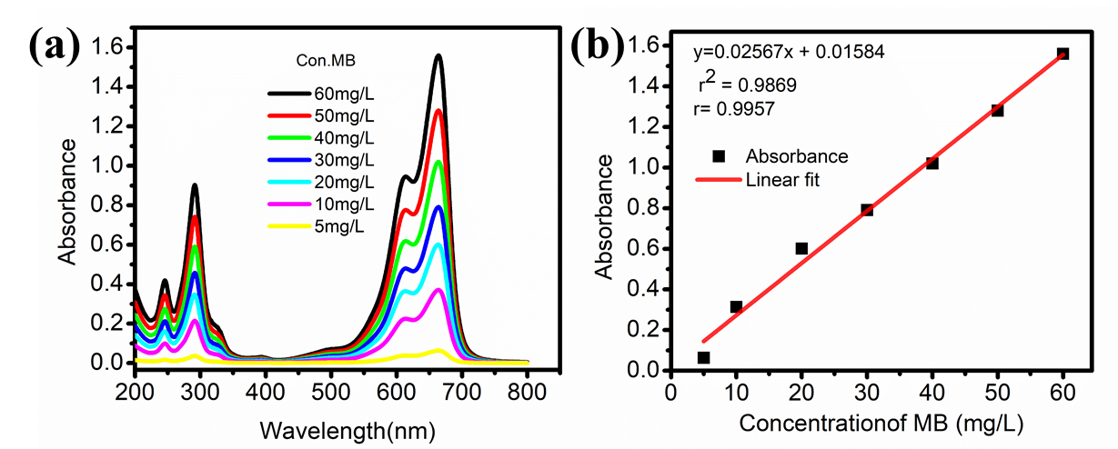
Fig. S1 (a) Uv-Vis spectra of MB at different concentrations and (b) Calibration curve of MB dye.
- Preparation of Kocho powder sample
The methods reported by Dibaba et al. (2018) were used to prepare the biosorbent (Kocho) from pseudostem and corm of enset[1]. Briefly, matured Enset plants (Fig. S3a) were identified by locally established maturity signs, such as, size of the central shoot, appearance of inflorescence and exposure of the corm. The pseudostem and corm from matured Enset plants were washed, cut, diced, and crushed traditionally (Fig. S3). The oozing liquid containing starch was collected from the pseudostem part and mixed with corm one. For the production of kocho powder, pseudo-stem, corm and starter amicho (previously fermented decorticated Enset pseudostem) were mixed together for about one month. The fermentation process was carried out in a ground pit, at a temperature about 25-30 °C, anaerobic fermentation. Finally, the local fermentation product known as Kocho (Fig. S3h) was carefully rinsed with tape water before being washed with distilled water. It spent 48 hours at 70 °C drying in the oven. The dried Kocho was then ground to a fine powder Kocho (Fig. Figure S3i)) using a steady arm grinder and the fine powder was chosen for the biosorption experiments. The main process for traditional Enset fermentation was given in the following flow chart[2], Fig. S2.
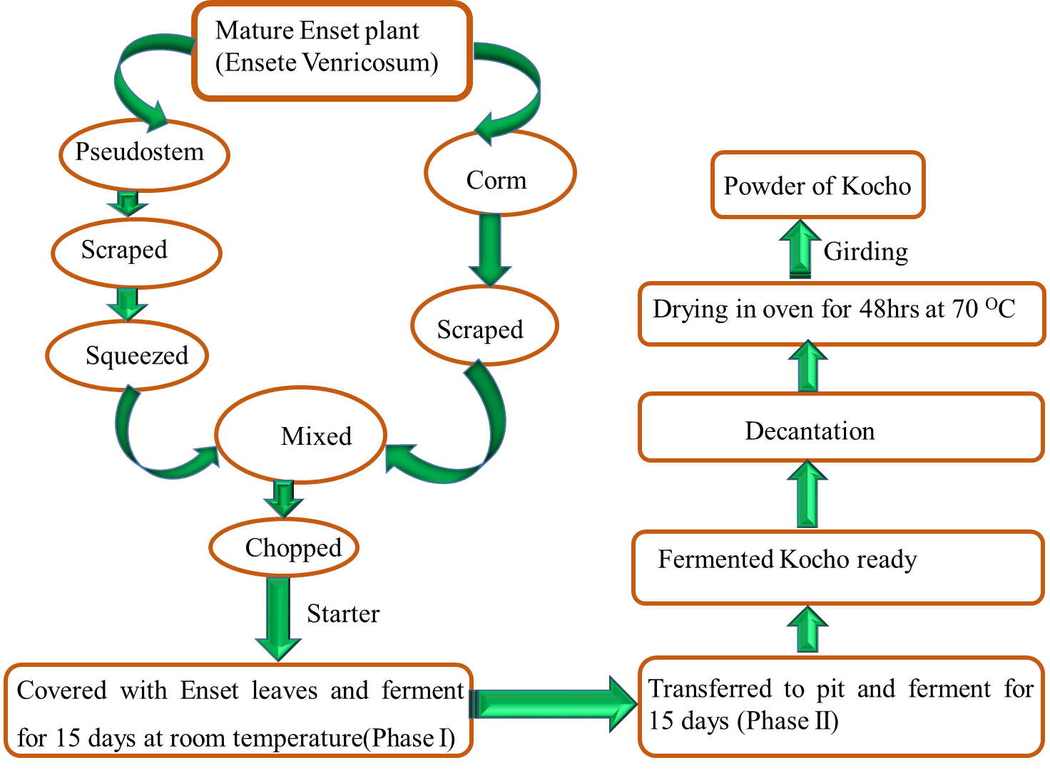
Fig. S2 Flow chart of traditional Enset fermentation.
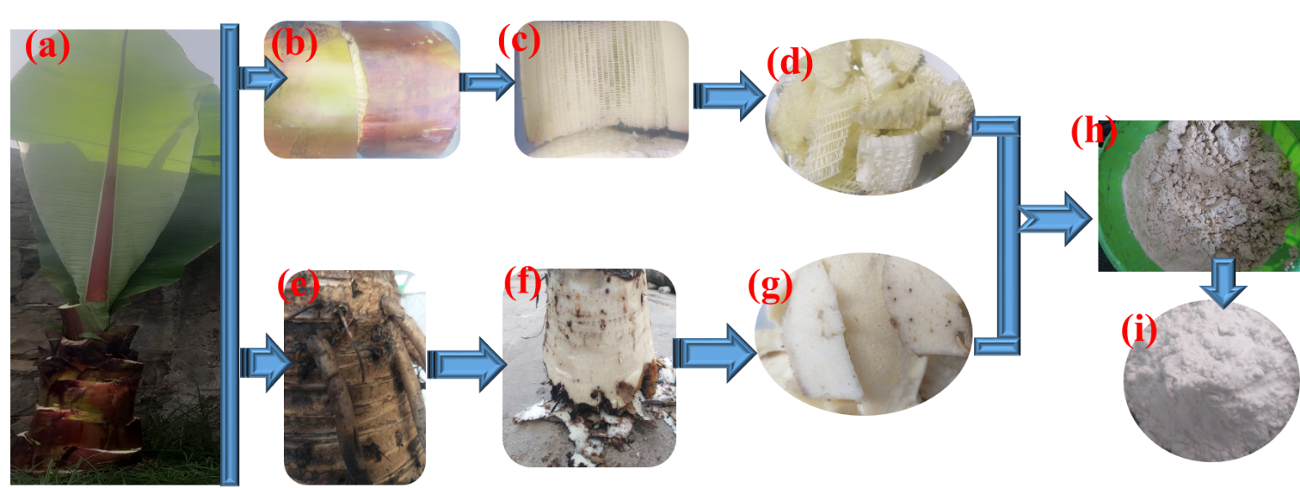
Fig. S3 Process flow diagram for preparing kocho powder (a) Enset (Ensete ventricosum) plant (b) outer layer pseudo stem (c) inner layer Pseudostem (d) chopped pseudostem (e)outer layer corm (f) Inner layer corm (g) chopped corm (h) fermented kocho (i) powder kocho
3. Characterization
Analyses of the morphology of pristine Kocho were investigated with the help of field emission scanning electron microscope (FE-SEM), of JEOL, JSM-7600, Japan). The sample was first coated with a thin layer of platinum in a vacuum chamber for 60 seconds before imaging. For SEM observation, the samples were stuck with the help of carbon tape onto a stub of 1 cm diameter. The SEM image was taken in secondary electron mode with a beam of energy 15.0 KV.
Thermal Gravimetric Analysis: Kocho powder samples (∼3 mg) were loaded to a platinum sample pan (TA instruments) and heated in nitrogen from 25 to 105 °C at 20 °C/min. After incubating at 105 °C for 10 min, it was heated further from 105 to 800 °C at a heating rate of 20 °C/min. TGA is an analysis through which physical and chemical changes are measured as a function of time and temperature with a constant heating rate thereby gathering information about the thermal stability of a sample.
The crystallographic information for the synthesized kocho powder was gathered from powder X-ray diffraction studies performed with Cu-Kα (α= 0.154 nm) radiation at a voltage of 40 kV and tube current of 30 mA. The scanning range was from 10–80 and the scan rate was 2 min⁻¹.
The FTIR spectra of the pristine kocho sample (before biosorption of MB) and the MB-loaded samples (biosorbent 0.1 g, 50 mg/ L MB for 50 min ) were obtained using a FTIR spectrometer (Alpha-T, Bruker) accumulating 64 scans at a spectral resolution of 1 cm⁻¹ in the range of 4000–400 cm⁻¹. Each sample was finely ground, mixed with KBr at a ratio of 1/50 (mg/mg) and pressed to prepare the pellet. FTIR spectroscopy was used to identify the functional groups present in the biosorbent before and after biosorption of MB.

- Effect of Various Parameters on Dye Adsorption
MB biosorption onto Kocho may be influenced by several parameters such as pH, dosage of the biosorbent, contact time and initial MB concentration. For each experiment, after filtering the agitated adsorbate solution over a 0.22 μm microfiltration membrane for each experiment, the remaining dye concentration in the filtrate was measured using a UV-VIS spectrophotometer at a pre-optimized maximum wavelength of 664 nm.
  - The effect of Dose
For studying the effect of biosorbent dosage on biosorption capacity, 20mL MB dye solutions (50 mgL⁻¹ ) were incubated with different Kocho dosages (0.01, 0.25, 0.1, 0.15 and 0.2 g) under optimized conditions pH (8), initial MB concentration (50mg/L), contact time(50 min) and agitation of 200 rpm at 298K. As shown in Fig. S4, The biosporption capacity of Kocho showed a significant decrease (57 mg/L to 9.4 mg/L) with an increase in biosorbent dosage from 0.01 to 0.1g which was attributed to the highest concentration gradient between MB dye molecules and biosorbent. While a further increase of Kocho to 0.15 g and 0.2 g resulted in no significant change in biosorption capacity 6.52 mg/L to 4.9 mg/L respectively. This suggests after a certain amount of biosorbent, a higher dosage may have caused saturation of active biosorption sites, in turn hampering further biosorption of dyes.
Fig. S4 Effect of biosorbent dosage on biosorption capacity (Co=50 mg/L, contact time =50 min, pH= 8 and agitation rate of 200 rpm at 278 K).
  - The effect of Initial MB Concentration
For studying the effect of dye concentration on biosorption capacity, 20 mL MB dye solutions at pH(8)with various concentrations (10, 25, 50, 75 and 100 mg/ L) were incubated with 0.1 g dose and 200 rpm agitation at 298 K. The obtained results are illustrated in Fig. S5. As the initial concentration of MB changed from10 mg/L to 100 mg/L, the biosorption capacity of kocho powder improved from 1.96 to 12.8 mg/g. At a lower initial concentration of MB, a few of the biosorbent molecules occupy the biosorbent’s surface; therefore, the percent of adsorbate removal is high. However, an increase in the initial MB concentration resulted in coverage of the adsorbent surface by MB molecules, causing in a decline in MB adsorption.

Fig. S5 Effect of initial MB concentration on biosorption capacity of Kocho (dose= 0.1 g, contact time=50min and pH=8, agitations of 200 rpm at 278 K).
  - The Effect of Solution pH
The effect of solution pH on the uptake of MB onto Kocho was studied by contacting 20 mL of 50 mg/L MB solutions for 50 minutes at pHs of 2, 3, 4, 5, 6, 7, 8, 9 and 10 with 0.1 g of biosorbent until the system reached equilibrium while being agitated at 200 rpm and 278K. The pH of the solution was adjusted as needed during the batch adsorption process by adding 0.1 M HCl or 0.1 M NaOH. The maximum equilibrium biosorption capacity of 9.4 mg/g corresponding to 94.2 % of removal efficiency was achieved at pH=8 (Fig. S6). Biosorption capacity increased as the pH of the solution increase from 2 to 8 from 2.9 mg/L to 9.4 mg/L whereas above pH(8) it showed negligible change.
Fig. S6 Effect of pH on biosorption capacity and (Co=50 mg/L, dose= 0.1 g and contact time= 50 min and agitation of 200 rpm at 278 K).
  - The effect of Contact Time
The effect of contact time on the biosorption capacity of Kocho was assessed throughout specific time periods of 10, 20, 30, 40, 50, 60, 90, and 120 min while maintaining the previously adjusted parameters. As shown in Fig. S7, biosorption capacity increases from 3.5 mg/g to 9.4 mg/g rapidly with increase in time from 10 min to 50 min before reaching equilibrium. After 50 minutes, it remains almost constant due to lack of active sites for dye biosorption.
Fig. S7 Effect of contact time on biosorption capacity of Kocho (Co=50 mg/L, dose= 0.1 g and pH=8 and agitation of 200 rpm at 278 K).

References
1. Dibaba A, Tuffa A, Gebremedhin E, Nugus G, Gebresenbet G: Microbiota and Physicochemical Analysis on Traditional Kocho Fermentation Enhancer to Reduce Losses (Gammaa) in the Highlands of Ethiopia. Microbiology and Biotechnology Letters 2018, 46(3):210-224.
2. Muhmood A, Majeed A, Niaz A, Shah AH, Afzal A, Arshad KuR, Rashid M, Nazarat A: A quantitative assessment of pollution from potentially toxic elements in groundwater and the accompanying health risks. Arabian Journal of Geosciences 2022, 15(24).

