Table 2. Information of the related microRNAs of MdPLATZ genes.
Gene name | MicroRNA name | Mature sequence | Stem-loop
MdPLATZ1 | miR398b | UGUGUUCUCAGGUCGCCCCUG | 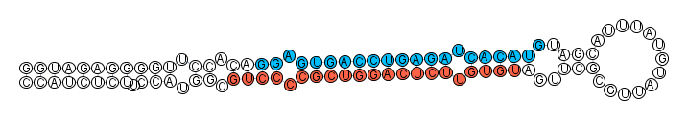
MdPLATZ1 | miR398c | UGUGUUCUCAGGUCGCCCCUG | 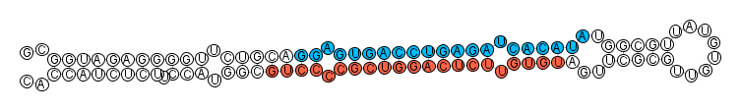
MdPLATZ3 | miR482d | AAUGGAAGGGUAGGAAAGAAG | 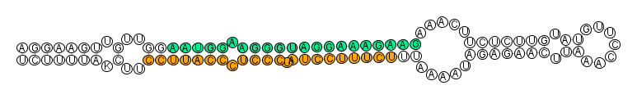
MdPLATZ5 | miR5225a | UCUGUCGAAGGUGAGAUGGUGC | 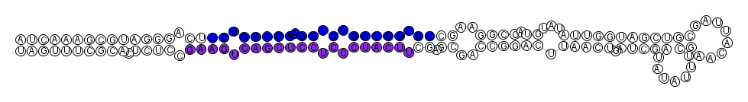
MdPLATZ5 | miR5225b | UCUGUCGAAGGUGAGAUGGUGC
MdPLATZ5 | miR5225c | UCUGUCGUGGGUGAGAUGGUGC | 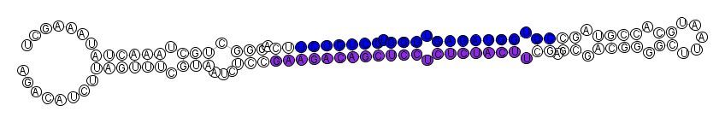
MdPLATZ9 | miR5225a | UCUGUCGAAGGUGAGAUGGUGC
MdPLATZ9 | miR5225b | UCUGUCGAAGGUGAGAUGGUGC
MdPLATZ9 | miR5225c | UCUGUCGUGGGUGAGAUGGUGC
MdPLATZ10 | miR7123a | AAGAGCGGGAUGUGUAAAAGG
MdPLATZ10 | miR7123b | AAGAGCGGGAUGUGUAAAAGG
MdPLATZ12 | miR393d | AUCAUGCGAUCCCUUCGGACG | 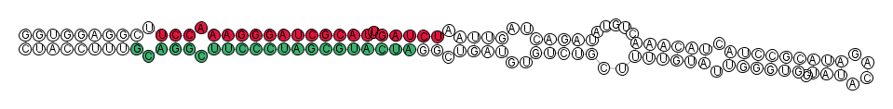
MdPLATZ12 | miR393e | AUCAUGCGAUCCCUUCGGACG
MdPLATZ12 | miR393f | AUCAUGCGAUCCCUUCGGACG | 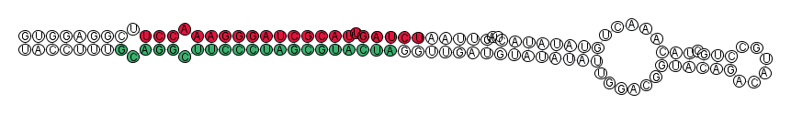
MdPLATZ15 | miR393d | AUCAUGCGAUCCCUUCGGACG
MdPLATZ15 | miR393e | AUCAUGCGAUCCCUUCGGACG
MdPLATZ15 | miR393f | AUCAUGCGAUCCCUUCGGACG

