SUPPLEMENTARY MATERIAL

"The footprint of anthropogenic climate change on heat-related deaths in summer 2022 in Switzerland" Vicedo-Cabrera et al.

Suppl Table 1. Description of the temperature and mortality data in June-August between 1990-2017. Number of all-cause deaths (N) per sex and age category in each canton. Average and range of the daily mean temperature by canton (population-weighted average).

 | All-cause mortality (N) |  |  |  | Mean temperature
 | Male 0-65 years | Male >65 years | Female 0-65 years | Female >65 years | Average [range]
Zurich | 7069 | 17649 | 4265 | 18691 | 18.0 [3.5;28.2]
Bern | 6358 | 20467 | 3289 | 22408 | 16.5 [-6.1;28.3]
Luzern | 2138 | 6234 | 1116 | 6771 | 17.2 [0.2;28.0]
Uri | 210 | 872 | 99 | 846 | 11.0 [-5.6;27.6]
Schwyz | 782 | 2369 | 406 | 2555 | 15.6 [-1.2;27.4]
Obwalden | 171 | 718 | 88 | 688 | 13.1 [-2.8;25.9]
Nidwalden | 212 | 697 | 119 | 703 | 15.4 [-0.6;27.4]
Glarus | 292 | 890 | 125 | 1008 | 12.2 [-2.3;23.1]
Zug | 554 | 1556 | 312 | 1791 | 17.1 [3.3;28.0]
Fribourg | 1808 | 4671 | 854 | 4502 | 17.0 [-0.0;28.3]
Solothurn | 1656 | 5330 | 928 | 5919 | 17.7 [3.7;28.8]
Basel-Stadt | 1161 | 2706 | 792 | 3156 | 19.0 [7.1;29.3]
Basel-Landschaft | 1526 | 5090 | 899 | 5492 | 18.0 [3.7;29.2]
Schaffhausen | 466 | 1637 | 288 | 1909 | 17.8 [4.9;27.8]
Appenzell Ausserrhoden | 340 | 1201 | 182 | 1400 | 16.1 [2.2;27.6]
Appenzell Innerrhoden | 92 | 340 | 54 | 337 | 15.2 [0.6;27.2]
St. Gallen | 2897 | 8671 | 1526 | 9652 | 16.8 [-1.1;28.6]
Graubunden | 1288 | 4064 | 607 | 4369 | 12.1 [-5.3;27.2]
Aargau | 3520 | 10091 | 1839 | 11081 | 18.1 [5.1;28.8]
Thurgau | 1487 | 4335 | 793 | 4957 | 17.9 [5.1;28.2]
Ticino | 1968 | 6354 | 1064 | 7488 | 18.3 [-3.8;29.8]
Vaud | 4073 | 11706 | 2263 | 13166 | 17.8 [-1.8;28.8]
Valais | 2141 | 5672 | 1021 | 5640 | 12.6 [-7.2;28.1]
Neuchatel | 1226 | 3514 | 635 | 4137 | 16.5 [2.2;28.6]
Geneva | 2420 | 5674 | 1443 | 6761 | 19.4 [8.4;29.6]
Jura | 526 | 1579 | 235 | 1683 | 16.8 [2.8;29.2]

Suppl Table 2. Mortality risk associated with heat in Switzerland and each canton by sex-age groups between 1990-2017 (June-August). These are defined as the relative risk (RR, and 95% confidence interval (CI)) at the 99th percentile of the summer temperature distribution, with reference to the temperature of minimum mortality (MMT, corresponding percentile denoted as MMP).

 | Male 0-65 years |  | Male >65 years |  | Female 0-65 years |  | Female >65 years
 | MMT (MMP) | Heat-RR [95% CI] | MMT (MMP) | Heat-RR [95% CI] | MMT (MMP) | Heat-RR [95% CI] | MMT (MMP) | Heat-RR [95% CI]
Pooled | 18.4 (69) | 1.15 [0.99 - 1.33] | 18.5 (70) | 1.23 [1.13 - 1.33] | 15.5 (41) | 1.08 [0.90 - 1.31] | 13.3 (23) | 1.36 [1.22 - 1.51]
Zürich | 15.8 (27) | 1.18 [1.00 - 1.40] | 15.6 (25) | 1.30 [1.18 - 1.42] | 20.5 (74) | 1.18 [0.88 - 1.57] | 15.6 (25) | 1.41 [1.21 - 1.65]
Bern | 18.8 (69) | 1.19 [1.05 - 1.35] | 19.1 (72) | 1.22 [1.14 - 1.31] | 14.3 (28) | 1.06 [0.91 - 1.24] | 14.5 (29) | 1.17 [1.04 - 1.33]
Luzern | 20.7 (82) | 1.12 [0.96 - 1.31] | 19.1 (67) | 1.25 [1.15 - 1.36] | 14.7 (25) | 1.09 [0.90 - 1.32] | 14.7 (25) | 1.42 [1.20 - 1.69]
Uri | 17.0 (90) | 0.94 [0.63 - 1.40] | 17.0 (90) | 1.06 [0.87 - 1.30] | 10.7 (46) | 1.23 [0.64 - 2.34] | 13.8 (72) | 1.29 [1.01 - 1.65]
Schwyz | 20.3 (88) | 1.12 [0.94 - 1.33] | 18.5 (75) | 1.21 [1.10 - 1.34] | 14.1 (35) | 1.07 [0.84 - 1.36] | 12.9 (25) | 1.39 [1.17 - 1.66]
Obwalden | 18.6 (90) | 0.96 [0.63 - 1.48] | 17.2 (82) | 1.13 [0.89 - 1.44] | 12.1 (40) | 1.09 [0.58 - 2.07] | 15.1 (66) | 1.42 [1.09 - 1.87]
Nidwalden | 20.2 (88) | 1.17 [0.98 - 1.39] | 18.5 (76) | 1.23 [1.11 - 1.36] | 14.3 (39) | 1.05 [0.82 - 1.34] | 12.6 (25) | 1.41 [1.18 - 1.69]
Glarus | 13.0 (55) | 0.75 [0.31 - 1.81] | 15.3 (76) | 1.08 [0.67 - 1.75] | 11.4 (41) | 1.07 [0.30 - 3.75] | 15.2 (75) | 1.46 [0.90 - 2.39]
Zug | 21.1 (85) | 1.18 [1.04 - 1.35] | 19.4 (71) | 1.26 [1.17 - 1.35] | 15.6 (34) | 1.07 [0.91 - 1.27] | 14.5 (25) | 1.41 [1.19 - 1.67]
Fribourg | 16.0 (38) | 1.14 [0.98 - 1.34] | 19.2 (70) | 1.20 [1.11 - 1.30] | 14.8 (27) | 1.11 [0.92 - 1.34] | 16.1 (39) | 1.18 [1.04 - 1.35]
Solothurn | 17.0 (42) | 1.13 [0.93 - 1.38] | 15.3 (25) | 1.18 [1.06 - 1.31] | 15.6 (28) | 1.17 [0.91 - 1.49] | 17.4 (46) | 1.18 [1.02 - 1.36]
Basel-Stadt | 16.5 (25) | 1.37 [1.10 - 1.70] | 16.5 (25) | 1.36 [1.20 - 1.53] | 16.5 (25) | 1.13 [0.84 - 1.53] | 20.8 (69) | 1.42 [1.19 - 1.69]
Basel-Land. | 15.4 (25) | 1.28 [1.09 - 1.51] | 19.8 (68) | 1.30 [1.19 - 1.43] | 15.4 (25) | 1.09 [0.89 - 1.35] | 20.0 (70) | 1.40 [1.20 - 1.63]
Schaffhausen | 16.7 (38) | 1.20 [1.00 - 1.43] | 15.3 (25) | 1.30 [1.18 - 1.43] | 19.3 (64) | 1.16 [0.88 - 1.53] | 20.1 (72) | 1.34 [1.14 - 1.59]
App. Auss. | 18.8 (74) | 1.24 [1.05 - 1.46] | 18.3 (70) | 1.28 [1.17 - 1.40] | 19.5 (80) | 1.12 [0.84 - 1.50] | 18.7 (73) | 1.32 [1.13 - 1.55]
App. Innerr. | 18.8 (79) | 1.23 [1.00 - 1.51] | 18.0 (73) | 1.27 [1.13 - 1.42] | 18.4 (76) | 1.11 [0.79 - 1.55] | 18.0 (73) | 1.33 [1.12 - 1.58]
St. Gallen | 19.4 (72) | 1.26 [1.08 - 1.47] | 18.8 (67) | 1.27 [1.17 - 1.38] | 20.8 (83) | 1.14 [0.87 - 1.48] | 19.4 (72) | 1.28 [1.11 - 1.47]
Graubünden | 17.8 (88) | 1.15 [0.82 - 1.63] | 16.8 (83) | 1.18 [0.97 - 1.44] | 13.7 (63) | 1.05 [0.63 - 1.75] | 15.6 (76) | 1.28 [1.03 - 1.60]
Aargau | 16.6 (34) | 1.14 [0.96 - 1.37] | 15.7 (25) | 1.23 [1.11 - 1.35] | 15.8 (26) | 1.15 [0.93 - 1.41] | 20.3 (72) | 1.34 [1.17 - 1.55]
Thurgau | 17.2 (42) | 1.14 [0.93 - 1.40] | 15.6 (25) | 1.23 [1.11 - 1.37] | 16.4 (33) | 1.16 [0.90 - 1.48] | 20.3 (74) | 1.27 [1.09 - 1.47]
Ticino | 21.7 (78) | 1.39 [1.01 - 1.92] | 20.8 (69) | 1.28 [1.08 - 1.51] | 22.9 (88) | 1.12 [0.72 - 1.75] | 15.7 (25) | 1.39 [1.12 - 1.71]
Vaud | 15.3 (25) | 1.33 [1.14 - 1.56] | 19.6 (66) | 1.28 [1.17 - 1.39] | 15.3 (25) | 1.06 [0.87 - 1.30] | 15.3 (25) | 1.47 [1.27 - 1.69]
Valais | 17.9 (85) | 1.38 [0.99 - 1.91] | 17.6 (83) | 1.23 [1.02 - 1.49] | 13.8 (58) | 0.96 [0.61 - 1.52] | 9.2 (25) | 1.43 [1.15 - 1.80]
Neuchâtel | 20.2 (81) | 1.30 [1.08 - 1.57] | 19.7 (77) | 1.26 [1.14 - 1.40] | 19.9 (79) | 1.04 [0.78 - 1.39] | 16.0 (44) | 1.19 [1.02 - 1.37]
Geneva | 18.4 (38) | 1.37 [1.09 - 1.71] | 17.1 (25) | 1.35 [1.19 - 1.52] | 17.1 (25) | 1.15 [0.87 - 1.53] | 17.8 (32) | 1.54 [1.28 - 1.84]
Jura | 16.9 (51) | 1.15 [0.99 - 1.34] | 19.5 (75) | 1.20 [1.12 - 1.28] | 15.9 (41) | 1.10 [0.94 - 1.30] | 16.5 (47) | 1.18 [1.04 - 1.34]

Suppl Table 3. Description of the temperature and mortality data in June-August 2022. Number of all-cause deaths (N) per sex and age category in each canton. Average and range of the daily mean temperature by canton (population-weighted average).

 | All-cause mortality (N) |  |  |  | Mean temperature
 | Male 0-65 years | Male >65 years | Female 0-65 years | Female >65 years | Average [range]
Zurich | 202 | 1191 | 129 | 1327 | 20.2 [13.4;27.0]
Bern | 186 | 977 | 104 | 1146 | 17.3 [11.3;23.3]
Luzern | 70 | 340 | 32 | 391 | 18.9 [11.8;26.1]
Uri | 6 | 19 | 4 | 26 | 13.0 [7.9;19.3]
Schwyz | 27 | 128 | 13 | 128 | 17.1 [10.2;23.6]
Obwalden | 7 | 26 | 2 | 32 | 16.1 [8.9;22.6]
Nidwalden | 6 | 38 | 5 | 51 | 17.1 [10.1;24.3]
Glarus | 6 | 27 | 5 | 40 | 14.5 [8.2;20.6]
Zug | 18 | 78 | 10 | 93 | 19.3 [12.4;26.4]
Fribourg | 48 | 254 | 46 | 250 | 19.0 [11.4;25.6]
Solothurn | 47 | 264 | 29 | 269 | 19.6 [13.1;26.2]
Basel-Stadt | 46 | 200 | 21 | 250 | 21.6 [15.8;28.7]
Basel-Landschaft | 48 | 314 | 28 | 324 | 20.4 [14.0;27.6]
Schaffhausen | 14 | 88 | 9 | 98 | 20.1 [12.9;26.5]
Appenzell Ausserrhoden | 12 | 51 | 5 | 62 | 17.7 [10.4;25.8]
Appenzell Innerrhoden | 6 | 18 | 2 | 21 | 16.9 [9.3;25.0]
St. Gallen | 100 | 411 | 48 | 467 | 18.0 [11.2;25.3]
Graubunden | 32 | 207 | 17 | 248 | 13.0 [8.1;18.1]
Aargau | 106 | 555 | 70 | 555 | 20.4 [13.8;27.1]
Thurgau | 47 | 235 | 36 | 243 | 20.1 [13.2;26.8]
Ticino | 54 | 344 | 33 | 406 | 17.8 [13.2;21.7]
Vaud | 119 | 598 | 74 | 733 | 19.8 [12.0;25.9]
Valais | 77 | 320 | 27 | 333 | 14.1 [9.3;19.1]
Neuchatel | 30 | 135 | 23 | 205 | 18.4 [11.2;24.9]
Geneva | 56 | 344 | 43 | 401 | 22.3 [14.1;28.6]
Jura | 10 | 71 | 2 | 75 | 19.0 [12.3;26.4]

Suppl. Table 4. Heat-related mortality between June-August 2022. "Observed" corresponds to the burden in the factual scenario (with climate change), "counterfactual" is the burden in the scenario without climate change, "difference" is the difference between the two scenarios corresponding to the burden attributable to human-induced climate change, "prop" is the proportion of observed heat-related deaths attributable to human-induced climate change. N, number of deaths; %, fraction over all-cause summer mortality.
 | N observed | N counterfct | N difference | % observed | % counterfct | % difference | % prop
Total | 623 [151;1069] | 253 [-27;594] | 370 [133;644] | 3.5 [0.9;6.1] | 1.4 [-0.2;3.4] | 2.1 [0.8;3.7] | 59.3
Male 0-65years | 48 [-0;87] | 22 [-3;51] | 25 [1;50] | 3.4 [-0.0;6.3] | 1.6 [-0.2;3.7] | 1.8 [0.1;3.6] | 52.8
Male >65years | 204 [73;326] | 79 [-4;182] | 125 [57;202] | 2.8 [1.0;4.5] | 1.1 [-0.1;2.5] | 1.7 [0.8;2.8] | 61.3
Female 0-65years | 32 [-25;77] | 17 [-18;50] | 14 [-8;35] | 3.9 [-3.1;9.4] | 2.1 [-2.2;6.1] | 1.8 [-1.0;4.3] | 45.1
Female >65years | 340 [73;591] | 135 [-14;324] | 205 [70;361] | 4.2 [0.9;7.2] | 1.6 [-0.2;4.0] | 2.5 [0.9;4.4] | 60.4
Male | 251 [73;407] | 101 [-6;233] | 150 [62;250] | 2.9 [0.9;4.7] | 1.2 [-0.1;2.7] | 1.7 [0.7;2.9] | 59.7
Female | 372 [60;659] | 152 [-25;366] | 220 [69;393] | 4.1 [0.7;7.3] | 1.7 [-0.3;4.1] | 2.4 [0.8;4.4] | 59.1
0-65years | 79 [-26;163] | 40 [-21;100] | 39 [-5;84] | 3.6 [-1.2;7.4] | 1.8 [-0.9;4.6] | 1.8 [-0.2;3.8] | 49.7
>65years | 544 [162;915] | 213 [-10;497] | 330 [129;565] | 3.5 [1.1;5.9] | 1.4 [-0.1;3.2] | 2.1 [0.8;3.7] | 60.8
Zürich | 149 [34;255] | 61 [-8;145] | 88 [35;149] | 5.2 [1.2;8.9] | 2.2 [-0.3;5.1] | 3.1 [1.2;5.2] | 58.8
Bern | 34 [-13;75] | 11 [-12;37] | 23 [-1;49] | 1.4 [-0.5;3.1] | 0.5 [-0.5;1.5] | 0.9 [-0.1;2.0] | 67.0
Luzern | 22 [-3;44] | 7 [-7;24] | 15 [3;28] | 2.7 [-0.4;5.3] | 0.9 [-0.8;2.8] | 1.8 [0.4;3.4] | 66.3
Uri | 0 [-0;1] | 0 [-0;0] | 0 [-0;1] | 0.6 [-0.7;1.8] | 0.1 [-0.3;0.6] | 0.5 [-0.5;1.5] | 85.4
Schwyz | 5 [-2;11] | 2 [-2;5] | 3 [-0;7] | 1.6 [-0.6;3.8] | 0.5 [-0.6;1.9] | 1.1 [-0.0;2.4] | 68.2
Obwalden | 1 [-1;3] | 1 [-0;1] | 1 [-0;2] | 1.9 [-1.1;4.5] | 0.8 [-0.5;2.2] | 1.2 [-0.7;3.0] | 59.6
Nidwalden | 2 [-1;5] | 1 [-1;3] | 1 [-0;3] | 2.2 [-1.1;5.2] | 0.7 [-1.0;2.7] | 1.5 [-0.2;3.3] | 68.2
Glarus | 1 [-3;3] | 0 [-1;1] | 1 [-2;2] | 1.0 [-3.8;4.4] | 0.2 [-1.4;1.8] | 0.8 [-2.4;3.1] | 78.1
Zug | 7 [1;12] | 2 [-1;7] | 4 [1;8] | 3.4 [0.3;6.3] | 1.2 [-0.4;3.3] | 2.2 [0.6;4.0] | 63.6
Fribourg | 18 [-0;33] | 7 [-3;18] | 10 [2;20] | 2.9 [-0.0;5.5] | 1.2 [-0.5;3.1] | 1.7 [0.4;3.3] | 59.1
Solothurn | 19 [-8;43] | 8 [-7;24] | 11 [-2;25] | 3.2 [-1.3;7.0] | 1.3 [-1.1;3.9] | 1.9 [-0.3;4.2] | 59.0
Basel-Stadt | 31 [13;47] | 14 [2;28] | 17 [8;28] | 6.0 [2.6;9.1] | 2.6 [0.4;5.3] | 3.3 [1.5;5.4] | 56.1
Basel-Landschaft | 27 [14;39] | 10 [3;20] | 17 [8;26] | 3.8 [2.0;5.4] | 1.4 [0.4;2.9] | 2.4 [1.2;3.7] | 63.3
Schaffhausen | 9 [4;14] | 3 [0;7] | 6 [3;9] | 4.3 [2.0;6.5] | 1.6 [0.2;3.5] | 2.8 [1.3;4.4] | 63.7
Ap. Ausserrhoden | 5 [3;7] | 2 [1;4] | 3 [1;4] | 3.5 [2.0;5.1] | 1.4 [0.5;2.7] | 2.2 [1.0;3.4] | 61.5
Ap. Innerrhoden | 0 [0;1] | 0 [-0;0] | 0 [0;1] | 0.7 [0.0;1.3] | 0.1 [-0.0;0.4] | 0.6 [0.1;1.1] | 83.5
St. Gallen | 15 [7;22] | 4 [0;10] | 11 [5;17] | 1.4 [0.7;2.1] | 0.4 [0.0;1.0] | 1.1 [0.5;1.6] | 74.2
Graubünden | 0 [-1;2] | 0 [-0;0] | 0 [-1;2] | 0.1 [-0.3;0.4] | 0.0 [-0.1;0.1] | 0.1 [-0.2;0.3] | 94.0
Aargau | 52 [13;88] | 21 [-5;50] | 31 [13;52] | 4.1 [1.0;6.8] | 1.6 [-0.4;3.9] | 2.4 [1.0;4.0] | 60.1
Thurgau | 23 [7;38] | 9 [-1;22] | 14 [7;23] | 4.2 [1.2;6.8] | 1.6 [-0.2;3.9] | 2.6 [1.2;4.1] | 61.5
Ticino | 11 [-9;28] | 4 [-3;13] | 7 [-6;20] | 1.3 [-1.0;3.4] | 0.5 [-0.4;1.6] | 0.9 [-0.7;2.4] | 65.8
Vaud | 87 [33;134] | 38 [2;80] | 49 [24;77] | 5.7 [2.2;8.8] | 2.5 [0.1;5.3] | 3.2 [1.6;5.1] | 56.4
Valais | 14 [-14;38] | 6 [-9;22] | 8 [-6;20] | 1.8 [-1.9;5.0] | 0.8 [-1.2;2.8] | 1.0 [-0.8;2.7] | 55.3
Neuchâtel | 9 [-0;17] | 3 [-1;8] | 6 [1;11] | 2.2 [-0.1;4.4] | 0.8 [-0.4;2.2] | 1.4 [0.2;2.8] | 65.2
Geneva | 78 [38;116] | 38 [10;73] | 40 [18;64] | 9.3 [4.4;13.8] | 4.5 [1.2;8.6] | 4.8 [2.2;7.6] | 51.3
Jura | 4 [1;7] | 2 [-0;4] | 2 [1;4] | 2.7 [0.4;4.7] | 1.2 [-0.1;2.7] | 1.5 [0.4;2.8] | 57.0

[attached pdf]

Suppl. Figure 1. Temperature-related mortality by age-sex subgroup in the 26 cantons in Switzerland between June-August 1990-2017. The association is expressed in terms of relative risk estimated for each temperature value, using the temperature of minimum mortality as reference. Shaded areas represent the 95% confidence intervals. Light blue: male 0-65 years, dark blue: male >65 years, light red: female 0-65 years, dark red: female >65 years. The plots also show the temperature distribution in each Canton.

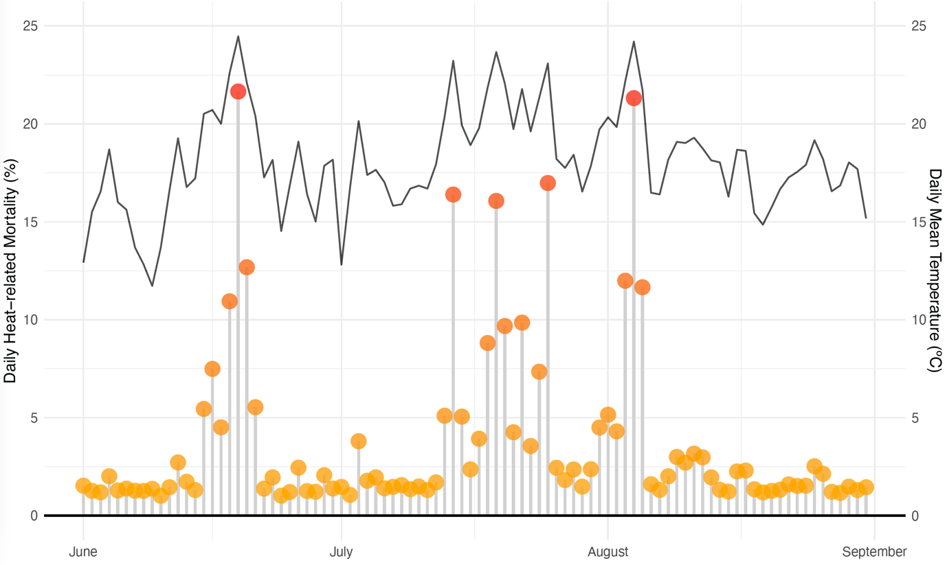

Suppl. Figure 2. Daily mean temperature and heat-related mortality (%) in Switzerland between June-August 2022. Heat-related mortality expressed as fraction of all-cause deaths that can be attributed to heat each day.

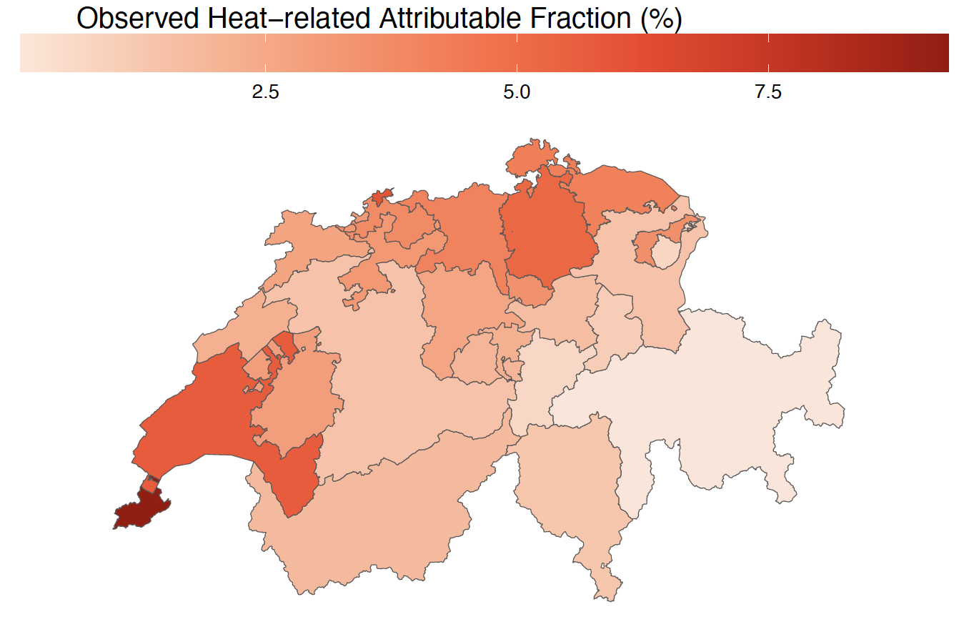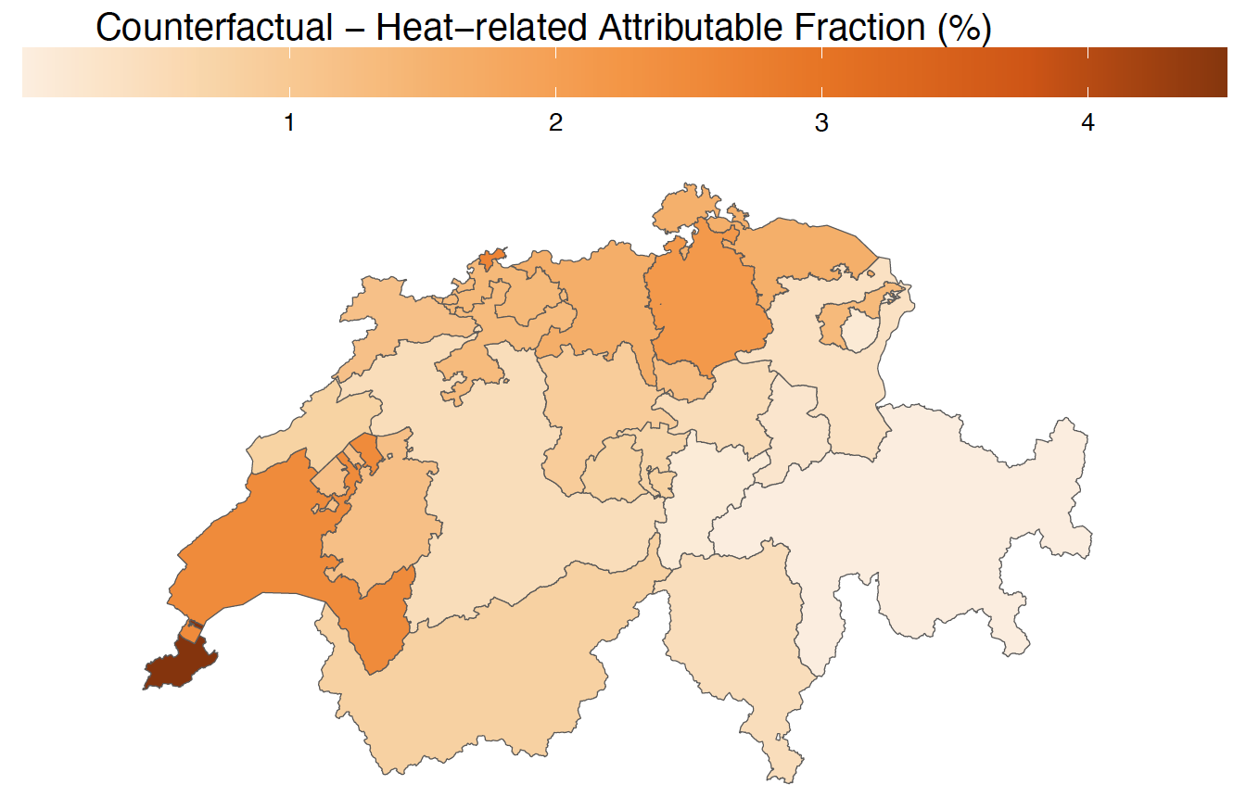

Suppl Figure 3. Canton-specific heat-related mortality fraction (%) in the factual ("observed") and the counterfactual scenario.

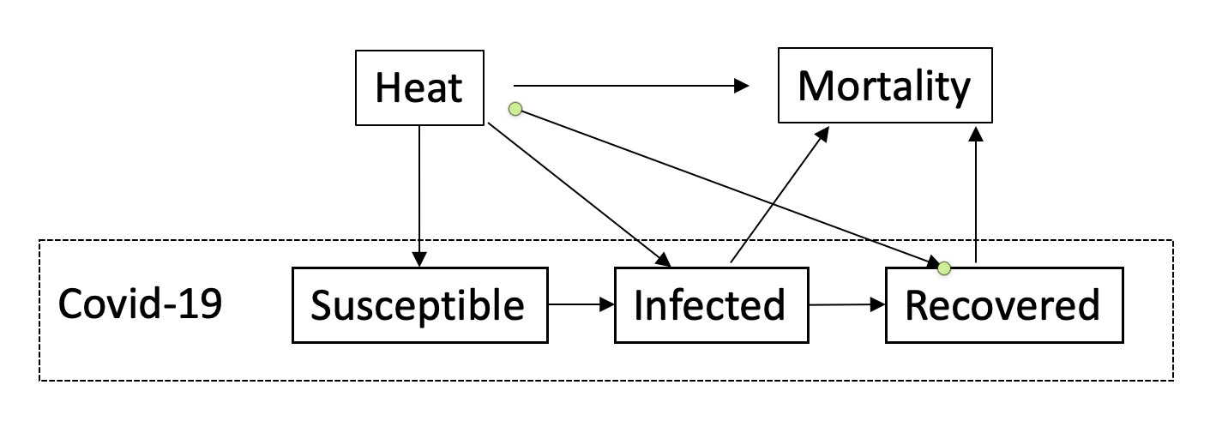

Suppl Figure 4. Direct acyclic graph (DAG) depicting the relationship between heat, mortality, and COVID-19.

