SEQ Chromatogram of wtDNA and mutDNA
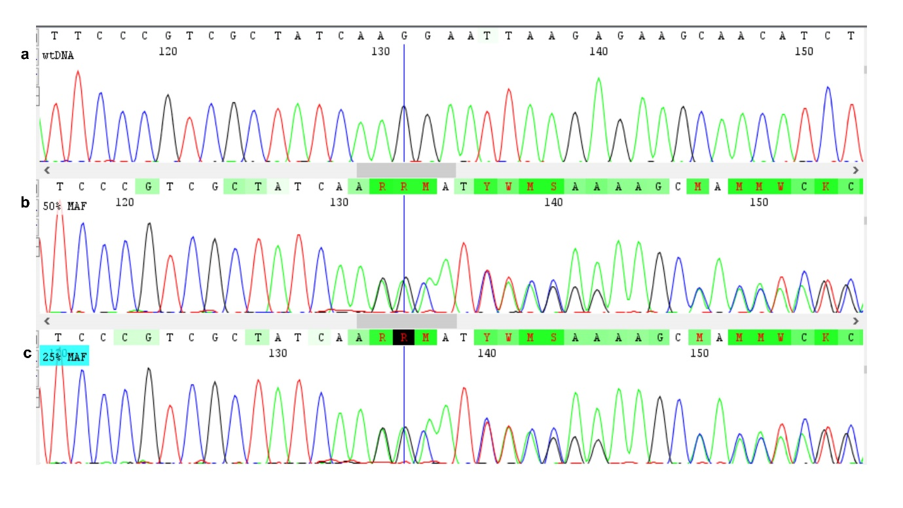

Figure S1: SEQ Chromatogram of wtDNA and mutDNA
The panel of chromatogram of the comparative SEQ of two DNA species, FFPE lung tissue derived wild type DNA and cell derived mutant standard DNA (Exon 19 standard; ΔE746-A750) in a 2.5ng/μl total DNA concentration assay. The first panel (S1a) is the SEQ data of wtDNA obtained from FFPE lung tissue. The second panel (S1b) is the SEQ data of standard cell-derived mutDNA obtained from Horizon, and the third panel marked “25% MAF” is the SEQ data of mixed DNA from both FFPE wtDNA and cell-derived standard mutDNA (1:1).

Full length raw gel images

Figure S2: Raw gel image of Figure 6 (Row A & C)
M denotes 100kbp ladder, lanes 1-4 represent the amplified products obtained at 55℃, 58℃, 60℃ and, 65℃ respectively for Exon 18. Lanes 5-8 represent the amplified products obtained at 55℃, 58℃, 60℃ and, 65℃ respectively for Exon 20.

Figure S3: Raw gel image of Figure 6 (Row B)
M denotes 100kbp ladder, lanes 1-4 represent the amplified products obtained at 55℃, 58℃, 60℃ and, 65℃ respectively for Exon 19.
Figure S4: Raw gel image of Figure 6 (Row D)
M denotes 100kbp ladder, lanes 1-4 represent the amplified products obtained at 55℃, 58℃, 60℃ and, 65℃ respectively for Exon 21.

