Supplementary File

Table S1. Detailed search strategy and process (EMBASE, Medline, and PUMBED).
Search number | Query | Results
EMBASE search strategy
1. | TAVI.ti,ab. | 11962
2. | "transcatheter aortic valve implant*".ti,ab. | 11889
3. | "transcatheter aortic valve replac*".ti,ab. | 10786
4. | Aortic Valve Stenosis/ | 5609
5. | Heart Valve Prosthesis/ | 21429
6. | exp Cardiac Surgical Procedures/ | 419691
7. | Heart Valve Prosthesis Implantation/ | 13932
8. | TAVR.ti,ab. | 9892
9. | Cardiac Catheterization/ | 70122
10. | 1 OR 2 OR 3 OR 4 OR 5 OR 6 OR 7 OR 8 OR 9 | 475860
11. | exp sarcopenia/ | 17539
12. | sarcopeni*.ti,ab. | 19864
13. | ((muscle or muscular) adj2 (atroph* or wasting* or weak* or loss* or depletion*)).ti,ab. | 74012
14. | 11 OR 12 OR 13 | 91872
15. | 10 and 14 | 598
Medline search strategy
1. | TAVI.ti,ab. | 4460
2. | "transcatheter aortic valve implant*".ti,ab. | 5529
3. | "transcatheter aortic valve replac*".ti,ab. | 5192
4. | Aortic Valve Stenosis/ | 30916
5. | Heart Valve Prosthesis/ | 39506
6. | exp Cardiac Surgical Procedures/ | 240480
7. | Heart Valve Prosthesis Implantation/ | 26524
8. | TAVR.ti,ab. | 4029
9. | Cardiac Catheterization/ | 51752
10. | 1 or 2 or 3 or 4 or 5 or 6 or 7 or 8 or 9 | 314588
11. | exp sarcopenia/ | 8107
12. | sarcopeni*.ti,ab. | 10150
13. | ((muscle or muscular) adj2 (atroph* or wasting* or weak* or loss* or depletion*)).ti,ab. | 43447
14. | 11 or 12 or 13 | 52043
15. | 10 and 14 | 163
PubMed search strategy
1. | exp sarcopenia/ | 625
2. | sarcopeni*[Title/Abstract] | 14,427
3. | ((muscle[tiab] OR muscular[tiab]) AND (atroph*[tiab] OR wasting*[tiab] OR weak*[tiab] OR loss*[tiab] OR depletion*[tiab])) | 118,525
4. | #1 OR #2 OR #3 | 128,025
5. | TAVI[Title/Abstract] | 5,757
6. | transcatheter aortic valve implant*[Title/Abstract] | 7,052
7. | transcatheter aortic valve replac*[Title/Abstract] | 6,957
8. | Aortic Valve Stenosis/ | 58,191
9. | Heart Valve Prosthesis/ | 58,935
10. | exp Cardiac Surgical Procedures/ | 934
11. | Heart Valve Prosthesis Implantation/ | 37,773
12. | TAVR[Title/Abstract] | 5,479
13. | Cardiac Catheterization/ | 75,209
14. | #5 OR #6 OR #7 OR #8 OR #9 OR #10 OR #11 OR #12 OR #13 | 169,038
15. | #4 AND #14 | 313

Table S2. Pooled 1, 2, 3-year cumulative probabilities of survival in patients with and without sarcopenia.

Survival | With sarcopenia (% and 95% CI) | Without sarcopenia (% and 95% CI) | P value
1-year survival | 74.0% (95% CI 58.0%-88.0%)；  4 studies, 299 patients | 91.0% (95% CI 78.0%- 99.0%);  4 studies, 740 patients | <0.05
2-year survival | 68.3% (95% CI 63.7%-72.7%);  2 studies, 410 patients | 78.0% (95% CI 71.0%-84.2%);  2 studies, 414 patients | <0.05
3-year survival | 72.6% (95% CI 68.2%-76.8%);  2 studies, 1176 patients | 79.8% (95% CI 74.6%- 84.5%);  2 studies, 801 patients | <0.05

Table S3. Quality assessment of individual studies using the quality in prognostic studies (QUIPS) instrument.
Study | Study  Participation | Study  Attrition | Prognostic  Factor  Measurement | Outcome  Measurement | Study  Confounding | Statistical  Analysis and  Reporting | Overall Risk  of Bias
Brouessard. 2021 | Low | Low | Low | Low | Low | Moderate | Low
Brown. 2022 | Low | Low | Low | Low | Moderate | Moderate | Moderate
Dahya. 2016 | Low | Low | Low | Low | Moderate | Moderate | Moderate
Gallone. 2022 | Low | Low | Low | Low | Low | Low | Low
Ginste. 2020 | Moderate | Low | Low | Low | Moderate | Moderate | Moderate
Heidari. 2019 | Low | Low | Low | Low | Low | Low | Low
Hsu. 2021 | Low | Low | Low | Low | Low | Moderate | Low
Krishnan. 2019 | Low | Low | Low | Low | Low | Low | Low
Mamane. 2019 | Moderate | Low | Low | Low | Moderate | Moderate | Moderate
Mok. 2016 | Low | Low | Low | Low | Low | Low | Low
Nemec. 2017 | Low | Low | Low | Low | Moderate | Moderate | Moderate
Tokuda. 2020 | Low | Low | Low | Low | Low | Low | Low
Yoon. 2020 | Low | Low | Low | Low | Low | Low | Low

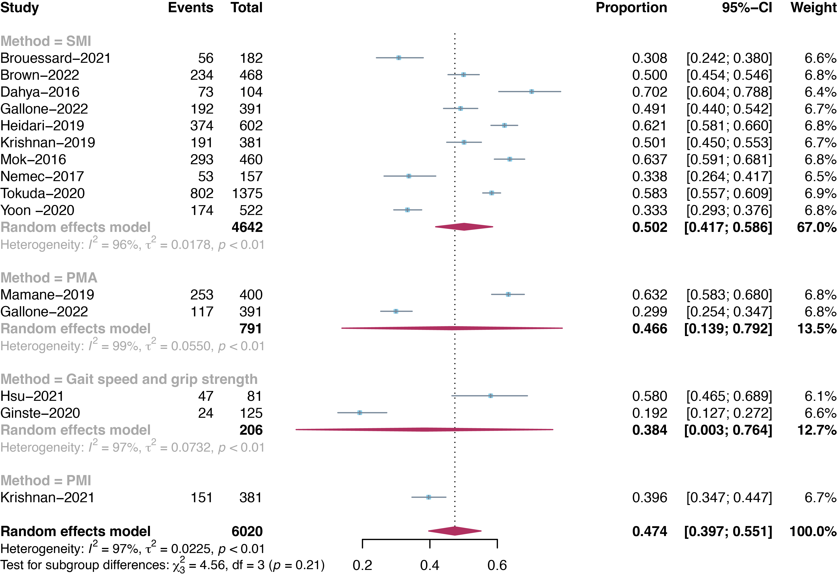

Figure S1. Prevalence of sarcopenia in patients undergoing TAVI according to different sarcopenia definitions. TAVI: Transcatheter Aortic Valve Implantation; SMI: skeletal muscle mass index; PMA: psoas muscle area; PMI: psoas muscle area index.
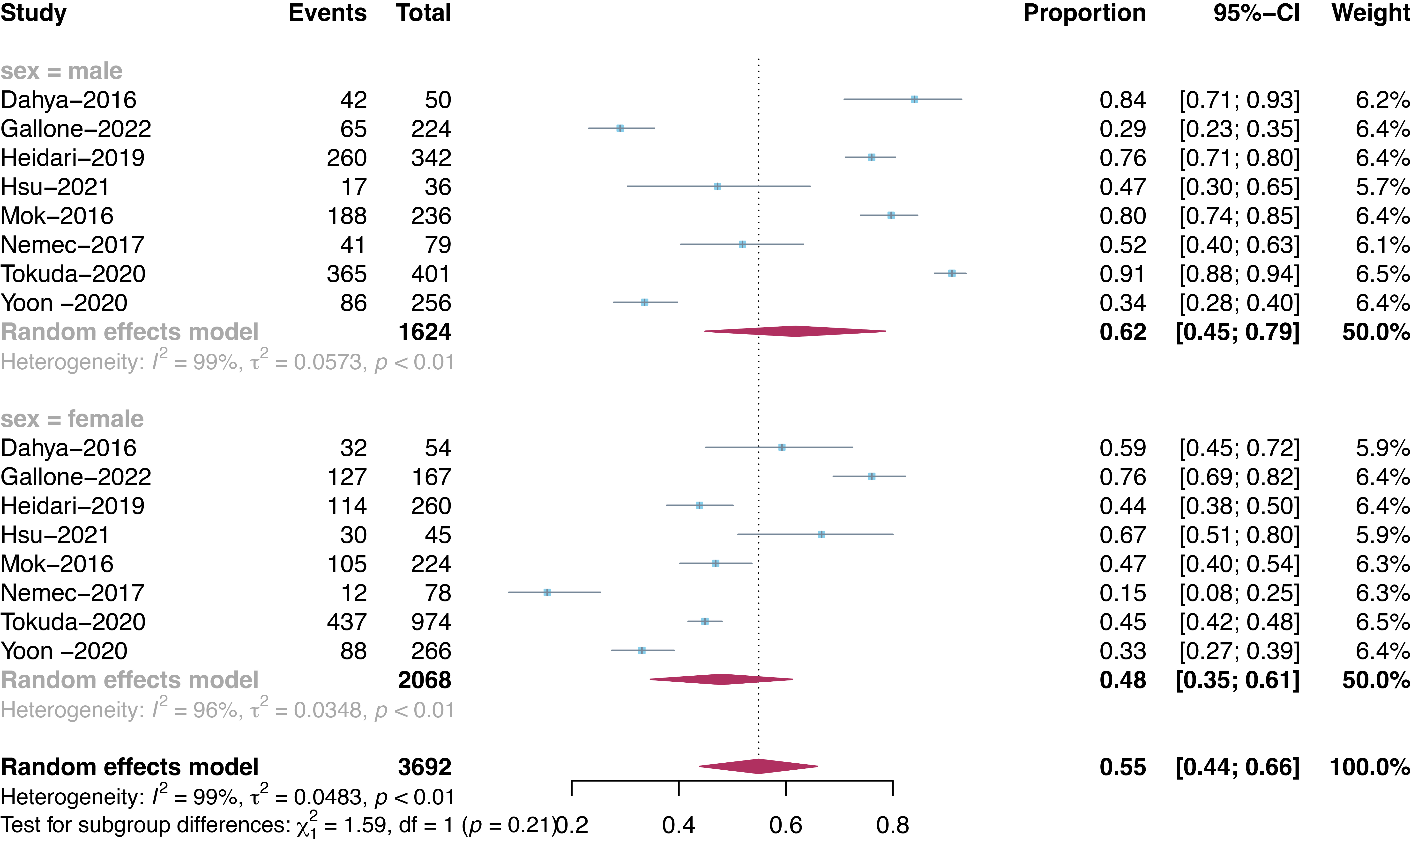

Figure S2. Prevalence of sarcopenia in patients undergoing TAVI according to sex. TAVI: Transcatheter Aortic Valve Implantation.

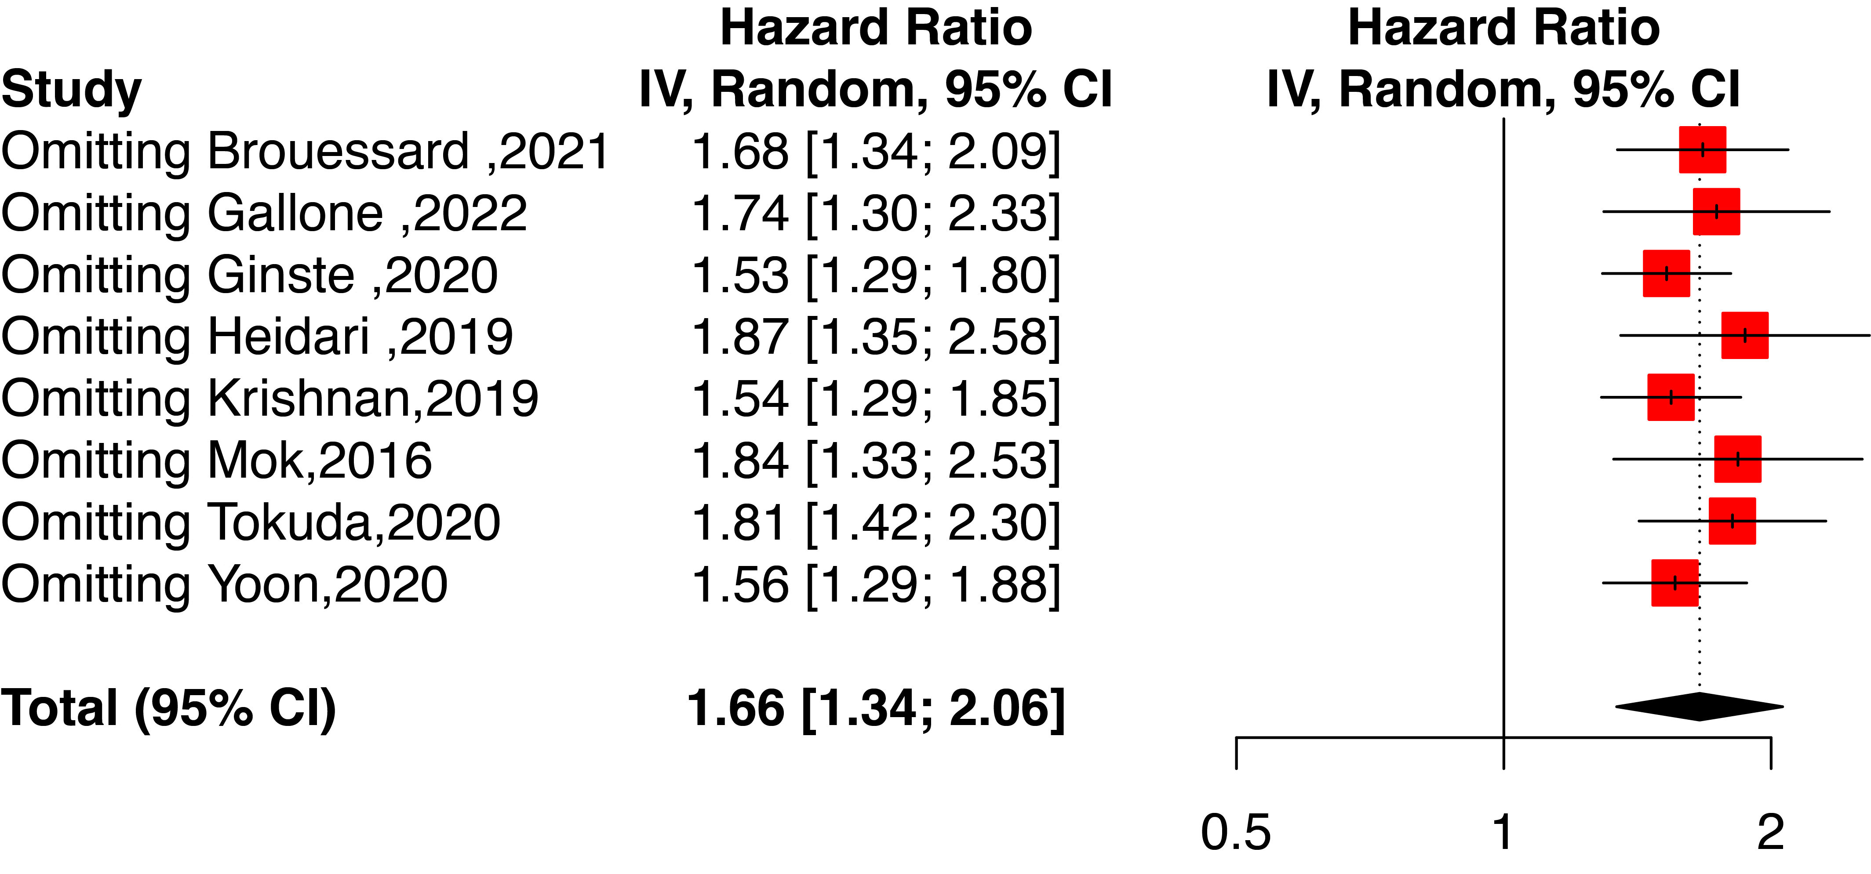

Figure S3. Sensitivity analysis for multivariate analysis by excluding a study at a time and then pooling the remaining studies.
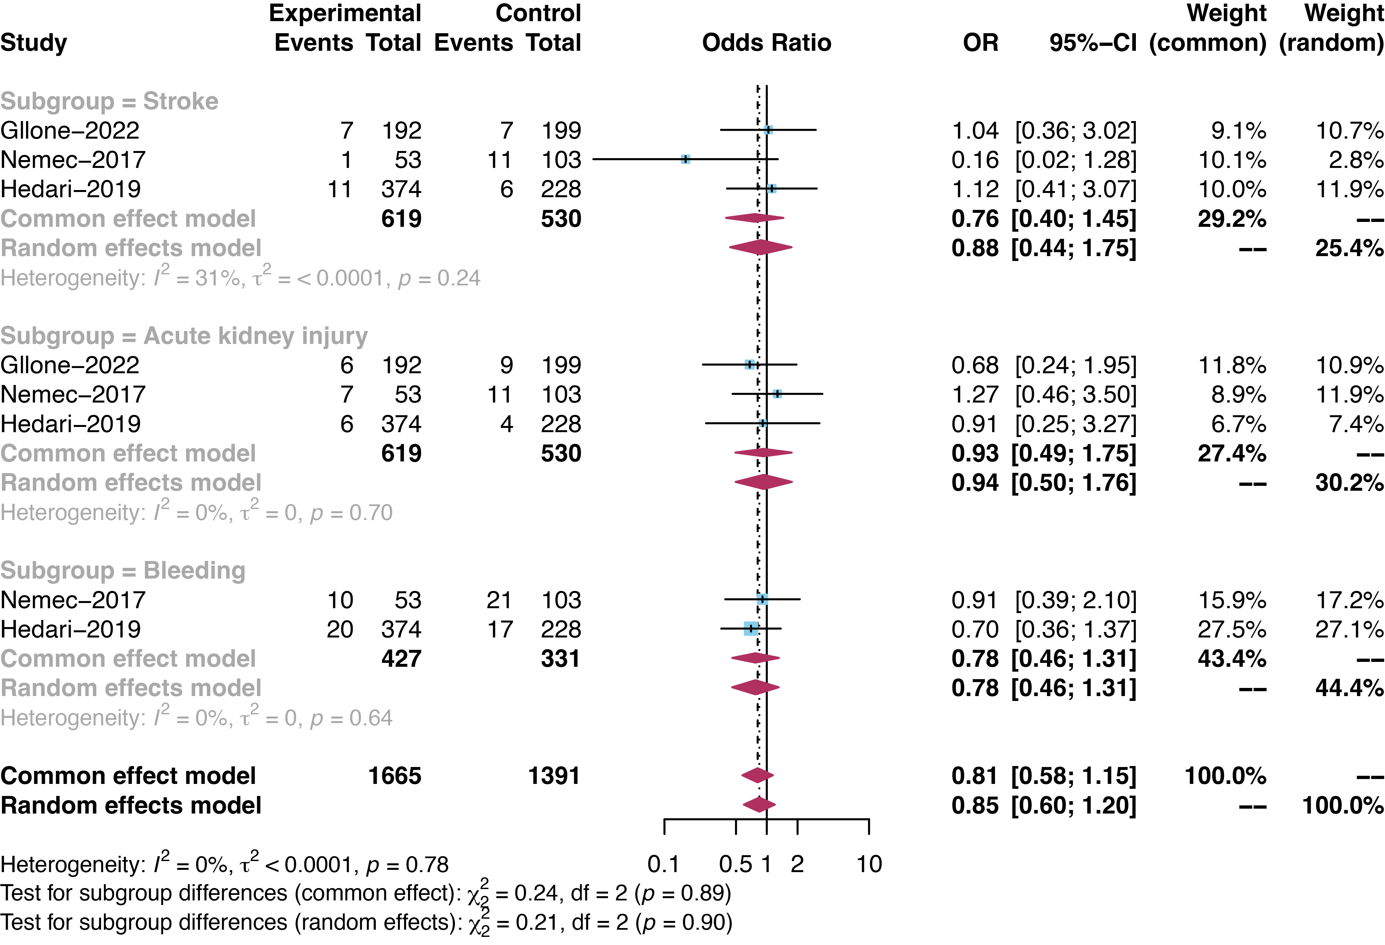

Figure S4. Forest plot for the association between sarcopenia and the risk of other adverse outcomes (stroke, acute kidney injury, and bleeding) after TAVI.

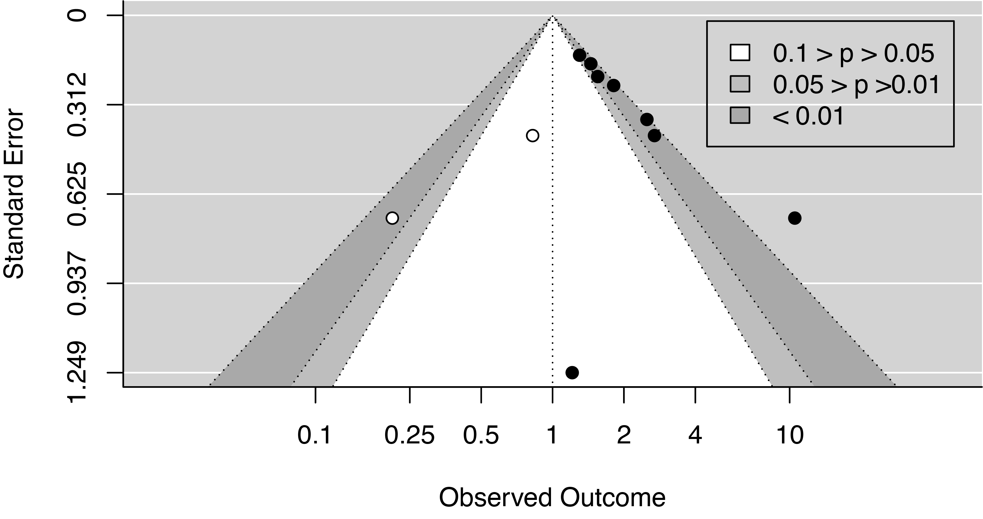

Figure S5. Funnel plot for assessing potential publication bias.

