Supplementary Materials

Sustainable high-energy radiation powering selective CO₂ reduction to CH₃OH over atomic dual-metal-sites embedded metal-organic framework
Changjiang Hu,^{1#} Zhiwen Jiang,^{1#} Qunyan Wu,^{2#} Shuiyan Cao,³ Qiuhao Li,¹ Chong Chen,¹ Liyong Yuan,² Yunlong Wang,¹ Jing Peng,⁴ Weiqun Shi,² Maolin Zhai,⁴* Mehran Mostafavi,⁵* Jun Ma ^{1,6}*
¹Department of Materials Science and Technology, Nanjing University of Aeronautics and Astronautics Nanjing 211106, P. R. China.
²Laboratory of Nuclear Energy Chemistry, Institute of High Energy Physics, Chinese Academy of Sciences, Beijing 100049, P. R. China.
³College of Physics, MIIT Key Laboratory of Aerospace Information Materials and Physics, Key Laboratory for Intelligent Nano Materials and devices, Nanjing University of Aeronautics and Astronautics Nanjing 211106, P. R. China.
⁴Beijing National Laboratory for Molecular Sciences, Radiochemistry and Radiation Chemistry Key Laboratory of Fundamental Science, the Key Laboratory of Polymer Chemistry and Physics of the Ministry of Education,
College of Chemistry and Molecular Engineering, Peking
University, Beijing 100871, P. R. China;
⁵Institut de Chimie Physique UMR8000, CNRS/Université Paris-Saclay, 91405 Orsay, France.
⁶School of Nuclear Science and Technology, University of Science and Technology of China, Hefei, Anhui 230026, P. R. China.
#These authors contributed equally to this work and should be considered co-first authors
*Corresponding authors: junma@nuaa.edu.cn;
mehran.mostafavi@universite-paris-saclay.fr;
mlzhai@pku.edu.cn;
Table S1. Cu and loadings of Cu SAs/UiO-66(Hf) and Ni SAs/UiO-66-Hf and Cu-Ni SAs/UiO-66-Hf.

Sample Name | Cu loading (wt%) | Ni loading (wt%)
Cu SAs/UiO-66-Hf | 1.8 | 0
Ni SAs/UiO-66-Hf | 0 | 0.42
Cu-Ni SAs/UiO-66-Hf | 1.6 | 0.33

Fig S1. N2 adsorption-desorption isotherms of CuNi SAs/UiO-66(Hf) and UiO-66(Hf).

Table S2. S_{BET}, pore volume and pore diameter of CuNi SAs/UiO-66(Hf) and UiO-66(Hf).
Sample | S_{BET} (m²/g) | Pore Volume (cm³/g) | Pore Diameter (nm)
UiO-66(Hf) | 775.9 | 0.4675 | 2.4
CuNi  SAs/UiO-66(Hf) | 759.7 | 0.6214 | 2.8

Fig S2. XRD patterns of CuNi SAs/UiO-66(Hf) before and after 4 times stability test.

Table S3. Structural parameters extracted from the Cu K-edge and Ni K-edge EXAFS fitting.

Sample | Scattering  pair | CN | R(Å) | σ(10⁻³ Å²) | ΔE₀(eV) | R factor
CuNi  SAs/UiO-66(Hf) | Cu-O | 2.64 | 1.93 | 4.5 | 4.16 | 0.009
CuNi  SAs/UiO-66(Hf) | Ni-O | 2.45 | 2.02 | 9.0 | -4.12 | 0.007
S02 is the amplitude reduction factor; CN is the coordination number; R is interatomic distance (the bond length between central atoms and surrounding coordination atoms); σ 2 is Debye-Waller factor (a measure of thermal and static disorder in absorber-scatterer distances); ΔE0 is edge-energy shift (the difference between the zero kinetic energy value of the sample and that of the theoretical model). R factor is used to value the goodness of the fitting.

Fig S3. Cu K-edge EXAFS spectrum fitting of Cu-Ni SAs/UiO-66-Hf.

Fig S4. EXAFS fitting curves of the CuNi SAs/UiO-66(Hf) at Cu k space.

Fig S5. Ni K-edge EXAFS spectrum fitting of CuNi SAs/UiO-66(Hf).

Fig S6. EXAFS fifitting curves of the CuNi SAs/UiO-66(Hf) at Ni k space.

Fig S7. X-ray photoelectron spectroscopy spectra of Cu 2p in CuNi SAs/UiO-66(Hf) samples.

Fig S8. X-ray photoelectron spectroscopy spectra of Ni 2p in CuNi SAs/UiO-66(Hf) samples.

Fig S9. X-ray photoelectron spectroscopy spectra of Hf 4f in CuNi SAs/UiO-66(Hf) samples.

Fig S10. Yield of MeOH and CO with catalyst CuNi SAs/UiO-66(Hf) in water with CO₂ saturated solution under 1-4 kGy γ-ray irradiation.

Fig S11. GC Spectra of CH₄, CO, C₂H₄, C₂H₆, C₂H₂ with the standard gases of high purities (> 99.99%) composited of CO₂ (99%), H₂ (1%), CH₄ (101 ppm), CO(58 ppm), C₂H₄ (100 ppm), C₂H₆ (100 ppm), C₂H₂ (100 ppm) and catalytic reaction gas sample after 0.5 kGy irradiation.

Fig S12. GC Spectra of CH₃OH with methanol solution (0.1mM) the and catalytic reaction gas sample after 0.5 kGy irradiation.

Fig S13. HPLC Spectra of CH₃OH with formic acid and oxalic acid the and catalytic reaction gas sample after 0.5 kGy irradiation.

Fig S14. The decreasing of CO in G-value with increasing concentration of a NO₃‒ and b Cd²⁺ ions.

Fig S15. Schematic diagram of water radiation solution and E⁰ values are shown for production of solvated electron (e_{aq}‒).

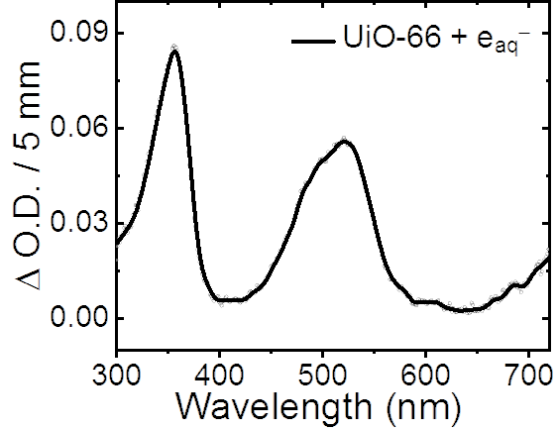
Fig S16. The transient absorption spectrum at 600 ns in 0.1 M tert-butanol solution containing 0.25 mg/mL UiO-66.

Fig S17. Views showing the four types of Cu and Ni single atom combined with UiO-66(Hf), Hf oxide cluster of UiO-66(Hf) and Cu single atom link.

Fig S18. PDOS plots for a. Cu SAs/UIO-66-Hf and b. CuNi SAs/UiO-66(Hf).

