Supplementary Figure 1: Relative frequencies of AFA responses for each item
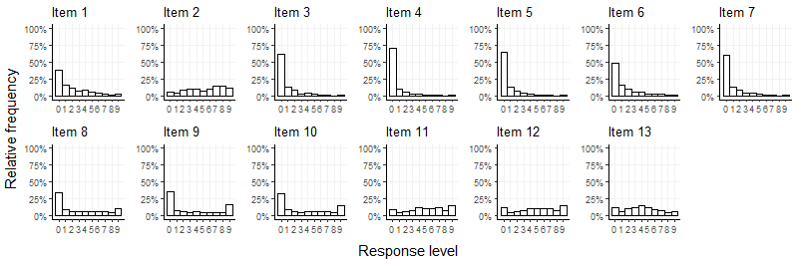

Supplementary Figure 2: Relative frequencies of BAOP responses for each item
