Supporting information
Tannic acid-poly ethyleneimine magnetic nanoparticles: an efficient and recyclable catalyst for green synthesis of 2,3-dihydroquinazole derivatives
Sahar Zirakjouª, Mohammad G. Dekamin*ª, Ehsan Valieyª and Mohammad Dohendouª
ªPharmaceutical and Heterocyclic Compounds Research Laboratory, Department of Chemistry, Iran University of Science and Technology, Tehran, 16846-13114, Iran.
*E-mail: mdekamin@iust.ac.ir

Page | Contents
S1 | Title page
S2 | Synthesis of catalysts
S4 | Characterization of the TPMS catalyst 1
S10 | General procedure for the synthesis of 2,3-dihydroquinazoline derivatives by using TPMS nanocatalyst
S11 | Chemical characterization of 1-(4-(dimethylamine) phenyl)-2,3-dihydroquinazolin- 4(1)-one (5h)
S12 | Chemical characterization of 2-(5-Bromo-2-hydroxyphenyl)-3-phenyl-2,3-dihydroquinazolin-4(1H)-one (5b)

Synthesis of TA / PEI catalyst (TP)
For this synthesis, tannic acid (0.25 g) was dispersed in 25 ml of acetonitrile, then (0.37 g) of polyethyleneimine was gradually added to the mixture and mixed to afford a homogenous phase. After that, (0.2 gr) of K₂CO₃ was added and mixed. Finally, 1 ml of the linker, 1,3- dromobropropane, was added dropwise followed by the addition of (0.28 g) of potassium iodide (KI). The system was put under reflux for 24 h. After a few hours, the color of the mixture turned completely black. The prepared TP was filtered and washed several times with ethanol, and finally dried at 60 ºC in the oven.
Preparation of Magnetic TP Catalyst (TPM)
TP (0.5 g) was dispersed in 25 ml of distilled water, then the mixture of (1.25 g) of FeCl₃ and (0.6 g) of FeCl₂ were added to the suspension and stirred vigorously. After 20 minutes, (12 ml) of ammonia was poured dropwise under nitrogen atmosphere followed by strong mixing. Next, the mixture was mixed for two h, then the nanomagnetic product was separated by using an external magnet. Finally, the nanomagnetic TA/PEI was rinsed and washed with distilled water.
Synthesis of TPM sulfonated (TPMS)
To synthesize TPMS, (0.5 g) of TPM nanoparticles was dispersed in 15 ml of DCM, then the premixed of chlorosulfuric acid (3 ml) in 5 ml of DCM was added to the mixture dropwise, then the suspension was stirred for 1 h to afford desired TPMS. Eventually, the product was separated and rinsed with DCM and plenty of water.
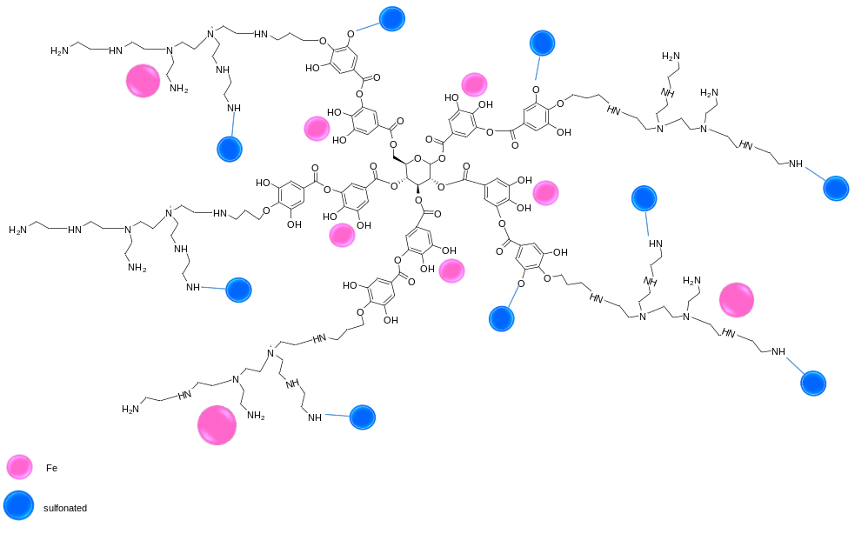
Scheme S1. The structure of prepared TPMS catalyst 1.

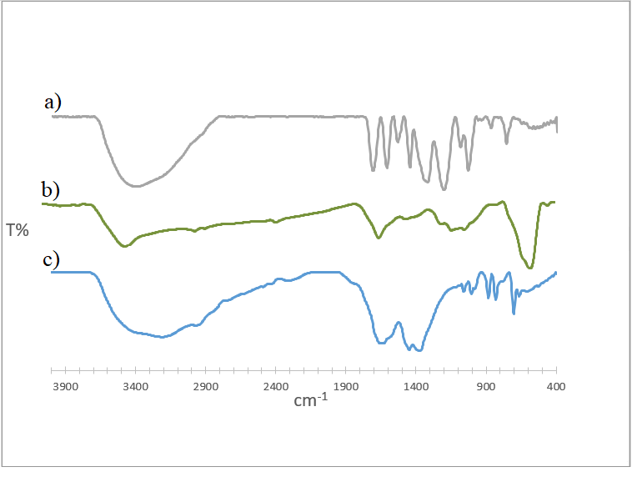
Fig. S1. FTIR spectra of a) TA b) TPMS c) TP.

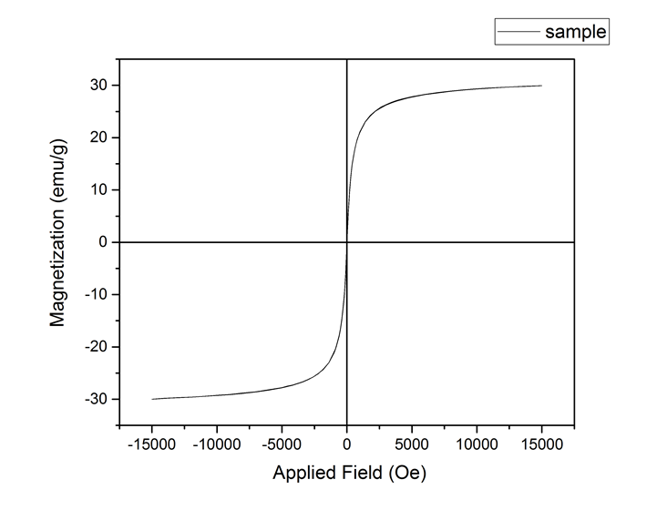
Fig. S2. VSM spectra of TPMS catalyst 1.
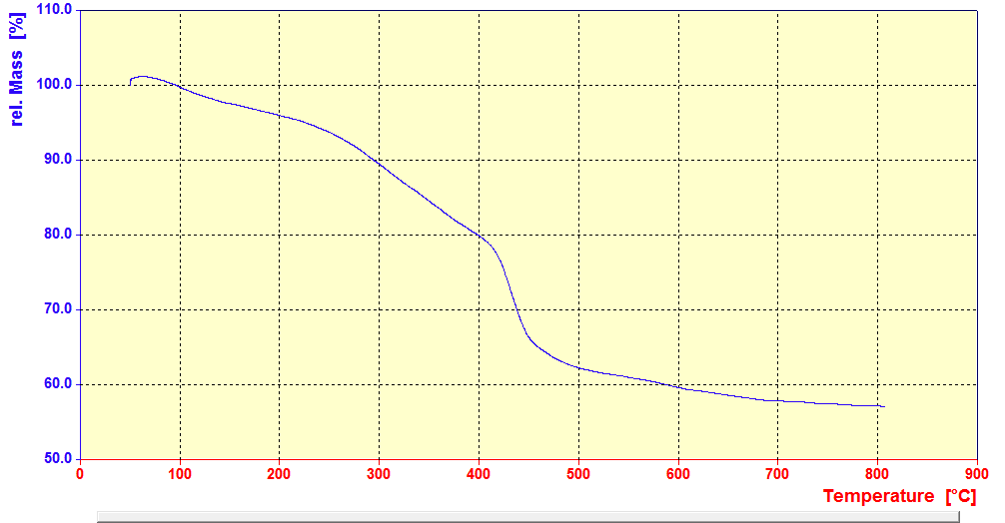
Fig. S3. TGA curve of TPMS catalyst 1.

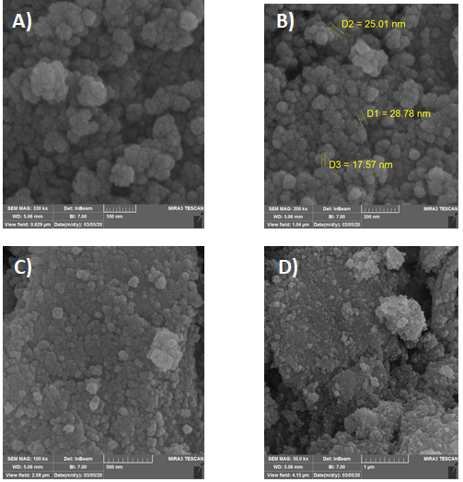
Fig. S4. FESEM images of TPMS A)100 nm B)200 nm C)500 nm D)1μm.

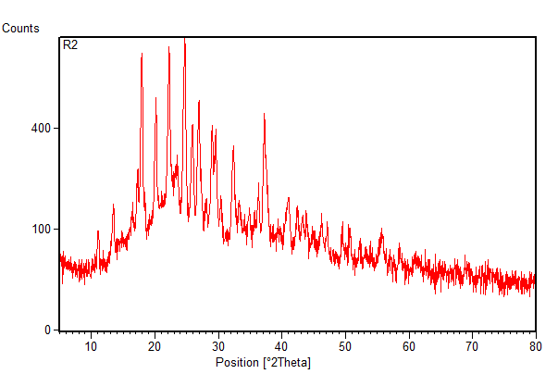
Fig. S5. XRD pattern of TPMS catalyst 1

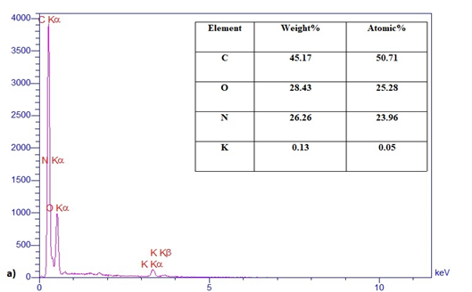
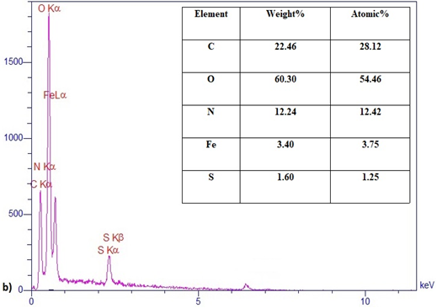
Fig. S6. Energy-dispersive X-ray (EDX) spectroscopy pattern of a) TP b) TPMS catalyst 1.

Procedure for the synthesis of 2,3-dihydroquinazoline derivatives by employing TPMS nanocatalyst 1.

After characterization TPMS nanocomposite (1), the three-component synthesis of 2,3-dihydroquinazole derivatives was chosen to examine its catalytic activity. For this purpose, the condensation, 1 mmol aldehyde (4a, 1 mmol) isatonic anhydride (2, 1 mmol) amine (3, 1 mmol) and TPMS (0.01 g) was selected as the model reaction for the synthesis of desire product (5a) . The mentioned amounts were added into 3 ml EtOH, as a solvent, in a 10 ml Round-bottom flask and placed on a magnetic stirrer under reflux conditions. The progression of the reaction was checked by thin-layer chromatography (TLC) using ethyl acetate and n-hexane in the ratio of 3: 1 as a mobile phase. After completion and cooling the reaction to r.t., the mixture was dissolved in hot ethanol, then the nanomagnetic catalyst was separated by using an external magnet bar. The final pure products was prepared by recrystallization and purification of crude products in (EtOH-H₂O) crystallization system.

Chemical characterization of 1-(4-(dimethylamine) phenyl)-2,3-dihydroquinazolin- 4(1)-one (5h)
White solid: MP 229-230°C. ¹H NMR (500 MHz, DMSO-d6): δ(ppm) 8.07 (s, 1H), 7.61 (d, J 8 Hz, 1H), 7.30 (d, J 12 Hz, 1H) 7.25-7.23 (m, 2H), 7.21(d, J 8 Hz, 1H) 6.92(d, J 8 Hz, 2H) 6.74-6.72 (m, 1H), 6.68 (s, 1H), 6.65 (s, 1H), 5.64 (s, 3H). FTIR (KBr): νmax/cm-1 3440 (NH), 1639 (CO), 1400-1500(C=C), 2927(C-H)
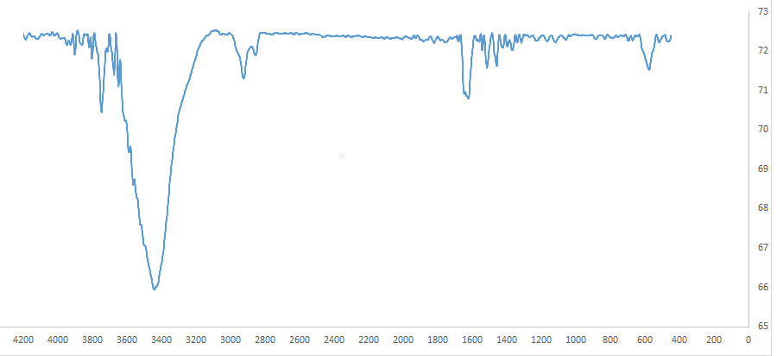
Fig. S7. FTIR spectrum of 1-(4-(dimethylamine) phenyl)-2,3-dihydroquinazolin- 4(1)-one (5h).
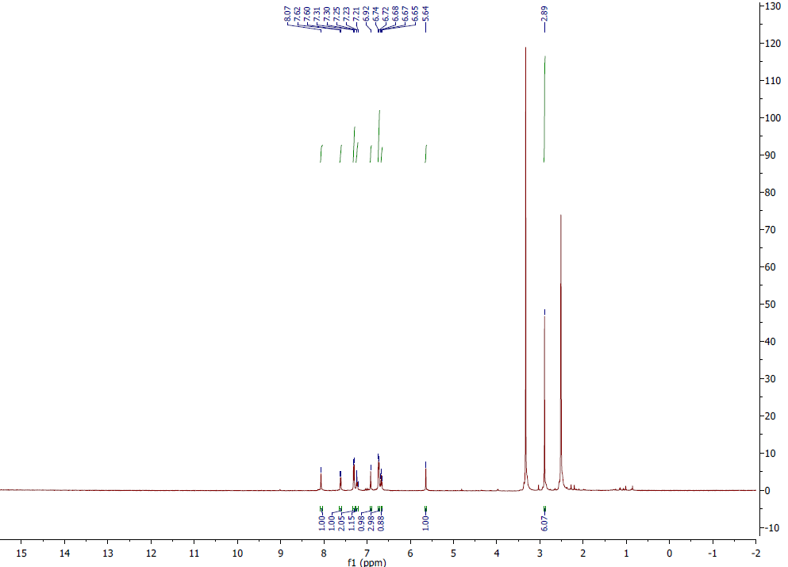
Fig. S8. ¹H NMR spectrum of 1-(4-(dimethylamine) phenyl)-2,3-dihydroquinazolin- 4(1)-one (5h).
Chemical characterization of 2-(5-Bromo-2-hydroxyphenyl)-3-phenyl-2,3-dihydroquinazolin-4(1H)-one (5b):
White solid: MP 210-217 °C; ¹H NMR (500 MHz, DMSO-d6): δ(ppm) 5.97 (s, 1H, CH), 6.78-6.71 (m, 3H, Ph), 7.26-7.24 (m, 8H, Ph), 7.64 (dd, J= 7.8 Hz, J= 1.2 Hz, 1H, Ph), 10.24 (1H, br s, OH); FTIR (KBr): νmax/cm-1 3400 (NH), 1636 (CO), 1400-1500(C=C), 2926(C-H)
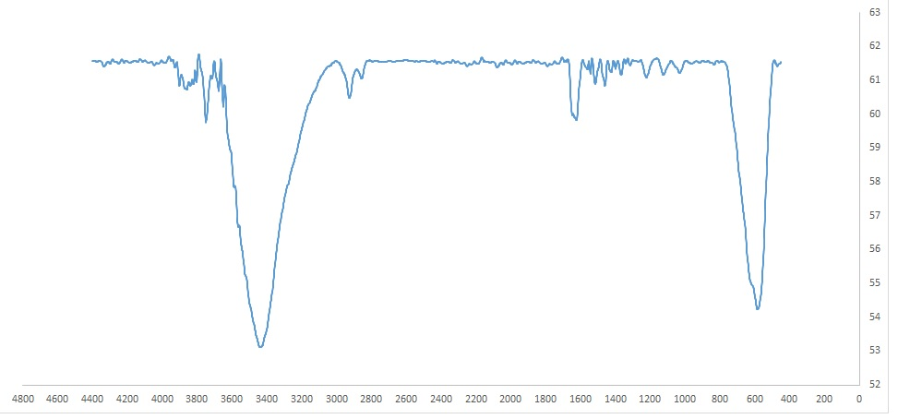
Fig. S9. FTIR spectrum of 2-(5-Bromo-2-hydroxyphenyl)-3-phenyl-2,3-dihydroquinazolin-4(1H)-one (5b):
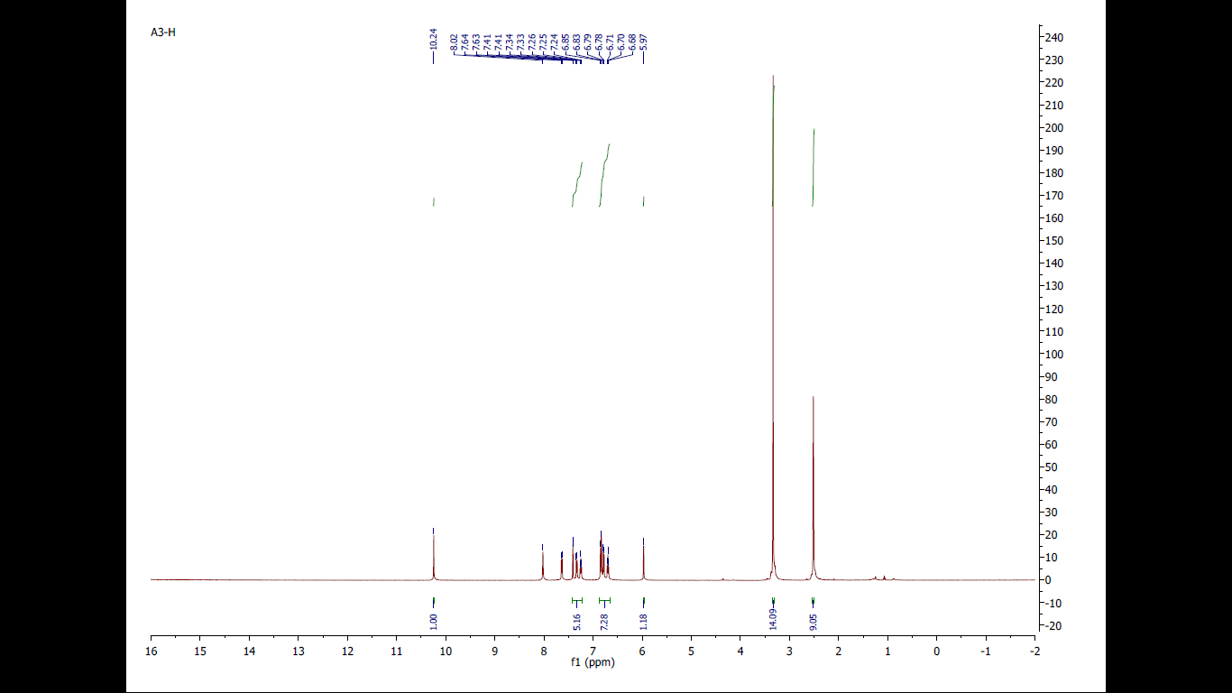
Fig. S10. ¹H NMR spectrum of 2-(5-Bromo-2-hydroxyphenyl)-3-phenyl-2,3-dihydroquinazolin-4(1H)-one (5b).

