Table 1. Optimization of the conditions for the model reaction in the presence of TA/PEI and TA/PEI/ Magnetic, TPMS.
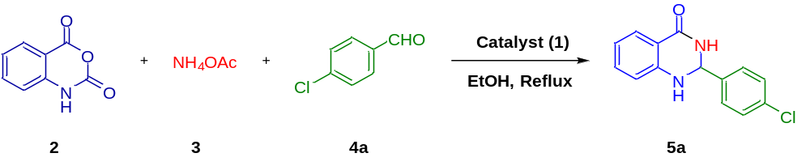
Entry | Catalyst | Product | Catalyst loading | Conditions | Time(min) | Yield (%)
1 | TA/PEI | 5a | 0.01 | EtOH / 80 ˚C | 45 | 70
2 | TA/PEI/M | 5a | 0.01 | EtOH / 80 ˚C | 30 | 80
3 | TPMS | 5a | 0.01 | EtOH / 80 ˚C | 15 | 94
4 | TPMS | 0.01 | EtOH | Reflux | 15 | 94
5 | TPMS | 0.01 | EtOH | r.t | 35 | 80
6 | TPMS | 0.01 | H₂O | Reflux | 25 | 85
7 | TPMS | 0.01 | H₂O | r.t. | 45 | 65
8 | TPMS | 0.01 | EtOH / H₂O  (1:1) | Reflux | 25 | 75
9 | TPMS | 0.01 | EtOH / H₂O  (1:1) | r.t. | 60 | 55
10 | TPMS | 0.007 | EtOH | Reflux | 45 | 84
11 | TPMS | 0.005 | EtOH | Reflux | 70 | 70
12 | TPMS | 0.003 | EtOH | Reflux | 110 | 55

Table 2. Investigation of the synthesis of desired products (5a-m) catalyzed by The TPMS catalyst (1) (Tannic Acid / Polyethylene imine / Magnetic / Sulfone) under the optimized conditions.ª
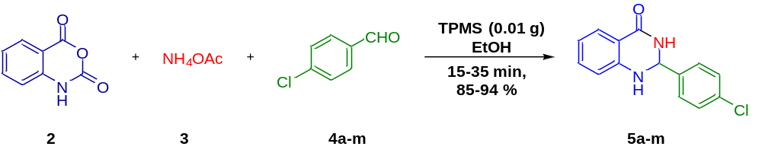
Entry | Aldehyde | Product | Time (min) | Yield^{b} (%) | m.p. ˚C (Obs.) | m.p. °C (Lit.)
1 | 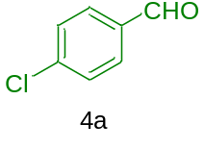 | 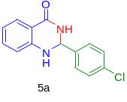 | 15 | 94 | 201-202 | 198-200  ¹¹⁶
2 | 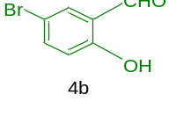 | 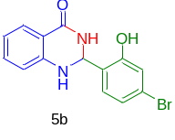 | 30 | 88 | 210-217 | 208-210
3 | 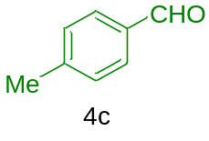 | 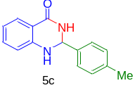 | 20 | 90 | 232-235 | 233-234  ¹¹⁷
4 | 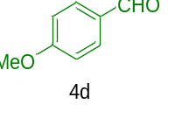 | 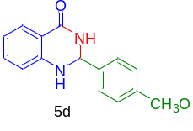 | 20 | 88 | 193-195 | 192-193  ¹¹⁸
5 | 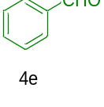 | 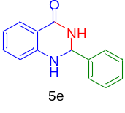 | 15 | 92 | 219-220 | 218-220
6 | 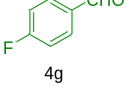 | 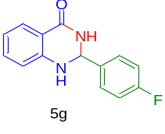 | 15 | 94 | 200-202 | 199-200  ¹¹⁹
7 | 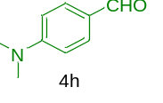 | 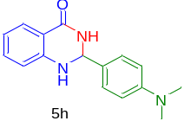 | 35 | 87 | 229-230 | 228-229
8 | 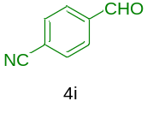 | 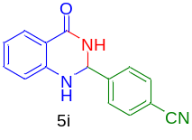 | 20 | 89 | 350-352 | 351-352  ¹¹⁹
9 | 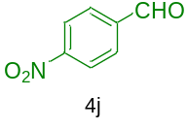 | 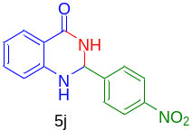 | 20 | 86 | 217-219 | 216-217  ¹¹⁹
10 | 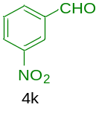 | 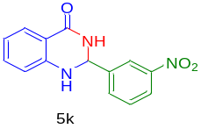 | 30 | 85 | 214-216 | 216-217  ¹¹⁹
11 | 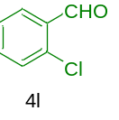 | 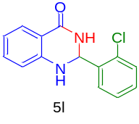 | 25 | 92 | 203-205 | 202-204  ¹¹⁶
12 | 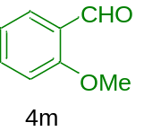 | 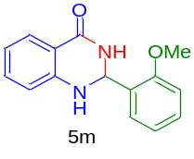 | 35 | 87 | 167-169 | 165-167  ¹⁰⁵

ª Isatoic anhydride (2, 1 mmol), ammonium acetate (3, 1 mmol), 4-chlorobenzaldehyde (4a , 1 mmol) and 0.01g of TPMS for the synthesis of 5a in EtOH at reflux conditions.
^{b} Isolated yields.

