Supplemental Materials
Combat Harmonization………………………………………………………………..Page 1
Sensitivity Analysis…………………………………………………………………….Pages 2-5
NeuroComBat MR Machine Harmonization
Confounding of biological processes by MR machine induced bias is a common and recognized problem in quantitative human brain imaging. A variety of approaches exist, but NeuroComBat, a method developed to adjust for batch effects in microarray expression data⁷⁹ is proving to be robust at reducing machine related differences in MRI data²³⁻²⁵ and was applied to the MRI data used in this analysis after adjusting for relevant covariates of age at MRI, sex, decade of birth and intracranial volume for hippocampal and cortical gray matter volumes as prescribed by the method developers²⁴.
We used the NeuroComBat R code developed by Jean-Philippe Fortin, fortin946@gmail.com on July 14, 2020, employed by R version 4.1.2 (2021-11-01). This is a modification of the ComBat function code from the sva package that can be found at https://bioconductor.org/packages/release/bioc/html/sva.html. The modified code is under the Artistic License 2.0. The NeuroComBat R-code can be found at github.com/Jfortin1/ComBatHarmonization. Results of application of NeuroComBat to the data used for this study are displayed in Supplemental Figure 1.
Supplemental Figure 1.
Distributions and analysis of difference for TCV, Hippocampus and Cortical thickness before and after Combat harmonization. The left panel under each measure caption is before and the right after Combat harmonization. Raw machine differences are small, but statistically significant prior to harmonization (except the hippocampus) and become insignificant after harmonization.
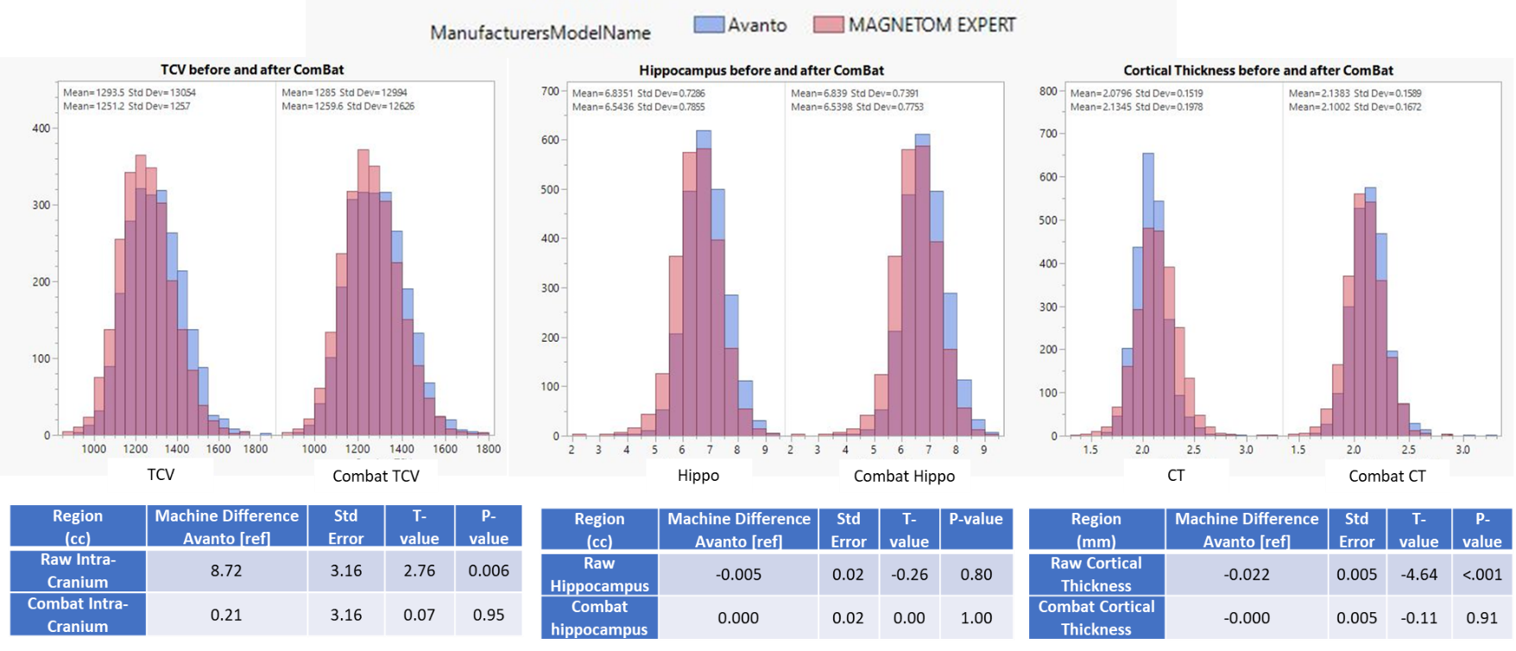
Sensitivity Analysis
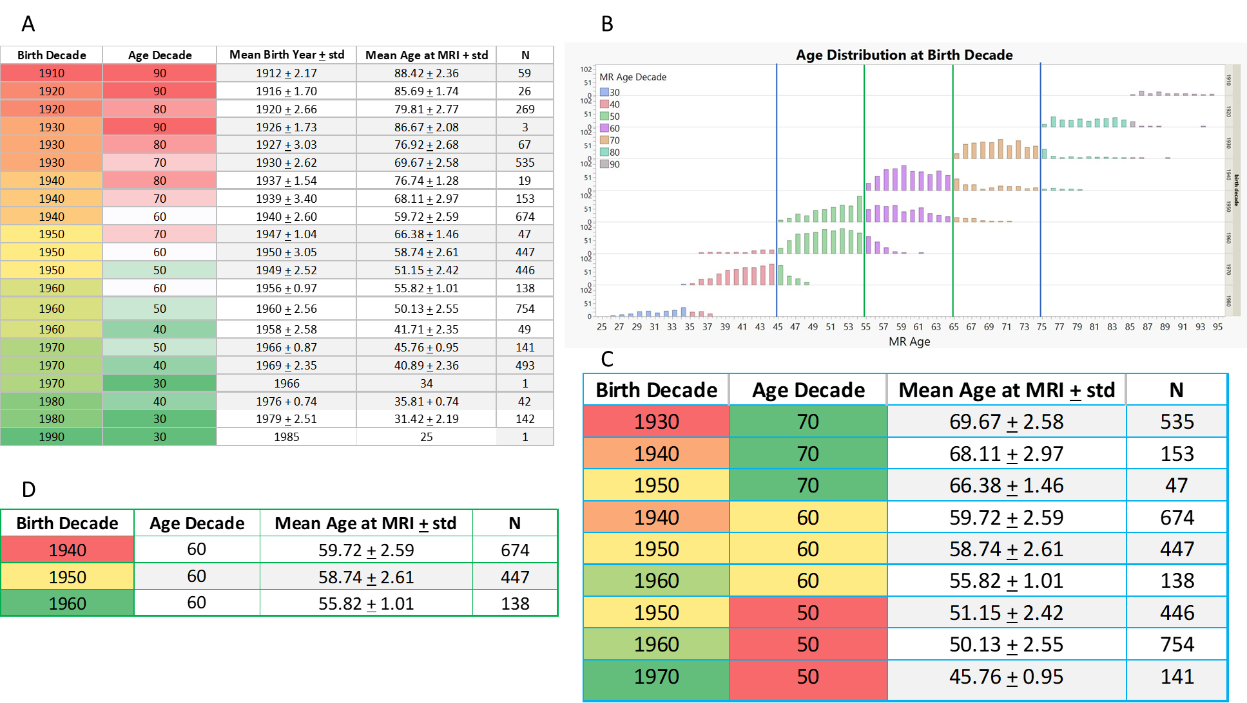
Supplemental Figure 2. Summary of cohort age distribution and differences with selective age restriction used for sensitivity analysis. Table 2a summarizes the number and demographics of participants at each age and birth decade by unique color. For example, individuals in the 6th decade of life (colored in white) span 3 birth decades. Figure 2b summarizes the age-range distributions for sensitivity analyses stratified by decade of birth and colored by age at time of MRI. Blue colored bars show the first restricted age range that overlaps with 3 different birth decades. The green lines show further restriction to a single decade of age that also spans 3 different birth decades. Table 2c summarizes the demographics in the first restricted sample and Table 2d shows demographics for the most restricted age range.
Supplemental Figure 3. Summary of impact of birth decade on hippocampal volume for the most restricted age range. Table 3a summarizes the mean age at each birth decade. Figure 3b shows the impact of decade of birth on hippocampal volume for men and woman showing significant mean increases in volume (Table 2 of manuscript). Figure 3c shows minimal age-related differences in hippocampal volume over this restricted age range confirming the positive effects of decade of birth.
