Supplemental information

Internal wave energy
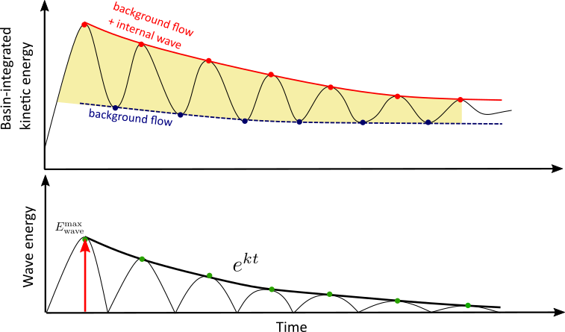
Fig. S1 Time-series of internal wave energy ($E_{wave}$) and the procedure to remove the background flow from the basin-integrated kinetic energy (Eq. 2 in the main text). Red and blue dots represent the identified maximum and minimum values from the time-series of basin-integrated kinetic energy, respectively. Red solid and blue dashed lines represent the total energy decay and the background flow decay, respectively. Green blue dot is the internal wave energy obtained from the difference between the basin-integrated kinetic energy (red dots) and the function of the background flow energy (blue dashed line), in which the first green dot (red arrow) describes the initial energy of the internal wave ($E_{wave}^{max}).$ $k$ is the internal wave damping coefficient (Eq. 3 in the main text).

Longitudinal cross sections (observed wind in response to a single wind event)
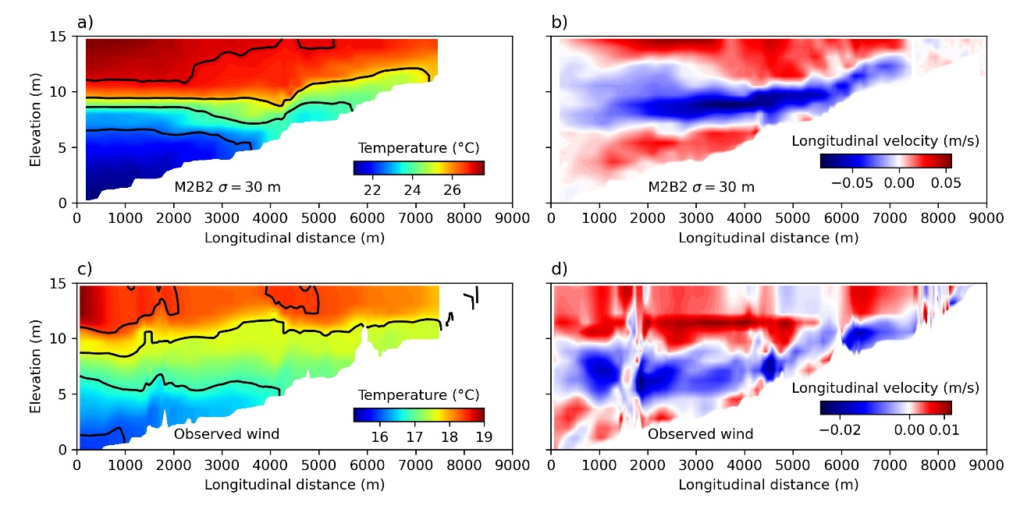
Fig. S2. Longitudinal sections of water temperature and horizontal flow velocity in Passauna Reservoir in response to an idealized 8-h wind episode (scenario M2B2) and with observed wind forcing. a) Water temperature and b) longitudinal flow velocity for scenario M2B2. c) Water temperature and d) longitudinal flow velocity simulated with observed wind dynamics and measured initial water temperature profile. The temperature distribution was obtained at the end of the wind episode, which was at t=8 h in a), while for the measured data the end of the wind episode was characterized by the end of a strong wind event measured on 29 June at 21 h 20 min (cf. Fig. 3 in the main text). The horizontal velocities are shown at the end of the wind event, during the initial seiche excitation. The solid black lines in a) and c) mark isothermal depth with 1.0 °C increment.

Hydrodynamic characterization of the analyzed period P1 and spectral analysis
No significant peaks that could be related to internal seiche activity were present in the power spectra of horizontal flow velocity in the lake interior (Fig. S3b and c). The low-frequency peaks (with period of 24 h and 12 h) identified in the power spectral density are more energetic near the water surface, indicating that the observed oscillatory response is related to the diurnal and semidiurnal components of the wind forcing that accelerate the water surface periodically. Particularly near the water surface, the spectra of the simulated horizontal velocity indicates the presence of oscillatory flows at a frequency of 4 $×$10⁻⁴ Hz (Fig. S3c). Since the model is not capable of resolving high-frequency (propagating) internal waves due to its coarse spatial resolution, the peak can likely be assigned to surface (baroclinic) seiches of different horizontal modes, which were hidden by other unresolved motions in the measured data. The theoretical period of the fundamental surface seiche in Passauna reservoir, assuming a reservoir-shaped basin (Rabinovich, 2009), is around 42 min, which matches the frequency of the spectral peak at 3.8 $×$ 10⁻⁴ Hz, corresponding to period of 43 min (Fig. S3c).

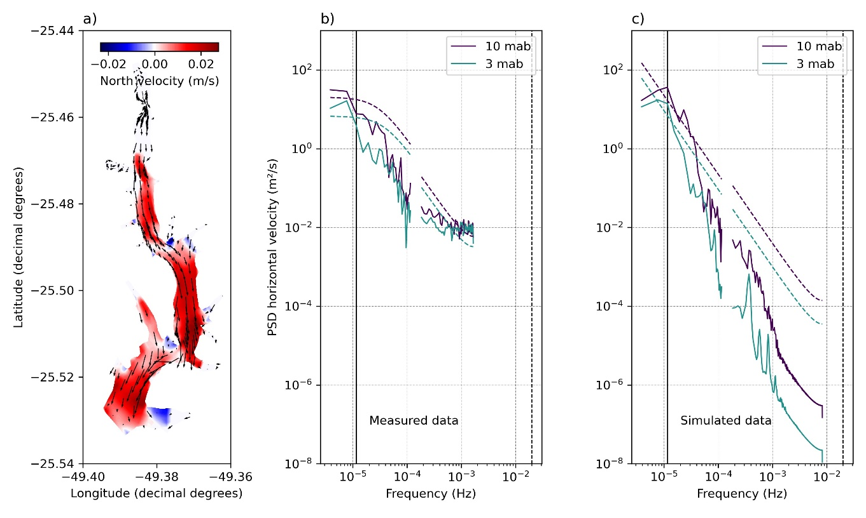
Fig. S3. Hydrodynamic characterization of the analyzed period P1. a) Simulated horizontal flow velocity during the upwelling event on June 29 (2018) at 17:00 h. The black arrows illustrate the horizontal velocity direction and magnitude near the water surface (2 m depth). The color scaling shows opposing (northward) flow in the hypolimnion (8 m above the deepest part of the reservoir). Power spectral density of b) observed, and c) simulated time series of horizontal flow velocity at two different depths at the monitoring station (red dot in Fig. 1a in the main text). For low-frequencies (10⁻⁶ to 10⁻⁴ Hz), the spectra were calculated with a window size of 3 d, while in the high-frequency range (up to 10⁻⁴ Hz), we used a window size of 12 h. The dashed lines show the 95 % confidence limit of the mean red noise spectrum estimated for each time series. The vertical black dashed line marks the buoyancy frequency ($N=0.02$ Hz), and the vertical solid black line shows a 24-h period.

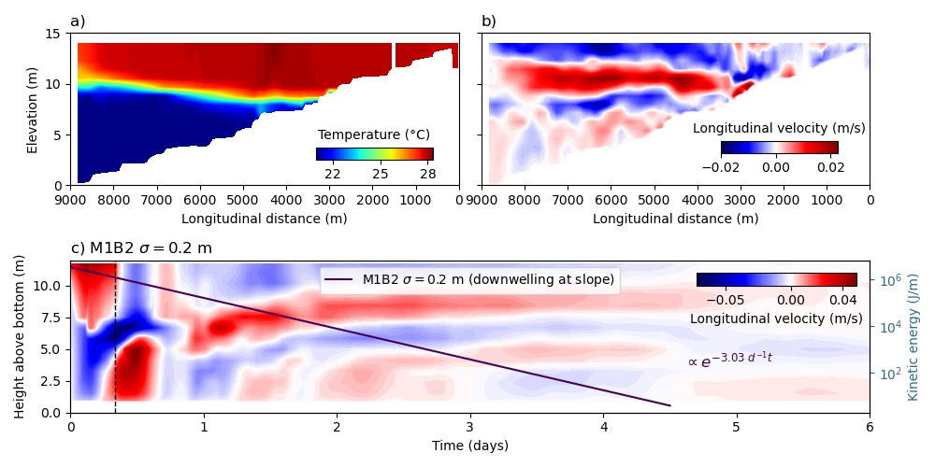
Fig. S4. The influence of bathymetry on internal seiches analyzed in scenario M1B2 (straight channel with sloping water depth) for nearly two-layer stratification ($σ=0.2$ m) in response to a wind event from southern direction (from the left towards the dam). a) Temperature distribution along the longitudinal cross section of the reservoir during the wind set-up ($t=0.3$d) and b) the longitudinal flow velocity distribution at $t≅$ 38.5 h. c) Time series of horizontal velocity profiles at the basin center. The solid lines illustrate the exponential wave energy decay (see labels for decay rates, in which t is defined in days).

Downwelling at sloping boundary

Temporal dynamics of the vertical profiles of horizontal flow velocities
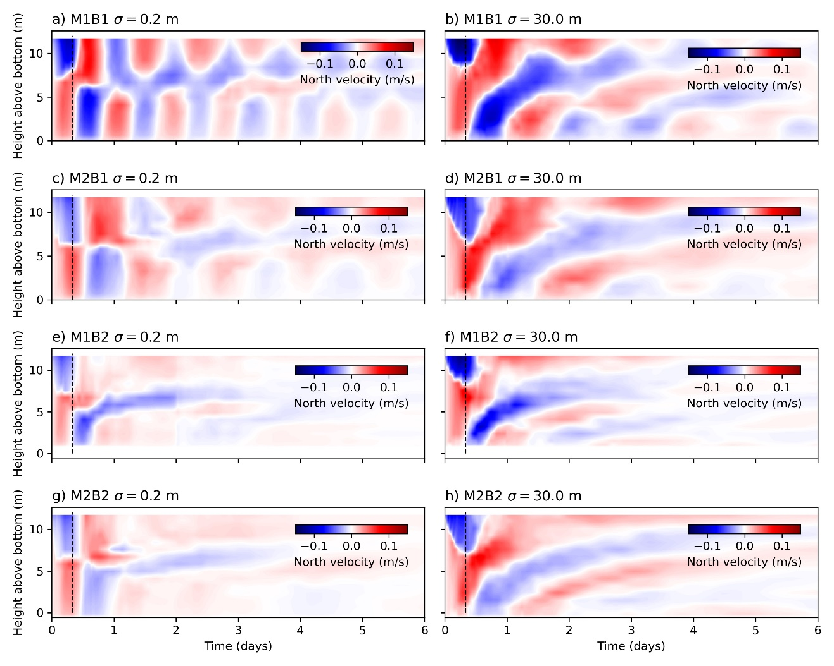
Fig. S5. Temporal dynamics of the vertical profiles of horizontal flow velocities near the center of the reservoir (station S1, velocity indicated by color) for scenario a) M1B1 $σ=0.2$ m, b) M1B1 $σ=30$ m, c) M2B1 $σ=0.2$ m, d) M2B1 $σ=30$ m, e) M1B2 $σ=0.2$ m f) M1B2 $σ=30$ m, g) M2B2 $σ=0.2$ m, and h) M2B2 $σ=30$ m. The vertical black dashed lines mark the end of the wind event.

Effects of sloping boundary
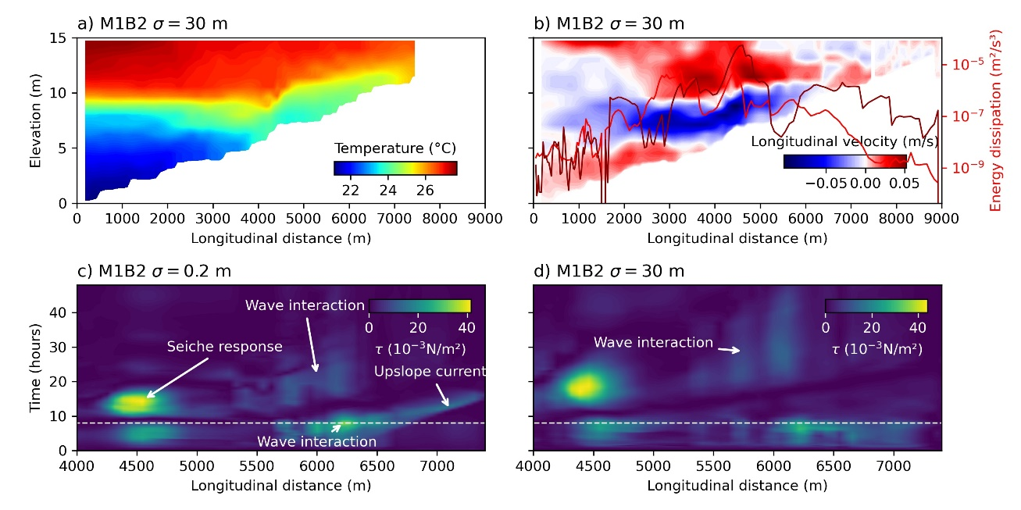
Fig. S6 Simulated water temperature, horizontal flow velocity, bed shear stress, and depth-integrated energy dissipation rates at the center line of Passaúna reservoir for scenario M1B2. a) Longitudinal cross section of water temperature (at $t=7$ h 12 min) and b) horizontal velocity (at $t=7$ h 12 min). Light and dark red lines show time series of integrated turbulent energy dissipation rates during the first interaction with the lakeshore for scenario M1B1 with $σ=0.2$ m and $σ=30$ m, respectively. Bed shear stress for c) $σ=0.2$ m and d) $σ=30$ m at the center line of Passaúna reservoir. High shear stress observed after the wind event (above the dashed white line) at the center of the basin (4500 m from the dam) indicates the response of internal seiche, since higher horizontal velocity are observed near the wave node (seiche response). Right after the end of the wind event high shear stress is observed near the shore, where the current shear across the density interface interacts with the bottom slope, at 6200 m from the dam (wave interaction). This occurs due to the acceleration of the flow near the sloping bottom, causing a up sloping current. This event persists for more wave periods (wave interaction) but promoting lower shear stresses since most part of the energy has been dissipated during the first interaction.

Numerical simulations
This appendix serves to provide a list of physical and numerical parameters that have been used in the numerical simulations. All input data to support the findings presented here are available at https://github.com/buenorc/wepaper.git (DOI: 10.5281/zenodo.5708040).
Table SI 1. List of physical and numerical parameters used in numerical simulations of the baseline and hypothetical scenarios with Delft3D.
Parameters | Value
Latitude | -25°
Number of layers | 20 (equally spaced)
Days of simulation | 10 days*
Time step of numerical computation | 0.1 min
Results - temporal resolution | 1.0 min
Gravity | 9.81 m s⁻²
Water density (reference) | 1000 kg m⁻³
Air density (reference) | 1 kg m⁻³
Salinity (reference) | 0 ppt
Wind drag coefficient (wind speed: 0.00 m s⁻¹) | 0
Wind drag coefficient (wind speed: 1.25 m s⁻¹) | 0.0025
Wind drag coefficient (wind speed: 3.00 m s⁻¹) | 0.0018
Bottom roughness | Manning - Uniform value | $n=0.035$
Wall roughness | Slip condition: Free
Model for 3D turbulence | $k-ε$ model
Background horizontal eddy diffusivity | 0 m² s⁻¹
Drying and flooding check at | Grid centers and faces
Depth at grid cell faces | Minimum
Threshold depth | 0.1 m
Marginal depth | Not applied
Smoothing time | 60 min
Advection scheme for momentum | Cyclic
Advection scheme for transport | Cyclic
Vertical grid system | Cartesian coordinate system (Z-model)
Maximum depth in the model (lower boundary) | -16.949524 m
Maximum water level in the model | 0.3 m
Heat flux model | Ocean (with solar radiation) **
Seechi depth | 2 m**
Dalton number | 0.0013**
Stanton number | 0.0013**
*10 days have been simulated for baseline and hypothetical scenarios, however, for baseline simulations (validation simulations) the first 4 days have been used for model spin-up and were discarded from further analysis. ** Heat flux model has been applied only for the baseline scenario, and neglected for hypothetical scenarios.

Damping Coefficients
Table SI 2. Damping coefficients for all hypothetical scenarios. σ is the standard deviation describing the Gaussian form of the buoyancy-frequency profile, in which σ = 0.2 m indicates that the basin approximates to a two-layer stratification and σ = 30 m indicates that the basin presents a linear stratification condition from surface to bottom.
Simulation | σ (m) | Damping Coefficient (d⁻¹)
M1B1 | 0.2 | 0.85
M1B1 | 3 | 0.94
M1B1 | 10 | 0.99
M1B1 | 30 | 1.01
M2B1 | 0.2 | 1.05
M2B1 | 3 | 1.15
M2B1 | 10 | 1.23
M2B1 | 30 | 1.31
M1B2 | 0.2 | 3.05
M1B2 | 3 | 1.96
M1B2 | 10 | 1.76
M1B2 | 30 | 1.71

Model validation
To evaluate the model's ability to reproduce the thermal stratification, modeled and measured temperature profiles were compared by their root mean square difference. The observed horizontal flow velocities were compared with simulations using the mean normalized velocity difference (Huang et al., 2010; Dissanayake et al., 2019):
$$\overline{D} = \sqrt{\frac{(u_{m}-u_{s})²}{u_{m}²}},$$ | SI 1
where $\overline{D}$ is the mean normalized difference, and $u_{m}$ and $u_{s}$ are the measured and simulated horizontal velocity components aligned to the wind direction, respectively.
To investigate the influence of the grid size on model performance, a similar simulation was run for a cell size of 200 m and a rectangular grid, thus, being 150 % coarser than the standard grid used in the baseline scenario.
The simulation results obtained from the three-dimensional hydrodynamic model were compared to measured data for the analysis periods P1 and P2 at the location of the monitoring station (Fig. S7). In general, the simulated temperature profiles were in good agreement with the observations, with a relatively small root mean square difference (0.64 °C ± 0.40 °C). The simulation slightly overestimated the water temperature during both analysis periods. During period P1, the root mean square difference was highest in the top 3 m (0.30 ± 0.20 °C). During summer (period P2), larger differences between measurements and simulations occurred near the reservoir bottom (1.2 °C).
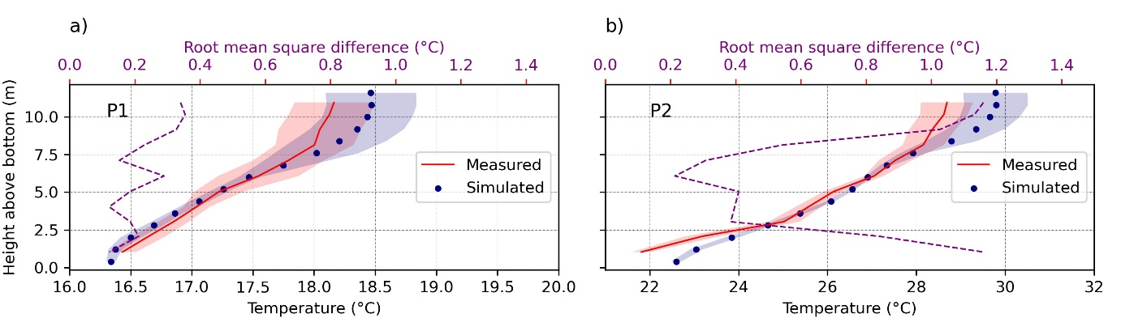
Fig. S7 Vertical stratification during the analysis periods at the sampling site near the intake station (Fig. 1a in the main text): a) P1 (from June 28 to July 04, 2018) and b) P2 (from January 29 to February 04, 2019). Both panels show the mean vertical profiles of simulated (blue dots) and measured (red solid line) temperature, with their standard deviations marked by the blue and red shaded areas. The purple dashed lines show the root mean square difference between simulations and observations.
The normalized root mean square difference (NRMSD) between the measured and simulated horizontal flow velocities (Eq. S1) was larger for small velocities, particularly for horizontal velocities smaller than 0.005 m s⁻¹ (Fig. S8a). The median of the NRMSD significantly decreased for larger velocities. The comparison also showed larger deviations at small velocities during period P2, when the density stratification was stronger (Fig. S8a).
For flow velocities exceeding 0.005 m s⁻¹, the differences between simulations and observations were generally small and without systematic differences between both periods.
The comparison of the directional components of the horizontal velocity between simulated and measured data also indicate decreasing deviations as the velocity increases, which is characterized by the increase of phase agreement in Fig. S8b.
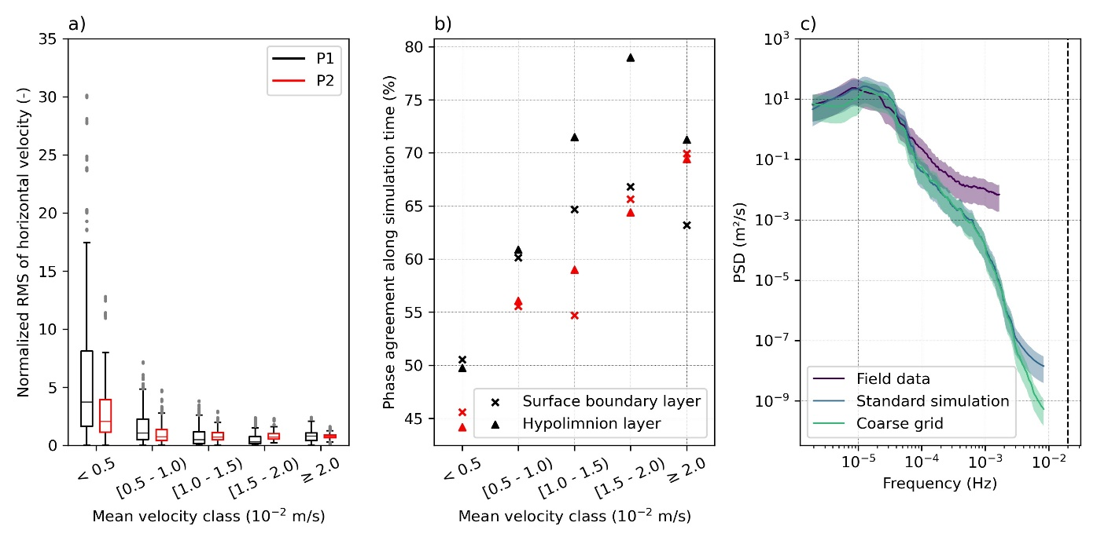
Fig. S8 Comparison of measured and simulated horizontal flow velocities for period P1 (weaker stratification) and P2 (stronger stratification). a) Normalized root mean square difference (NRMSD) of the horizontal velocity difference between measured and simulated data for different velocity classes for period P1 (black) and P2 (red). The boxes extend over the 25th and 75th quartiles, whilst the horizontal line indicates the median value. The whiskers extend to the minimum and maximum values neglecting outliers, which are represented by gray dots. b) Period of time (in percentage) that the direction of simulated horizontal velocities agreed with measured data for both periods and for different velocity classes. Crosses and triangles represent data from near the reservoir bottom (2.5 m above the bottom) and near the water surface (9 m above the bottom), respectively. c) Power spectral density of horizontal velocity variations at approximately 2.5 m above the bottom for measured (purple) and two simulations (blue and green). The solid blue line represents the spectral density of simulations using the standard grid size of our scenario analyses, whilst the solid green line represents PSD obtained from a coarser numerical grid. The colored shaded area shows the 95 % confidence interval.
Fig. 4 in the main text provides an exemplary comparison of simulated and observed flow dynamics at the monitoring station, indicating that the model was able to capture the hydrodynamics of Passaúna reservoir reasonably well. Even though the simulated horizontal velocity components were slightly lower than the measurements, the dynamics and vertical distribution of larger-scale flow structures were well reproduced by the model (Fig.4 b and c in the main text), in which discrepancies were small, especially for horizontal velocity larger than 5 $×$ 10⁻³ m s⁻¹ (Fig. S8a).
Finally, we compared the power spectral density of measured and simulated horizontal velocity variations (Fig. S8c). The spectra show good agreement for low-frequency variability, but the spectral variance of the simulated velocities decreased strongly for frequencies exceeding 8 $×$ 10⁻⁴ Hz (corresponding to a period of 21 min). The sharp drop-off in the spectra of simulated velocities can be caused by the spatial discretization of the numerical model, or by other unresolved motions.
To evaluate the influence of grid size on the spectrum, we analyzed simulations using a 150 % coarser numerical grid. Low frequency variations and the general drop-off of power spectral are not affected by the increase in grid size (Fig. S8c). The spectra deviated only in the highest frequency bands, near the buoyancy frequency (2 $×$10⁻² Hz), suggesting large-scale motions can be well captured by the model even increasing the grid size at the point of interest from approximately 62 m to 200 m. For extremely coarse grids, we may also expect a stronger influence on large-scale motions due to the poor description of the longitudinal variability in reservoir topography and flow conditions.

