Supplementary information
A Robust Lateral Shift Free (LSF) Electrothermal Micromirror With Flexible Multi-Morph Beams
Hengzhang Yang ¹, Anrun Ren ¹, Yingtao Ding ¹, Lei Xiao ¹, Teng Pan ¹, Yangyang Yan ², Wenlong Jiao² and Huikai Xie ^{1,} *
¹School of Integrated Circuits and Electronics, Beijing Institute of Technology, Beijing 100081, China
²BIT Chongqing Institute of Microelectronics and Microsystems, Chongqing 400030, China
* hk.xie@ieee.org

Supplementary Materials:
Figures S1, S2.
Table S1, S2.
References S1, S2.
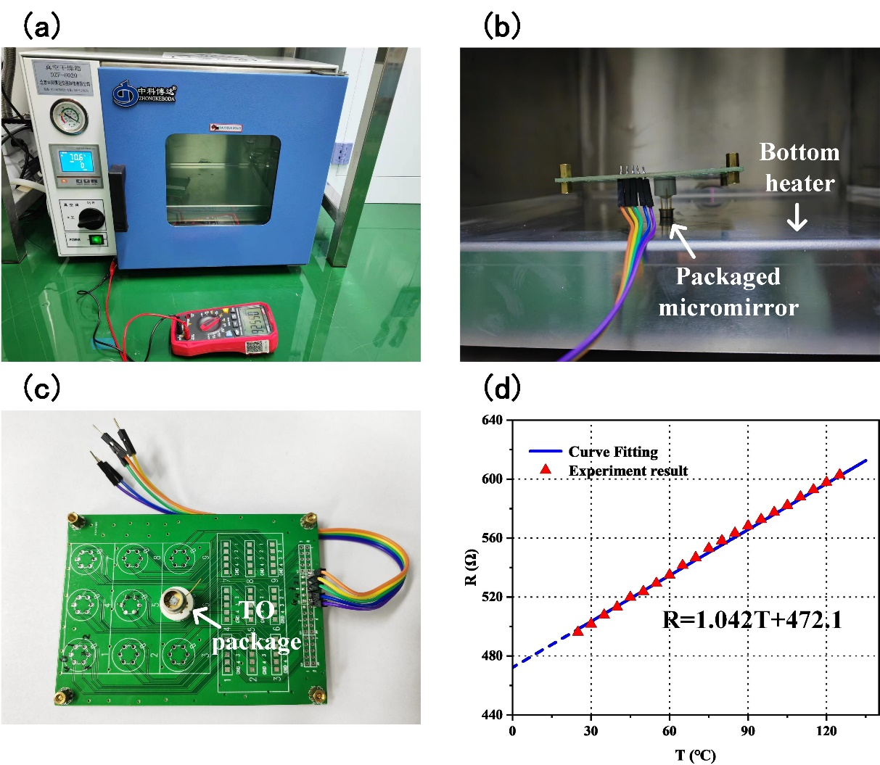
Figure S1. The test method for temperature coefficient of resistance. (a) The whole view of the test setup. A temperature-controlled oven is used to set the temperature, and a multimeter is used to measure the resistance value at the specific temperature. (b) A close view of the device in the oven. To maximize the heat concentration on the micromirror, the TO package is inverted on the bottom heating plate. (c) A close view of the PCB circuit board of the micromirror. (d) The relationship between the resistances and the temperature. The measurement error of the resistance is ±1 Ω. The TCR of the resistance can be calculated as the ratio of the slope to the R-axis intercept of its R-T curve [S1], and the value is 0.0022/K.

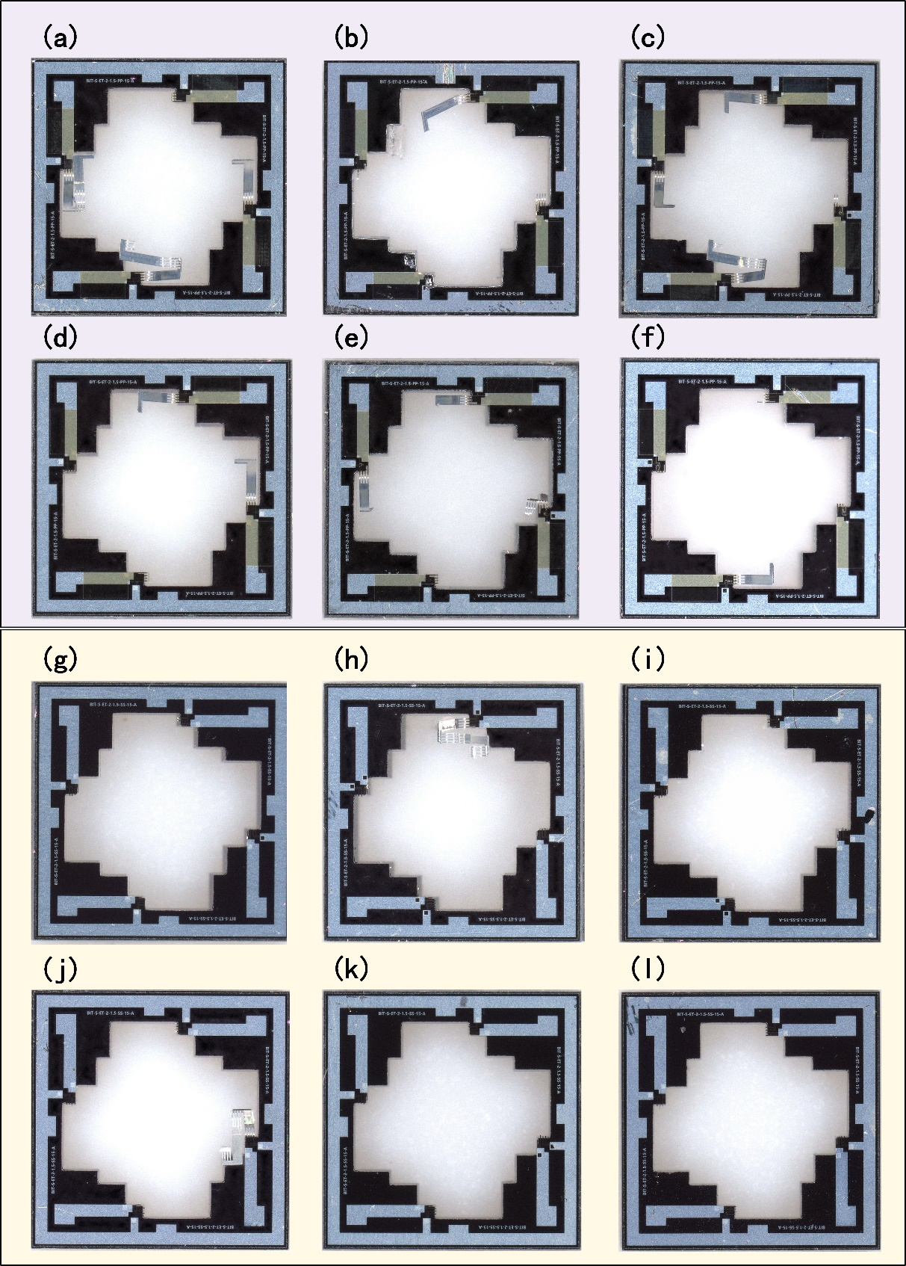
Figure S2. Damaged pictures of the two types of micromirrors. (a~f). The PSPI-type micromirrors. (g ~ l). The SiO₂-type micromirrors.

Table S1. Comparison of properties of the selected materials
Material | Young’s modulus (GPa) | CTE (ppm K⁻¹) | Thermal conductivity (W m⁻¹ K⁻¹) | Electrical conductivity (S m⁻¹)
Al [S2] | 70 | 23.1 | 237 | 35.5 × 10⁶
SiO₂ [S2] | 70 | 0.5 | 1.4 | Insulator
Pt [S2] | 168 | 8.8 | 71.6 | 8.9 × 10⁶
PSPI [S2] | 2.3 | 20 | 0.15 | Insulator

Table S2. The resistance and frequency test results of a PSPI-type micromirror in the drop test
Drop height(cm) | R₁ (Ω) | R₂ (Ω) | R₃ (Ω) | R₄ (Ω) | f₁(Hz) | f₂(Hz) | Microscopic Examination
1 | 528.6 | 534.1 | 526.7 | 529.2 | 198 | 388 | OK
3 | 528.7 | 533.4 | 525.7 | 528.3 | 198 | 388 | OK
5 | 529.1 | 535.2 | 528.8 | 530.4 | 198 | 387 | OK
7 | 528.3 | 537.7 | 524.3 | 527.4 | 197 | 386 | OK
9 | 530.1 | 536.3 | 527.1 | 529.7 | 197 | 386 | OK
11 | 531.4 | 533.1 | 529.4 | 531.2 | 195 | 385 | OK
13 | 529.7 | 534.7 | 531.2 | 533.4 | 190 | 383 | OK
15 | 530.4 | 537.4 | 527.4 | 530.6 | 184 | 371 | OK
17 | 533.1 | 536.3 | 534.1 | 532.8 | 177 | 366 | OK
19 | 532.6 | 533.9 | 536.5 | 530.3 | 162 | 344 | OK
21 | 531.8 | 535.2 | 537.1 | 533.4 | 155 | 336 | OK
23 | \ | \ | \ | \ | \ | \ | Fail*
*The mirror plate detached from the device.

Reference
[S1] L. Xiao, Y. Ding, P. Wang & H. Xie. Analog-controlled light microshutters based on electrothermal actuation for smart windows. Opt Express 28, 33106-33122 (2020).
[S2] S. Pal & H. Xie. Fabrication of robust electrothermal MEMS devices using aluminum–tungsten bimorphs and polyimide thermal isolation. Journal of Micromechanics and Microengineering 22, (2012).

