Supplementary material

Nature-skin-based multi-responsive controlled-release electroactive scaffolds for integrated melanoma postoperative relapse prevention and wound therapy
Manhui Zheng^{1,2}, Xuechuan Wang^{1,2,}*, Jiamin Zhang^{1,2}, Ouyang Yue^{1,2}, Jingyu Zhang³, Zhongxue Bai^{1,2}, Huie Jiang¹, Ling Wen^{4,5}*, and Xinhua Liu^{1,2,}*
- College of Bioresources Chemical and Materials Engineering, Shaanxi University of Science &Technology, Xi'an 710021, China
- Institute of Biomass & Functional Materials, Shaanxi University of Science &Technology, Xi'an 710021, China
- Department of General Surgery, The Second Affiliated Hospital of Soochow University, Suzhou, 215004, China
- Department of Radiology, The First Affiliated Hospital of Soochow University, Suzhou 215000, China
- Institute of Medical Imaging, Soochow University, Suzhou 215000, China
*Correspondence e-mail: wxc-mail@163.com (X. Wang); liuxinhua@sust.edu.cn (X. Liu)
Keywords: dermal matrix, multi-responsive, controlled-release, melanoma relapse, wound healing

This PDF file includes:
Nature-skin-based multi-responsive controlled-release electroactive scaffolds for integrated melanoma postoperative relapse prevention and wound therapy 1
This PDF file includes: 1
Materials and methods 2
Materials 2
Fabrication of PADM-MX-Ag-Si@Dox 2
Characterization methods 3
(1) Morphological characterization 3
(2) Thermal stability analysis 3
(3) Water absorption, retention, and degradability performance 3
(4) Specific surface area test and porosity testing 4
(5) Zeta potential and hydrodynamic diameters testing 4
(6) Controlled release performance of Dox 4
(7) Antibacterial capability 5
(8) Electrochemical performance 5
(9) Biocompatibility evaluation 5
(10) Scratch wound-healing migration assay 5
(11) Assessment of the ability to promote cell proliferation 5
(12) Cellular uptake of Dox assay 6
(13) pH-sensitive studies for tumor monitoring 6
(16) In vivo antitumor and wound healing efficacy of scaffolds 6
(17) In vivo full-thickness skin defect model 7
Characterization analysis 7
(1) Schematic illustration of the synthesis of TSOHSiO₂@Dox with multiple responses property 7
(2) Three-dimensional microscope images of scaffolds 8
(3) Thermogravimetry analysis 8
(4) A standard curve of Dox 9
(5) Biocompatibility analysis 10
(6) Flow cytometry analysis of cell cycle distribution 11
(7) Dox distribution of B16F10 cells seeded on the nanofiber scaffolds 12
(8) Dox distribution of B16F10 cells 12
Reference 12

Materials and methods

Materials
Polyvinylpyrrolidone (K-30, > 99.5%), styrene (St, > 99.0%), 2,2’-Azobis (2-methylpropionamidine) dihydrochloride (V-50, > 97.0%), hexadecyl trimethyl ammonium bromide (CTAB, > 99.0%), ethanol (> 99.8%), ammonium hydroxide solution (28 wt%), tetraethoxysilane (TEOS, > 99.9%), paraffin liquid (ρ = 0.86-0.89 g/mL), sodium hydroxide (NaOH, > 96.0%), acrylic acid (AA, > 99.0%), N-Isopropylacrylamide (NIPAM, > 98.0%), N, Nʹ-Methylenebis (MBA, > 99.0%), sodium dodecyl sulfate (SDS, > 99.0%), Titanium carbide (MXences, > 99.9%) and doxorubicin hydrochloride (Dox, > 98.0%) were purchased from Aladdin. Silver Nanowire (AgNWs, 30 nm, 20 μm) was purchased from Jiangsu Xianfeng Nano Material Technology Co., Ltd., and collagenase from Clostridium histolyticum (Type I, ≥ 125 CDU/mg) was purchased from Sigma-Aldrich.

Fabrication of PADM-MX-Ag-Si@Dox
(1) Synthesis of HSiO₂^{[1]}
0.2 g of K-30 was dissolved in 88 g of ultrapure water under vigorous stirring. 10 g of St was added to the K-30 aqueous solution and kept stirring at 800 rpm under nitrogen purge for 30 min to form an emulsion. After heating to 70℃, 2 mL of V-50 solution (wt% = 12%) was injected to initiate the polymerization. The emulsion was then polymerized for 24 h under nitrogen to form the latex.
3.2 g of CTAB, 38.4 g of ultrapure water, 44 g of Ethanol, and 8 mL of ammonium hydroxide solution were mixed before 100 g of latex was added dropwise under vigorous stirring. After sonicated for 15 min and stirring for 30 min, 6 g of TEOS was added dropwise. The mixture was kept at room temperature for 48 h and centrifugalized at 7000 rpm for 15 min. The precipitate was washed three times with copious ethanol and calcined at 600℃ for 8 h in air.
(2) Synthesis of OHSiO₂
500 mg of HSiO₂ was ultrasonically dispersed in 20 mL of ultrapure water for 30 min. 2 g of paraffin liquid was added under vigorous stirring after HSiO₂ dispersion heated to 80℃. Kept stirring for 30 min at 80℃ before vacuum filtration. The filter residue was immersed in 20 mL of sodium hydroxide (1 mol·L⁻¹) for 15 min. Vacuum filtrated and ultrasonically washed three times with ultrapure water before vacuum drying at 60°C overnight.
(3) Synthesis of TSOHSiO₂
500 mg of OHSiO₂ was ultrasonically dispersed in 100 mL of ultrapure water for 30 min. 0.8 × 10⁻³ mol of AA was added after OHSiO₂ dispersion heated to 70℃ and kept stirring for 4 h at 70℃. 5 × 10⁻³ mol of NIPAM, 3.5 × 10⁻⁵ mol of MBA and 5 × 10⁻⁵ mol of SDS were respectively added in the above mixture and kept stirring for 30 min. 2 mL of APS water solution (0.01 mol·L⁻¹) was divided into five injections into five five-minute intervals before kept stirring for 20 h. Vacuum filtrated and ultrasonically washed three times with ethanol before vacuum drying at 60°C overnight.
(3) Synthesis of PADM
PADM was prepared according to our previous invention patent (CN1569260). In brief, fresh porcine skin was obtained from a local slaughterhouse (Chengdu, China). Matched pieces were taken from the back area of the porcine skin. The chemicals used in the following procedure were based on the weight of the skin. Porcine skin was first completely washed in a drum (Φ = 40 cm) with a 300% float containing 0.3% peregal at 30 °C for 1 h. After this step, the subdermal fat tissue was excised under a fleshing process, followed by rotating in the drum in a 300% float containing 2.5% Na₂CO₃ and 0.5% peregal at 30°C for 3 h. Next, the hair of porcine skin was removed by coating 2.5% trypsin (250 μ/mg) on the surface of the flesh side at 25°C overnight. In the following step, the skin was cut into pieces with a thickness of 0.5 mm and purified with a method of alkali-enzyme hydrolysis to remove the fat, cells, and residual hair roots. Then, carefully washed samples were frozen at -50°C for 5 h, and subsequently lyophilized at a low chamber vacuum (0.05 bar).
(4) Synthesis of PADM-MX-Ag
Several pieces of round PADM samples with a diameter of 3 cm were weighted (W_{P}). 0.1 W_{P} of MXenes was ultrasonically dispersed in 5 W_{P} of PBS (pH 7.4) for 30 min. 1 W_{P} of AgNWs (5mg·mL⁻¹) was ultrasonically dispersed in 5 W_{P} of PBS, and ultrapure for 30 min. The dried PADM was first immersed in MXenes solution for 6 h and then transferred to AgNWs solution for 6 h. Ultrasonically cleaning twice by PBS and freeze-dried to obtain PADM@MX-Ag.
(5) Synthesis of PADM-MX-Ag-Si@Dox
Several pieces of PADM-MX-Ag were weighted (W_{P}ʹ). 0.2 W_{P}ʹ of TSOHSiO₂ was ultrasonically dispersed in 20 W_{P}ʹ of PBS for 30 min. 0.01 W_{P}ʹ of Dox were added and kept stirring at 4℃ for 4 h in a dark place before PADM@MX-Ag were added. After stirring for 20 h, PADM-MX-Ag-Si@Dox were generated after ultrasonically washing three times by PBS and freeze-drying.

Characterization methods

Morphological characterization
HSiO₂, TSOHSiO₂, PADM, and PADM-MX-Ag-Si@Dox were observed by scanning electron microscopy (SEM, Vega 3 SBH, TESCAN, Czech Republic). HSiO₂, OHSiO₂, and TSOHSiO₂ were observed by transmission electron microscope (TEM, FEI, USA). The infrared spectrum was gained by Fourier transform infrared spectroscopy (FT-IR, Perkin Elmer FT-IR Spectrum Two, USA). Raman spectra (RS) were measured in a laser-scanning confocal micro-Raman spectrometer.

Thermal stability analysis
Dried samples were heated from 0 - 800°C under a rate of 10°C·min⁻¹, and analyzed by differential scanning calorimetry (DSC, TA Instruments). The thermal degradability of samples was evaluated by thermogravimetric analysis (TGA, TA Instruments) after being heated to 800°C under a rate of 20°C·min⁻¹.

Water absorption, retention, and degradability performance
The PADM and PADM-MX-Ag-Si@Dox were soaked in ultrapure water for 24 h at room temperature. Carefully wiped the surface moisture with filter paper and weighed as W₀. Then centrifuged at 10000 r·min⁻¹ for 10 min and weighed as W₁. Finally, drying at 105℃ to keep constant weight and record the constant weight as W₂. Water absorption rate (q_{ab}) = ((W₀ - W₂) / W₂) × 100% and water retention rate (q_{re}) = ((W₀ - W₁) / W₂) × 100%.
Collagenase was solubilized in PBS solution (1 U·mL⁻¹, 1 mL⁻¹·mg⁻¹ of sample weight) for 1, 2, 4, and 7 days. The degradation experiment was carried out in a constant temperature and humidity incubator (HWS-150B, TAISITE, China) at 37°C with 60% humidity. Samples with constant weight were weighted as W_{s} before being impregnated into collagenase degradation solution. At specific intervals, freeze-dried and weighed as W_{t}. Degradation rate (DR) = (W_{s} - W_{t}) / W_{s} × 100%.

Specific surface area test and porosity testing
The N₂ adsorption-desorption isotherm (BET) surface area, t-Plot volume, and surface area of micropore and DFT pore volume and Surface area were determined by automatic specific surface and porosity analyzer (Autosorb iQ Station 2, Quantachrome Instruments, USA).
The porosity of PADM and PADM-MX-Ag-Si@Dox were detected by an automatic Mercury porosimeter.

Zeta potential and hydrodynamic diameters testing
5 mg of HSiO₂ and TSOHSiO₂ were dispersed through sonication in 50 mL of PBS before being diluted 1,000-fold and measured by Nanoparticle size and surface potential analyzer (Zetasizer Nano ZSP, Malvern, UK).

Controlled release performance of Dox
The standard curve of Dox concentration: 2.5 mg Dox was accurately weighed and dissolved into a 50 mL volumetric flask to obtain 50 μg·mL⁻¹ Dox standard reserve solution. The maximum absorption wavelength (λ_{max}) of 5 μg·mL⁻¹ Dox was tested by UV scanning in the wavelength range of 200 - 760 nm. 50 μg·mL⁻¹ Dox standard reserve solution was diluted with PBS into 1.0, 3.0, 5.0, 10.0, 20.0, and 50.0 μg·mL⁻¹ standard working solution of Dox. The absorbance values (A) of the standard working solution were determined at λ_{max} to obtain the linear equation and correlation coefficient (R²).
Dox loading rate (LR) = (1 - C_{WS} / (0.01 × W_{P} × 10⁶ / 20 × W_{P}) × 100% = (1- C_{WS} / 500) × 100%,
W_{P}: The weight of PADM; C_{WS}: The Dox concentration of the waste solution (diluted to 50-fold) of the synthesis of PADM-MX-Ag-Si@Dox.
PADM-MX-Ag-Si@Dox was weighted as W_{p} and soaked in 20 W_{P} PBS (pH = 4, 5.8, 6.8, 7.4, 8). Fixed in a constant temperature air bath oscillator (ZYC-100BR, Gemtop, China) at 37°C, 300 rpm, and tested the Dox concentration of at λ_{max} of specific intervals (0.5 h, 1 h, 5 h, 12 h, 24 h, 36 h, 48 h, 60 h, 72 h). The specific steps are as follows: after extracting 1 mL of leaching solution (diluted to 50-fold) and testing the Dox concentration (C_{LS}), 1 mL of fresh PBS was added to fill up the volume difference. Controlled Release rate (CR) = (C_{LS} / (0.01 × Wp × 10⁶ / 20 × Wp) × LR) = C_{LS} / (500 - C_{WS}).

Antibacterial capability
Using E. coli and S. aureus as experimental strains, referring to appendix C5 of GB15979-2002, the bacterial inhibition ability was estimated by measuring the number of colonies. The specific steps were as follows. A total of 0.75 g of the sample was accurately weighed and put into a 250-mL conical flask. Added 70 mL of PBS and 5 mL of bacterial solution (1.5 × 10⁴ CFU·mL⁻¹). Fixed in a constant temperature air bath oscillator (ZYC-100BR, Gemtop, China) at 300 rpm for 1 h. 0.5 mL of fluid samples after shaking and diluting 100-fold were inoculated onto an agar plate. Colony counts were performed after cultured for 24 h. 50 μL bacterial solution (1.5 × 10⁶ CFU·mL⁻¹) was uniformly coated onto a solid medium, and the circular samples with a diameter of 2 cm were placed directly on the solid medium. Antifungal activity was determined by measuring the diameter of the inhibition zone after incubating at 37 °C for 24 h.

Electrochemical performance
Resistance measurements were performed by the standard four-probe method using a Multifunctional Digital Four-probe Tester (ST-2258C, Beijing Tongde Venture Co., Ltd.). PADM-MX-Ag-Si@Dox scaffolds were cropped to 1 × 1 cm squares, and resistance was calculated by the formula: R_{s} = ρ / d (ρ: resistivity, d: thickness).
The conductivity of the PADM-MX-Ag-Si@Dox scaffolds was evaluated using a Princeton Electrochemical Workstation VersaStudio (P4000+, Ametek Co., LTD). The variation sensitivity was detected by demonstrating the relative resistance (ΔR / R₀ = (D - value of resistance) / initial resistance × 100%)
PADM-MX-Ag-Si@Dox scaffolds were cut into a rectangular shape with 2 cm in width and 4 cm in length. Copper tapes were attached to both ends of the conductive gel to form a strain sensor. Subsequently, the sensor was attached to different positions of an observer (wrist, the first joint of the forefinger, and the elbow) to detect electrical signals.

Biocompatibility evaluation
The cytotoxicity of the samples was evaluated with MTT assays; Live/Dead cells of Chinese Hamster Lung (CHL) were visualized using a Calcein-AM/PI Double Stain Kit and a Leica TCS SP8 STED inverted confocal microscope.

Scratch wound-healing migration assay
Scaffolds were placed into 48-well plates and seeded with B16F10s at a density of 2.0 × 10⁵ cells/well in advance. Incubated at 37°C and 5% CO₂ for 24 h to allow the B16F10s to adhere to the scaffolds. B16F10s were seeded on coverslips. Subsequently, a scratch wound was made on monolayer B16F10s by using a 10 μL pipette tip. Incubated for 24 h before being observed under the digital microscope (DMB5-223IPL-5, Motic, China).

Assessment of the ability to promote cell proliferation
The PADM-MX-Ag-Si@Dox was co-cultured with CHL cells under electrical stimulation in homemade special equipment. The following ES scheme was adopted: After one day of cultivation, the PADM-MX-Ag-Si@Dox+ES group underwent electrical stimulation for 7 days. The circuit voltage is 1 V, frequency is 25 Hz, at intervals of 24 hours. In one period, ES was performed twice for 1 h, with an interval of 1 h between each time. The performance of cell proliferation promotion was monitored by an inverted confocal microscope (DMi8) and flow cytometry (FACSCalibur).

Cellular uptake of Dox assay
To monitor the DOX distribution in B16F10 cells, the groups of Dox, PADM scaffold, PADM-MX-Ag-Si@Dox scaffold, PADM-MX-Ag-Si@Dox scaffold + ES were placed in 48-well plates and the B16F10 cells were seeded onto the scaffolds at 4 × 10⁴ cells/well. ES condition: V = 1 V, f = 25 Hz. The intracellular fluorescence in B16F10 cells was then analyzed by a CytoFLEX system (Beckman Coulter).
For the confocal laser microscopic (CLSM) analysis, the scaffolds were placed in confocal dishes and the B16F10 cells were seeded onto the scaffolds at 1 × 10⁵ cells per dish. ES condition: V = 1 V, f = 25 Hz. The intracellular fluorescence of B16F10 cells and scaffolds was monitored by Leica TCS SP8 confocal laser microscope.

pH-sensitive studies for tumor monitoring
pH-sensitive studies were performed by detecting the different conductivity of PADM-MX-Ag-Si@Dox scaffolds after immersed in 10 mL 1 × PBS solution with various pH values (pH =4.0, 5.0, 5.8, 6.8, 7.4, and 8.0). The PADM-MX-Ag-Si@Dox scaffolds were removed after 0.5 h immersion, and excess water was removed by wiping with the filter paper. The electrical conductivity was measured by the Princeton Electrochemical Workstation VersaStudio (P4000+, Ametek Co., LTD).
- Effects of skin cells ingrowth on tumor monitoring
The PADM-MX-Ag-Si@Dox scaffolds (diameter of 2.0 cm) were put in 12-well plates, and 2 mL 1 × 10⁵ CHL cells were added in each well. The PADM-MX-Ag-Si@Dox scaffolds were removed after being co-cultured for 1, 2, 3, 4, 5, 6, and 7 days. Excess water was removed by wiping it with filter paper. The electrical conductivity was measured by an electrochemical workstation.
- In vitro anticancer real-time monitoring
The PADM-MX-Ag-Si@Dox scaffolds were connected to an electrochemical workstation via the wires. The glass beads were dropped onto the scaffolds from 1 cm above the scaffolds. The variation sensitivity was detected by demonstrating the relative resistance (ΔR / R₀ = (D - value of resistance) / initial resistance × 100%).

In vivo antitumor and wound healing efficacy of scaffolds
6-8 weeks old C57BL/6 mice were obtained from Changzhou Cavens Biological Technology (Jiangsu, China). All of the animal experiments were performed according to protocols approved by the Institutional Animal Care and Use Committee of Soochow University (NO.202241755). The tumor-bearing was performed by subcutaneous injecting of 1 × 10⁶ B16 cells (suspended in 100 μL PBS) into the right flanks of the molted mice, after a week of adaptive feeding. The volumes of the tumors were calculated according to the equation:
V_{(tumor)} = L × W² / 2 (L: maximum diameter of the tumor, W: minimum diameters of the tumor).
When the volumes of the tumor reached 100 mm³ (about a week), the tumors were performed surgical resection following anesthesia of the mice with chloral hydrate. Afterward, the mice were randomly divided into three groups and treated with NC (Control, G1), PADM-MX-Ag-Si@Dox (G2), and PADM-MX-Ag-Si@Dox+ES (G3). The electrical stimulus was implemented on days 1, 3, and 5 with a parameter of voltage = 1.0 V, frequency = 25 Hz, at intervals of 12 hours. On day 7, the mice were sacrificed. Recurrent tumors and spleen were taken out and recorded with photographs. The spleen weight index was calculated following the equation:
Spleen weight index = W_{(spleen)} / W_{(body)} ×10 (W_{(spleen)}: spleen weight, W_{(body)}: body weight)

In vivo full-thickness skin defect model
Specific Pathogen Free (SPF) rats (conventional), 6-8-week-old, and 200 - 220 g were obtained from the Institute for Hygiene of Ordnance Industry (Xi’an, China). They were maintained with free access to pellet food (Jiangsu Xietong Biotechnology Co., Ltd, Nanjing, China) and water in plastic cages at 18 - 26℃ and kept on a 12-h light / dark cycle. Animal welfare and experimental procedures were carried out strictly in accordance with the guide for the care and use of laboratory animals (Shaanxi Province Science and Technology Department of China, SYXK (SHAN) 2021-008) and the related ethical regulations of the Institute for Hygiene of Ordnance Industry. All efforts were made to minimize animal suffering and to reduce the number of animals used. A round full-thickness wound with a diameter of 1 cm was created by a punch on the back of SPF rats. The rats were divided into 4 groups that were treated with the PADM-MX-Ag-Si@Dox+ES group, PADM-MX-Ag-Si@Dox group, PADM group, and Control group. A continuous ES was applied with an amplitude of 1V and a frequency of 25 Hz at intervals of 24 hours. In one period, ES was performed twice for 1 h, with an interval of 1 h between each time. The wound areas were first recorded by photos and the tissue specimens were stained with H&E staining, Masson staining, and CD31 on day 7, and day 14.

Characterization analysis

Schematic illustration of the synthesis of TSOHSiO₂@Dox with multiple responses property
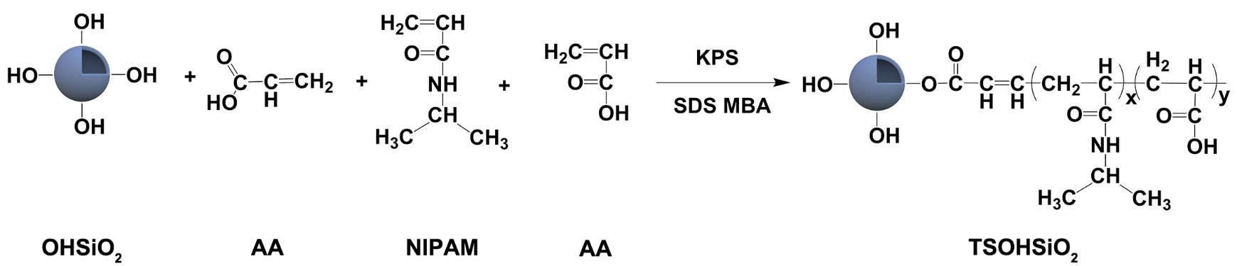
Figure S1. Schematic illustration of the synthesis of TSOHSiO₂@Dox with multiple responses property

Three-dimensional microscope images of scaffolds
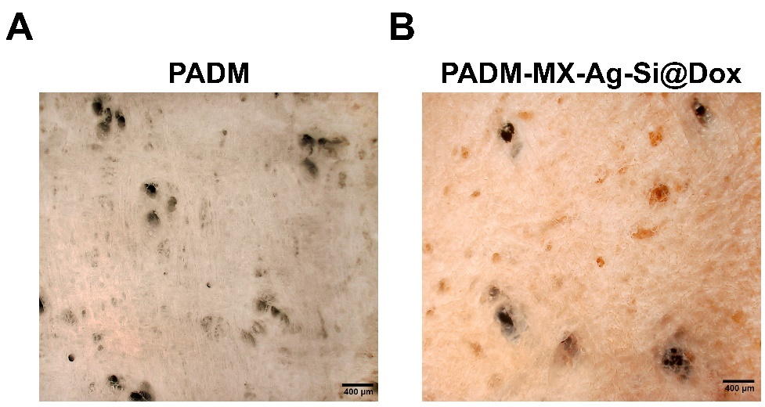
Figure S2. Three-dimensional microscope images of (A) PADM and (B) PADM-MX-Ag-Si@Dox scaffolds. A smooth nanofiber surface can be observed and a biomimetic fibrous structure similar to skin and soft tissues in PADM and PADM-MX-Ag-Si@Dox.

Thermogravimetry analysis
Figure S3. Thermogravimetry analysis (A) and differential scanning calorimetry analysis (B) of PADM and PADM-MX-Ag-Si@Dox scaffolds. From Figure S2A, the higher amount of ash (1-∆W₁-∆W₂) resulted from the doping of fillers. Besides, Figure 2SB indicates that PADM-MX-Ag-Si@Dox has a higher thermostability than PADM.

A standard curve of Dox
UV detection of different concentrations of DOX was performed at 490 nm. A standard curve was prepared by plotting the obtained absorbance values against Dox concentrations, indicated below in Table 1.

Table S1. Absorbance values against Dox concentrations
Concentrations of Dox  (μg·mL⁻¹) | Absorbance values |  |  | Average value
1 | 0.01119 | 0.01040 | 0.00952 | 0.01037
3 | 0.03872 | 0.03911 | 0.03949 | 0.03911
5 | 0.06355 | 0.06407 | 0.06517 | 0.06426
10 | 0.14147 | 0.14274 | 0.14409 | 0.14277
20 | 0.30158 | 0.31300 | 0.31626 | 0.31028
50 | 0.74937 | 0.75502 | 0.75186 | 0.75208

Figure S4. A standard curve of Dox. (A) UV detection of 5 μg·mL⁻¹ Dox from 200 nm to 760 nm. (B) A standard curve of Dox at 490 nm. As shown in Figure S5A, consider λ = 490 nm as the maximum absorption wavelengths (λmax) of Dox. The standard curve was: y = 0.01523 x − 0.00615 (R² = 0.99938).

Biocompatibility analysis
Figure S5. Live/dead assay staining of biocompatibility test at days 1, 3, and 5. (n = 6 independent experiments per group).

Flow cytometry analysis of cell cycle distribution
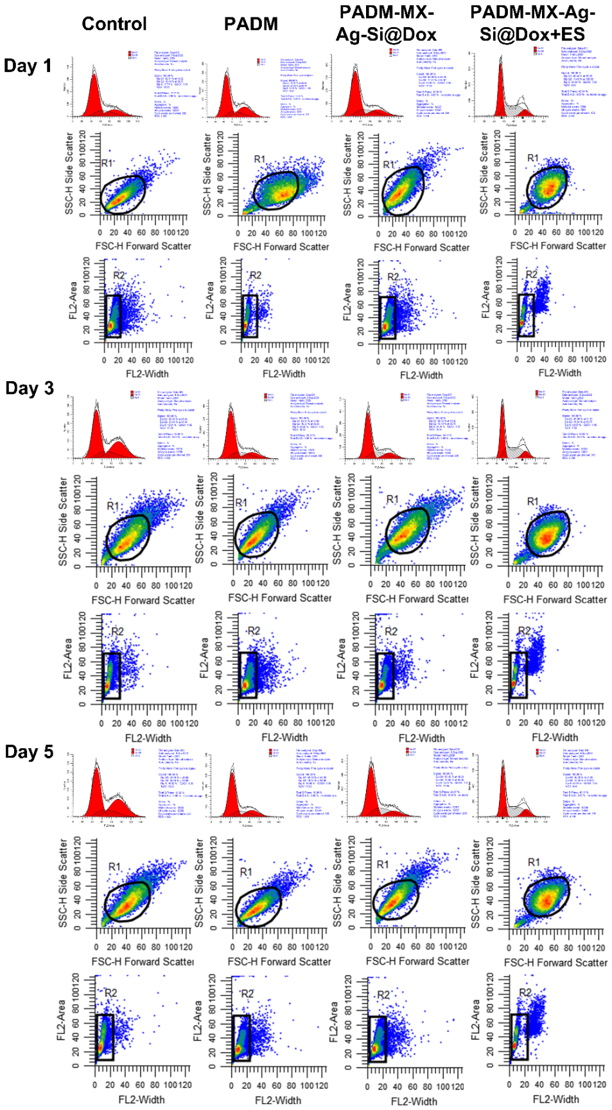
Figure S6. Histograms, and scatter plots derived from flow cytometric analysis of B16F10s at day 1, 3, and 5 after co-cultured with samples.

Dox distribution of B16F10 cells seeded on the nanofiber scaffolds

Figure S7. Confocal laser scanning microscopic images about the Dox distribution of B16F10 cells seeded on the nanofiber scaffolds and cultured for 1, 3, and 5 days. (scale bar = 500 μm, n = 6 independent experiments per group).

Dox distribution of B16F10 cells
Figure S8. Confocal laser scanning microscopic images about the intracellular Dox distribution of B16F10 cells at days 1, 3, and 5. (n = 6 independent experiments per group).

Reference
[1] G. G. Qi, Y. B. Wang, L. Estevez, A. K. Switzer, X. N. Duan, X. F. Yang, E. P. Giannelis, Chemistry of Materials 2010, 22, 2693.

