Scalable synthesis of 2D Ti₂CT_{x} MXene and MoS₂ composites with excellent microwave absorbing performance
Scalable synthesis of 2D Ti₂CT_{x} MXene and molybdenum disulfide composites with excellent microwave absorbing performance
Baoji Miao^{a, 1}, Yange Cao^{a,1}, Qingsong Zhu^{a,*}, Muhammad Asif Nawaz^{a, b,*}, Jose Antonio Ordiozola^{b}, Tomas Ramirez Reina^{b}, Zhiming Bai^{c,*}, Junna Ren ^{d,e}, Fengchun Weiª
ª Henan International Joint Laboratory of Nano-photoelectric magnetic materials. Henan university of technology, Zhengzhou, Henan 450001, China
^{b} Department of Inorganic Chemistry and Material Sciences Institute of Seville, University of Seville-CSIC, Seville 41092, Spain.
^{c} Hefei Innovation Research Institute, BeiHang University, Hefei 230000, China
^{d} College of Materials Science and Engineering, Taiyuan University of Science and Technology, Taiyuan, 030024, China
^{e} Mechanical and Construction Engineering, Northumbria University, Newcastle Upon Tyne, NE1 8ST, UK

*Corresponding author Email: Qingsong Zhu, qingsong_zhu@haut.edu.cn; Muhammad Asif Nawaz, Mnawaz@us.es; Zhiming Bai, bzm@buaa.edu.cn

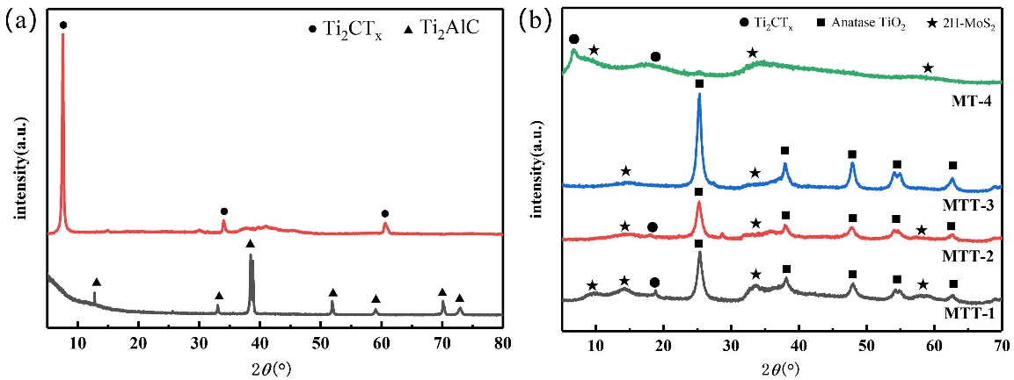
Figure SI 1 (a) XRD patterns of Ti₂AlC and Ti₂CT_{x}, and (b) XRD patterns of MTT-1, MTT-2, MTT-3 and MT-4.

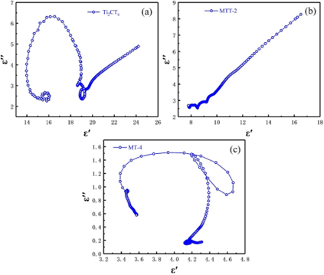
Figure SI 2 Cole-Cole plots for (a)Ti2CTx, (b)MTT-2, and (c)MT-4 materials.

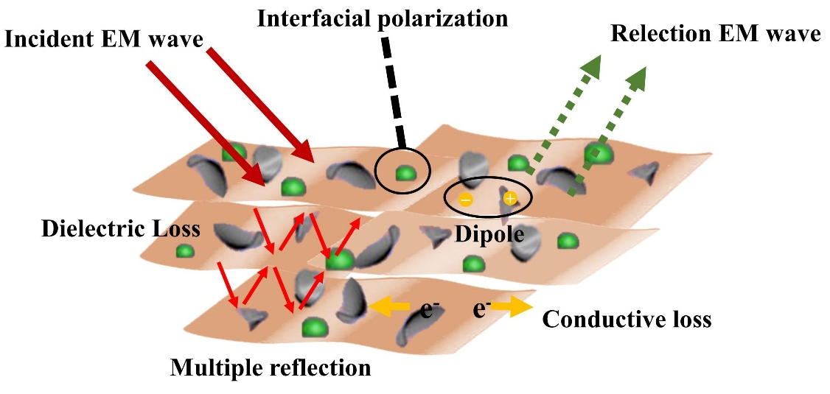

Figure SI 3 The wave-absorbing mechanism diagram with MoS2/TiO2/Ti2CTx material as an example.

