SUPPLEMENTARY DATA
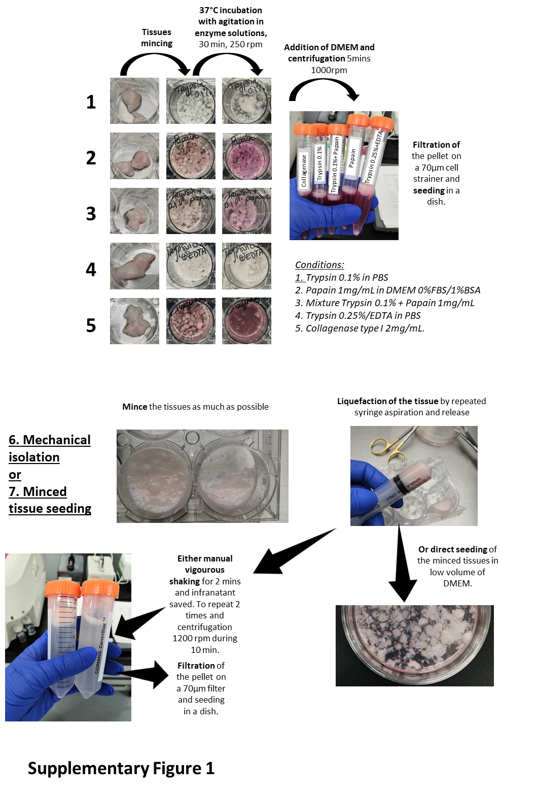
Supplementary Figure 1: Comparison of edible bovine ADSC isolation methods.

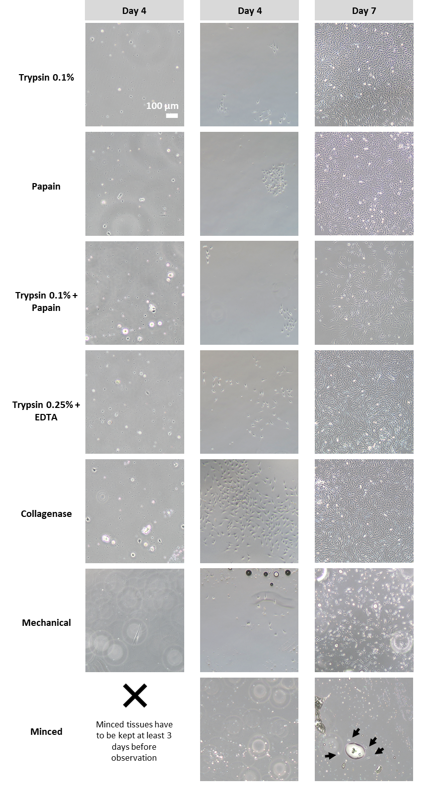
Supplementary Figure 2: Comparison of isolated bovine ADSC proliferation depending of the edible methods.

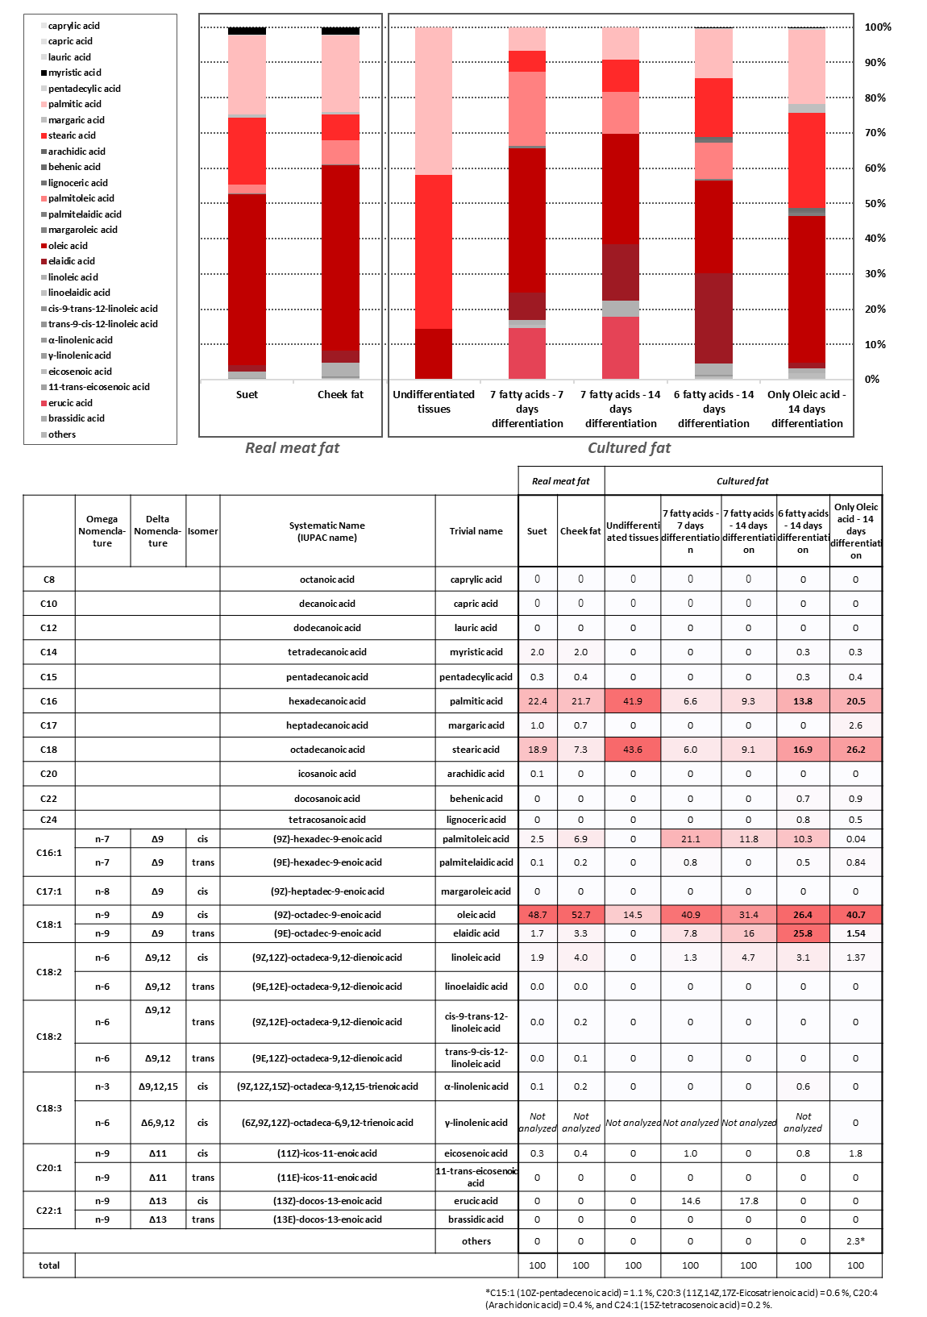
Supplementary Figure 3: Quantification of fatty acid components on cultured bovine adipose tissue or bovine real fat meat controls.

