Genetic Deletion of cyclooxygenase-1 ameliorates neuroinflammation and cognitive impairment in 5×FAD mice

Jie Wang^{1#}, Hong Ni^{1#}, luyao Wei¹, Hanqing Ding¹, Zhongzhao Guo¹, Ying Yu², Jia Luo³, Zun-Ji Ke^{1*}
- The Academy of Integrative Medicine, Shanghai University of Traditional Chinese Medicine, 1200 Cailun Road, Shanghai 201203, P.R. China.
- Department of Pharmacology and Tianjin Key Laboratory of Inflammatory Biology, Tianjin Medical University, Tianjin, 300070, China.
- Department of Pathology, University of Iowa Carver College of Medicine, 51 Newton Road, Iowa City, IA, 52242, USA.

#These authors contributed equally to this work.
*Corresponding author.
Running title: Deletion of cyclooxygenase-1 ameliorate neuroinflammation
Correspondence:
Zun-Ji Ke, M.D., Ph.D.
The Academy of Integrative Medicine, Shanghai Key Laboratory of Health Identification and Assessment, Shanghai University of Traditional Chinese Medicine, 1200 Cailun Road, Shanghai 201203, P.R. China. TEl: 086-21-51323171; Email:kezunji@shutcm.edu.cn
Figure S1. The expression of COX-1 in the hippocampus of WT, COX-1KO and 5×FAD mice. (A) Genotyping of COX-1 KO mice by PCR, the PCR product of COX1 was 900bp; (B) COX-1 protein expression in the hippocampus of WT and COX-1 KO mice detected by Western blot (n=3); (C) The expression and localization of COX-1 in the hippocampus of WT 5×FAD and COX-1 KO mice at 9-month-old were examined by immunofluorescent staining. The COX-1-positive cells were double stained with Iba-1(a marker for microglia) and expression of COX-1 and Iba-1 increased in 5×FAD mice compared to WT mice (n=5). Green: COX-1; red: Iba1; blue: DAPI; Scale bar = 100μm.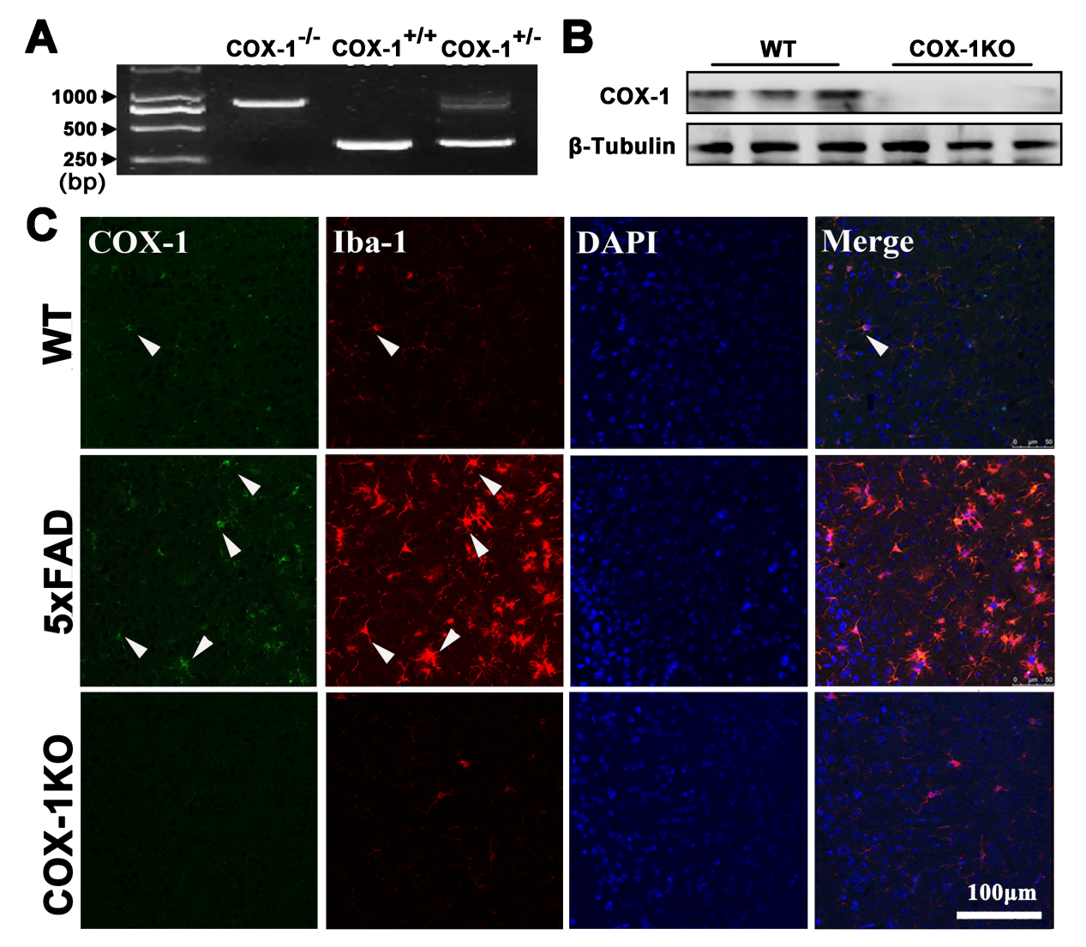
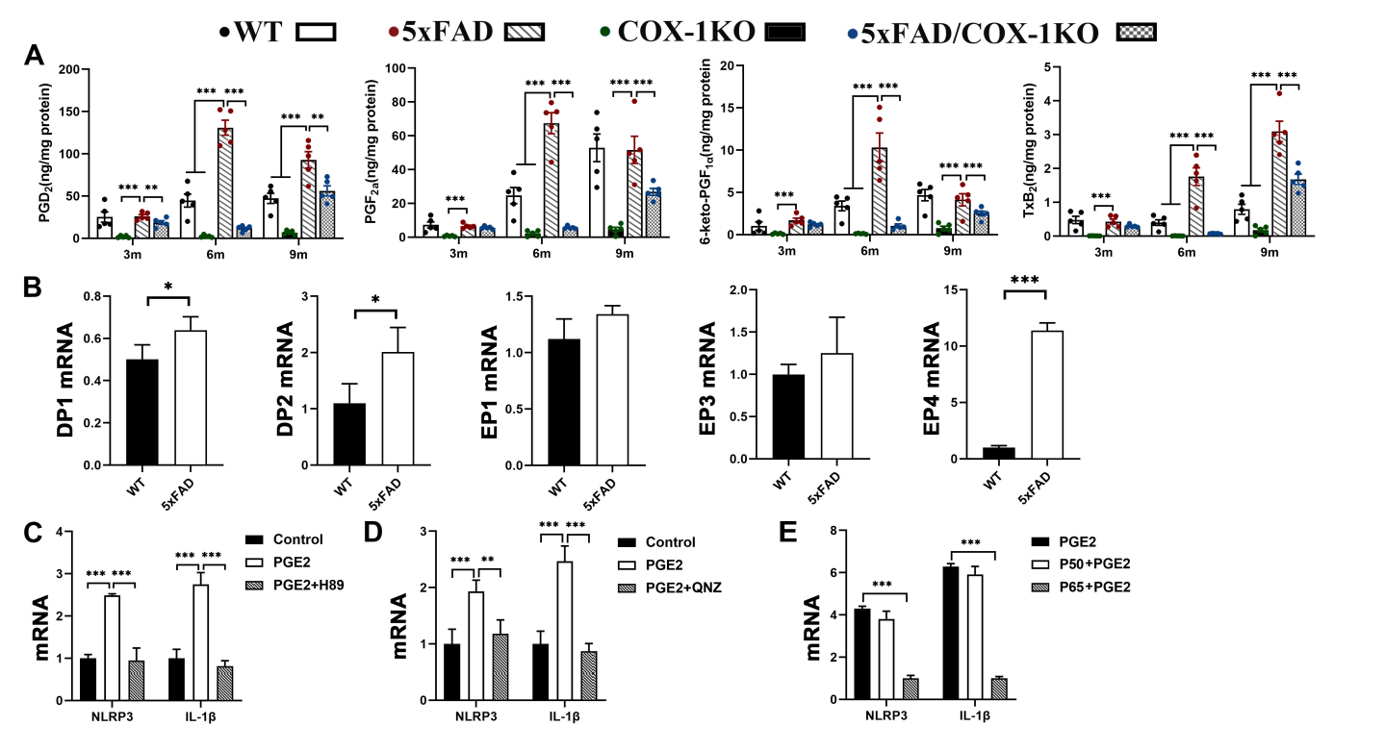
Figure S2. Levels of the other PG_{S}, DP/EP receptors and qRT-PCR results of BV2 experiment.
(A) Proteins of PGD₂, 6-keto-PGF_{1a}, PGF_{2a}, and TxB₂ measured by HPLC/mass spectrometry in the hippocampus of WT, COX-1KO, 5×FAD and 5×FAD/COX-1KO mice at 3-, 6-, and 9-month-old. (B) Expression of mRNAs for DP-1, DP-1, EP-1, EP-3, and EP-4 in the hippocampus of WT and 5×FAD mice at 9-month-old. (C) Expression of mRNAs for NLRP3 and IL-1β in BV2 cells and BV2 cells treated by PGE₂ with or without H89. (D) Expression of mRNAs for NLRP3 and IL-1β in BV2 cells and BV2 cells treated by PGE₂ with or without NF-κB inhibitor-QNZ. (E) Expression of mRNAs for NLRP3 and IL-1β in BV2 cells treated with PGE₂ combined siRNA NC, siRNA NF-κB p65 or siRNA NF-κB p50. (The bars indicate the means ± SD; n = 5 per group; *𝑝 < 0.05, **𝑝 < 0.01, ***𝑝 < 0.001)

