Calibration of the SPEAR_{pesticides} bioindicator for cost-effective pesticide monitoring in sub-Saharan Africa
Akbar A. Ganatra, Faith Jebiwot Kandie, Ulrike Fillinger, Francis McOdimba, Baldwyn Torto, Werner Brack , Matthias Liess, Henner Hollert, Jeremias Becker

Supplementary Material
1. Guidance on the application of the East African SPEAR_{pesticides} index
2. Supplementary tables: Tables S1 – S3
3. Raw data: Tables S4 – S6 (see separate excel file)

Guidance on the application of the East African SPEAR_{pesticides} index

Sampling site selection
The domain of applicability of the SPEAR_{pesticides} bioindicator is limited to small and medium (semi-)natural streams. SPEAR_{pesticides} is not considered to work in large rivers or temporary streams, in streams with highly degraded morphology or (almost) standing water, and in heavily polluted streams such as waste water treatment plant or mining effluents. Under those conditions, the macroinvertebrate community is expected to differ substantially from those observed in small reference streams, so that changes in the community composition may not be attributed to pesticide pollution.
The East African SPEAR_{pesticides} index has been calibrated using data from 13 streams in Western Kenya. This area is characterized by a tropical climate with two rainy seasons separated by dry months. Based on the widespread applicability of the European SPEAR_{pesticides} index across Europe (Liess et al. 2008), we expect that the East African SPEAR_{pesticides} index may work also in various areas across the afrotropical region. However, applications should be verified with chemical analyses on a subset of sites, particularly when climatic conditions differ from those in Western Kenya.

Macroinvertebrate sampling
Macroinvertebrate samples should be collected in seasons when pesticide exposure in streams is expected to be high. In seasons with low exposure, macroinvertebrate communities may partly recover due to recolonization and reproduction which may blur the observable effects of pesticides. E. g., in Central Europe, SPEAR_{pesticides} performs best with samples collected in spring and early summer when most insecticides (the group of pesticides with the highest potential risk) are applied and washed into streams following heavy rainfall. In Western Kenya, we expect that insecticides may be applied rather all year long and collected samples during the two rainy seasons when run-off potential is high. There is no experience yet regarding how seasonal changes in African macroinvertebrate communities may affect the SPEAR_{pesticides} index. Ideally, a number of samples may be collected from the same sites in different seasons to assess the optimal timing and consistency of effects. However, macroinvertebrates should not be collected during a flooding event when organisms hide or get washed away.
The sampling of macroinvertebrates should follow a standardized methodology to ensure a consistent sampling effort across sites so that samples will be comparable. Various microhabitats such as sand, stones, organic matter and aquatic plants should be sampled according to their proportion at a site. International sampling protocols are available e. g. in ISO 10870:2012 (https://www.iso.org/oristandard/46251.html) recommended for monitoring under the EU Water Framework Directive (European Commission 2003), or in the guidelines for the South African Scoring System 5 (SASS5, Dickens and Graham 2002). We used a modified SASS5 sampling protocol described in Becker et al. (2020) and in the methods section of the present publication.
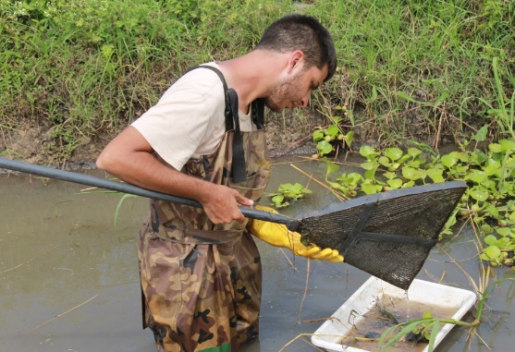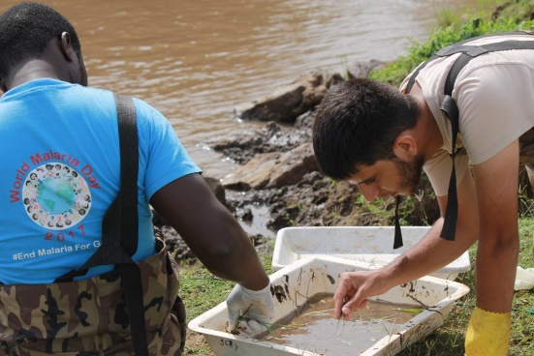

Taxonomic identification
Taxa should be generally identified to the family level, either in the field or in the laboratory. The ecotoxicological trait data base for the European SPEAR_{pesticides} index offers optionally higher resolution for some taxonomic groups, based on an operational taxa list from www.freshwaterecology.info. However, no such taxonomic detail is available for African taxa, whereas we found that most of the families in Western Kenya were available in the European data base. Beketov et al. (2009) showed that the explanatory power of the SPEAR_{pesticides} index is not significantly lower when calculated from family-level data as compared to species-level data.
The availability of taxonomic literature on East African freshwater macroinvertebrates is limited. We used identification keys provided in Brown (1994), Day et al. (1999), Day et al. (2001), Day (2001), Day and de Moor (2002), Day et al. (2002), Day (2002), de Moor (2003a), de Moor (2003b), and Harrison (2009). Calculations of the SPEAR_{pesticides} index require that the abundance of each taxon is ratio scaled (absolute individual counts or population density in individuals per m²), i. e. the use of frequency indices should be avoided. Samples with very few taxa (< 5) or individuals (< 30) indicate either issues with the sampling method or a heavily degraded macroinvertebrate community, and may be excluded from SPEAR_{pesticides} calculations.

Calculation of the SPEAR index
We recommend to use the software INDICATE freely available for download at http://www.systemecology.eu/indicate/. Here we refer to the current software version 1.2.0. A manual and background information can be found on the web page. In brief, open the SPEAR_{pesticides} program and enter the monitoring data including name, taxa and abundances for each sample.
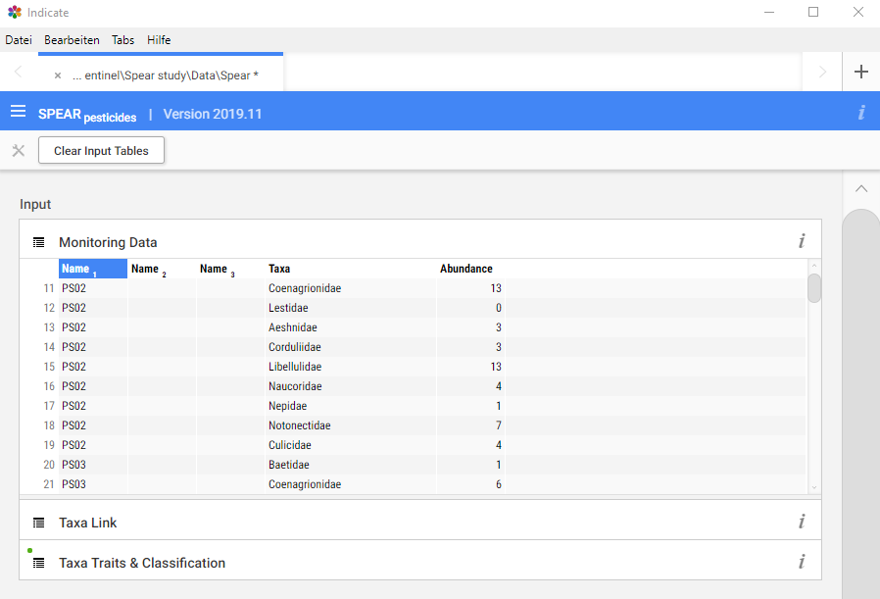
Next, open the button “Taxa Link” and check if the automatic identification of your taxon names by the software was correct. Otherwise, taxon names in the monitoring data can be manually linked to taxa in the ecotoxicological trait data base for SPEAR_{pesticides} calculation. Click on the respective field and enter a new name or choose from the opening dropdown list. Taxa not found in the trait data base should be linked to higher-level taxa, and if not possible, be excluded from SPEAR_{pesticides} calculations (blank field). Note: Some taxa such as “Diptera” are detected by INDICATE but not considered for SPEAR_{pesticides} calculation. Such taxa could not be classified as being “at risk” or “not at risk” due to high trait variation among its species. A warning is given out.
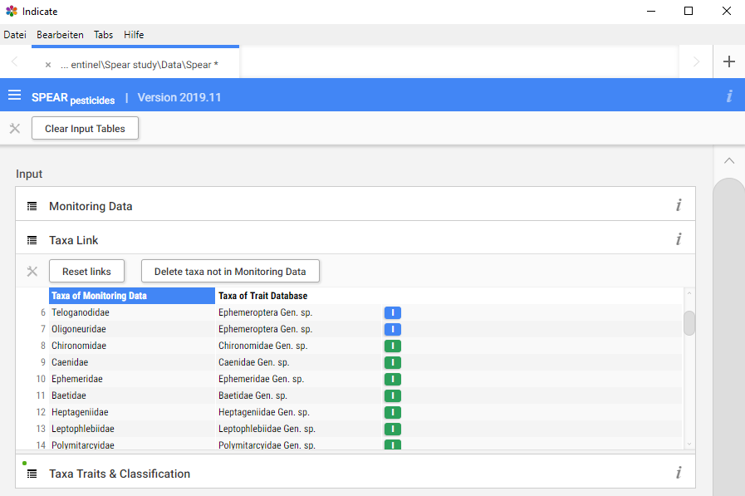
By default, INDICATE v. 1.2.0 uses a trait data base for the European SPEAR_{pesticides} index v. 2019.11 (Knillmann et al. 2018). In order to use the adapted SPEAR_{pesticides} version for East Africa, open the trait data base under “Taxa Traits & Classification” and repeat the modifications we describe in the results section of the main article: First, set the sensitivity (s-value) of Coenagrionidae to -0.4, so that the taxon will move from the SPEAR_{pesticides} class 1 (“at risk” to 0 (“not at risk”). Second, change the trait “Exposed” for Corixidae from 0 (“not exposed”) to 1 (“exposed”), so that the taxon will move from the SPEAR_{pesticides} class 1 to 0. These modifications are only relevant and possible if the monitoring data contain those taxa; taxa in the trait data base that have not been linked to the monitoring data are hidden under “Taxa Traits & Classification”. However, the full trait data base can be viewed (and edited) in the section “Advanced Settings” at the bottom of the menu.
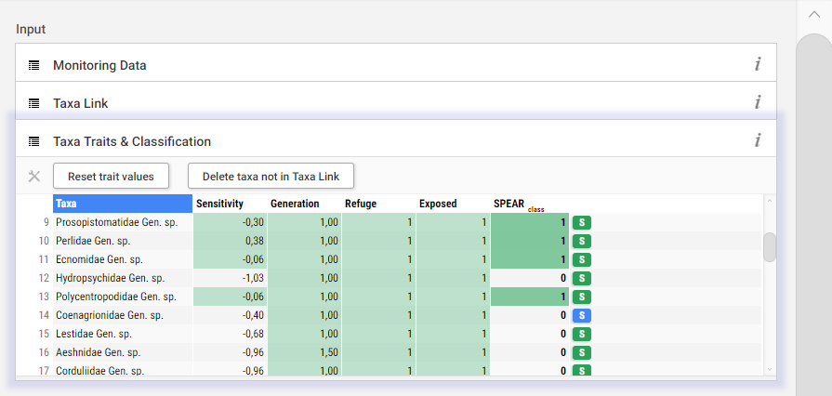
After these modifications, INDICATE automatically calculates the East African SPEAR index according to equation 2 in the main article:
$${SPEAR}_{pesticides}=\frac{\sum_{i=1}^{n}{\log_{10}\left(4x_{i}+1\right)·y}}{\sum_{i=1}^{n}{\log_{10}⁡(4x_{i}+1)}}$$
with x_{i} being the observed number of individuals of taxon i, and y being 1 for those taxa classified at risk and 0 for taxa not at risk. SPEAR values for each site can be viewed under “Effect & Exposure” in the “Results” section, and also exported as .csv file.
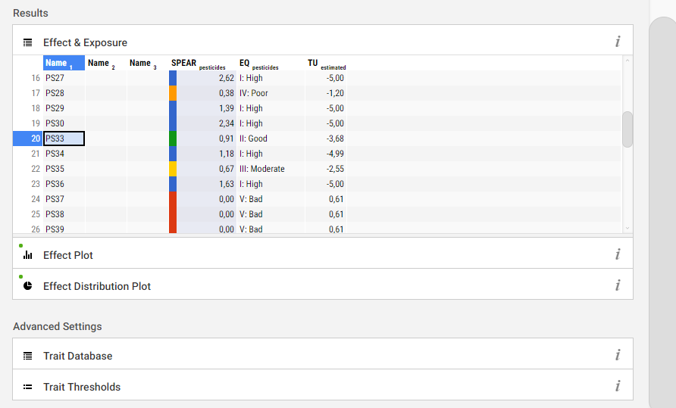

Conversion of SPEAR_{pesticides} to pesticide toxicity and environmental quality
INDICATE v. 1.2.0 automatically converts SPEAR_{pesticides} values to an estimated pesticide toxicity (in maximum toxic unit, TU_{max}) and to an environmental quality (EQ) class that is related to the ecological status classess according to the EU Water Framework Directive (Beketov et al. 2009). However, TU_{max} and EQ provided in INDICATE are not valid when the East African SPEAR_{pesticides} index is used, because they are calculated based on conversion schemes for the European SPEAR_{pesticides} index (Beketov et al. 2009, Knillmann et al. 2018).
Instead, the East African SPEAR_{pesticides} index may be manually converted to a predicted background toxicity using equation 5 from the main article:
$${background TU}_{max}={10}^{\frac{{SPEAR}_{pesticides} + 0.02}{-0.43}}$$
This equation has been established using macroinvertebrate and water samples concurrently collected from 16 sites in 13 streams in Western Kenya (see main article). Samples were collected during the main rainy season, but not during flooding events. Therefore, the equation relates SPEAR_{pesticides} values to background toxicity outside run-off events. Studies in European streams showed that long-term pesticide effects on the macroinvertebrate community are typically driven by short-term peak concentrations during run-off events following heavy rainfall (Liess and Schulz 1999, Liess and von der Ohe 2005, Reiber et al. 2020). Peak pesticide concentrations in water during run-off events are approximately four times as high as the background concentrations outside such events in temperate streams of Europe and North America (Williams et al. 1995, Kreuger 1998, Liess et al. 1999, Schäfer et al. 2008, Münze et al. 2017). Assuming that this relation may also hold in afrotropical streams, peak pesticide exposure during run-off may be estimated from the East African SPEAR_{pesticides} values using equation 6 from the main article:
$${estimated peak TU}_{max}= 4*{10}^{\frac{SPEAR{SPEAR}_{pesticides} + 0.02}{-0.43}}$$
The button “Effect Plot” in INDICATE provides a graphical overview on the distribution of SPEAR values across the sampling sites. The color code refers to the EQ classes for the European SPEAR index and thus should be ignored when using the East African SPEAR_{pesticides} index. Similarly, the button “Effect Distribution Plots” provides an overview on the distribution of EQ classes and should not be considered for East African samples.
We established no conversion scheme from the East African SPEAR_{pesticides} index to EQ classes because they relate to the Water Frame Work Directive that is only relevant in the European regulatory context. African countries have developed or may develop own criteria for the classification of water quality. As a guideline, pesticide exposure in sampling sites may be classified based on the estimated TU_{max} during run-off as follows:
log₁₀(TU_{max}) > -1.5 -> high pesticide exposure
-3.5 < log₁₀(TU_{max}) ≤ -1.5 -> moderate pesticide exposure
log₁₀(TU_{max}) ≤ -3.5 -> low pesticide exposure
These thresholds follow observations in European streams that SPEAR_{pesticides} values decrease most strongly in the range between -1.5 and -3.5 to -4.0 log₁₀(TU_{max}) (Schaefer et al. 2012, Knillmann et al. 2018). This trend was also indicated in the Kenyan samples (Fig. 3 of the main article). In the same range of toxicity, leaf litter degradation (Schaefer et al. 2012, Münze et al. 2017), the exchange of sensitive vs. tolerant species (Reiber et al. 2020) and the development of insecticide resistance (Becker and Liess 2017, Shahid et al. 2018) responded most strongly to pesticide pollution. When the thresholds are converted from TU_{max} to SPEAR_{pesticides} values using equation 6 from the main article, pesticide exposure may be directly classified from the East African SPEAR_{pesticides} index as follows:
SPEAR_{pesticides} < 0.9 -> high pesticide pollution
0.9 ≤ SPEAR_{pesticides} < 1.8 -> moderate pesticide pollution
SPEAR_{pesticides} > 1.8 -> low pesticide pollution

References
Becker JM, Ganatra AA, Kandie F, Mühlbauer L, Ahlheim J, Brack W, Torto B, Agola EL, McOdimba F, Hollert H, Fillinger U, Liess M (2020) Pesticide pollution in freshwater paves the way for schistosomiasis transmission. Scientific Reports 10(1): 3650. doi: 10.1038/s41598-020-60654-7.
Becker JM, Liess M (2017) Species Diversity Hinders Adaptation to Toxicants. Environ Sci Technol 51(17): 10195–10202. doi: 10.1021/acs.est.7b02440.
Beketov MA, Foit K, Schaefer RB, Schriever CA, Sacchi A, Capri E, Biggs J, Wells C, Liess M (2009) SPEAR indicates pesticide effects in streams - Comparative use of species- and family-level biomonitoring data. Environ Pollut 157(6): 1841-1848. doi: 10.1016/j.envpol.2009.01.021.
Brown DS (1994). Freshwater Snails Of Africa And Their Medical Importance CRC Press; London, UK.
Day J, de Moor I (2002) Guides to the Freshwater Invertebrates of Southern Africa: Volume 6: Arachnida and Mollusca (Araneae, water mites and Mollusca). WRC Report no TT182/02. Water Research Commission, Pretoria 24.
Day J, Harrison A, De Moor I (2002) Guides to the freshwater invertebrates of southern Africa. Volume 9: Diptera. WRC Report No. TT 201/02. Water Research Commission, Pretoria, South Africa.
Day J, Stewart B, De Moor I, Louw A (1999) Guides to the Freshwater Invertebrates of Southern Africa: Volume 2 Crustacea I–Notostraca, Anostraca, Conchostraca and Cladocera. WRC Report no. TT 121/00. Water Research Commission, Pretoria: 126.
Day J, Stewart B, De Moor I, Louw A (2001) Guides to the Freshwater Invertebrates of Southern Africa–Vol. 4: Crustacea III Bathynellacea, Amphipoda, Isopoda, Spelaeogriphacea, Tanaidacea and Decapoda. Water Research Commission Report TT141/01, Pretoria.
Day JA (2001). Guides to the Freshwater Invertebrates of Southern Africa: Ostracoda, Copepoda and Branchiura. Crustacea II. Water Research Commission.
Day JA (2002). Guides to Freshwater Invertebrates of Southern Africa: The Protozoans, Porifera, Cnidaria, Platyhelminthes, Nemertea, Rotifera, Nematoda, Nematomorpha, Gastrotrichia, Bryozoa, Tardigrada, Polychaeta, Oligochaeta & Hirudinea. Non-arthropods. Water Research Commission.
de Moor I (2003a). Guides to Freshwater Invertebrates of Southern Africa: Ephemeroptera, Odonata & Plecoptera. Insecta I. Water Research Commission.
de Moor I (2003b). Guides to Freshwater Invertebrates of Southern Africa: Hemiptera, Megaloptera, Neuroptera, Trichoptera & Lepidoptera. Insecta II. Water Research Commission.
Dickens CW, Graham PM (2002) The South African Scoring System (SASS) Version 5 Rapid Bioassessment Method for Rivers. African Journal of Aquatic Science 27(1): 1-10. doi: 10.2989/16085914.2002.9626569.
European Commission (2003). Guidance Document No 7 Monitoring under the Water Framework Directive. European Commission; Luxembourg.
Harrison JdG (2009) Guides to the freshwater invertebrates of Southern Africa. Volume 10: Coleoptera. African Entomology 17(2): 235-238.
Knillmann S, Orlinskiy P, Kaske O, Foit K, Liess M (2018) Indication of pesticide effects and recolonization in streams. Sci Total Environ 630: 1619-1627. doi: 10.1016/j.scitotenv.2018.02.056.
Kreuger J (1998) Pesticides in stream water within an agricultural catchment in southern Sweden, 1990–1996. Sci Total Environ 216(3): 227-251. doi: 10.1016/S0048-9697(98)00155-7.
Liess M, Schafer RB, Schriever CA (2008) The footprint of pesticide stress in communities - species traits reveal community effects of toxicants. Sci Total Environ 406(3): 484-490. doi: 10.1016/j.scitotenv.2008.05.054.
Liess M, Schulz R (1999) Linking insecticide contamination and population response in an agricultural stream. Environ Toxicol Chem 18(9): 1948–1955. doi: 10.1002/etc.5620180913.
Liess M, Schulz R, Liess MHD, Rother B, Kreuzig R (1999) Determination of insecticide contamination in agricultural headwater streams. Water Research 33(1): 239-247. doi: 10.1016/s0043-1354(98)00174-2.
Liess M, von der Ohe PC (2005) Analyzing effects of pesticides on invertebrate communities in streams. Environ Toxicol Chem 24(4): 954–965. doi: 10.1897/03-652.1.
Münze R, Hannemann C, Orlinskiy P, Gunold R, Paschke A, Foit K, Becker JM, Kaske O, Paulsson E, Peterson M, Jernstedt H, Kreuger J, Schüürmann G, Liess M (2017) Pesticides from wastewater treatment plant effluents affect invertebrate communities. Sci Total Environ 599-600: 387-399. doi: 10.1016/j.scitotenv.2017.03.008.
Reiber L, Knillmann S, Foit K, Liess M (2020) Species occurrence relates to pesticide gradient in streams. Sci Total Environ 735: 138807. doi: 10.1016/j.scitotenv.2020.138807.
Schaefer RB, von der Ohe PC, Rasmussen J, Kefford BJ, Beketov MA, Schulz R, Liess M (2012) Thresholds for the Effects of Pesticides on Invertebrate Communities and Leaf Breakdown in Stream Ecosystems. Environ Sci Technol 46(9): 5134-5142. doi: 10.1021/es2039882.
Schäfer RB, Paschke A, Vrana B, Mueller R, Liess M (2008) Performance of the Chemcatcher® passive sampler when used to monitor 10 polar and semi-polar pesticides in 16 Central European streams, and comparison with two other sampling methods. Water Research 42(10): 2707-2717. doi: 10.1016/j.watres.2008.01.023.
Shahid N, Becker JM, Krauss M, Brack W, Liess M (2018) Adaptation of Gammarus pulex to agricultural insecticide contamination in streams. Sci Total Environ 621: 479-485. doi: 10.1016/j.scitotenv.2017.11.220.
Williams RJ, Brooke DN, Matthiessen P, Mills M, Turnbull A, Harrison RM (1995) Pesticide Transport to Surface Waters within an Agricultural Catchment. Water and Environment Journal 9(1): 72-81. doi: 10.1111/j.1747-6593.1995.tb00928.x.

Supplementary tables

Table S1: Linear one-way regression of bioindicators of freshwater pollution vs. environmental parameters. Pesticide pollution was quantified as TU_{max}, TU_{sum} and as runoff potential (based on slope and buffer strips); flow velocity (Flow) is shown in m/s; NH₄, NO₂₋, NO₃₋, PO₄ and dissolved oxygen (O₂) in mg/L; temperature in °C; conductivity in µS/cm; carbonate hardness (CH) in °dH and turbidity (Turb.) in NTU. Flow, NH₄, NO₂₋, NO₃₋, PO₄, conductivity, O₂, CH and turbidity were ln-transformed prior to analysis. Freshwater macroinvertebrates were identified to the family level. For the BMWP and SASS5 indicator, the average score per taxon (aspt) was calculated. n = 13, df = 1 and residual df = 12 in all analyses. Significant results (p < 0.05) are shown in bold, marginally significant results (0.05 ≤ p < 0.1) in gray.
 | SPEAR_{pesticides} (revised) |  |  |  |  | SPEAR_{pesticides} v. 2019.11 |  |  |  |  | BMWP (aspt)
 | R² | F | p | Slope |  | R² | F | P | Slope |  | R² | F | p | Slope
TU_{max} | 0.53 | 12.35 | 0.005 | -0.43 |  | 0.43 | 8.15 | 0.016 | -0.37 |  | 0.33 | 5.49 | 0.039 | -0.27
TU_{sum} | 0.52 | 11.96 | 0.005 | -0.41 |  | 0.43 | 8.16 | 0.016 | -0.35 |  | 0.35 | 5.85 | 0.034 | -0.27
Runoff | 0.45 | 9.09 | 0.012 | -0.38 |  | 0.38 | 6.75 | 0.025 | -0.34 |  | 0.20 | 2.70 | 0.129 | -0.20
Flow | 0.22 | 3.12 | 0.105 | 0.26 |  | 0.30 | 4.74 | 0.052 | 0.29 |  | 0.08 | 0.91 | 0.360 | 0.12
NH₄⁺ | <0.01 | 0.01 | 0.910 | -0.03 |  | <0.01 | 0.04 | 0.836 | -0.06 |  | 0.01 | 0.06 | 0.811 | -0.06
NO₂⁻ | 0.09 | 1.14 | 0.309 | -0.19 |  | 0.06 | 0.70 | 0.420 | 0.22 |  | 0.73 | 0.73 | 0.412 | -0.12
NO₃⁻ | 0.03 | 0.39 | 0.547 | 0.17 |  | 0.06 | 0.72 | 0.415 | -0.22 |  | 0.01 | 0.13 | 0.722 | -0.08
PO₄³⁻ | 0.21 | 2.95 | 0.114 | -0. 43 |  | 0.04 | 1.87 | 0.171 | -0.25 |  | 0.30 | 4.66 | 0.054 | -0.41
Temp. | 0.17 | 2.32 | 0.156 | -0.08 |  | 0.05 | 0.60 | 0.455 | -0.04 |  | 0.24 | 3.45 | 0.090 | -0.08
CH | 0.36 | 6.06 | 0.032 | -0.75 |  | 0.30 | 4.67 | 0.054 | -0.66 |  | 0.40 | 7.47 | 0.019 | -0.65
Cond. | 0.56 | 14.27 | 0.003 | -0.83 |  | 0.47 | 9.71 | 0.010 | -0.73 |  | 0.54 | 12.69 | 0.004 | -0.65
pH | 0.20 | 2.69 | 0.129 | 0.26 |  | 0.20 | 2.76 | 0.125 | 0.26 |  | 0.03 | 0.33 | 0.576 | 0.08
O₂ | 0.06 | 0.68 | 0.427 | 0.44 |  | 0.12 | 1.55 | 0.239 | 0.61 |  | 0.11 | 1.42 | 0.259 | 0.49
Turb. | 0.42 | 8.07 | 0.016 | -0.23 |  | 0.29 | 4.56 | 0.056 | -0.18 |  | 0.25 | 3.73 | 0.080 | -0.14
 | SASS5 (aspt) |  |  |  |  | EPTª |  |  |  |  | Shannon
 | R² | F | p | Slope |  | R² | Χ² | P | Slope |  | R² | Χ² | p | Slope
TU_{max} | 0.19 | 2.63 | 0.133 | -0.56 |  | 0.10 | 6.62 | 0.010 | -0.83 |  | 0.23 | 3.33 | 0.095 | 0.27
TU_{sum} | 0.19 | 2.57 | 0.137 | -0.53 |  | 0.10 | 6.37 | 0.012 | -0.79 |  | 0.22 | 3.11 | 0.106 | 0.25
Runoff | 0.20 | 2.69 | 0.129 | -0.54 |  | 0.09 | 3.50 | 0.061 | -0.73 |  | 0.31 | 4.90 | 0.049 | 0.30
Flow | <0.01 | <0.01 | 0.951 | 0.02 |  | 0.15 | 4.90 | 0.027 | 0.97 |  | 0.10 | 1.21 | 0.295 | -0.17
NH₄⁺ | 0.01 | 0.08 | 0.786 | 0.18 |  | 0.01 | 0.44 | 0.509 | -0.43 |  | 0.25 | 3.67 | 0.082 | 0.47
NO₂⁻ | 0.01 | 0.12 | 0.734 | -0.14 |  | 0.01 | 0.43 | 0.513 | -0.27 |  | 0.16 | 2.09 | 0.176 | 0.23
NO₃⁻ | 0.01 | 0.17 | 0.691 | -0.24 |  | 0.06 | 2.21 | 0.137 | 0.98 |  | 0.08 | 0.97 | 0.347 | -0.25
PO₄³⁻ | 0.29 | 4.52 | 0.057 | -1.09 |  | <0.01 | 0.01 | 0.915 | -0.08 |  | <0.01 | <0.01 | 0.972 | -0.01
Temp. | 0.28 | 4.35 | 0.061 | -0.22 |  | 0.01 | 0.17 | 0.685 | -0.06 |  | <0.01 | <0.01 | 0.999 | <0.01
CH | 0.16 | 2.05 | 0.180 | -1.07 |  | 0.10 | 4.86 | 0.028 | -1.76 |  | 0.23 | 3.33 | 0.095 | 0.57
Cond. | 0.32 | 5.08 | 0.046 | -1.33 |  | 0.07 | 3.16 | 0.076 | -1.27 |  | 0.21 | 2.89 | 0.117 | 0.48
pH | 0.22 | 3.10 | 0.106 | 0.60 |  | <0.01 | 0.11 | 0.740 | 0.13 |  | 0.10 | 1.16 | 0.304 | -0.17
O₂ | <0.01 | 0.05 | 0.827 | -0.26 |  | 0.05 | 1.39 | 0.238 | 1.72 |  | 0.02 | 0.22 | 0.649 | -0.24
Turb. | 0.34 | 5.72 | 0.036 | -0.44 |  | 0.19 | 6.23 | 0.013 | -0.70 |  | 0.20 | 2.77 | 0.124 | 0.15
ªEffects on the proportion of ephemeropteran, plecopteran and trichopteran taxa (EPT) were analyzed using a quasibinomial generalized linear model with a logit link function and the number of taxa as weights; χ² from likelihood ratio tests and McKelvey & Zavoina’s pseudo-R² are shown.

Table S2: Correlations among those environmental variables that influenced SPEAR_{pesticides} or other bioindicators. Significant results (p < 0.05) are shown in bold, marginally significant results (0.05 ≤ p < 0.1) in gray. n = 13, df = 11 for all correlations. Carbonate hardness (CH), flow velocity (Flow), conductivity (Cond.), phosphate concentration (PO₄⁻³) and turbidity (Turb.) were ln-transformed prior to analysis.
 | TU_{max} |  |  |  | Runoff potential |  |  |  | Carbonate hardness |  |  |  | Conductivity
 | r | t | p |  | r | t | p |  | r | t | p |  | r | t | p
Runoff | 0.70 | 3.25 | 0.008 |  | - | - | - |  | - | - | - |  | - | - | -
CH | 0.67 | 2.98 | 0.013 |  | 0.56 | 2.24 | 0.047 |  | - | - | - |  | - | - | -
Cond. | 0.76 | 3.85 | 0.003 |  | 0.76 | 3.82 | 0.003 |  | 0.85 | 5.27 | <0.001 |  | - | - | -
Turb. | 0.67 | 2.99 | 0.012 |  | 0.62 | 2.62 | 0.024 |  | 0.34 | 1.21 | 0.252 |  | 0.38 | 1.35 | 0.204
PO₄⁻³ | 0.49 | 1.84 | 0.092 |  | 0.55 | 2.17 | 0.053 |  | 0.28 | 0.97 | 0.354 |  | 0.58 | 2.35 | 0.039
Flow | -0.55 | -2.19 | 0.051 |  | -0.63 | -2.66 | 0.022 |  | -0.44 | -1.65 | 0.128 |  | -0.55 | -2.16 | 0.054
TU_{sum} | 1.00 | 61.44 | <0.001 |  | 0.69 | 3.14 | 0.009 |  | 0.66 | 2.89 | 0.015 |  | 0.75 | 3.79 | 0.003

Table S3: Correlations among the applied bioindicators for freshwater pollution. For the BMWP and SASS5 indicator, the average score per taxon (aspt) was calculated. Significant results (p < 0.05) are shown in bold, marginally significant results (0.05 ≤ p < 0.1) in gray. n = 13, df = 11 for all correlations.
 | SPEAR_{pesticides} (revised) |  |  |  | BMWP (aspt) |  |  |  | SASS5 (aspt) |  |  |  | EPT
 | r | t | p |  | r | t | p |  | R | t | p |  | r | t | p
BMWP | 0.70 | 3.25 | 0.008 |  | - | - | - |  | - | - | - |  | - | - | -
SASS5 | 0.77 | 4.03 | 0.002 |  | 0.77 | 4.00 | 0.002 |  | - | - | - |  | - | - | -
EPT | 0.85 | 5.40 | <0.001 |  | 0.40 | 1.44 | 0.176 |  | 0.43 | 1.59 | 0.140 |  | - | - | -
Shannon | -0.73 | -3.59 | 0.004 |  | -0.30 | -1.05 | 0.315 |  | -0.51 | -1.96 | 0.076 |  | -0.82 | -4.68 | 0.001

