SUPPLEMENT TO “TROPICAL SOURCES DOMINATED METHANE CHANGES OF THE LAST GLACIAL MAXIMUM AND DEGLACIATION”

1. Melt-extraction measurement method.
CH₄ measurements were made using a discrete melt-refreeze extraction system in the Oregon State University (OSU) ice core laboratory (methods described in detail in ^{1,2}). Briefly, 40-60 g samples of ice are cut, shaved, and placed into glass flasks that are mounted to a vacuum line used for gas extraction. Prior to melting, the flasks are evacuated for 1.5 hours while refrigerated at -60°C. Subsequently, the samples are isolated under vacuum and flasks are submerged in a 50°C warm water bath. Once completely melted, the sample flasks are refrozen in a -60°C ethanol bath. This effectively extracts the air from the sample, with a small fraction dissolved in the melt water. Because CH₄ is more soluble than bulk air components, slightly more CH₄ is dissolved in the meltwater, leading to a small decrease in the measured [CH₄]. We use an empirically derived solubility correction ^{2,3} to correct for this effect (Table 1). Larger ice samples require a slightly larger solubility correction due to enhanced dissolution driven by larger meltwater volume ³.

Next, the air from each sample is expanded into a 10cc stainless sample steel loop where pressure is recorded, and then injected into an Agilent 6890N gas chromatograph. The CH₄ is separated from other trace gas species by passing through a GC Column (1.8m length, 80/100 mesh Hayesep D) and then quantified using a flame ionization detector. The measured [CH₄] is an average of four individual measurements of the air liberated from each sample. To quantify the system blank, air free ice made in the laboratory is placed in the flasks which are then filled with standard air of quantities similar to a sample. The ice is melted and refrozen, and the air analyzed, in the same fashion as for a sample. The blank (the difference between the calibrated value of the standard and the solubility-corrected measured value when measured with gas-free ice) typically ranges from 5-10 ppb and is subtracted from the raw measured [CH₄]. The standard gas is calibrated on the NOAA04 CH₄ scale ⁴.

2. Discrete Ice Core records
2.1. North Greenland Eemian Ice Core (NEEM)
Our discrete NEEM [CH₄] record was measured between 2010 and 2013 and spans from HS1 to the early Holocene (19 – 8 kyr), though only results older than 11.5 kyr were used to calculate the rIPD due to limited early Holocene WAIS Divide (WD) data ⁵. In 2010 and 2011, samples from NEEM were measured with a depth resolution ranging from 14 cm – 55 cm (10 to 50 years) for a total of 495 discrete sample, 315 of which were measured in duplicate. Higher resolution sampling initially targeted periods of rapid [CH₄] change, but sometimes fall in more stable periods because the NEEM gas age scale was not known when samples were chosen. 14 duplicate samples were measured in 2012 in conjunction with the bulk of the WD measurements, mainly to quantify any analytical offsets between measurement campaigns (see Supplementary Section 2.1.4). In 2013, 130 additional samples (106 in duplicate at identical depths) were measured at the same time as WD ice to provide an accurate NEEM and WD comparison. The blank, solubility and gravitational settling corrections made to the measured [CH₄] were made using the values shown in table 1 (main text). The solubility correction factor of 1.014 was smaller for NEEM due to the smaller, 40 g samples used ³. The gravitational correction factor for each sample was determined using data from Buizert et al., 2014 ⁶. 46 additional NEEM samples were measured in 2021 to characterize variability in CH_{4xs}, however; we do not use these results to reconstruct the CH₄ IPD due to a lack of corresponding WD samples and duplicate measurements to characterize precision.

2.2. Greenland Ice Sheet Project 2 Ice Core (GISP2)
The GISP2 discrete record used in this study was produced primarily as part of an ongoing effort within the OSU Ice Core and Quaternary Geochemistry Laboratory to obtain a high resolution, discrete [CH₄] record for this core (Martin et al., in review). In 2018 and 2019, samples with gas ages between 14.5 kyr and 27.5 kyr were measured. In 2018, 253 measurements (169 in duplicate) were made, with an additional 276 (175 in duplicate) in 2019. The depth resolution is 0.5 m except during the LGM section (22 – 18 kyr) where it is 1.8 m. The GISP2 data were corrected for blank offset, solubility effects, and gravitational fractionation using the methods described in the previous sections (Table 1, main text). A solubility correction factor of 1.017 was used for these ~50 g samples. The gravitational correction factor for each sample was determined using data from Seierstad et al., 2014 ⁷, using the gravitational fractionation component of the δ¹⁵N-N₂ variations.

2.3. West Antarctic Ice Sheet Divide Ice Core (WD)
The bulk of the WD discrete record was measured between 2011 and 2013 with a depth resolution of 1.3 m (or about 25 years). We use a subset of this record that spans 27.5 – 11.5 kyr. Unlike other Antarctic ice cores, the WAIS Divide site has a modern mean annual temperature and accumulation rate analogous to the NEEM and GISP2 sites, so physical processes that change ice core-derived trace gas records from the contemporary atmospheric value (i.e., firn smoothing and gravitational settling) likely had comparable impacts on each core in the past. This makes the WD core the best candidate for measuring the rIPD relative to other Antarctic Ice Cores. The physical similarities between these cores are especially important during periods of abrupt [CH₄] changes, when firn smoothing can dampen the magnitude of the change ⁸. 518 measurements (313 in duplicate) were made in 2011 and 2012 with an average depth resolution of 1.3 m (~25 years). An additional 99 samples were measured (all in duplicate) with the 2013 NEEM samples to provide a standard for NEEM and WD comparison (see methods).

In 2018 and 2019, a smaller subset of 65 (9 duplicates) and 20 (6 duplicates) WD samples were measured, respectively, as part of the GISP2 measurement campaign. Because these WD samples overlap with those from the 2013 campaign, they were used to quantify any offsets between the NEEM and GISP2 measurement campaigns and incorporated into the WD record used to calculate the IPD. WD data were corrected using the same protocols used for the Greenland samples (Table 1, main text). The 2012 WD sample size averaged 50 g, so a solubility factor of 1.017 was used. The gravitational correction factor for each sample was determined using data from Buizert et al., 2015 ⁹.

3. Determining the CH_{4xs} correction factor
In this section, we describe the methods used to determine the value and uncertainty of the CH_{4xs} correction factor used to correct the GISP2 and NEEM [CH₄] records.
3.1. CH_{4xs}, Ca²⁺ relationship
We adopt the correction procedure outlined by Lee et al., 2020, which used a repeated melt/refreeze cycle to calculate the quantity of CH_{4xs} released during analysis ¹⁰. The difference in concentration between the first and second melt/refreeze is used to retroactively estimate how much CH_{4xs} was released during the first melt/refreeze. The linear regression between this measurement and the Ca²⁺ content of the sample can then be used to estimate CH_{4xs} when direct measurements are not available. To calculate the Ca²⁺ content (moles) of the sample, data from detailed Ca²⁺ datasets for NEEM ¹¹ and GISP2 ¹² were interpolated onto the depth range of each sample. The number of moles of Ca²⁺ in each sample was calculated from the sample mass and Ca²⁺ concentration.

Initially, 108 CH_{4xs} measurements were made on samples from the GISP2 ice core in 2016 and established a linear relationship of 5.16 ± 0.25 micromoles of CH_{4xs} per mole of Ca²⁺ (R² = 0.78) ¹⁰. We incorporate an additional 34, 200, and 64 GISP2 measurements of CH_{4xs} made in 2016, 2018 and 2019, respectively. These measurements encompass a wider range of depths and dust content. Lee et al. (2020) also made 41 CH_{4xs} measurements on NEEM ice in 2016 and derived a regression of 7.01 ± 0.68 micromoles of CH_{4xs} per mole of Ca²⁺ (R² = 0.74) ¹⁰. An additional 46 NEEM samples were measured in 2021.

The production mechanism is unknown ¹⁰ and it is possible that the Ca²⁺ vs. CH_{4xs} regression varies with ice age, location on the ice sheet, or is dependent on when the measurement was made due to slight changes in the analytical system and methods over time. To test the stability of the linear regression as a function of age, all 407 GISP2 CH_{4xs} measurements were binned by ice age (core depth) (Supplementary Table 1). Next, the linear regression and standard error for each bin were calculated (Supplementary Table 1, Supplementary Fig. 2c-d) ), limiting the data used so that the range of Ca²⁺ concentrations was restricted to that of the bin with the smallest range to ensure an unbiased comparison. Analysis of Covariance (ANCOVA) tests, a statistical technique that merges the analysis of variance and the linear regression, reveal a statistically significant difference in the Ca²⁺ vs CH_{4xs} regression between the youngest and middle age bins using a 95% confidence interval, with the youngest slope statistically greater than the middle-aged slope (Supplementary Fig. 3a). The calculated slope for the oldest bin was intermediate between the youngest and middle bins and was not statistically different from either.

Next, to test whether there is geographic variability of the Ca²⁺ vs. CH_{4xs} relationship, we performed similar statistical analyses (Ca²⁺ range restriction and ANCOVA regression comparison) on the NEEM and GISP2 CH_{4xs} data (Supplementary Fig. 2g-h). These cores are separated by over 500 km and might in principle receive dust of somewhat differing compositions that could alter the CH_{4xs} production rate. Establishing any difference is important because we utilize the relationship derived primarily from GISP2 data to correct our NEEM [CH₄] record used for the rIPD reconstruction. The ANCOVA test reveals no statistically significant differences between the GISP2 and NEEM Ca²⁺ vs. CH_{4xs} regression (Supplementary Fig. 3c), suggesting that the regression is stable across multiple cores. We therefore derive a new CH_{4xs} regression of 5.41 ± 0.18 micromoles of CH_{4xs} per mole of Ca²⁺ that incorporates all GISP2 data as well as the NEEM 2016 data (bottom row, Supplementary Table 1), and use this to correct our NEEM and GISP2 rIPD records. NEEM 2021 was not included due to a large data offset (large y-intercept in Supplementary Fig. 2e-f).

Finally, we consider if the CH_{4xs} regression may be sensitive to slight changes in the analytical methods used over time (e.g., meltwater temperature, melt time, changes in sample preparation). Establishing this dependence is important because the NEEM and GISP2 measurements used in this study were measured over 8 years apart. We grouped the GISP2 measurements by year (2016, 2018, & 2019) and NEEM measurements by year (2016 and 2021) over identical Ca²⁺ content ranges and again performed ANCOVA testing to compare the regressions of each (Supplementary Fig. 2a-b, e-f). There are insufficient data to also normalize these groups by sample depth because each measurement campaign contains samples covering a unique range of depths. The ANCOVA tests reveal statistically significant differences in the Ca²⁺ vs. CH_{4xs} regressions for each of the GISP2 measurement campaigns (2016, 2018, 2019), despite relatively minor changes to extraction line methods over the last decade ^{1,2}, with the regression slope decreasing as the year measured increase (Supplementary Fig. 3b). This implies that the CH_{4xs} vs. Ca²⁺ regression is sensitive to when the measurements were made, though no statistical difference was found between the relationship derived in the 2016 and 2021 NEEM measurement campaign.

It is important to incorporate the apparent variability in the CH_{4xs} vs. Ca²⁺ regression that we use to correct our discrete GISP2 and NEEM [CH₄] records into the uncertainty of the subsequent rIPD calculations. To do this, we applied a correction uncertainty equal to a 95% confidence interval derived from the weighted standard deviation of the regression slopes calculated in the binning tests (± 0.24 µmol CH_{4xs} / mol Ca²⁺). This is larger than any of the individual uncertainties from each bin (Supplementary Table 1) and thus makes our uncertainty estimate for the correction conservative. This uncertainty is then combined with other forms of uncertainty (i.e. measurement and tie point uncertainty) within our Monte-Carlo analysis used to calculate the rIPD to generate 95% confidence intervals for our NEEM- and GISP2-derived rIPDs (see Methods).

3.2. Correction of NEEM and GISP2 CH₄ record
To make the correction for CH_{4xs}, we calculate the absolute molar quantity of CH₄ and Ca²⁺ in the sample and use the linear regression described above to determine the amount of CH_{4xs} expected using:
${CH}_{4C}=\frac{{[{CH}_{4}]}_{f}}{{10}^{9}} * \left(\frac{m* P_{STP}*TAC}{R*T_{STP}}\right)- \left(\frac{\left[{Ca}^{2+}\right]* m}{{10}^{9}*40.078}\right)*C_{xs}$ (1)
Where CH_{4C} is the CH_{4xs} corrected number of moles of CH₄ in the sample. The measured [CH₄] that is blank, solubility and gravity corrected ([CH₄]_{f} in ppb) is converted to moles using the mass of the sample (m), the total air content of the sample (TAC), which is derived using the methods described in ¹³, and ideal gas law constants. The Ca²⁺ content ( in moles) for each sample was estimated from the [Ca²⁺] records for NEEM ¹¹ and GISP2 ¹² by interpolating the average [Ca²⁺] across the depth range of a single sample. The correction factor (C_{xs}), or the Ca²⁺ vs. CH₄ regression, is defined as 5.47 ± 0.28 micromoles of CH_{4xs} per mole of Ca²⁺ (see Supplementary Section 3.1). To convert back to concentration in ppb, we use:
${{[CH}_{4}]}_{C}= \frac{{CH}_{4C} * {10}^{9}*R*T_{STP}}{m*TAC* P_{STP }}$ (2)
Where [CH₄]_{C} is the corrected concentration of the sample. Substituting equation (1) into equation (2), we obtain:
${{[CH}_{4}]}_{C}= {[{CH}_{4}]}_{f}- \frac{\left[{Ca}^{2+ }\right]*R* T_{STP}* C_{xs}}{40.078*TAC* P_{STP}}$ (3)
Note that the mass of the sample (m) cancels, so only the measured [CH₄]_{f}, interpolated [Ca²⁺], and TAC are required. The uncertainties associated with the linear regression used to correct the data are incorporated into rIPD uncertainty estimates within the Monte Carlo method used to calculate the IPD (see Methods).

3.3. Comparison of independently derived CH_{4xs} correction methods
The rate of CH_{4xs} release when an ice sample is in the melted state has been shown to decrease the longer the sample is in the melted state ¹⁰ (Mühl et al., in review). Because our estimate of CH_{4xs} is calculated using the release during the second melt/refreeze cycle, it is possible that more is released during the first, which would result in an underestimated CH_{4xs} correction factor (C_{xs}). To explore this possibility, we compare our CH_{4xs} corrected data to [CH₄] data corrected using other methods that attempt to account for the temporal variability of CH_{4xs} release (Supplementary Fig. 4).

One method is to estimate C_{xs} by testing various correction factors on Greenland data in dusty intervals with stable Antarctic CH₄. Because of the high variability of dust, the residuals of measured [CH₄] from the running mean are elevated compared to background variability in non-dusty intervals when CH_{4xs} is expected to be minimal. Assuming the gas age scales between Antarctic CH₄ and Greenland agree reasonably well, the [CH₄] from each would be expected to parallel one another closely, especially during periods of stable [CH₄]. By applying different C_{xs} to uncorrected Greenland data, an optimal value can be found where (1) the mean residual in dusty intervals is lowest and (2) the Greenland data most closely parallel the Antarctic data. Because this is a retroactive correction, it accounts for any temporal dependence on CH_{4xs} release. NGRIP CH4 data measured by the University of Bern ¹⁴ were corrected using this retroactive method, and are displayed in light blue in Supplementary Fig. 4. The trends in the data corrected this way agree well with those in the OSU CH_{4xs} corrected NEEM and GISP2 data (Supplementary Table 2), suggesting that our correction method is accurate.

A second, more quantitative and direct method is described in Mühl et al., in review. In summary, the University of Bern Ice Core Laboratory derived a robust relationship between the release of CH_{4xs} and similar releases of ethane (C₂H₆) and propane (C₃H₈). Because the quantity of propane and ethane released are orders of magnitude greater than the known atmospheric values, nearly all of the measured propane and ethane is of non-atmospheric origin. Using the measured propane and ethane and their established CH₄:C₂H₆:C₃H₈ release ratio (Mühl et al., in review), the quantity of CH_{4xs} can be calculated without the need to run a second melt/refreeze cycle. NGRIP [CH₄] data corrected for CH_{4xs} using this method were provided by the Bern group and compared to the OSU CH_{4xs} corrected data in Supplementary Fig. 4. Note the good agreement between this correction and the other methods described above.

Supplementary Table 2 shows the mean and standard deviation of the offsets of the two NGRIP datasets and the OSU GISP2 and NEEM data, which were calculated using the methods described in the main text to determine campaign offsets. There is virtually no offset between the GISP2 and NEEM data and the retroactively corrected NGRIP data. The data corrected using the CH₄:C₂H₆:C₃H₈ release ratio are on average 3.4 and 5.8 ppb lower than the OSU GISP2 and NEEM data, respectively, which is not significant relative to the standard deviation of the individual offsets for this limited data set (see Supplementary Table 2). The robust agreement and small offsets between the CH_{4xs} corrected GISP2, NEEM and NGRIP data provides strong evidence that the release of CH_{4xs} between the first and second melt-refreeze cycle on the OSU system is roughly equivalent and that our correction is robust.

4. Four-box model sensitivity tests
In the methods section of the main text, we explore the impact that changing lifetime and atmospheric exchange rates can have on our box model interpretations of the rIPD. Using a four-box model framework ¹⁵, we also explored how shifting tropical sources can influence the rIPD in ways that would not be captured in our box model analyses when northern and southern tropical sources are assumed to be equal. We find that relatively minor increases (decreases) in northern (southern) tropical sources can drastically increase the rIPD (Supplementary Fig. 9a). In a scenario where the tropical rain belts shifted northward, the main equatorial “barrier” to interhemispheric mixing northward would also likely move northward, thus decreasing (increasing) the size of the northern (southern) tropical box in the four-box model framework. To further explore how this might impact the interpretation of the rIPD, we ran sensitivity tests in our four-box troposphere model where the border between the northern and southern tropical boxes was incrementally shifted latitudinally, thus changing the size of these two boxes. To ensure that mass balance was retained, transport rates between each of the boxes were adjusted accordingly. Supplementary Fig. 9b shows the minimal impact that changing the box sizes can have on the rIPD, assuming the source strength in each box changes proportionally to the change in box size. For example, as the equatorial “barrier” shifts northward, a slight increase in rIPD is expected, which would enhance the impact that a northward shift of tropical sources has on the rIPD (discussed in the methods), though this additional affect is small.

5. Comparison to previous results
To directly compare our results to previous work, we calculate rIPD interval averages for those defined by Baumgartner et al., 2012 (Supplementary Table 4), the most comprehensive previous study ¹⁶. Existing rIPD data are also plotted in Fig. 2, main text ¹⁶⁻¹⁸. Our CH_{4xs} corrected rIPD interval averages are consistently lower than Baumgartner et al., 2012, except for the YD when they are roughly equal. Figure 2 shows the excellent agreement between our CH_{4xs} uncorrected rIPD and the Baumgartner reconstruction, until the onset of HS1. Results Brook et al., 2000 also agrees reasonably well with the uncorrected rIPD, though that study is averaged over a much longer time period. We hypothesize that the release of CH_{4xs} is ubiquitous in all Greenland ice measured using a melt-extraction system and thus impacted all existing rIPD records, which were all made prior to CH_{4xs} discovery ¹⁰. We note that the quantity of CH_{4xs} released is dependent on the amount of time the sample is melted during analysis ¹⁰, which may vary from system to system ^{1,19,20}. Contrary to the minimum rIPD that we observe during HS1, Baumgartner et al. observe a maximum value of 7.6 ± 1.6% (Supplementary Table 4). This major offset can be explained by a combination of the impact of CH_{4xs} (our uncorrected interval average is 4.4 ± 0.5% during HS1) and synchronization errors that are particularly impactful during periods of changing [CH₄]. Our synchronization uses 10 tie points within HS1, while Baumgartner et al. had only 2 available. This, and the close agreement between our NEEM and GISP2 derived rIPDs suggest that our HS1 rIPD reconstruction is more accurate.

Supplementary Tables
Data Grouping | Regression and std error (µmol CH_{4xs} / mol Ca²⁺). | R² | # of samples | Depth Range (m) | Ice age range (kyr) | Gas age range (kyr)
Lee et al. (2020) GISP2 | 5.16 ± 0.25 | 0.78 | 108 | - | - | -
Updated GISP2 | 5.47 ± 0.19 | 0.67 | 406 | - | - | -
Youngest GISP2 | 8.91 ± 1.23 | 0.36 | 116 | 1768 - 1902 | 14.0 - 19.4 | 13.7 - 18.1
Middle GISP2 | 5.79 ± 0.90 | 0.42 | 59 | 1902 - 2200 | 19.4 – 37.0 | 18.1 - 36.2
Oldest GISP2 | 6.96 ± 0.49 | 0.58 | 150 | 2200 -2400 | 37.0 – 50.0 | 36.2 - 49.8
GISP2 2016 | 7.94 ± 0.37 | 0.77 | 139 | - | - | -
GISP2 2018 | 6.28 ± 0.68 | 0.35 | 160 | - | - | -
GISP2 2019 | 4.63 ± 0.79 | 0.36 | 64 | - | - | -
NEEM 2016 | 7.01 ± 0.68 | 0.74 | 41 | - | - | -
NEEM 2021 | 8.81 ± 0.55 | 0.24 | 29 | - | - | -
All Data | 5.41 ± 0.18 | 0.67 | 447
Supplementary Table 1. Compilation of all CH_{4xs} relationships used to derive the CH_{4xs}, Ca²⁺ linear regression and establish variability between age, measurement year, and campaign. The regression, standard error, R², and number of samples are shown for each. The first two rows show the original ¹⁰ and updated overall GISP2 regressions, followed by the three, depth binned GISP2 groups and three campaign binned groups. Lastly, the 2016 NEEM derived regression is shown, which primarily contains data published in Lee et al., ¹⁰. Depth binning ranges and their ice/gas ages are shown for GISP2. Data were restricted to the [Ca²⁺] range of the bin that had the smallest range. GISP2 ice and gas ages were obtained from the GISP2 GICC05 age scale ²¹.

Data comparison | Mean offset | Stdev of offset | # of samples
(NEEM) - (NGRIP CH₄:C₂H₆:C₃H₈ corrected) | 5.8 ppb | 10.2 ppb | 22
(GISP2) - (NGRIP CH₄:C₂H₆:C₃H₈ corrected) | 3.4 ppb | 5.1 ppb | 26
(NEEM) - (NGRIP Ca²⁺ corrected) | 0.4 ppb | 13.3 ppb | 411
(GISP2) - (NGRIP Ca²⁺ corrected) | -2.8 ppb | 9.9 ppb | 316
Supplementary Table 2. Comparison of different CH_{4xs} correction methods. Calculated offsets between the CH_{4xs} corrected NEEM and GISP2 data used in this study and the CH_{4xs} corrected NGRIP measured in Bern (Mühl et al., 2000) using both the CH₄:C₂H₆:C₃H₈ (top) and retroactive (bottom) correction methods described in Supplementary Section 3. The mean offset, standard deviation and number of samples used in each comparison are shown from left to right.

Box | Lifetime (yr) | Transport time to/between tropical boxes (yr)
Northern Extratropical | 15.6 | 0.21
Northern Tropical | 6.8 | 0.59
Southern Tropical | 6.8 | 0.59
Southern Extratropical | 22.4 | 0.21
Supplementary Table 3. Four-box model parameters. Atmospheric CH₄ lifetime of each box and transport time between boxes used in our four-box model, as in ¹⁶. These regional lifetime values result in a mean lifetime of ~10 years.

Climate interval | Age range (ybp) | Baumgartner et al mean & stdev. (%). | This study uncorrected mean and stdev. (%) | This study corrected mean and stdev. (%)
YD | 11707 - 12449 | 5.6 ± 0.8 | 6.7 ± 0.5 | 6.2 ± 0.4
BA1 | 12943 - 13735 | 6.6 ± 1.0 | 4.9 ± 0.6 | 4.8 ± 0.6
BA2 | 13735 - 14353 | 6.8 ± 0.9 | 4.9 ± 0.5 | 4.5 ± 0.5
HS1 | 14705 - 17803 | 7.6 ± 1.6 | 3.9 ± 0.6 | 2.2 ± 0.5
st1 | 17803 - 20415 | 6.1 ± 0.5 | 4.7 ± 0.6 | 3.2 ± 0.6
LGM | 21217 - 21873 | 3.7 ± 0.7 | 3.9 ± 0.8 | 2.3 ± 0.8
DO2 | 22113 - 23097 | 7.1 ± 0.5 | 7.4 ± 0.7 | 3.5 ± 0.7
st2 | 24388 - 26956 | 5.0 ± 0.8 | 4.0 ± 0.6 | 1.6 ± 0.6
Supplementary Table 4. Direct comparison of interval averages between this study and Baumgartner et al., 2012 using age ranges defined by Baumgartner ¹⁶. We define climate intervals differently in our results and discussion: st1 and the LGM in Baumgartner et al. encompass the period between HS2a and HS1 in our study and st2 is HS2a and HS2b in this study.

Supplementary Figures:

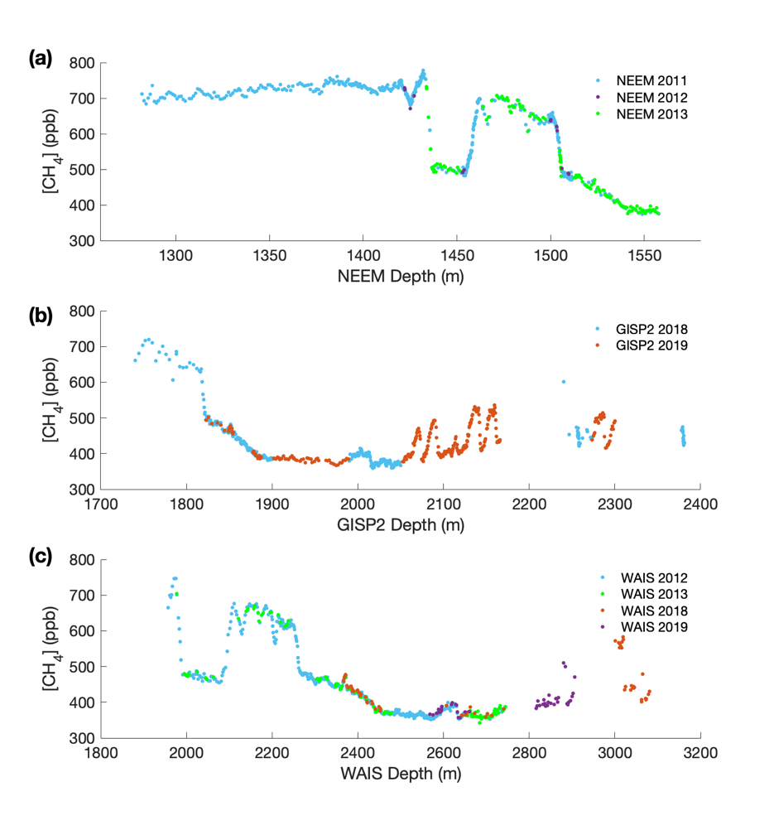
Supplementary Figure 1. Discrete [CH₄] data used in this study, separated by measurement campaign. [CH₄] data corrected for blank/ solubility, and gravitational effects measured from samples from the NEEM (a), GISP2 (b) and WD (c) ice cores, color-coded by measurement campaign. This visualizes the depth ranges where different campaigns overlap which are periods used to calculate campaign offsets. The NEEM and WD 2013 campaigns are denoted in red and were used as the main reference for all other campaigns prior to adjustment to match the GISP2 2018/2019 data (see main text). For NEEM, the 2011 and 2013 campaigns overlap from 1436 – 1452 m, 1464 – 1497.5 m, 1512 – 1557 m. The 2012 NEEM campaign fully overlaps with the 2013 campaign. For GISP2, the two campaigns overlap from 1820 – 1900 m. For WD, the 2013 record prior to 2600 m fully overlaps with the 2012 campaign. The 2018 and 2013 campaigns overlap from 2360 – 2460 m and 2650 – 2750 m. Lastly, because the 2019 WD campaign does not overlap with 2013, the offset between 2012 and 2019 was calculated using the overlap from 2560 – 2650m, which was then used with the 2013, 2012 offset to calculate the WD 2019, 2013 offset.
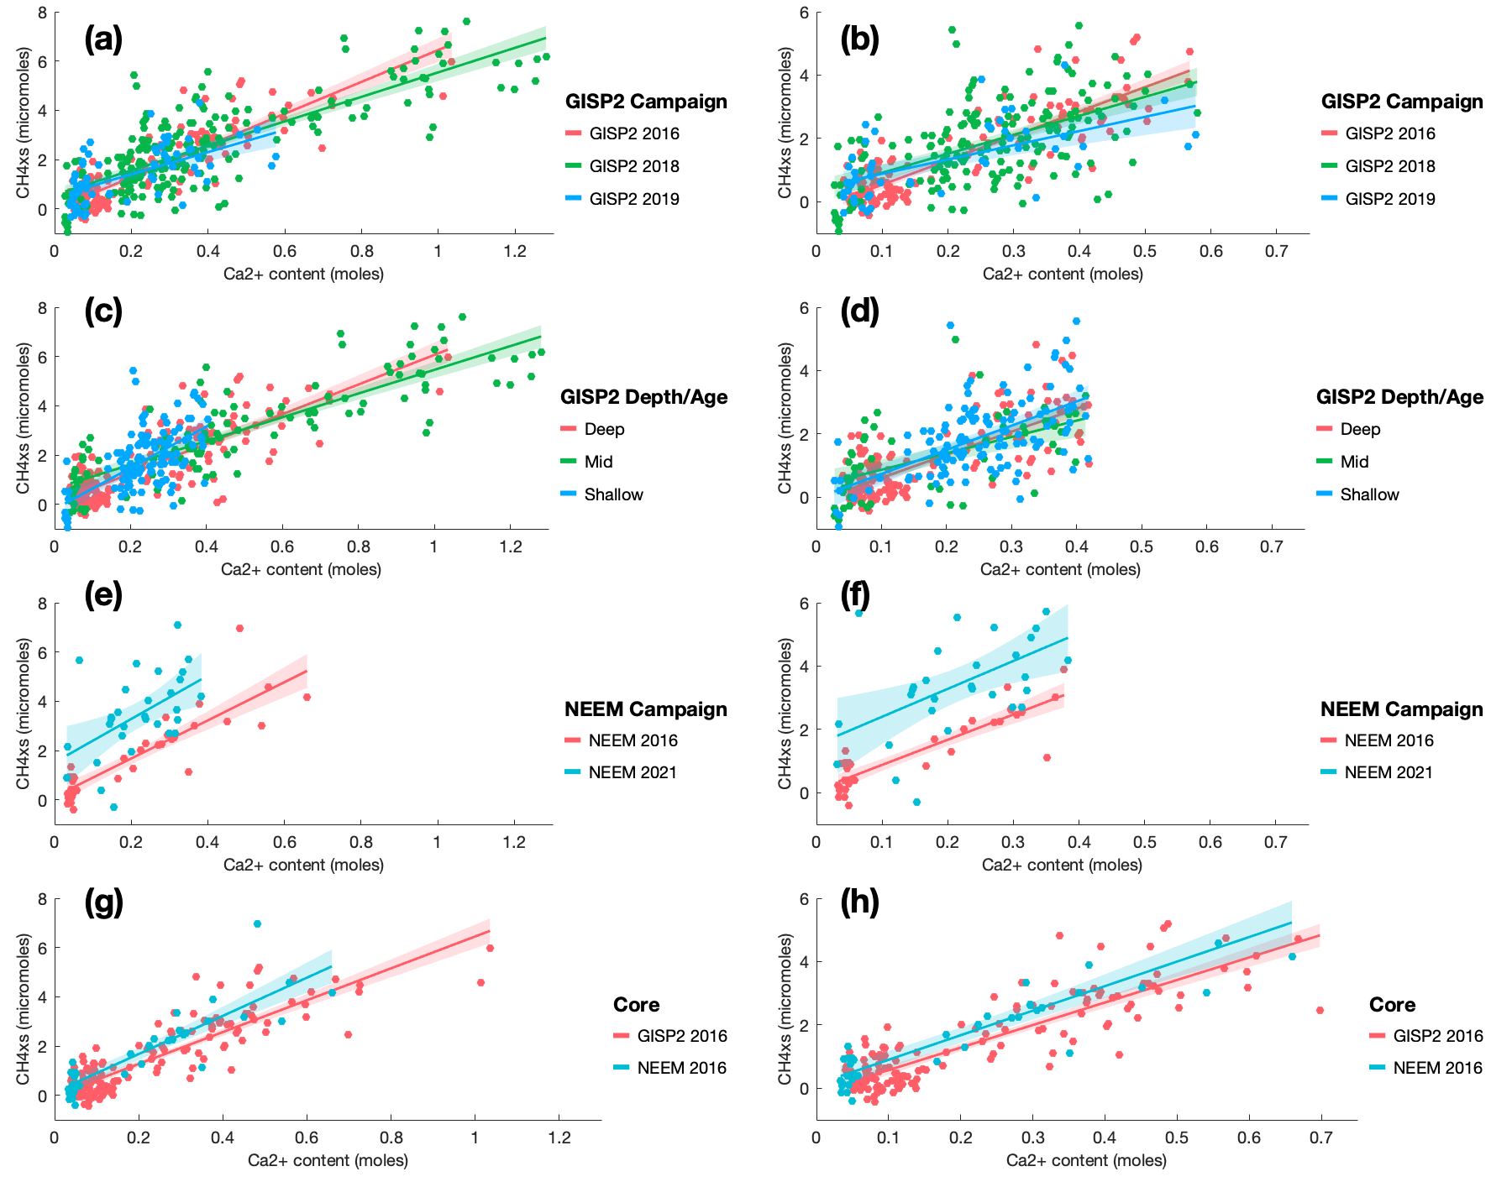
Supplementary Figure 2. Regressions and uncertainties of each of the binning tests. For each test, the left figure shows all data within each bin and the right figure shows each of those bins with identical ranges of [Ca²⁺]. From top to bottom, the subfigures show binning for (a - b) GISP2 measurement campaign, (c - d) GISP2 ice age/depth, (e -f) NEEM measurement campaign, and (g - h) GISP2 vs. NEEM.
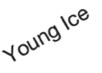

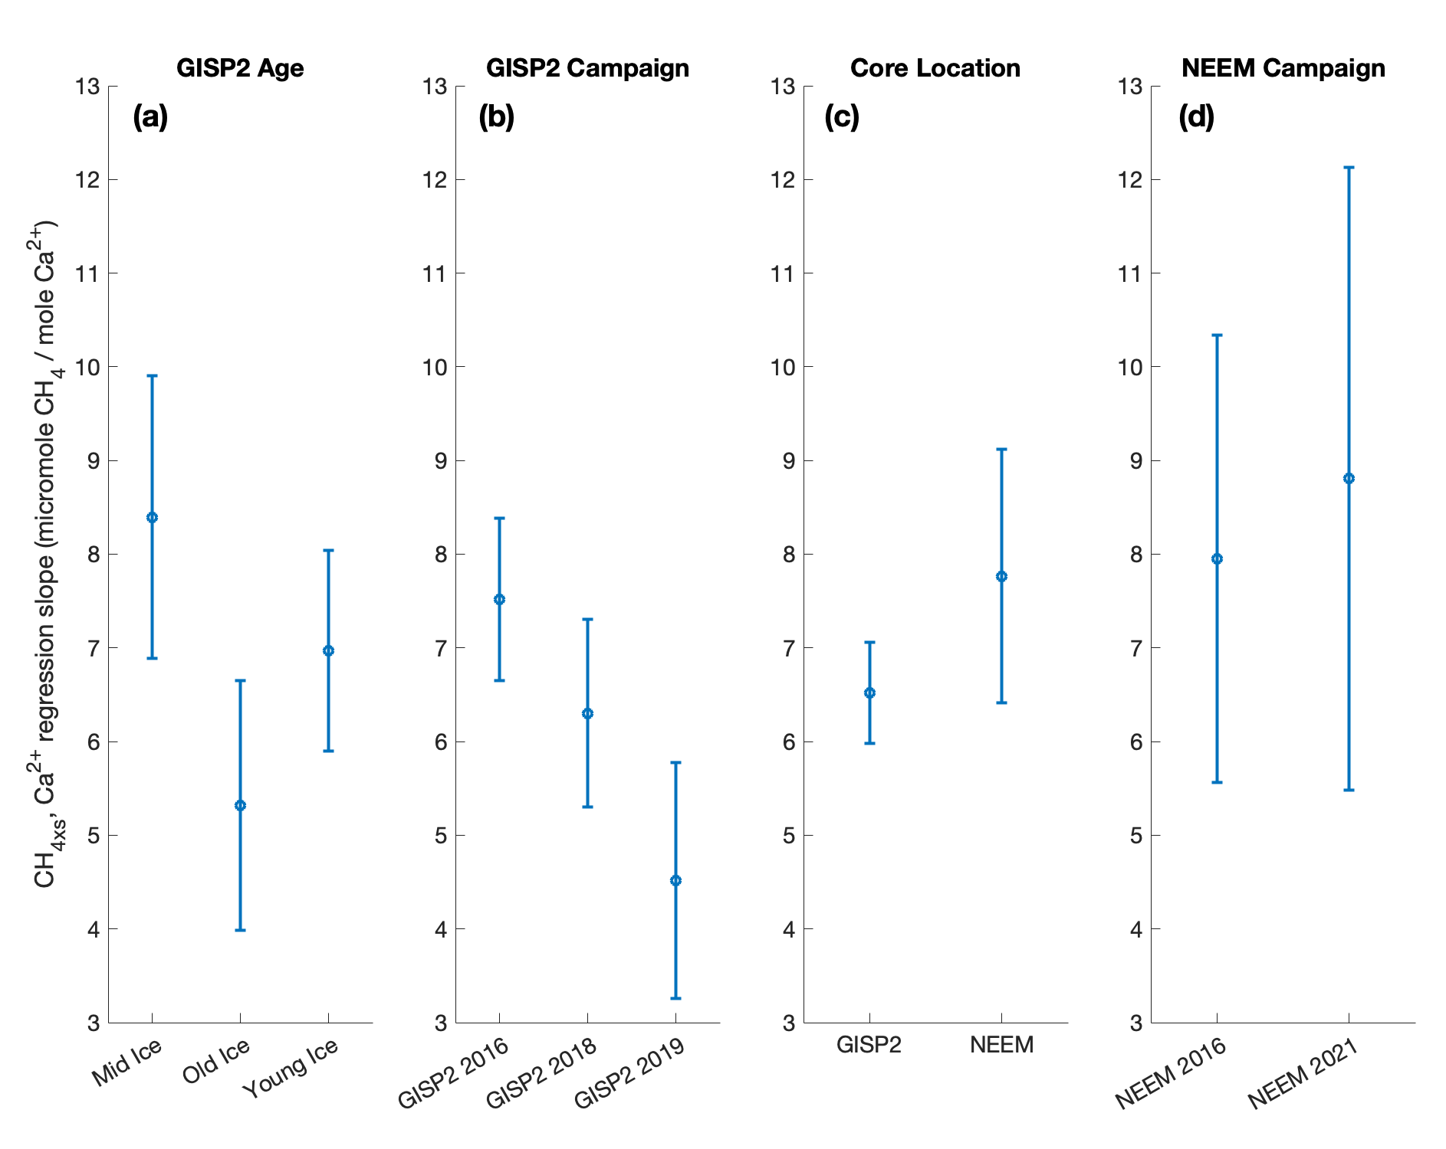

Supplementary Figure 3. Results of the ANCOVA (analysis of covariance) tests conducted on the binned CH_{4xs} data. Each subplot shows the 95% confidence intervals of the CH_{4xs} vs. Ca²⁺ regression slopes (using data covering equal [Ca²⁺] ranges) of the (a) age/depth binned GISP2 data, (b) campaign binned GISP2 data, (c) core comparison data, and (d) campaign binned NEEM data. There were statistically significant differences in the regression slope for (a) and (b). To account for this potential variability, we assign larger error for correcting the CH4xs data used in our rIPD reconstruction.

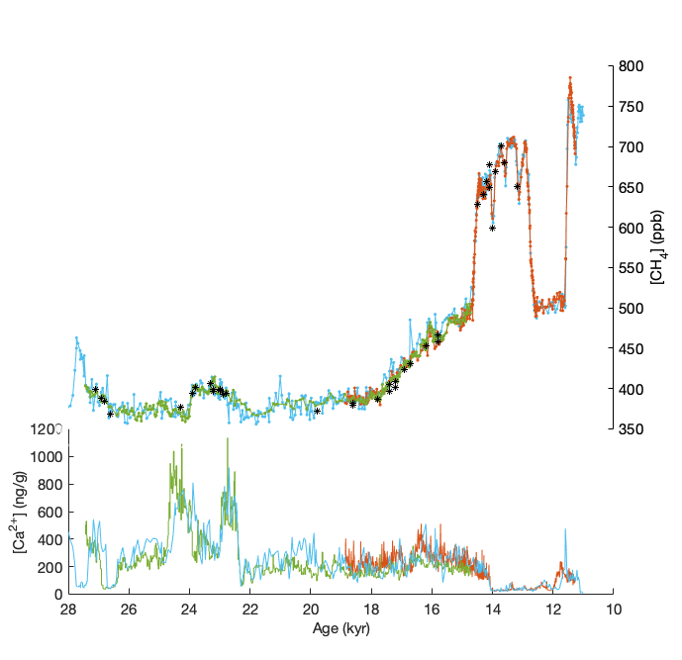
Supplementary Figure 4. Comparison of CH_{4xs} correction methods. OSU GISP2 and NEEM CH_{4xs} corrected data using the Lee et al., 2020 correction method ¹⁰ are compared with NGRIP data corrected using methods described in Supplementary Section 3.3. Top: CH_{4xs} corrected NEEM (orange), GISP2 (green), NGRIP using the retroactive method (light blue) and NGRIP using the CH₄:C₂H₆:C₃H₈ ratio method (purple asterisks). Bottom: Ca²⁺ data for each core, color coded according to the top panel. Data are plotted on gas age scales internally synchronized to the WAIS Divide ice core gas age scale to aid with direct comparison.

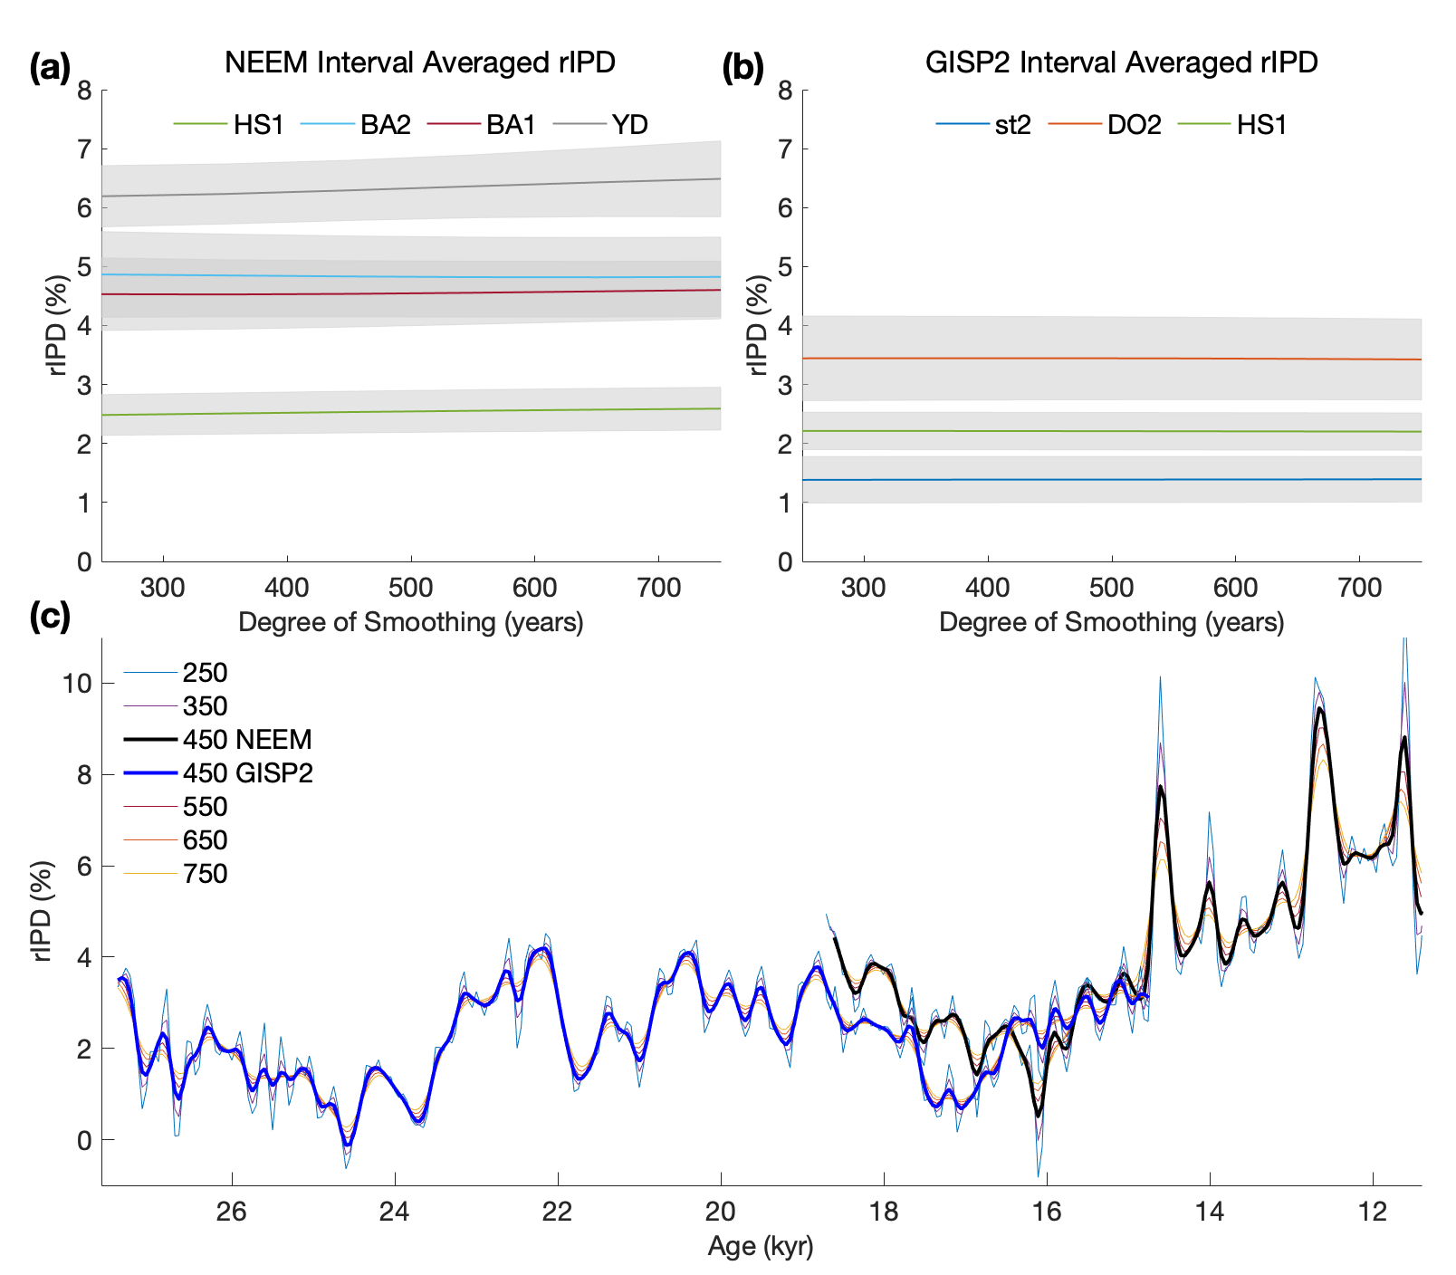
Supplementary Figure 5. Smoothing sensitivity test results. (a) and (b) show the interval averages and their 95% confidence intervals for select intervals described in Baumgartner et al., 2012 ¹⁶. Note that the interval averages and their uncertainties are not sensitive to changes in the degrees of smoothing. The LGM and st1 GISP2 intervals were omitted to prevent overcrowding in the figure but the results are the same. (c) shows the impact of the various degrees of smoothing on the GISP2 (blue) and NEEM (black) rIPD records. Note that shorter smoothing windows allow more centennial scale variability. Due to the sensitivity of centennial variability in the rIPD to firn smoothing, we caution against rIPD interpretations at this scale.
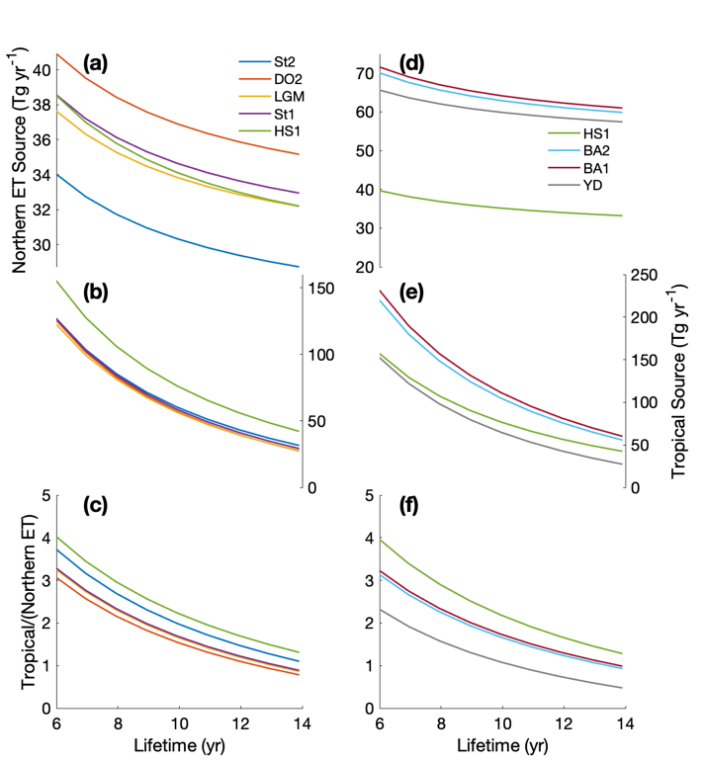
Supplementary Figure 6. Four-box model sensitivity test results. Using our four-box model, we calculated equilibrium source strengths for climate intervals described in Baumgartner et al., 2012 ¹⁶ (color-coded, see legend) using the GISP2 (a – c) and NEEM (d – f) derived rIPDs. For each interval, global average lifetime was varied between 6 and 14 years (x-axis), with proportional changes to lifetime in each box, to calculate the impact that varying lifetime has on source strengths. (a) and (d) show the results for total tropical sources, and (b) and (e) for northern extratropical sources. (c) and (f) display the ratio of tropical to northern extratropical sources and can be used to calculate the change in lifetime required to explain rIPD variability between different climate intervals assuming no latitudinal variability in the source strength. For example, in (f), the difference in the rIPD between HS1 and the YD (Supplementary Table 4) can either be explained by a change in the tropical to extratropical source ratio from ~1 to ~2 with a constant lifetime, or a change in the lifetime from ~8 to ~12 years with a constant tropical to extratropical source ratio. This exercise is used to explore the sensitivity of our rIPD interpretations to the assumption of no change in global lifetime between climate intervals.

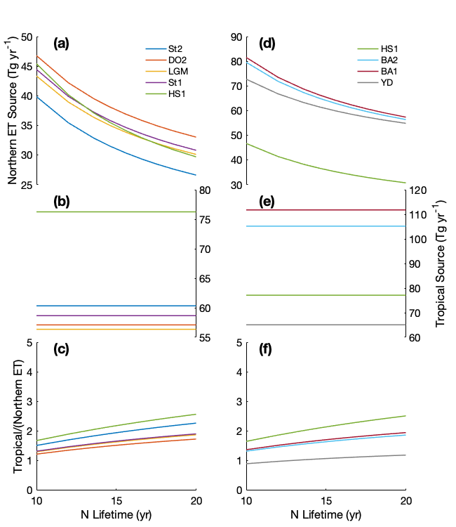
Supplementary Figure 7. Four-box model sensitivity test results continued. Here, lifetime was varied only in the northern extratropical box (hemispheric exchange rate, tropical lifetime and southern lifetime were held constant). Results are displayed in the same manner as Supplementary Fig. 6. Implications are discussed in the methods section of the main text.
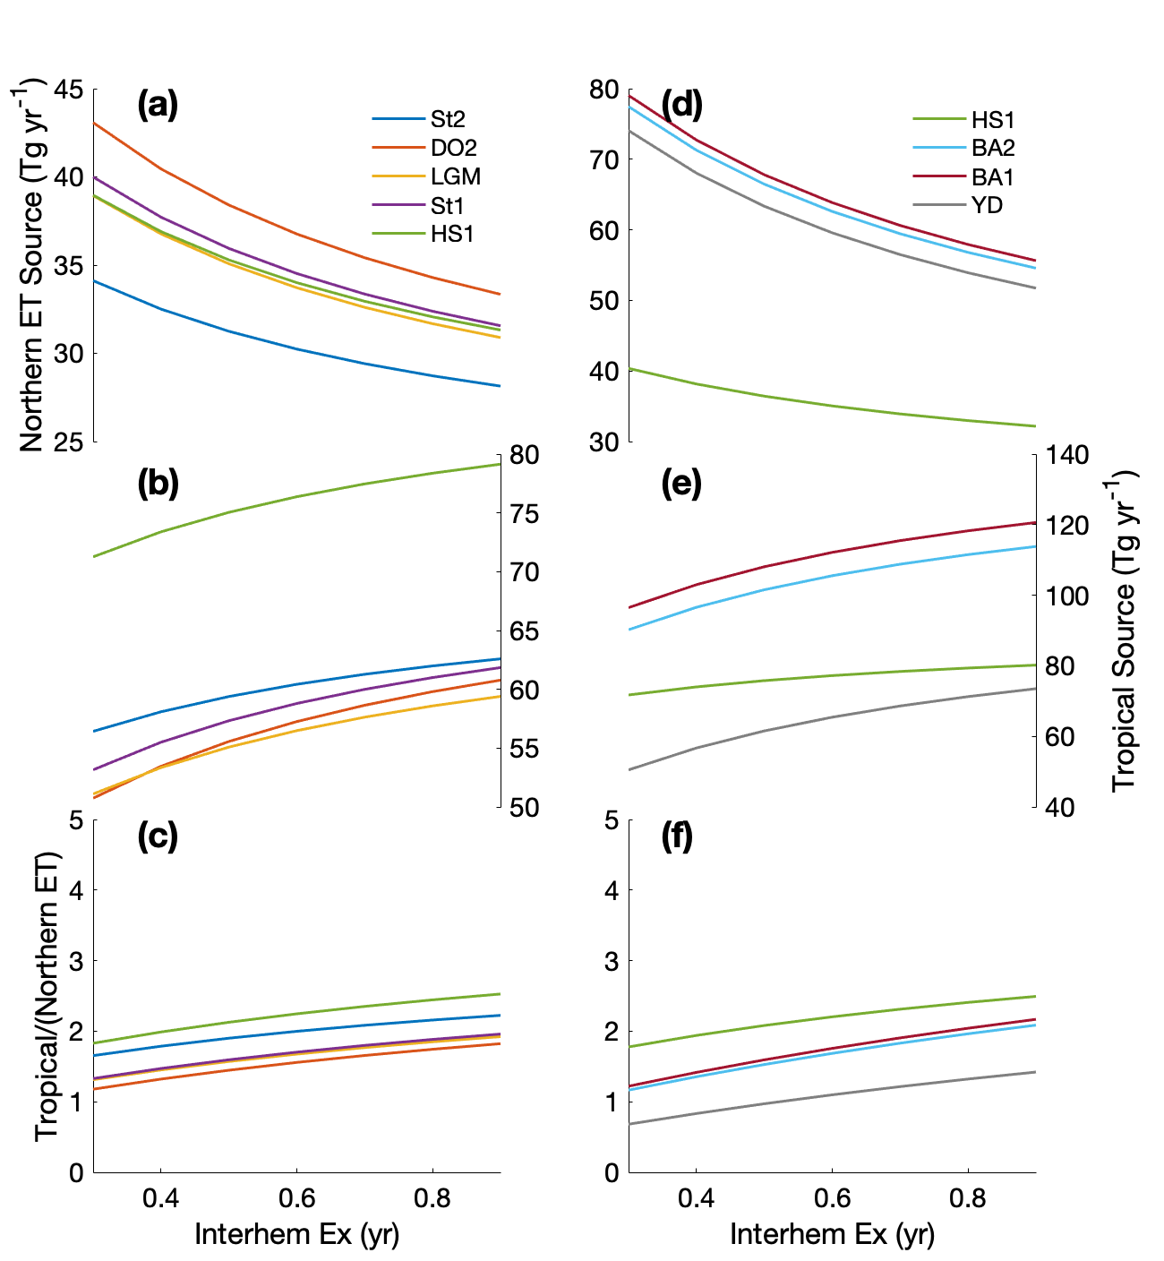

Supplementary Figure 8. Four-box model sensitivity test results continued. Here, interhemispheric exchange time (exchange between the two tropical boxes) was varied and lifetime was held constant. Results are displayed in the same manner as Supplementary Fig. 6. Implications are discussed in the methods section of the main text.
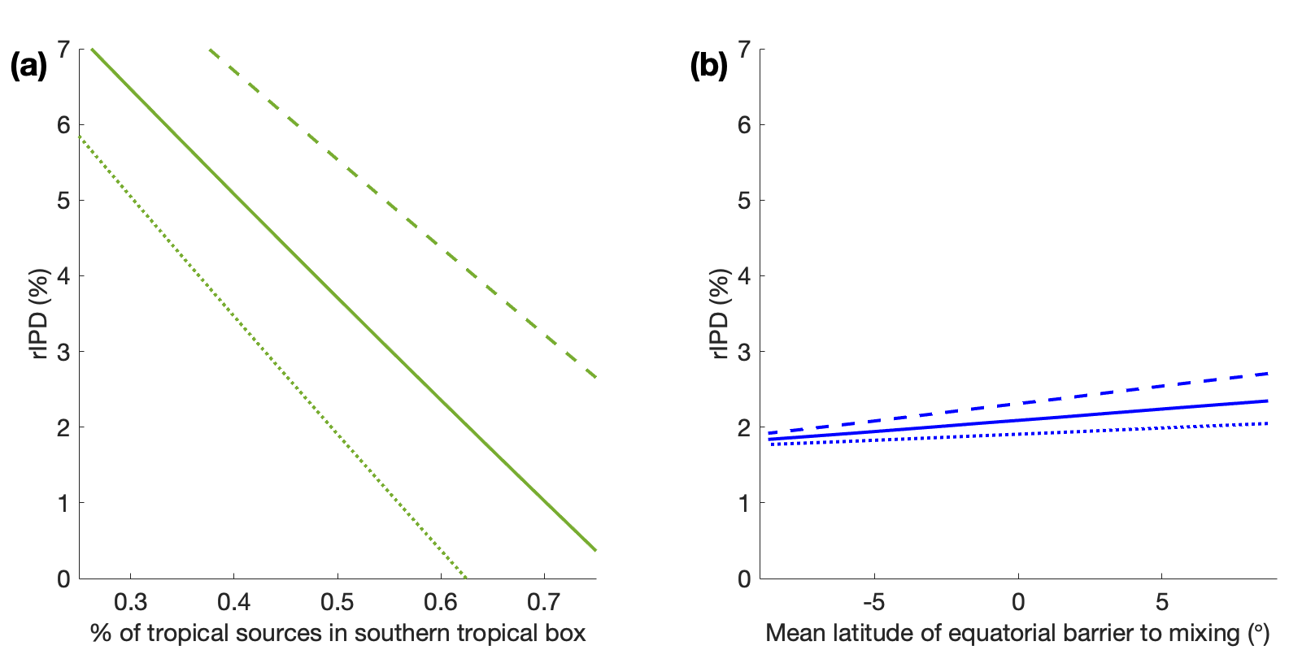
Supplementary Figure 9. Four-box model sensitivity test results. a) Sensitivity of the rIPD to latitudinal shifts in tropical sources. Tropical sources were varied between the North (0 – 30° N) and South tropics (0 – 30° S) while keeping the total tropical source constant, and the equilibrium rIPD was calculated for scenario to derive a linear relationship. The x-axis is the percent of total tropical sources within the southern tropical box. b) Sensitivity of the rIPD to changes in box sizes due to possible atmospheric circulation changes in response to the shifting latitude of the ITCZ. To simulate this, the northern and southern tropical box sizes were changed by latitudinally shifting the mean boundary to interhemispheric mixing as a function of latitude (x-axis). Northern tropical and southern tropical sources were varied proportional to the change in box sizes, thus assuming that tropical sources are equally distributed within each box. The affect that changing box sizes has on the rIPD is minimal but acts in the same direction as the results displayed in Supplementary Fig. 9a. For both a & b), the dashed and dotted lines show the same calculations but for 10% higher (dashed) and 10% lower (dotted) proportions of northern extratropical to total tropical sources, respectively to demonstrate the minimal sensitivity of the linear relationship to changes in source partitioning between the high and low latitude boxes, as well as lifetime and exchange rate (not shown).

Supplementary References

1 Mitchell, L. E., Brook, E. J., Sowers, T., McConnell, J. & Taylor, K. Multidecadal variability of atmospheric methane, 1000–1800 CE. Journal of Geophysical Research: Biogeosciences 116 (2011).
2 Lee, J. E. et al. An 83 000-year-old ice core from Roosevelt Island, Ross Sea, Antarctica. Climate of the Past 16, 1691-1713 (2020).
3 Mitchell, L., Brook, E., Lee, J. E., Buizert, C. & Sowers, T. Constraints on the late Holocene anthropogenic contribution to the atmospheric methane budget. Science 342, 964-966 (2013).
4 Dlugokencky, E. J. et al. Conversion of NOAA atmospheric dry air CH4 mole fractions to a gravimetrically prepared standard scale. Journal of Geophysical Research: Atmospheres 110 (2005).
5 Rosen, J. L. Augmenting and interpreting ice core greenhouse gas records PhD Dissertation thesis, Oregon State University, (2014).
6 Buizert, C. et al. Greenland temperature response to climate forcing during the last deglaciation. Science 345, 1177-1180 (2014).
7 Seierstad, I. K. et al. Consistently dated records from the Greenland GRIP, GISP2 and NGRIP ice cores for the past 104 ka reveal regional millennial-scale δ18O gradients with possible Heinrich event imprint. Quaternary Science Reviews 106, 29-46 (2014).
8 Buizert, C. et al. Gas transport in firn: multiple-tracer characterisation and model intercomparison for NEEM, Northern Greenland. Atmospheric Chemistry and Physics 12, 4259-4277 (2012).
9 Buizert, C. et al. The WAIS Divide deep ice core WD2014 chronology–Part 1: Methane synchronization (68–31 kaBP) and the gas age–ice age difference. Climate of the Past 11 (2015).
10 Lee, J. E. et al. Excess methane in Greenland ice cores associated with high dust concentrations. Geochimica et cosmochimica acta 270, 409-430 (2020).
11 Schüpbach, S. et al. Greenland records of aerosol source and atmospheric lifetime changes from the Eemian to the Holocene. Nature communications 9, 1-10 (2018).
12 Mayewski, P. A. et al. Major features and forcing of high‐latitude northern hemisphere atmospheric circulation using a 110,000‐year‐long glaciochemical series. Journal of Geophysical Research: Oceans 102, 26345-26366 (1997).
13 Buizert, C. et al. Antarctic surface temperature and elevation during the Last Glacial Maximum. Science 372, 1097-1101 (2021).
14 Baumgartner, M. et al. NGRIP CH 4 concentration from 120 to 10 kyr before present and its relation to a δ 15 N temperature reconstruction from the same ice core. Climate of the Past 10, 903-920 (2014).
15 Rasmussen, R. a. & Khalil, M. Atmospheric methane in the recent and ancient atmospheres: concentrations, trends, and interhemispheric gradient. Journal of Geophysical Research: Atmospheres 89, 11599-11605 (1984).
16 Baumgartner, M. et al. High-resolution interpolar difference of atmospheric methane around the Last Glacial Maximum. Biogeosciences 9, 3961-3977 (2012).
17 Brook, E. J., Harder, S., Severinghaus, J., Steig, E. J. & Sucher, C. M. On the origin and timing of rapid changes in atmospheric methane during the last glacial period. Global Biogeochemical Cycles 14, 559-572 (2000).
18 Dällenbach, A. et al. Changes in the atmospheric CH4 gradient between Greenland and Antarctica during the Last Glacial and the transition to the Holocene. Geophysical Research Letters 27, 1005-1008 (2000).
19 Chappellaz, J. et al. Changes in the atmospheric CH4 gradient between Greenland and Antarctica during the Holocene. Journal of Geophysical Research: Atmospheres 102, 15987-15997 (1997).
20 Flückiger, J. et al. High‐resolution Holocene N2O ice core record and its relationship with CH4 and CO2. Global Biogeochemical Cycles 16, 10-11-10-18 (2002).
21 Andersen, K. K. et al. The Greenland ice core chronology 2005, 15–42 ka. Part 1: constructing the time scale. Quaternary Science Reviews 25, 3246-3257 (2006).

