Supplementary Material A
The algorithm from Malaret et al. (1985) was used to calculate the surface temperature for the Landsat 5 imagery (Equation 1). This algorithm was selected to estimate surface temperature due to their high accuracy when compared to measured surface temperature data, R² = 0.8 (Malaret et al. 1985).

$T_{s5}=\left(209.831 + 0.834 {LS5}_{vi} - 0.0013 {\left({LS5}_{vi}\right)}^{2}\right)-273.15$ (1)

Where $T_{s5}$ is the estimated surface temperature for Landsat 5, and ${LS5}_{vi}$ is the respective thermal band (band six). L represents spectral radiance at the top of the atmosphere.
The algorithm from Avdan and Jovanovska (2016) (Equation 2 to 6) was applied to estimate the surface temperature for the Landsat 8 data. This algorithm was chosen to estimate surface temperature due to their demonstrated accuracy when compared to measured surface temperature data, R² = 0.7 (Avdan and Jovanovska, 2016). The Avdan and Jovanovska (2016) algorithm started calculating the spectral radiance at the top of the atmosphere ($L$) (Equation 2).

$L=M {LS8}_{X}+A_{L}$ (2)

The parameter M is the band-specific multiplicative factor (3.342 x 10-4), ${LS8}_{X}$ the thermal band in Landsat 8 (band ten), and $A_{L}$ is the band-specific additive factor (0.1). In sequence, the brightness temperature of the image ($BT$) was calculated using Equation 3:

$BT= \frac{Y_{2}}{Ln(\left(\frac{Y_{1}}{L}\right)+1)}-273.15$ (3)

Where Y1 and Y2 represent the specific thermal conversion constants of the Landsat 8 thermal band, which are represented by 774.8853 and 1321.0789, respectively. Subsequently, the Normalized Difference Vegetation Index was calculated by Equation 4.

$NDVI=\frac{{LS8}_{v}-{LS8}_{iv}}{{LS8}_{v}+{LS8}_{iv}}$ (4)

In Equation 4 ${LS8}_{iv}$ and ${LS8}_{v}$ are the red (i.e. band four) and near-infrared (i.e. band five) bands of Landsat 8. Thereafter, the proportion of vegetation ($P_{V}$) is estimated using the minimum (NDVImin) and maximum (NDVImax) NDVI values in Equation 5.

$P_{V}={\left(\frac{NDVI-{NDVI}_{min.}}{{NDVI}_{max.}-{NDVI}_{min.} }\right)}^{2}$ (5)

Subsequently, emissivity (ε) was calculated (Equation 6), and then the surface temperature for Landsat 8 imagery ($T_{s8}$) was estimated by Equation 7.

$ε=0.004P_{V}+0.986$ (6)

$T_{s8}=\frac{BT}{(1+\left(0.00115\frac{BT}{1.4388}\right)Ln\left(ε\right))}$ (7)

ε is emissivity and $T_{s8}$ the estimated surface temperature for Landsat 8. The whole methodology as well as why and what is the purpose of each parameter to calculate the surface temperature are detailed by Malaret et al. (1985) for Landsat 5, and Avdan and Jovanovska (2016) for Landsat 8.
Since the aforementioned algorithms estimate surface temperature, whereas the Stephens–Stewart Equation requests air temperature. According to Dugdale et al. (2017), air temperature ($T_{air}$) can be assumed to be 20% higher than water temperature in equatorial regions, and this recommendation was adopted as depicted in Equation 8.

$T_{air}=T_{w} 1.2$ (8)

In Equation 8, $T_{w}$ represents the water surface temperature (ºF).

Supplementary Material B
The Bastiaanssen (2000) methodology was used to calculate the incoming short-wave radiation ($Q_{S↓}$), and it was applied as it presents a high accuracy (R² = 0.92) compared with measured data from the weather station (Equation 9).

$Q_{S↓}=G_{sc} cosθ d_{r} τ_{sw}$ (9)

In Equation 9, G_{sc} is the solar constant (1367 W/m²), cos θ the solar zenith angle, d_{r} the inverse square relative earth-sun distance, and τ_{sw} represents atmospheric transmissivity. After that, in order to calculate the solar zenith angle, the Equation 10 should be employed.

$θ=90-α$ (10)

Where $α$ stands for the solar elevation angle, which can be obtained in the metadata of the scene. Subsequently, the d_{r} is estimated by Equation 11.

$d_{r}=1+0.33cos⁡(DOY\frac{2π}{365.25})$ (11)

Here DOY is the Julian day when the image was captured. The d_{r} values may vary between 0.97 and 1.03 and are dimensionless (Allen et al., 2002). By means of Equation 12, $τ_{sw}$ was calculated.

$τ_{sw}=0.75+0.00002 Z$ (12)

Z is the elevation above sea level (m). The topography elevation data (Z) were obtained from NASA’s Shuttle Radar Topography Mission (SRTM). Values for $Q_{S↓}$ range from 200 – 1000 W/m² depending on image time and location. A more detailed explanation of short-wave radiation estimation by remote sensing can be found in Waters et al. (2002).

Supplementary Material C
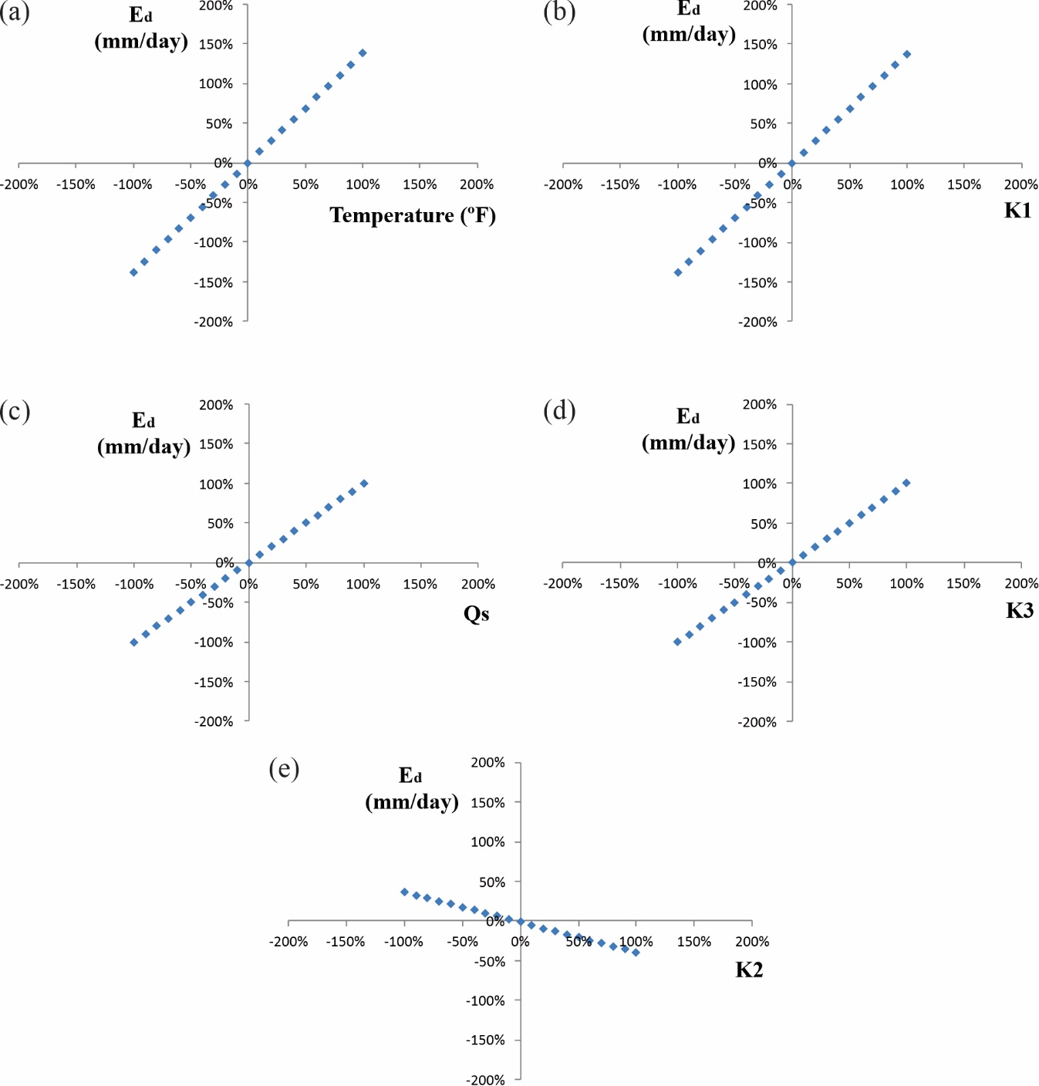
Fig. S1: Sensitive analyses of the Stephens-Stewart equation parameters: (a) Air Temperature, (b) K₁, (c) Short-wave radiation, (d) K₃, and (d) K₂

