File S1: Alignment of CHKIV consensus sequences used to identify target regions.

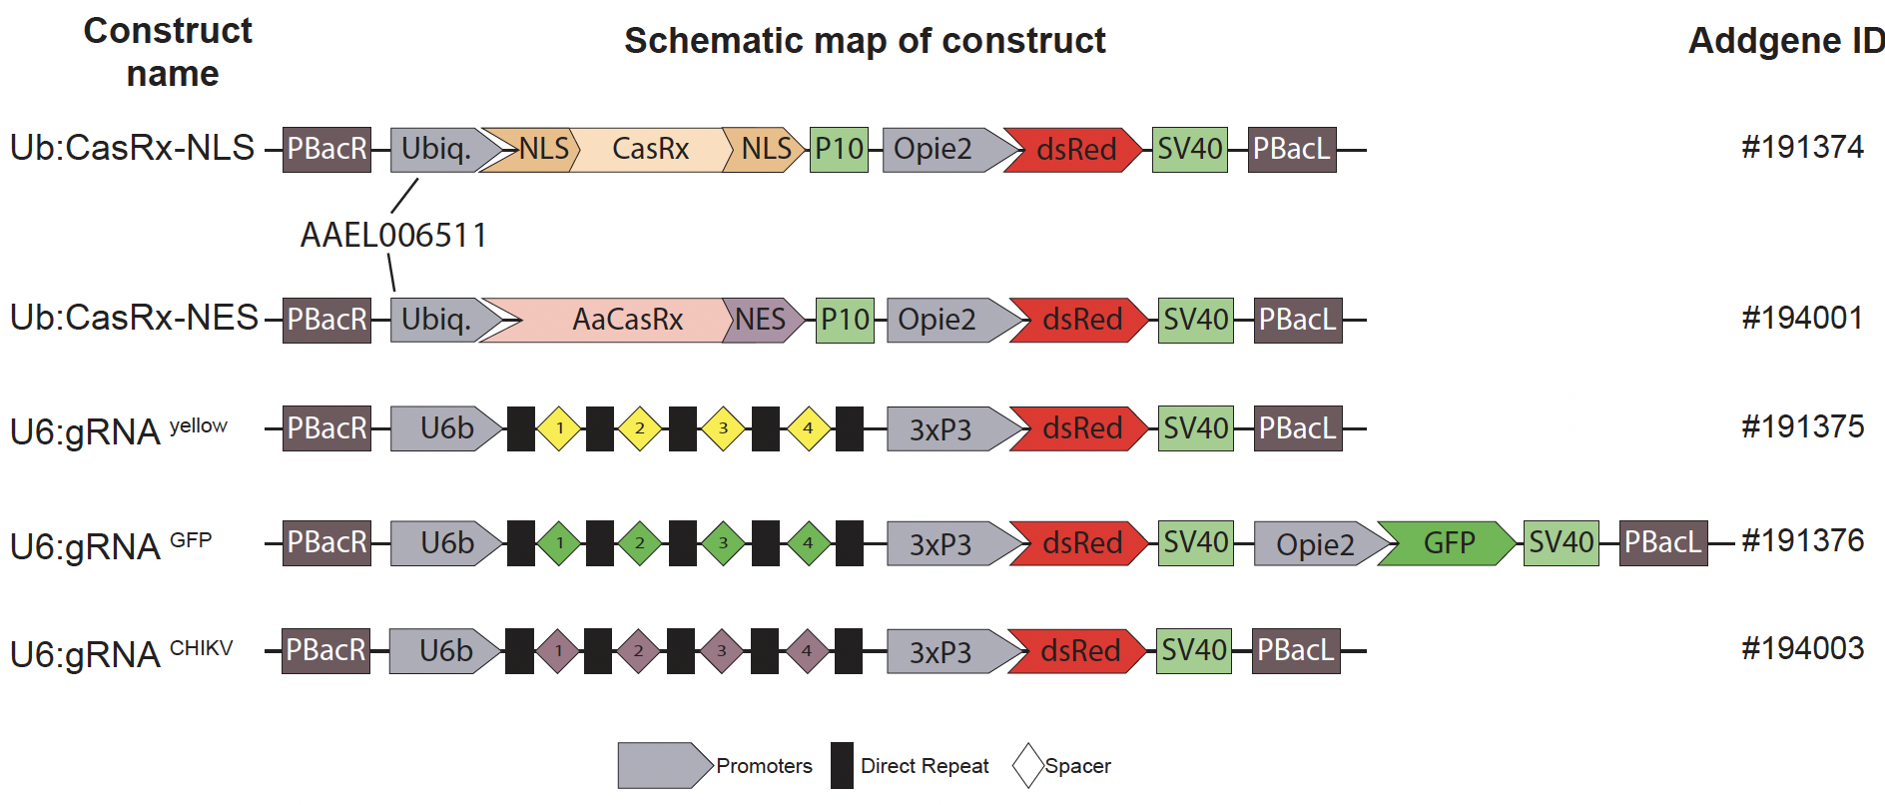
Fig. S1: Schematic representation of constructs generated for this study.

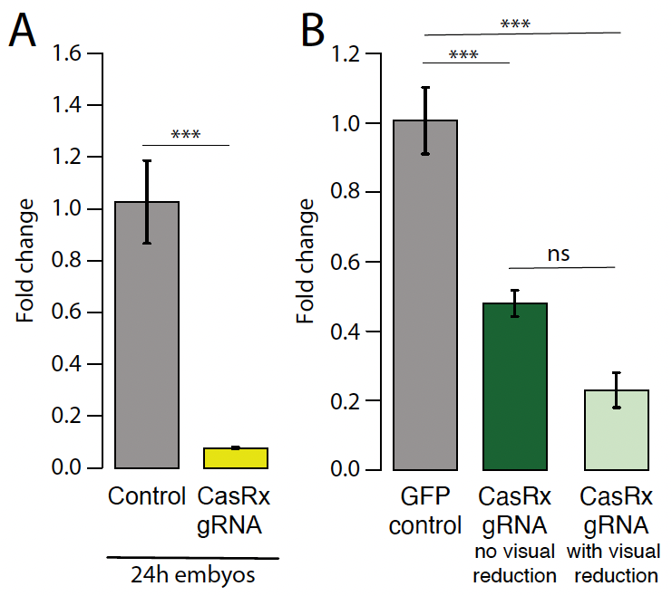
Fig. S2: qPCR data validating RNAseq results. (A) qPCR result for yellow gene in 24–hr-old embryos and surviving larvae. (B) GFP expression comparison in controls and transheterozygote larvae with and without visual reduction in GFP. Asterisks indicate significant reduction in hatching rate in transheterozygotes by one-way ANOVA with Tukey’s multiple-comparison test (***P < 0.001).

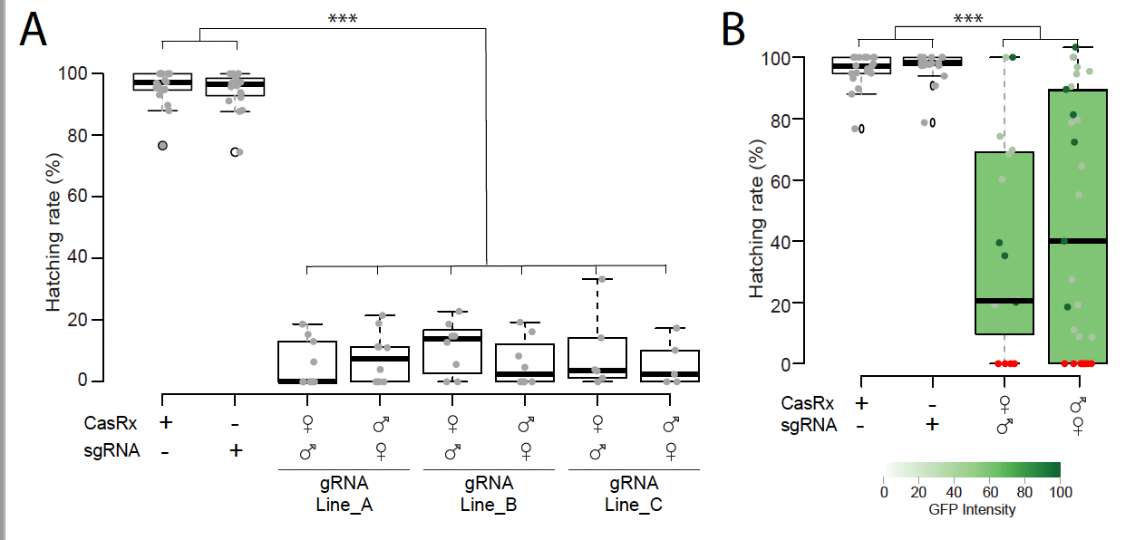
Fig. S3: Hatching rate from bidirectional crosses. (A) when targeting yellow gene and (B) when targeting GFP transgene. Phenotype penetrance is depicted by green shading in the box plot, with colors ranging from light green (low EGFP levels) to dark green (high EGFP levels). Red dots represent dead individuals and thus non quantifiable EGFP. Asterisks indicate significant reduction in hatching rate in transheterozygotes by one-way ANOVA with Tukey’s multiple-comparison test (***P < 0.001).

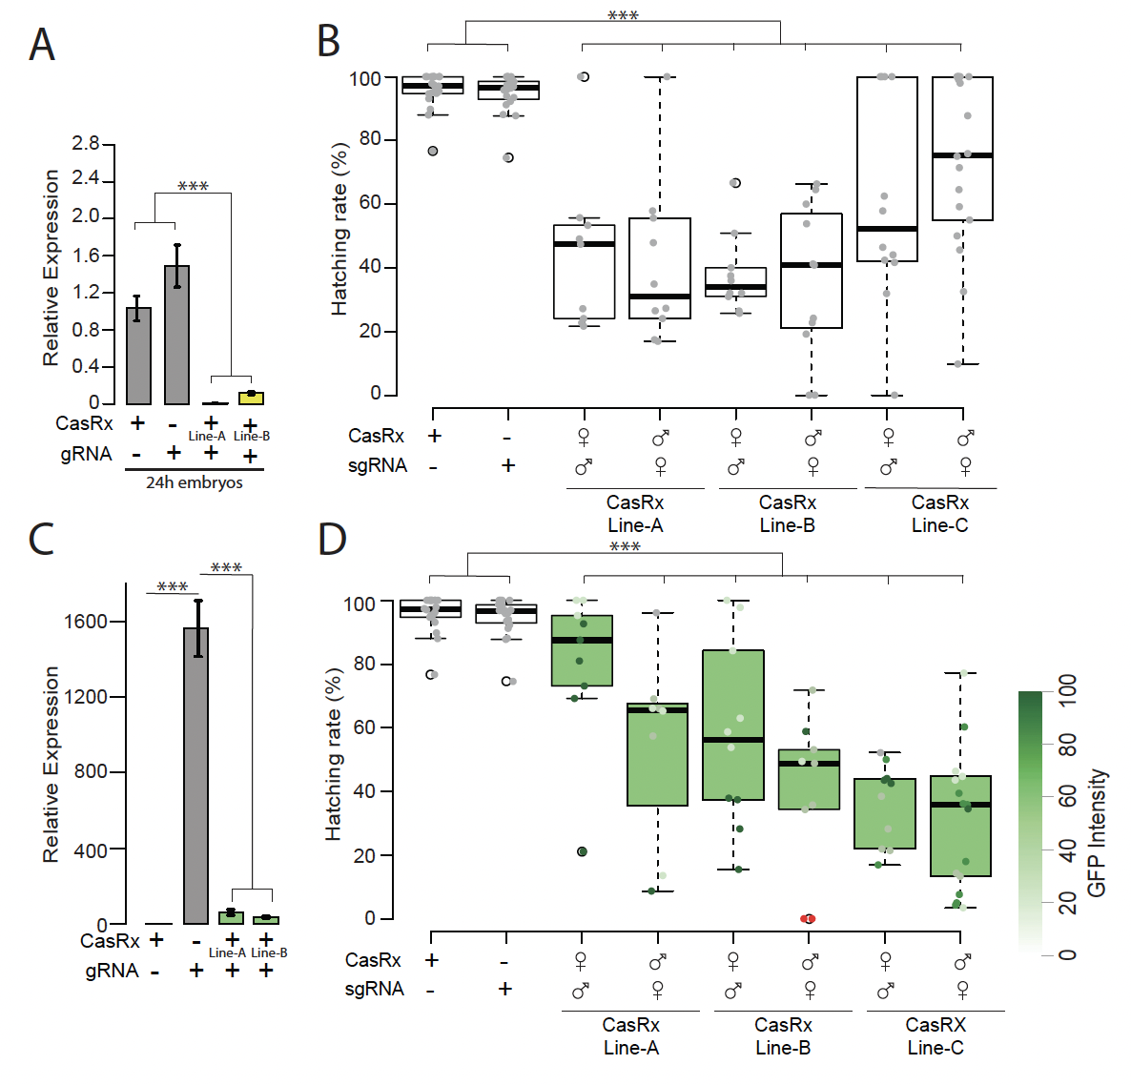Fig. S4: Assessment of yellow and GFP transcript reduction mediated by Ub:AeCasRx-NES. (A) qPCR result for yellow gene in 24–hr-old embryos, (B) Hatching rate from bidirectional crosses using the three Ub:CasRx-NES lines A, B and C (table S2). (C) qPCR result for GFP gene in surviving larvae showing visual reduction in GFP expression. (D) Hatching rate from bidirectional crosses using the three Ub:CasRx-NES lines. Phenotype penetrance is depicted by green shading in the box plot, with colors ranging from light green (low EGFP levels) to dark green (high EGFP levels). Red dots represent dead individuals and thus non quantifiable EGFP Asterisks indicate significant differences by one-way ANOVA with Tukey’s multiple-comparison test (*** P < 0.001).

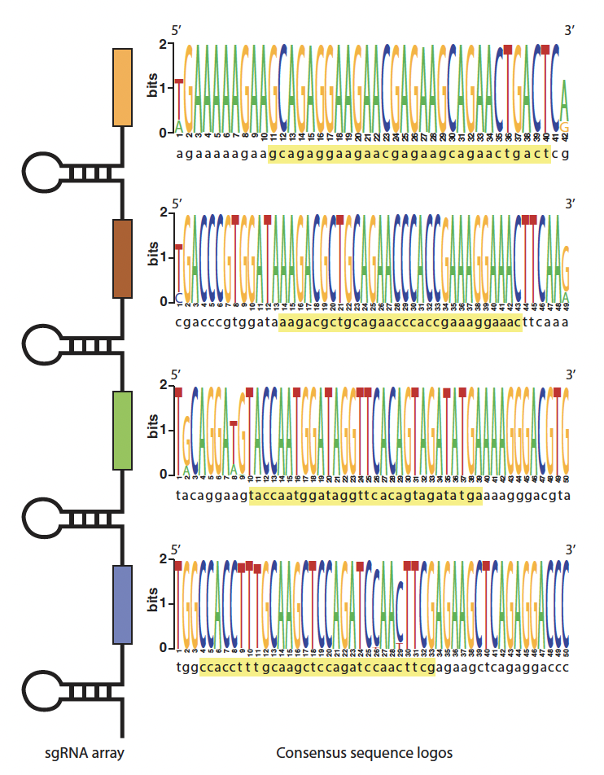
Fig. S5: CHIKV consensus sequences of the target sites. Consensus sequences were generated from conserved CHIKV genome regions aligned to the lab strain. They contain the 30nt target region (yellow highlight) used to design the gRNA employed in the study.

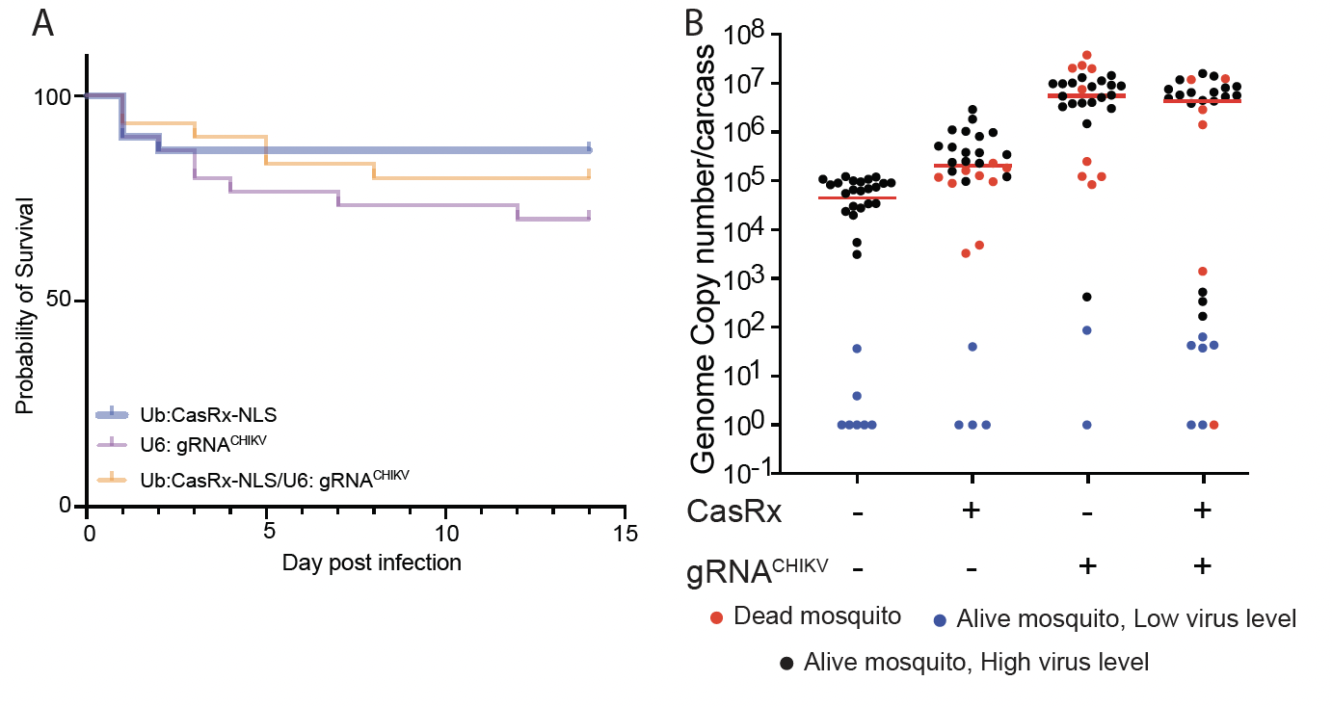Fig. S6: Virus challenge assays using Ub:CasRx-NLS. (A) Adult survival curves (log-rank Mantel-Cox test) of CHIKV exposed females per treatment. No significant differences were found between Survival curves. (B) The viral genome copy number and infection prevalence of CHIKV were measured after an infected blood meal challenge (n = 30). qRT-PCR was used to assess genome copy number and infection prevalence in individual mosquitoes, with each dot representing the viral load from individual mosquitoes. Each pie-chart indicates the percentage of mosquitos that died by day 5 (in red), that are alive but with lower virus level of ≤10² (blue), or that have an high virus level (black). Horizontal red lines indicate the median of the viral loads. Considering the non-normal distribution of viral titers, the median was used to describe central tendency. The non-parametric Mann-Whitney test was used to compare median viral titers, and Fisher’s exact test was used to compare infection prevalence. *P < 0.05, **P < 0.01, ****P < 0.0001.

