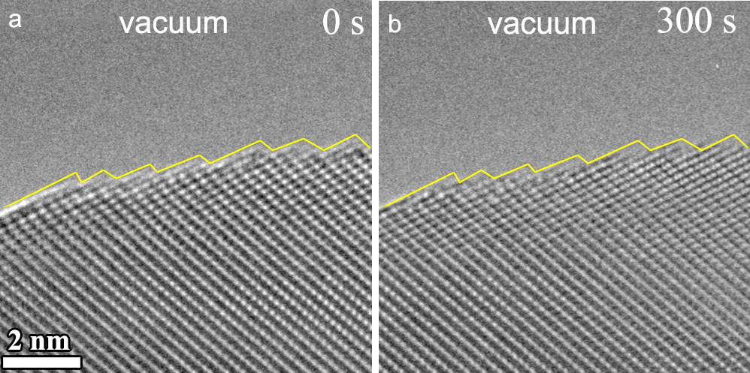
Extended Data Fig. 1 | In-situ TEM imaging of vacuum annealing of CuO. a, b, Time-sequence HRTEM images of the surface configuration of CuO in vacuum at 300 °C within a time period of 300 s of the continuous electron beam irradiation. The yellow lines in a, b, outline the surface profile of the CuO, showing negligible changes in the surface morphology. This indicates that experimentally observed formation and self-interconversions of the Cu₈O₇ and Cu₈O₂ terminations are induced by H₂-CuO surface reactions.
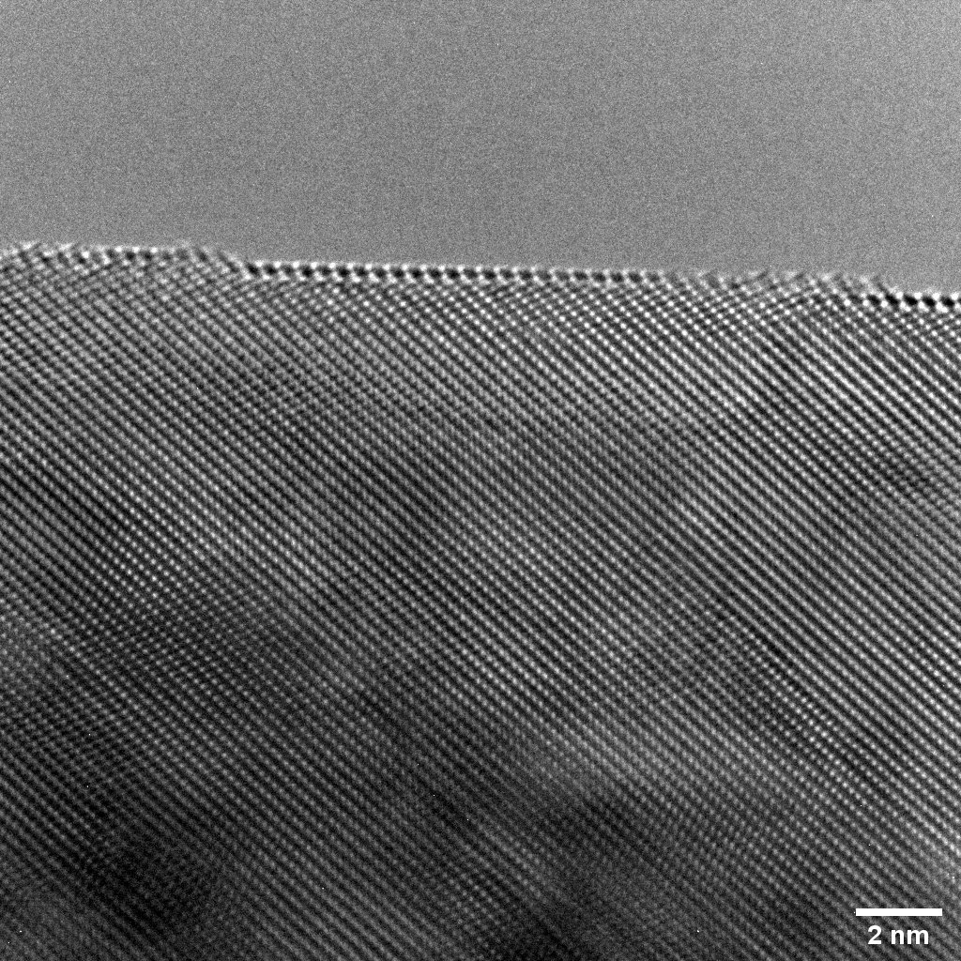
Extended Data Fig. 2 | CuO $\left(\overline{3}12\right)$ surface consisting of Cu₈O₇ and Cu₈O₂ terminations during the H₂ gas flow at 0.5 Pa and 300 °C. The originally rough surface evolves into the flat morphology upon the formation of the Cu₈O₂ and Cu₈O₇ terminations and their cyclic interconversions in the H₂ gas flow.
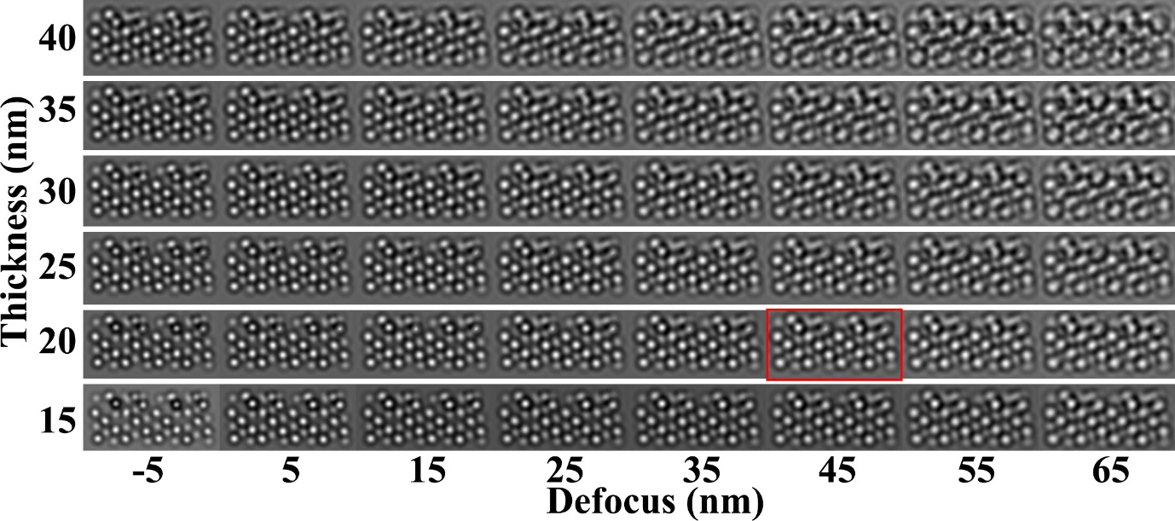
Extended Data Fig. 3 | Simulated HRTEM images the Cu₈O₇ surface termination. Specimen thickness increases from bottom to top, and defocus increases from left to right. The one marked in red matches the experimental HRTEM image in Fig. 1.
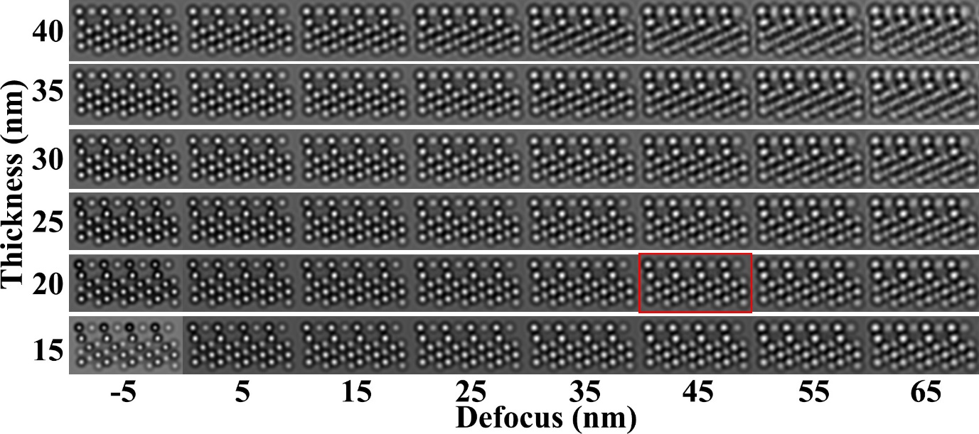
Extended Data Fig. 4 | Simulated HRTEM images of the Cu₈O₂ surface termination. Specimen thickness increases from bottom to top, and defocus increases from left to right. The one marked in red matches the experimental HRTEM image in Fig. 1.
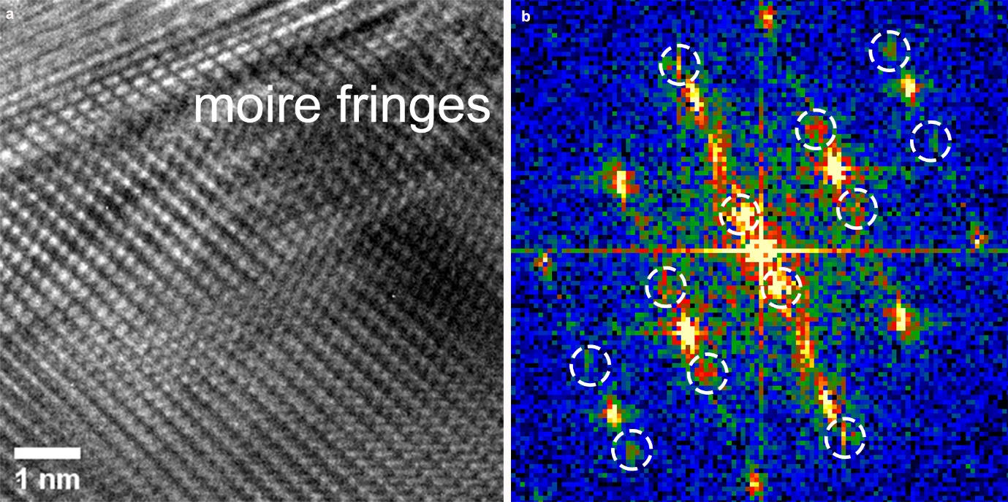
Extended Data Fig. 5 | Aggregation of Cu atoms released from receding motion of surface steps during the CuO reduction at ≈ 300 °C and ≈ 0.5 Pa of H₂ gas flow. a, HRTEM image showing the presence of the moiré fringe contrast as a result of overlapping of substrate CuO with the Cu overlayer that is formed via the aggregation of Cu adatoms released from the receding motion of atomic steps at the CuO surface. b, Diffractogram of the HRTEM image in a, showing the double reflection spots (white circles) resulting from the overlapping of aggregated Cu and substrate CuO.
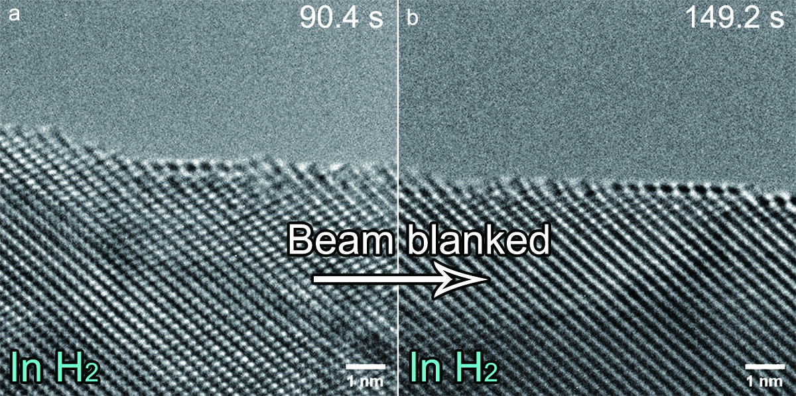
Extended Data Fig. 6 | Excluding the electron beam effects on the observed surface faceting and restructuring. a, HRTEM image showing a relatively rough surface with the local Cu₈O₂ termination. b, The electron beam was blanked for ≈ 60 s and then unblanked for TEM imaging, showing surface becomes flat with the presence of both the Cu₈O₂ and Cu₈O₇ terminations. These comparison experiments reveal the formation of the Cu₈O₂ and Cu₈O₇ terminations and their self-interconversion are intrinsic behaviors of CuO in H₂.
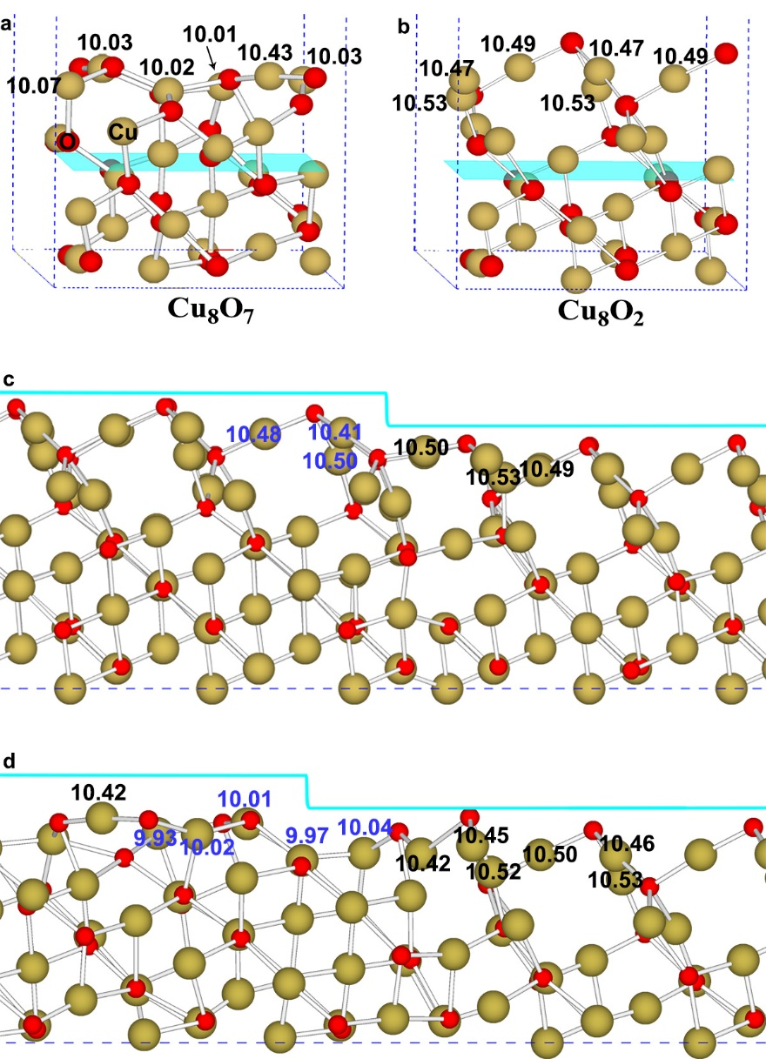
Extended Data Fig. 7 | DFT calculations of the Bader charge of Cu atoms in Cu₈O₇ and Cu₈O₂. a, b, Bader charge of Cu atoms in Cu₈O₇ and Cu₈O₂, respectively. The larger Bader charges of Cu atoms in Cu₈O₂ indicate that the lattice O is coordinated by metallic-like Cu that results in stronger Pauli repulsion toward H adsorption, leading to a lower reducibility of the Cu₈O₂ termination. c, d, DFT-relaxed structures of the surface consisting of Cu₈O₂ and Cu₈O₇ terraces separated by a monoatomic step, and the surface consisting of Cu₈O₇ and Cu₈O₇ terraces separated by a monoatomic step, showing the smaller Bader charges of the step-edge Cu atoms than terrace Cu atoms. This favors H₂ adsorption, O vacancy formation, and Cu detachment along the step edges. Blue number labels Bader charge of Cu atoms at the step edges in c, d. Yellow and red balls represent Cu and O atoms, respectively.
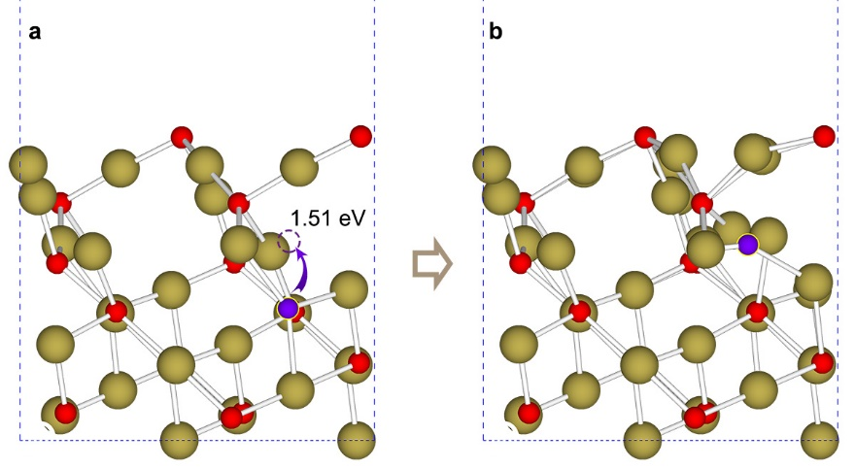
Extended Data Fig. 8 | Diffusion barriers of O atoms from the subsurface to the Cu₈O₂ surface. a, Atomic model showing the diffusion pathway of the O (purple ball) in the subsurface to the Cu₈O₂ terminated surface (purple dashed circle) with the diffusion barrier of 1.51 eV. b, DFT-relaxed structure of the Cu₈O₂ after refilling the O vacancy (purple) with the O from the subsurface, showing the tendency of the Cu₈O₂→Cu₈O₇ conversion in the local region. Yellow, red (and purple) balls represent Cu and O atoms, respectively.
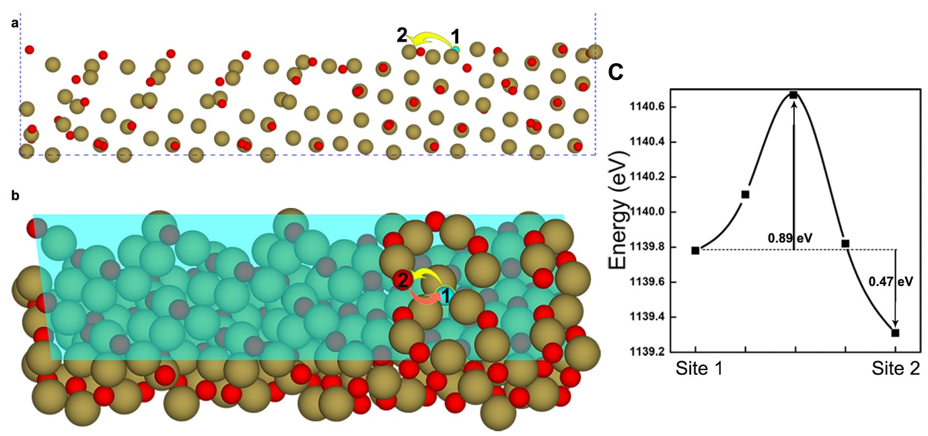
Extended Data Fig. 9 | O vacancy segregation to step edges. Side (a) and perspective (b) views of the atomic model showing the O vacancy (cyan ball) diffusion from a terrace site 1 to the step edge (site 2). c, Energetics showing the favorable O vacancy segregation from site 1 to 2 in b. Yellow, red, and cyan balls represent Cu, O, and O vacancy, respectively.
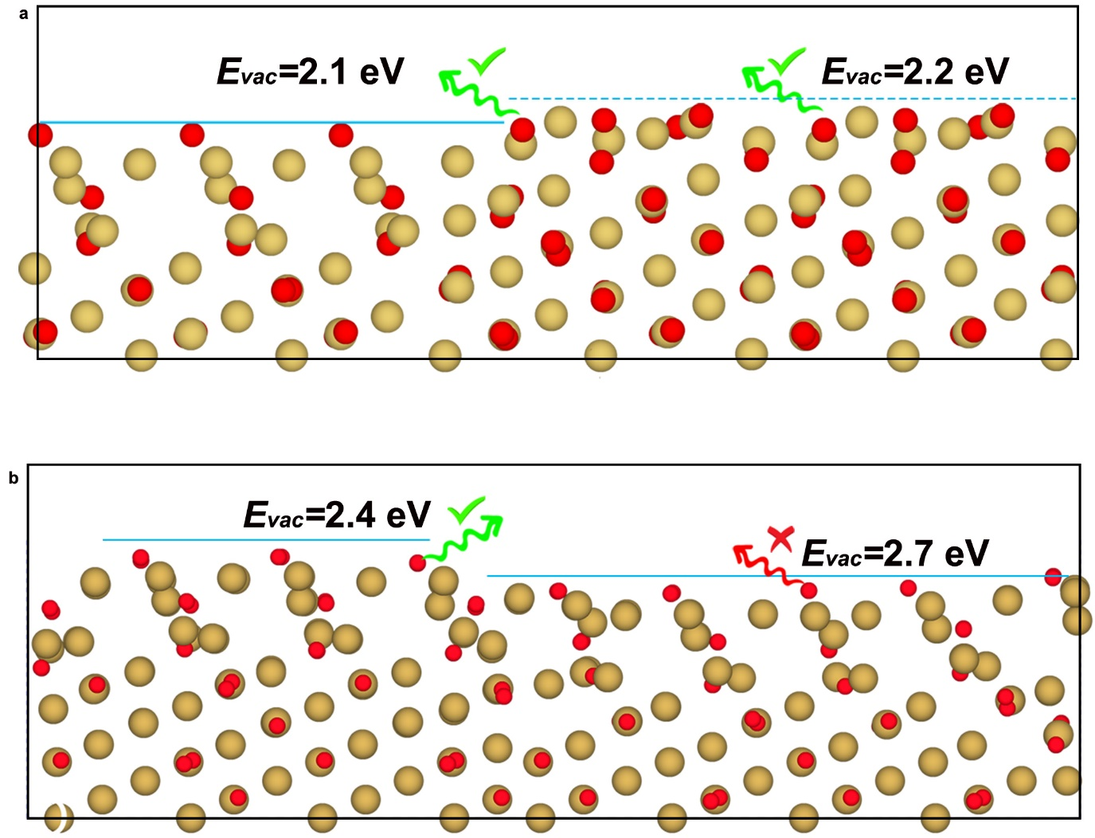
Extended Data Fig. 10 | Energies of O vacancy formation along the step edge and in the terrace. a, b DFT-relaxed structures of the surface consisting of Cu₈O₇ and Cu₈O₂ terraces separated by a monoatomic step, and the surface consisting of Cu₈O₂ and Cu₈O₂ terraces separated by a monoatomic step. Yellow and red balls represent Cu and O atoms, respectively.

Captions for Movies
Movie S1: In Situ TEM movie showing the stable surface configuration of the CuO at 300 ℃ and in vacuum.
Movie S2: In Situ TEM movie showing surface evolution of the CuO at 300 ℃ and 0.5 Pa of H₂ gas flow. The electron beam was blanked for about 60 s to evaluate potential beam effects on the oxide reduction.
Movie S3: In Situ TEM movie showing the Cu₈O₂→Cu₈O₇ conversion out of the atomically flat Cu₈O₂ termination at 300 ℃ and 0.5 Pa of H₂ gas flow.
Movie S4: In Situ TEM movie showing the step-flow Cu₈O₇→Cu₈O₂ conversion with step height of two atomic layers of $\left(\overline{3}12\right)$ at 300 ℃ and 0.5 Pa of H₂ gas flow.
Movie S5: In Situ TEM movie showing the step-flow Cu₈O₇→Cu₈O₂ conversion with the step height of three atomic layers of $\left(\overline{3}12\right)$ at 300 ℃ and 0.5 Pa of H₂ gas flow.
Movie S6: In Situ TEM movie showing the step-flow Cu₈O₇→Cu₈O₂ conversion with the step height of one atomic layer of $\left(\overline{3}12\right)$ at 300 ℃ and 0.5 Pa of H₂ gas flow.
Movie S7: In Situ TEM movie of the step-flow Cu₈O₂→Cu₈O₂ conversion with the step height of one atomic layer of $\left(\overline{3}12\right)$ at 300 ℃ and 0.5 Pa of H₂ gas flow.
Movie S8: In Situ TEM movie showing the step-flow Cu₈O₂→Cu₈O₂ conversion with the step height of two atomic layers of $\left(\overline{3}12\right)$ at 300 ℃ and 0.5 Pa of H₂ gas flow.
Movie S9: In Situ TEM movie showing cyclic self-interconversions of Cu₈O₇ and Cu₈O₂ surface terminations at 300 ℃ and 0.5 Pa of H₂ gas flow.

