Number of online-only document: 4, as following:
Supp. 1.Demographics and Clinicopathological of 27 Patients
Supp. 2.Kaplan-Meier curves for with/without brain metastasis subgroup analysis of TCRT evaluation cohort.
Supp. 3.Kaplan-Meier curves for ES-SCLC patients in TCRT evaluation cohort.
Supp. 4.Kaplan-Meier curves for LRRFS in timing of RT analysis.

Supp. 2. (A)/(B)OS and LRRFS with brain metastasis. (C)/(D)OS and LRRFS without brain metastasis.
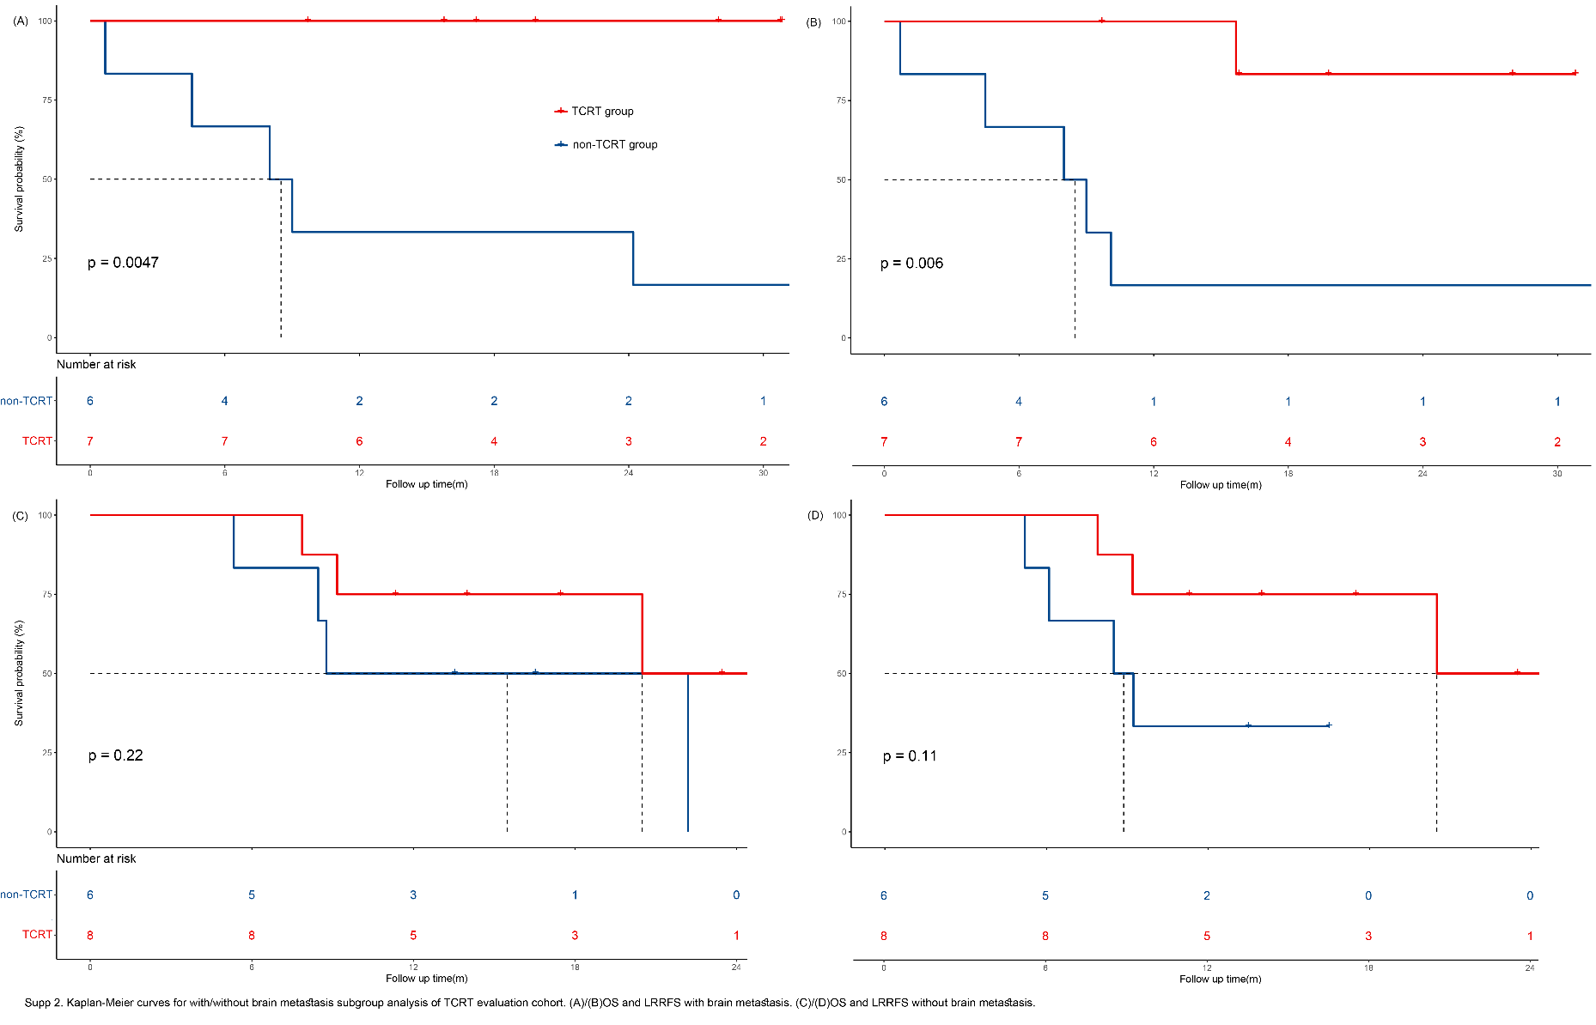
Supp. 3 ES-SCLC Patients in TCRT Evaluation Cohort, (A)OS. (B)PFS. (C)LRRFS.

Supp. 4 LRRFS in Timing of RT Analysis.

