On the study of dye sensitized solar cells with high light harvesting efficiency and correlation of its chemical reactivity parameters with overall performance
Harkishan Dua¹, Savaş Kaya² and Utpal Sarkar¹*
¹Department of Physics, Assam University, Silchar-788011, India
²Sivas Cumhuriyet University, Health Services Vocational School, Department of Pharmacy, 58140 Sivas, Turkey
*Corresponding author E-mail address: utpalchemiitkgp@yahoo.com

Supplementary Materials

Table S1. Excited state data of dyes made from thirteen donors
DONOR No. | Donor | Excitation energy (eV) |  | Wavelength $(λ)$ (nm) |  | Oscillator strength
1. | Phenoxazine [1] |  | 2.186 |  | 567.252 | 0.594
2. | 3-oxo-[1,2,4]-triazolo[3,4-a]isoquinoline [2] |  | 2.829 |  | 438.277 | 1.167
3. | 7,7,13,13-tetramethyl-8,9,12,13-tetrahydro-2H,5H,7H,11Hpyrano[2′,3′:4,5]pyrano[2,3-f]pyrido[3,2,1-ij]quinoline-2,5-dione (Donor N1) [2] |  | 2.357 |  | 526.092 | 1.709
4. | 9-ethyl-9H-pyreno[4,5-d]imidazole [2] |  | 2.329 |  | 532.258 | 0.666
5. | 9-bis(4-methoxyphenyl)indolizino[6,5,4,3-ija]quinoline (ullazine) [2] |  | 2.066 |  | 600.146 | 0.443
6. | N-phenyl-carbazole [3] |  | 2.527 |  | 490.599 | 0.489
7. | Piperdine-phenyl [4] |  | 2.492 |  | 497.589 | 1.053
8. | Julolidine [4] |  | 2.386 |  | 519.501 | 0.937
9. | N,N dialkylaniline [4] |  | 2.215 |  | 559.723 | 0.885
10. | Diphenyl ethylene benzene [4] |  | 2.591 |  | 478.445 | 1.419
11. | Chrysene [4] |  | 2.753 |  | 450.377 | 1.235
12. | 10-(4-methoxyphenyl)-10Hphenothiazine [2] |  | 2.316 |  | 535.338 | 0.513
13. | Di(9H-fluoren-2-yl)amine [2] |  | 2.455 |  | 505.089 | 0.947

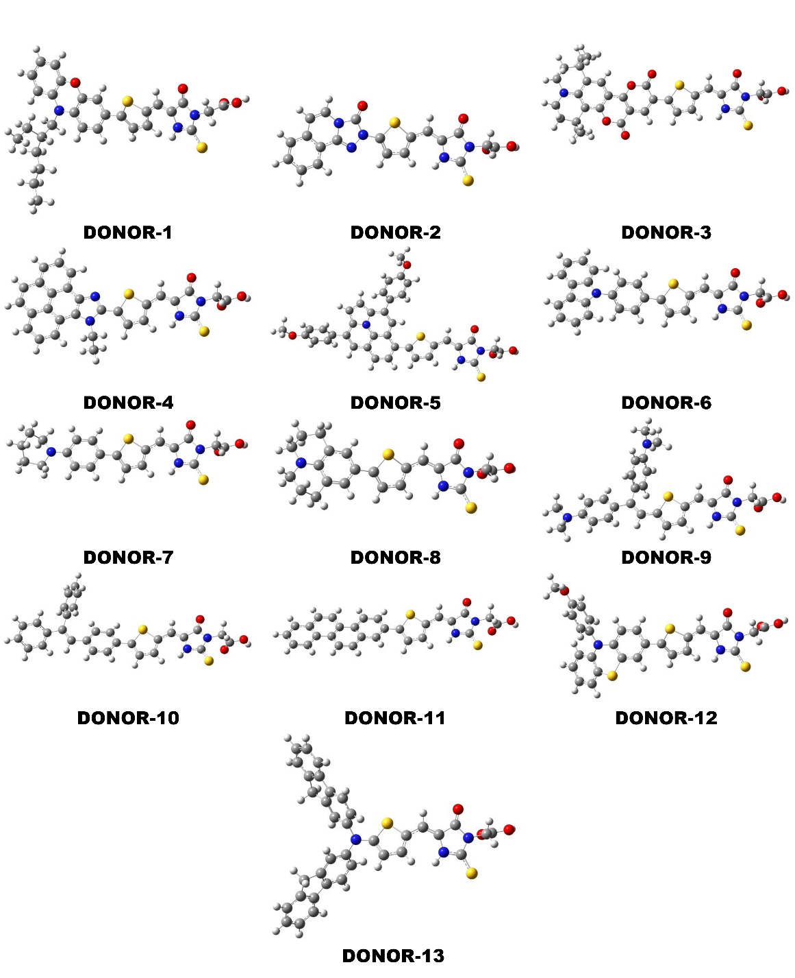
Figure S1. Optimised structures of the dyes made from thirteen different donors.

References
1. Mei S, Shao W, Huang S, et al (2021) Novel D–A−π–A Organic Dyes with Phenoxazine as a Donor Unit for Dye-Sensitized Solar Cells: The Effect of an Ethynyl Group on Performance. Energy & Fuels 35:19748–19755. https://doi.org/10.1021/acs.energyfuels.1c02955
2. Nabil E, Hasanein AA, Alnoman RB, Zakaria M (2021) Optimizing the Cosensitization Effect of SQ02 Dye on BP-2 Dye-Sensitized Solar Cells: A Computational Quantum Chemical Study. J Chem Inf Model 61:5098–5116. https://doi.org/10.1021/acs.jcim.1c00739
3. Murakami TN, Koumura N, Kimura M, Mori S (2014) Structural Effect of Donor in Organic Dye on Recombination in Dye-Sensitized Solar Cells with Cobalt Complex Electrolyte. Langmuir 30:2274–2279. https://doi.org/10.1021/la4047808
4. Divya V V, Suresh CH (2020) Density functional theory study on the donating strength of donor systems in dye-sensitized solar cells. New J Chem 44:7200–7209. https://doi.org/10.1039/D0NJ00723D

