Supplementary Online Content

eAppendix. Trial Inclusion and Exclusion Criteria
eTable 1. Classification of postoperative complications
eTable 2. Definition and diagnostic criteria of complications
eTable 3. Laboratory data for amino acid supplementation and standard care groups (Intention-to-Treat Population).
eTable 4. Mean Daily Energy and Amino Acids Intake During the 5 Days After Surgery
eTable 5. Distribution of Severe gastrointestinal intolerance during intervention or follow-up
eTable 6. Distribution of amino acid treatment-related adverse events during the intervention
eFigure 1. Trial design
eFigure 2. Actual intake of amino acids during the intervention period in the AAS and SC groups
eReferences

eAppendix. Trial Inclusion and Exclusion Criteria
Inclusion criteria:
- Age: 18-80 years
- Nontraumatic elective surgery for gastrointestinal tumors in patients. Surgical methods include: proximal gastrectomy, distal gastrectomy, total gastrectomy, right hemicolectomy, transverse colectomy, left hemicolectomy, sigmoid colectomy, Dixon, Hartmann and Miles
Exclusion criteria:
- Psychiatric disorders
- Pregnancy or breastfeeding women
- Severe malnutrition
  - Weight loss >10%–15% in 6 months
  - Body mass index < 18.5
  - PG-SGA score with stage C
  - Albumin < 30 g/L
- Unstable vital signs or unstable hemodynamics (defined as systolic blood pressure < 90 mm Hg or mean arterial pressure < 70 mm Hg after rapid infusion of 500 mL of crystal or 200 mL of gel, or 50% increase in vascular active drug infusion rate in an hour)
- Refusal to participate in the study
- Pre-existing infection (confirmed or strongly suspected infection episodes before randomization)
- Mortality rates are expected to be more than 50% in 6 months with malignant or irreversibility diseases
  - Cancer in the terminal stage
  - HIV positive at end-stage or CD4 ＜50/mm3
  - Cardiopulmonary resuscitation before cardiac arrest and nervous system function not fully recovered
  - Class IV limitation of physical activity defined by the New Y ork Heart Association
  - Relying on the breathing machine because of chronic diseases;
- Life expectancy of dying patients less than 24 h
- Refractory shock to meet any of the following conditions:
- Infusion rate of dopamine ＞15 µg/(kg. min)
- Infusion rate of dobutamine ＞15 µg/(kg .min)
- Infusion rate of epinephrine and norepinephrine＞30 µg/min
- Infusion rate of phenylephrine ＞50 µg/min
- Infusion rate of milrinone ＞0.5 µg/kg/min
- Infusion rate of vasopressin ＞0.04 U/min
- Inter-aortic balloon pump
- Hepatic insufficiency (alanine/aspartate transaminase/bilirubin 200% above the normal range)
- Renal insufficiency (creatinine 200% above the normal range)
- Metabolic diseases (hyperthyroidism, hypothyroidism, type 1 diabetes mellitus, Wilson disease, phenylketonuria, and adrenal cortex disorders)
- Burn area exceeding 20% of the patient's body surface
- Autoimmune diseases (systemic lupus erythematosus, Sjogren's syndrome, and dermatomyositis)
- History of organ transplantation (liver, kidney, heart, and lung transplantation)
- International standardization ratio more than 3.0 or platelet count＜30,000 cells/mm3
- Intracranial hemorrhage 1 month before enrolment
- History of severe allergy against ingredients of enteral and parenteral nutrition
- Already participated in another clinical trial
- Nutritional support therapy started before enrolment
- Severe hyperglycemia (under intensive medical treatment or insulin treatment)

eTable1. Classification of postoperative complications
Infectious complications | Intra-abdominal infection; Surgical site infection; Pneumonia; Bloodstream infection; Urinary tract infection
Total complications | Intra-abdominal infection; Surgical site infection; Pneumonia; Bloodstream infection; Urinary tract infection; Adverse effects; Anastomotic leakage; Severe gastrointestinal intolerance; Anastomotic bleeding; Intra-abdominal bleeding; Venous thrombosis lower limb

eTable2. Definition and diagnostic criteria of complications
Complication | Definition and diagnostic criteria
Abdominal  infection | Intraabdominal, not specified elsewhere including gallbladder, bile ducts, liver (excluding viral hepatitis), spleen, pancreas, peritoneum, subphrenic or subdiaphragmatic space, or other intraabdominal tissue or area not specified elsewhere^{[1]}  Intraabdominal infections must meet at least 1 of the following criteria:  1. Patient has organisms cultured from purulent material from intraabdominal space obtained during a surgical operation or needle aspiration.  2. Patient has abscess or other evidence of intraabdominal infection seen during a surgical operation or histopathologic examination.  3. Patient has at least 2 of the following signs or symptoms with no other recognized cause: fever(＞38℃), nausea, vomiting, abdominal pain, or jaundice and at least 1 of the following:  a. organisms cultured from drainage from surgically placed drain (eg, closed suction drainage system, open drain, T -tube drain)  b. organisms seen on Gram’s stain of drainage or tissue obtained during surgical operation or needle aspiration  c. organisms cultured from blood and radiographic evidence of infection (eg, abnormal findings on ultrasound, CT scan, MRI, or radiolabel scans [gallium, technetium, etc] or on abdominal x-ray).
Surgical site  infection | SIS-Superficial incisional surgical site infection^{[1]}  A superficial incisional SSI (SIS) must meet the following criterion:  Infection occurs within 30 days after the operative procedure and  involves only skin and subcutaneous tissue of the incision  And patient has at least 1 of the following:  1. purulent drainage from the superficial incision  2. organisms isolated from an aseptically obtained culture of fluid  or tissue from the superficial incision  3. at least 1 of the following signs or symptoms of infection: pain  or tenderness, localized swelling, redness, or heat, and  superficial incision is deliberately opened by surgeon and is  culture positive or not cultured. A culture-negative finding does  not meet this criterion. 4. diagnosis of superficial incisional SSI by the surgeon or attending physician.  DIS-Deep incisional surgical site infection^{[1]}  A deep incisional SSI (DIS) must meet the following criterion:  Infection occurs within 30 days after the operative procedure if no implant1 is left in place or within 1 year if implant is in place and the infection appears to be related to the operative procedure and involves deep soft tissues (eg, fascial and muscle layers) of the incision and patient  has at least 1 of the following:  1. purulent drainage from the deep incision but not from the  organ/space component of the surgical site  2. a deep incision spontaneously dehisces or is deliberately  opened by a surgeon and is culture-positive or not cultured  when the patient has at least 1 of the following signs or  symptoms: fever (>38℃), or localized pain or tenderness. A  culture-negative finding does not meet this criterion.  3. an abscess or other evidence of infection involving the deep  incision is found on direct examination, during reoperation, or  by histopathologic or radiologic examination  4. diagnosis of a deep incisional SSI by a surgeon or attending  physician.  Organ/space-Organ/space surgical site infection^{[1]}  An organ/space SSI involves any part of the body, excluding the skin incision, fascia, or muscle layers, that is opened or manipulated during the operative procedure. Specific sites are assigned to organ/space SSI to identify further the location of the infection.  Listed below in reporting instructions are the specific sites that must be used to differentiate organ/space SSI. An example is appendectomy with subsequent subdiaphragmatic abscess, which would be reported as an organ/space SSI at the intraabdominal specific site (SSI-IAB).  An organ/space SSI must meet the following criterion:  Infection occurs within 30 days after the operative procedure if no implant1 is left in place or within 1 year if implant is in place and the infection appears to be related to the operative procedure and  infection involves any part of the body, excluding the skin incision, fascia, or muscle layers, that is opened or manipulated during the operative procedure and patient has at least 1 of the following:  1. purulent drainage from a drain that is placed through a stab wound into the organ/space  2. organisms isolated from an aseptically obtained culture of fluid or tissue in the organ/space  3. an abscess or other evidence of infection involving the organ/space that is found on direct examination, during reoperation, or by histopathologic or radiologic examination  4. diagnosis of an organ/space SSI by a surgeon or attending physician.
Pneumonia | PNU1-clinically defined pneumonia^{[1]}  Radiology  Two or more serial chest radiographs with at least 1 of the  following:  1. New or progressive and persistent infiltrate  2. Consolidation  3. Cavitation  Signs/Symptoms  For any patient, at least 1 of the following:  1. Fever (>38℃) with no other recognized cause  2. Leukopenia (<4000 WBC/mm3) or leukocytosis (≥12,000  WBC/mm3)  3. For adults≥70 years, altered mental status with no other  recognized cause  And at least 2 of the following:  1. New onset of purulent sputum or change in character of  sputum or increased respiratory secretions or increased  suctioning requirements  2. New onset or worsening cough, or dyspnea, or tachypnea  3. Rales or bronchial breath sounds  4. Worsening gas exchange (eg, O2 desaturations [eg, PaO2/FiO2≤240], increased oxygen requirements, or increased  ventilator demand  PNU2-Pneumonia with specific laboratory findings was  defined as^{[1]} VAP-Ventilator-associated pneumonia^{[2]} and other  lower respiratory tract infections were defined as^{[1]}
Bloodstream  infection | LCBI-Laboratory-confirmed bloodstream infection^{[1]}  LCBI criteria 1 and 2 may be used for patients of any age LCBI must meet at least 1 of the following criteria:  1. Patient has a recognized pathogen cultured from 1 or more  blood cultures and organism cultured from blood is not related to  an infection at another site.  2. Patient has at least 1 of the following signs or symptoms: fever  (>38°C), chills, or hypotension and signs and symptoms and  positive laboratory results are not related to an infection at  another site and common skin contaminant (ie, diphtheroids  [Corynebacterium spp], Bacillus [not B anthracis] spp,  Propionibacterium spp, coagulase-negative staphylococci  [including S epidermidis], viridans group streptococci,  Aerococcus spp, Micrococcus spp) is cultured from 2 or more  blood cultures drawn on separate occasions.
Urinary tract  infection | SUTI-Symptomatic urinary tract infection[1]  A symptomatic urinary tract infection must meet at least 1 of the  following criteria:  1. Patient has at least 1 of the following signs or symptoms with  no other recognized cause: fever (>38℃), urgency, frequency,  dysuria, or suprapubic tenderness and patient has a positive  urine culture, that is,≥105microorganisms per cc of urine with  no more than 2 species of microorganisms.  2. Patient has at least 2 of the following signs or symptoms with  no other recognized cause: fever (>38℃), urgency, frequency,  dysuria, or suprapubic tenderness  And at least 1 of the following:  1. positive dipstick for leukocyte esterase and/ or nitrate  2. pyuria (urine specimen with≥10 white blood cell [WBC]/mm3  or≥3 WBC/high power field of unspun urine)  3. organisms seen on Gram’s stain of unspun urine  4. at least 2 urine cultures with repeated isolation of the same  uropathogen (gram negative bacteria or Staphylococcus  saprophyticus) with≥102 colonies/mL in nonvoided specimens.  5. ≤105 colonies/mL of a single uropathogen (gram-negative  bacteria or S saprophyticus) in a patient being treated with an  effective antimicrobial agent for a urinary tract infection  6. physician diagnosis of a urinary tract infection  7. physician institutes appropriate therapy for a urinary tract  infection.  OUTI-Other infections of the urinary tract (kidney, ureter,  bladder, urethra, or tissue surrounding the retroperitoneal or  perinephric space)[1]  Other infections of the urinary tract must meet at least 1 of the  following criteria:  1. Patient has organisms isolated from culture of fluid (other than  urine) or tissue from affected site.  2. Patient has an abscess or other evidence of infection seen on  direct examination, during a surgical operation, or during a  histopathologic examination.  3. Patient has at least 2 of the following signs or symptoms with  no other recognized cause: fever (>38℃), localized pain, or  localized tenderness at the involved site  And at least 1 of the following:  1. purulent drainage from affected site  2. organisms cultured from blood that are compatible with  suspected site of infection  3. radiographic evidence of infection (eg, abnormal ultrasound,  computerized tomography [CT] scan, magnetic resonance  imaging [MRI], or radiolabel scan [gallium, technetium], etc)  4. physician diagnosis of infection of the kidney, ureter, bladder,  urethra, or tissues surrounding the retroperitoneal or  perinephric space  5. physician institutes appropriate therapy for an infection of the  kidney, ureter, bladder, urethra, or tissues surrounding the  retroperitoneal or perinephric space.
Anastomotic leakage | Any dehiscence with clinical and radiological evidence.
Severe gastrointestinal intolerance | Gastrointestinal tolerance was assessed based on episodes of significant vomiting (defined as the expulsion of gastric contents from the oro- or nasopharynx), abdominal distention (defined as the presence of a tense or rigid abdomen with guarding or rebound on examination), diarrhea (more than 300 mL of liquid stool or more than four loose stools per day), constipation (no stool for more than 6 days), and abdominal pain (defined as feeling pain anywhere between the chest and the groin). We defined as severe gastrointestinal intolerance when the above gastrointestinal intolerance developed and resulted in interruption of enteral nutrition due to prolonged duration and poor response to treatment.
Anastomotic bleeding | After digestive tract reconstruction surgery, bloody drainage fluid, hematemesis or hematochezia appear from the gastrointestinal decompression tube, which may be accompanied by changes in vital signs such as heart rate and blood pressure and decreased hemoglobin concentration. Emergency gastrointestinal endoscopy was performed to confirm the diagnosis when necessary.
Intra-abdominal bleeding | Abdominal tenderness with decreased bowel sounds, abdominal distension, nausea, decreased hematocrit, tachycardia, oliguria, and bloody abdominal drainage after major gastrointestinal surgery often indicate intra-abdominal bleeding. CT and selective angiography can assist in the diagnosis.
Venous thrombosis lower limb | Preoperative lower limb venous ultrasonography showed no abnormalities, postoperative D-dimer elevation, with or without lower limb swelling and other manifestations, and venous thrombosis was diagnosed by lower limb venous ultrasonography.

eTable3. Laboratory data for amino acid supplementation and standard care groups (Intention-to-Treat Population).
Variable | AAS(n=204) | SC(n=203) | P value
Nutritional indicators
Albumin, median (IQR), g/L
POD1 (Baseline) | 35.45(33.45-37.38) | 35.40(32.30-37.10) | .095
POD3 | 36.50(34.10-38.20) | 35.90(34.0-38.60) | .541
POD5 | 37.05(35.30-39.00) | 37.30(35.2-39.2) | .854
Prealbumin, mean (SD), mg/L
POD1 (Baseline) | 176.41(40.97) | 172.17(38.31) | .282
POD3 | 142.99(33.35) | 133.83(36.95) | .009
POD5 | 147.72(37.57) | 135.32(42.90) | .014
Total protein, median (IQR), g/L
POD1 (Baseline) | 59.70(55.20-62.10) | 58.10(55.00-61.53) | .077
POD3 | 60.40(56.90-63.70) | 59.50(54.58-63.63) | .025
POD5 | 62.30(58.30-65.30) | 61.40(56.98-64.85) | .224
Retinol binding protein, mean (SD), mg/L
POD1 (Baseline) | 20.78(6.67) | 20.50(6.69) | .681
POD3 | 18.37(6.24) | 17.36(6.06) | .100
POD5 | 19.47(6.70) | 19.26(6.55) | .793
Inflammatory biomarkers
Procalcitonin, median (IQR), ng/mL
POD1 (Baseline) | .18(.08-.50) | .22(.10-.67) | .791
POD3 | .20(.13-.46) | .23(.11-.51) | .495
POD5 | .18(.12-.31) | .15(.10-.30) | .144
Interleukin-6, median (IQR), pg/ml
POD1 (Baseline) | 16.93(10.89-36.10) | 25.55(11.91-58.88) | .411
POD3 | 16.2(10.07-28.48) | 16.07(9.69-33.58) | .187
POD5 | 12.61(6.99-25.26) | 12.98(8.14-27.98) | .543
C-reactive protein, median (IQR), mg/L
POD1 (Baseline) | 28.50(16.33-48.76) | 32.45(18.00-52.60) | .296
POD3 | 40.30(23.13-71.18) | 52.10(31.30-90.90) | .018
POD5 | 34.65(17.90-60.03) | 40.20(18.60-68.70) | .247
Hepatic and renal function
Blood urea nitrogen, median (IQR), mmol/L
POD1 (Baseline) | 3.75(2.93-4.70) | 3.60(2.80-4.85) | .147
POD3 | 7.00(5.93-8.50) | 5.90(5.00-7.10) | .000
POD5 | 7.90(6.70-8.98) | 6.80(5.90-8.25) | .000
Serum Creatinine, median (IQR), μmoI/L
POD1 (Baseline) | 58.95(50.73-66.98) | 59.25(50.43-69.58) | .255
POD3 | 54.45(44.98-62.98) | 57.80(50.02-66.48) | .001
POD5 | 56.20(46.80-65.63) | 59.00(50.53-67.65) | .250
eGFR, median (IQR), ml/min
POD1 (Baseline) | 106.00(97.00-111.00) | 104.00(97.00-112.00) | .322
POD3 | 108.00(99.00-116.00) | 105.00(99.00-113.00) | .037
POD5 | 107.00(100.00-115.00) | 105.00(95.75-112.00) | .051
β2-MG, mean (SD), mg/L
POD1 (Baseline) | 1.54(.57) | 1.62(.52) | .138
POD3 | 1.80(.62) | 2.00(.75) | .004
POD5 | 2.10(.74) | 2.28(.74) | .032
AST, median (IQR), U/L
POD1 (Baseline) | 23.00(17.00-34.000) | 26.00(19.00-45.00) | .098
POD3 | 17.00(15.00-20.75) | 19.00(15.00-24.00) | .133
POD5 | 18.00(14.00-29.75) | 21.00(16.00-29.50) | .106
ALT, median (IQR), U/L
POD1 (Baseline) | 19.00(12.00-36.00) | 23.00(14.00-39.00) | .510
POD3 | 14.00(10.00-20.00) | 17.00(11.00-23.75) | .209
POD5 | 17.00(12.00-27.00) | 19.50(13.00-29.75) | .260
ALP, median (IQR), U/L
POD1 (Baseline) | 61.50(53.00-76.00) | 59.00(49.50-70.75) | .048
POD3 | 58.00(51.00-69.00) | 57.00(46.00-66.50) | .020
POD5 | 61.00(51.00-75.00) | 60.00(49.50-72.00) | .382
TBIL, median (IQR), μmol/L
POD1 (Baseline) | 14.90(10.90-18.60) | 14.10(10.97-17.81) | .681
POD3 | 10.77(8.43-14.10) | 12.60(9.30-15.69) | .000
POD5 | 13.30(10.55-17.02) | 13.94(10.55-19.48) | .254
Blood routine
Red blood cell, mean (SD), 10^12/L
POD1 (Baseline) | 4.10(0.54) | 4.07(0.52) | .581
POD3 | 4.04(0.49) | 3.96(0.55) | .115
POD5 | 4.16(0.50) | 3.96(0.58) | .004
Hemoglobin, mean (SD), g/L
POD1 (Baseline) | 121.46(18.30) | 120.90(18.40) | .761
POD3 | 119.67(17.18) | 117.51(19.26) | .234
POD5 | 121.90(17.42) | 115.89(18.98) | .007
White blood cell, median (IQR), 10^9/L
POD1 (Baseline) | 10.17(8.62-12.31) | 10.69(8.66-12.45) | .782
POD3 | 7.50(6.36-9.98) | 7.90(5.85-9.60) | .084
POD5 | 7.02(5.91-8.91) | 7.00(5.51-9.41) | .751
Platelets, median (IQR), 10^9/L
POD1 (Baseline) | 212(169.25-256.75) | 196(151-257.50) | .243
POD3 | 202.50(163.25-246.75) | 178(142.50-230) | .031
POD5 | 216.50(184.50-265) | 208(159-255) | .052
Lymphocytes, mean (SD), 10^9/L
POD1 (Baseline) | .93(.54) | .82(.41) | .029
POD3 | 1.16(.50) | 1.00(.44) | .001
POD5 | 1.29(.51) | 1.18(.48) | .069
Neutrophils, median (IQR), 10^9/L
POD1 (Baseline) | 8.73(7.23-10.60) | 9.08(7.52-11.10) | .762
POD3 | 5.86(4.68-7.66) | 5.90(4.36-7.85) | .324
POD5 | 4.79(3.86-6.31) | 4.95(3.71-7.03) | .747
Immune function
Globulin, mean (SD), g/L
POD1 (Baseline) | 23.79(3.76) | 23.33(3.23) | .191
POD3 | 24.58(3.41) | 23.44(3.54) | .001
POD5 | 24.97(3.83) | 24.15(4.45) | .096
Metabolism-related index
Total cholesterol, mean (SD), mmol/L
POD1 (Baseline) | 4.27(.90) | 4.19(1.19) | .471
POD3 | 4.05(.80) | 3.98(1.57) | .626
POD5 | 3.97(.72) | 3.87(.90) | .338
Triglyceride, median (IQR), mmol/L
POD1 (Baseline) | .97(.72-1.36) | .85(.70-1.13) | .109
POD3 | .80(.65-1.08) | .79(.66-1.05) | .714
POD5 | .81(.66-1.01) | .83(.71-1.01) | .243
HDL, mean (SD), mmol/L
POD1 (Baseline) | 1.21(.27) | 1.21(.27) | .771
POD3 | 1.17(.28) | 1.14(.23) | .211
POD5 | 1.05(.26) | 1.00(.25) | .201
LDL, mean (SD), mmol/L
POD1 (Baseline) | 2.62(.74) | 2.50(.72) | .099
POD3 | 2.47(.64) | 2.36(.70) | .135
POD5 | 2.56(.56) | 2.50(.68) | .438
Blood glucose, median (IQR), mmol/L
POD1 (Baseline) | 6.24(5.46-8.27) | 6.66(6.01-8.22) | .302
POD3 | 6.10(5.41-7.30) | 6.37(5.48-7.23) | .904
POD5 | 5.76(5.04-7.14) | 5.82(5.24-6.72) | .887
Continuous data described as mean (SD) or median (IQR) were compared using the t test or Mann–Whitney U test.
Abbreviations: AAS, amino acid supplementation; SC, standard care; eGFR, estimated glomerular filtration rate; β2-MG, β2 microglobulin; AST, Aspartate aminotransferase; ALT, Alanine aminotransferase; ALP, alkaline phosphatase; TBIL, total bilirubin; HDL, high-density lipoprotein; LDL, Low-density lipoprotein.

eTable 4. Mean Daily Energy and Amino Acids Intake During the 5 Days After Surgery
 | AAS group  (n=204) | SC group  (n=203) | P Value
Mean daily energy intake during the 5 days after surgery
Mean energy intake on POD1 (kcal/kg/day) | 23.48±5.03 | 23.16±5.13 | .524
Mean energy intake on POD2 (kcal/kg/day) | 24.24±5.37 | 23.91±5.48 | .550
Mean energy intake on POD3 (kcal/kg/day) | 24.91±5.63 | 24.58±5.74 | .565
Mean energy intake on POD4 (kcal/kg/day) | 29.48±5.36 | 29.00±5.39 | .372
Mean energy intake on POD5 (kcal/kg/day) | 29.66±5.31 | 29.15±5.32 | .335
Mean daily energy intake during intervention (kcal/kg/day) | 25.53±5.27 | 26.16±5.36 | .493
Mean daily amino acid intake during the 5 days after surgery
Mean amino acid intake on POD1 (g/kg/day) | 1.65±0.32 | 0.79±0.15 | ＜.001
Mean amino acid intake on POD2 (g/kg/day) | 1.74±0.35 | 0.89±0.18 | ＜.001
Mean amino acid intake on POD3 (g/kg/day) | 1.85±0.37 | 0.98±0.21 | ＜.001
Mean amino acid intake on POD4 (g/kg/day) | 1.98±0.37 | 1.09±0.21 | ＜.001
Mean amino acid intake on POD5 (g/kg/day) | 1.16±0.23 | 1.13±0.20 | .245
Mean daily amino acid during intervention (g/kg/day) | 1.81±0.34 | 0.94±0.18 | ＜.001
Data are mean (SD) unless otherwise noted. Continuous data described as mean (SD) were compared using the t test or Mann–Whitney U test.
Abbreviations: AAS, amino acid supplementation; SC, standard care; POD, postoperative day.

eTable 5. Distribution of Severe gastrointestinal intolerance during intervention or follow-up
 | AAS group  (n=204) | SC group  (n=203) | Risk Difference  (95% CI) | P Value
Total | 11(5.4%) | 5(2.5%) | 2.93(-0.83 to 6.69) | .201
Vomiting | 2(1.0%) | 1(0.5%) | 0.49(-1.17 to 2.15) | 1.000
Abdominal distension | 6(2.9%) | 3(1.5%) | 1.46(-1.39 to 4.31) | .503
Abdominal pain | 2(1.0%) | 1(0.5%) | 0.49(-1.17 to 2.15) | 1.000
Diarrhea | 1(0.5%) | 0(0.0%) | 0.49(-0.47 to 1.45) | 1.000
Data are the numbers of participants (%). Outcomes expressed as percentages of patients with each outcome were compared between the two groups using the χ2 or Fisher’s exact test.
Severe gastrointestinal intolerance includes the development of vomiting, abdominal distension, diarrhea, and abdominal pain leading to discontinuation of enteral nutrition.
Abbreviations: AAS, amino acid supplementation; SC, standard care

eTable 6. Distribution of amino acid treatment-related adverse events during the intervention
 | AAS group  (n=204) | SC group  (n=203) | Risk Difference  (95% CI) | P Value
Gastrointestinal reactions: nausea, vomiting | 2(1.0%) | 0(0.0%) | 0.98(-0.37 to 2.33) | .499
Allergic reaction | 1(0.5%) | 0(0.0%) | 0.49(-0.47 to 1.45) | 1.000
Data are the numbers of participants (%). Outcomes expressed as percentages of patients with each outcome were compared between the two groups using the χ2 or Fisher’s exact test.
Abbreviations: AAS, amino acid supplementation; SC, standard care.

eFigure 1. Trial design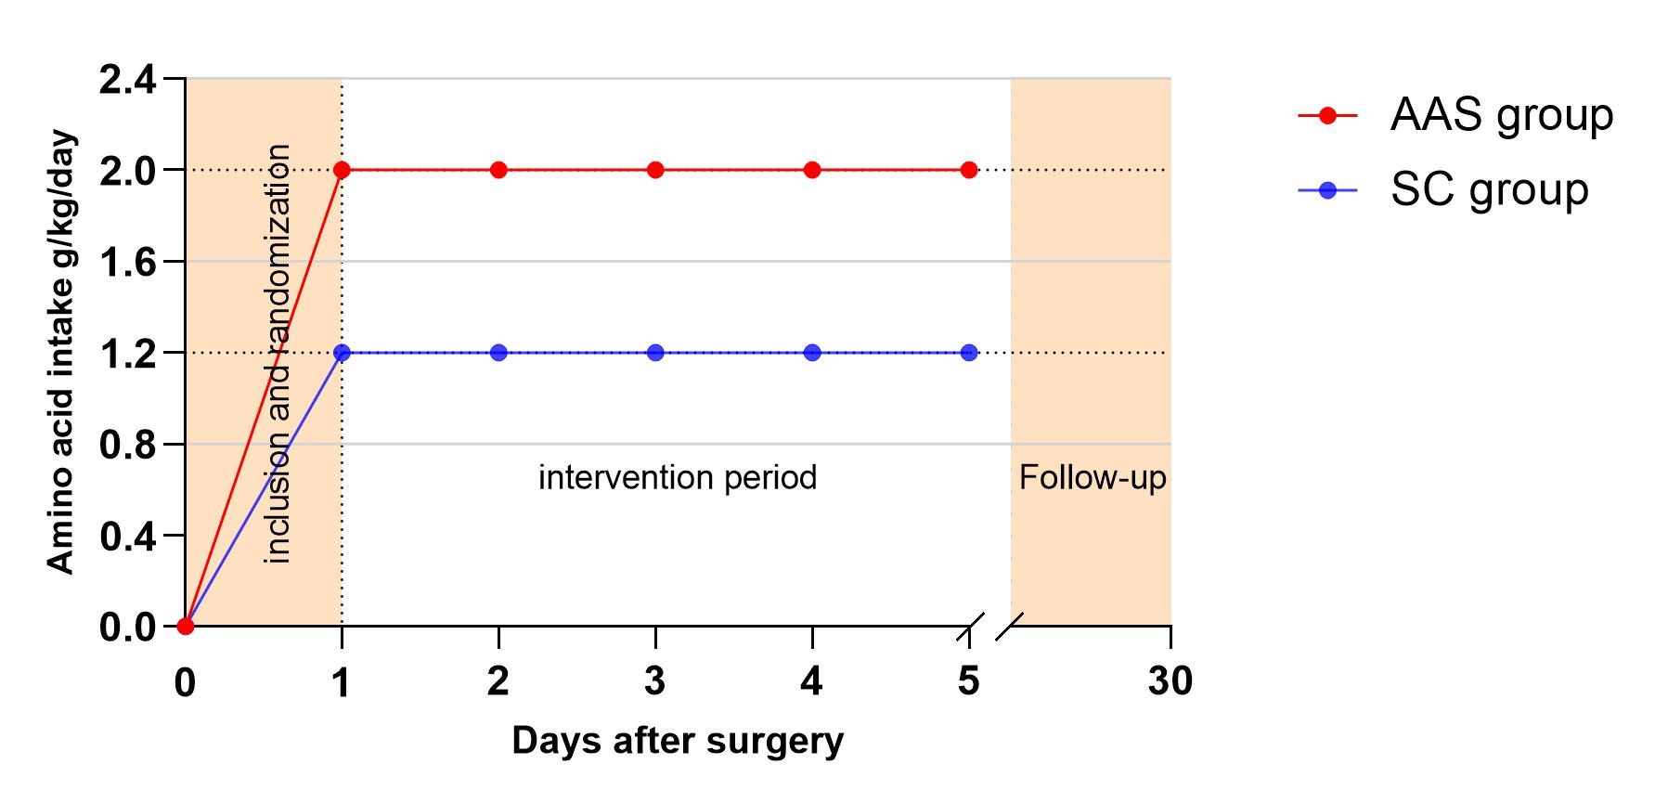
The red line represents the target amino acid intake level of 2.0 g/kg daily for patients in the AAS group from the first postoperative day. The blue line represents the target amino acid intake level of 1.2 g/kg daily for patients in the SC group from the first postoperative day. The intervention lasted for a total of 4 days. Follow up was performed from day 5 until one month after surgery.
Abbreviations: AAS, amino acid supplementation; SC, standard care.

eFigure 2. Actual intake of amino acids during the intervention period in the AAS and SC groups
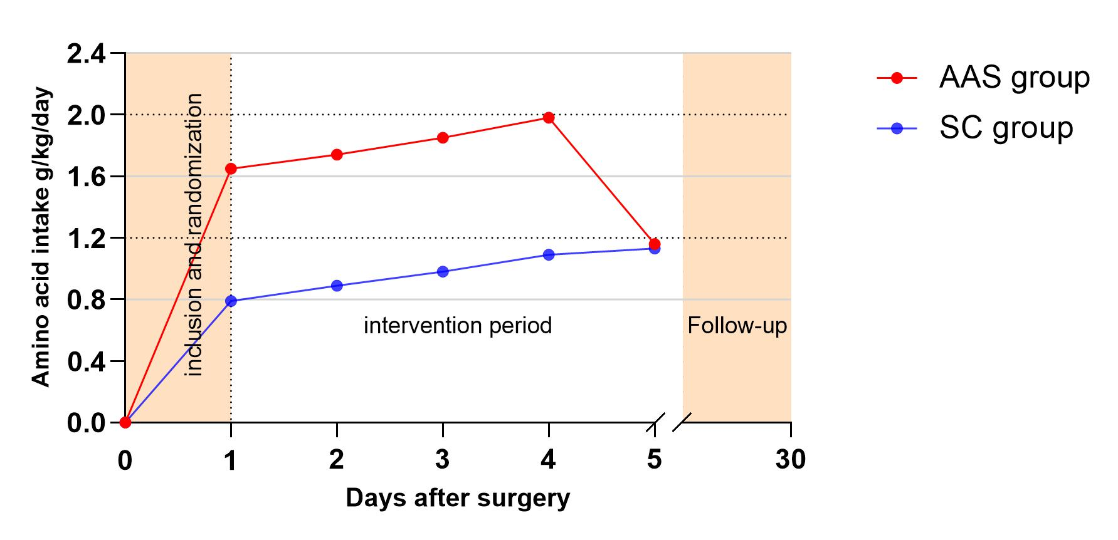
The red line represents the actual mean amino acid intake in the AAS group. The blue line represents the actual mean amino acid intake in the SC group.
Abbreviations: AAS, amino acid supplementation, SC, standard care.

eReferences
[1] Horan T C, Andrus M, Dudeck M A. CDC/NHSN surveillance definition of health care-associated infection and criteria for specific types of infections in the acute care setting[J]. Am J Infect Control, 2008,36(5):309-332.
[2] Spalding M C, Cripps M W, Minshall C T. Ventilator-Associated Pneumonia: New Definitions[J]. Crit Care Clin, 2017,33(2):277-292.

