Effect of amino acid supplementation on short-term complications after gastrointestinal tumor surgery: the AMIGITS randomized clinical trial

Summary
Title: Effect of amino acid supplementation on short-term complications after gastrointestinal tumor surgery: the AMIGITS randomized clinical trial
Proposed indications: Amino acid supplementation
Study objective: To investigate the effect of higher dose amino acid supplementation (AAS) on the incidence of infection 30 days after major surgery in patients with gastrointestinal tumors.
Study design: A prospective, single-center, open-label, randomized controlled clinical trial
Study centers: Single center (Shandong Provincial Hospital)
Investigational product: AAS group (2.0 g/kg daily)
Control product: Standard care (SC) group (1.2 g/kg daily)
Sample size: 407 (AAS group, 204; SC group, 203)
Inclusion criteria:
- Age: 18-80 years
- Nontraumatic elective surgery for gastrointestinal tumors in patients. Surgical methods include: proximal gastrectomy, distal gastrectomy, total gastrectomy, right hemicolectomy, transverse colectomy, left hemicolectomy, sigmoid colectomy, Dixon, Hartmann and Miles
- Exclusion criteria:
- Psychiatric disorders
- Pregnancy or breastfeeding women
- Severe malnutrition
  - Weight loss >10%–15% in 6 months
  - Body mass index < 18.5
  - PG-SGA score with stage C
  - Albumin < 30 g/L
- Unstable vital signs or unstable hemodynamics (defined as systolic blood pressure < 90 mm Hg or mean arterial pressure < 70 mm Hg after rapid infusion of 500 mL of crystal or 200 mL of gel, or 50% increase in vascular active drug infusion rate in an hour)
- Refusal to participate in the study
- Pre-existing infection (confirmed or strongly suspected infection episodes before randomization)
- Mortality rates are expected to be more than 50% in 6 months with malignant or irreversibility diseases
  - Cancer in the terminal stage
  - HIV positive at end-stage or CD4 ＜50/mm3
  - Cardiopulmonary resuscitation before cardiac arrest and nervous system function not fully recovered
  - Class IV limitation of physical activity defined by the New Y ork Heart Association
  - Relying on the breathing machine because of chronic diseases;
- Life expectancy of dying patients less than 24 h
- Refractory shock to meet any of the following conditions:
- Infusion rate of dopamine ＞15 µg/(kg. min)
- Infusion rate of dobutamine ＞15 µg/(kg .min)
- Infusion rate of epinephrine and norepinephrine＞30 µg/min
- Infusion rate of phenylephrine ＞50 µg/min
- Infusion rate of milrinone ＞0.5 µg/kg/min
- Infusion rate of vasopressin ＞0.04 U/min
- Inter-aortic balloon pump
- Hepatic insufficiency (alanine/aspartate transaminase/bilirubin 200% above the normal range)
- Renal insufficiency (creatinine 200% above the normal range)
- Metabolic diseases (hyperthyroidism, hypothyroidism, type 1 diabetes mellitus, Wilson disease, phenylketonuria, and adrenal cortex disorders)
- Burn area exceeding 20% of the patient's body surface
- Autoimmune diseases (systemic lupus erythematosus, Sjogren's syndrome, and dermatomyositis)
- History of organ transplantation (liver, kidney, heart, and lung transplantation)
- International standardization ratio more than 3.0 or platelet count＜30,000 cells/mm3
- Intracranial hemorrhage 1 month before enrolment
- History of severe allergy against ingredients of enteral and parenteral nutrition
- Already participated in another clinical trial
- Nutritional support therapy started before enrolment
- Severe hyperglycemia (under intensive medical treatment or insulin treatment)
Primary endpoints: incidence of infection 30 days after major surgery
Secondary endpoints: Actual caloric intake and protein intake, infectious complication in hospital, amino acid-related adverse events, postoperative hospital stay, other complications, and postoperative laboratory tests, including procalcitonin, interleukin-6, blood routine, and hepatic and renal function.
Treatment duration: 4 days (POD1-POD4)
Preservation of clinical data and results: During the clinical trial, all the information of the trial should be kept by the principal investigator.
Aims
To investigate the effect of higher dose amino acid supplementation (AAS) on the incidence of infection 30 days after major surgery in patients with gastrointestinal tumors.
Study Design, Materials, and Methods
Study Design
AMIGITS is a prospective, single-center, open-label randomized clinical trial comparing amino acid supplementation and standard care in patients with gastrointestinal tumors undergoing major surgery
Setting and patient eligibility for inclusion and recruitment
Patients were eligible after surgery if they fulfilled the following inclusion criteria:
- Age: 18-80 years
- Nontraumatic elective surgery for gastrointestinal tumors in patients. Surgical methods include: proximal gastrectomy, distal gastrectomy, total gastrectomy, right hemicolectomy, transverse colectomy, left hemicolectomy, sigmoid colectomy, Dixon, Hartmann and Miles

The exclusion criteria were as follow:
- Psychiatric disorders
- Pregnancy or breastfeeding women
- Severe malnutrition
  - Weight loss >10%–15% in 6 months
  - Body mass index < 18.5
  - PG-SGA score with stage C
  - Albumin < 30 g/L
- Unstable vital signs or unstable hemodynamics (defined as systolic blood pressure < 90 mm Hg or mean arterial pressure < 70 mm Hg after rapid infusion of 500 mL of crystal or 200 mL of gel, or 50% increase in vascular active drug infusion rate in an hour)
- Refusal to participate in the study
- Pre-existing infection (confirmed or strongly suspected infection episodes before randomization)
- Mortality rates are expected to be more than 50% in 6 months with malignant or irreversibility diseases
  - Cancer in the terminal stage
  - HIV positive at end-stage or CD4 ＜50/mm3
  - Cardiopulmonary resuscitation before cardiac arrest and nervous system function not fully recovered
  - Class IV limitation of physical activity defined by the New Y ork Heart Association
  - Relying on the breathing machine because of chronic diseases;
- Life expectancy of dying patients less than 24 h
- Refractory shock to meet any of the following conditions:
- Infusion rate of dopamine ＞15 µg/(kg. min)
- Infusion rate of dobutamine ＞15 µg/(kg .min)
- Infusion rate of epinephrine and norepinephrine＞30 µg/min
- Infusion rate of phenylephrine ＞50 µg/min
- Infusion rate of milrinone ＞0.5 µg/kg/min
- Infusion rate of vasopressin ＞0.04 U/min
- Inter-aortic balloon pump
- Hepatic insufficiency (alanine/aspartate transaminase/bilirubin 200% above the normal range)
- Renal insufficiency (creatinine 200% above the normal range)
- Metabolic diseases (hyperthyroidism, hypothyroidism, type 1 diabetes mellitus, Wilson disease, phenylketonuria, and adrenal cortex disorders)
- Burn area exceeding 20% of the patient's body surface
- Autoimmune diseases (systemic lupus erythematosus, Sjogren's syndrome, and dermatomyositis)
- History of organ transplantation (liver, kidney, heart, and lung transplantation)
- International standardization ratio more than 3.0 or platelet count＜30,000 cells/mm3
- Intracranial hemorrhage 1 month before enrolment
- History of severe allergy against ingredients of enteral and parenteral nutrition
- Already participated in another clinical trial
- Nutritional support therapy started before enrolment
- Severe hyperglycemia (under intensive medical treatment or insulin treatment)
Data collection at study entry
All baseline assessments were obtained after obtaining informed consent from the patients or their legally authorized representative, but prior to the initiation of study procedures. The baseline assessments included the following:
  - Sociodemographic and baseline characteristics (sex, age, height, weight, body mass index (BMI), NRS-2002 score, comorbidities, disease diagnosis, obstruction, and neoadjuvant therapy)
  - Surgical type, surgical approach, operation duration, and postoperative tumor pathological stage
  - Blood was collected for laboratory tests at 6 AM on the first postoperative day before the intervention, including procalcitonin, interleukin-6, blood routine, and hepatic and renal function.
During the study period, all patients were assessed daily by two physicians to evaluate nutritional intake and whether nutritional targets were met. The actual energy and aminoaid intakes each day in the intervention period were recorded.
Blood samples were collected on postoperative day 3 and postoperative day 5 for subsequent batch measurements of nutritional markers and other biomarkers. Postoperative infectious complications, postoperative hospital stay, amino acid treatment-related complications, ICU admission, severe gastrointestinal intolerance, intra-abdominal bleeding, anastomotic bleeding, lower extremity venous thrombosis, and Clavien-Dindo (CD) Grade were also recorded.
Nutritional support protocol
The nutritional support protocol, including nutritional treatments and measures designed to evaluate gastrointestinal intolerance, was standardized as follows.
General principles of nutritional support in both study arms
Patients were randomized to receive SC and AAS on the day after surgery. Each participant 's daily caloric target was estimated from ideal body weight and was 25 kcal/kg ideal body weight. Criteria for other treatments were consistent in both groups except for different levels of amino acid intake. Oral feeding was recommended as early as possible after surgery and enteral feeding was started no later than 24 hours. Parenteral nutrition was started on the first postoperative day if the patient could not tolerate enteral feeding or could not reach energy goals with enteral feeding. Target caloric requirements were achieved by enteral nutrition combined with supplemental parenteral nutrition. Moreover, our responsible physician will gradually reduce the dose of supplementary parenteral nutrition according to the increase in the patient 's tolerance to enteral nutrition. Both groups received nutritional support for at least 4 days after randomization.
Actual energy and amino acid delivery were monitored regularly by comparing with predefined daily calorie and amino acid targets. Any disruption of energy and amino acid delivery should be reported to the responsible physician. In general, nutritional support is not interrupted when the patient is transported. All patients remained in semi-supine position.
Nutritional formulas
All patients received commercially available standardized enteral nutrition formulas. The EN products comprising polymeric formulas were routinely prescribed at all hospitals, which contained 1.3 kcal/mL of energy (18% proteins, 50% lipids, and 32% carbohydrates). PN formulas consisted of 0.88 kcal/mL of energy (15% proteins, 40% lipids [20% long-chain triglycerides], and 45% carbohydrates) and supplemental vitamins and minerals. PN infusion was administered via the central veins.
Additional intakes
Patients in the AAS group additionally ingested compound amino acid injection (250 ml 8.5%) to achieve amino acid targets (2.0 g/kg daily), and patients in the SC group received 5% glucose injection to obtain the same energy as they did.
Complications possibly related to nutrition management
In order to monitor the quality of the nutrition management during the study we will register all known complications possibly related to them.
amino acid supplementation-related complications
- Systemic reactions: chills, rigors, fever;
- Gastrointestinal reactions: nausea, vomiting;
- Central and peripheral nervous system: dizziness, headache;
- Renal function: impaired renal function
- Allergic reactions: manifested as rash, itching, etc., anaphylactic shock may occur in severe cases;
- Others: palpitations, facial flushing, hyperhidrosis, thrombophlebitis, metabolic acidosis, etc.
Complications possibly related to enteral feeding
Gastrointestinal intolerance: diarrhea, vomiting, abdominal distention, constipation, and abdominal pain.
Complicated insertion of feeding tubes: nasal bleeding.
Mechanical complications: feeding tube displacement or obstruction.
Complications possibly related to parenteral feeding
Mechanical complications: occlusion and dislodging of central venous catheters.
Clinical complications: pneumothorax, hemothorax, and subclavian artery, liver function abnormalities, hyperlipidemia, hyperglycemia, central line replacement due to suspicion of blood stream-related infections (BSRI).
Gastrointestinal intolerance monitoring
Gastrointestinal tolerance was assessed based on episodes of significant vomiting (defined as the expulsion of gastric contents from the oropharynx or nasopharynx), abdominal distention (defined as the presence of a tense or rigid abdomen with guarding or rebound on examination), diarrhea (more than 300 mL of liquid stool or more than four loose stools per day), constipation (no stool for more than 6 days), and abdominal pain (defined as feeling pain anywhere between the chest and the groin). We defined as severe gastrointestinal intolerance when the above gastrointestinal intolerance developed and resulted in interruption of enteral nutrition due to prolonged duration and poor response to treatment.
Patients were monitored every 6 hours by the medical team for gastrointestinal intolerance when they were stable and every 2 hours until they disappeared when any gastrointestinal intolerance developed. We can evaluate patients more frequently if clinical conditions permit. Gastrointestinal intolerance was treated with a predefined treatment regimen. In case of vomiting, prokinetic agents were used first after confirming that there were no contraindications. In the presence of abdominal distension, the enteral feeding rate was reduced to 10 mL/h and patients were encouraged to intensify their activities. In addition, patients were reassessed every 2 hours until abdominal distension improved. For diarrhea, the medical team was encouraged to minimize adverse medications and initiate medication. Enteral feeding was interrupted if diarrhea worsened. When abdominal pain was reported, EN was continued and reassessed every 2 hours until the condition improved. If abdominal pain worsened, EN was discontinued and an abdominal x-ray was performed. After confirming resolution of intolerance symptoms, restart tube feeding at the highest specified flow rate. The medical team interrupts or stops enteral feeding if deemed necessary for the patient 's health.
Study endpoints
All patients underwent daily assessments prior to discharge, structured interviews with the investigators by telephone after discharge, and outpatient follow-up at 1 month after surgery to assess the incidence of infection and postoperative complications within 1 month after randomization.
Primary outcomes
The primary outcome was the incidence of infection within 30 days of surgery. Infections are defined according to the Centers for Disease Control and Prevention. Five infection types were defined: Bloodstream infection (laboratory-confirmed bloodstream infection and clinical sepsis), pneumonia (clinically defined pneumonia, pneumonia with specific laboratory findings, ventilator-associated pneumonia, and other lower respiratory tract infections), urinary tract infection (symptomatic urinary tract infection and other urinary tract infections), surgical site infection (superficial or deep incisional surgical site infection and organ/space surgical site infection), and intra-abdominal infection.
Secondary outcomes
Actual caloric intake and protein intake, incidence of complications related to amino acid therapy, incidence of infection during hospitalization, incidence of other complications 30 days after surgery (including anastomotic leakage, severe gastrointestinal intolerance, ICU admission, anastomotic bleeding, intra-abdominal bleeding, and lower limb venous thrombosis), postoperative hospital stay, postoperative laboratory tests, including procalcitonin, interleukin-6, C-reactive protein, albumin, prealbumin, glucose, blood routine, and hepatic and renal function.
Randomization and Masking
Patients who met the inclusion criteria were divided into 2 groups according to the principle of randomization on the day after surgery and received AAS and standard care (SC). The randomized list was computer-generated. Allocation concealment was implemented by sequentially numbered, sealed, opaque envelopes. Investigators and participants were not masked to the treatment assignment, but the follow-up assessments were performed by trained physicians and nurses who were blinded to the patient’s assignment. The statisticians were blinded to the treatment group during the data analysis.
Informed consent
The research physician investigator explained the objectives of this study and its potential risks and benefits to the patient or his/her surrogate decision-maker. Once they agreed, written consent was obtained. The participants could withdraw from the study at any time without any impact on treatment.
Ethical considerations
This clinical study was conducted in accordance with the Declaration of Helsinki and all applicable Chinese laws and regulations on clinical trial conduct. The study was approved by the institutional ethics committees (IEC) of the hospital and conducted in compliance with the protocol approved by the IEC and according to the international conference of harmonization (ICH)-Good Clinical Practice standards. Before initiating the study, each of the investigators had written and dated approval/favorable opinion from their concerned IEC for the study protocol (and any amendments), written informed consent form, consent form updates, patient recruitment procedures (e.g., advertisements), and any other written information to be provided to patients.
All enrolled participants were asked to provide written informed consent.
Statistical analysis
Sample size calculation
A previous systematic meta-analysis(1) found an overall infection rate of 10%-30% in patients following abdominal surgery. The trial assumed a 25% incidence of infection 30 days postoperatively in patients receiving SC following major gastrointestinal surgery. We hypothesized that AAS reduces the infection incidence to 11%. With a 2-tailed type I error rate of 5%, this effect was detected at a statistical power level of 80%. Considering a 5% loss to follow-up, a sample size of 120 patients per group was required.
Missing data
Since the primary outcome was the rate of infection, all randomized participants who died during hospitalization or withdrew from the study were assigned to occurring infection.
Analysis populations
Intent-to-treat (ITT) set: This set included participants randomized to receive AAS in the intervention arm and those randomized to receive SC in the control arm. ITT analyses were conducted for all outcomes.
Full analysis set (FAS): This set was the same as the ITT population except participants who did not receive any intervention. This population was the primary population for the primary outcome.
Per-protocol set (PPS): This was a subset of the ITT population, including participants who did not violate the inclusion/exclusion criteria or experience significant protocol deviations. Primary outcome and some secondary outcome analyses were also repeated in the PP population as sensitivity analyses.
Safety set (SS): The set of participants to be summarized was usually defined as randomized participants who received at least one dose of investigation and a one-time safety assessment after treatment. The incidence of amino acid treatment-related adverse events (the principal safety outcome) was compared among participants in the safety set.
Throughout the analyses, statistical significance was accepted at a p-value of .05. All analyses were performed using SPSS software version 25.0.
Patients Demographics and Clinical Characteristics
Specified demographics and clinical characteristics were presented for the AAS and SC groups. Continuous variables, including age, weight, body mass index, operation duration, hematological index (albumin, pre-albumin, retinol-binding protein, Globulin, total protein, white blood cell, C-reactive protein, Procalcitonin, Interleukin-6, Red blood cell, hemoglobin, platelets, lymphocytes, neutrophils, glucose, cholesterol, triglyceride, LDL, HDL, AST, ALT, ALP, TBiL, urea nitrogen, β2-MG,eGRF and creatinine), were summarized with their means and standard deviation (normal distribution) or medians and interquartile range (non-normal distribution). Categorical data (sex, NRS 2002, operative site, diagnosis, comorbidities, obstruction, neoadjuvant therapy, surgical type, operative approach, and pathologic TNM stage) were described by the number and percentage of patients.
Demographics and clinical characteristics were compared between the two groups with appropriate statistical tests to assess the balance of randomization. The Shapiro-Wilk test was used to test the normality of continuous variables. The student t-test was used for continuous variables, and the Mann–Whitney U test was used to compare ordinal data. The categorical data were performed using the Chi-square test or Fisher’s exact test.
Analyses of efficacy outcome
Primary outcome analyses
The primary analysis was based on the ITT principle. The primary outcome was the incidence of infection at 30 days after surgery. The primary outcome was the incidence of infection within 30 days of surgery. Infections are defined according to the Centers for Disease Control and Prevention. Five infection types were defined: Bloodstream infection (laboratory-confirmed bloodstream infection and clinical sepsis), pneumonia (clinically defined pneumonia, pneumonia with specific laboratory findings, ventilator-associated pneumonia, and other lower respiratory tract infections), urinary tract infection (symptomatic urinary tract infection and other urinary tract infections), surgical site infection (superficial or deep incisional surgical site infection and organ/space surgical site infection), and intra-abdominal infection. Meanwhile, the difference and its two-sided 95% confidence interval (CI) between the two groups were calculated. Primary outcome analyses were also performed in FAS and PPS populations. We also performed subgroup analyses of the primary outcomes, including the following variables: age (<65 vs. ≥65 years), sex (male vs. female), NRS-2002 score (<3 vs. ≥3), BMI (<18.5 vs. ≥18.5), comorbidities (yes vs. no), obstruction (yes vs. no), neoadjuvant therapy (yes or no), surgical type (robotic vs. laparoscopic), and surgical site (gastric vs. colorectal).
Secondary efficacy analyses
Secondary outcome measures included the following:
- Daily energy received from total nutrition support (kcal/kg per day)
- Daily protein from total nutrition support (g/kg per day)
- Amino Acid Treatment Related Adverse effects
- infectious complication in hospital
- Length of postoperative hospital stay
- Anastomotic leakage
- Severe gastrointestinal intolerance
- ICU admission
- Anastomotic bleeding
- Intra-abdominal bleeding
- Venous thrombosis lower limb
- Clavien-Dindo (CD) Grade
- Postoperative nutritional indicators (albumin, pre-albumin, total protein, and retinol-binding protein)
- Postoperative hepatic and renal function (ALT, AST, ALP, TBiL, blood urea nitrogen, β2-MG, eGFR and serum creatinine)
- Postoperative metabolism-related index (blood glucose, total cholesterol, triglyceride, HDL, and LDL)
- Postoperative inflammatory biomarkers (Procalcitonin, Interleukin-6, and C-reactive protein)
- Postoperative blood routine index (red blood cell, hemoglobin, white blood cell, platelets, lymphocytes, and neutrophils)
- Postoperative Immune function (globulin)
Comparisons of secondary outcomes between two arms were performed using the Chi-square test or Fisher’s exact test as appropriate (#3, #4, #6, #7, #8, #9, #10, #11, and #12). The Student’s test or Mann–Whitney U test was used in the analyses of continuous and ordinal outcome data (#1, #2, #5, #13, #14, #15, #16, #17, and #18) between the two groups.
Safety analyses
- Systemic reactions: chills, rigors, fever;
- Gastrointestinal reactions: nausea, vomiting;
- Central and peripheral nervous system: dizziness, headache;
- Renal function: impaired renal function
- Allergic reactions: manifested as rash, itching, etc., anaphylactic shock may occur in severe cases;
- Others: palpitations, facial flushing, hyperhidrosis, thrombophlebitis, metabolic acidosis, etc.
The number and proportion of amino acid treatment-related adverse events were reported in both groups. Since the safety outcome measures were all categorical data, the Chi-square test or Fisher’s exact test was used to analyze the differences between the two treatment groups as appropriate.
Administrative and legal aspects
Direct access to CRFs, source data, and study master files will be provided by the sponsor for monitoring, Independent Ethics Committee review, and regulatory inspection. An independent Data and Safety Monitoring Board will be established by the investigator to oversee the conduct of the study and review blinded safety data. The investigator assigned two monitors. The monitor will verify whether the trial is conducted according to the protocol described in the China National Medical Products Administration and the Declaration of Helsinki. Monitoring will be performed and reported per sponsor sop.
Study personnel
A list of all study personnel and investigators will be updated in the study master file.

Appendix 1: Trial design
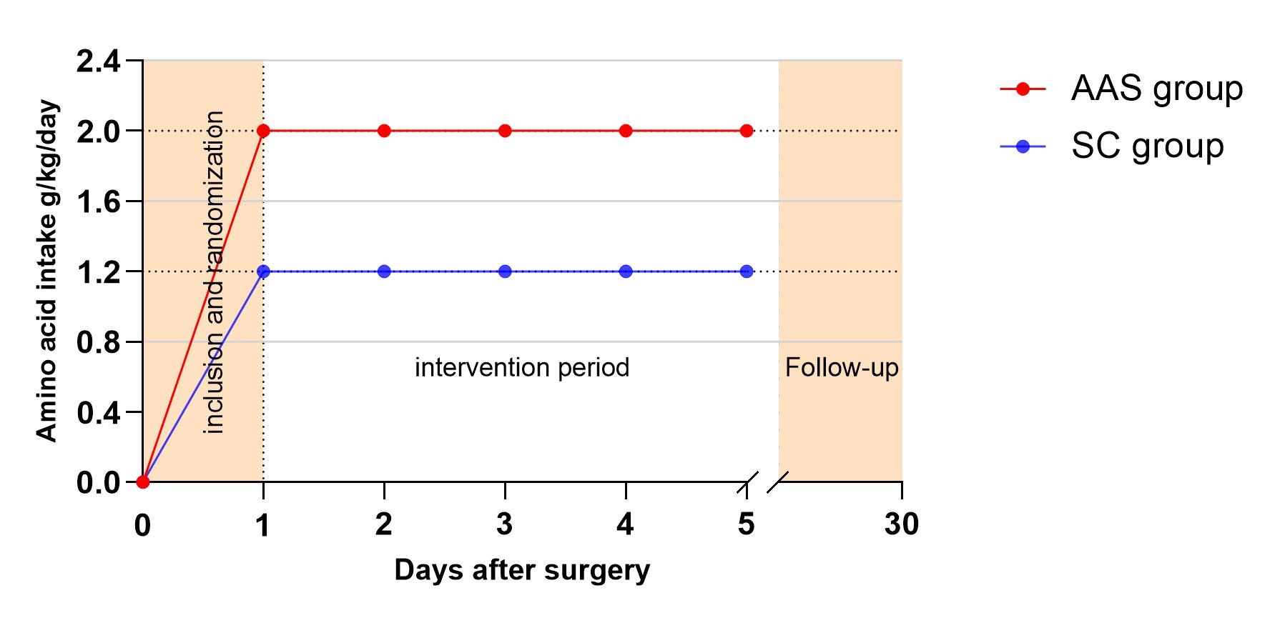
The red line represents the target amino acid intake level of 2.0 g/kg daily for patients in the AAS group from the first postoperative day. The blue line represents the target amino acid intake level of 1.2 g/kg daily for patients in the SC group from the first postoperative day. The intervention lasted for a total of 4 days. Follow up was performed from day 5 until one month after surgery.
AAS = amino acid supplementation, SC = standard care.

Appendix 2: Actual intake of amino acids during the intervention period in the AAS and SC groups
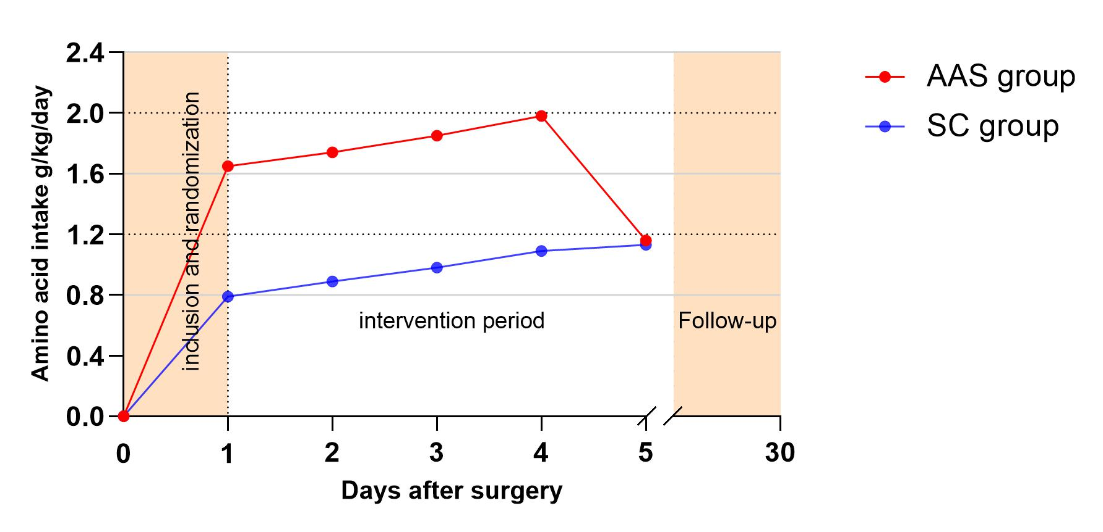
The red line represents the actual mean amino acid intake in the AAS group. The blue line represents the actual mean amino acid intake in the SC group.
AAS = amino acid supplementation, SC = standard care.

Appendix 3: Protocol for nutritional screening.(2)
Nutritional risk screening (NRS 2002)
Impaired nutritional status |  | Severity of disease (=increase in requirements)
Absent Score 0 | Normal nutritional status | Absent Score 0 | Normal nutritional requirements
Mid Score 1 | Wt loss > 5% in 3 mths or Food intake  below 50-75% of normal requirement in preceding week | Mid Score 1 | Hip fracture* Chronic patients, in  particular with acute complications:  cirrhosis*, COPD*, Chronic  hemodialysis, diabetes, oncology
Moderate Score 2 | Wt loss > 5% in 2 mths or BMI 18.5 -  20.5 + impaired general condition or  Food intake 25-50% of normal  requirement in preceding week | Moderate Score 2 | Major abdominal surgery*  Stroke* Severe pneumonia,  hematological malignancy
Severe Score 3 | Wt loss > 5% in 1 mth (> 15% in 3  mths) or BMI < 18.5 + impaired general condition or Food intake 0-25% of normal requirement in preceding week in preceding week | Severe Score 3 | Head injury* Bone marrow  transplantation* Intensive care  patients (APACHE > 10).
Score: + Score: = Total score
Age | If 70 years: add 1 to total score above | = age adjusted total score
Score 3: the patient is nutrionally at-risk and a nutritional care plan is initiated.
Score < 3: weekly re-screening of the patient. E.g., if the patient is scheduled for a major operation, a preventive nutritional care plan is considered to avoid the associated risk status.
NRS-2002 is based on an interpretation of available randomized clinical trials.
*Indicates that a trial directly supports the categorization of patients with that diagnosis. Diagnosis shown in italics is based on the prototypes given below.
Nutritional risk is defined by the present nutritional status and risk of impairment of present status, due to increased requirements caused by stress metabolism of the clinical condition.
Appendix 4: Formula for calculating Ideal Body Weight (IBW)
Female：IBW=45.5+ [0.91*(Height cm -152.4)]
Male：IBW=50+ [0.91*(Height cm -152.4)]
Corrected Ideal body weight
If 27≥BMI≥18.5, IBW
If BMI > 27, IBW *1.2

References
1. Mazaki T, Ebisawa K. Enteral versus parenteral nutrition after gastrointestinal surgery: a systematic review and meta-analysis of randomized controlled trials in the English literature. J Gastrointest Surg 2008;12:739-55.
2. Kondrup J. Nutritional risk screening (NRS 2002): a new method based on an analysis of controlled clinical trials. Clinical Nutrition 2003;22:321-336.

