Table 2 DSF cavity configurations [30].
Typology | Key Features | Illustration
Multistorey (Building-Hight) / BH  The entire facade or, in certain situations, a number of rooms and floors without any separators are covered by the cavity space between the inner and outer skins of the building. Vent apertures are situated close to both the roof and the ground. | - Throughout the height, there are no restrictions on vertical airflow.  - The building's bottom is usually where the air inlet is located.  - Because the ventilation rate is not even throughout the building, this type of DSF is not suited for natural ventilation  - Concerns include noise transfer between floors and fire safety. | 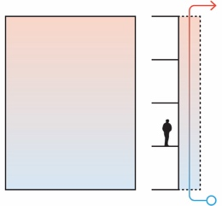
Corridor (Story-Hight) / SH  Divided into sections at each floor level or spanning multiple floors. For each level, air vents on the external skin should be placed close to the floor and ceiling. Three different ventilation types are possible: mechanical, natural, and hybrid. | - There is only one floor of vertical airflow.  - There is no restriction on horizontal airflow.  - Each floor has air vents and inlets at the bottom and top.  - Natural ventilation is made possible by this kind of DSF, which also enhances fire safety. | 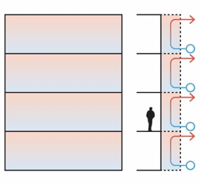
Shaft-Box / SB  For the stack effect, this type draws air from its own cavity into unique nearby shafts that extend over a number of stories. | - Vertical and horizontal partitions on each floor and at each box unit limit airflow.  - It is possible to achieve improved sound insulation inside the cavity and natural ventilation. | 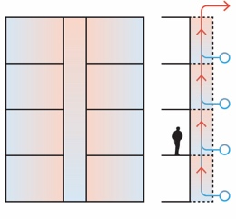
Box-Window / BW  Each box has its own air circulation and is enclosed both horizontally and vertically. | - Combines a building-high vertical shaft with a story-high cavity.  - Through the inlets on each level, air enters the cavity that is one story high and converges at the vertical shafts.  - Due to buoyancy in the shaft, natural ventilation is made feasible even with minimal outside wind. | 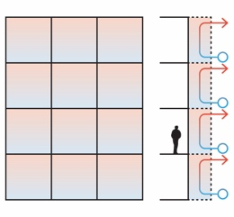

Table 6 The results of the iteration scenarios for north façade.
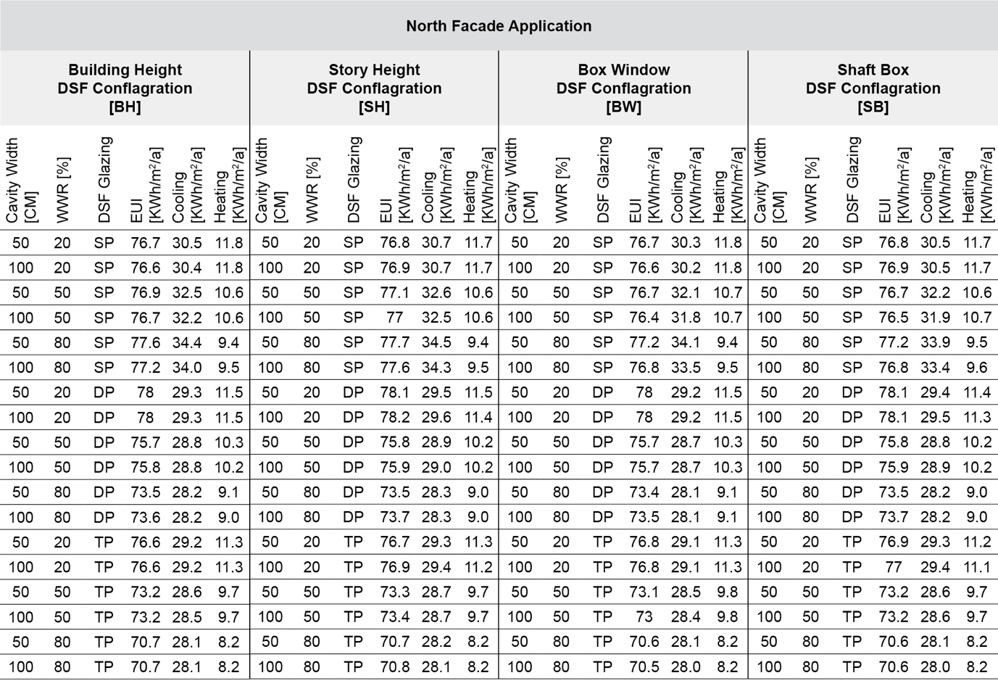

Table 7 The results of the iteration scenarios for east façade.
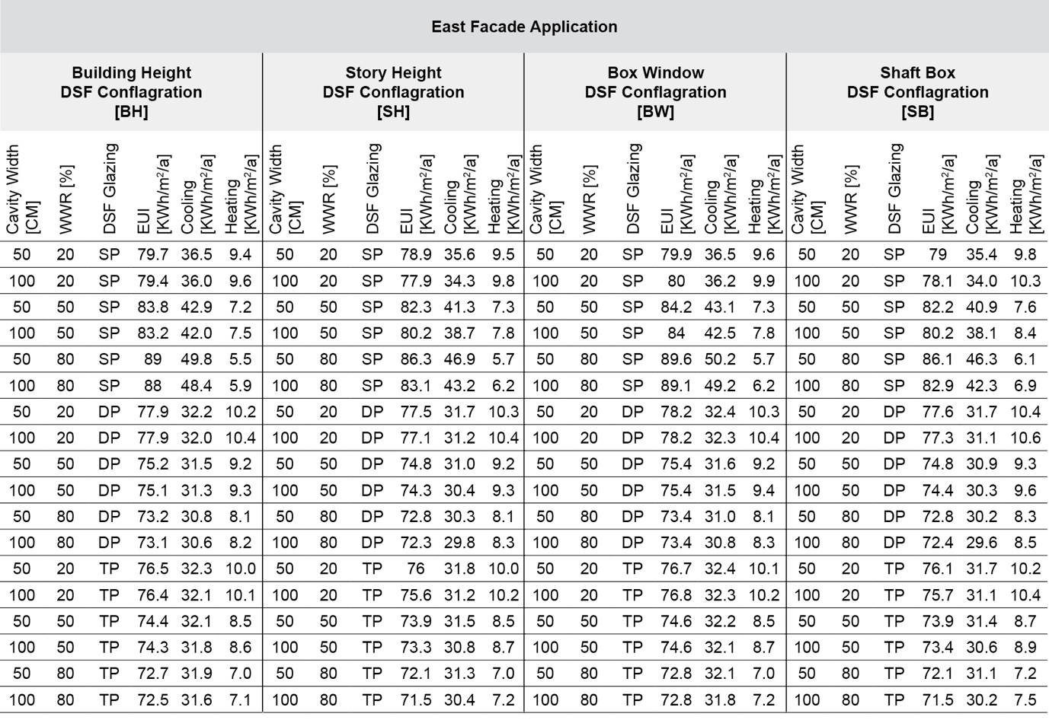

Table 8 The results of the iteration scenarios for south façade.
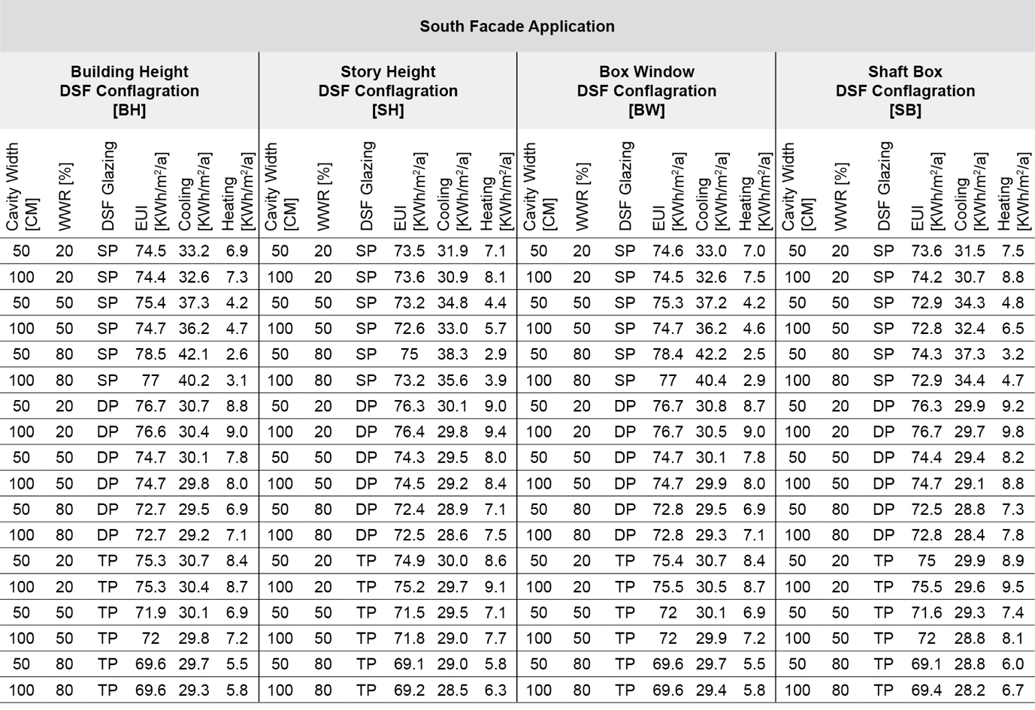

Table 9 The results of the iteration scenarios for west façade.
