Supplementary Material

Probiotic potential of Vaginal flora from healthy Indian women against Urinary pathogens

Veena G Nair^{1,5}, C.S. Srinandan¹, Dhiviya Narbhavi², Anupriya A³, Prabhusaran N^{4,} Sai Subramanian N ^{5*}
* Corresponding Author: Dr Sai Subramanian N, Antimicrobial Resistance Lab, Centre for Research in Infectious diseases, School of Chemical and Biotechnology, SASTRA Deemed to be University, Thanjavur 613401, Tamil Nadu, India. Phone: +91 4362 2641011,
email: sai@scbt.sastra.edu

¹ Microbial Biofilm Lab, Centre for Research in Infectious diseases, School of Chemical and Biotechnology, SASTRA Deemed to be University, Thanjavur 613401, Tamil Nadu, India. Phone: +91 4362 264101
² Assistant Professor, Department of Obstetrics and Gynaecology, TSRMMCH&RC, Tiruchirappalli, Tamil Nadu, India
³Associate Professor, Department of Microbiology, TSRMMCH&RC, Tiruchirappalli, Tamil Nadu, India
⁴ Research Faculty, Institutional Research Board TSRMMCH&RC, Tiruchirappalli, Tamil Nadu, India

⁵Antimicrobial Resistance Lab, Centre for Research in Infectious diseases, School of Chemical and Biotechnology, SASTRA Deemed to be University, Thanjavur 613401, Tamil Nadu, India.

Strains | Accession Number
Ralstonia insidiosa strain SSV | OP630602
Ralstonia syzygii subsp. indonesiensis strain SSV | OP630599
Enterococcus faecalis strain SSV | OP642363
Pandoraea pnomenusa strain SASTRA-3 | OP648138
Ralstonia insidiosa strain MBL | OP649852
Enterococcus faecalis strain SASTRA-2 | OP648136

.

.

Table S1 Strains isolated from Vaginal Swab other than Lactobacillus sp. and their accession numbers.

Fig. S1 Phylogenetic tree of isolated Lactobacilli sps. Constructed using MEGA 11 software boot strap method

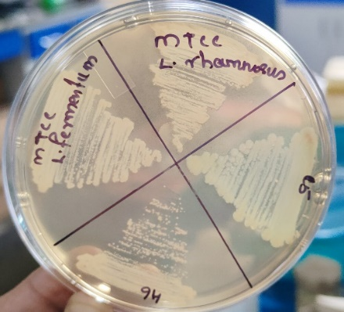
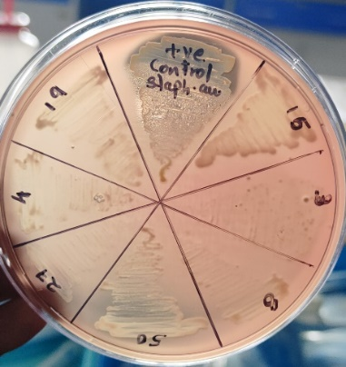

Fig. S2 Haemolytic activities of 9 tested isolated were evaluated on blood agar plates. None of the tested strains showed haemolysis on blood agar plates. Positive control used is Staphylococcus aureus ATCC 25923

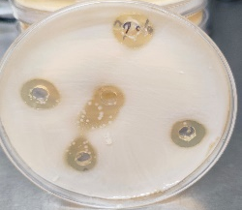
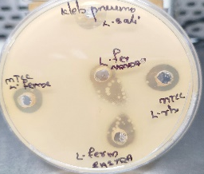
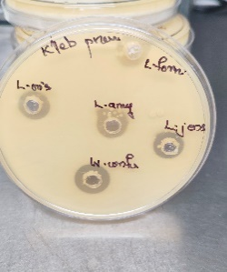
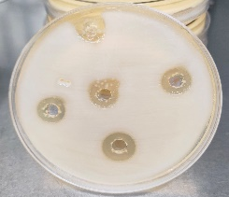
A) B)
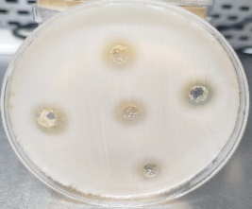
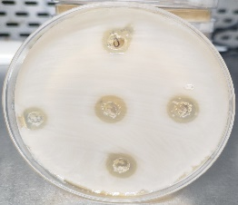
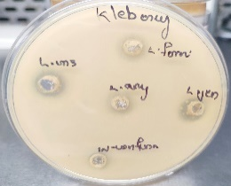
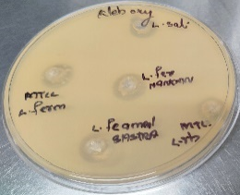

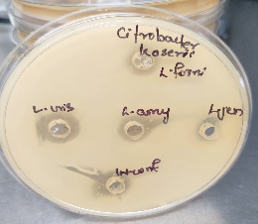
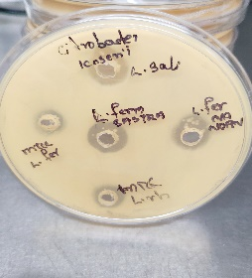
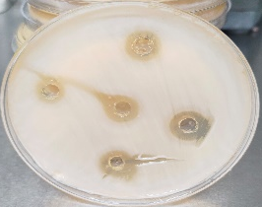
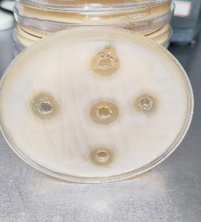
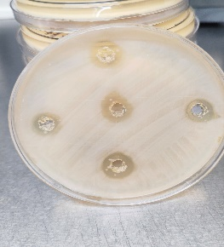
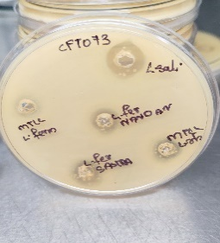
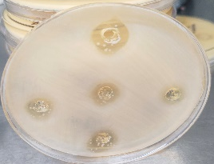
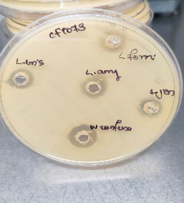
C) D)
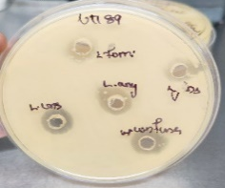
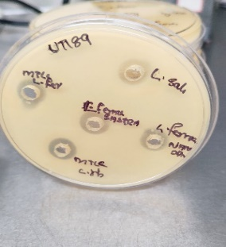
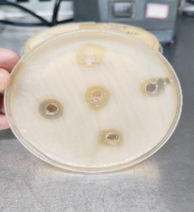
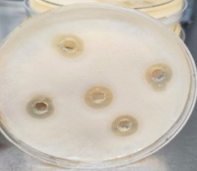
E)

Fig. S3 Antagonistic activity of Cell free supernatant of isolated Lactobacilli sps. A) Against MDR Klebsiella oxytoca B) Against K. pneumoniae C) Citrobacter koserii D) E-coli CFT073 E) E-coli UTI89

Fig. S4 Growth Assay of isolated Lactobacilli sp. The blue line indicates the growth in MRS without mucin and the orange line indicates the growth in the presence of mucin. Data from three biological replicates are presented as means with standard error of measurement.

Fig. S5 Survival rates of Lactobacillus strains at pH 2,3 and 6 after 6,12 and 12 hrs of incubation. Lj- L. jensenii, LfrNANDAN- L. fermentum strain NANDAN, Lc -L. crispatus, La- L. amylovorus, L. fornicalis, Wc- W. confusa Ls-L. salivarius, LfrSASTRA_SSV-, L. fermentum control (MTCC). Data from three biological replicates are presented as means with standard error of measurement.

Fig. S6 Antioxidant Property of the isolated Lactobacillus sp. DPPH activity of isolated Lactobacillus sp. (mean ± SD, n = 3), Simulated Vaginal Media (SMV) without organism is used as the negative control and L. rhamnosus MTCC, L. fermentum MTCC and L. acidophilus MTCC are a positive control.

Fig. S7 A: Effect of oestradiol on biofilm formation after 48hof incubation. a) Inoculated Simulated Vaginal Media (SVM) incorporated with oestradiol b) Inoculated SVM, c) Inoculated SVM with ethanol (Ethanol is used as vehicle control). SVM without organism is used as negative control. L. rhamnosus MTCC, L. fermentum MTCC and L. acidophilus MTCC are the positive control strains used in this experiment.

Fig. S7 B: Vaginal Media (SVM) incorporated with oestradiol, b) Inoculated SVM, c) Inoculated SVM with ethanol (Ethanol is used as vehicle control). SVM without organism is used as negative control and L. rhamnosus MTCC, L. fermentum MTCC and L. acidophilus MTCC are the positive control strains used in this experiment.

