Global long-term mapping of surface temperature shows intensified intra-city urban heat island extremes
  - Lorenzo Mentaschi¹, Grégory Duveiller¹, Grazia Zulian¹, Christina Corbane¹, Martino Pesaresi¹, Joachim Maes¹, Alessandro Stocchino², Luc Feyen¹‬‬‬‬‬‬‬‬‬‬‬‬‬‬‬‬‬‬‬‬‬‬‬‬‬‬
¹: Joint Research Centre (JRC), European Commission, Ispra, Italy.
²: Department of Civil and Environmental Engineering, The Hong Kong Polytechnic University, Hong Kong.

Supplementary Information

Quantity | Definition | median (K) | 95th perc. (K) | max (K) | % below 0
$$SUHI_{18y}$$ | 18-year warm-season maximum of the 3-day moving average of daytime SUHI | 5.9 | 11.3 | >16 | 2.3
$$SUHI_{1y}$$ | 1-year warm-season maximum of the 3-day moving average of daytime SUHI | 4.0 | 9.1 | >13 | 7.0
$$SUHI_{seas}$$ | Warm-season median of the 3-day moving average of daytime SUHI | 2.5 | 7.3 | >12 | 18.0
$$SUHI_{18y}-SUHI_{seas}$$ | Pixel-wise difference between 18-year maximum and warm-season median | 3.3 | 6.9 | >12 | -
$$SUHI_{1y}-SUHI_{seas}$$ | Pixel-wise Difference between 1-year maximum and warm-season median | 1.4 | 4.2 | >7 | -
Table S1: Quantities examined in this study ($SUHI_{18y}$, $SUHI_{1y}$, $SUHI_{seas}$, and the differences $SUHI_{18y}-SUHI_{seas}$ and $SUHI_{1y}-SUHI_{seas}$) and their definitions, and space-time statistics: median, 95th percentile, maxima, % below 0. The figures for $SUHI_{18y}$ are computed from the global spatial distribution of urban pixels. The figures for $SUHI_{1y}$ and $SUHI_{seas}$ are computed by performing a median on the annual values and then considering the resulting global spatial distribution.

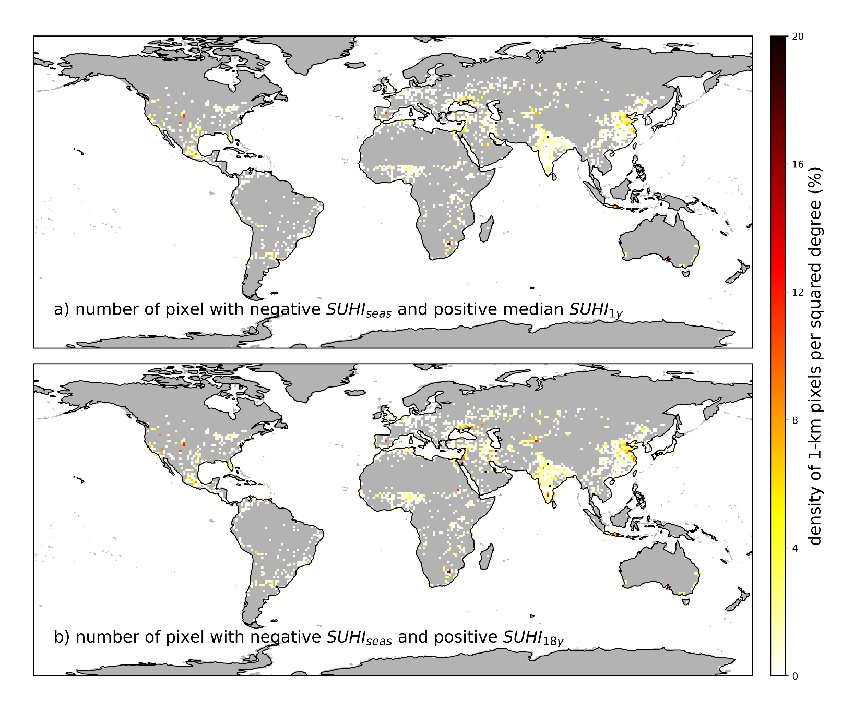
Fig. S1 ǀ Number of 1-km pixels per squared degree experiencing (a) negative $SUHI_{seas}$ (median of annual values) and positive $SUHI_{1y}$ (median of annual values) and (b) negative $SUHI_{seas}$ and positive $SUHI_{18y}$.

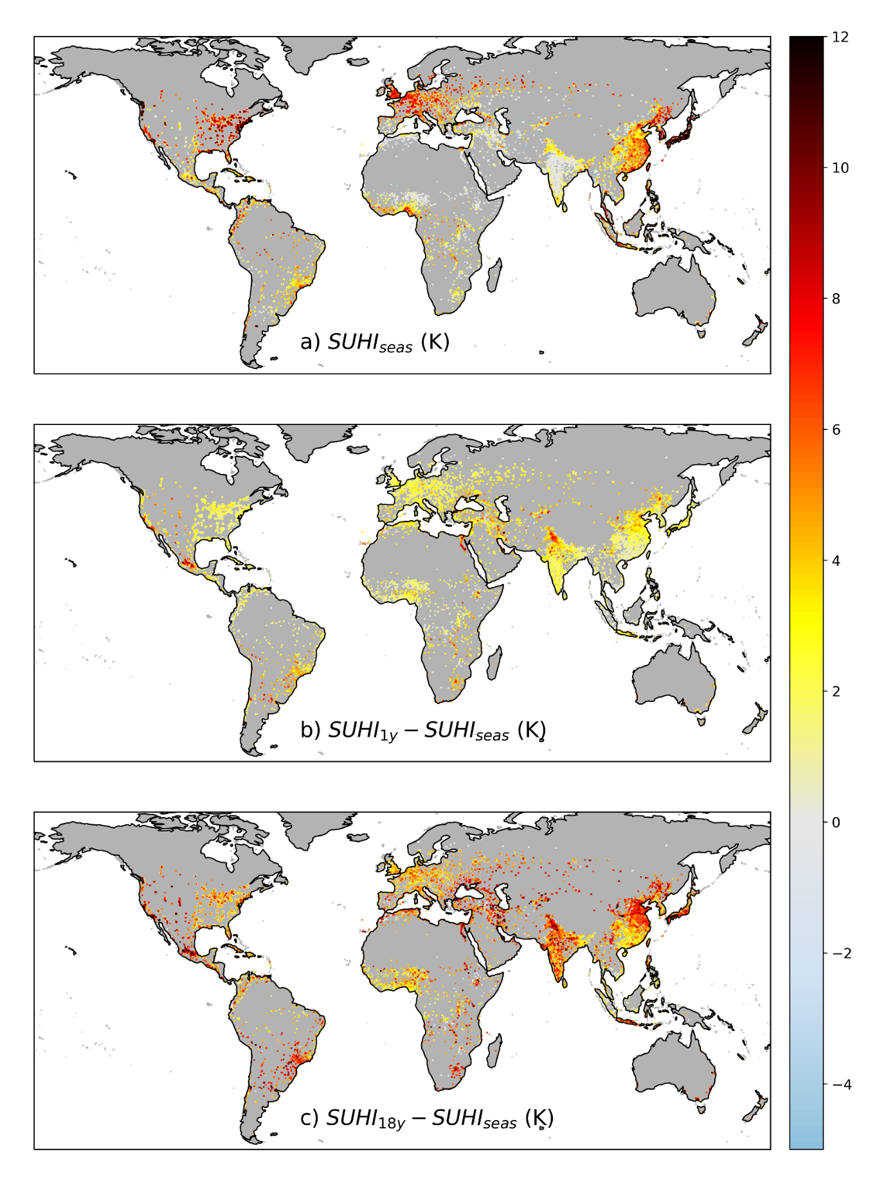
Fig. S2 ǀ Seasonal median SUHI ($SUHI_{seas}$, a), difference between annual maxima ($SUHI_{1y}$) and $SUHI_{seas}$ (b), and between 18-year maxima ($SUHI_{18y}$) and $SUHI_{seas}$ (c).
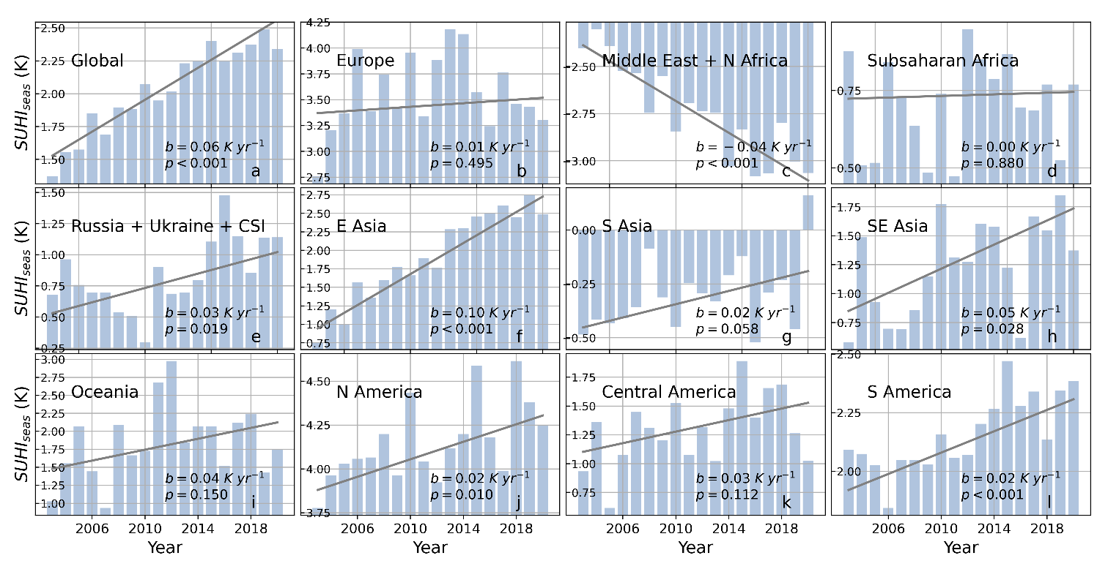
Fig. S3 ǀ Trend of $SUHI_{seas}$ in different macro-areas. In each panel are reported: the Theil-Sen slope (b) and the p-value (p).

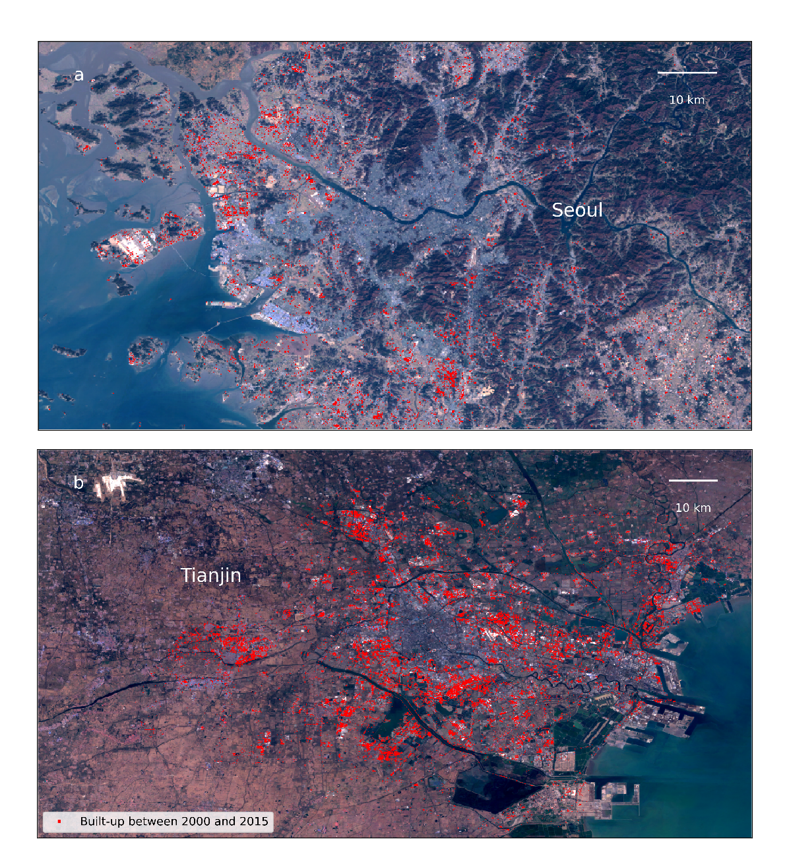
Fig. S4 ǀ Areas built-up (in red) between 2000 and 2015 according to GHSL¹ in Seoul (a) and Tianjin (b).

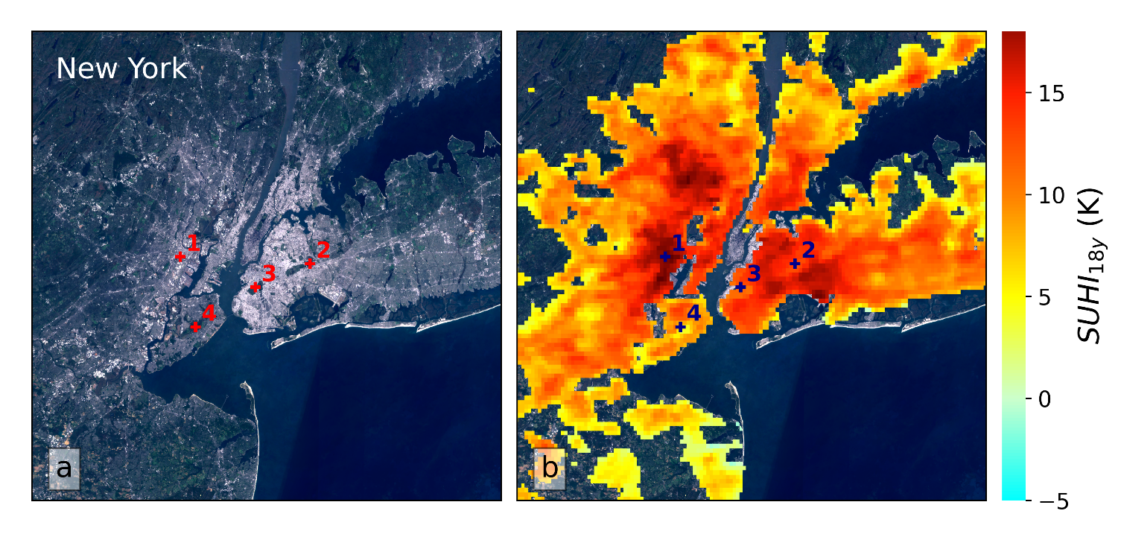
Fig. S5 ǀ Detailed view of New York. a, Sentinel-2 imagery. b, map of SUHI_{18y}. The spots highlighted in the maps are: 1) Railroad facility north of the Newark airport; 2) Forest park; 3) Prospect park, and 4) La Tourette park.

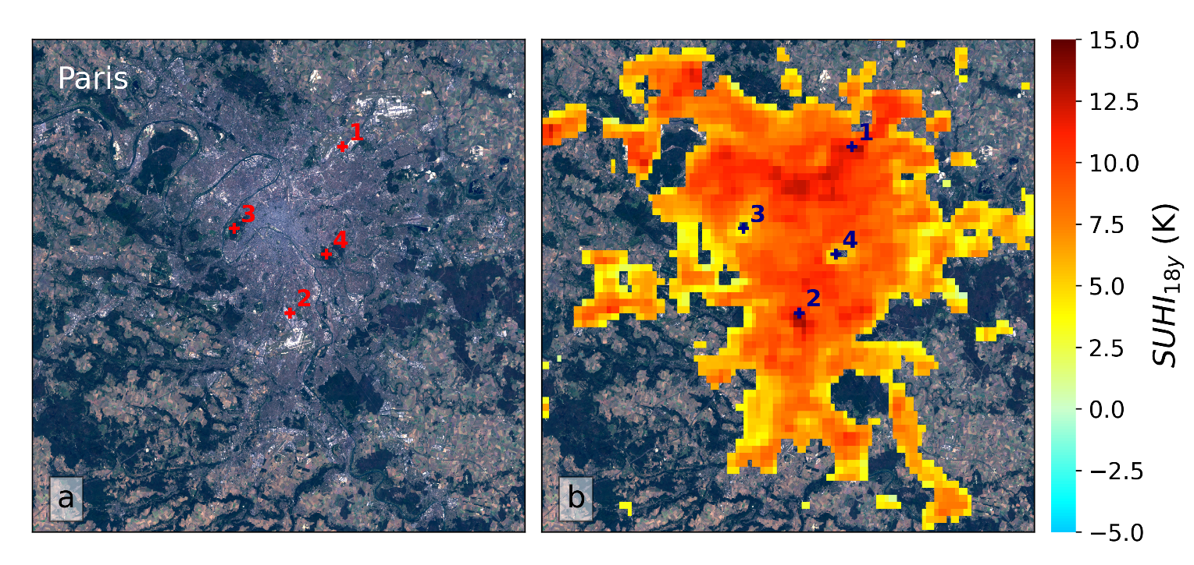
Fig. S6 ǀ Detailed view of Paris. a, Sentinel-2 imagery. b, map of SUHI_{18y}. The spots highlighted in the maps are: 1) Industrial facilities east of Saint Denise; 2) Industrial facilities close to Chevilly Larue; and 3) Bois de Boulogne. and 4) Bois de Vincennes.
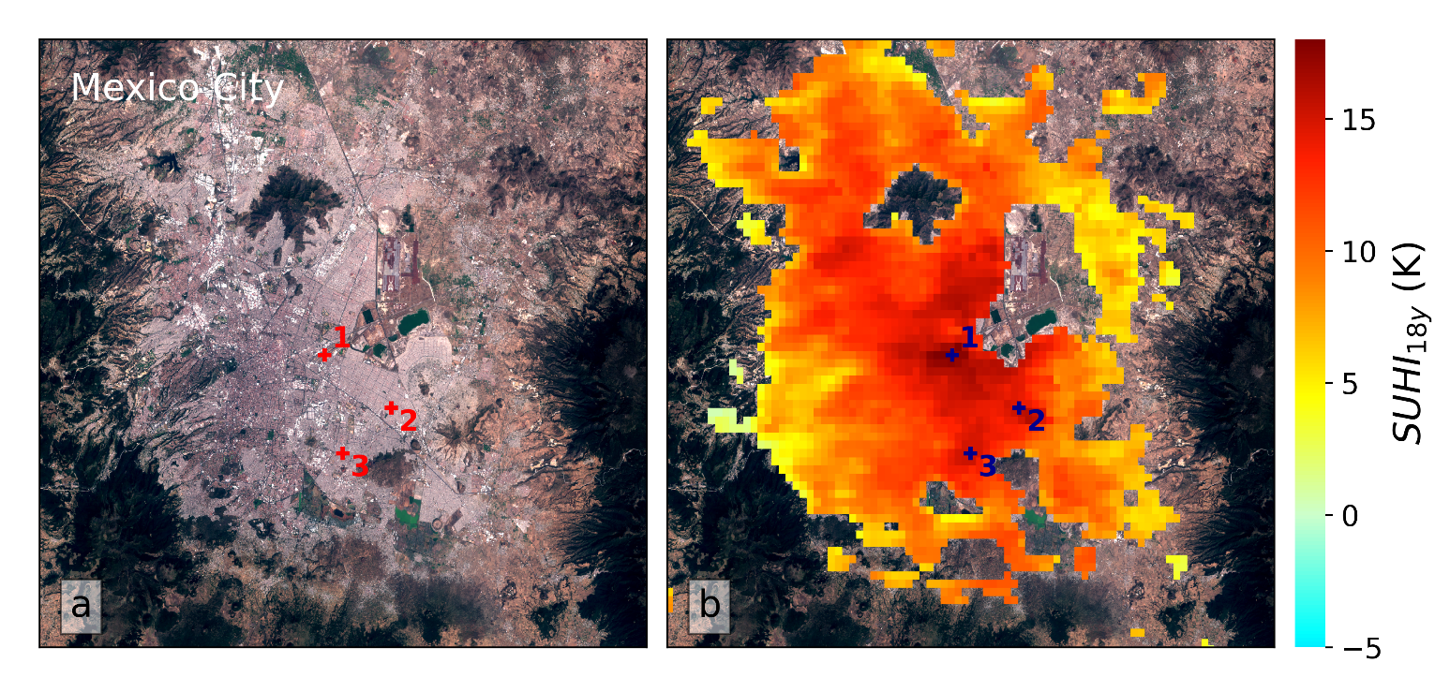
Fig. S7 ǀ Detailed view of Mexico City. a, Sentinel-2 imagery. b, map of SUHI_{18y}. The spots highlighted in the maps are: 1) the international airport; 2) Ciudad Nezahualcóyotl; and 3) Iztapalapa.

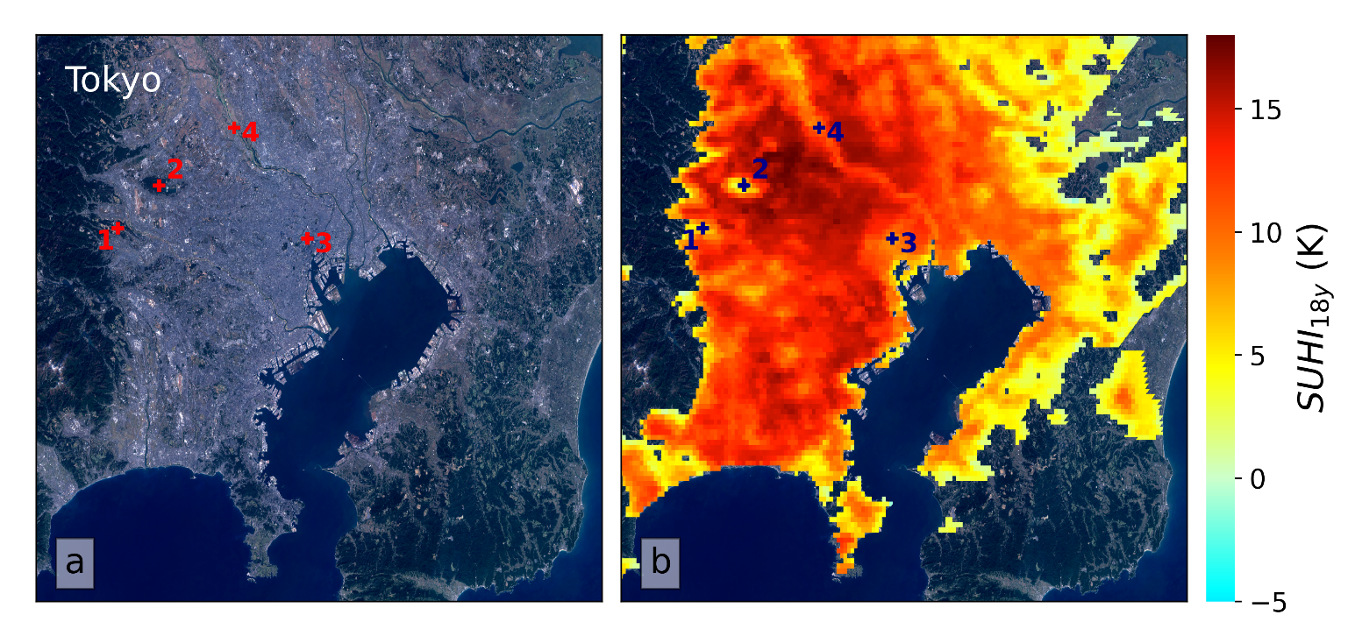
Fig. S8 ǀ Detailed view of Tokyo. a, Sentinel-2 imagery. b, map of SUHI_{18y}. The spots highlighted in the figure are: 1) the Hachioji forest area; 2) Sayama lake; 3) Chioda city; and 4) Arakawa river.

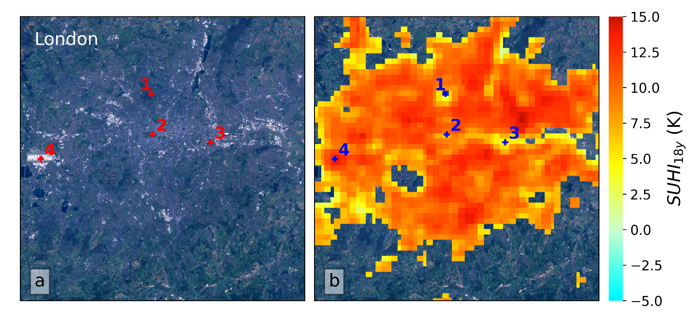
Fig. S9 ǀ Detailed view of London. a, Sentinel-2 imagery. b, map of SUHI_{18y}. The spots highlighted in the figure are: 1) Hampstead Heath; 2) Hyde park; 3) Thames river; and 4) Heathrow airport.

Bibliography
1. European Commission. GHSL - Global Human Settlement Layer. Joint Research Centre (JRC) (2015). doi:10.1039/C6FD00116E

