Appendix

Performed tests: testing for stationarity.

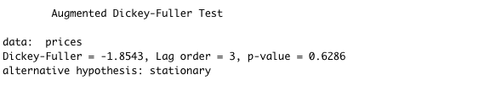
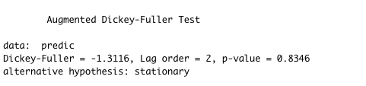

ADF test on LN values
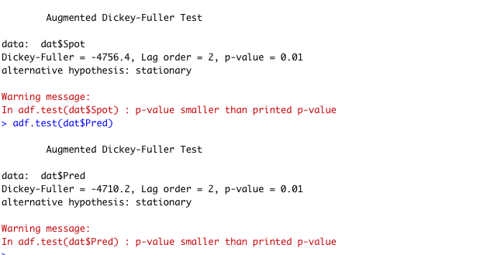

Performed test for cointegration:

