Supplementary table 1. Criteria for AIGA severity on the anhidrotic area

Score | Area of anhidrotic lesions
0 | <25%
1 | 25% to <50%
2 | 50% to <75%
3 | More than 75%

Supplementary Table 2. The list of AIGA patients

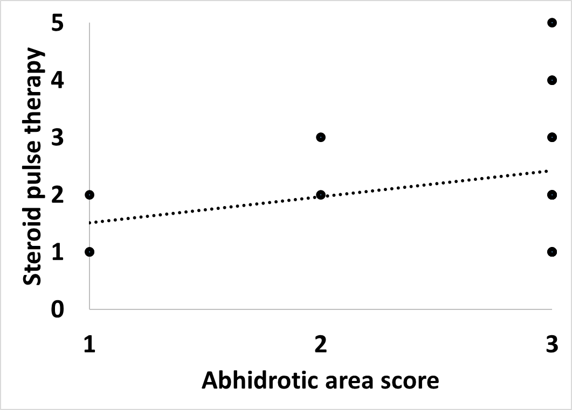
Supplementary figure 1. Correlation between anhidrotic area and steroid pulse therapy

The horizontal axis is the score of the anhidrosis area and the vertical axis is the number of courses of steroid pulse therapy. Patients who received steroid pulse therapy were plotted. An approximate curve was also drawn.

