The International Journal of Colorectal Disease
A comparative study of scoring systems that accurately predict the prognosis of lower gastrointestinal bleeding
Sang Hoon Yeon¹, Hee Seok Moon^{1*}, Seong Woo Choi¹, Sun Hyung Kang¹, Jae Kyu Sung¹, Hyun Yong Jeong¹
¹Division of Gastroenterology, Department of Internal Medicine, Chungnam National University Hospital, Chungnam National University School of Medicine, Daejeon, South Korea
*Corresponding author:
Hee Seok Moon, MD, PhD
Email: mhs1357@cnuh.co.kr
SUPPLEMENTARY INFORMATION
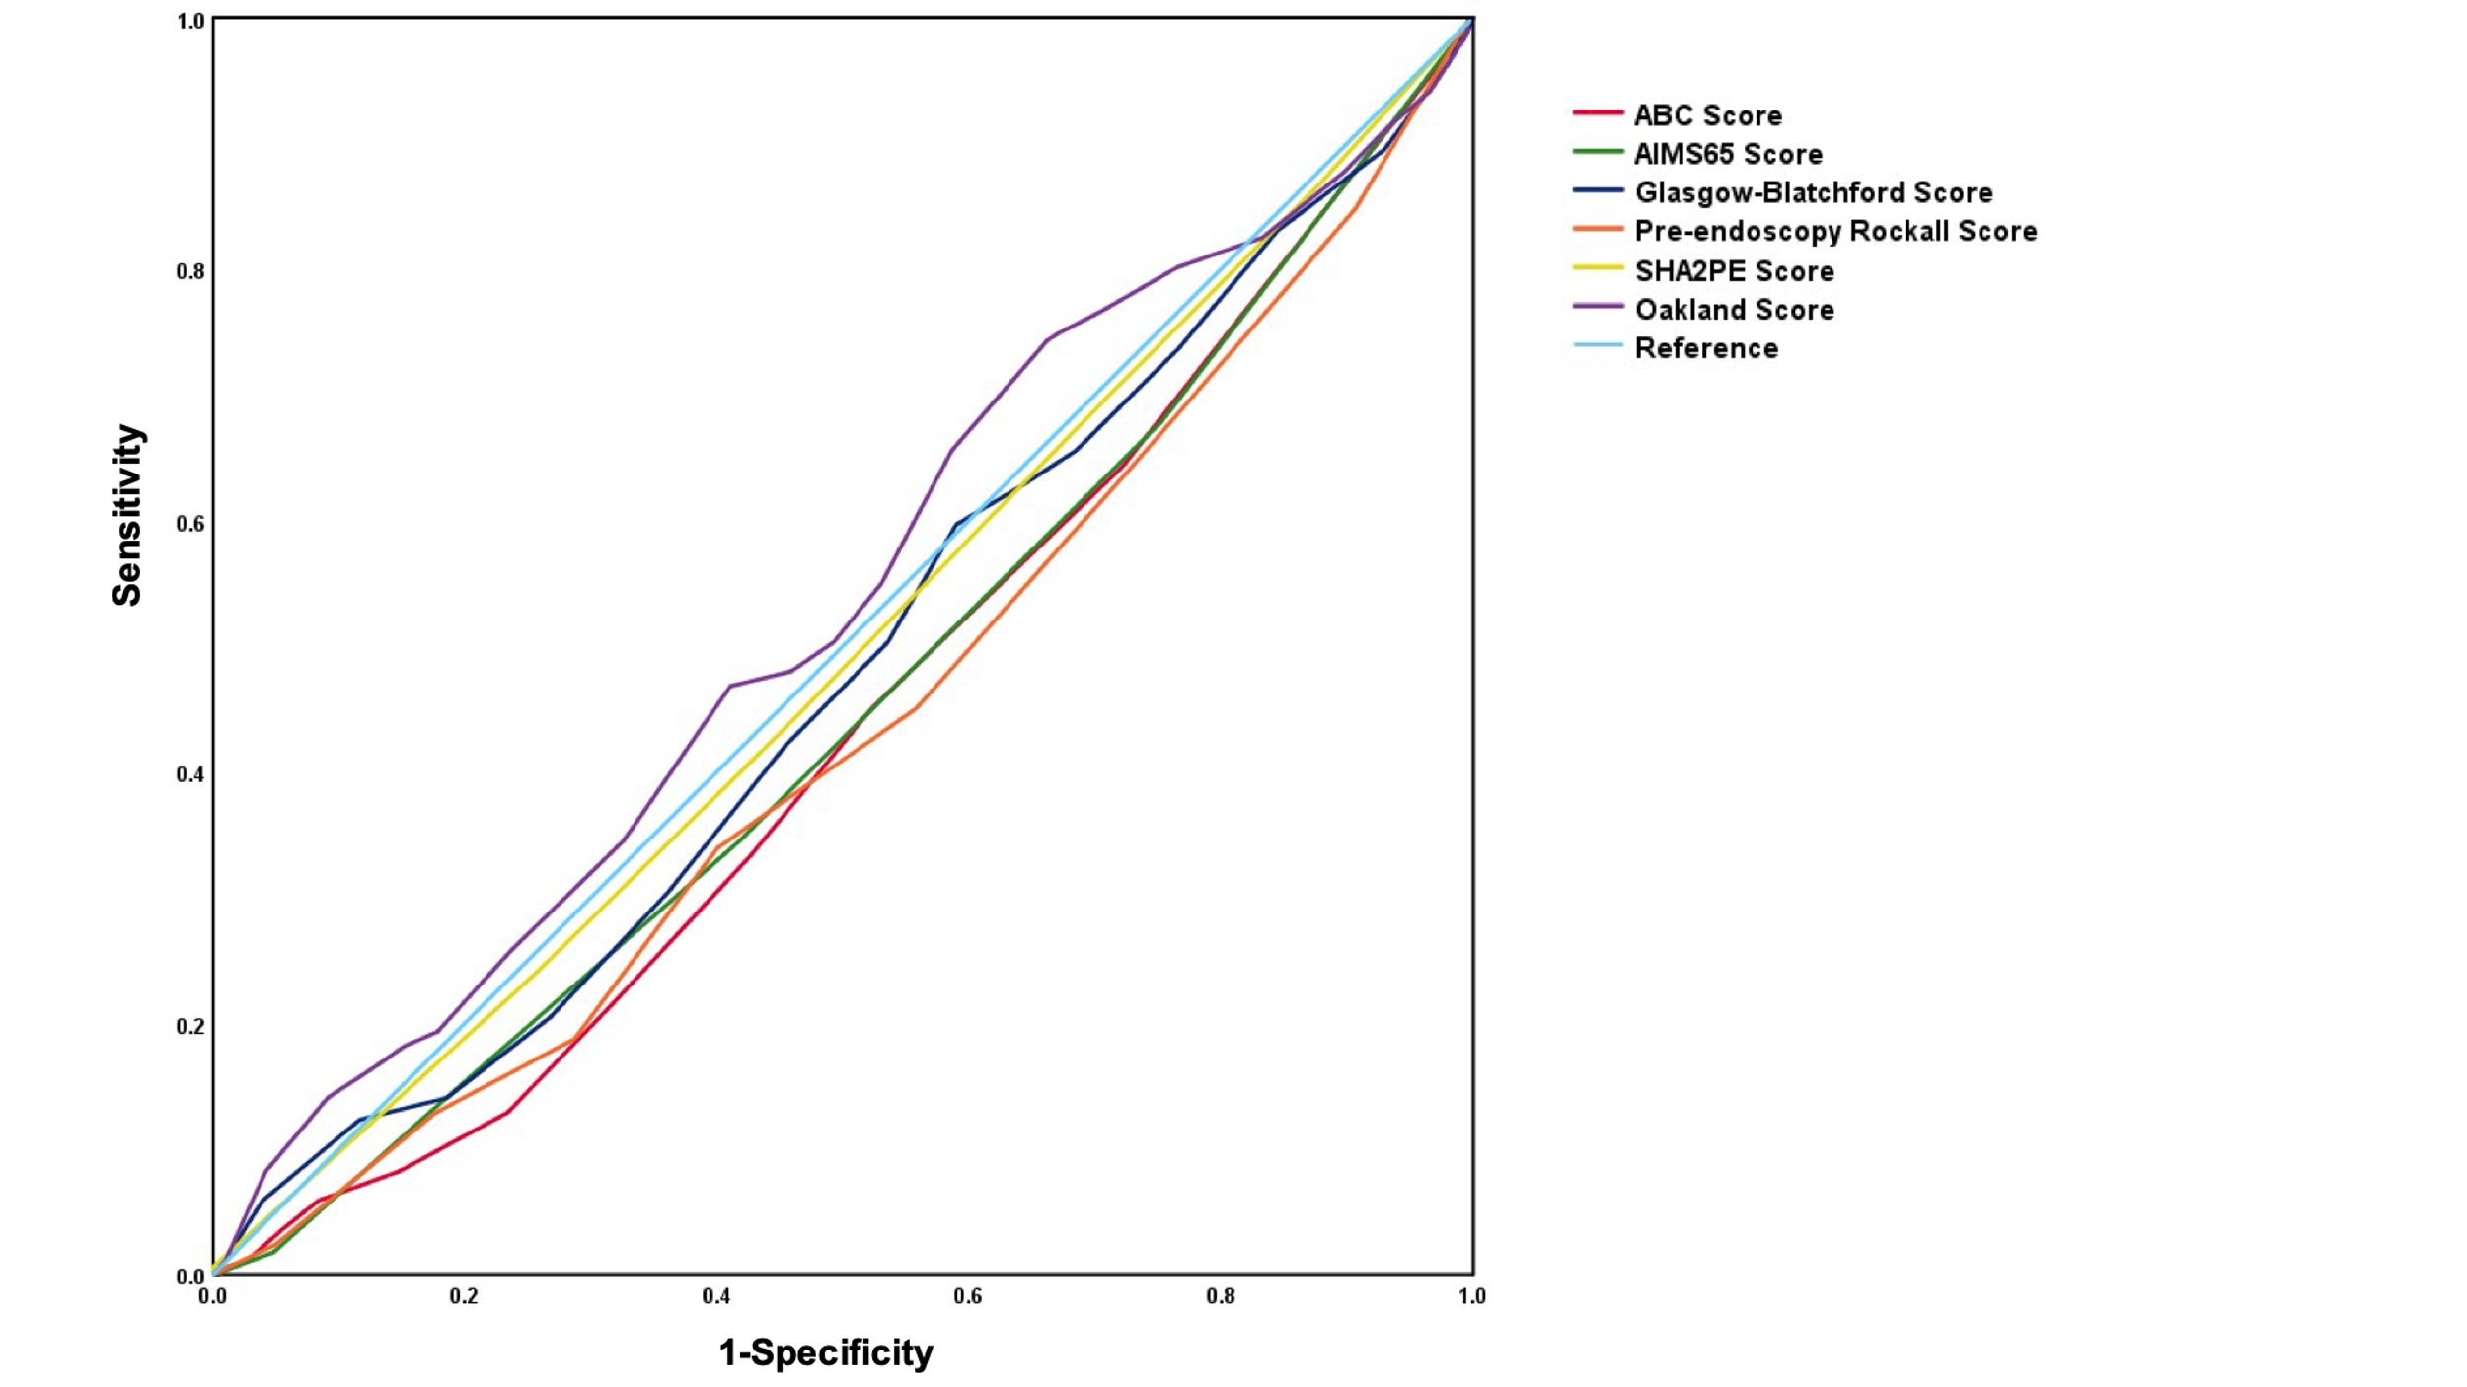
Supplementary Fig.1 Therapeutic Intervention
Supplementary Table 1 Comparison of AUROCs for scoring systems in predicting outcomes
Scoring system | AUROC  (95%, CI) | P value | P value for comparison
Scoring system | AUROC  (95%, CI) | P value | ABC | AIMS65 | GBS | Rockall | SHA₂PE | Oakland
30-day mortality
ABC | 0.835 (0.791-0.879) | <0.001 | - | 0.753 | 0.032 | 0.010 | 0.011 | 0.012
AIMS65 | 0.845 (0.790-0.899) | <0.001 |  | - | 0.103 | 0.001 | 0.047 | 0.040
GBS | 0.773 (0.705-0.840) | <0.001 |  |  | - | 0.598 | 0.777 | 0.173
Rockall | 0.752 (0.686-0.818) | <0.001 |  |  |  | - | 0.661 | 0.784
SHA2PE | 0.767 (0.703-0.830) | <0.001 |  |  |  |  | - | 0.335
Oakland | 0.740 (0.658-0.821) | <0.001 |  |  |  |  |  | -
Prolonged hospital stay
ABC | 0.710 (0.673-0.747) | <0.001 | - | 0.879 | 0.383 | 0.077 | 0.353 | 0.126
AIMS65 | 0.712 (0.674-0.750) | <0.001 |  | - | 0.296 | 0.163 | 0.386 | 0.075
GBS | 0.695 (0.657-0.734) | <0.001 |  |  | - | 0.600 | 0.012 | 0.27
Rockall | 0.686 (0.647-0.725) | <0.001 |  |  |  | - | 0.016 | 0.814
SHA2PE | 0.728 (0.690-0.765) | <0.001 |  |  |  |  | - | 0.001
Oakland | 0.681 (0.643-0.720) | <0.001 |  |  |  |  |  | -
Therapeutic intervention
ABC | 0.435 (0.389-0.481) | 0.007 | - | 0.004 | 0.032 | 0.864 | 0.061 | 0.348
AIMS65 | 0.447 (0.399-0.494) | 0.029 |  | - | 0.155 | 0.004 | 0.034 | 0.196
GBS | 0.474 (0.426-0.521) | 0.227 |  |  | - | 0.026 | 0.264 | 0.175
Rockall | 0.432 (0.385-0.479) | 0.005 |  |  |  | - | 0.062 | 0.337
SHA2PE | 0.489 (0.441-0.536) | 0.642 |  |  |  |  | - | 0.008
Oakland | 0.527 (0.479-0.576) | 0.263 |  |  |  |  |  | -
CI, confidence interval; AUROC, area under the receiver operating characteristic curve

Supplementary Table 2 Performance of scoring systems in predicting outcomes
Scoring system | Cutoff | Sensitivity (%) | Specificity (%) | PPV (%) | NPV (%)
30-day mortality
ABC | 5.5 | 85.7 | 72.0 | 10.3 | 99.2
AIMS65 | 2.5 | 68.5 | 85.5 | 15.1 | 98.6
GBS | 8.5 | 1 | 37.7 | 5.7 | 1
Rockall | 4.5 | 91.4 | 47.5 | 6.1 | 99.3
SHA2PE | 4.5 | 65.7 | 76.1 | 9.4 | 98.3
Oakland | 27.5 | 62.8 | 77.4 | 9.5 | 98.2
Prolonged hospital stay
ABC | 2.5 | 86.6 | 45.7 | 32.7 | 91.8
AIMS65 | 1.5 | 68.8 | 68.1 | 39.7 | 87.7
GBS | 11.5 | 68 | 62.1 | 35.4 | 86.4
Rockall | 6.5 | 49.3 | 79.9 | 42.8 | 83.8
SHA2PE | 3.5 | 73.3 | 63.8 | 38.1 | 88.7
Oakland | 23.5 | 71.1 | 57.1 | 33.6 | 86.6
Therapeutic intervention
ABC | 15 | 0 | 1 | - | 82.2
AIMS65 | 6 | 0 | 1 | - | 82.2
GBS | 16.5 | 5.8 | 96.0 | 24.3 | 82.5
Rockall | 1.5 | 1 | 0.2 | 17.7 | 1
SHA2PE | 5.5 | 0.5 | 1 | 1 | -
Oakland | 19.5 | 74.2 | 33.8 | 19.5 | 85.8
PPV, positive predictive value; NPV, negative predictive value

Supplementary Table 3 Logistic regression analysis results for risk factors of prolonged hospital stay
 | Univariate analysis |  | Multivariate analysis
 | OR (95% CI) | p-value | OR (95% CI) | p-value
Male sex | 1.359 (1.008-1.834) | 0.045
Age ≥75 years | 1.379 (1.014-1.867) | 0.041
Cancer | 1.789 (1.260-2.541) | 0.001
COPD | 0.816 (0.303-2.199) | 0.688
Renal failure | 1.519 (0.979-2.359) | 0.062
Heart failure | 0.968 (0.598-1.568) | 0.896
Liver cirrhosis | 4.734 (2.989-7.498) | 0.000 | 2.983 (1.709-5.207) | 0.000
Antiplatelet | 0.855 (0.581-1.258) | 0.426
Anticoagulant | 1.227 (0.762-1.976) | 0.399
NSAIDs | 2.591 (1.891-3.551) | 0.000
SBP (< 100 mmHg) | 5.410 (3.884-7.536) | 0.000 | 2.892 (1.904-4.391) | 0.000
DBP (<60 mmHg) | 2.115 (1.494-2.995) | 0.000
Heart rate (>100 beats/min) | 3.308 (2.397-4.564) | 0.000
Hemoglobin (≤10.0 g/dL) | 3.108 (2.212-4.366) | 0.000 | 2.442 (1.048-5.692) | 0.039
Hematocrit (≤30.0%) | 2.819 (2.013-3.947) | 0.000
Platelet (≤100,000/uL) | 3.826 (2.743-5.337) | 0.000
Creatinine (>1.5 mg/dL) | 1.696 (1.187-2.425) | 0.004
BUN (≥30 mg/dL) | 1.918 (1.403-2.622) | 0.000
INR (>1.50) | 3.044 (2.072-4.473) | 0.000
Albumin (≤3.0 g/dL) | 8.198 (5.55-12.102) | 0.000 | 4.576 (2.85-7.34) | 0.000
OR, odds ratio; CI, confidence interval; COPD, chronic obstructive pulmonary disease; NSAIDs, non-steroidal anti-inflammatory drugs; SBP, systolic blood pressure; DBP, diastolic blood pressure; BUN, blood urea nitrogen; INR, international normalized ratio.

