Supplementary Materials

Integrating computer vision and a strain sensor for human–machine interfaces with enhanced versatility and scalability

Sunguk Hong¹, Vega Pradana Rachim², Jin-Hyeok Baek³, Sung-Min Park^{1,2,3,4,5}*

¹Department of Mechanical Engineering, Pohang University of Science and Technology (POSTECH), Pohang 37673, South Korea. ²Department of Creative IT Engineering, Pohang University of Science and Technology (POSTECH), Pohang 37673, South Korea. ³School of Interdisciplinary Bioscience and Bioengineering, Pohang University of Science and Technology (POSTECH), Pohang 37673, South Korea. ⁴Department of Electrical Engineering, Pohang University of Science and Technology (POSTECH), Pohang 37673, South Korea. ⁵Institute of Convergence Science, Yonsei University, Seoul 120-749, South Korea.

*Corresponding author. Email: sungminpark@postech.ac.kr

  - Supplementary Figures 1-8

  - Supplementary Tables 1-3

  - Caption for Supplementary Video 1-3
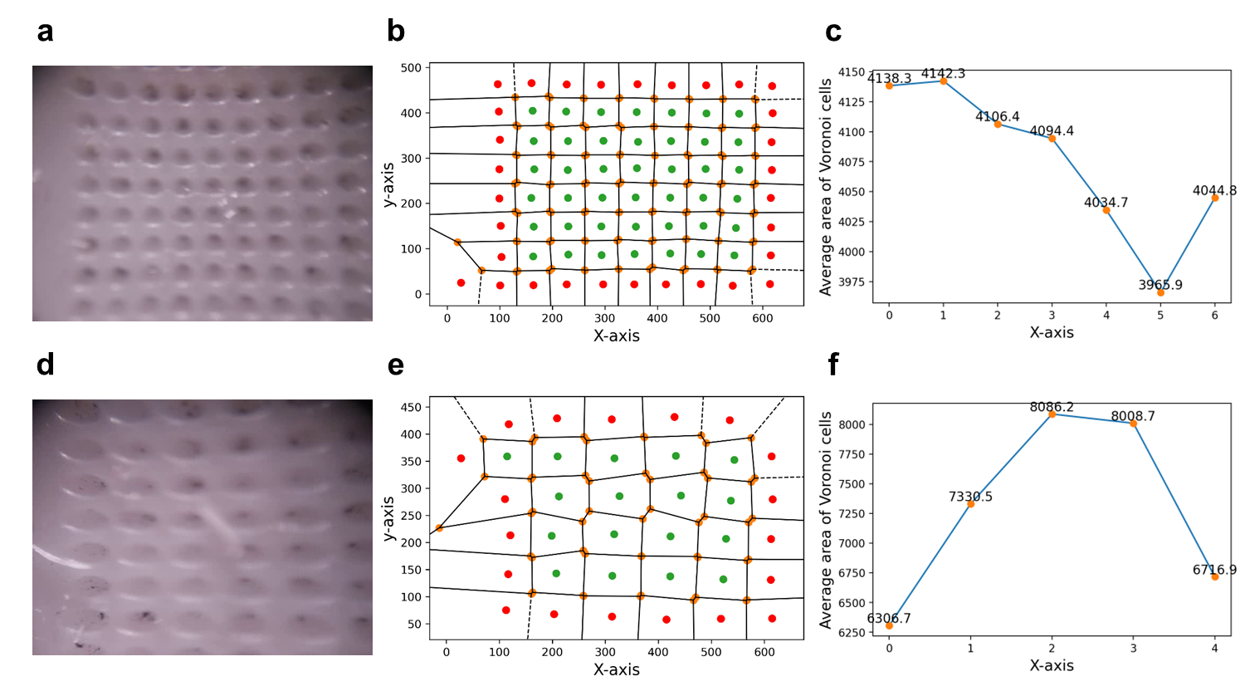
Supplementary Figure 1. Voronoi diagram according to curvature state. In the linear state: a captured image from the optical system (a), Voronoi diagram of captured image (b), and average area of Voronoi cells according to the x-axis (c). In the bending state (R10): a captured image from the optical system (d), Voronoi diagram of captured image (e), and average area of Voronoi cells according to the x-axis (f).

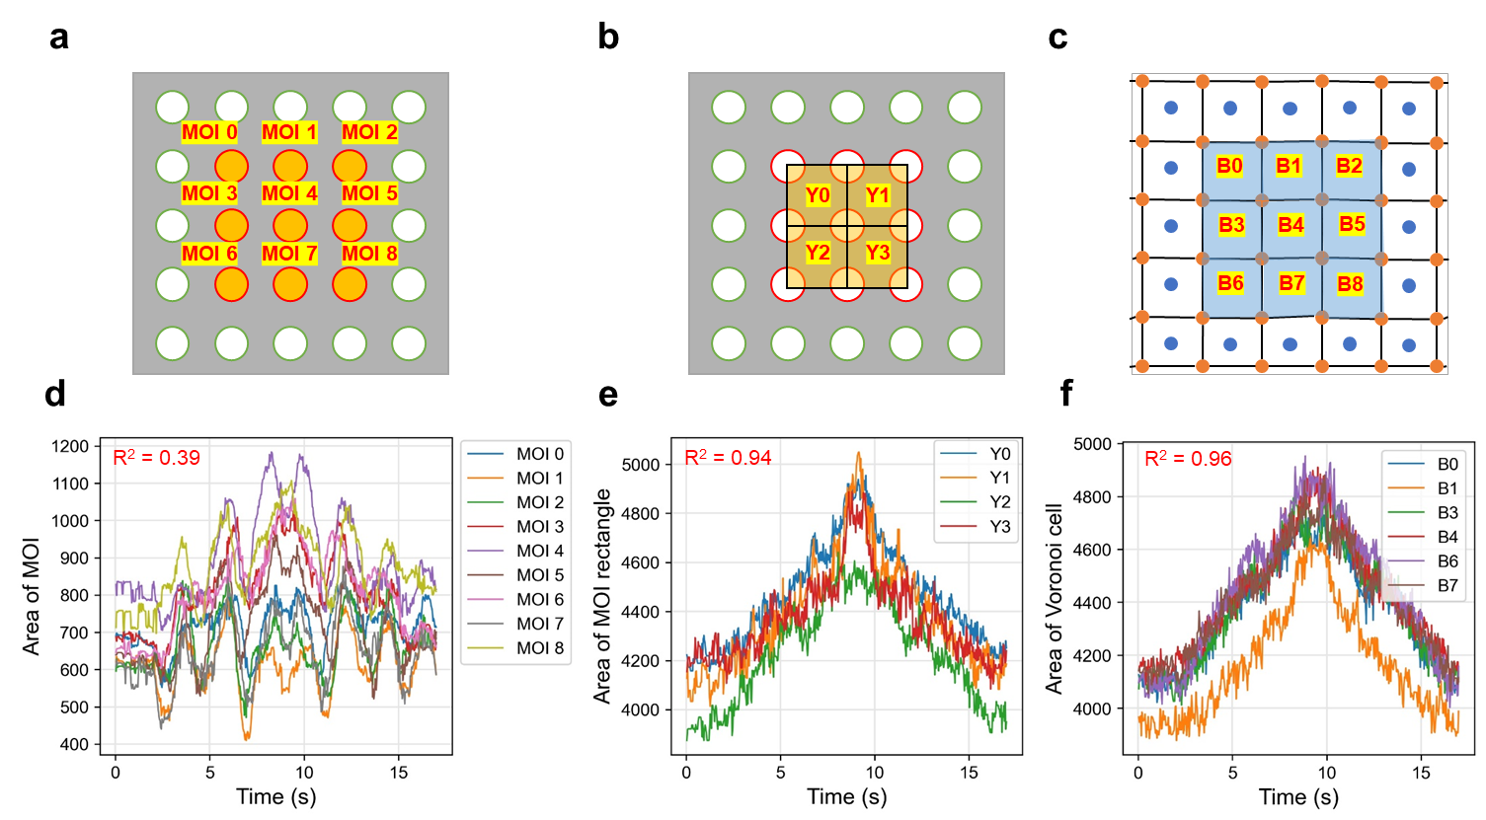
Supplementary Figure 2. The comparison of area factors. Schematic images of area factors in surface of sensing part: orange circles are area of MOIs (a), yellow boxes are area of MOI rectangles (b), and blue boxes are area of Voronoi cells in a Voronoi diagram (c). Area change during a loading–unloading cycle in MOIs (d), MOI rectangles (e), and Voronoi cells (f). The graphs indicate the Voronoi cells are suitable indicators of the influence of micro-markers.

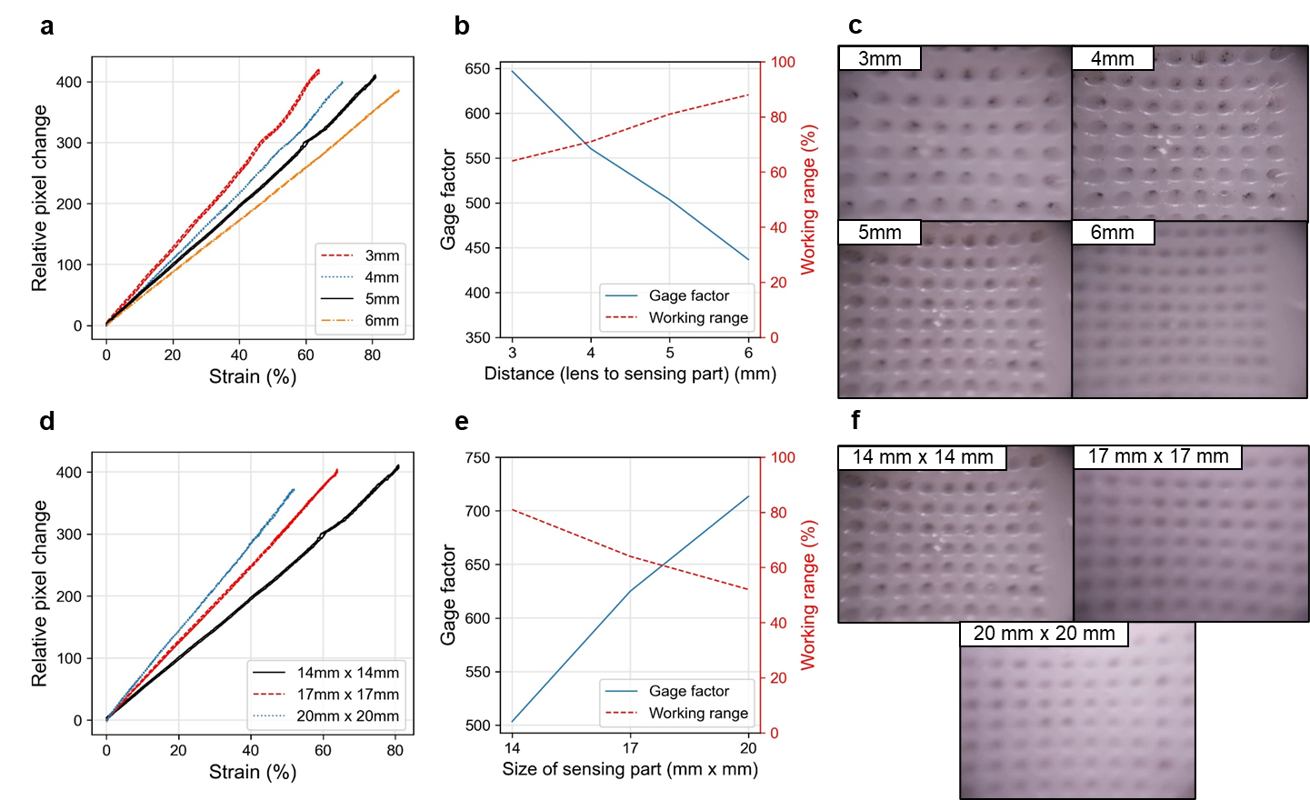
Supplementary Figure 3. The design parameters affects the characteristics of the CVOS sensor. Distance of the lens from the sensing part: relative pixel change during the loading–unloading cycle according to the distance (a), GF and working range according to the distance (b), and captured images of sensing part according to the distance (c). Size of the sensing part: relative pixel change during the loading–unloading cycle according to the size (d), GF and working range according to the size (e), and captured images of sensing part according to the size (f).

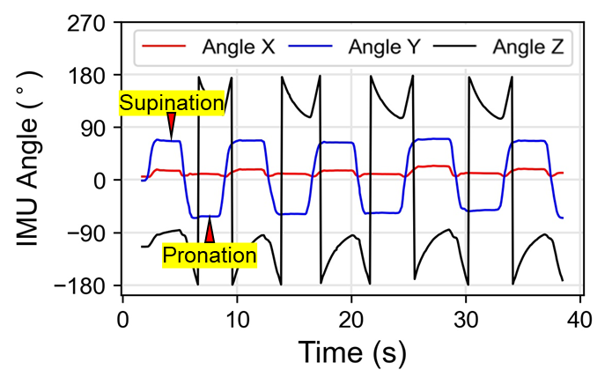
Supplementary Figure 4. IMU data in forearm rotation test. Angle Y is related to forearm rotation.

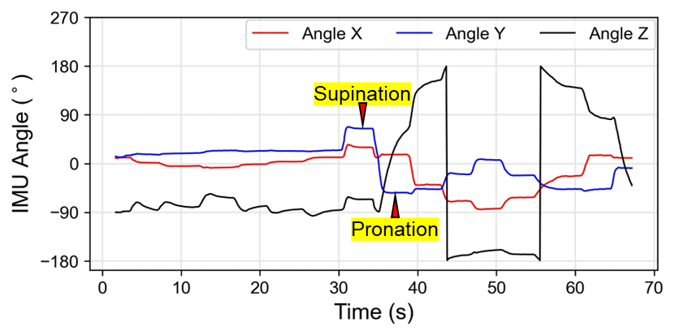
Supplementary Figure 5. IMU data in the complex body motion test. Angle X is related to the elbow bending angle to the humerus bone of the arm.

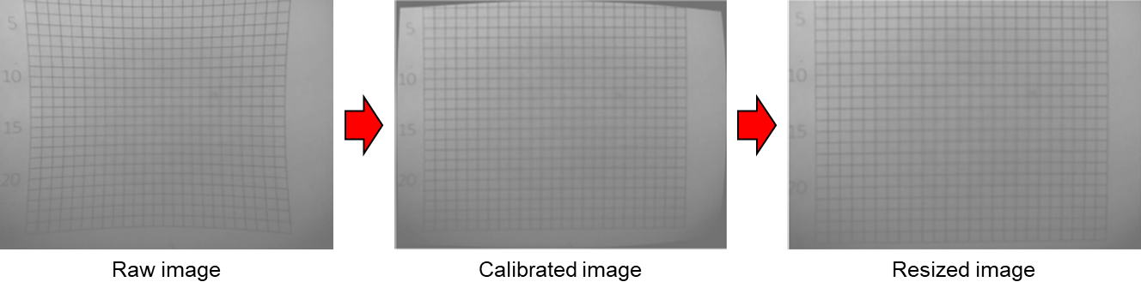
Supplementary Figure 6. Images of the calibration process.

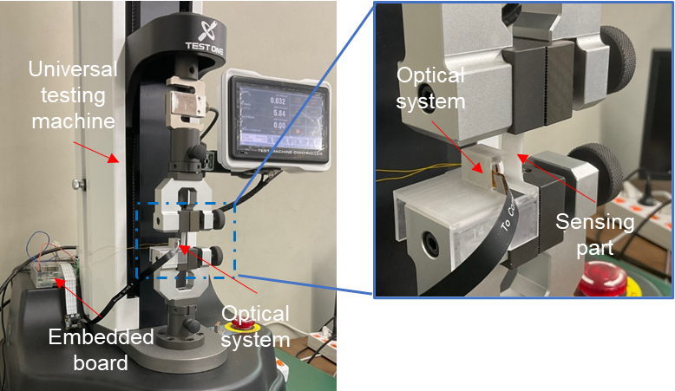
Supplementary Figure 7. Images of the performance test setup.

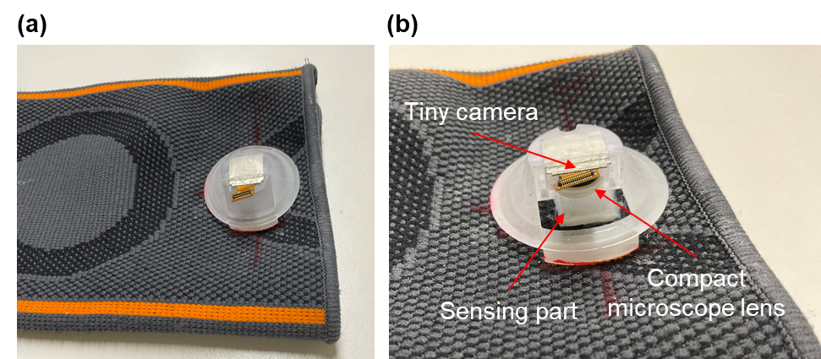
Supplementary Figure 8. Body motion monitoring system based on the CVOS sensor and elbow brace. a The photo of the system. b Structure of the monitoring system.

Supplementary Table 1. The performance of the sensors according to the distance from the lens to the sensing part.
Distance from the lens to the sensing part (mm) | Gauge factor | Working range (%) | Hysteresis (%) | Linearity  (R²)
3 | 646.8 | 64 | 0.91 | 0.998
4 | 560.3 | 71 | 0.60 | 0.999
5 | 503.4 | 81 | 0.91 | 0.999
6 | 436.7 | 88 | 0.19 | 0.999

Supplementary Table 2. The performance of the sensors according to the size of the sensing part.
Size of the sensing part  (mm × mm) | Gauge factor | Working range (%) | Hysteresis (%) | Linearity  (R²)
14 × 14 | 503.4 | 81 | 0.91 | 0.999
17 × 17 | 623.6 | 64 | 0.68 | 0.999
20 × 20 | 713.5 | 52 | 0.30 | 0.999

Supplementary Table 3. Processing speed comparison (in FPS) according to computing devices and image size.
Computing device |  |  | Image size | Results
Device name | CPU | RAM | Image size | FPS  (sampling rate)
PC  (Windows 10/64-bit) | i7-8700/3.2 GHz | 16 GB | 640 × 480 | 83
Raspberry PI 4  (Bullseye/64-bit) | Cortex-A72/2.0 GHz | 8 GB | 640 × 480 | 15
Raspberry PI 4  (Bullseye/64-bit) | Cortex-A72/2.0 GHz | 8 GB | 320 × 240 | 30
Raspberry PI zero2  (Bullseye/64-bit) | Cortex-A57/1.4 GHz (Overclock) | 512 MB | 640 × 480 | 8

Supplementary Video

Supplementary Video 1. MOI tracking.
Supplementary Video 2. Real-time monitoring of the CVOS sensor.
Supplementary Video 3. Real-time human motion monitoring.

